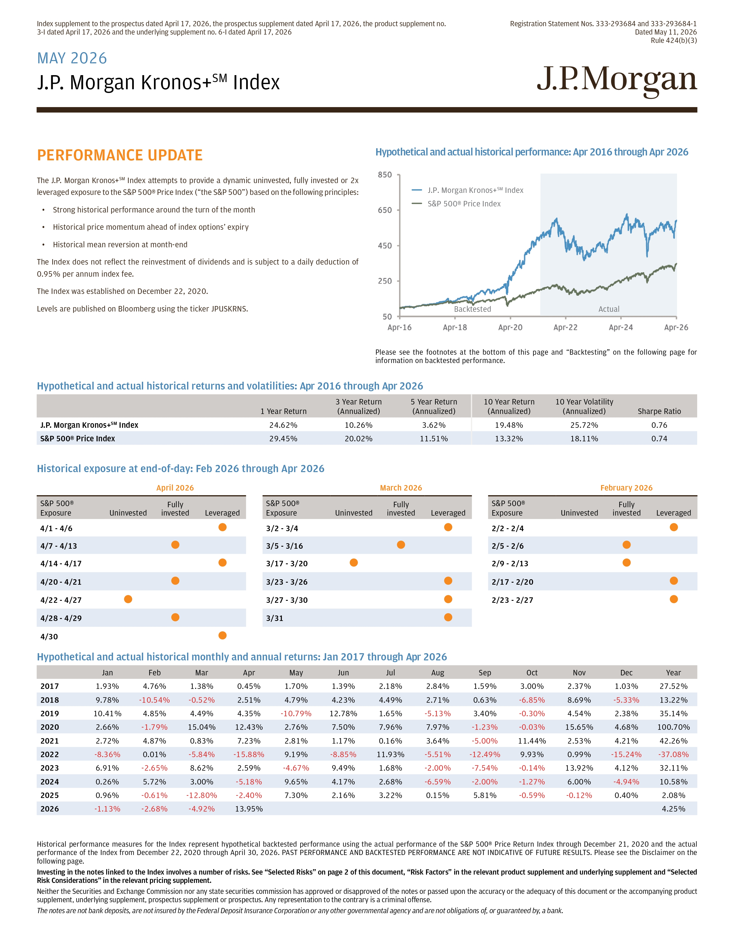
Index supplement to the prospectus dated April 17, 2026, the prospectus supplement dated April 17, 2026, the product supplement no. 3 - I dated April 17, 2026 and the underlying supplement no. 6 - I dated April 17, 2026 Registration Statement Nos. 333 - 293684 and 333 - 293684 - 1 Dated May 11, 2026 Rule 424(b)(3) PERFORMANCE UPDATE The J.P. Morgan Kronos+ SM Index attempts to provide a dynamic uninvested, fully invested or 2x leveraged exposure to the S&P 500® Price Index (“the S&P 500”) based on the following principles: • Strong historical performance around the turn of the month • Historical price momentum ahead of index options’ expiry • Historical mean reversion at month - end The Index does not reflect the reinvestment of dividends and is subject to a daily deduction of 0.95% per annum index fee. The Index was established on December 22, 2020. Levels are published on Bloomberg using the ticker JPUSKRNS. Hypothetical and actual historical performance: Apr 2016 through Apr 2026 Please see the footnotes at the bottom of this page and “Backtesting” on the following page for information on backtested performance. Hypothetical and actual historical returns and volatilities: Apr 2016 through Apr 2026 J.P. Morgan Kronos+ Index S&P 500 ® Price Index Backtested Actual J.P. Morgan Kronos+ SM Index S&P 500 Price Index Backtested Actua Sharpe Ratio 10 Year Volatility (Annualized) 10 Year Return (Annualized) 5 Year Return (Annualized) 3 Year Return (Annualized) 1 Year Return 0.76 25.72% 19.48% 3.62% 10.26% 24.62% J.P. Morgan Kronos+ SM Index 0.74 18.11% 13.32% 11.51% 20.02% 29.45% S&P 500® Price Index Historical exposure at end - of - day: Feb 2026 through Apr 2026 Hypothetical and actual historical monthly and annual returns: Jan 2017 through Apr 2026 Year Dec Nov Oct Sep Aug Jul Jun May Apr Mar Feb Jan 27.52% 1.03% 2.37% 3.00% 1.59% 2.84% 2.18% 1.39% 1.70% 0.45% 1.38% 4.76% 1.93% 2017 13.22% - 5.33% 8.69% - 6.85% 0.63% 2.71% 4.49% 4.23% 4.79% 2.51% - 0.52% - 10.54% 9.78% 2018 35.14% 2.38% 4.54% - 0.30% 3.40% - 5.13% 1.65% 12.78% - 10.79% 4.35% 4.49% 4.85% 10.41% 2019 100.70% 4.68% 15.65% - 0.03% - 1.23% 7.97% 7.96% 7.50% 2.76% 12.43% 15.04% - 1.79% 2.66% 2020 42.26% 4.21% 2.53% 11.44% - 5.00% 3.64% 0.16% 1.17% 2.81% 7.23% 0.83% 4.87% 2.72% 2021 - 37.08% - 15.24% 0.99% 9.93% - 12.49% - 5.51% 11.93% - 8.85% 9.19% - 15.88% - 5.84% 0.01% - 8.36% 2022 32.11% 4.12% 13.92% - 0.14% - 7.54% - 2.00% 1.68% 9.49% - 4.67% 2.59% 8.62% - 2.65% 6.91% 2023 10.58% - 4.94% 6.00% - 1.27% - 2.00% - 6.59% 2.68% 4.17% 9.65% - 5.18% 3.00% 5.72% 0.26% 2024 2.08% 0.40% - 0.12% - 0.59% 5.81% 0.15% 3.22% 2.16% 7.30% - 2.40% - 12.80% - 0.61% 0.96% 2025 4.25% 13.95% - 4.92% - 2.68% - 1.13% 2026 MAY 2026 J.P. Morgan Kronos+ SM Index Historical performance measures for the Index represent hypothetical backtested performance using the actual performance of the S&P 500 ® Price Return Index through December 21 , 2020 and the actual performance of the Index from December 22 , 2020 through April 30 , 2026 . PAST PERFORMANCE AND BACKTESTED PERFORMANCE ARE NOT INDICATIVE OF FUTURE RESULTS . Please see the Disclaimer on the following page . Investing in the notes linked to the Index involves a number of risks . See “Selected Risks” on page 2 of this document, “Risk Factors” in the relevant product supplement and underlying supplement and “Selected Risk Considerations” in the relevant pricing supplement . Neither the Securities and Exchange Commission nor any state securities commission has approved or disapproved of the notes or passed upon the accuracy or the adequacy of this document or the accompanying product supplement, underlying supplement, prospectus supplement or prospectus . Any representation to the contrary is a criminal otfense . The notes are not bank deposits, are not insured by the Federal Deposit Insurance Corporation or any other governmental agency and are not obligations of, or guaranteed by, a bank . February 2026 March 2026 April 2026 Fully S&P 500® Fully S&P 500® Fully S&P 500® Leveraged invested Uninvested Exposure Leveraged invested Uninvested Exposure Leveraged invested Uninvested Exposure 2/2 - 2/4 3/2 - 3/4 4/1 - 4/6 2/5 - 2/6 3/5 - 3/16 4/7 - 4/13 2/9 - 2/13 3/17 - 3/20 4/14 - 4/17 2/17 - 2/20 3/23 - 3/26 4/20 - 4/21 2/23 - 2/27 3/27 - 3/30 4/22 - 4/27 3/31 4/28 - 4/29 4/30
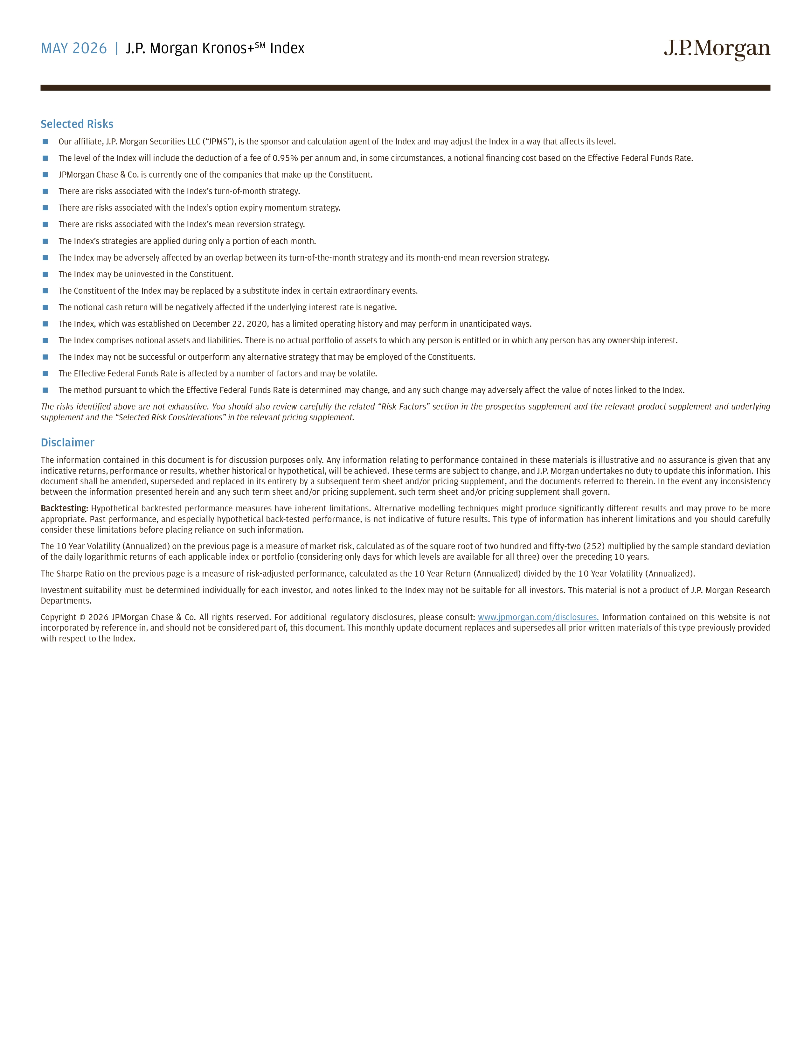
MAY 2026 | J.P. Morgan Kronos+ SM Index Selected Risks  Our affiliate, J.P. Morgan Securities LLC (“JPMS”), is the sponsor and calculation agent of the Index and may adjust the Index in a way that atfects its level.  The level of the Index will include the deduction of a fee of 0.95% per annum and, in some circumstances, a notional financing cost based on the Etfective Federal Funds Rate.  JPMorgan Chase & Co. is currently one of the companies that make up the Constituent.  There are risks associated with the Index’s turn - of - month strategy.  There are risks associated with the Index’s option expiry momentum strategy.  There are risks associated with the Index’s mean reversion strategy.  The Index’s strategies are applied during only a portion of each month.  The Index may be adversely atfected by an overlap between its turn - of - the - month strategy and its month - end mean reversion strategy.  The Index may be uninvested in the Constituent.  The Constituent of the Index may be replaced by a substitute index in certain extraordinary events.  The notional cash return will be negatively atfected if the underlying interest rate is negative.  The Index, which was established on December 22, 2020, has a limited operating history and may perform in unanticipated ways.  The Index comprises notional assets and liabilities. There is no actual portfolio of assets to which any person is entitled or in which any person has any ownership interest.  The Index may not be successful or outperform any alternative strategy that may be employed of the Constituents.  The Etfective Federal Funds Rate is atfected by a number of factors and may be volatile.  The method pursuant to which the Etfective Federal Funds Rate is determined may change, and any such change may adversely atfect the value of notes linked to the Index. The risks identified above are not exhaustive. You should also review carefully the related “Risk Factors” section in the prospectus supplement and the relevant product supplement and underlying supplement and the “Selected Risk Considerations” in the relevant pricing supplement. Disclaimer The information contained in this document is for discussion purposes only . Any information relating to performance contained in these materials is illustrative and no assurance is given that any indicative returns, performance or results, whether historical or hypothetical, will be achieved . These terms are subject to change, and J . P . Morgan undertakes no duty to update this information . This document shall be amended, superseded and replaced in its entirety by a subsequent term sheet and/or pricing supplement, and the documents referred to therein . In the event any inconsistency between the information presented herein and any such term sheet and/or pricing supplement, such term sheet and/or pricing supplement shall govern . Backtesting : Hypothetical backtested performance measures have inherent limitations . Alternative modelling techniques might produce significantly ditferent results and may prove to be more appropriate . Past performance, and especially hypothetical back - tested performance, is not indicative of future results . This type of information has inherent limitations and you should carefully consider these limitations before placing reliance on such information . The 10 Year Volatility (Annualized) on the previous page is a measure of market risk, calculated as of the square root of two hundred and fifty - two ( 252 ) multiplied by the sample standard deviation of the daily logarithmic returns of each applicable index or portfolio (considering only days for which levels are available for all three) over the preceding 10 years . The Sharpe Ratio on the previous page is a measure of risk - adjusted performance, calculated as the 10 Year Return (Annualized) divided by the 10 Year Volatility (Annualized) . Investment suitability must be determined individually for each investor, and notes linked to the Index may not be suitable for all investors . This material is not a product of J . P . Morgan Research Departments . Copyright © 2026 JPMorgan Chase & Co . All rights reserved . For additional regulatory disclosures, please consult : www . jpmorgan . com/disclosures . Information contained on this website is not incorporated by reference in, and should not be considered part of, this document . This monthly update document replaces and supersedes all prior written materials of this type previously provided with respect to the Index .

