UNITED STATES
SECURITIES AND EXCHANGE COMMISSION
Washington, D.C. 20549
FORM 8-K
CURRENT REPORT
Pursuant to Section 13 or 15(d) of the Securities Exchange Act of 1934
Date of Report (date of earliest event reported): July 14, 2026
JPMorgan Chase & Co.
(Exact name of registrant as specified in its charter)
Delaware |  |  |  |  |  | 1-5805 |  |  |  |  |  | 13-2624428
(State or other jurisdiction of  incorporation or organization) |  |  |  |  |  | (Commission File Number) |  |  |  |  |  | (I.R.S. employer  identification no.)
270 Park Avenue,
New York, |  |  | New York |  |  |  |  |  |  |  |  | 10017
(Address of principal executive offices) |  |  |  |  |  |  |  |  |  |  |  | (Zip Code)
Registrant’s telephone number, including area code: (212) 270-6000
Check the appropriate box below if the Form 8-K filing is intended to simultaneously satisfy the filing obligation of the registrant under any of the following provisions:
☐ |  |  |  |  |  | Written communications pursuant to Rule 425 under the Securities Act (17 CFR 230.425)
☐ |  |  |  |  |  | Soliciting material pursuant to Rule 14a-12 under the Exchange Act (17 CFR 240.14a-12)
☐ |  |  |  |  |  | Pre-commencement communications pursuant to Rule 14d-2(b) under the Exchange Act (17 CFR 240.14d-2(b))
☐ |  |  |  |  |  | Pre-commencement communications pursuant to Rule 13e-4(c) under the Exchange Act (17 CFR 240.13e-4(c))
Securities registered pursuant to Section 12(b) of the Act:
Title of each class |  |  | Trading Symbol(s) |  |  | Name of each exchange on which registered
Common stock |  |  | JPM |  |  | The New York Stock Exchange
Depositary Shares, each representing a one-four hundredth interest in a share of 5.75% Non-Cumulative Preferred Stock, Series DD |  |  | JPM PR D |  |  | The New York Stock Exchange
Depositary Shares, each representing a one-four hundredth interest in a share of 6.00% Non-Cumulative Preferred Stock, Series EE |  |  | JPM PR C |  |  | The New York Stock Exchange
Depositary Shares, each representing a one-four hundredth interest in a share of 4.75% Non-Cumulative Preferred Stock, Series GG |  |  | JPM PR J |  |  | The New York Stock Exchange
Depositary Shares, each representing a one-four hundredth interest in a share of 4.55% Non-Cumulative Preferred Stock, Series JJ |  |  | JPM PR K |  |  | The New York Stock Exchange
Depositary Shares, each representing a one-four hundredth interest in a share of 4.625% Non-Cumulative Preferred Stock, Series LL |  |  | JPM PR L |  |  | The New York Stock Exchange
Depositary Shares, each representing a one-four hundredth interest in a share of 4.20% Non-Cumulative Preferred Stock, Series MM |  |  | JPM PR M |  |  | The New York Stock Exchange
Guarantee of Callable Fixed Rate Notes due June 10, 2032 of JPMorgan Chase Financial Company LLC |  |  | JPM/32 |  |  | The New York Stock Exchange
Guarantee of Alerian MLP Index ETNs due January 28, 2044 of JPMorgan Chase Financial Company LLC |  |  | AMJB |  |  | NYSE Arca, Inc.
Guarantee of Inverse VIX Short-Term Futures ETNs due March 22, 2045 of JPMorgan Chase Financial Company LLC |  |  | VYLD |  |  | NYSE Arca, Inc.
Indicate by check mark whether the registrant is an emerging growth company as defined in Rule 405 of the Securities Act of 1933 (§230.405 of this chapter) or Rule 12b-2 of the Securities Exchange Act of 1934 (§240.12b-2 of this chapter).
Emerging growth company ☐
If an emerging growth company, indicate by check mark if the registrant has elected not to use the extended transition period for complying with any new or revised financial accounting standards provided pursuant to Section 13(a) of the Exchange Act. ☐

Item 7.01 Regulation FD Disclosure
On July 14, 2026, JPMorgan Chase & Co. (“JPMorganChase” or the “Firm”) held an investor presentation to review 2026 second quarter earnings.
Exhibit 99 is a copy of slides furnished for, and posted on the Firm’s website in connection with, the presentation. The slides are being furnished pursuant to Item 7.01, and the information contained therein shall not be deemed to be “filed” for purposes of Section 18 of the Securities Exchange Act of 1934, or otherwise subject to the liabilities under that Section. Furthermore, the information contained in Exhibit 99 shall not be deemed to be incorporated by reference into the filings of the Firm under the Securities Act of 1933.
This Current Report on Form 8-K (including the Exhibit hereto) contains forward-looking statements within the meaning of the Private Securities Litigation Reform Act of 1995. These statements are based on the beliefs and expectations of JPMorganChase’s management, speak only as of the date on which they were made, and are subject to significant risks and uncertainties. Actual results may differ from those set forth in the forward-looking statements. Factors that could cause JPMorganChase’s actual results to differ materially from those described in the forward-looking statements can be found in JPMorganChase’s Annual Report on Form 10-K for the year ended December 31, 2025 and Quarterly Report on Form 10-Q for the quarter ended March 31, 2026, which have been filed with the Securities and Exchange Commission and are available on JPMorganChase’s website (https://jpmorganchaseco.gcs-web.com/ir/sec-other-filings/overview) and on the Securities and Exchange Commission’s website (www.sec.gov). JPMorganChase does not undertake to update any forward-looking statements.

Item 9.01 Financial Statements and Exhibits

(d) Exhibit
Exhibit No. |  |  |  |  |  | Description of Exhibit
99 |  |  |  |  |  | JPMorgan Chase & Co. Earnings Presentation Slides – Financial Results – 2Q26
101 |  |  |  |  |  | Pursuant to Rule 406 of Regulation S-T, the cover page is formatted in Inline XBRL (Inline eXtensible Business Reporting Language).
104 |  |  |  |  |  | Cover Page Interactive Data File (embedded within the Inline XBRL document and included in Exhibit 101).

2

SIGNATURE

Pursuant to the requirements of the Securities Exchange Act of 1934, the Registrant has duly caused this report to be signed on its behalf by the undersigned hereunto duly authorized.
JPMorgan Chase & Co.
(Registrant)

By: |  |  | /s/ Elena Korablina
 |  |  | Elena Korablina
 |  |  | Managing Director and Firmwide Controller
 |  |  | (Principal Accounting Officer)

Dated: |  |  | July 14, 2026

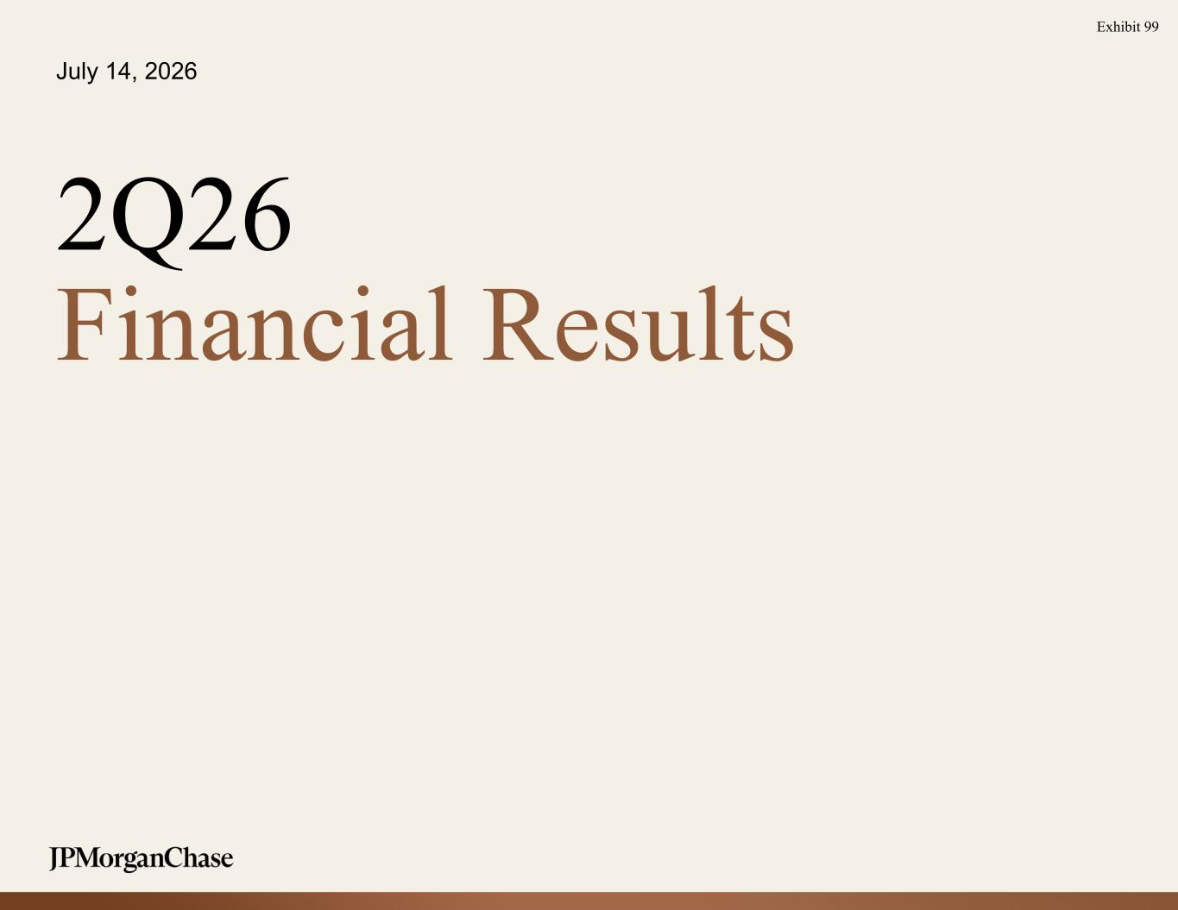
3
July 14, 2026 2Q26 Financial Results Exhibit 99

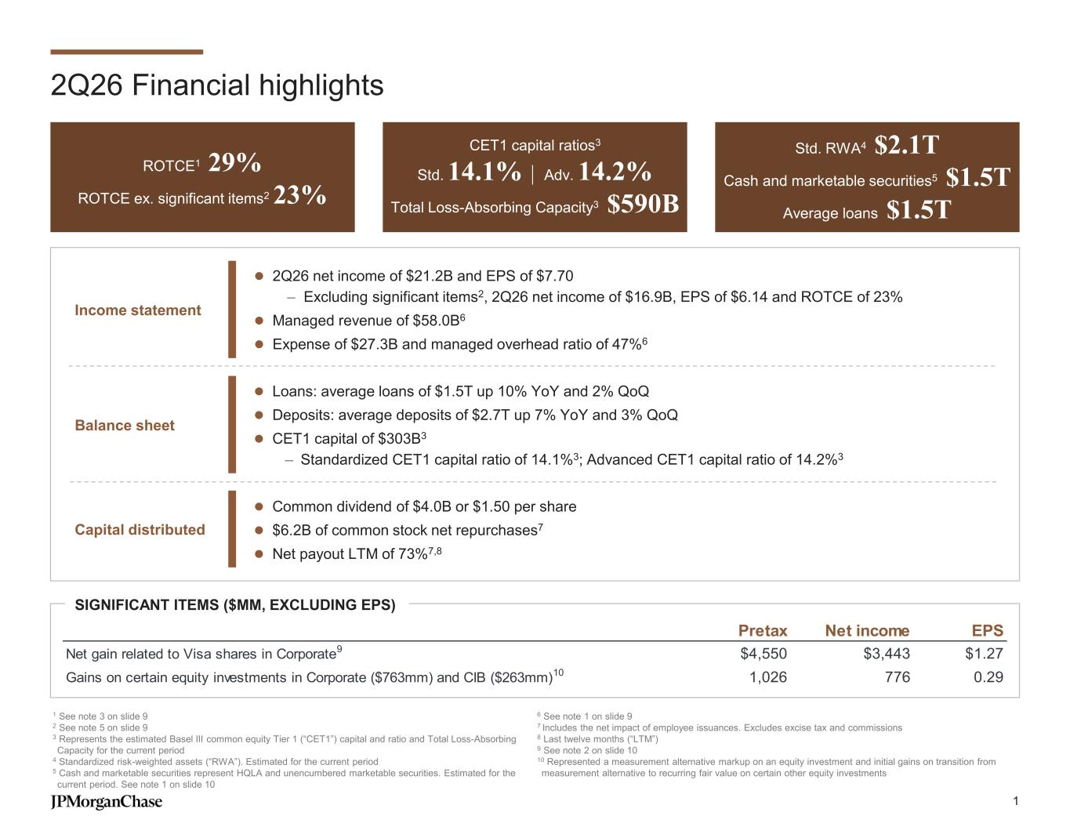
2Q26 Financial highlights ROTCE1 29% ROTCE ex. significant items223% CET1 capital ratios3 Std. 14.1% | Adv. 14.2% Total Loss-Absorbing Capacity3 $590B Std. RWA4 $2.1T Cash and marketable securities5 $1.5T Average loans $1.5T 1 See note 3 on slide 9 2 See note 5 on slide 9 3 Represents the estimated Basel III common equity Tier 1 (“CET1”) capital and ratio and Total Loss-Absorbing Capacity for the current period 4 Standardized risk-weighted assets (“RWA”). Estimated for the current period 5 Cash and marketable securities represent HQLA and unencumbered marketable securities. Estimated for the current period. See note 1 on slide 10 6 See note 1 on slide 9 7 Includes the net impact of employee issuances. Excludes excise tax and commissions 8 Last twelve months (“LTM”) 9 See note 2 on slide 10 10 Represented a measurement alternative markup on an equity investment and initial gains on transition from measurement alternative to recurring fair value on certain other equity investments ⚫ Common dividend of $4.0B or $1.50 per share ⚫ $6.2B of common stock net repurchases7 ⚫ Net payout LTM of 73%7,8 ⚫ Loans: average loans of $1.5T up 10% YoY and 2% QoQ ⚫ Deposits: average deposits of $2.7T up 7% YoY and 3% QoQ ⚫ CET1 capital of $303B3 – Standardized CET1 capital ratio of 14.1%3; Advanced CET1 capital ratio of 14.2%3 ⚫ 2Q26 net income of $21.2B and EPS of $7.70 – Excluding significant items2, 2Q26 net income of $16.9B, EPS of $6.14 and ROTCE of 23% ⚫ Managed revenue of $58.0B6 ⚫ Expense of $27.3B and managed overhead ratio of 47%6 SIGNIFICANT ITEMS ($MM, EXCLUDING EPS) Balance sheet Capital distributed Income statement Pretax Net income EPS Net gain related to Visa shares in Corporate9 $4,550 $3,443 $1.27 Gains on certain equity investments in Corporate ($763mm) and CIB ($263mm)10 1,026 776 0.29 1

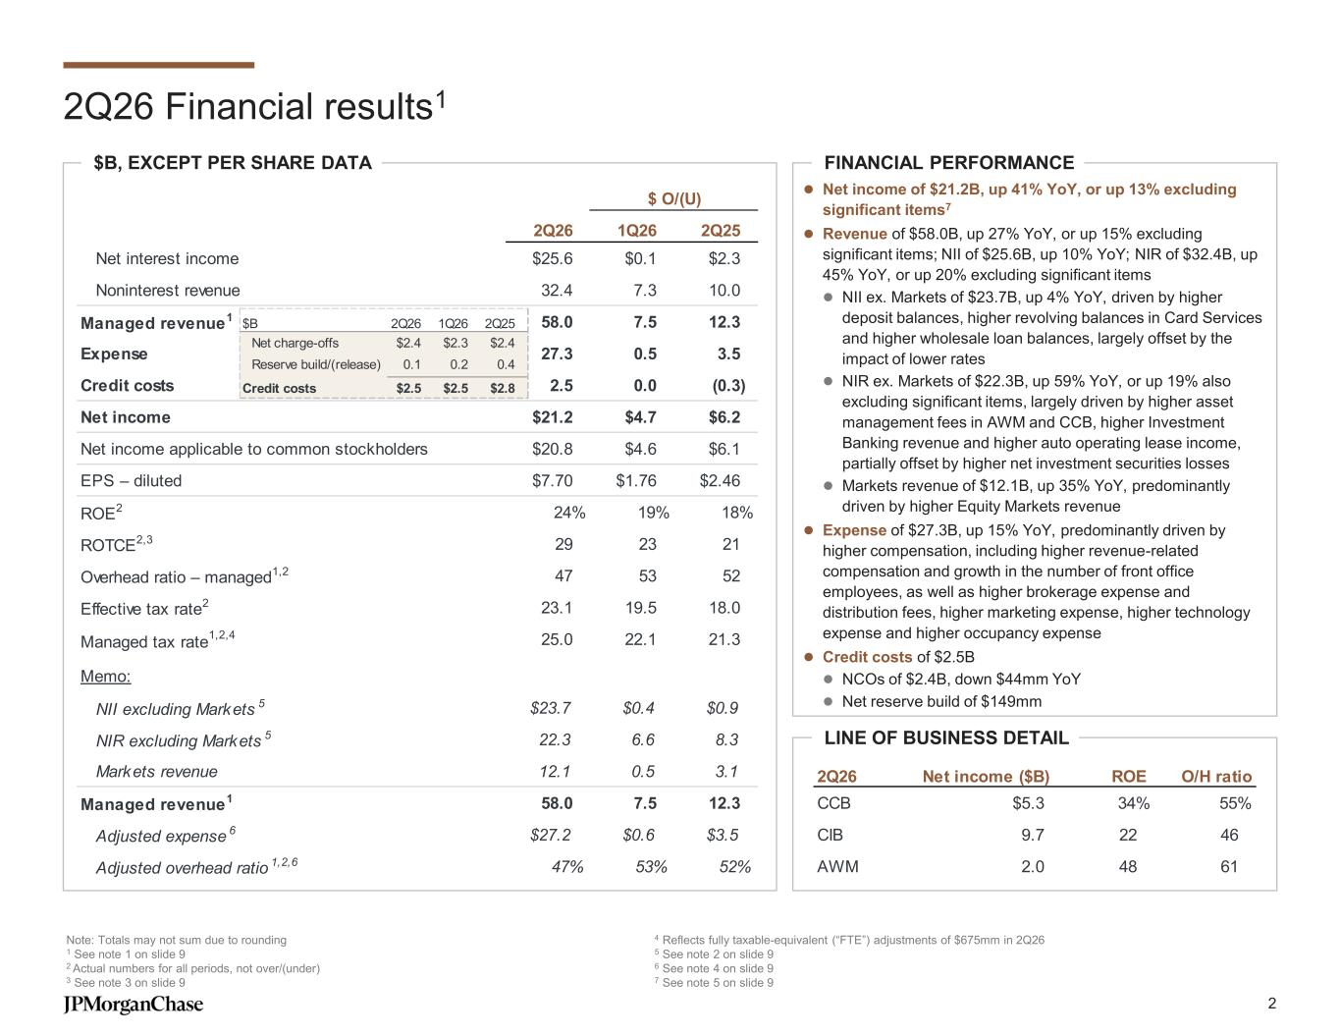
2Q26 1Q26 2Q25 Net interest income $25.6 $0.1 $2.3 Noninterest revenue 32.4 7.3 10.0 Managed revenue1 58.0 7.5 12.3 Expense 27.3 0.5 3.5 Credit costs 2.5 0.0 (0.3) Net income $21.2 $4.7 $6.2 Net income applicable to common stockholders $20.8 $4.6 $6.1 EPS – diluted $7.70 $1.76 $2.46 ROE2 24% 19% 18% ROTCE2,3 29 23 21 Overhead ratio – managed1,2 47 53 52 Effective tax rate2 23.1 19.5 18.0 Managed tax rate 1,2,4 25.0 22.1 21.3 Memo: NII excluding Markets 5 $23.7 $0.4 $0.9 NIR excluding Markets 5 22.3 6.6 8.3 Markets revenue 12.1 0.5 3.1 Managed revenue1 58.0 7.5 12.3 Adjusted expense 6 $27.2 $0.6 $3.5 Adjusted overhead ratio 1,2,6 47% 53% 52% $ O/(U) 2Q26 Financial results1 Note: Totals may not sum due to rounding 1 See note 1 on slide 9 2 Actual numbers for all periods, not over/(under) 3 See note 3 on slide 9 4 Reflects fully taxable-equivalent (“FTE”) adjustments of $675mm in 2Q26 5 See note 2 on slide 9 6 See note 4 on slide 9 7 See note 5 on slide 9 FINANCIAL PERFORMANCE LINE OF BUSINESS DETAIL $B, EXCEPT PER SHARE DATA 2Q26 Net income ($B) ROE O/H ratio CCB $5.3 34% 55% CIB 9.7 22 46 AWM 2.0 48 61 $B 2Q26 1Q26 2Q25 Net charge-offs $2.4 $2.3 $2.4 Reserve build/(release) 0.1 0.2 0.4 Credit costs $2.5 $2.5 $2.8 ⚫ Net income of $21.2B, up 41% YoY, or up 13% excluding significant items7 ⚫ Revenue of $58.0B, up 27% YoY, or up 15% excluding significant items; NII of $25.6B, up 10% YoY; NIR of $32.4B, up 45% YoY, or up 20% excluding significant items ⚫ NII ex. Markets of $23.7B, up 4% YoY, driven by higher deposit balances, higher revolving balances in Card Services and higher wholesale loan balances, largely offset by the impact of lower rates ⚫ NIR ex. Markets of $22.3B, up 59% YoY, or up 19% also excluding significant items, largely driven by higher asset management fees in AWM and CCB, higher Investment Banking revenue and higher auto operating lease income, partially offset by higher net investment securities losses ⚫ Markets revenue of $12.1B, up 35% YoY, predominantly driven by higher Equity Markets revenue ⚫ Expense of $27.3B, up 15% YoY, predominantly driven by higher compensation, including higher revenue-related compensation and growth in the number of front office employees, as well as higher brokerage expense and distribution fees, higher marketing expense, higher technology expense and higher occupancy expense ⚫ Credit costs of $2.5B ⚫ NCOs of $2.4B, down $44mm YoY ⚫ Net reserve build of $149mm 2

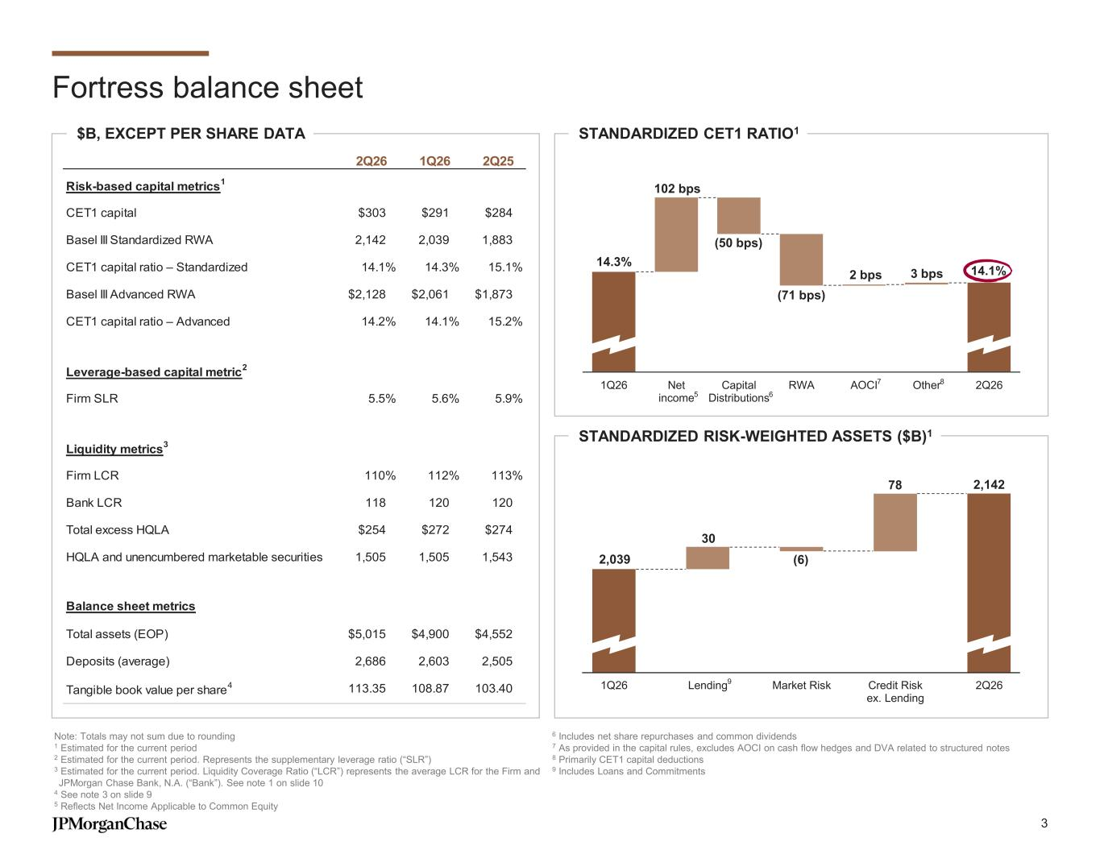
Fortress balance sheet $B, EXCEPT PER SHARE DATA Note: Totals may not sum due to rounding 1 Estimated for the current period 2 Estimated for the current period. Represents the supplementary leverage ratio (“SLR”) 3 Estimated for the current period. Liquidity Coverage Ratio (“LCR”) represents the average LCR for the Firm and JPMorgan Chase Bank, N.A. (“Bank”). See note 1 on slide 10 4 See note 3 on slide 9 5 Reflects Net Income Applicable to Common Equity 6 Includes net share repurchases and common dividends 7 As provided in the capital rules, excludes AOCI on cash flow hedges and DVA related to structured notes 8 Primarily CET1 capital deductions 9 Includes Loans and Commitments STANDARDIZED CET1 RATIO1 STANDARDIZED RISK-WEIGHTED ASSETS ($B)1 2Q26 1Q26 2Q25 Risk-based capital metrics 1 CET1 capital $303 $291 $284 Basel III Standardized RWA 2,142 2,039 1,883 CET1 capital ratio – Standardized 14.1% 14.3% 15.1% Basel III Advanced RWA $2,128 $2,061 $1,873 CET1 capital ratio – Advanced 14.2% 14.1% 15.2% Leverage-based capital metric 2 Firm SLR 5.5% 5.6% 5.9% Liquidity metrics 3 Firm LCR 110% 112% 113% Bank LCR 118 120 120 Total excess HQLA $254 $272 $274 HQLA and unencumbered marketable securities 1,505 1,505 1,543 Balance sheet metrics Total assets (EOP) $5,015 $4,900 $4,552 Deposits (average) 2,686 2,603 2,505 Tangible book value per share 4 113.35 108.87 103.40 14.3% 14.1% (50 bps) (71 bps) 102 bps 2 bps 3 bps 1Q26 Net income Capital Distributions RWA AOCI Other 2Q26 65 7 8 2,039 2,142 (6) 30 78 1Q26 Lending Market Risk Credit Risk ex. Lending 2Q269 3

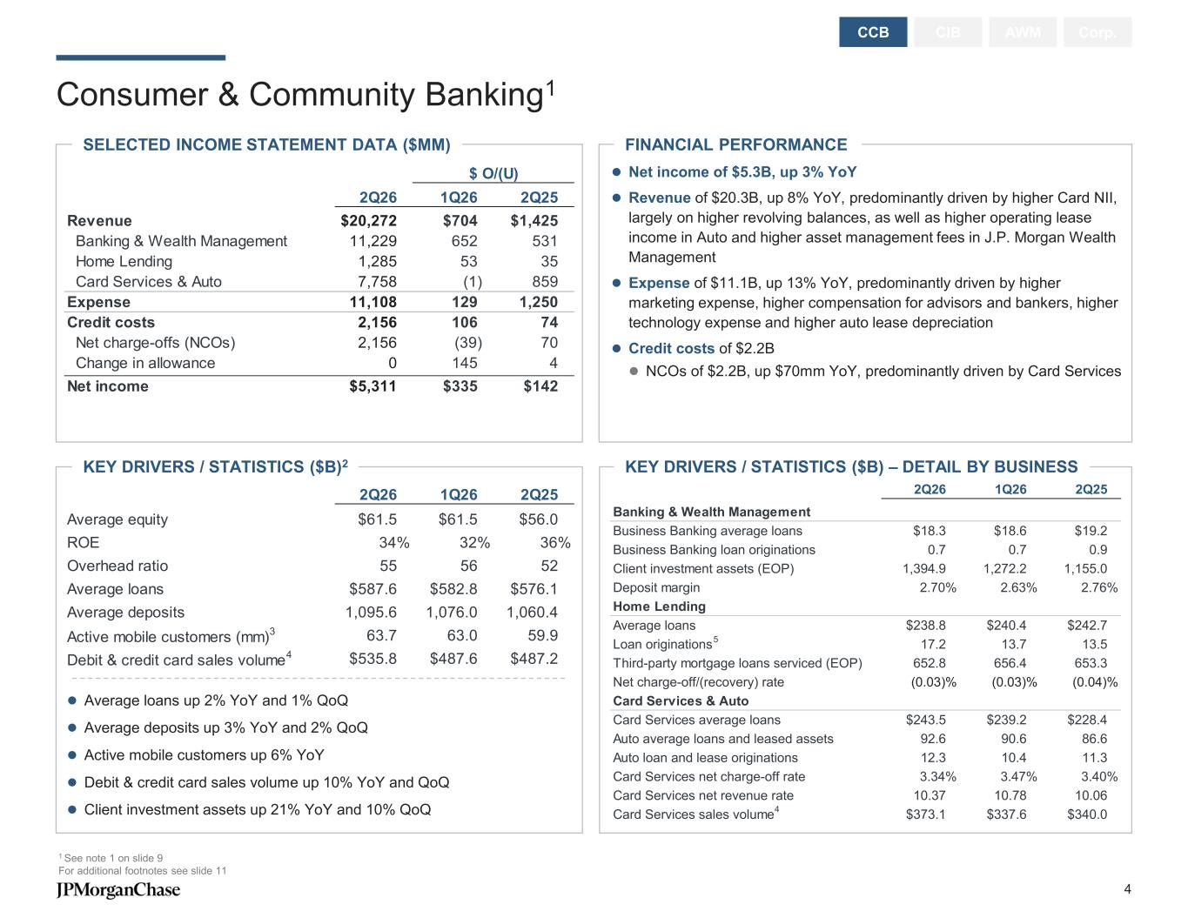
Consumer & Community Banking1 CIB AWM Corp.CCB ⚫ Average loans up 2% YoY and 1% QoQ ⚫ Average deposits up 3% YoY and 2% QoQ ⚫ Active mobile customers up 6% YoY ⚫ Debit & credit card sales volume up 10% YoY and QoQ ⚫ Client investment assets up 21% YoY and 10% QoQ KEY DRIVERS / STATISTICS ($B) – DETAIL BY BUSINESS FINANCIAL PERFORMANCESELECTED INCOME STATEMENT DATA ($MM) KEY DRIVERS / STATISTICS ($B)2 1 See note 1 on slide 9 For additional footnotes see slide 11 ⚫ Net income of $5.3B, up 3% YoY ⚫ Revenue of $20.3B, up 8% YoY, predominantly driven by higher Card NII, largely on higher revolving balances, as well as higher operating lease income in Auto and higher asset management fees in J.P. Morgan Wealth Management ⚫ Expense of $11.1B, up 13% YoY, predominantly driven by higher marketing expense, higher compensation for advisors and bankers, higher technology expense and higher auto lease depreciation ⚫ Credit costs of $2.2B ⚫ NCOs of $2.2B, up $70mm YoY, predominantly driven by Card Services $ O/(U) 2Q26 1Q26 2Q25 Revenue $20,272 $704 $1,425 Banking & Wealth Management 11,229 652 531 Home Lending 1,285 53 35 Card Services & Auto 7,758 (1) 859 Expense 11,108 129 1,250 Credit costs 2,156 106 74 Net charge-offs (NCOs) 2,156 (39) 70 Change in allowance 0 145 4 Net income $5,311 $335 $142 2Q26 1Q26 2Q25 Average equity $61.5 $61.5 $56.0 ROE 34% 32% 36% Overhead ratio 55 56 52 Average loans $587.6 $582.8 $576.1 Average deposits 1,095.6 1,076.0 1,060.4 Active mobile customers (mm) 3 63.7 63.0 59.9 Debit & credit card sales volume 4 $535.8 $487.6 $487.2 2Q26 1Q26 2Q25 Banking & Wealth Management Business Banking average loans $18.3 $18.6 $19.2 Business Banking loan originations 0.7 0.7 0.9 Client investment assets (EOP) 1,394.9 1,272.2 1,155.0 Deposit margin 2.70% 2.63% 2.76% Home Lending Average loans $238.8 $240.4 $242.7 Loan originations 17.2 13.7 13.5 Third-party mortgage loans serviced (EOP) 652.8 656.4 653.3 Net charge-off/(recovery) rate (0.03)% (0.03)% (0.04)% Card Services & Auto Card Services average loans $243.5 $239.2 $228.4 Auto average loans and leased assets 92.6 90.6 86.6 Auto loan and lease originations 12.3 10.4 11.3 Card Services net charge-off rate 3.34% 3.47% 3.40% Card Services net revenue rate 10.37 10.78 10.06 Card Services sales volume $373.1 $337.6 $340.0 5 4 4

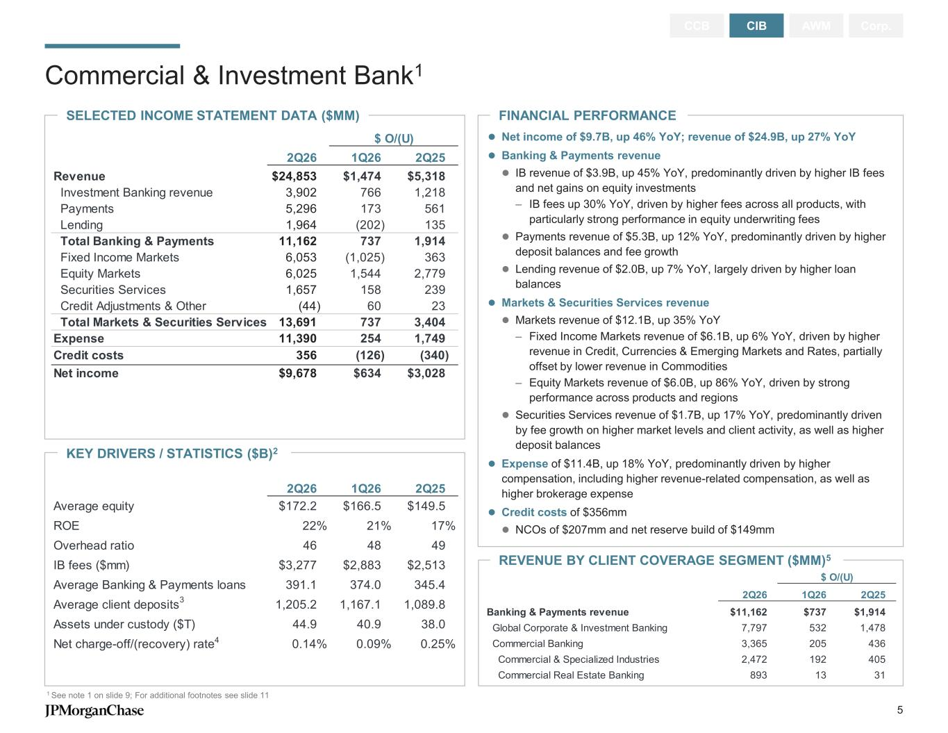
KEY DRIVERS / STATISTICS ($B)2 FINANCIAL PERFORMANCE Commercial & Investment Bank1 1 See note 1 on slide 9; For additional footnotes see slide 11 CCB CIB AWM Corp. SELECTED INCOME STATEMENT DATA ($MM) ⚫ Net income of $9.7B, up 46% YoY; revenue of $24.9B, up 27% YoY ⚫ Banking & Payments revenue ⚫ IB revenue of $3.9B, up 45% YoY, predominantly driven by higher IB fees and net gains on equity investments – IB fees up 30% YoY, driven by higher fees across all products, with particularly strong performance in equity underwriting fees ⚫ Payments revenue of $5.3B, up 12% YoY, predominantly driven by higher deposit balances and fee growth ⚫ Lending revenue of $2.0B, up 7% YoY, largely driven by higher loan balances ⚫ Markets & Securities Services revenue ⚫ Markets revenue of $12.1B, up 35% YoY – Fixed Income Markets revenue of $6.1B, up 6% YoY, driven by higher revenue in Credit, Currencies & Emerging Markets and Rates, partially offset by lower revenue in Commodities – Equity Markets revenue of $6.0B, up 86% YoY, driven by strong performance across products and regions ⚫ Securities Services revenue of $1.7B, up 17% YoY, predominantly driven by fee growth on higher market levels and client activity, as well as higher deposit balances ⚫ Expense of $11.4B, up 18% YoY, predominantly driven by higher compensation, including higher revenue-related compensation, as well as higher brokerage expense ⚫ Credit costs of $356mm ⚫ NCOs of $207mm and net reserve build of $149mm REVENUE BY CLIENT COVERAGE SEGMENT ($MM)5 $ O/(U) 2Q26 1Q26 2Q25 Revenue $24,853 $1,474 $5,318 Investment Banking revenue 3,902 766 1,218 Payments 5,296 173 561 Lending 1,964 (202) 135 Total Banking & Payments 11,162 737 1,914 Fixed Income Markets 6,053 (1,025) 363 Equity Markets 6,025 1,544 2,779 Securities Services 1,657 158 239 Credit Adjustments & Other (44) 60 23 Total Markets & Securities Services 13,691 737 3,404 Expense 11,390 254 1,749 Credit costs 356 (126) (340) Net income $9,678 $634 $3,028 2Q26 1Q26 2Q25 Average equity $172.2 $166.5 $149.5 ROE 22% 21% 17% Overhead ratio 46 48 49 IB fees ($mm) $3,277 $2,883 $2,513 Average Banking & Payments loans 391.1 374.0 345.4 Average client deposits 1,205.2 1,167.1 1,089.8 Assets under custody ($T) 44.9 40.9 38.0 Net charge-off/(recovery) rate 0.14% 0.09% 0.25%4 3 $ O/(U) 2Q26 1Q26 2Q25 Banking & Payments revenue $11,162 $737 $1,914 Global Corporate & Investment Banking 7,797 532 1,478 Commercial Banking 3,365 205 436 Commercial & Specialized Industries 2,472 192 405 Commercial Real Estate Banking 893 13 31 5

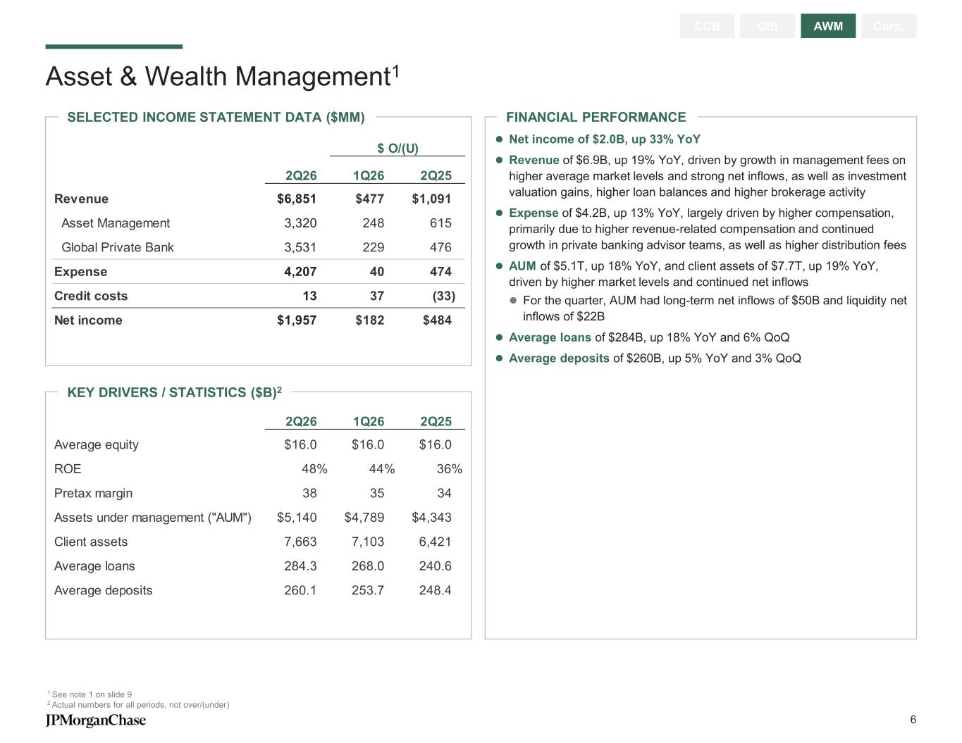
FINANCIAL PERFORMANCESELECTED INCOME STATEMENT DATA ($MM) Asset & Wealth Management1 1 See note 1 on slide 9 2 Actual numbers for all periods, not over/(under) CCB CIB AWM Corp. KEY DRIVERS / STATISTICS ($B)2 ⚫ Net income of $2.0B, up 33% YoY ⚫ Revenue of $6.9B, up 19% YoY, driven by growth in management fees on higher average market levels and strong net inflows, as well as investment valuation gains, higher loan balances and higher brokerage activity ⚫ Expense of $4.2B, up 13% YoY, largely driven by higher compensation, primarily due to higher revenue-related compensation and continued growth in private banking advisor teams, as well as higher distribution fees ⚫ AUM of $5.1T, up 18% YoY, and client assets of $7.7T, up 19% YoY, driven by higher market levels and continued net inflows ⚫ For the quarter, AUM had long-term net inflows of $50B and liquidity net inflows of $22B ⚫ Average loans of $284B, up 18% YoY and 6% QoQ ⚫ Average deposits of $260B, up 5% YoY and 3% QoQ $ O/(U) 2Q26 1Q26 2Q25 Revenue $6,851 $477 $1,091 Asset Management 3,320 248 615 Global Private Bank 3,531 229 476 Expense 4,207 40 474 Credit costs 13 37 (33) Net income $1,957 $182 $484 2Q26 1Q26 2Q25 Average equity $16.0 $16.0 $16.0 ROE 48% 44% 36% Pretax margin 38 35 34 Assets under management ("AUM") $5,140 $4,789 $4,343 Client assets 7,663 7,103 6,421 Average loans 284.3 268.0 240.6 Average deposits 260.1 253.7 248.4 6

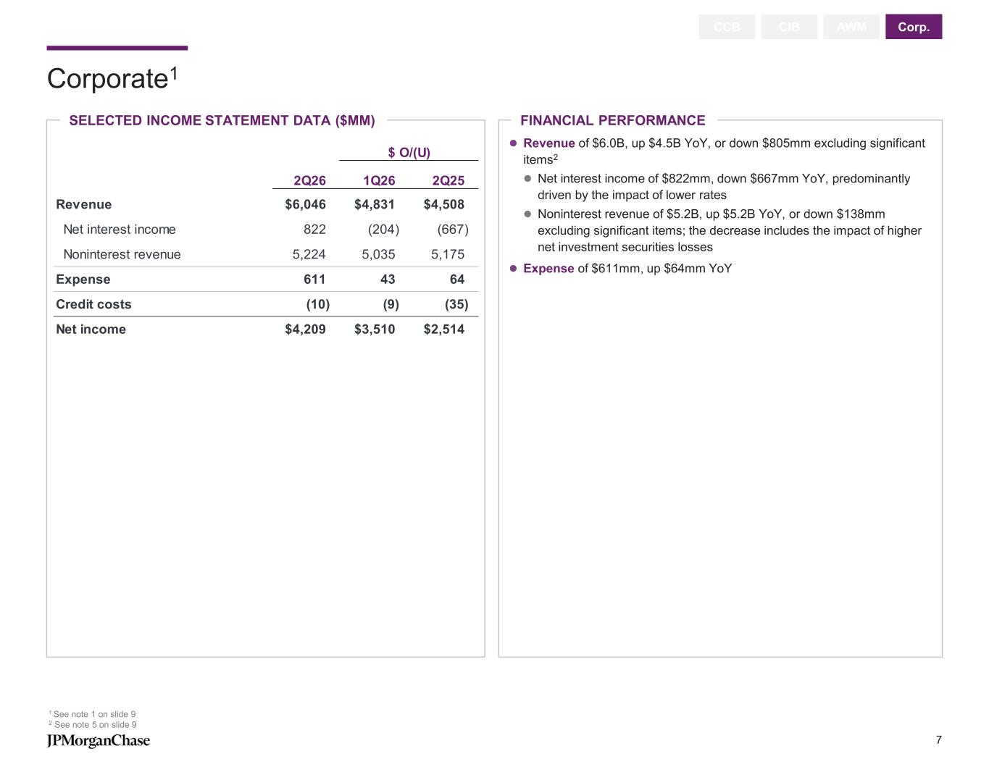
Corporate1 1 See note 1 on slide 9 2 See note 5 on slide 9 CCB CIB AWM Corp. SELECTED INCOME STATEMENT DATA ($MM) FINANCIAL PERFORMANCE ⚫ Revenue of $6.0B, up $4.5B YoY, or down $805mm excluding significant items2 ⚫ Net interest income of $822mm, down $667mm YoY, predominantly driven by the impact of lower rates ⚫ Noninterest revenue of $5.2B, up $5.2B YoY, or down $138mm excluding significant items; the decrease includes the impact of higher net investment securities losses ⚫ Expense of $611mm, up $64mm YoY $ O/(U) 2Q26 1Q26 2Q25 Revenue $6,046 $4,831 $4,508 Net interest income 822 (204) (667) Noninterest revenue 5,224 5,035 5,175 Expense 611 43 64 Credit costs (10) (9) (35) Net income $4,209 $3,510 $2,514 7

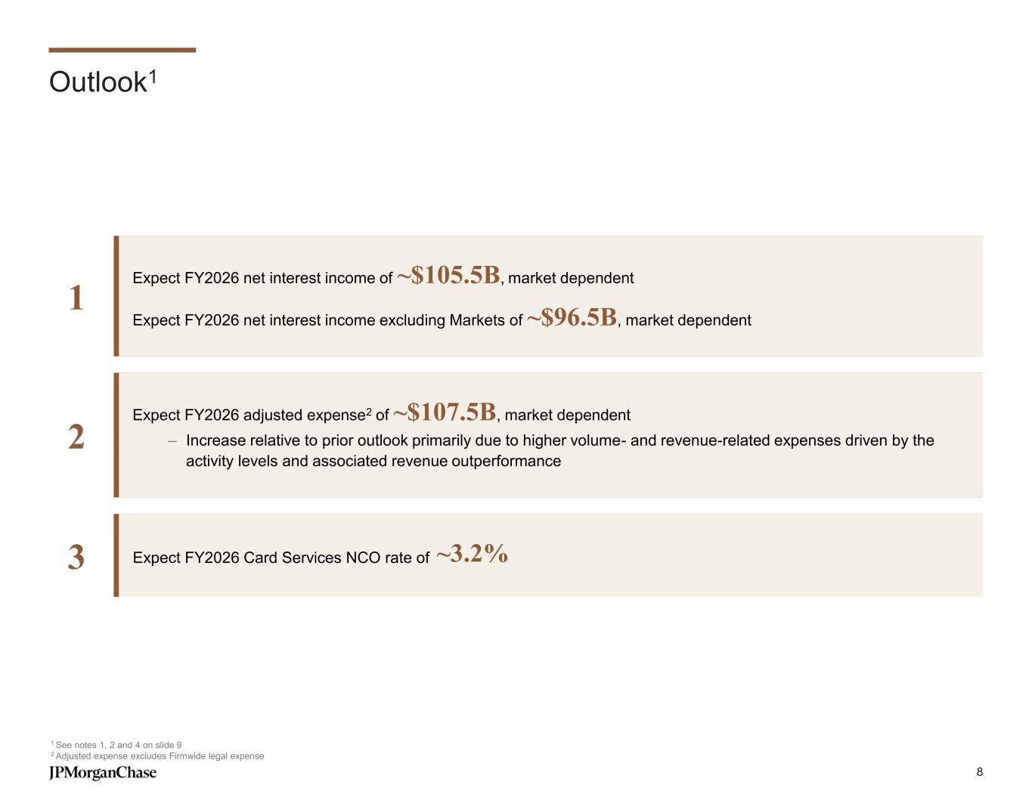
Outlook1 1 See notes 1, 2 and 4 on slide 9 2 Adjusted expense excludes Firmwide legal expense Expect FY2026 net interest income of ~$105.5B, market dependent Expect FY2026 net interest income excluding Markets of ~$96.5B, market dependent Expect FY2026 Card Services NCO rate of ~3.2%3 Expect FY2026 adjusted expense2 of ~$107.5B, market dependent – Increase relative to prior outlook primarily due to higher volume- and revenue-related expenses driven by the activity levels and associated revenue outperformance 2 1 8

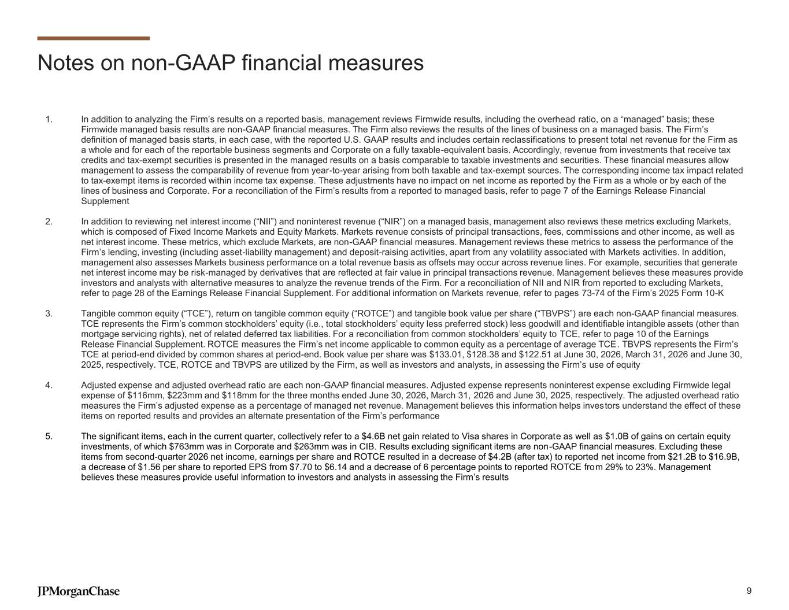
Notes on non-GAAP financial measures 1. In addition to analyzing the Firm’s results on a reported basis, management reviews Firmwide results, including the overhead ratio, on a “managed” basis; these Firmwide managed basis results are non-GAAP financial measures. The Firm also reviews the results of the lines of business on a managed basis. The Firm’s definition of managed basis starts, in each case, with the reported U.S. GAAP results and includes certain reclassifications to present total net revenue for the Firm as a whole and for each of the reportable business segments and Corporate on a fully taxable-equivalent basis. Accordingly, revenue from investments that receive tax credits and tax-exempt securities is presented in the managed results on a basis comparable to taxable investments and securities. These financial measures allow management to assess the comparability of revenue from year-to-year arising from both taxable and tax-exempt sources. The corresponding income tax impact related to tax-exempt items is recorded within income tax expense. These adjustments have no impact on net income as reported by the Firm as a whole or by each of the lines of business and Corporate. For a reconciliation of the Firm’s results from a reported to managed basis, refer to page 7 of the Earnings Release Financial Supplement 2. In addition to reviewing net interest income (“NII”) and noninterest revenue (“NIR”) on a managed basis, management also reviews these metrics excluding Markets, which is composed of Fixed Income Markets and Equity Markets. Markets revenue consists of principal transactions, fees, commissions and other income, as well as net interest income. These metrics, which exclude Markets, are non-GAAP financial measures. Management reviews these metrics to assess the performance of the Firm’s lending, investing (including asset-liability management) and deposit-raising activities, apart from any volatility associated with Markets activities. In addition, management also assesses Markets business performance on a total revenue basis as offsets may occur across revenue lines. For example, securities that generate net interest income may be risk-managed by derivatives that are reflected at fair value in principal transactions revenue. Management believes these measures provide investors and analysts with alternative measures to analyze the revenue trends of the Firm. For a reconciliation of NII and NIR from reported to excluding Markets, refer to page 28 of the Earnings Release Financial Supplement. For additional information on Markets revenue, refer to pages 73-74 of the Firm’s 2025 Form 10-K 3. Tangible common equity (“TCE”), return on tangible common equity (“ROTCE”) and tangible book value per share (“TBVPS”) are each non-GAAP financial measures. TCE represents the Firm’s common stockholders’ equity (i.e., total stockholders’ equity less preferred stock) less goodwill and identifiable intangible assets (other than mortgage servicing rights), net of related deferred tax liabilities. For a reconciliation from common stockholders’ equity to TCE, refer to page 10 of the Earnings Release Financial Supplement. ROTCE measures the Firm’s net income applicable to common equity as a percentage of average TCE. TBVPS represents the Firm’s TCE at period-end divided by common shares at period-end. Book value per share was $133.01, $128.38 and $122.51 at June 30, 2026, March 31, 2026 and June 30, 2025, respectively. TCE, ROTCE and TBVPS are utilized by the Firm, as well as investors and analysts, in assessing the Firm’s use of equity 4. Adjusted expense and adjusted overhead ratio are each non-GAAP financial measures. Adjusted expense represents noninterest expense excluding Firmwide legal expense of $116mm, $223mm and $118mm for the three months ended June 30, 2026, March 31, 2026 and June 30, 2025, respectively. The adjusted overhead ratio measures the Firm’s adjusted expense as a percentage of managed net revenue. Management believes this information helps inves tors understand the effect of these items on reported results and provides an alternate presentation of the Firm’s performance 5. The significant items, each in the current quarter, collectively refer to a $4.6B net gain related to Visa shares in Corporate as well as $1.0B of gains on certain equity investments, of which $763mm was in Corporate and $263mm was in CIB. Results excluding significant items are non-GAAP financial measures. Excluding these items from second-quarter 2026 net income, earnings per share and ROTCE resulted in a decrease of $4.2B (after tax) to reported net income from $21.2B to $16.9B, a decrease of $1.56 per share to reported EPS from $7.70 to $6.14 and a decrease of 6 percentage points to reported ROTCE from 29% to 23%. Management believes these measures provide useful information to investors and analysts in assessing the Firm’s results 9

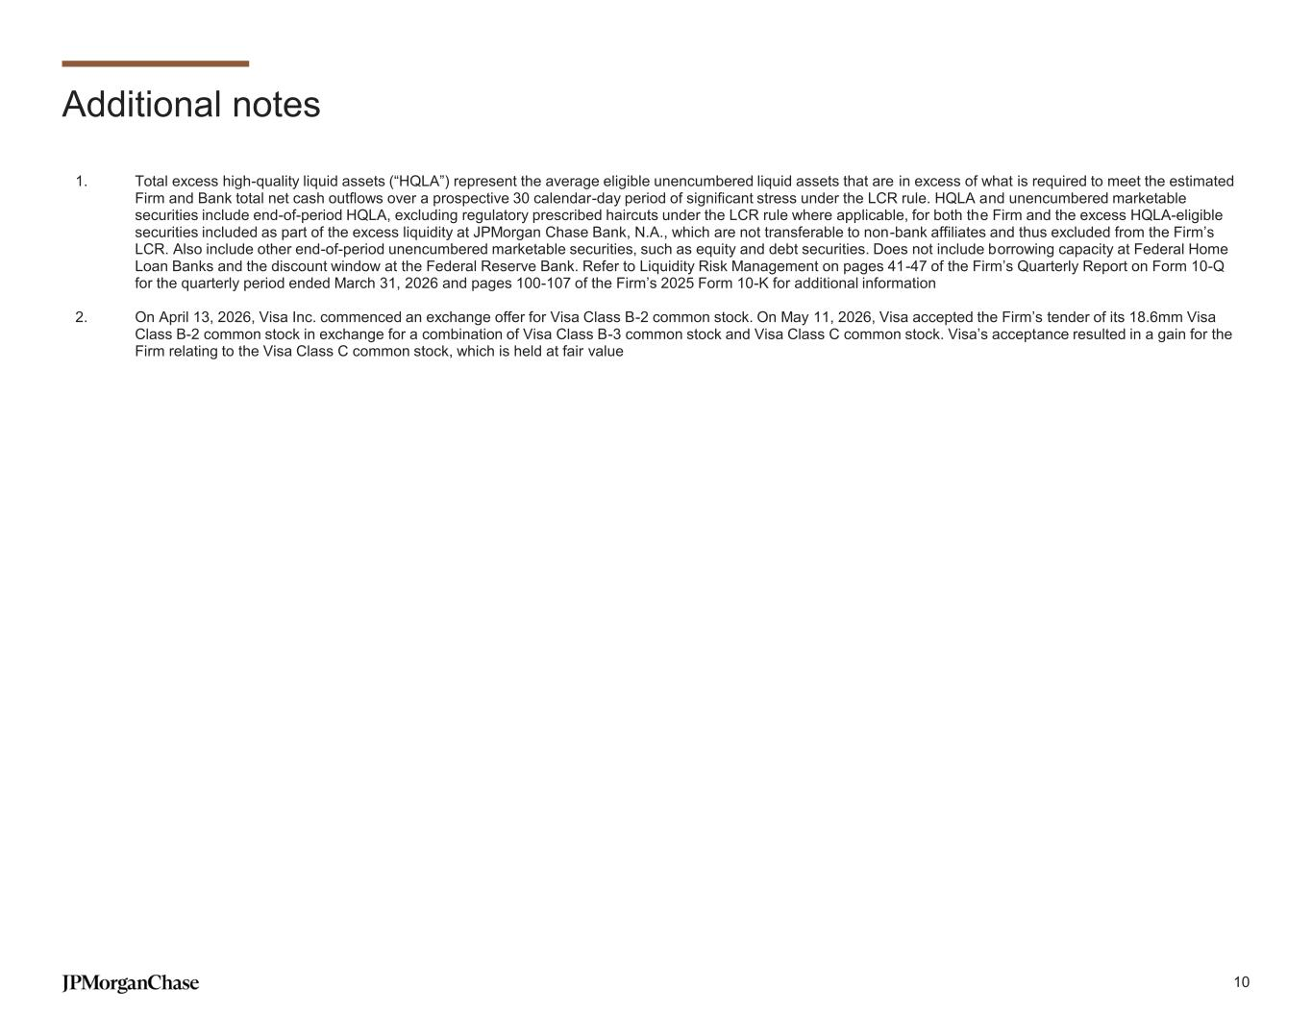
Additional notes 1. Total excess high-quality liquid assets (“HQLA”) represent the average eligible unencumbered liquid assets that are in excess of what is required to meet the estimated Firm and Bank total net cash outflows over a prospective 30 calendar-day period of significant stress under the LCR rule. HQLA and unencumbered marketable securities include end-of-period HQLA, excluding regulatory prescribed haircuts under the LCR rule where applicable, for both the Firm and the excess HQLA-eligible securities included as part of the excess liquidity at JPMorgan Chase Bank, N.A., which are not transferable to non-bank affiliates and thus excluded from the Firm’s LCR. Also include other end-of-period unencumbered marketable securities, such as equity and debt securities. Does not include borrowing capacity at Federal Home Loan Banks and the discount window at the Federal Reserve Bank. Refer to Liquidity Risk Management on pages 41-47 of the Firm’s Quarterly Report on Form 10-Q for the quarterly period ended March 31, 2026 and pages 100-107 of the Firm’s 2025 Form 10-K for additional information 2. On April 13, 2026, Visa Inc. commenced an exchange offer for Visa Class B-2 common stock. On May 11, 2026, Visa accepted the Firm’s tender of its 18.6mm Visa Class B-2 common stock in exchange for a combination of Visa Class B-3 common stock and Visa Class C common stock. Visa’s acceptance resulted in a gain for the Firm relating to the Visa Class C common stock, which is held at fair value 10


Additional notes on slides 4-5 Slide 4 – Consumer & Community Banking 2. Actual numbers for all periods, not over/(under) 3. Users of all mobile platforms who have logged in within the past 90 days 4. Excludes Commercial Card 5. Firmwide mortgage origination volume was $21.2B, $16.6B and $16.3B for the three months ended June 30, 2026, March 31, 2026 and June 30, 2025, respectively Slide 5 – Commercial & Investment Bank 2. Actual numbers for all periods, not over/(under) 3. Client deposits and other third-party liabilities (“client deposits”) pertain to the Payments and Securities Services businesses 4. Loans held-for-sale and loans at fair value were excluded when calculating the net charge-off/(recovery) rate 5. Refer to page 70 of the Firm’s Annual Report on Form 10-K for the year ended December 31, 2025 for a description of each of the client coverage segments 11

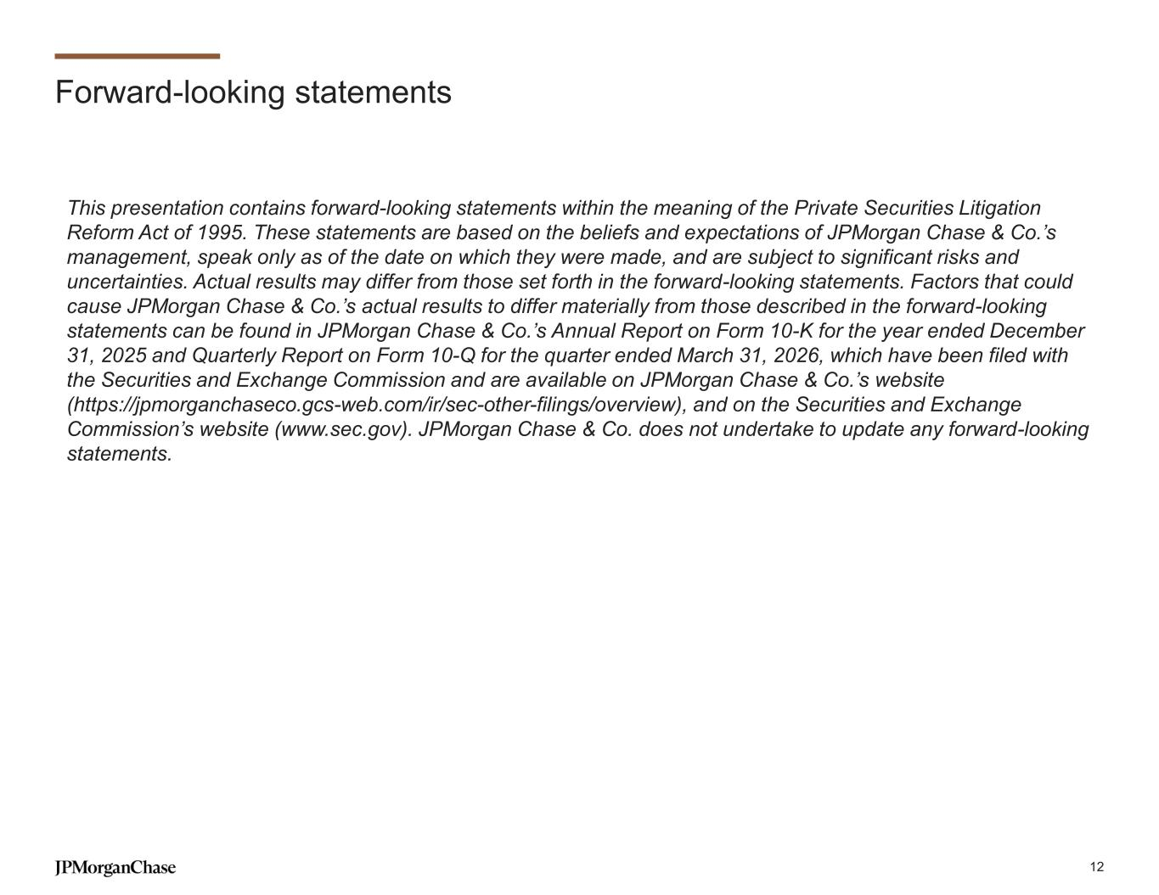
Forward-looking statements This presentation contains forward-looking statements within the meaning of the Private Securities Litigation Reform Act of 1995. These statements are based on the beliefs and expectations of JPMorgan Chase & Co.’s management, speak only as of the date on which they were made, and are subject to significant risks and uncertainties. Actual results may differ from those set forth in the forward-looking statements. Factors that could cause JPMorgan Chase & Co.’s actual results to differ materially from those described in the forward-looking statements can be found in JPMorgan Chase & Co.’s Annual Report on Form 10-K for the year ended December 31, 2025 and Quarterly Report on Form 10-Q for the quarter ended March 31, 2026, which have been filed with the Securities and Exchange Commission and are available on JPMorgan Chase & Co.’s website (https://jpmorganchaseco.gcs-web.com/ir/sec-other-filings/overview), and on the Securities and Exchange Commission’s website (www.sec.gov). JPMorgan Chase & Co. does not undertake to update any forward-looking statements. 12

