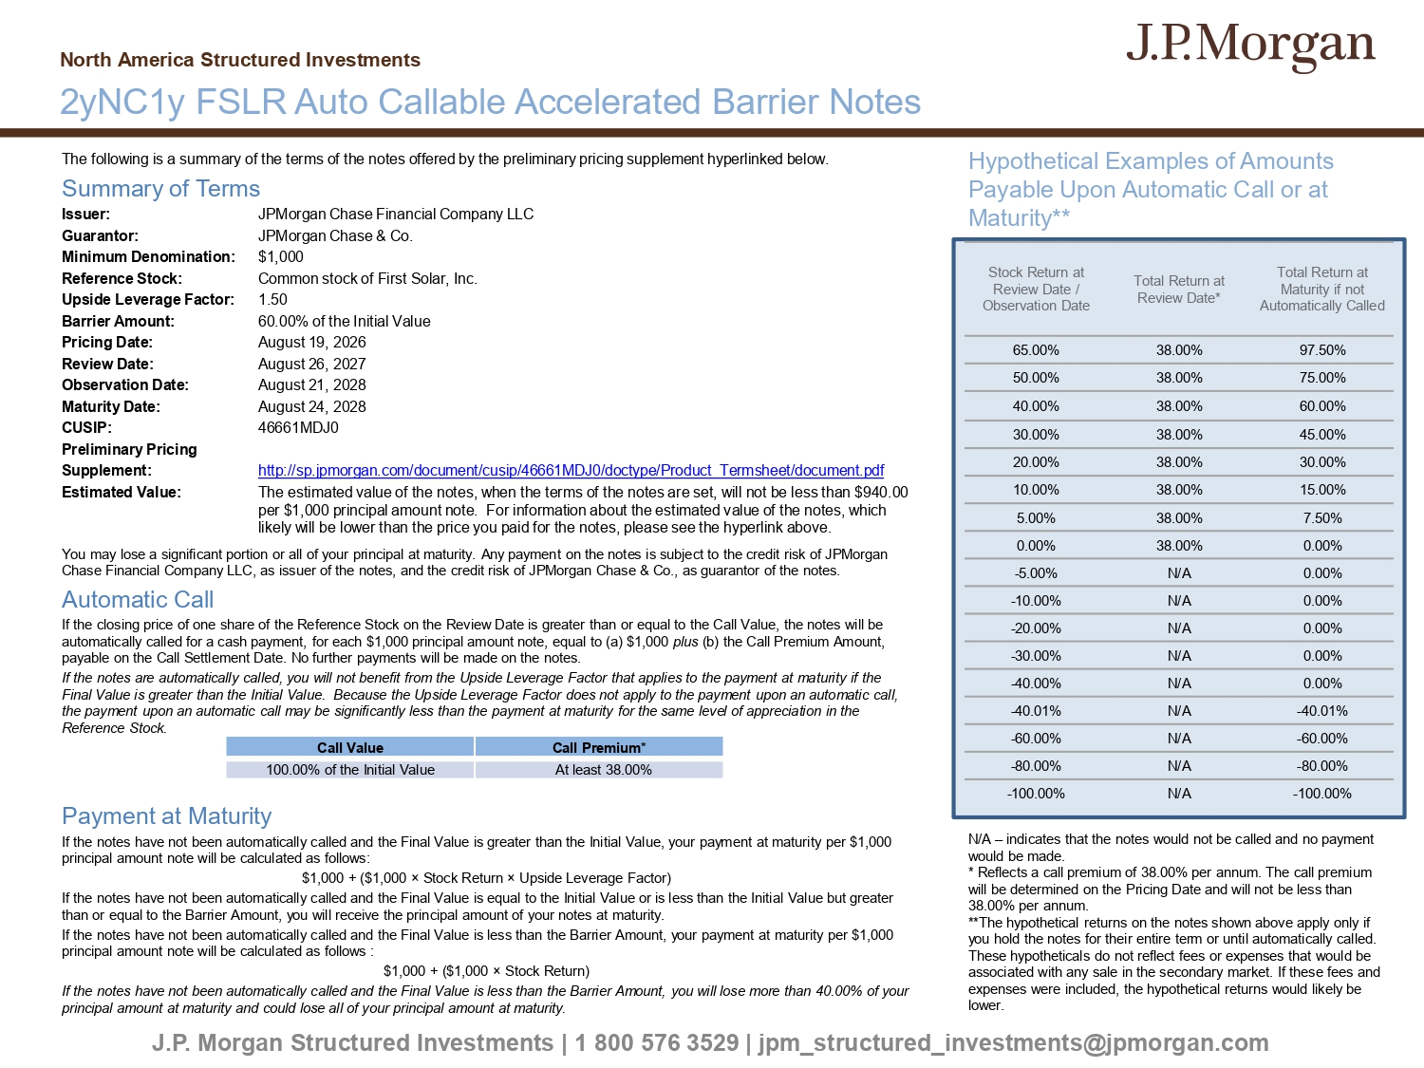
The following is a summary of the terms of the notes offered by the preliminary pricing supplement hyperlinked below. Summary of Terms Issuer: JPMorgan Chase Financial Company LLC Guarantor: JPMorgan Chase & Co. Minimum Denomination: $1,000 Reference Stock: Common stock of First Solar, Inc. Upside Leverage Factor: 1.50 Barrier Amount: 60.00% of the Initial Value Pricing Date: August 19, 2026 Review Date: August 26, 2027 Observation Date: August 21, 2028 Maturity Date: August 24, 2028 CUSIP: 46661MDJ0 Preliminary Pricing Supplement: http://sp.jpmorgan.com/document/cusip/46661MDJ0/doctype/Product_Termsheet/document.pdf Estimated Value: The estimated value of the notes, when the terms of the notes are set, will not be less than $940.00 per $1,000 principal amount note. For information about the estimated value of the notes, which likely will be lower than the price you paid for the notes, please see the hyperlink above. You may lose a significant portion or all of your principal at maturity. Any payment on the notes is subject to the credit ri sk of JPMorgan Chase Financial Company LLC, as issuer of the notes, and the credit risk of JPMorgan Chase & Co., as guarantor of the notes. Automatic Call If the closing price of one share of the Reference Stock on the Review Date is greater than or equal to the Call Value, the n ote s will be automatically called for a cash payment, for each $1,000 principal amount note, equal to (a) $1,000 plus (b) the Call Premium Amount, payable on the Call Settlement Date. No further payments will be made on the notes. If the notes are automatically called, you will not benefit from the Upside Leverage Factor that applies to the payment at ma tur ity if the Final Value is greater than the Initial Value. Because the Upside Leverage Factor does not apply to the payment upon an auto mat ic call, the payment upon an automatic call may be significantly less than the payment at maturity for the same level of appreciation in the Reference Stock. Payment at Maturity If the notes have not been automatically called and the Final Value is greater than the Initial Value, your payment at maturi ty per $1,000 principal amount note will be calculated as follows: $1,000 + ($1,000 î Stock Return î Upside Leverage Factor) If the notes have not been automatically called and the Final Value is equal to the Initial Value or is less than the Initial Va lue but greater than or equal to the Barrier Amount, you will receive the principal amount of your notes at maturity. If the notes have not been automatically called and the Final Value is less than the Barrier Amount, your payment at maturity pe r $1,000 principal amount note will be calculated as follows : $1,000 + ($1,000 î Stock Return) If the notes have not been automatically called and the Final Value is less than the Barrier Amount, you will lose more than 40. 00% of your principal amount at maturity and could lose all of your principal amount at maturity. J.P. Morgan Structured Investments | 1 800 576 3529 | jpm_structured_investments@jpmorgan.com 2yNC1y FSLR Auto Callable Accelerated Barrier Notes North America Structured Investments Call Premium* Call Value At least 38.00% 100.00% of the Initial Value Hypothetical Examples of Amounts Payable Upon Automatic Call or at Maturity** N/A – indicates that the notes would not be called and no payment would be made. * Reflects a call premium of 38.00% per annum. The call premium will be determined on the Pricing Date and will not be less than 38.00% per annum. **The hypothetical returns on the notes shown above apply only if you hold the notes for their entire term or until automatically called. These hypotheticals do not reflect fees or expenses that would be associated with any sale in the secondary market. If these fees and expenses were included, the hypothetical returns would likely be lower. Total Return at Maturity if not Automatically Called Total Return at Review Date* Stock Return at Review Date / Observation Date 97.50% 38.00% 65.00% 75.00% 38.00% 50.00% 60.00% 38.00% 40.00% 45.00% 38.00% 30.00% 30.00% 38.00% 20.00% 15.00% 38.00% 10.00% 7.50% 38.00% 5.00% 0.00% 38.00% 0.00% 0.00% N/A - 5.00% 0.00% N/A - 10.00% 0.00% N/A - 20.00% 0.00% N/A - 30.00% 0.00% N/A - 40.00% - 40.01% N/A - 40.01% - 60.00% N/A - 60.00% - 80.00% N/A - 80.00% - 100.00% N/A - 100.00%
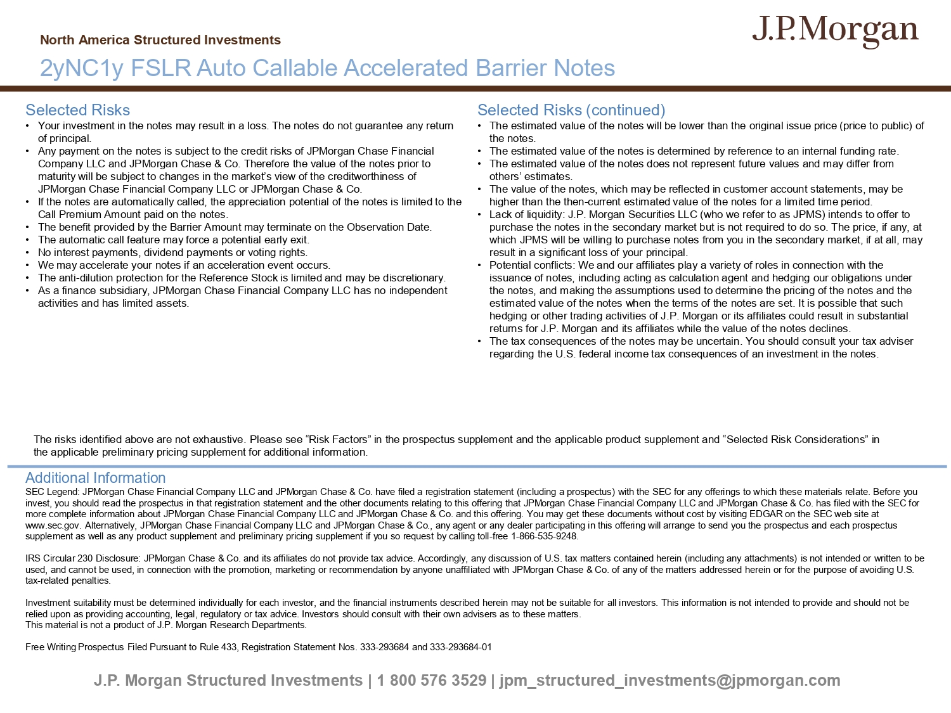
J.P. Morgan Structured Investments | 1 800 576 3529 | jpm_structured_investments@jpmorgan.com Selected Risks • Your investment in the notes may result in a loss. The notes do not guarantee any return of principal. • Any payment on the notes is subject to the credit risks of JPMorgan Chase Financial Company LLC and JPMorgan Chase & Co. Therefore the value of the notes prior to maturity will be subject to changes in the market’s view of the creditworthiness of JPMorgan Chase Financial Company LLC or JPMorgan Chase & Co. • If the notes are automatically called, the appreciation potential of the notes is limited to the Call Premium Amount paid on the notes. • The benefit provided by the Barrier Amount may terminate on the Observation Date. • The automatic call feature may force a potential early exit. • No interest payments, dividend payments or voting rights. • We may accelerate your notes if an acceleration event occurs. • The anti - dilution protection for the Reference Stock is limited and may be discretionary. • As a finance subsidiary, JPMorgan Chase Financial Company LLC has no independent activities and has limited assets. Selected Risks (continued) • The estimated value of the notes will be lower than the original issue price (price to public) of the notes. • The estimated value of the notes is determined by reference to an internal funding rate. • The estimated value of the notes does not represent future values and may differ from others’ estimates. • The value of the notes, which may be reflected in customer account statements, may be higher than the then - current estimated value of the notes for a limited time period. • Lack of liquidity: J.P. Morgan Securities LLC (who we refer to as JPMS) intends to offer to purchase the notes in the secondary market but is not required to do so. The price, if any, at which JPMS will be willing to purchase notes from you in the secondary market, if at all, may result in a significant loss of your principal. • Potential conflicts: We and our affiliates play a variety of roles in connection with the issuance of notes, including acting as calculation agent and hedging our obligations under the notes, and making the assumptions used to determine the pricing of the notes and the estimated value of the notes when the terms of the notes are set. It is possible that such hedging or other trading activities of J.P. Morgan or its affiliates could result in substantial returns for J.P. Morgan and its affiliates while the value of the notes declines. • The tax consequences of the notes may be uncertain. You should consult your tax adviser regarding the U.S. federal income tax consequences of an investment in the notes. Additional Information SEC Legend: JPMorgan Chase Financial Company LLC and JPMorgan Chase & Co. have filed a registration statement (including a pr osp ectus) with the SEC for any offerings to which these materials relate. Before you invest, you should read the prospectus in that registration statement and the other documents relating to this offering that JPM organ Chase Financial Company LLC and JPMorgan Chase & Co. has filed with the SEC for more complete information about JPMorgan Chase Financial Company LLC and JPMorgan Chase & Co. and this offering. You may get the se documents without cost by visiting EDGAR on the SEC web site at www.sec.gov. Alternatively, JPMorgan Chase Financial Company LLC and JPMorgan Chase & Co., any agent or any dealer participat ing in this offering will arrange to send you the prospectus and each prospectus supplement as well as any product supplement and preliminary pricing supplement if you so request by calling toll - free 1 - 866 - 535 - 9248. IRS Circular 230 Disclosure: JPMorgan Chase & Co. and its affiliates do not provide tax advice. Accordingly, any discussion o f U .S. tax matters contained herein (including any attachments) is not intended or written to be used, and cannot be used, in connection with the promotion, marketing or recommendation by anyone unaffiliated with JPMorgan Cha se & Co. of any of the matters addressed herein or for the purpose of avoiding U.S. tax - related penalties. Investment suitability must be determined individually for each investor, and the financial instruments described herein may not be suitable for all investors. This information is not intended to provide and should not be relied upon as providing accounting, legal, regulatory or tax advice. Investors should consult with their own advisers as to the se matters. This material is not a product of J.P. Morgan Research Departments. Free Writing Prospectus Filed Pursuant to Rule 433, Registration Statement Nos. 333 - 293684 and 333 - 293684 - 01 North America Structured Investments 2yNC1y FSLR Auto Callable Accelerated Barrier Notes The risks identified above are not exhaustive. Please see “Risk Factors” in the prospectus supplement and the applicable prod uct supplement and “Selected Risk Considerations” in the applicable preliminary pricing supplement for additional information.

