June 20, 2025 Registration Statement Nos. 333-270004 and 333-270004-01; Rule 424(b)(2)
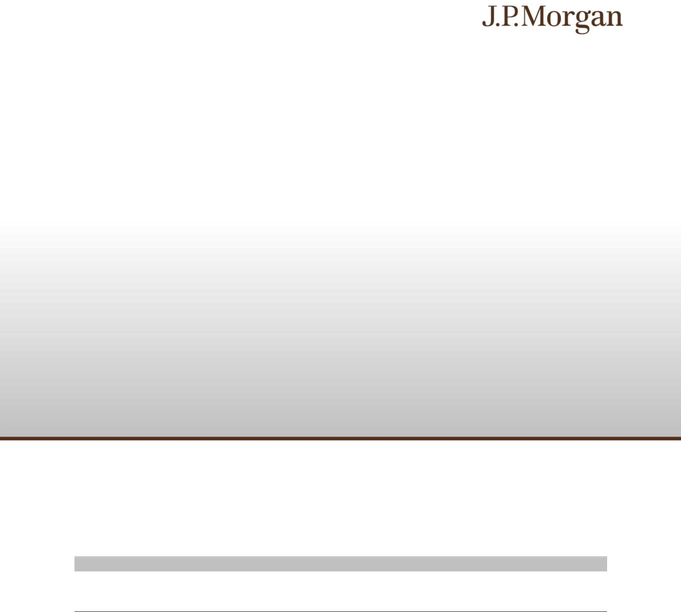

JPMorgan Chase Financial Company LLC Structured Investments

$2,000,000

Bearish Knock-Out Notes Linked to the S&P 500® Index due December 21, 2026

Fully and Unconditionally Guaranteed by JPMorgan Chase & Co.

- The notes provide limited bearish exposure to the S&P 500® Index, which we refer to as the Index. The notes are designed for investors who seek a capped, unleveraged positive return based on any depreciation (up to the Knock-Out

Percentage of 67.00%) of the Index at maturity if a Knock-Out Event has not occurred. A Knock-Out Event occurs if, on any day during the Monitoring Period, the closing level of the Index is less than the Strike Value by more than the Knock-Out Percentage.

- If a Knock-Out Event has not occurred and the Index appreciates or is flat over the term of the notes, or if a Knock-Out Event has occurred, investors will receive only the principal amount of their notes at maturity.

- Investors should be willing to forgo interest and dividend payments, while seeking full repayment of principal at maturity.

- The notes are unsecured and unsubordinated obligations of JPMorgan Chase Financial Company LLC, which we refer to as JPMorgan Financial, the payment on which is fully and unconditionally guaranteed by JPMorgan Chase & Co. Any payment on the notes is subject to the credit risk of JPMorgan Financial, as issuer of the notes, and the credit risk of JPMorgan Chase & Co., as guarantor of the notes.

- Minimum denominations of $1,000 and integral multiples thereof

- The notes priced on June 20, 2025 (the “Pricing Date”) and are expected to settle on or about June 25, 2025. The Strike

Value has been determined by reference to the closing level of the Index on June 16, 2025 and not by reference to the closing level of the Index on the Pricing Date.

- CUSIP: 48136EU29

Investing in the notes involves a number of risks. See “Risk Factors” beginning on page S-2 of the accompanying prospectus supplement, Annex A to the accompanying prospectus addendum, “Risk Factors” beginning on page PS-12 of the accompanying product supplement and “Selected Risk Considerations” beginning on page PS-3 of this pricing supplement.

Neither the Securities and Exchange Commission (the “SEC”) nor any state securities commission has approved or disapproved of the notes or passed upon the accuracy or the adequacy of this pricing supplement or the accompanying product supplement, underlying supplement, prospectus supplement, prospectus and prospectus addendum. Any representation to the contrary is a criminal offense.

 | Price to Public (1) | Fees and Commissions (2) | Proceeds to Issuer
Per note | $1,000 | $7.25 | $992.75
Total | $2,000,000 | $14,500 | $1,985,500

- See “Supplemental Use of Proceeds” in this pricing supplement for information about the components of the price to public of the notes.

- J.P. Morgan Securities LLC, which we refer to as JPMS, acting as agent for JPMorgan Financial, will pay all of the selling commissions of $7.25 per $1,000 principal amount note it receives from us to other affiliated or unaffiliated dealers. See “Plan of Distribution (Conflicts of Interest)” in the accompanying product supplement.

The estimated value of the notes, when the terms of the notes were set, was $989.10 per $1,000 principal amount note.
See “The Estimated Value of the Notes” in this pricing supplement for additional information.

The notes are not bank deposits, are not insured by the Federal Deposit Insurance Corporation or any other governmental agency and are not obligations of, or guaranteed by, a bank.

Pricing supplement to product supplement no. 3-I dated April 13, 2023, underlying supplement no. 1-I dated April 13, 2023, the prospectus and prospectus supplement, each dated April 13, 2023, and the prospectus addendum dated June 3, 2024

Key Terms

Issuer: JPMorgan Chase Financial Company LLC, a direct, wholly owned finance subsidiary of JPMorgan Chase & Co.

Guarantor: JPMorgan Chase & Co.

Index: The S&P 500® Index (Bloomberg ticker: SPX)

Downside Participation Rate: 100.00%

Knock-Out Percentage: 67.00%

Strike Date: June 16, 2025

Pricing Date: June 20, 2025

Original Issue Date (Settlement Date): On or about June 25, 2025

Observation Date*: December 16, 2026

Maturity Date*: December 21, 2026

- Subject to postponement in the event of a market disruption event

and as described under “General Terms of Notes — Postponement of a Determination Date — Notes Linked to a Single Underlying —

Notes Linked to a Single Underlying (Other Than a Commodity Index)” and “General Terms of Notes — Postponement of a Payment Date” in the accompanying product supplement

PS-1 | Structured Investments

Bearish Knock-Out Notes Linked to the S&P 500® Index

Payment at Maturity:
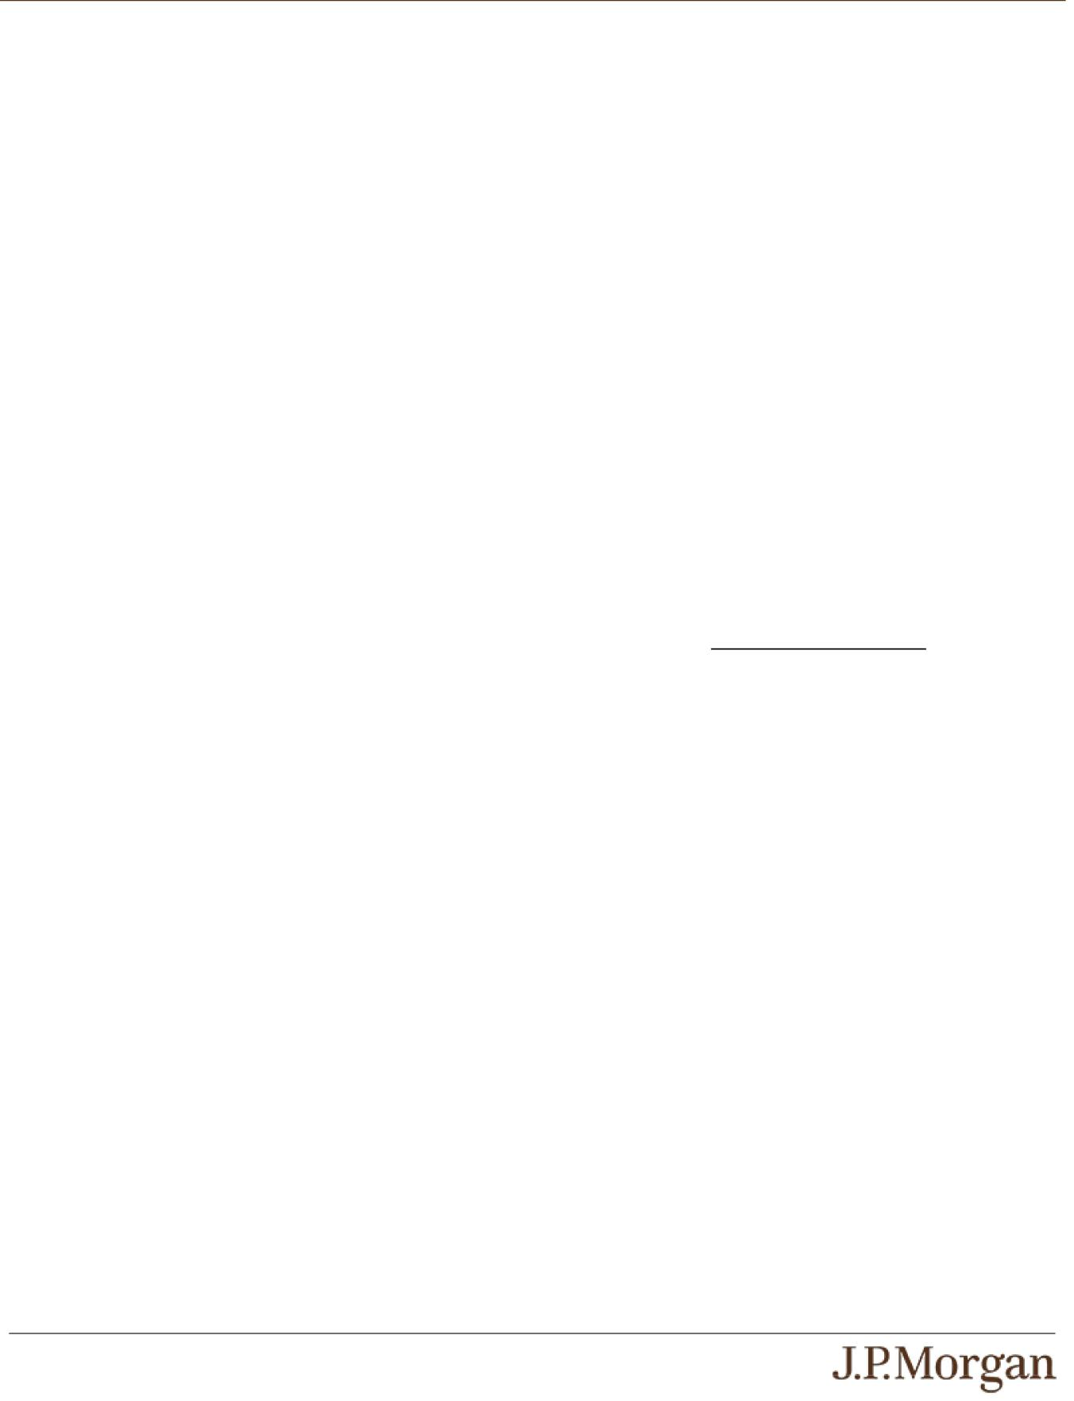

At maturity, you will receive a cash payment, for each $1,000 principal amount note, of $1,000 plus the Additional Amount, which may be zero.

You are entitled to repayment of principal in full at maturity, subject to the credit risks of JPMorgan Financial and JPMorgan Chase & Co.

Additional Amount: The Additional Amount payable at maturity per $1,000 principal amount note will equal:

- if a Knock-Out Event has not occurred: $1,000 × the Bearish Index Return × the Downside Participation Rate, provided that the Additional Amount will not be less than zero; or

- if a Knock-Out Event has occurred: $0.

This payout formula results in an effective cap of 67.00% on your return at maturity. Under these circumstances, your maximum payment at maturity is $1,670.00 per $1,000 principal amount note.

Knock-Out Event: A Knock-Out Event occurs if, on any day during the Monitoring Period, the closing level of the Index is less than the Strike Value by more than the Knock-Out Percentage.

Monitoring Period: The period from but excluding the Pricing Date to and including the Observation Date

Bearish Index Return:

(Strike Value – Final Value)

Strike Value

Strike Value: The closing level of the Index on the Strike Date, which was 6,033.11. The Strike Value is not the closing level of the Index on the Pricing Date.

Final Value: The closing level of the Index on the Observation Date

Supplemental Terms of the Notes
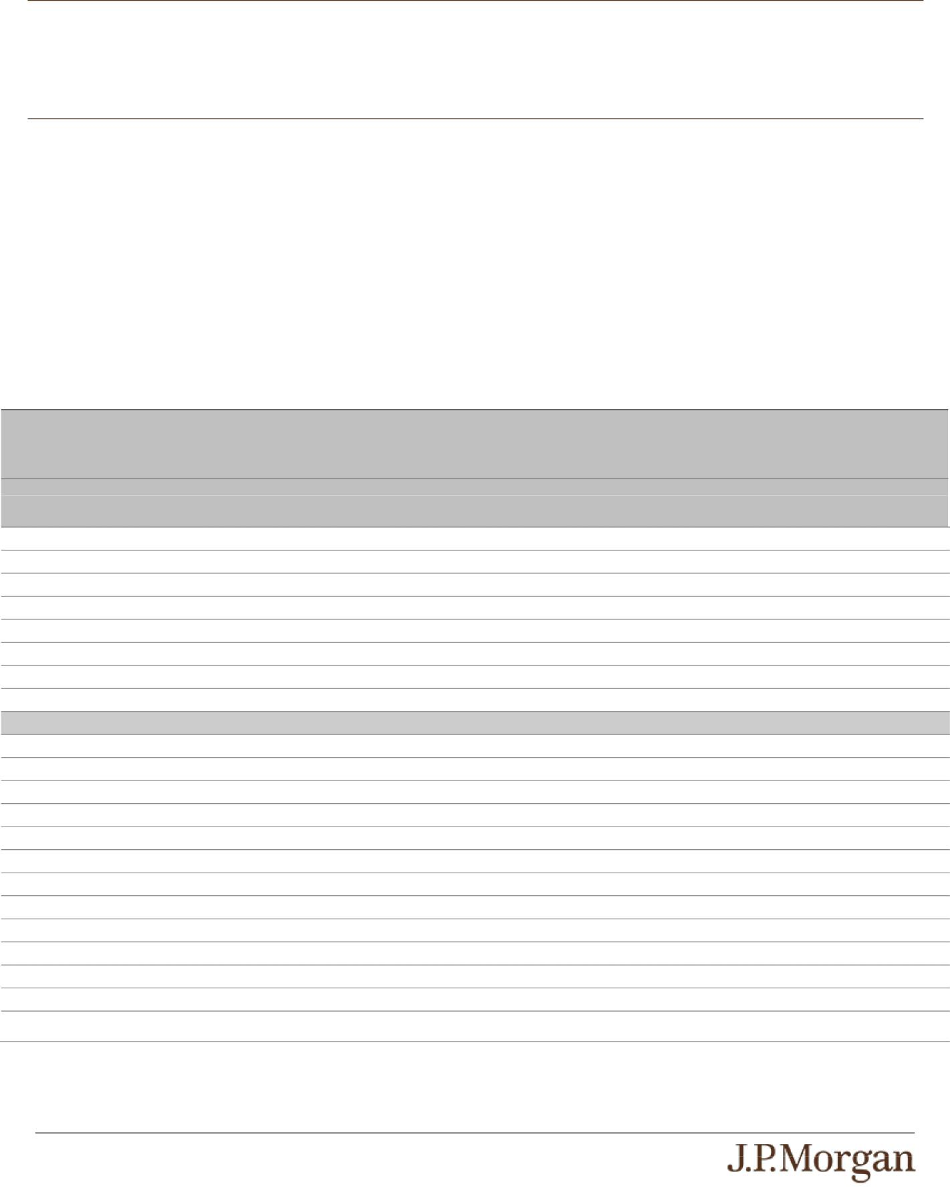

Any values of the Index, and any values derived therefrom, included in this pricing supplement may be corrected, in the event of manifest error or inconsistency, by amendment of this pricing supplement and the corresponding terms of the notes. Notwithstanding anything to the contrary in the indenture governing the notes, that amendment will become effective without consent of the holders of the notes or any other party.

Hypothetical Payout Profile

The following table illustrates the hypothetical payment at maturity on the notes linked to a hypothetical Index. The hypothetical payments set forth below assume the following:

- a Strike Value of 100.00;

- a Downside Participation Rate of 100.00%; and

- a Knock-Out Percentage of 67.00%.

As used in this section, the Index Return is equal to (Final Value – Strike Value) / Strike Value. The hypothetical Strike Value of 100.00 has been chosen for illustrative purposes only and does not represent the actual Strike Value. The actual Strike Value is the closing level of the Index on the Strike Date and is specified under “Key Terms — Strike Value” in this pricing supplement. For historical data regarding the actual closing levels of the Index, please see the historical information set forth under “The Index” in this pricing supplement.

Each hypothetical payment at maturity set forth below is for illustrative purposes only and may not be the actual payment at maturity applicable to a purchaser of the notes. The numbers appearing in the following table have been rounded for ease of analysis.

Final Value Index Return Bearish A Knock-Out Event Has Not Occurred (1) A Knock-Out Event Has Occurred (1) Index

Return

 |  |  | Additional Amount | Payment at Maturity | Additional | Payment at
 |  |  |  |  | Amount | Maturity
180.00 | 80.00% | -80.00% | $0.00 | $1,000.00 | $0.00 | $1,000.00
165.00 | 65.00% | -65.00% | $0.00 | $1,000.00 | $0.00 | $1,000.00
150.00 | 50.00% | -50.00% | $0.00 | $1,000.00 | $0.00 | $1,000.00
140.00 | 40.00% | -40.00% | $0.00 | $1,000.00 | $0.00 | $1,000.00
130.00 | 30.00% | -30.00% | $0.00 | $1,000.00 | $0.00 | $1,000.00
120.00 | 20.00% | -20.00% | $0.00 | $1,000.00 | $0.00 | $1,000.00
110.00 | 10.00% | -10.00% | $0.00 | $1,000.00 | $0.00 | $1,000.00
105.00 | 5.00% | -5.00% | $0.00 | $1,000.00 | $0.00 | $1,000.00
100.00 | 0.00% | 0.00% | $0.00 | $1,000.00 | $0.00 | $1,000.00
99.00 | -1.00% | 1.00% | $10.00 | $1,010.00 | $0.00 | $1,000.00
95.00 | -5.00% | 5.00% | $50.00 | $1,050.00 | $0.00 | $1,000.00
90.00 | -10.00% | 10.00% | $100.00 | $1,100.00 | $0.00 | $1,000.00
80.00 | -20.00% | 20.00% | $200.00 | $1,200.00 | $0.00 | $1,000.00
70.00 | -30.00% | 30.00% | $300.00 | $1,300.00 | $0.00 | $1,000.00
60.00 | -40.00% | 40.00% | $400.00 | $1,400.00 | $0.00 | $1,000.00
50.00 | -50.00% | 50.00% | $500.00 | $1,500.00 | $0.00 | $1,000.00
40.00 | -60.00% | 60.00% | $600.00 | $1,600.00 | $0.00 | $1,000.00
33.00 | -67.00% | 67.00% | $670.00 | $1,670.00 | $0.00 | $1,000.00
30.00 | -70.00% | 70.00% | N/A | N/A | $0.00 | $1,000.00
20.00 | -80.00% | 80.00% | N/A | N/A | $0.00 | $1,000.00
10.00 | -90.00% | 90.00% | N/A | N/A | $0.00 | $1,000.00
0.00 | -100.00% | 100.00% | N/A | N/A | $0.00 | $1,000.00

- A Knock-Out Event occurs if, on any day during the Monitoring Period, the closing level of the Index is less than the Strike Value by more than the Knock-Out Percentage.

PS-2 | Structured Investments

Bearish Knock-Out Notes Linked to the S&P 500® Index

How the Notes Work
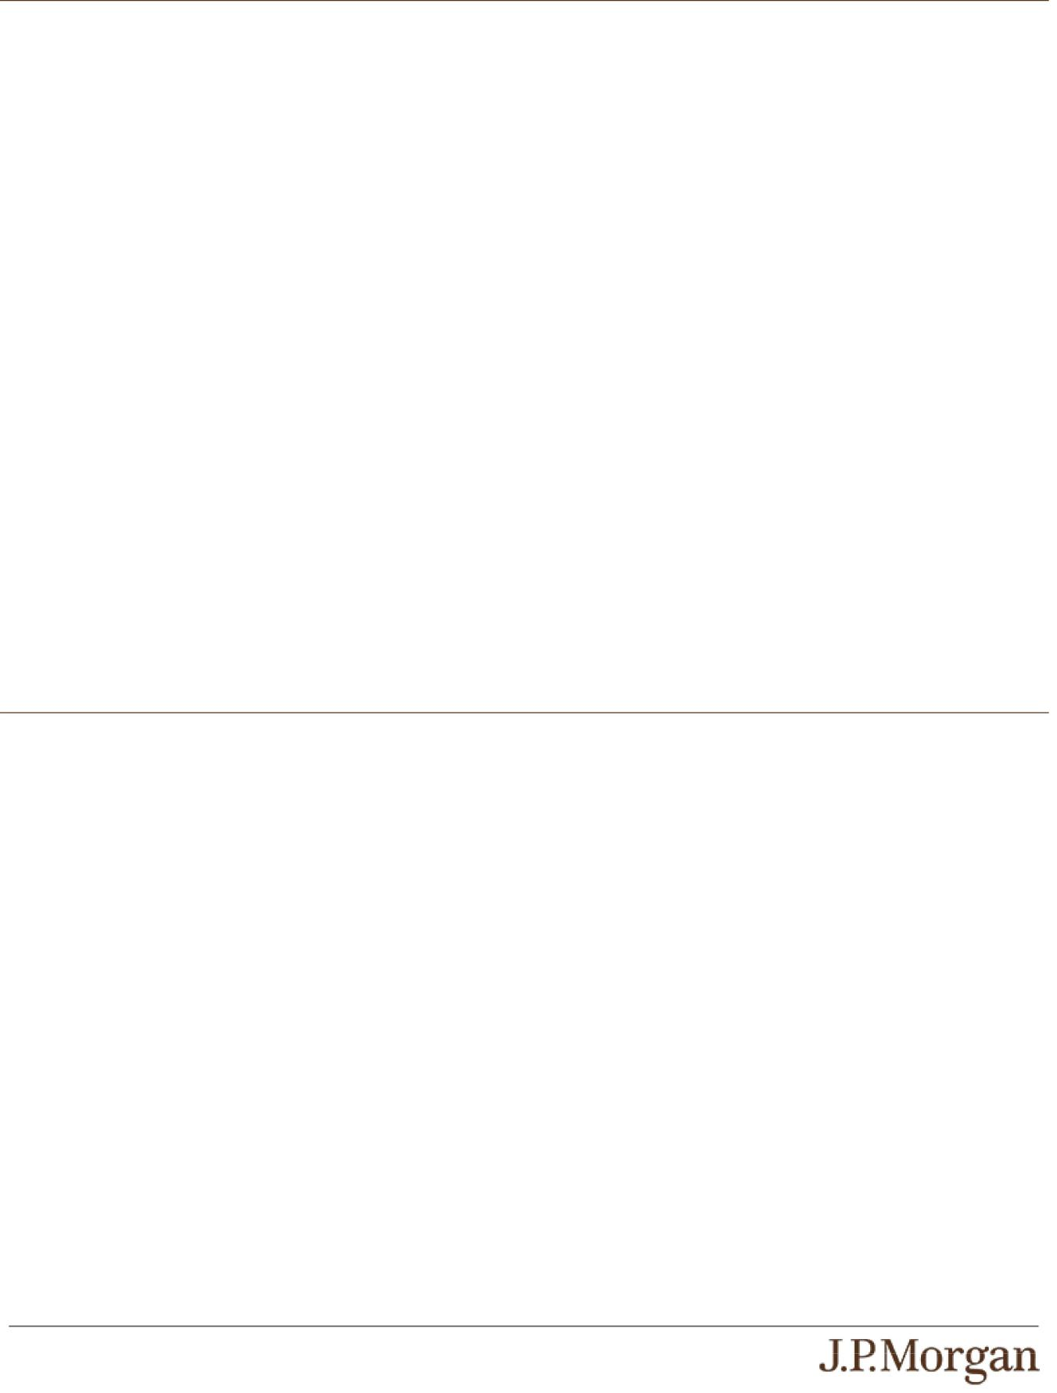

At maturity, investors will receive a cash payment, for each $1,000 principal amount note, of $1,000 plus the Additional Amount, which may be zero. The value of the Additional Amount depends on whether a Knock-Out Event has occurred. A Knock-Out Event occurs if, on any day during the Monitoring Period, the closing level of the Index is less than the Strike Value by more than the Knock-Out Percentage of 67.00%.

No Knock-Out Event Scenario:

If a Knock-Out Event has not occurred, the Additional Amount per $1,000 principal amount note will be equal to $1,000 times the Bearish Index Return times the Downside Participation Rate of 100.00%, provided that the Additional Amount will not be less than zero.

- For example, if (i) a Knock-Out Event has not occurred and (ii) the closing level of the Index declines 10.00%, investors will receive at maturity a return equal to 10.00%, or $1,100.00 per $1,000 principal amount note.

- For example, if (i) a Knock-Out Event has not occurred and (ii) the closing level of the Index increases 10.00%, investors will receive at maturity the principal amount of their notes.

- For example, if (i) a Knock-Out Event has not occurred and (ii) the closing level of the Index declines 67.00%, investors will receive at maturity a return equal to 67.00%, or $1,670.00 per $1,000 principal amount note, which reflects the maximum payment at maturity.

Knock-Out Event Scenario:

If a Knock-Out Event has occurred, the Additional Amount will be zero and investors will receive at maturity only the principal amount of their notes.

- For example, if (i) a Knock-Out Event has occurred and (ii) the closing level of the Index declines 10.00%, investors will receive at maturity the principal amount of their notes.

- For example, if (i) a Knock-Out Event has occurred and (ii) the closing level of the Index increases 10.00%, investors will receive at maturity the principal amount of their notes.

The hypothetical returns and hypothetical payments on the notes shown above apply only if you hold the notes for their entire term. These hypotheticals do not reflect the fees or expenses that would be associated with any sale in the secondary market. If these fees and expenses were included, the hypothetical returns and hypothetical payments shown above would likely be lower.

Selected Risk Considerations

An investment in the notes involves significant risks. These risks are explained in more detail in the “Risk Factors” sections of the accompanying prospectus supplement and product supplement and in Annex A to the accompanying prospectus addendum.

Risks Relating to the Notes Generally

- THE NOTES MAY NOT PAY MORE THAN THE PRINCIPAL AMOUNT AT MATURITY —

If a Knock-Out Event has not occurred and the Final Value is greater than or equal to the Strike Value, or if a Knock-Out Event has occurred, you will receive only the principal amount of your notes at maturity, and you will not be compensated for any loss in value due to inflation and other factors relating to the value of money over time.

- THE NOTES ARE BEARISH ON THE INDEX —

Because the notes are bearish on the Index, your return on the notes will not benefit from any appreciation of the Index over the term of the notes.

- YOUR MAXIMUM GAIN ON THE NOTES IS LIMITED BY THE KNOCK-OUT PERCENTAGE —

Because the payment at maturity will not reflect the Bearish Index Return if a Knock-Out Event has occurred, the Knock-Out Percentage is effectively a cap on your return at maturity. The maximum payment at maturity is $1,670.00 per $1,000 principal amount note.

- CREDIT RISKS OF JPMORGAN FINANCIAL AND JPMORGAN CHASE & CO. —

Investors are dependent on our and JPMorgan Chase & Co.’s ability to pay all amounts due on the notes. Any actual or potential change in our or JPMorgan Chase & Co.’s creditworthiness or credit spreads, as determined by the market for taking that credit risk, is likely to adversely affect the value of the notes. If we and JPMorgan Chase & Co. were to default on our payment obligations, you may not receive any amounts owed to you under the notes and you could lose your entire investment.

PS-3 | Structured Investments

Bearish Knock-Out Notes Linked to the S&P 500® Index

- AS A FINANCE SUBSIDIARY, JPMORGAN FINANCIAL HAS NO INDEPENDENT OPERATIONS AND HAS LIMITED ASSETS

—

As a finance subsidiary of JPMorgan Chase & Co., we have no independent operations beyond the issuance and administration of our securities and the collection of intercompany obligations. Aside from the initial capital contribution from JPMorgan Chase & Co., substantially all of our assets relate to obligations of JPMorgan Chase & Co. to make payments under loans made by us to

JPMorgan Chase & Co. or under other intercompany agreements. As a result, we are dependent upon payments from JPMorgan Chase & Co. to meet our obligations under the notes. We are not a key operating subsidiary of JPMorgan Chase & Co. and in a
bankruptcy or resolution of JPMorgan Chase & Co. we are not expected to have sufficient resources to meet our obligations in respect of the notes as they come due. If JPMorgan Chase & Co. does not make payments to us and we are unable to make payments on the notes, you may have to seek payment under the related guarantee by JPMorgan Chase & Co., and that guarantee will rank pari passu with all other unsecured and unsubordinated obligations of JPMorgan Chase & Co. For more information, see the accompanying prospectus addendum.

- A KNOCK-OUT EVENT MAY OCCUR ON ANY DAY DURING THE MONITORING PERIOD —

If, on any day during the Monitoring Period, the closing level of the Index is less than the Strike Value by more than the Knock-Out Percentage (i.e., a Knock-Out Event occurs), you will receive at maturity only the principal amount of your notes, and you will not participate in the Bearish Index Return, regardless of any depreciation of the Index, which may be significant.

- THE NOTES DO NOT PAY INTEREST.

- YOU WILL NOT RECEIVE DIVIDENDS ON THE SECURITIES INCLUDED IN THE INDEX OR HAVE ANY RIGHTS WITH RESPECT TO THOSE SECURITIES.

- LACK OF LIQUIDITY —

The notes will not be listed on any securities exchange. Accordingly, the price at which you may be able to trade your notes is likely to depend on the price, if any, at which JPMS is willing to buy the notes. You may not be able to sell your notes. The notes are not designed to be short-term trading instruments. Accordingly, you should be able and willing to hold your notes to maturity.

Risks Relating to Conflicts of Interest

- POTENTIAL CONFLICTS —

We and our affiliates play a variety of roles in connection with the notes. In performing these duties, our and JPMorgan Chase & Co.’s economic interests are potentially adverse to your interests as an investor in the notes. It is possible that hedging or trading activities of ours or our affiliates in connection with the notes could result in substantial returns for us or our affiliates while the value of the notes declines. Please refer to “Risk Factors — Risks Relating to Conflicts of Interest” in the accompanying product supplement.

Risks Relating to the Estimated Value and Secondary Market Prices of the Notes

- THE ESTIMATED VALUE OF THE NOTES IS LOWER THAN THE ORIGINAL ISSUE PRICE (PRICE TO PUBLIC) OF THE NOTES —

The estimated value of the notes is only an estimate determined by reference to several factors. The original issue price of the notes exceeds the estimated value of the notes because costs associated with selling, structuring and hedging the notes are included in the original issue price of the notes. These costs include the selling commissions, the projected profits, if any, that our affiliates expect to realize for assuming risks inherent in hedging our obligations under the notes and the estimated cost of hedging our obligations under the notes. See “The Estimated Value of the Notes” in this pricing supplement.

- THE ESTIMATED VALUE OF THE NOTES DOES NOT REPRESENT FUTURE VALUES OF THE NOTES AND MAY DIFFER FROM OTHERS’ ESTIMATES —

See “The Estimated Value of the Notes” in this pricing supplement.

- THE ESTIMATED VALUE OF THE NOTES IS DERIVED BY REFERENCE TO AN INTERNAL FUNDING RATE —

The internal funding rate used in the determination of the estimated value of the notes may differ from the market-implied funding rate for vanilla fixed income instruments of a similar maturity issued by JPMorgan Chase & Co. or its affiliates. Any difference may be based on, among other things, our and our affiliates’ view of the funding value of the notes as well as the higher issuance, operational and ongoing liability management costs of the notes in comparison to those costs for the conventional fixed income instruments of JPMorgan Chase & Co. This internal funding rate is based on certain market inputs and assumptions, which may prove to be incorrect, and is intended to approximate the prevailing market replacement funding rate for the notes. The use of an

PS-4 | Structured Investments

Bearish Knock-Out Notes Linked to the S&P 500® Index

internal funding rate and any potential changes to that rate may have an adverse effect on the terms of the notes and any secondary market prices of the notes. See “The Estimated Value of the Notes” in this pricing supplement.

- THE VALUE OF THE NOTES AS PUBLISHED BY JPMS (AND WHICH MAY BE REFLECTED ON CUSTOMER ACCOUNT STATEMENTS) MAY BE HIGHER THAN THE THEN-CURRENT ESTIMATED VALUE OF THE NOTES FOR A LIMITED TIME PERIOD —

We generally expect that some of the costs included in the original issue price of the notes will be partially paid back to you in connection with any repurchases of your notes by JPMS in an amount that will decline to zero over an initial predetermined period. See “Secondary Market Prices of the Notes” in this pricing supplement for additional information relating to this initial period. Accordingly, the estimated value of your notes during this initial period may be lower than the value of the notes as published by JPMS (and which may be shown on your customer account statements).

- SECONDARY MARKET PRICES OF THE NOTES WILL LIKELY BE LOWER THAN THE ORIGINAL ISSUE PRICE OF THE NOTES —

Any secondary market prices of the notes will likely be lower than the original issue price of the notes because, among other things, secondary market prices take into account our internal secondary market funding rates for structured debt issuances and, also, because secondary market prices may exclude selling commissions, projected hedging profits, if any, and estimated hedging costs that are included in the original issue price of the notes. As a result, the price, if any, at which JPMS will be willing to buy the notes from you in secondary market transactions, if at all, is likely to be lower than the original issue price. Any sale by you prior to the Maturity Date could result in a substantial loss to you.

- SECONDARY MARKET PRICES OF THE NOTES WILL BE IMPACTED BY MANY ECONOMIC AND MARKET FACTORS —

The secondary market price of the notes during their term will be impacted by a number of economic and market factors, which may either offset or magnify each other, aside from the selling commissions, projected hedging profits, if any, estimated hedging costs and the level of the Index. Additionally, independent pricing vendors and/or third party broker-dealers may publish a price for the notes, which may also be reflected on customer account statements. This price may be different (higher or lower) than the price of the notes, if any, at which JPMS may be willing to purchase your notes in the secondary market. See “Risk Factors — Risks Relating to the Estimated Value and Secondary Market Prices of the Notes — Secondary market prices of the notes will be impacted by many economic and market factors” in the accompanying product supplement.

Risks Relating to the Index

- JPMORGAN CHASE & CO. IS CURRENTLY ONE OF THE COMPANIES THAT MAKE UP THE INDEX,

but JPMorgan Chase & Co. will not have any obligation to consider your interests in taking any corporate action that might affect the level of the Index.

PS-5 | Structured Investments

Bearish Knock-Out Notes Linked to the S&P 500® Index

The Index
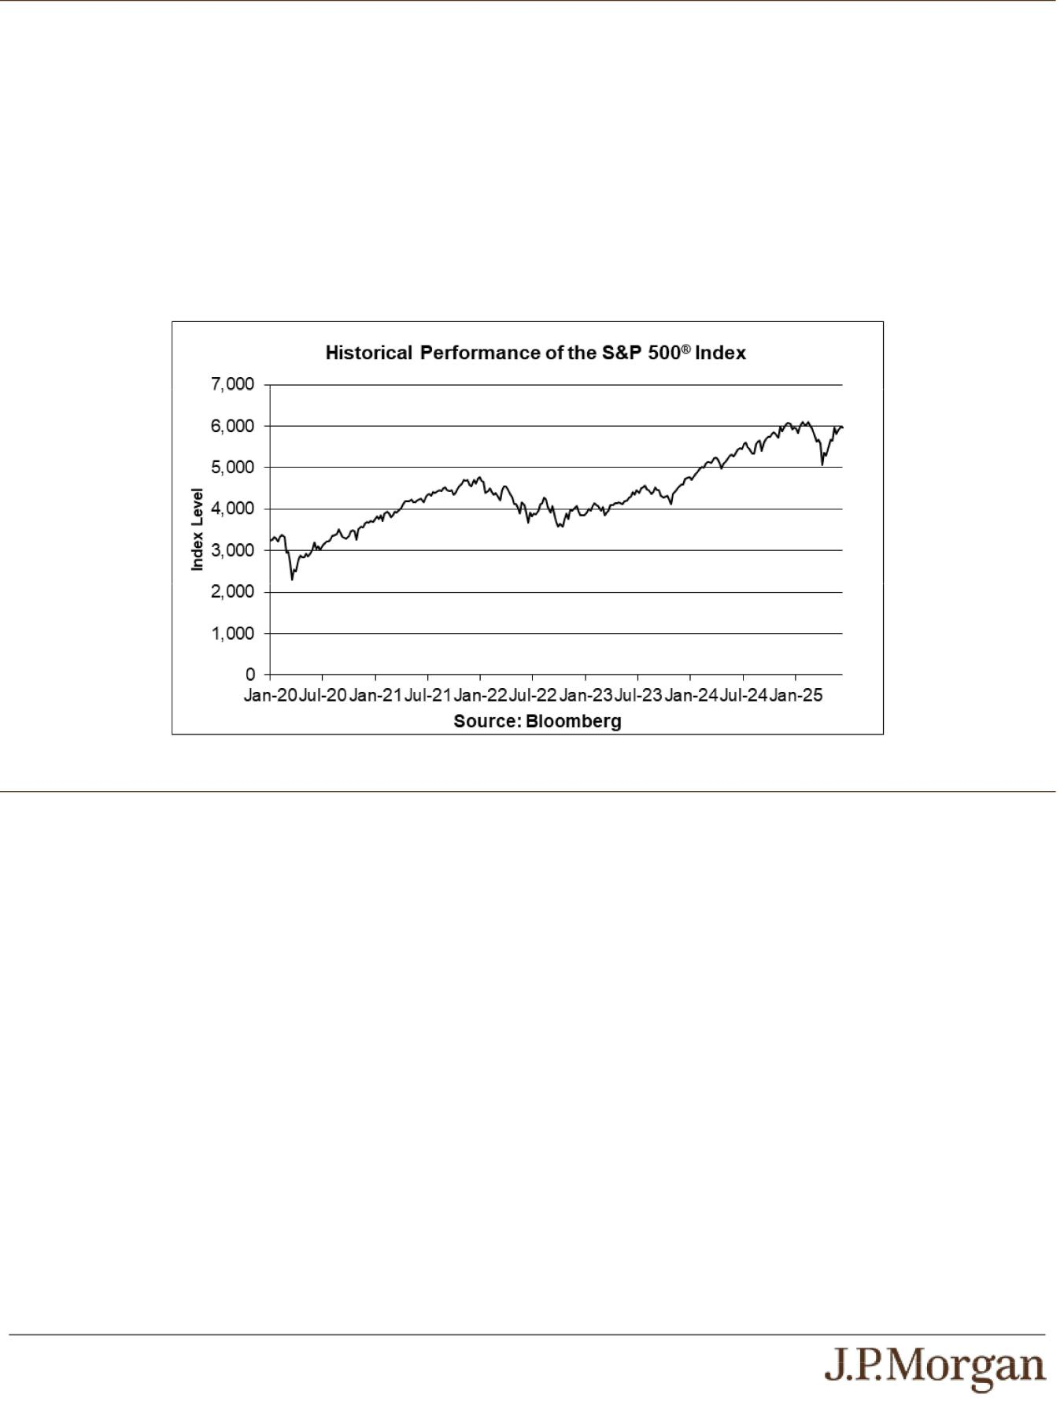

The Index consists of stocks of 500 companies selected to provide a performance benchmark for the U.S. equity markets. For additional information about the Index, see “Equity Index Descriptions — The S&P U.S. Indices” in the accompanying underlying supplement.

Historical Information

The following graph sets forth the historical performance of the Index based on the weekly historical closing levels of the Index from January 3, 2020 through June 13, 2025. The closing level of the Index on June 16, 2025 was 6,033.11. We obtained the closing levels above and below from the Bloomberg Professional® service (“Bloomberg”), without independent verification.
The historical closing levels of the Index should not be taken as an indication of future performance, and no assurance can be given as to the closing level of the Index on the Observation Date or any day during the Monitoring Period. There can be no assurance that the performance of the Index will result in a payment at maturity in excess of your principal amount, subject to the credit risks of JPMorgan Financial and JPMorgan Chase & Co.

Tax Treatment

There is uncertainty regarding the U.S. federal income tax consequences of an investment in the notes due to the lack of governing authority. You should review carefully the section entitled “Material U.S. Federal Income Tax Consequences,” and in particular the subsection thereof entitled “— Tax Consequences to U.S. Holders — Notes with a Term of More than One Year — Notes Treated as Contingent Payment Debt Instruments” in the accompanying product supplement no. 3-I. Based on current market conditions, we intend to treat the notes for U.S. federal income tax purposes as “contingent payment debt instruments.” Assuming this treatment is respected, as discussed in that subsection, unlike a traditional debt instrument that provides for periodic payments of interest at a single fixed rate, with respect to which a cash-method investor generally recognizes income only upon receipt of stated interest, you generally will be required to accrue original issue discount (“OID”) on your notes in each taxable year at the “comparable yield,” as determined by us, although we will not make any payment with respect to the notes until maturity. Upon sale or exchange (including at maturity), you will recognize taxable income or loss equal to the difference between the amount received from the sale or exchange and your adjusted basis in the note, which generally will equal the cost thereof, increased by the amount of OID you have accrued in respect of the note. You generally must treat any income as interest income and any loss as ordinary loss to the extent of previous interest inclusions, and the balance as capital loss. The deductibility of capital losses is subject to limitations. Special rules may apply if the amount payable at maturity is treated as becoming fixed prior to maturity. You should consult your tax adviser concerning the application of these rules. The discussions herein and in the accompanying product supplement do not address the consequences to taxpayers subject to special tax accounting rules under Section 451(b) of the Code. Purchasers who are not initial purchasers of notes at their issue price should consult their tax advisers with respect to the tax consequences of an investment in notes, including the treatment of the difference, if any, between the basis in their notes and the notes’ adjusted issue price.

Our intended treatment of the notes as CPDIs will be binding on you, unless you properly disclose to the IRS an alternative treatment. Also, the IRS may challenge the treatment of the notes as CPDIs. If the IRS successfully challenges the treatment of the notes as CPDIs, then the notes will be treated as debt instruments that are not CPDIs and, would require the accrual of original issue discount as

PS-6 | Structured Investments

Bearish Knock-Out Notes Linked to the S&P 500® Index

ordinary interest income based on a yield to maturity higher than the comparable yield. Accordingly, under this treatment, your annual taxable income from (and adjusted tax basis in) the notes would be higher than if the notes were treated as CPDIs, and any loss recognized upon a disposition of the notes (including upon maturity) would be capital loss, the deductibility of which is subject to limitations. Accordingly, this alternative treatment could result in adverse tax consequences to you.
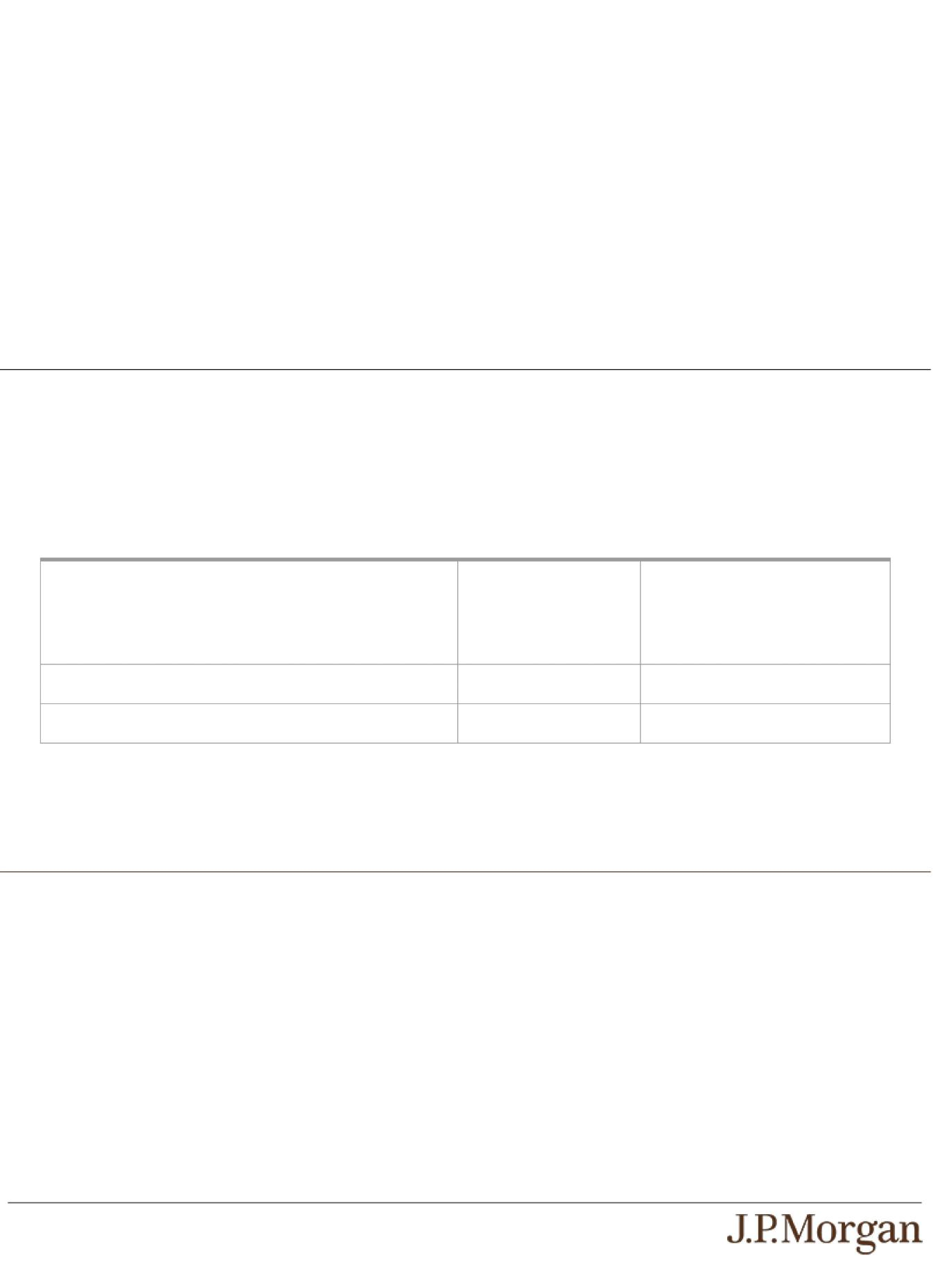

Section 871(m) of the Code and Treasury regulations promulgated thereunder (“Section 871(m)”) generally impose a 30% withholding tax (unless an income tax treaty applies) on dividend equivalents paid or deemed paid to Non-U.S. Holders with respect to certain financial instruments linked to U.S. equities or indices that include U.S. equities. Section 871(m) provides certain exceptions to this withholding regime, including for instruments linked to certain broad-based indices that meet requirements set forth in the applicable Treasury regulations. In light of the bearish economics of the notes, payment on the notes to Non-U.S. Holders will not be subject to Section 871(m).

The discussions in the preceding paragraphs, when read in combination with the section entitled “Material U.S. Federal Income Tax Consequences” (and in particular the subsection thereof entitled “— Tax Consequences to U.S. Holders — Notes with a Term of More than One Year — Notes Treated as Contingent Payment Debt Instruments”) in the accompanying product supplement, to the extent they reflect statements of law, constitute the full opinion of Davis Polk & Wardwell LLP regarding the material U.S. federal income tax consequences of owning and disposing of the notes.

Comparable Yield and Projected Payment Schedule

Although it is not entirely clear how the comparable yield and projected payment schedule should be determined when a debt instrument may be redeemed by the issuer prior to maturity, we have determined that the “comparable yield,” based upon the term to maturity of the notes assuming no early redemption occurs and a variety of other factors, including actual market conditions and our borrowing costs for debt instruments of comparable maturities at the time of issuance, is an annual rate of 4.69%, compounded semiannually. Based on our determination of the comparable yield, the “projected payment schedule” per $1,000 principal amount note consists of a single payment at maturity, equal to $1,071.49. Assuming a semiannual accrual period, the following table sets out the amount of OID that will accrue with respect to a note during each calendar period, based upon our determination of the comparable yield and projected payment schedule.

 | Accrued OID During | Total Accrued OID from Original
 | Calendar Period (Per | Issue Date (Per $1,000 Principal
 | $1,000 Principal | Amount Note) as of End of
Calendar Period | Amount Note) | Calendar Period
June 25, 2025 through December 31, 2025……..……..... | $24.12 | $24.12
January 1, 2026 through December 21, 2026…………….… | $47.37 | $71.49

The comparable yield and projected payment schedule are determined solely to calculate the amount on which you will be taxed with respect to the notes in each year and are neither a prediction nor a guarantee of what the actual yield or timing of the payment or payments will be. The amount you actually receive at maturity or earlier sale or exchange of your notes will affect your income for that year, as described above under “Tax Treatment.”

The Estimated Value of the Notes

The estimated value of the notes set forth on the cover of this pricing supplement is equal to the sum of the values of the following hypothetical components: (1) a fixed-income debt component with the same maturity as the notes, valued using the internal funding rate described below, and (2) the derivative or derivatives underlying the economic terms of the notes. The estimated value of the notes does not represent a minimum price at which JPMS would be willing to buy your notes in any secondary market (if any exists) at any time. The internal funding rate used in the determination of the estimated value of the notes may differ from the market-implied funding rate for vanilla fixed income instruments of a similar maturity issued by JPMorgan Chase & Co. or its affiliates. Any difference may be based on, among other things, our and our affiliates’ view of the funding value of the notes as well as the higher issuance, operational and ongoing liability management costs of the notes in comparison to those costs for the conventional fixed income instruments of JPMorgan Chase & Co. This internal funding rate is based on certain market inputs and assumptions, which may prove to be incorrect, and is intended to approximate the prevailing market replacement funding rate for the notes. The use of an internal funding rate and any potential changes to that rate may have an adverse effect on the terms of the notes and any secondary market prices of the notes. For additional information, see “Selected Risk Considerations — Risks Relating to the Estimated Value and Secondary Market Prices of the Notes — The Estimated Value of the Notes Is Derived by Reference to an Internal Funding Rate” in this pricing supplement.

PS-7 | Structured Investments

Bearish Knock-Out Notes Linked to the S&P 500® Index

The value of the derivative or derivatives underlying the economic terms of the notes is derived from internal pricing models of our affiliates. These models are dependent on inputs such as the traded market prices of comparable derivative instruments and on various other inputs, some of which are market-observable, and which can include volatility, dividend rates, interest rates and other factors, as well as assumptions about future market events and/or environments. Accordingly, the estimated value of the notes is determined when the terms of the notes are set based on market conditions and other relevant factors and assumptions existing at that time.

The estimated value of the notes does not represent future values of the notes and may differ from others’ estimates. Different pricing models and assumptions could provide valuations for the notes that are greater than or less than the estimated value of the notes. In addition, market conditions and other relevant factors in the future may change, and any assumptions may prove to be incorrect. On future dates, the value of the notes could change significantly based on, among other things, changes in market conditions, our or JPMorgan Chase & Co.’s creditworthiness, interest rate movements and other relevant factors, which may impact the price, if any, at which JPMS would be willing to buy notes from you in secondary market transactions.

The estimated value of the notes is lower than the original issue price of the notes because costs associated with selling, structuring and hedging the notes are included in the original issue price of the notes. These costs include the selling commissions paid to JPMS and other affiliated or unaffiliated dealers, the projected profits, if any, that our affiliates expect to realize for assuming risks inherent in hedging our obligations under the notes and the estimated cost of hedging our obligations under the notes. Because hedging our obligations entails risk and may be influenced by market forces beyond our control, this hedging may result in a profit that is more or less than expected, or it may result in a loss. A portion of the profits, if any, realized in hedging our obligations under the notes may be allowed to other affiliated or unaffiliated dealers, and we or one or more of our affiliates will retain any remaining hedging profits. See “Selected Risk Considerations — Risks Relating to the Estimated Value and Secondary Market Prices of the Notes — The Estimated Value of the Notes Is Lower Than the Original Issue Price (Price to Public) of the Notes” in this pricing supplement.

Secondary Market Prices of the Notes
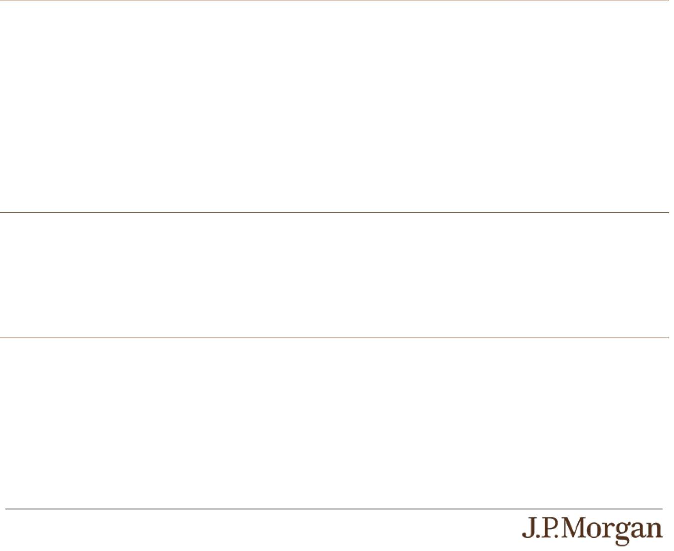

For information about factors that will impact any secondary market prices of the notes, see “Risk Factors — Risks Relating to the Estimated Value and Secondary Market Prices of the Notes — Secondary market prices of the notes will be impacted by many economic and market factors” in the accompanying product supplement. In addition, we generally expect that some of the costs included in the original issue price of the notes will be partially paid back to you in connection with any repurchases of your notes by JPMS in an amount that will decline to zero over an initial predetermined period. These costs can include selling commissions, projected hedging profits, if any, and, in some circumstances, estimated hedging costs and our internal secondary market funding rates for structured debt issuances. This initial predetermined time period is intended to be the shorter of six months and one-half of the stated term of the notes. The length of any such initial period reflects the structure of the notes, whether our affiliates expect to earn a profit in connection with our hedging activities, the estimated costs of hedging the notes and when these costs are incurred, as determined by our affiliates. See “Selected Risk Considerations — Risks Relating to the Estimated Value and Secondary Market Prices of the Notes — The Value of the Notes as Published by JPMS (and Which May Be Reflected on Customer Account Statements) May Be Higher Than the Then-Current Estimated Value of the Notes for a Limited Time Period” in this pricing supplement.

Supplemental Use of Proceeds

The notes are offered to meet investor demand for products that reflect the risk-return profile and market exposure provided by the notes. See “Hypothetical Payout Profile” and “How the Notes Work” in this pricing supplement for an illustration of the risk-return profile of the notes and “The Index” in this pricing supplement for a description of the market exposure provided by the notes.

The original issue price of the notes is equal to the estimated value of the notes plus the selling commissions paid to JPMS and other affiliated or unaffiliated dealers, plus (minus) the projected profits (losses) that our affiliates expect to realize for assuming risks inherent in hedging our obligations under the notes, plus the estimated cost of hedging our obligations under the notes.

Validity of the Notes and the Guarantee

In the opinion of Davis Polk & Wardwell LLP, as special products counsel to JPMorgan Financial and JPMorgan Chase & Co., when the notes offered by this pricing supplement have been issued by JPMorgan Financial pursuant to the indenture, the trustee and/or paying agent has made, in accordance with the instructions from JPMorgan Financial, the appropriate entries or notations in its records relating to the master global note that represents such notes (the “master note”), and such notes have been delivered against payment as contemplated herein, such notes will be valid and binding obligations of JPMorgan Financial and the related guarantee will constitute a valid and binding obligation of JPMorgan Chase & Co., enforceable in accordance with their terms, subject to applicable bankruptcy, insolvency and similar laws affecting creditors’ rights generally, concepts of reasonableness and equitable principles of general applicability (including, without limitation, concepts of good faith, fair dealing and the lack of bad faith), provided that such counsel expresses no opinion as to (i) the effect of fraudulent conveyance, fraudulent transfer or similar provision of applicable law on the conclusions expressed above or (ii) any provision of the indenture that purports to avoid the effect of fraudulent conveyance, fraudulent

PS-8 | Structured Investments

Bearish Knock-Out Notes Linked to the S&P 500® Index

transfer or similar provision of applicable law by limiting the amount of JPMorgan Chase & Co.’s obligation under the related guarantee. This opinion is given as of the date hereof and is limited to the laws of the State of New York, the General Corporation Law of the State of Delaware and the Delaware Limited Liability Company Act. In addition, this opinion is subject to customary assumptions about the trustee’s authorization, execution and delivery of the indenture and its authentication of the master note and the validity, binding nature and enforceability of the indenture with respect to the trustee, all as stated in the letter of such counsel dated February 24, 2023, which was filed as an exhibit to the Registration Statement on Form S-3 by JPMorgan Financial and JPMorgan Chase & Co. on February 24, 2023.

Additional Terms Specific to the Notes
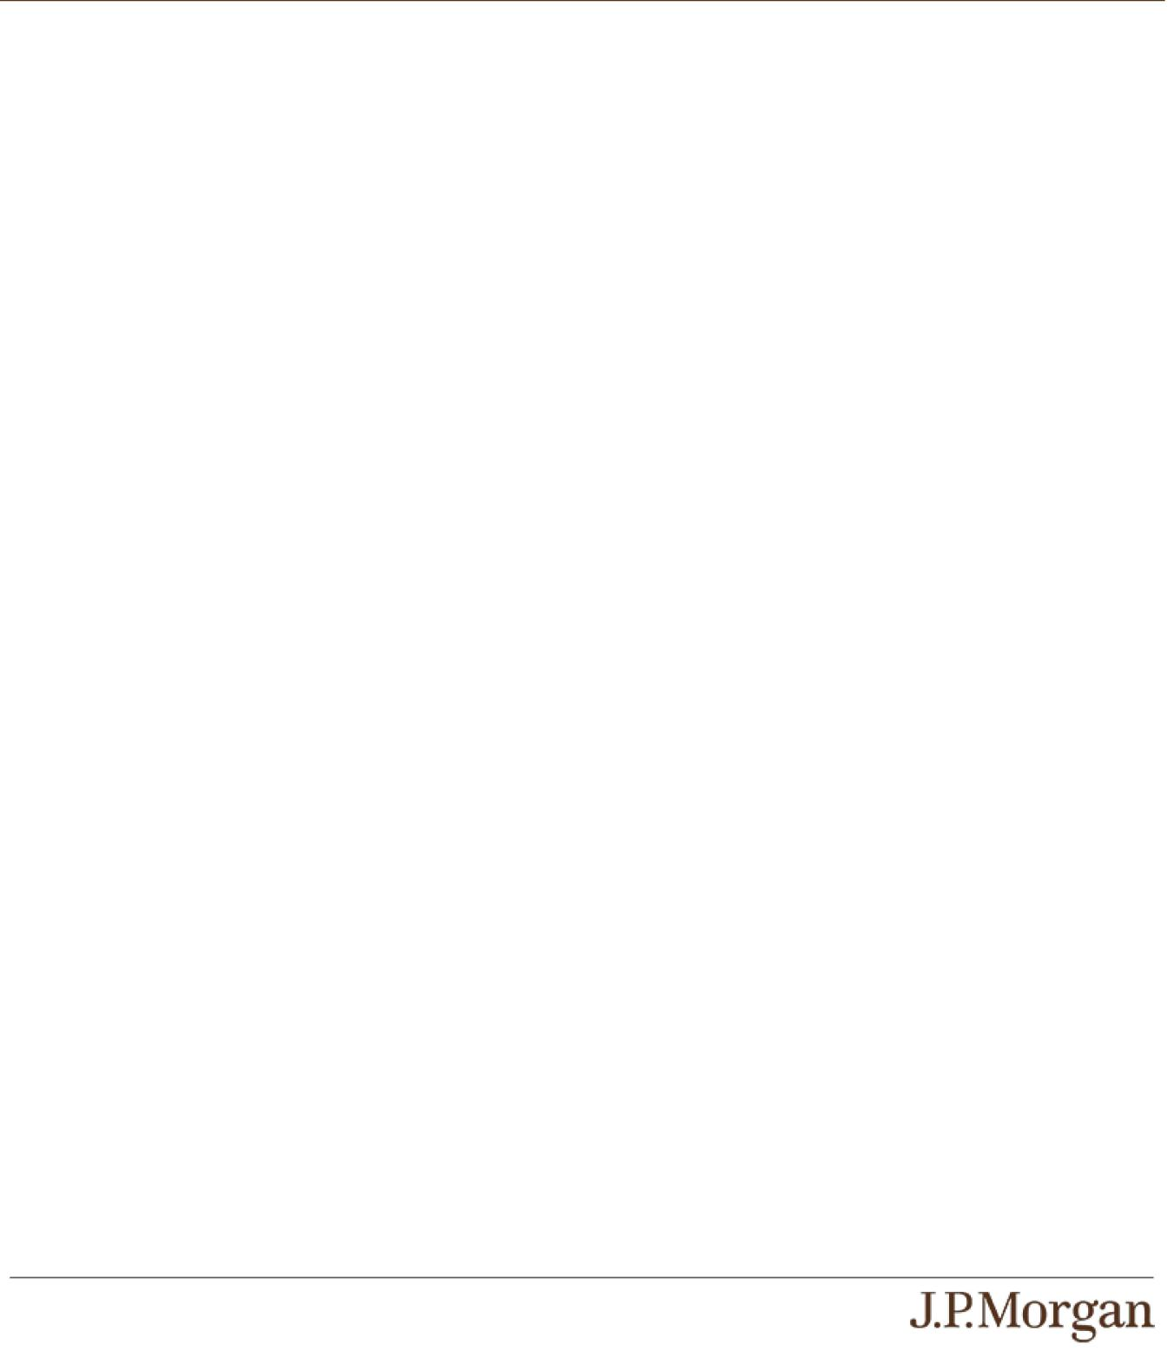

You should read this pricing supplement together with the accompanying prospectus, as supplemented by the accompanying prospectus supplement relating to our Series A medium-term notes of which these notes are a part, the accompanying prospectus addendum and the more detailed information contained in the accompanying product supplement and the accompanying underlying supplement. This pricing supplement, together with the documents listed below, contains the terms of the notes and supersedes all other prior or contemporaneous oral statements as well as any other written materials including preliminary or indicative pricing terms, correspondence, trade ideas, structures for implementation, sample structures, fact sheets, brochures or other educational materials of ours. You should carefully consider, among other things, the matters set forth in the “Risk Factors” sections of the accompanying prospectus supplement and the accompanying product supplement and in Annex A to the accompanying prospectus addendum, as the notes involve risks not associated with conventional debt securities. We urge you to consult your investment, legal, tax, accounting and other advisers before you invest in the notes.

You may access these documents on the SEC website at www.sec.gov as follows (or if such address has changed, by reviewing our filings for the relevant date on the SEC website):

- Product supplement no. 3-I dated April 13, 2023: http://www.sec.gov/Archives/edgar/data/19617/000121390023029706/ea153081_424b2.pdf

- Underlying supplement no. 1-I dated April 13, 2023: http://www.sec.gov/Archives/edgar/data/19617/000121390023029543/ea151873_424b2.pdf

- Prospectus supplement and prospectus, each dated April 13, 2023: http://www.sec.gov/Archives/edgar/data/19617/000095010323005751/crt_dp192097-424b2.pdf

- Prospectus addendum dated June 3, 2024: http://www.sec.gov/Archives/edgar/data/1665650/000095010324007599/dp211753_424b3.htm
Our Central Index Key, or CIK, on the SEC website is 1665650, and JPMorgan Chase & Co.’s CIK is 19617. As used in this pricing supplement, “we,” “us” and “our” refer to JPMorgan Financial.

PS-9 | Structured Investments

Bearish Knock-Out Notes Linked to the S&P 500® Index

Calculation of Filing Fee Tables

S-3

JPMORGAN CHASE & CO

Narrative Disclosure

The maximum aggregate offering price of the securities to which the prospectus relates is $2,000,000. The prospectus

is a final prospectus for the related offering.

