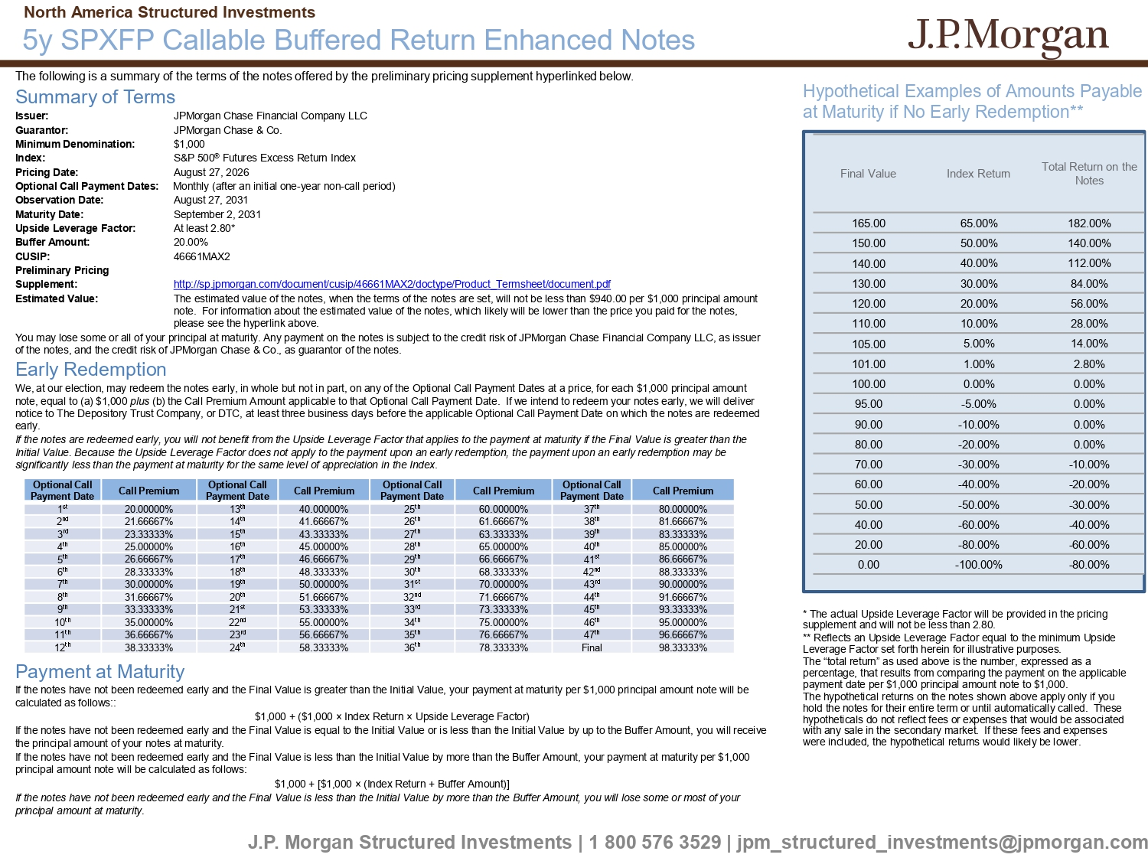
The following is a summary of the terms of the notes offered by the preliminary pricing supplement hyperlinked below. Summary of Terms Issuer: JPMorgan Chase Financial Company LLC Guarantor: JPMorgan Chase & Co. Minimum Denomination: $1,000 Index: S&P 500 ® Futures Excess Return Index Pricing Date: August 27, 2026 Optional Call Payment Dates: Monthly (after an initial one - year non - call period) Observation Date: August 27, 2031 Maturity Date: September 2, 2031 Upside Leverage Factor: At least 2.80* Buffer Amount: 20.00% CUSIP: 46661MAX2 Preliminary Pricing Supplement: http://sp.jpmorgan.com/document/cusip/46661MAX2/doctype/Product_Termsheet/document.pdf Estimated Value: The estimated value of the notes, when the terms of the notes are set, will not be less than $940.00 per $1,000 principal amo unt note. For information about the estimated value of the notes, which likely will be lower than the price you paid for the not es, please see the hyperlink above. You may lose some or all of your principal at maturity. Any payment on the notes is subject to the credit risk of JPMorgan Ch ase Financial Company LLC, as issuer of the notes, and the credit risk of JPMorgan Chase & Co., as guarantor of the notes. Early Redemption We, at our election, may redeem the notes early, in whole but not in part, on any of the Optional Call Payment Dates at a pri ce, for each $1,000 principal amount note, equal to (a) $1,000 plus (b) the Call Premium Amount applicable to that Optional Call Payment Date. If we intend to redeem your notes early, we will de liver notice to The Depository Trust Company, or DTC, at least three business days before the applicable Optional Call Payment Date on which the notes are redeemed early. If the notes are redeemed early, you will not benefit from the Upside Leverage Factor that applies to the payment at maturity if the Final Value is greater than the Initial Value. Because the Upside Leverage Factor does not apply to the payment upon an early redemption, the payment upon an ea rly redemption may be significantly less than the payment at maturity for the same level of appreciation in the Index . Payment at Maturity If the notes have not been redeemed early and the Final Value is greater than the Initial Value, your payment at maturity per $1 ,000 principal amount note will be calculated as follows:: $1,000 + ($1,000 î Index Return î Upside Leverage Factor) If the notes have not been redeemed early and the Final Value is equal to the Initial Value or is less than the Initial Value by up to the Buffer Amount, you will receive the principal amount of your notes at maturity. If the notes have not been redeemed early and the Final Value is less than the Initial Value by more than the Buffer Amount, you r payment at maturity per $1,000 principal amount note will be calculated as follows: $1,000 + [$1,000 î (Index Return + Buffer Amount)] If the notes have not been redeemed early and the Final Value is less than the Initial Value by more than the Buffer Amount, you will lose some or most of your principal amount at maturity . J.P. Morgan Structured Investments | 1 800 576 3529 | jpm_structured_investments@jpmorgan.com 5y SPXFP Callable Buffered Return Enhanced Notes North America Structured Investments Hypothetical Examples of Amounts Payable at Maturity if No Early Redemption** Total Return on the Notes Index Return Final Value 182.00% 65.00% 165.00 140.00% 50.00% 150.00 112.00% 40.00% 140.00 84.00% 30.00% 130.00 56.00% 20.00% 120.00 28.00% 10.00% 110.00 14.00% 5.00% 105.00 2.80% 1.00% 101.00 0.00% 0.00% 100.00 0.00% - 5.00% 95.00 0.00% - 10.00% 90.00 0.00% - 20.00% 80.00 - 10.00% - 30.00% 70.00 - 20.00% - 40.00% 60.00 - 30.00% - 50.00% 50.00 - 40.00% - 60.00% 40.00 - 60.00% - 80.00% 20.00 - 80.00% - 100.00% 0.00 * The actual Upside Leverage Factor will be provided in the pricing supplement and will not be less than 2.80. ** Reflects an Upside Leverage Factor equal to the minimum Upside Leverage Factor set forth herein for illustrative purposes. The “total return” as used above is the number, expressed as a percentage, that results from comparing the payment on the applicable payment date per $1,000 principal amount note to $1,000. The hypothetical returns on the notes shown above apply only if you hold the notes for their entire term or until automatically called. These hypotheticals do not reflect fees or expenses that would be associated with any sale in the secondary market. If these fees and expenses were included, the hypothetical returns would likely be lower. Call Premium Optional Call Payment Date Call Premium Optional Call Payment Date Call Premium Optional Call Payment Date Call Premium Optional Call Payment Date 80.00000% 37 th 60.00000% 25 th 40.00000% 13 th 20.00000% 1 st 81.66667% 38 th 61.66667% 26 th 41.66667% 14 th 21.66667% 2 nd 83.33333% 39 th 63.33333% 27 th 43.33333% 15 th 23.33333% 3 rd 85.00000% 40 th 65.00000% 28 th 45.00000% 16 th 25.00000% 4 th 86.66667% 41 st 66.66667% 29 th 46.66667% 17 th 26.66667% 5 th 88.33333% 42 nd 68.33333% 30 th 48.33333% 18 th 28.33333% 6 th 90.00000% 43 rd 70.00000% 31 st 50.00000% 19 th 30.00000% 7 th 91.66667% 44 th 71.66667% 32 nd 51.66667% 20 th 31.66667% 8 th 93.33333% 45 th 73.33333% 33 rd 53.33333% 21 st 33.33333% 9 th 95.00000% 46 th 75.00000% 34 th 55.00000% 22 nd 35.00000% 10 th 96.66667% 47 th 76.66667% 35 th 56.66667% 23 rd 36.66667% 11 th 98.33333% Final 78.33333% 36 th 58.33333% 24 th 38.33333% 12 th
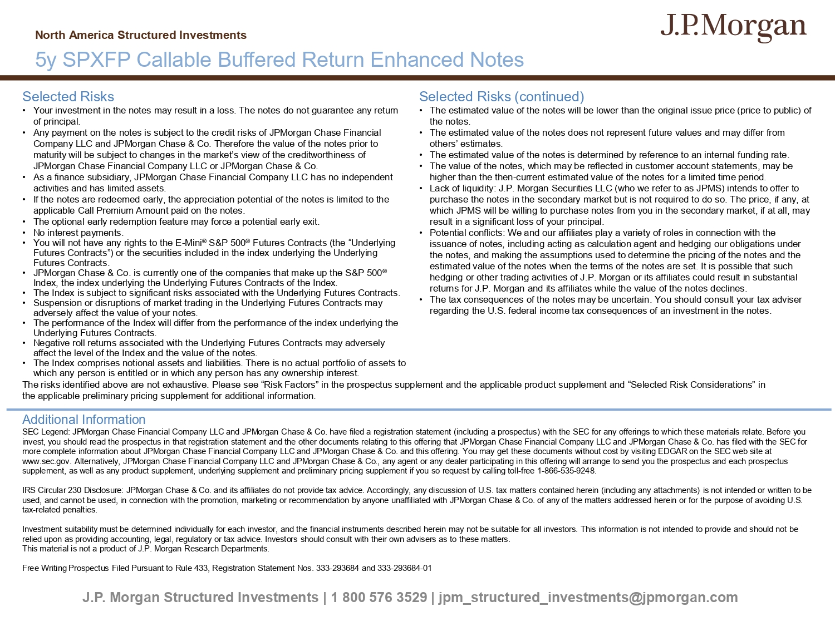
J.P. Morgan Structured Investments | 1 800 576 3529 | jpm_structured_investments@jpmorgan.com Selected Risks • Your investment in the notes may result in a loss. The notes do not guarantee any return of principal. • Any payment on the notes is subject to the credit risks of JPMorgan Chase Financial Company LLC and JPMorgan Chase & Co. Therefore the value of the notes prior to maturity will be subject to changes in the market’s view of the creditworthiness of JPMorgan Chase Financial Company LLC or JPMorgan Chase & Co. • As a finance subsidiary, JPMorgan Chase Financial Company LLC has no independent activities and has limited assets. • If the notes are redeemed early, the appreciation potential of the notes is limited to the applicable Call Premium Amount paid on the notes. • The optional early redemption feature may force a potential early exit. • No interest payments. • You will not have any rights to the E - Mini ® S&P 500 ® Futures Contracts (the “Underlying Futures Contracts”) or the securities included in the index underlying the Underlying Futures Contracts. • JPMorgan Chase & Co. is currently one of the companies that make up the S&P 500 ® Index, the index underlying the Underlying Futures Contracts of the Index. • The Index is subject to significant risks associated with the Underlying Futures Contracts. • Suspension or disruptions of market trading in the Underlying Futures Contracts may adversely affect the value of your notes. • The performance of the Index will differ from the performance of the index underlying the Underlying Futures Contracts. • Negative roll returns associated with the Underlying Futures Contracts may adversely affect the level of the Index and the value of the notes. • The Index comprises notional assets and liabilities. There is no actual portfolio of assets to which any person is entitled or in which any person has any ownership interest. Selected Risks (continued) • The estimated value of the notes will be lower than the original issue price (price to public) of the notes. • The estimated value of the notes does not represent future values and may differ from others’ estimates. • The estimated value of the notes is determined by reference to an internal funding rate. • The value of the notes, which may be reflected in customer account statements, may be higher than the then - current estimated value of the notes for a limited time period. • Lack of liquidity: J.P. Morgan Securities LLC (who we refer to as JPMS) intends to offer to purchase the notes in the secondary market but is not required to do so. The price, if any, at which JPMS will be willing to purchase notes from you in the secondary market, if at all, may result in a significant loss of your principal. • Potential conflicts: We and our affiliates play a variety of roles in connection with the issuance of notes, including acting as calculation agent and hedging our obligations under the notes, and making the assumptions used to determine the pricing of the notes and the estimated value of the notes when the terms of the notes are set. It is possible that such hedging or other trading activities of J.P. Morgan or its affiliates could result in substantial returns for J.P. Morgan and its affiliates while the value of the notes declines. • The tax consequences of the notes may be uncertain. You should consult your tax adviser regarding the U.S. federal income tax consequences of an investment in the notes. Additional Information SEC Legend: JPMorgan Chase Financial Company LLC and JPMorgan Chase & Co. have filed a registration statement (including a pr osp ectus) with the SEC for any offerings to which these materials relate. Before you invest, you should read the prospectus in that registration statement and the other documents relating to this offering that JPM organ Chase Financial Company LLC and JPMorgan Chase & Co. has filed with the SEC for more complete information about JPMorgan Chase Financial Company LLC and JPMorgan Chase & Co. and this offering. You may get the se documents without cost by visiting EDGAR on the SEC web site at www.sec.gov. Alternatively, JPMorgan Chase Financial Company LLC and JPMorgan Chase & Co., any agent or any dealer participat ing in this offering will arrange to send you the prospectus and each prospectus supplement, as well as any product supplement, underlying supplement and preliminary pricing supplement if you so request by cal ling toll - free 1 - 866 - 535 - 9248. IRS Circular 230 Disclosure: JPMorgan Chase & Co. and its affiliates do not provide tax advice. Accordingly, any discussion o f U .S. tax matters contained herein (including any attachments) is not intended or written to be used, and cannot be used, in connection with the promotion, marketing or recommendation by anyone unaffiliated with JPMorgan Cha se & Co. of any of the matters addressed herein or for the purpose of avoiding U.S. tax - related penalties. Investment suitability must be determined individually for each investor, and the financial instruments described herein may not be suitable for all investors. This information is not intended to provide and should not be relied upon as providing accounting, legal, regulatory or tax advice. Investors should consult with their own advisers as to the se matters. This material is not a product of J.P. Morgan Research Departments. Free Writing Prospectus Filed Pursuant to Rule 433, Registration Statement Nos. 333 - 293684 and 333 - 293684 - 01 North America Structured Investments 5y SPXFP Callable Buffered Return Enhanced Notes The risks identified above are not exhaustive. Please see “Risk Factors” in the prospectus supplement and the applicable prod uct supplement and “Selected Risk Considerations” in the applicable preliminary pricing supplement for additional information.

