STRICTLY PRIVATE AND CONFIDENTIAL

CORE COMMODITY- IGAR SIGMA LONG-SHORT

October 2009


CORE COMMODITY-IGAR SIGMA LONG-SHORT

Executive summary

- The JPMorgan Commodity-Investable Global Asset Rotator (“Commodity-IGAR”) product suite uses momentum-based algorithms that seek to maximize the performance of investments in a selection of the S&P GSCI™ commodity excess return sub-indices. The particular Commodity-IGAR strategy chosen depends on each investor’s objective.

- Core Commodity-IGAR Sigma Long-Short (“C-IGAR Sigma”) synthetically invests in up to 7 long positions based upon the best performing sub-indices which have positive 12-month returns and pass the Consistency and Reversal Tests¹, and up to 7 short positions based upon the worst performing sub-indices which have negative 12-month returns and pass the Consistency and Reversal Tests¹. The hypothetical historical performance of the Core Commodity-IGAR Sigma Long-Short is 14.83% with a volatility of 15.94%² on an annualized basis.

Source: JPMorgan
¹ Please refer to the Appendix for more details on the Consistency and Reversal Tests
² Information is calculated for the period January 1991 to September 2009, please refer to the important notice in relation to composite performance

Hypothetical excess return profile
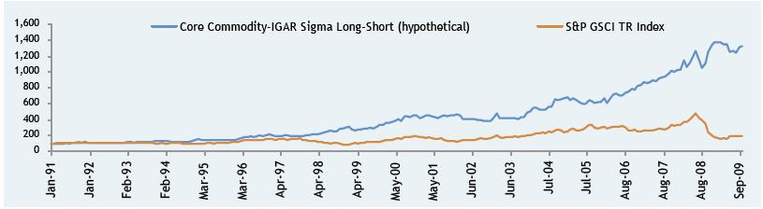

Source: JPMorgan. Information is calculated for the period January 1991 to September 2009
S&P GSCI TR Index refers to Standard & Poor’s Goldman Sachs Total Return Commodity Index™

1

Please refer to the important notices including that in relation to composite performance, and the certain risk factors herein.

Past performance is not a guide to future results.

CORE COMMODITY-IGAR SIGMA LONG-SHORT

Core Commodity-IGAR: Current Investment Universe

Sector: Energy |  |  | Sector: Industrial metals
S&P GSCI™ excess return sub-indices | Bloomberg ticker |  | S&P GSCI™ excess return sub-indices | Bloomberg ticker
n Natural gas | SPGCNGP index |  | n Nickel | SPGCIKP index
n Gasoline | SPGCHUP index |  | n Lead | SPGCILP index
n Heating oil | SPGCHOP index |  | n Copper | SPGCICP index
n Brent crude | SPGCBRP index |  | n Aluminium | SPGCIAP index
n WTI Crude oil | SPGCCLP index
Sector: Agricultural |  |  | Sector: Precious metals
S&P GSCI™ excess return sub-indices | Bloomberg ticker |  | S&P GSCI™ excess return sub-indices | Bloomberg ticker
n Wheat | SPGCWHP index |  | n Silver | SPGCSIP index
n Soybean | SPGCSOP index |  | n Gold | SPGCGCP index
n Corn | SPGCCNP index

2

Please refer to the important notices including that in relation to composite performance, and the certain risk factors herein.

Past performance is not a guide to future results.

CORE COMMODITY-IGAR SIGMA LONG-SHORT

Core Commodity-IGAR Sigma Long-Short rotation methodology

Illustrative summary¹
- The monthly reallocation helps identify the long and short positions and consists of a series of tests leading to a refinement of the global investment universe
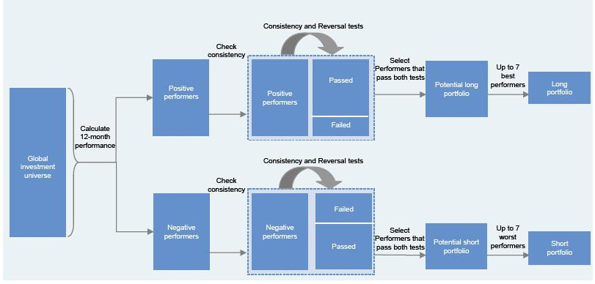

¹ For illustration only – For a more detailed description of the algorithm, please refer to the Appendix and the Synthetic Strategy Rules

3

Please refer to the important notices including that in relation to composite performance, and the certain risk factors herein.

Past performance is not a guide to future results.

CORE COMMODITY-IGAR SIGMA LONG-SHORT

Consistency test

Illustration of the weights
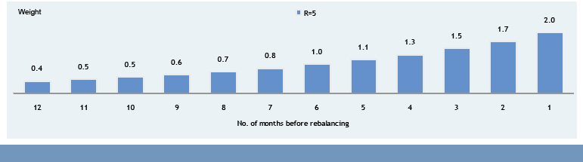

Illustration for potential long positions
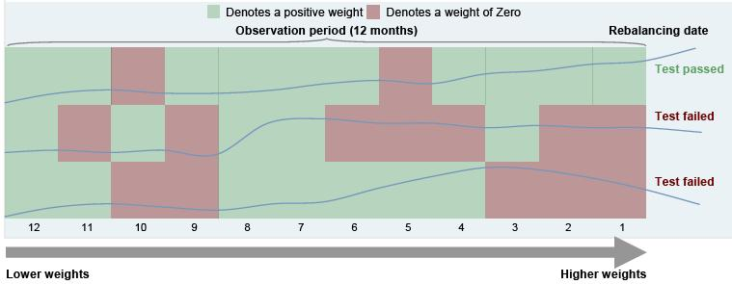

For illustration purposes only

4

Please refer to the important notices including that in relation to composite performance, and the certain risk factors herein.

Past performance is not a guide to future results.

CORE COMMODITY-IGAR SIGMA LONG-SHORT

Reversal test

- To avoid rapid breakdowns in momentum, C-IGAR Sigma incorporates a “Reversal Test”

- If the momentum of a commodity is consistently positive (or negative) but has shown a rapid reversal as indicated by a downward (upward) move exceeding 10%, the commodity is considered ineligible for selection in the long (short) leg of C-IGAR Sigma

- If the positive (negative) momentum of a commodity later reasserts itself, the commodity becomes eligible once again

- If more than 7 commodities are eligible for inclusion in the long leg and the Reversal Test excludes one or more out of the 7 commodities exhibiting the strongest 12 month performance, C-IGAR Sigma will include other commodities which pass both the Consistency and Reversal tests up to a total of 7

- In the hypothetical backtest since 1991, the Reversal test has come into effect on roughly 30% of all months

Illustration for potential long positions
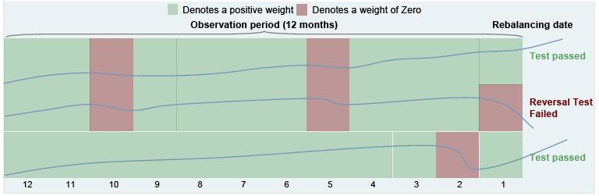

For illustration purposes only

5

Please refer to the important notices including that in relation to composite performance, and the certain risk factors herein.

Past performance is not a guide to future results.

CORE COMMODITY-IGAR SIGMA LONG-SHORT

Rebalancing Dates and Volatility Control Factor

Index Rebalancing Methodology

The Core Commodity-IGAR Sigma Long-Short is reweighted monthly on the 11th dealing day as an equally-weighted basket of five component indices. Each component index rebalances the C-IGAR Sigma Long-Short portfolio (selected on the 10th dealing day of each month) on a separate day.

Rebalancing Dates of the component indices are:

The Core Commodity-IGAR Long-Only and the Core Commodity-IGAR Long-Short component indices rebalance on the 12th to 16th dealing day of the month

Important Note: New weightings are only effective from the close of the Rebalancing Date

Volatility Control

- Volatility Control is a mechanism to adjust the overall leverage of C-IGAR Sigma Long-Short, aiming to achieve realised volatility at or below the Target Volatility Level (20%)

- To achieve this, the realized volatility¹ over the last 21 days and 63 days is measured

- Whenever either of these exceed the Target Volatility Level for the index, the overall index exposure is reduced by multiplying by:

Target Volatility Level / Max[21-day volatility, 63-day volatility]

n The Volatility Control mechanism has been applied on roughly 40% of all months in the hypothetical backtest since 1991

¹ Realised volatility is measured as per the hypothetical historical performance of the C-IGAR Sigma Index assuming leverage of 100%

6

Please refer to the important notices including that in relation to composite performance, and the certain risk factors herein.

Past performance is not a guide to future results.

CORE COMMODITY-IGAR SIGMA LONG-SHORT

Core Commodity-IGAR Sigma Long-Short: hypothetical net exposure to commodities over time

Hypothetical excess return profile
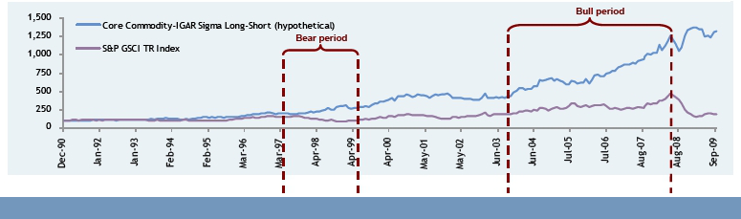

Hypothetical net exposure to commodities
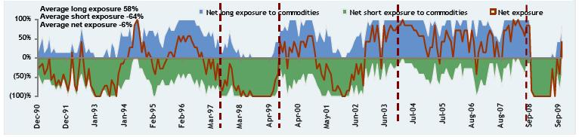

Source: JPMorgan. Information is calculated for the period January 1991 to September 2009 S&P GSC TR Index refers to Standard & Poor’s Goldman Sachs Total Return Commodity Index®
Net long (resp. short) exposure to commodities means hypothetical historical percentage long (resp. short) allocation of the Core Commodity-IGAR investment portfolio Net exposure is defined as the sum of the net long exposure and the net short exposure

7

Please refer to the important notices including that in relation to composite performance, and the certain risk factors herein.

Past performance is not a guide to future results.

CORE COMMODITY-IGAR SIGMA LONG-SHORT

Bloomberg Tickers

The Commodity-IGAR Sigma Long Short strategy is available on Bloomberg. The ticker is as follows:

Core Commodity-IGAR Sigma Long-Short:

CMDSLSTR <INDEX>

Bloomberg® Ticker: CMDUYER Index
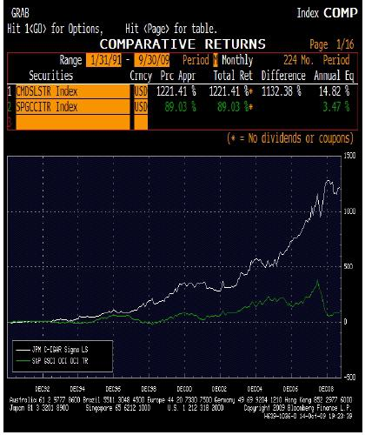

8

Please refer to the important notices including that in relation to composite performance, and the certain risk factors herein.

Past performance is not a guide to future results.

CORE COMMODITY-IGAR SIGMA LONG-SHORT

IMPORTANT NOTICE RELATING TO COMPOSITE PERFORMANCE OF INDICES (REPLICATING THE HYPOTHETICAL HISTORICAL PERFORMANCE OF C-IGAR Sigma AND THE S&P GSCI Index™

Any historical composite performance record included in this presentation is hypothetical and it should be noted that the Constituents have not previously traded together in the manner shown in the composite historical replication of the JPMorgan Core Commodity Investable Global Asset Rotator Sigma Long Short Index (“C-IGAR Sigma” or “The Index”). Hypothetical performance results have many inherent limitations, some of which are described below. No representation is being made that C-IGAR Sigma will achieve a composite performance record similar to that shown. In fact, there are frequently sharp differences between a hypothetical historical composite performance record and the actual record of the combination of those underlying elements subsequently achieved.

It should be noted that certain important assumptions have been used in compiling the back-testing information included in this presentation. In considering the “historical” hypothetical performance of the C-IGAR Sigma, it has been assumed that rebalancing could occur instantaneously: in the CIGAR Sigma going forward there is in fact a delay between the rotational selection of weighting for the Constituents and the implementation of that weighting in the C-IGAR Sigma basket.

Any “back-testing” information provided herein is illustrative only and derived from proprietary models based on certain historic data (which may or may not correspond with the historic data that someone else would use to back-test this product) and assumptions and estimates (not all of which may be specified herein, which are subject to change without notice and which may not accurately reflect the characteristics of the product described herein). Without limiting the generality of the foregoing, JPMorgan has assumed historical monthly observation points and data: reference to different observation points might have produced different results over time. In addition, the sub-components used in the back-testing
do not necessarily match over the full hypothetical historical period the historical composition of the S&P GSCI Index®. Those constituents of the
C-IGAR Sigma (that is, sub indices of the S&P GSCI Index®) which have not formed part of the S&P GSCI Index® throughout the hypothetical historical period used for back-testing, have been ascribed an excess return over cash of zero (0). More generally, the results obtained from different models, assumptions, estimates and/or historic data may be materially different from the results presented herein and such “back-testing” information should not be considered indicative of the actual results that might be obtained from an investment or participation in a financial instrument or transaction referencing the product described herein. JPMorgan expressly disclaims any responsibility for (i) the accuracy or completeness of the models, assumptions, estimates and historic data used in deriving the “back-testing” information, (ii) the failure of any of the assumptions or estimates used in deriving the "back-testing" information to accurately reflect the characteristics of the product described herein,

- any errors or omissions in computing or disseminating the “back-testing” information, and (iv) any uses to which the “back-testing” information may be put by any recipient of such information.

Please refer to the important notices including that in relation to composite performance, and the certain risk factors herein.

Past performance is not a guide to future results.

CORE COMMODITY-IGAR SIGMA LONG-SHORT

IMPORTANT NOTICE

SEC Legend: JPMorgan Chase & Co. has filed a registration statement (including a prospectus) with the SEC for any offerings to which these materials relate. Before you invest, you should read the prospectus in that registration statement and the other documents relating to this offering that JPMorgan Chase & Co. has filed with the SEC for more complete information about JPMorgan Chase & Co. and this offering. You may get these documents without cost by visiting EDGAR on the SEC Web site at www.sec.gov. Alternatively, JPMorgan Chase & Co., any agent or any dealer participating in the this offering will arrange to send you the prospectus and each prospectus supplement as well as any product supplement and term sheet if you so request by calling toll-free 866-535-9248.

IRS Circular 230 Disclosure: JPMorgan Chase & Co. and its affiliates do not provide tax advice. Accordingly, any discussion of U.S. tax matters contained herein (including any attachments) is not intended or written to be used, and cannot be used, in connection with the promotion, marketing or recommendation by anyone unaffiliated with JPMorgan Chase & Co. of any of the matters address herein or for the purpose of avoiding U.S. tax-related penalties.

Investment suitability must be determined individually for each investor, and the financial instruments described herein may not be suitable for all investors. The products described herein should generally be held to maturity as early unwinds could result in lower than anticipated returns. This information is not intended to provide and should not be relied upon as providing accounting, legal, regulatory or tax advice. Investors should consult with their own advisors as to these matters.

This material is not a product of JPMorgan Research Departments. Structured Investments may involve a high degree of risk, and may be appropriate investments only for sophisticated investors who are capable of understanding and assuming the risks involved. JPMorgan and its affiliates may have positions (long or short), effect transactions or make markets in securities or financial instruments mentioned herein (or options with respect thereto), or provide advice or loans to, or participate in the underwriting or restructuring of the obligations of, issuers mentioned herein. JPMorgan is the marketing name for JPMorgan Chase & Co. and its subsidiaries and affiliates worldwide. J.P. Morgan Securities Inc. is a member of NASD, NYSE and SIPC. Clients should contact their salespersons at, and execute transactions through, a JPMorgan entity qualified in their home jurisdiction unless governing law permits otherwise.

When considering whether to purchase any financial instrument, or otherwise participate in any transaction, referenced herein, no reliance should be placed on the information in this presentation. Such information is preliminary and subject to change without notice and does not constitute all the information necessary to evaluate the consequences of purchasing any financial instrument, or otherwise participating in any transaction, referenced herein. In addition, this presentation includes information obtained from sources believed to be reliable, but JPMorgan does not warrant its completeness or accuracy. Accordingly, any decision to purchase any financial instrument, or otherwise participate in any transaction, referenced herein should be based solely on the final documentation related to such financial instrument or transaction, which will contain the definitive terms and conditions thereof.

Nothing in this presentation should be construed as a recommendation to purchase any financial instrument, or participate in any transaction, or as legal, tax, regulatory or accounting advice. Any prospective investor or transaction participant must make an independent assessment of such matters in consultation with its own professional advisors.

Any “forward-looking” information herein (such as illustrative cashflows, yields or returns) is based upon certain assumptions about future events or conditions and is intended only to illustrate hypothetical results under those assumptions (not all of which will be specified herein). Actual events or conditions are unlikely to be consistent with, and may differ materially from, those assumed. Accordingly, actual results will vary and the variations may be material.

Information herein about the past performance of any reference index (each a “Constituent” of the C-IGAR Sigma) should not be viewed as indicative of future results.

Please refer to the important notices including that in relation to composite performance, and the certain risk factors herein.

Past performance is not a guide to future results.

CORE COMMODITY-IGAR SIGMA LONG-SHORT

IMPORTANT NOTICE (Cont.)

JPMorgan may hedge its anticipated exposure under an investment product referencing the C-IGAR Sigma by buying or selling traded contracts or entering into over the counter transactions in relation to the Constituents or any combination of the Constituents (including the S&P GSCI Index). JPMorgan Chase & Co. or its affiliates may also issue other products referencing the C-IGAR Sigma, any combination of Constituents or the S&P GSCI Index. Any of these activities may indirectly affect the performance of the Constituents.

This presentation is not intended for distribution to, or use by, any person in any jurisdiction where such distribution or use is prohibited by law or regulation. This presentation may contain confidential or proprietary information and its distribution, or the divulgence of its contents to any person, other than the person to whom the presentation was originally delivered, is prohibited.

Additional information is available upon request. Clients should contact JPMorgan representatives in their home jurisdictions unless governing law permits otherwise. JPMorgan is the marketing name for J.P. Morgan Securities Inc. (member, NYSE), J.P. Morgan Securities Ltd. (member, LSE; authorized and regulated by FSA) and their investment banking affiliates.

Standard & Poor’s Disclaimer

The JPMorgan Core Commodity Investable Global Asset Rotator Sigma Long-Short Index is not sponsored, endorsed, sold or promoted by Standard & Poor’s, a division of the McGraw-Hill Companies, Inc. Standard & Poor’s makes no representation or warranty, express or implied, of the ability of the Standard & Poor’s Goldman Sachs Commodity Index Excess Return (the “S&P GSCITM”) or any component sub-index to track general commodity market performance or any segment thereof respectively. Standard & Poor’s’ only relationship to JPMorgan (in such capacity, the “Licensee”) is the licensing of the S&P GSCITM and any component sub-indices, all of which are determined, composed and calculated by Standard & Poor’s without regard to the Licensee or the index. Standard & Poor’s has no obligation to take the needs of the Licensee or the index into consideration in determining, composing or calculating the S&P GSCITM or any component sub-index. The S&P GSCITM and the component sub-indices thereof are not owned, endorsed, or approved by or associated with Goldman Sachs & Co. or its affiliated companies.

STANDARD AND POOR’S DOES NOT GUARANTEE THE ACCURACY AND/OR THE COMPLETENESS OF THE S&P GSCITM OR ANY COMPONENT SUB-INDEX THEREOF OR ANY DATA INCLUDED THEREIN. STANDARD AND POOR’S SHALL HAVE NO LIABILIY FOR ANY ERRORS, OMISSIONS, OR INTERRUPTION THEREIN. STANDARD AND POOR’S MAKES NO WARRANTY, EXPRESS OR IMPLIED, AS TO RESULTS TO BE OBTAINED BY LICENSEE OR ANY OTHER PERSON OR ENTITY FROM THE USE OF THE S&P GSCITM OR ANY COMPONENT SUB-INDEX THEREOF OR ANY DATA INCLUDED THEREIN IN CONNECTION WITH THE RIGHTS LICENSED TO LICENSEE. STANDARD AND POOR’S MAKES NO EXPRESS OR IMPLIED WARRANTIES, AND HEREBY EXPRESSLY DISCLAIMS ALL WARRANTIES OF MERCHANTABILITY OR FITNESS FOR A PARTICULAR PURPOSE OR USE WITH RESPECT TO THE S&P GSCITM OR ANY COMPONENT SUB-INDEX THEREOF OR ANY DATA INCLUDED THEREIN. WITHOUT LIMITING ANY OF THE FOREGOING, IN NO EVENT SHALL STANDARD AND POOR’S HAVE ANY LIABILITY FOR ANY SPECIAL, PUNITIVE, INDIRECT, OR CONSEQUENTIAL DAMAGES (INCLUDING LOST PROFITS), EVEN IF NOTIFIED OF THE POSSIBILITY OF SUCH DAMAGES.

Webinar sponsored by Rydex|SGI, an affiliate of Rydex Distributors, Inc. Rydex|SGI offers funds with investment strategies similar to the referenced indices. However, performance presented is that of the referenced indices or indicators and not that of any Rydex|SGI fund. Returns do not reflect any management fees, transaction costs or expenses. The index is unmanaged and not available for direct investment.

Please refer to the important notices including that in relation to composite performance, and the certain risk factors herein.

Past performance is not a guide to future results.

CORE COMMODITY-IGAR SIGMA LONG-SHORT

IMPORTANT RISK FACTORS

An investment in notes linked to C-IGAR Sigma involves significant risks. Investing in such notes is not equivalent to investing directly in the S&P GSCITM constituent sub-indices, in any of the commodities whose futures contracts determine the levels of the S&P GSCITM constituent sub-indices, or in any contracts relating to such commodities for which there is an active secondary market. These risks are explained in more detail in the “Risk Factors” section of the product supplement no. 167-A-II dated October 7, 2009.

Commodity prices are characterized by high and unpredictable volatility, which could lead to high and unpredictable volatility in C-IGAR Sigma.

Market prices of the commodity options futures contracts underlying the constituent sub-indices that compose C-IGAR Sigma tend to be highly volatile and may fluctuate rapidly based on numerous factors, including: changes in supply and demand relationships; governmental programs and policies, national and international monetary, trade, political and economic events, changes in interest and exchange rates, speculation and trading activities in commodities and related contracts, weather, and agricultural, trade, fiscal and exchange control policies. Many commodities are also highly cyclical. These factors may affect the level of the constituent sub-indices and the level of C-IGAR Sigma in varying ways, and different factors may cause the value of different commodities included in C-IGAR Sigma, and the commodity futures contracts of their prices, to move in inconsistent directions at inconsistent rates. This, in turn, will affect the value of the notes linked to the C-IGAR Sigma.

C-IGAR Sigma provides one avenue for exposure to commodities. The high volatility and cyclical nature of commodity markets may render these investments inappropriate as the focus of an investment portfolio. However, commodities investments may fluctuate independently of stock and bond investments, rendering moderate exposure a method of obtaining overall portfolio diversification.

Because C-IGAR Sigma may include notional short positions, C-IGAR Sigma may be subject to additional risks.

C-IGAR Sigma employs a technique generally known as “long-short” strategy. This means C-IGAR Sigma could include a number of notional long positions and a number of notional short positions. Unlike long positions, short positions are subject to unlimited risk of loss because there is no limit on the amount by which the price that the relevant asset may appreciate before the short position is closed. It is possible that any notional short position included in C-IGAR Sigma may appreciate substantially with an adverse impact on the performance of C-IGAR Sigma.

C-IGAR Sigma lacks an extensive operating history and may perform in unanticipated ways.

C-IGAR Sigma was established on June 15, 2009, and therefore has limited historical performance. Back-testing or similar analysis in respect of C-IGAR Sigma must be considered illustrative only and may be based on estimates or assumptions not used by the C-IGAR Sigma Calculation Agent when determining the C-IGAR Sigma values. The actual future performance of C-IGAR Sigma may bear little relation to its hypothetical and historical returns.

The performance of sub-indices underlying C-IGAR Sigma may offset each other.

C-IGAR Sigma consists of 14 different sub-indices, each of which will be assigned a weight based on the rebalancing algorithm. The algorithm under which the weights for the constituent sub-indices are established and rebalanced allows various constituent sub-indices to be weighted positively or negatively (i.e., a short position could be established for one or more constituent sub-indices) or accorded zero weight. For any period of time, gains attributable to long or short positions in particular constituent sub-indices could be reduced, offset or more than offset by losses attributable to the performance of other constituent sub-indices. Similarly, losses attributable to long or short positions in particular constituent sub-indices could be reduced, offset or more than offset by gains attributable to the performance of other constituent sub-indices.

Please refer to the important notices including that in relation to composite performance, and the certain risk factors herein.

Past performance is not a guide to future results.

CORE COMMODITY-IGAR SIGMA LONG-SHORT

IMPORTANT RISK FACTORS (continued)

The weightings of the constituent sub-indices for any monthly period will be based on, among other things, the assumption that past performance can be used as an indicator for future performance. Past performance is not necessarily indicative of future performance, and a reversal in momentum may result in a decline in the constituent sub-index and a decline in the level of C-IGAR Sigma. C-IGAR Sigma is not designed to respond to rapid changes in momentum (or changes in momentum of limited duration).

An investment in the notes carries the risks associated with C-IGAR Sigma momentum investment strategy.

C-IGAR Sigma employs a mathematical model intended to implement what is generally known as a momentum investment strategy, which seeks to capitalize on consistent positive market price trends based on the supposition that consistent positive market price trends may continue. This strategy is different from a strategy that seeks long-term exposure to a portfolio consisting of constant components. C-IGAR Sigma strategy may fail to realize gains that could occur as a result of holding a commodity that has experienced price declines, but after which experiences a sudden price spike. Further, the rules of C-IGAR Sigma limit exposure to rapidly appreciating sub-indices. This is because C-IGAR Sigma rebalances its exposure to sub-indices each month so that the exposure to any one sub-index does not exceed one-twelfth of the total synthetic portfolio as of the time of a monthly rebalancing. By contrast, a synthetic portfolio that does not rebalance monthly in this manner could see greater compounded gains over time through exposure to a consistently and rapidly appreciating sub-index.

No assurance can be given that the investment strategy used to construct C-IGAR Sigma will be successful or that C-IGAR Sigma will outperform any alternative basket that might be constructed from the constituent sub-indices. Furthermore, because the rules of C-IGAR Sigma limit the synthetic portfolio to holding only to sub-indices that have shown consistent positive price appreciation, the synthetic portfolio may experience periods where it holds few or no sub-indices, and therefore is unlikely during such periods to achieve returns that exceed the returns realized by other investment strategies or be able to capture gains from other appreciating assets in the market that are not included in the universe of constituent sub-indices.

C-IGAR Sigma may not be successful and may not outperform any alternative strategy that might be employed with respect to the constituent sub-indices.

C-IGAR Sigma follows a proprietary strategy that operates on the basis on pre-determined rules. No assurance can be given that the investment strategy on which C-IGAR Sigma is based will be successful or that C-IGAR Sigma will outperform any alternative strategy that might be employed with respect to the constituent sub-indices.

C-IGAR Sigma may perform poorly during periods characterized by short-term volatility.

C-IGAR Sigma’s strategy is based on momentum investing. Momentum investing strategies are effective at identifying the current market direction in trending markets. However, in non-trending, sideways markets, momentum investment strategies are subject to ‘whipsaws.’ A whipsaw occurs when the market reverses and does the opposite of what is indicated by the trend indicator, resulting in a trading loss during the particular period. Consequently, C-IGAR Sigma may perform poorly in non-trending, “choppy” markets characterized by short-term volatility.

Suspension or disruptions of market trading in the commodity and related futures markets may affect the level of one or more of the constituent sub-indices and thus may adversely affect the level of C-IGAR Sigma.

The commodity markets are subject to temporary distortions or other disruptions due to various factors, including the lack of liquidity in the markets, the participation of speculators and government regulation and intervention. In addition, U.S. futures exchanges and some foreign exchanges have regulations that limit the amount of fluctuation in futures contract prices that may occur during a single business day. These limits are generally referred to as “daily price fluctuation limits” and the maximum or minimum price of a contract on any given day as a result of these limits is referred to as a “limit price.” Once the limit price has been reached in a particular contract, no trades may be made at a price higher than the maximum price or lower than the minimum price. Limit prices may have the effect of precluding trading in a particular contract or forcing the liquidation of contracts at disadvantageous times or prices. These circumstances could affect the levels of the constituent sub-indices, which in turn may adversely affect the performance of C-IGAR Sigma.

Please refer to the important notices including that in relation to composite performance, and the certain risk factors herein.

Past performance is not a guide to future results.

CORE COMMODITY-IGAR SIGMA LONG-SHORT

IMPORTANT RISK FACTORS (continued)

The commodity futures contracts underlying the constituent sub-indices of C-IGAR Sigma are subject to legal and regulatory regimes and changes to such regimes or the occurrence of certain extraordinary events may have an adverse effect on the level of C-IGAR Sigma.

The commodity futures contracts that underlie the constituent sub-indices of C-IGAR Sigma are subject to legal and regulatory regimes in the United States and, in some cases, in other countries that may change in ways that could negatively affect the performance of C-IGAR Sigma. Changes to the legal or regulatory regimes applicable to the commodity futures contracts that underlie the constituent sub-indices of C-IGAR Sigma may result in the C-IGAR Sigma Calculation Agent exercising its discretionary right under Strategy Rules to remove and/or replace constituent sub-indices of C-IGAR Sigma, which may, in turn, have a negative effect on the performance of C-IGAR Sigma strategy. The removal or replacement of constituent sub-indices described above could affect the diversification amongst the constituent sub-indices or the volatility of C-IGAR Sigma notwithstanding the normal diversification and volatility constraints imposed on C-IGAR Sigma by Strategy Rules. In addition, changes to the legal or regulatory regimes applicable to the commodity futures contracts that underlie the constituent sub-indices of C-IGAR Sigma may also result in modifications to the Strategy Rules, which may, in turn, have a negative effect on the performance of C-IGAR Sigma strategy. Furthermore, if an upon the occurrence of legal or regulatory changes that the C-IGAR Sigma Calculation Agent determines have interfered with JPMorgan’s or its affiliates’ ability to hedge obligations in relation to notes linked to C-IGAR Sigma, or if for any other reason JPMorgan or its affiliates are unable to enter into or maintain hedge positions the C-IGAR Sigma Calculation Agent deems necessary to hedge obligations under notes linked to C-IGAR Sigma, the C-IGAR Sigma Calculation Agent may exclude or substitute affected constituent sub-index or sub-indices or accelerate such notes. The exclusion of one or more constituent sub-index may adversely affect the performance of C-IGAR Sigma by restricting the available number of constituent sub-indices that can be referenced. Additionally, the substitution of an affected sub-index will alter C-IGAR Sigma, and such substitution may adversely change the level of C-IGAR Sigma. For example, the substitute constituent sub-index may have a higher volatility or less of a directional bias than the original sub-index.

Higher future prices of the commodity futures contracts constituting the underlying sub-indices relative to their current prices may affect the level of the C-IGAR Sigma.

The potential constituent sub-indices underlying the C-IGAR Sigma strategy are composed of futures contracts on physical commodities. Unlike equities, which typically entitle the holder to a continuing stake in a corporation, commodity futures contracts normally specify a certain date for delivery of the underlying physical commodity. As the exchange-traded futures contracts that compose the constituent sub-indices approach expiration, they are replaced by contracts that have a later expiration. Thus, for example, a contract purchased and held in August may specify an October expiration. As time passes, the contract expiring in October is replaced by a contract for delivery in November. This process is referred to as “rolling. ” If the market for these contracts is (putting aside other considerations) in “backwardation,” where the prices are lower in the distant delivery months than in the nearer delivery months, the sale of the October contract would take place at a price that is higher than the price of the November contract, thereby creating a positive “roll yield.” The presence of backwardation could adversely affect the value of constituent sub-indices with a short weighting at the time and thus the performance of C-IGAR Sigma. While many of the contracts included in the constituent sub-indices have historically exhibited consistent periods of backwardation, backwardation will most likely not exist at all times. The presence of “contango” in the commodity markets, where the prices are higher in the distant delivery months than in the nearer delivery months, could result in negative “roll yields,” which could adversely affect the value of constituent sub-indices with a long weighting at that time and thus the performance of the C-IGAR Sigma strategy.

Commodity prices may change unpredictably, affecting the level of C-IGAR Sigma in unforeseeable ways.

Trading in commodity futures contracts underlying the constituent sub-indices is speculative and can be extremely volatile. Market prices of the commodities on which such futures contracts are based may fluctuate rapidly based on numerous factors, including: changes in supply and demand relationships; weather; agriculture; trade; fiscal, monetary and exchange control programs; domestic and foreign political and economic events and policies; legal, regulatory and administrative rules (and proposed and actual changes to such rules) applicable to trading in commodity futures contracts; disease; technological developments and changes in interest rates. These factors may affect the level of the constituent sub-indices and, therefore, the level of CIGAR Sigma in varying and unpredictable ways.

Please refer to the important notices including that in relation to composite performance, and the certain risk factors herein.

Past performance is not a guide to future results.

CORE COMMODITY-IGAR SIGMA LONG-SHORT

IMPORTANT RISK FACTORS (continued)

The commodities markets are subject to temporary distortions or other disruptions due to various factors, including the lack of liquidity in the markets, the participation of speculators and government regulation and intervention. These circumstances could adversely affect the price of futures contracts and, therefore, the performance of the constituent sub-indices and of CIGAR Sigma.

Some of the potential constituent sub-indices will be subject to pronounced risks of pricing volatility.

As a general matter, the risk of low liquidity or volatile pricing around the maturity date of a commodity futures contract is greater than in the case of other futures contracts because (among other factors) a number of market participants take physical delivery of the underlying commodities. Many commodities, like those in the energy and industrial metals sectors, have liquid futures contracts that expire every month. Therefore, these contracts are rolled forward every month. Contracts based on certain other commodities, most notably agricultural and livestock products, tend to have only a few contract months each year that trade with substantial liquidity. Thus, these commodities, with related futures contracts that expire infrequently, roll forward less frequently than every month, and can have further pronounced pricing volatility during extended periods of low liquidity. In respect of sub-indices that represent energy, it should be noted that due to the significant level of its continuous consumption, limited reserves, and oil cartel controls, energy commodities are subject to rapid price increases in the event of perceived or actual shortages.

Investment in the C-IGAR Sigma strategy is subject to interest rate risk associated with total return indices.

C-IGAR Sigma is a total return index, which means that it includes an interest component that reflects hypothetical interest earned on the cash deposited as collateral for the purchase of the relevant futures contracts. Because a portion of the performance of C-IGAR Sigma will be based on the t-bill rate, changes in interest rates will affect the performance of C-IGAR Sigma. In general, if interest rates increase, we might expect the level of C-IGAR Sigma to increase, notwithstanding the excess return associated with the selected constituent sub-indices, and, conversely, if the interest rates decrease, we might expect that the level of C-IGAR Sigma may decline because the appreciation of the C-IGAR Sigma level is linked to the t-bill rate.

C-IGAR Sigma is not a fully diversified portfolio.

Diversification is generally considered to reduce the amount of risk associated with generating returns. The results that may be obtained from investing in any security or investment or otherwise participating in any transaction linked to C-IGAR Sigma might well be significantly different from the results that could theoretically be obtained from a direct investment in the constituent sub-indices or any related derivatives. In addition, diversification is generally considered to reduce the amount of risk associated with generating returns, however there can be no assurance that C-IGAR Sigma will be sufficiently diversified at any time to reduce or minimize such risks to any extent.

The C-IGAR Sigma synthetic portfolio will not replicate the components or weightings of the S&P GSCITM Commodity Index

The synthetic portfolio referenced from time to time by C-IGAR Sigma will consist of between zero and seven long positions and between zero and seven short positions in equally-weighted components. By contrast, the S&P GSCITM seeks to allocate weights based on the relative importance of component commodities within the overall economy. In addition, a portion or even all of C-IGAR Sigma synthetic portfolio could be deemed uninvested in any given month. For example, as of February 1, 2009, the C-IGAR Sigma Long-Short synthetic portfolio contains a long position in one component and short positions in seven components. As a result, C-IGAR Sigma will not track an econometric-weighted commodity portfolio or assume constant exposure to commodity positions.

Please refer to the important notices including that in relation to composite performance, and the certain risk factors herein.

Past performance is not a guide to future results.

CORE COMMODITY-IGAR SIGMA LONG-SHORT

IMPORTANT RISK FACTORS (continued)

Prior to maturity, the value of the notes will be influenced by many unpredictable factors.

Many economic and market factors will affect the value of notes linked to C-IGAR Sigma. We expect that, generally, the level of the constituent sub-indices and interest rates on any day will affect the value of such notes more than any other single factor. However, you should not expect the value of such notes in the secondary market to vary in proportion to changes in the level of the constituent sub-indices. The value of such notes will be affected by a number of other factors that may either offset or magnify each other, including:

the volatility in the constituent sub-indices;

the time to maturity of such notes;

the market price of the physical commodities upon which the futures contracts that compose the constituent sub-indices are based; interest and yield rates in the market generally;
economic, financial, political, regulatory, geographical, agricultural, meteorological or judicial events that affect the commodities underlying

the constituent sub-indices or markets generally and which may affect the value of the commodity futures contracts, and thus the closing

levels of the constituent sub-indices; and

our creditworthiness.

Certain calculations and determinations will be made in the sole discretion of the C-IGAR Sigma Calculation Agent.

JPMorgan and its affiliates play a variety of roles in connection with C-IGAR Sigma, and J.P. Morgan Securities Ltd., one of its affiliates, will act as the C-IGAR Sigma Calculation Agent. The C-IGAR Sigma Calculation Agent has responsibility for calculating and publishing the closing levels of C-IGAR Sigma. It is entitled to exercise discretion in relation to C-IGAR Sigma, including but not limited to, the determination of the values to be used in the event of market disruptions that affect its ability to calculate and publish the closing levels of C-IGAR Sigma, its ability to substitute or exclude constituent sub-indices and the interpretation of the rules for valuing C-IGAR Sigma. Although the Optimax Calculation Agent will make all determinations and take all action in relation to C-IGAR Sigma acting in good faith, it should be noted that such discretion could have an impact, positive or negative, on the levels and performance of C-IGAR Sigma. The C-IGAR Sigma Calculation Agent is under no obligation to consider your interests in taking any actions that might affect C-IGAR Sigma.

Please refer to the important notices including that in relation to composite performance, and the certain risk factors herein.

Past performance is not a guide to future results.

