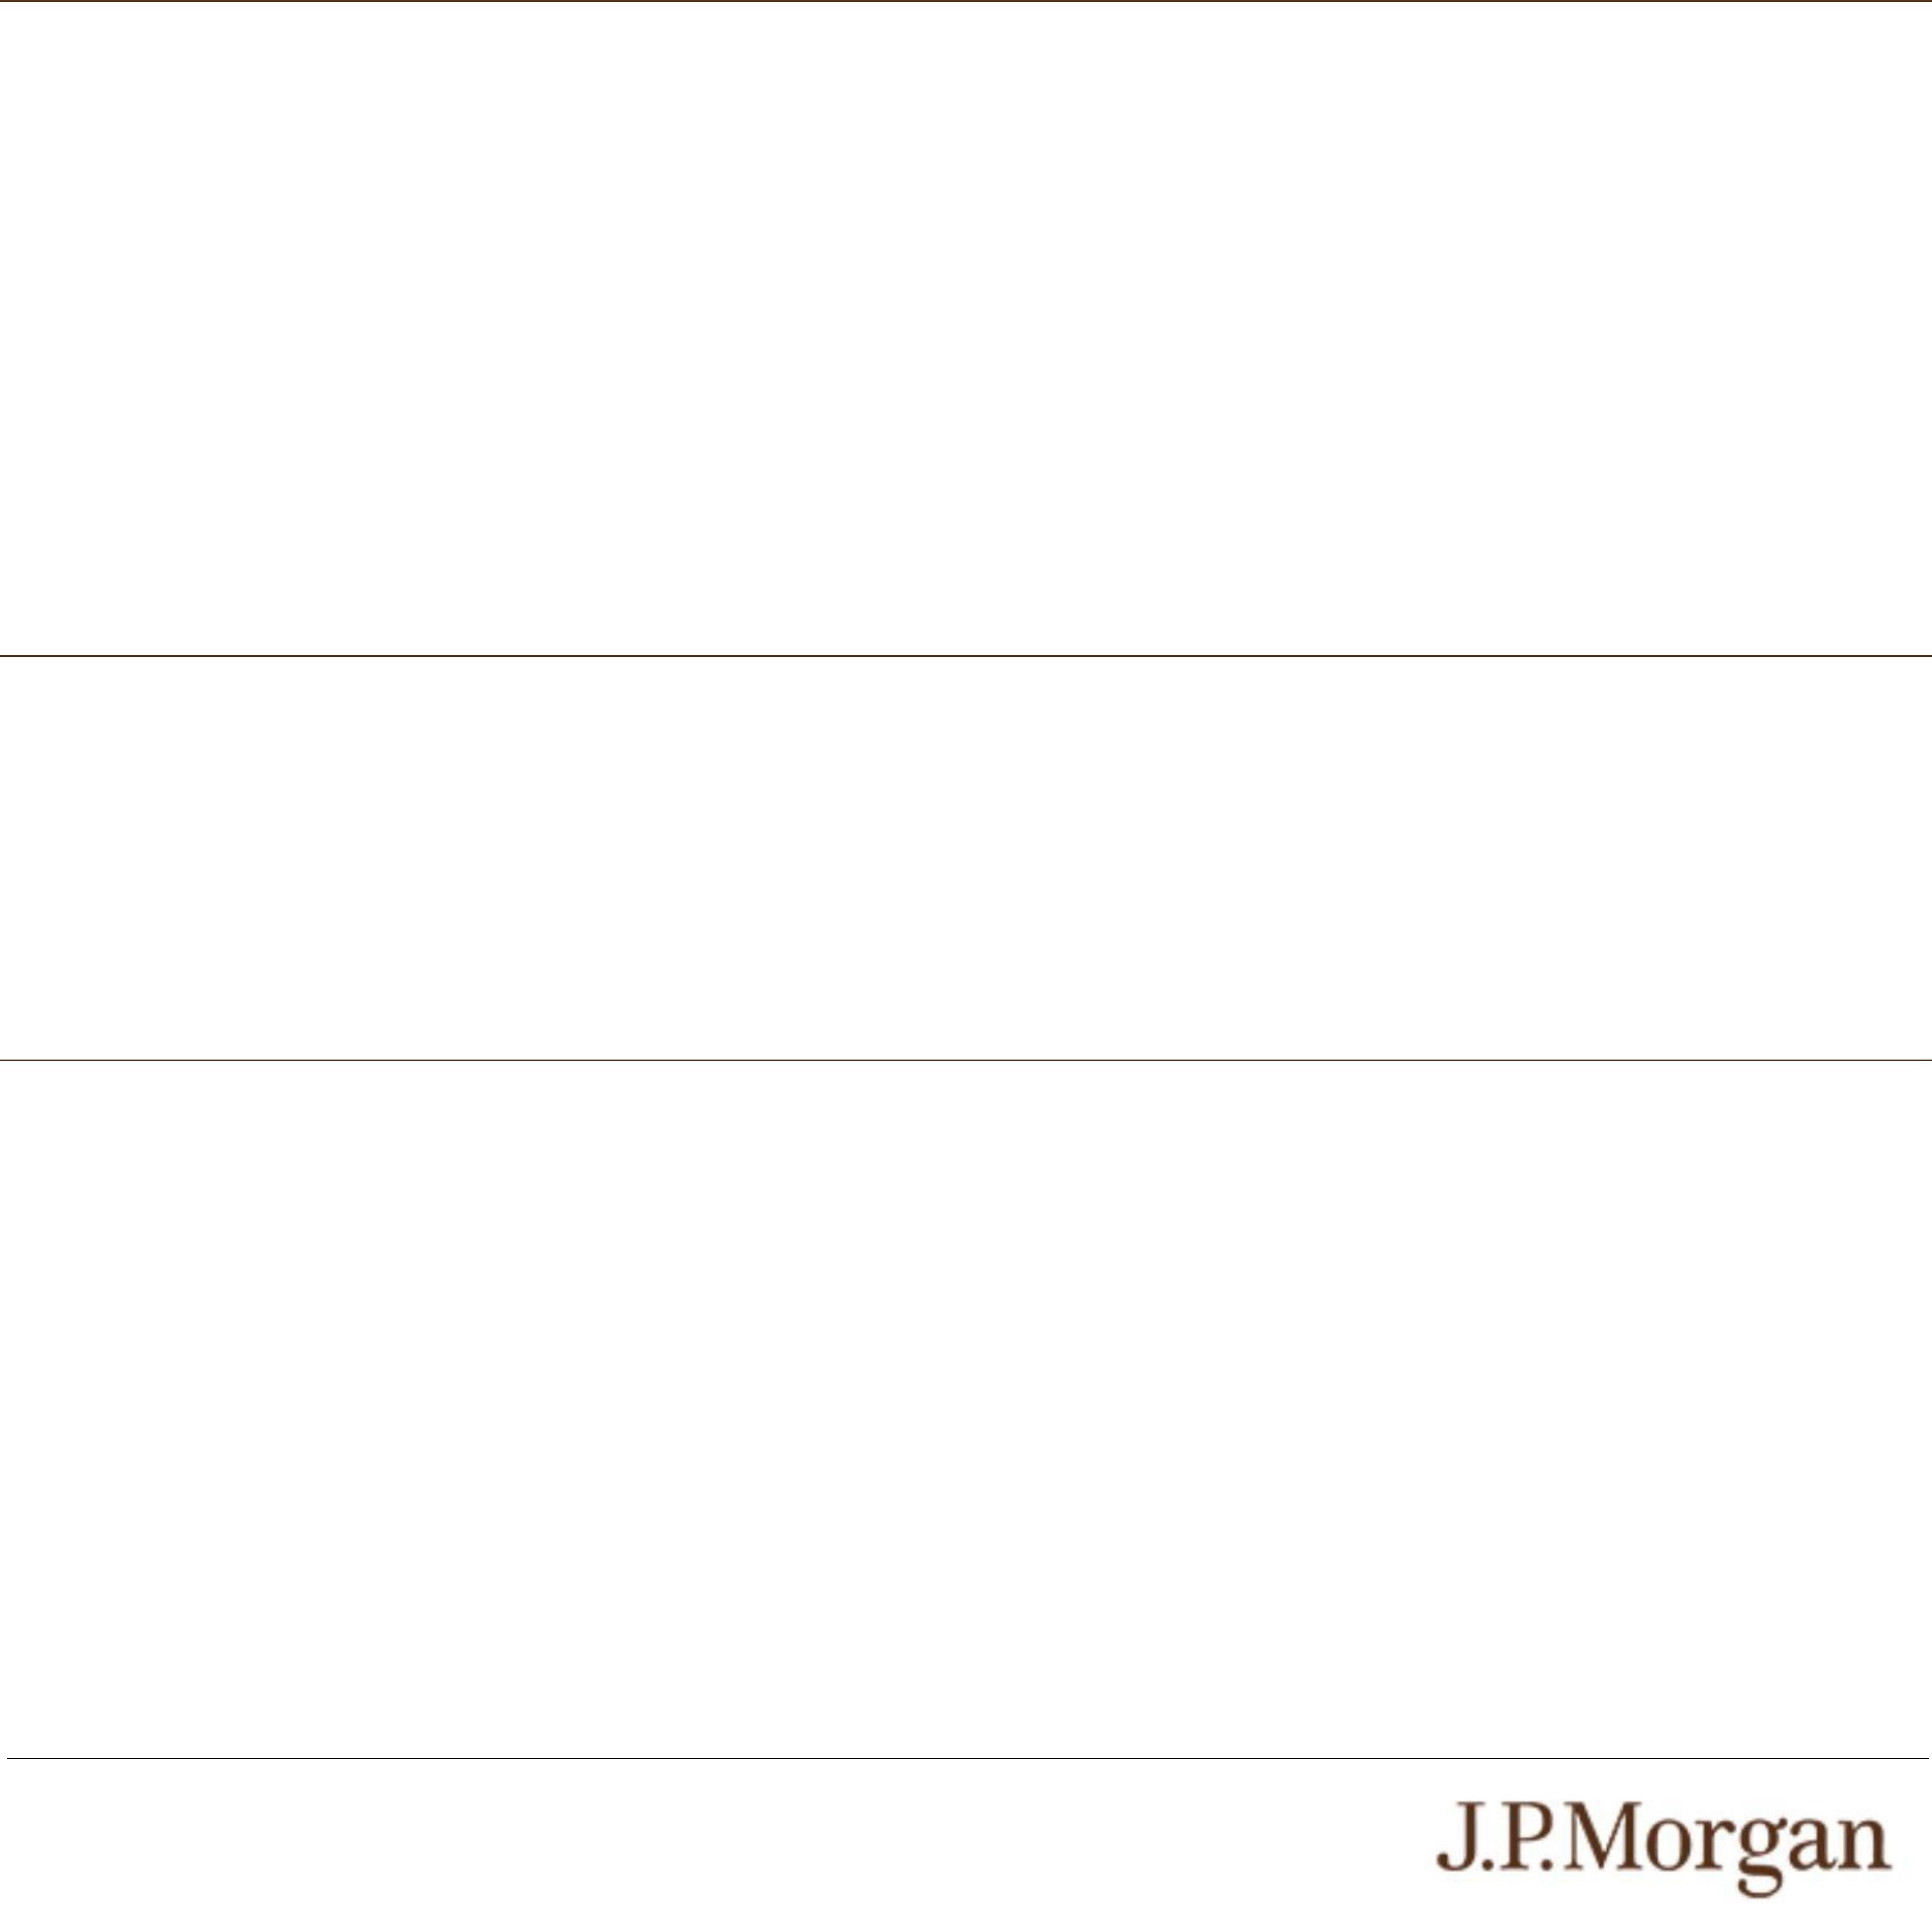
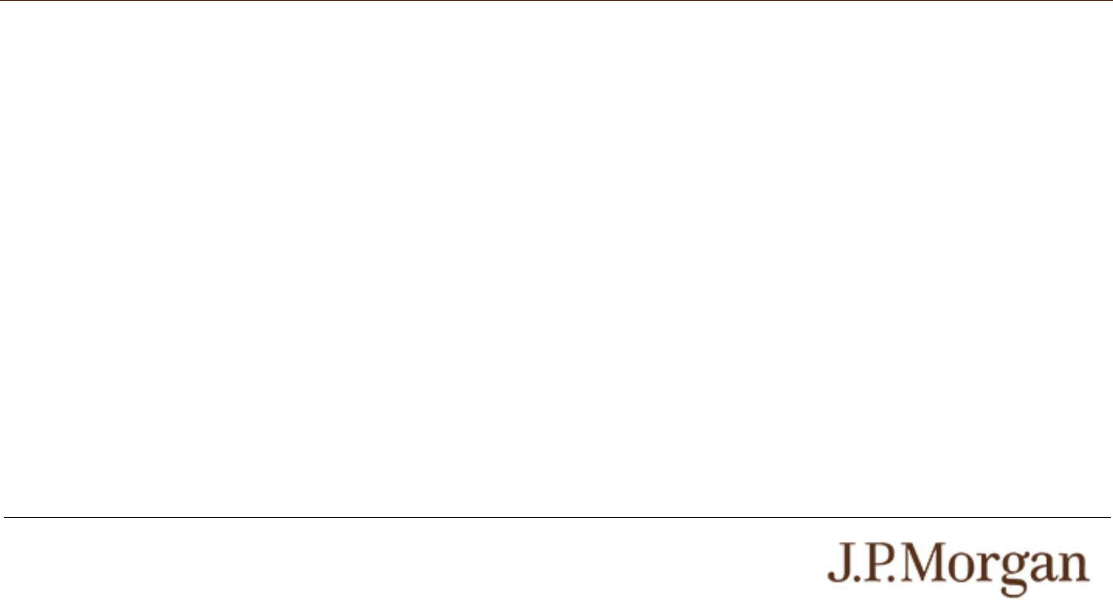
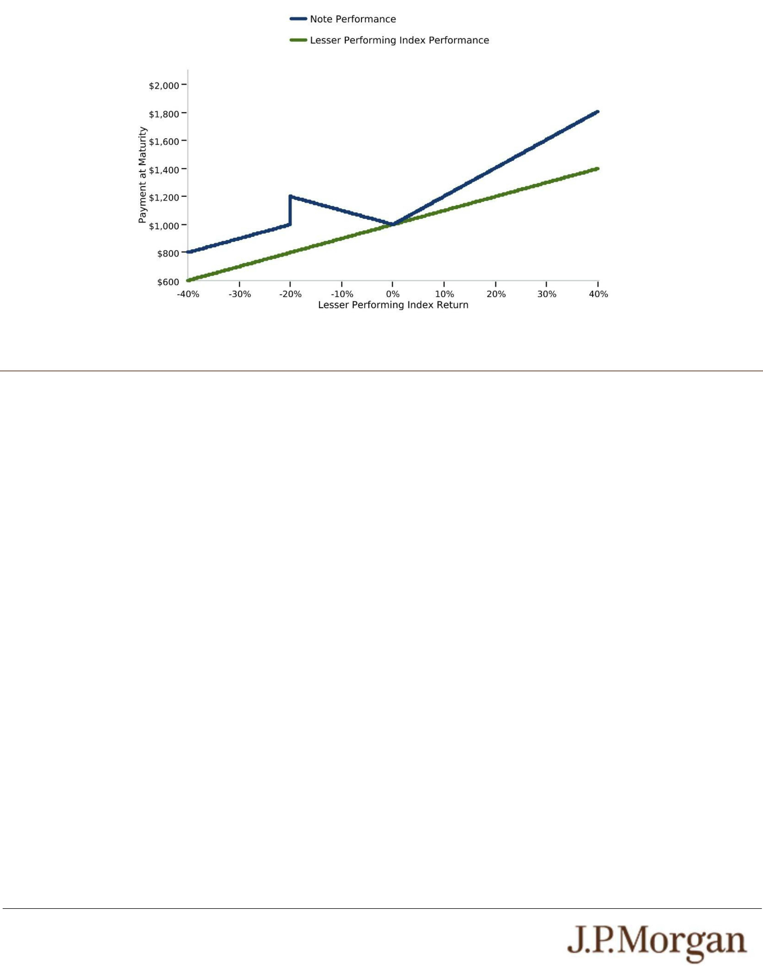
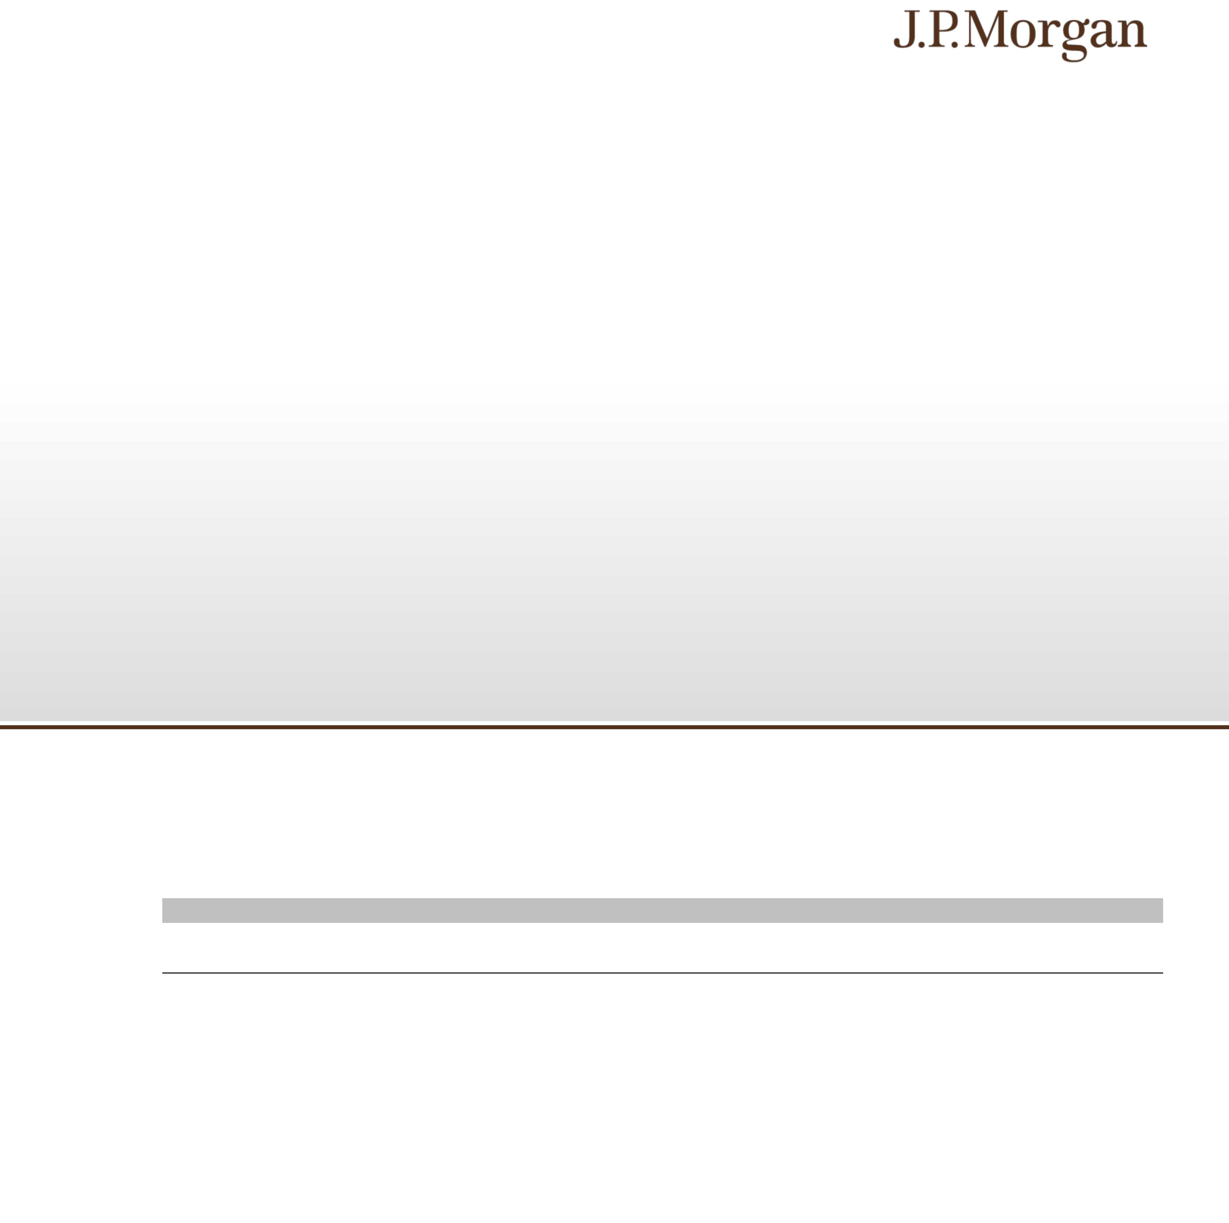

PS-10| Structured Investments
Uncapped Dual Directional Buffered Return Enhanced Notes Linked to the Lesser Performing
of the Nasdaq-100 Index® and the S&P 500® Futures Excess Return Index

You may access these documents on the SEC website at www.sec.gov as follows (or if such address has changed, by reviewing
our filings for the relevant date on the SEC website):
● Product supplement no. 3-I dated April 17, 2026:
http://www.sec.gov/Archives/edgar/data/19617/000121390026045198/ea0285802-20_424b2.pdf
● Underlying supplement no. 1-I dated April 17, 2026:
http://www.sec.gov/Archives/edgar/data/19617/000121390026045209/ea0285802-11_424b2.pdf
● Prospectus supplement and prospectus, each dated April 17, 2026:
http://www.sec.gov/Archives/edgar/data/19617/000095010326005889/crt_dp245141-424b2.pdf
Our Central Index Key, or CIK, on the SEC website is 1665650, and JPMorgan Chase & Co.’s CIK is 19617. As used in this pricing
supplement, “we,” “us” and “our” refer to JPMorgan Financial.

PS-9| Structured Investments
Uncapped Dual Directional Buffered Return Enhanced Notes Linked to the Lesser Performing
of the Nasdaq-100 Index® and the S&P 500® Futures Excess Return Index

The estimated value of the notes does not represent future values of the notes and may differ from others’ estimates. Different pricing
models and assumptions could provide valuations for the notes that are greater than or less than the estimated value of the notes. In
addition, market conditions and other relevant factors in the future may change, and any assumptions may prove to be incorrect. On
future dates, the value of the notes could change significantly based on, among other things, changes in market conditions, our or
JPMorgan Chase & Co.’s creditworthiness, interest rate movements and other relevant factors, which may impact the price, if any, at
which JPMS would be willing to buy notes from you in secondary market transactions.
The estimated value of the notes will be lower than the original issue price of the notes because costs associated with selling,
structuring and hedging the notes are included in the original issue price of the notes. These costs include the selling commissions paid
to JPMS and other affiliated or unaffiliated dealers, the projected profits, if any, that our affiliates expect to realize for assuming risks
inherent in hedging our obligations under the notes, the estimated cost of hedging our obligations under the notes and the fees, if any,
paid for third-party data analytics and/or electronic platform services. Because hedging our obligations entails risk and may be
influenced by market forces beyond our control, this hedging may result in a profit that is more or less than expected, or it may result in
a loss. A portion of the profits, if any, realized in hedging our obligations under the notes may be allowed to other affiliated or
unaffiliated dealers, and we or one or more of our affiliates will retain any remaining hedging profits. See “Selected Risk Considerations
— Risks Relating to the Estimated Value and Secondary Market Prices of the Notes — The Estimated Value of the Notes Will Be Lower
Than the Original Issue Price (Price to Public) of the Notes” in this pricing supplement.
Secondary Market Prices of the Notes
For information about factors that will impact any secondary market prices of the notes, see “Risk Factors — Risks Relating to the
Estimated Value and Secondary Market Prices of the Notes — Secondary market prices of the notes will be impacted by many
economic and market factors” in the accompanying product supplement. In addition, we generally expect that some of the costs
included in the original issue price of the notes will be partially paid back to you in connection with any repurchases of your notes by
JPMS in an amount that will decline to zero over an initial predetermined period. These costs can include selling commissions,
projected hedging profits, if any, and, in some circumstances, estimated hedging costs, our internal secondary market funding rates for
structured debt issuances and the fees paid for third-party data analytics and/or electronic platform services. This initial predetermined
time period is intended to be the shorter of six months and one-half of the stated term of the notes. The length of any such initial period
reflects the structure of the notes, whether our affiliates expect to earn a profit in connection with our hedging activities, the estimated
costs of hedging the notes and when these costs are incurred, as determined by our affiliates. See “Selected Risk Considerations —
Risks Relating to the Estimated Value and Secondary Market Prices of the Notes — The Value of the Notes as Published by JPMS
(and Which May Be Reflected on Customer Account Statements) May Be Higher Than the Then-Current Estimated Value of the Notes
for a Limited Time Period” in this pricing supplement.
Supplemental Use of Proceeds
The notes are offered to meet investor demand for products that reflect the risk-return profile and market exposure provided by the
notes. See “Hypothetical Payout Profile” and “How the Notes Work” in this pricing supplement for an illustration of the risk-return profile
of the notes and “The Indices” in this pricing supplement for a description of the market exposure provided by the notes.
The original issue price of the notes is equal to the estimated value of the notes plus the selling commissions paid to JPMS and other
affiliated or unaffiliated dealers, plus (minus) the projected profits (losses) that our affiliates expect to realize for assuming risks inherent
in hedging our obligations under the notes, plus the estimated cost of hedging our obligations under the notes and plus the fees, if any,
paid for third-party data analytics and/or electronic platform services.
Additional Terms Specific to the Notes
You may revoke your offer to purchase the notes at any time prior to the time at which we accept such offer by notifying the applicable
agent. We reserve the right to change the terms of, or reject any offer to purchase, the notes prior to their issuance. In the event of any
changes to the terms of the notes, we will notify you and you will be asked to accept such changes in connection with your purchase.
You may also choose to reject such changes, in which case we may reject your offer to purchase.
You should read this pricing supplement together with the accompanying prospectus, as supplemented by the accompanying
prospectus supplement relating to our Series A medium-term notes of which these notes are a part, and the more detailed information
contained in the accompanying product supplement and the accompanying underlying supplement. This pricing supplement, together
with the documents listed below, contains the terms of the notes and supersedes all other prior or contemporaneous oral statements as
well as any other written materials including preliminary or indicative pricing terms, correspondence, trade ideas, structures for
implementation, sample structures, fact sheets, brochures or other educational materials of ours. You should carefully consider, among
other things, the matters set forth in the “Risk Factors” sections of the accompanying prospectus supplement and the accompanying
product supplement, as the notes involve risks not associated with conventional debt securities. We urge you to consult your
investment, legal, tax, accounting and other advisers before you invest in the notes.

PS-8| Structured Investments
Uncapped Dual Directional Buffered Return Enhanced Notes Linked to the Lesser Performing
of the Nasdaq-100 Index® and the S&P 500® Futures Excess Return Index

Tax Treatment
You should review carefully the section entitled “United States Federal Taxation” in the accompanying prospectus supplement. The
following discussion, when read in combination with that section, constitutes the full opinion of our special tax counsel, Davis Polk &
Wardwell LLP, regarding the material U.S. federal income tax consequences of owning and disposing of notes.
Based on current market conditions, in the opinion of our special tax counsel it is reasonable to treat the notes as “open transactions”
that are not debt instruments for U.S. federal income tax purposes, as more fully described in “United States Federal Taxation — Tax
Consequences to U.S. Holders — Program Securities Treated as Prepaid Financial Contracts That are Open Transactions” in the
accompanying prospectus supplement. Assuming this treatment is respected, the gain or loss on your notes should be treated as long-
term capital gain or loss if you hold your notes for more than a year, whether or not you are an initial purchaser of notes at the issue
price. However, the IRS or a court may not respect this treatment, in which case the timing and character of any income or loss on the
notes could be materially and adversely affected. In addition, in 2007 Treasury and the IRS released a notice requesting comments on
the U.S. federal income tax treatment of “prepaid forward contracts” and similar instruments. The notice focuses in particular on
whether to require investors in these instruments to accrue income over the term of their investment. It also asks for comments on a
number of related topics, including the character of income or loss with respect to these instruments; the relevance of factors such as
the nature of the underlying property to which the instruments are linked; the degree, if any, to which income (including any mandated
accruals) realized by non-U.S. investors should be subject to withholding tax; and whether these instruments are or should be subject
to the “constructive ownership” regime, which very generally can operate to recharacterize certain long-term capital gain as ordinary
income and impose a notional interest charge. While the notice requests comments on appropriate transition rules and effective dates,
any Treasury regulations or other guidance promulgated after consideration of these issues could materially and adversely affect the
tax consequences of an investment in the notes, possibly with retroactive effect. You should consult your tax adviser regarding the U.S.
federal income tax consequences of an investment in the notes, including possible alternative treatments and the issues presented by
this notice.
Section 871(m) of the Code and Treasury regulations promulgated thereunder (“Section 871(m)”) generally impose a 30% withholding
tax (unless an income tax treaty applies) on dividend equivalents paid or deemed paid to Non-U.S. Holders with respect to certain
financial instruments linked to U.S. equities or indices that include U.S. equities. Section 871(m) provides certain exceptions to this
withholding regime, including for instruments linked to certain broad-based indices that meet requirements set forth in the applicable
Treasury regulations. Additionally, a recent IRS notice excludes from the scope of Section 871(m) instruments issued prior to January
1, 2027 that do not have a delta of one with respect to underlying securities that could pay U.S.-source dividends for U.S. federal
income tax purposes (each an “Underlying Security”). Based on certain determinations made by us, we expect that Section 871(m) will
not apply to the notes with regard to Non-U.S. Holders. Our determination is not binding on the IRS, and the IRS may disagree with this
determination. Section 871(m) is complex and its application may depend on your particular circumstances, including whether you enter
into other transactions with respect to an Underlying Security. If necessary, further information regarding the potential application of
Section 871(m) will be provided in the pricing supplement for the notes. You should consult your tax adviser regarding the potential
application of Section 871(m) to the notes.
The Estimated Value of the Notes
The estimated value of the notes set forth on the cover of this pricing supplement is equal to the sum of the values of the following
hypothetical components: (1) a fixed-income debt component with the same maturity as the notes, valued using the internal funding
rate described below, and (2) the derivative or derivatives underlying the economic terms of the notes. The estimated value of the notes
does not represent a minimum price at which JPMS would be willing to buy your notes in any secondary market (if any exists) at any
time. The internal funding rate used in the determination of the estimated value of the notes may differ from the market-implied funding
rate for vanilla fixed income instruments of a similar maturity issued by JPMorgan Chase & Co. or its affiliates. Any difference may be
based on, among other things, our and our affiliates’ view of the funding value of the notes as well as the higher issuance, operational
and ongoing liability management costs of the notes in comparison to those costs for the conventional fixed income instruments of
JPMorgan Chase & Co. This internal funding rate is based on certain market inputs and assumptions, which may prove to be incorrect,
and is intended to approximate the prevailing market replacement funding rate for the notes. The use of an internal funding rate and
any potential changes to that rate may have an adverse effect on the terms of the notes and any secondary market prices of the notes.
For additional information, see “Selected Risk Considerations — Risks Relating to the Estimated Value and Secondary Market Prices of
the Notes — The Estimated Value of the Notes Is Derived by Reference to an Internal Funding Rate” in this pricing supplement.
The value of the derivative or derivatives underlying the economic terms of the notes is derived from internal pricing models of our
affiliates. These models are dependent on inputs such as the traded market prices of comparable derivative instruments and on various
other inputs, some of which are market-observable, and which can include volatility, dividend rates, interest rates and other factors, as
well as assumptions about future market events and/or environments. Accordingly, the estimated value of the notes is determined when
the terms of the notes are set based on market conditions and other relevant factors and assumptions existing at that time.

PS-7| Structured Investments
Uncapped Dual Directional Buffered Return Enhanced Notes Linked to the Lesser Performing
of the Nasdaq-100 Index® and the S&P 500® Futures Excess Return Index

Historical Performance of the Nasdaq-100 Index®
Source: Bloomberg

Historical Performance of the S&P 500® Futures Excess Return Index
Source: Bloomberg

PS-6| Structured Investments
Uncapped Dual Directional Buffered Return Enhanced Notes Linked to the Lesser Performing
of the Nasdaq-100 Index® and the S&P 500® Futures Excess Return Index

● SUSPENSION OR DISRUPTIONS OF MARKET TRADING IN THE UNDERLYING FUTURES CONTRACTS MAY ADVERSELY
AFFECT THE VALUE OF YOUR NOTES —
Futures markets are subject to temporary distortions or other disruptions due to various factors, including lack of liquidity, the
participation of speculators, and government regulation and intervention. In addition, futures exchanges generally have regulations
that limit the amount of the Underlying Futures Contract price fluctuations that may occur in a single day. These limits are
generally referred to as “daily price fluctuation limits” and the maximum or minimum price of a contract on any given day as a result
of those limits is referred to as a “limit price.” Once the limit price has been reached in a particular contract, no trades may be
made at a price beyond the limit, or trading may be limited for a set period of time. Limit prices have the effect of precluding trading
in a particular contract or forcing the liquidation of contracts at potentially disadvantageous times or prices. These circumstances
could delay the calculation of the level of the Index and could adversely affect the level of the Index and any payments on, and the
value of, your notes.
● THE PERFORMANCE OF THE INDEX WILL DIFFER FROM THE PERFORMANCE OF THE INDEX UNDERLYING THE
UNDERLYING FUTURES CONTRACTS —
A variety of factors can lead to a disparity between the performance of a futures contract on an equity index and the performance
of that equity index, including the expected dividend yields of the equity securities included in that equity index, an implicit financing
cost associated with futures contracts and policies of the exchange on which the futures contracts are traded, such as margin
requirements. Thus, a decline in expected dividends yields or an increase in margin requirements may adversely affect the
performance of the Index. In addition, the implicit financing cost will negatively affect the performance of the Index, with a greater
negative effect when market interest rates are higher. During periods of high market interest rates, the Index is likely to
underperform the equity index underlying the Underlying Futures Contracts, perhaps significantly.
● NEGATIVE ROLL RETURNS ASSOCIATED WITH THE UNDERLYING FUTURES CONTRACTS MAY ADVERSELY AFFECT
THE LEVEL OF THE INDEX AND THE VALUE OF THE NOTES —
The Index tracks the excess return of the Underlying Futures Contracts. Unlike common equity securities, futures contracts, by
their terms, have stated expirations. As the exchange-traded Underlying Futures Contracts approach expiration, they are replaced
by contracts of the same series that have a later expiration. For example, an Underlying Futures Contract notionally purchased
and held in June may specify a September expiration date. As time passes, the contract expiring in September is replaced by a
contract for delivery in December. This is accomplished by notionally selling the September contract and notionally purchasing the
December contract. This process is referred to as “rolling.” Excluding other considerations, if prices are higher in the distant
delivery months than in the nearer delivery months, the notional purchase of the December contract would take place at a price
that is higher than the price of the September contract, thereby creating a negative “roll return.” Negative roll returns adversely
affect the returns of the Underlying Futures Contracts and, therefore, the level of the Index and any payments on, and the value of,
the notes. Because of the potential effects of negative roll returns, it is possible for the level of the Index to decrease significantly
over time, even when the levels of the underlying index referenced by the Underlying Futures Contracts are stable or increasing.
● NON-U.S. SECURITIES RISK WITH RESPECT TO THE NASDAQ-100 INDEX® —
The non-U.S. equity securities included in the Nasdaq-100 Index® have been issued by non-U.S. companies. Investments in
securities linked to the value of such non-U.S. equity securities involve risks associated with the home countries and/or the
securities markets in the home countries of the issuers of those non-U.S. equity securities. Also, with respect to equity securities
that are not listed in the U.S., there is generally less publicly available information about companies in some of these jurisdictions
than there is about U.S. companies that are subject to the reporting requirements of the SEC.
● OTHER KEY RISK:
o THE INDEX COMPRISES NOTIONAL ASSETS AND LIABILITIES. THERE IS NO ACTUAL PORTFOLIO OF ASSETS TO
WHICH ANY PERSON IS ENTITLED OR IN WHICH ANY PERSON HAS ANY OWNERSHIP INTEREST.
The Indices
The Nasdaq-100 Index® is a modified market capitalization-weighted index that is designed to measure the performance of 100 of the
largest non-financial companies listed on The Nasdaq Stock Market. For additional information about the Nasdaq-100 Index®, see
“Equity Index Descriptions — The Nasdaq-100 Index®” in the accompanying underlying supplement.
The S&P 500® Futures Excess Return Index measures the performance of a rolling position in the nearest maturing quarterly E-mini®
S&P 500® futures contracts (Symbol: ES) (the “Underlying Futures Contracts”) trading on the Chicago Mercantile Exchange. E-mini®
S&P 500® futures contracts are U.S. dollar-denominated futures contracts based on the S&P 500® Index. The S&P 500® Index consists
of stocks of 500 companies selected to provide a performance benchmark for the large market capitalization segment of the U.S. equity
markets. For additional information about the S&P 500® Futures Excess Return Index, see “Equity Futures Index Descriptions — The
S&P® 500 Futures Excess Return Index” in the accompanying underlying supplement.
Historical Information
The following graphs set forth the historical performance of each Index based on the weekly historical closing levels from January 8,
2021 through May 29, 2026. The closing level of the Nasdaq-100 Index® on June 4, 2026 was 30,407.81. The closing level of the S&P
500® Futures Excess Return Index on June 4, 2026 was 610.04. We obtained the closing levels above and below from the Bloomberg
Professional® service (“Bloomberg”), without independent verification.
The historical closing levels of each Index should not be taken as an indication of future performance, and no assurance can be given
as to the closing level of either Index on the Pricing Date or the Observation Date. There can be no assurance that the performance of
the Indices will result in the return of any of your principal amount in excess of $200.00 per $1,000.00 principal amount note, subject to
the credit risks of JPMorgan Financial and JPMorgan Chase & Co.

PS-5| Structured Investments
Uncapped Dual Directional Buffered Return Enhanced Notes Linked to the Lesser Performing
of the Nasdaq-100 Index® and the S&P 500® Futures Excess Return Index

Risks Relating to the Estimated Value and Secondary Market Prices of the Notes
● THE ESTIMATED VALUE OF THE NOTES WILL BE LOWER THAN THE ORIGINAL ISSUE PRICE (PRICE TO PUBLIC) OF
THE NOTES —
The estimated value of the notes is only an estimate determined by reference to several factors. The original issue price of the
notes will exceed the estimated value of the notes because costs associated with selling, structuring and hedging the notes are
included in the original issue price of the notes. These costs include the selling commissions, the projected profits, if any, that our
affiliates expect to realize for assuming risks inherent in hedging our obligations under the notes, the estimated cost of hedging our
obligations under the notes and the fees, if any, paid for third-party data analytics and/or electronic platform services. See “The
Estimated Value of the Notes” in this pricing supplement.
● THE ESTIMATED VALUE OF THE NOTES DOES NOT REPRESENT FUTURE VALUES OF THE NOTES AND MAY DIFFER
FROM OTHERS’ ESTIMATES —
See “The Estimated Value of the Notes” in this pricing supplement.
● THE ESTIMATED VALUE OF THE NOTES IS DERIVED BY REFERENCE TO AN INTERNAL FUNDING RATE —
The internal funding rate used in the determination of the estimated value of the notes may differ from the market-implied funding
rate for vanilla fixed income instruments of a similar maturity issued by JPMorgan Chase & Co. or its affiliates. Any difference may
be based on, among other things, our and our affiliates’ view of the funding value of the notes as well as the higher issuance,
operational and ongoing liability management costs of the notes in comparison to those costs for the conventional fixed income
instruments of JPMorgan Chase & Co. This internal funding rate is based on certain market inputs and assumptions, which may
prove to be incorrect, and is intended to approximate the prevailing market replacement funding rate for the notes. The use of an
internal funding rate and any potential changes to that rate may have an adverse effect on the terms of the notes and any
secondary market prices of the notes. See “The Estimated Value of the Notes” in this pricing supplement.
● THE VALUE OF THE NOTES AS PUBLISHED BY JPMS (AND WHICH MAY BE REFLECTED ON CUSTOMER ACCOUNT
STATEMENTS) MAY BE HIGHER THAN THE THEN-CURRENT ESTIMATED VALUE OF THE NOTES FOR A LIMITED TIME
PERIOD —
We generally expect that some of the costs included in the original issue price of the notes will be partially paid back to you in
connection with any repurchases of your notes by JPMS in an amount that will decline to zero over an initial predetermined period.
See “Secondary Market Prices of the Notes” in this pricing supplement for additional information relating to this initial period.
Accordingly, the estimated value of your notes during this initial period may be lower than the value of the notes as published by
JPMS (and which may be shown on your customer account statements).
● SECONDARY MARKET PRICES OF THE NOTES WILL LIKELY BE LOWER THAN THE ORIGINAL ISSUE PRICE OF THE
NOTES —
Any secondary market prices of the notes will likely be lower than the original issue price of the notes because, among other
things, secondary market prices take into account our internal secondary market funding rates for structured debt issuances and,
also, because secondary market prices may exclude selling commissions, projected hedging profits, if any, and estimated hedging
costs and fees, if any, paid for third-party data analytics and/or electronic platform services that are included in the original issue
price of the notes. As a result, the price, if any, at which JPMS will be willing to buy the notes from you in secondary market
transactions, if at all, is likely to be lower than the original issue price. Furthermore, if you sell your notes, you will likely be charged
a commission for secondary market transactions, or the price will likely reflect a dealer discount and/or fees for use of an electronic
platform to facilitate secondary market activity. Any sale by you prior to the Maturity Date could result in a substantial loss to you.
● SECONDARY MARKET PRICES OF THE NOTES WILL BE IMPACTED BY MANY ECONOMIC AND MARKET FACTORS —
The secondary market price of the notes during their term will be impacted by a number of economic and market factors, which
may either offset or magnify each other, aside from the selling commissions, projected hedging profits, if any, estimated hedging
costs and the levels of the Indices. Additionally, independent pricing vendors and/or third party broker-dealers may publish a price
for the notes, which may also be reflected on customer account statements. This price may be different (higher or lower) than the
price of the notes, if any, at which JPMS may be willing to purchase your notes in the secondary market. See “Risk Factors —
Risks Relating to the Estimated Value and Secondary Market Prices of the Notes — Secondary market prices of the notes will be
impacted by many economic and market factors” in the accompanying product supplement.
Risks Relating to the Indices
● JPMORGAN CHASE & CO. IS CURRENTLY ONE OF THE COMPANIES THAT MAKE UP THE S&P 500® INDEX, THE INDEX
UNDERLYING THE UNDERLYING FUTURES CONTRACTS OF THE INDEX,
but JPMorgan Chase & Co. will not have any obligation to consider your interests in taking any corporate action that might affect
the level of the Index.
● THE INDEX IS SUBJECT TO SIGNIFICANT RISKS ASSOCIATED WITH THE UNDERLYING FUTURES CONTRACTS —
The Index tracks the excess return of the Underlying Futures Contracts. The price of an Underlying Futures Contract depends not
only on the level of the underlying index referenced by the Underlying Futures Contract, but also on a range of other factors,
including but not limited to the performance and volatility of the U.S. stock market, corporate earnings reports, geopolitical events,
governmental and regulatory policies and the policies of the Chicago Mercantile Exchange (the “Exchange”) on which the
Underlying Futures Contracts trade. In addition, the futures markets are subject to temporary distortions or other disruptions due to
various factors, including the lack of liquidity in the markets, the participation of speculators and government regulation and
intervention. These factors and others can cause the prices of the Underlying Futures Contracts to be volatile and could adversely
affect the level of the Index and any payments on, and the value of, your notes.

PS-4| Structured Investments
Uncapped Dual Directional Buffered Return Enhanced Notes Linked to the Lesser Performing
of the Nasdaq-100 Index® and the S&P 500® Futures Excess Return Index

Selected Risk Considerations
An investment in the notes involves significant risks. These risks are explained in more detail in the “Risk Factors” sections of the
accompanying prospectus supplement and product supplement.
Risks Relating to the Notes Generally
● YOUR INVESTMENT IN THE NOTES MAY RESULT IN A LOSS —
The notes do not guarantee any return of principal. If the Final Value of either Index is less than its Initial Value by more than
20.00%, you will lose 1% of the principal amount of your notes for every 1% that the Final Value of the Lesser Performing Index is
less than its Initial Value by more than 20.00%. Accordingly, under these circumstances, you will lose up to 80.00% of your
principal amount at maturity.
● YOUR MAXIMUM GAIN ON THE NOTES IS LIMITED BY THE BUFFER AMOUNT IF THE LESSER PERFORMING INDEX
RETURN IS NEGATIVE —
Because the payment at maturity will not reflect the Absolute Index Return of the Lesser Performing Index if its Final Value is less
than its Initial Value by more than the Buffer Amount, the Buffer Amount is effectively a cap on your return at maturity if the Lesser
Performing Index Return is negative. The maximum payment at maturity if the Lesser Performing Index Return is negative is
$1,200.00 per $1,000 principal amount note.
● CREDIT RISKS OF JPMORGAN FINANCIAL AND JPMORGAN CHASE & CO. —
Investors are dependent on our and JPMorgan Chase & Co.’s ability to pay all amounts due on the notes. Any actual or potential
change in our or JPMorgan Chase & Co.’s creditworthiness or credit spreads, as determined by the market for taking that credit
risk, is likely to adversely affect the value of the notes. If we and JPMorgan Chase & Co. were to default on our payment
obligations, you may not receive any amounts owed to you under the notes and you could lose your entire investment.
● AS A FINANCE SUBSIDIARY, JPMORGAN FINANCIAL HAS NO INDEPENDENT ACTIVITIES AND HAS LIMITED ASSETS —
As a finance subsidiary of JPMorgan Chase & Co., we have no independent activities beyond the issuance and administration of
our securities and the collection of intercompany obligations. Aside from the initial capital contribution from JPMorgan Chase & Co.,
substantially all of our assets relate to obligations of JPMorgan Chase & Co. to make payments under loans made by us to
JPMorgan Chase & Co. or under other intercompany agreements. As a result, we are dependent upon payments from JPMorgan
Chase & Co. to meet our obligations under the notes. We are not an operating subsidiary of JPMorgan Chase & Co. and in a
bankruptcy or resolution of JPMorgan Chase & Co. we are not expected to have sufficient resources to meet our obligations in
respect of the notes as they come due. If JPMorgan Chase & Co. does not make payments to us and we are unable to make
payments on the notes, you may have to seek payment under the related guarantee by JPMorgan Chase & Co., and that
guarantee will rank pari passu with all other unsecured and unsubordinated obligations of JPMorgan Chase & Co. For more
information, see “Risk Factors — Holders of securities issued by JPMorgan Financial may be subject to losses if JPMorgan Chase
& Co. were to enter into a resolution” in the accompanying prospectus supplement.
● YOU ARE EXPOSED TO THE RISK OF DECLINE IN THE LEVEL OF EACH INDEX —
Payments on the notes are not linked to a basket composed of the Indices and are contingent upon the performance of each
individual Index. Poor performance by either of the Indices over the term of the notes may negatively affect your payment at
maturity and will not be offset or mitigated by positive performance by the other Index.
● YOUR PAYMENT AT MATURITY WILL BE DETERMINED BY THE LESSER PERFORMING INDEX.
● THE NOTES DO NOT PAY INTEREST.
● YOU WILL NOT HAVE ANY RIGHTS WITH RESPECT TO THE E-MINI® S&P 500® FUTURES CONTRACTS (THE
“UNDERLYING FUTURES CONTRACTS”) OR THE SECURITIES INCLUDED IN THE INDEX UNDERLYING THE
UNDERLYING FUTURES CONTRACTS.
● LACK OF LIQUIDITY—
The notes will not be listed on any securities exchange. Accordingly, the price at which you may be able to trade your notes is likely
to depend on the price, if any, at which JPMS is willing to buy the notes. You may not be able to sell your notes. The notes are not
designed to be short-term trading instruments. Accordingly, you should be able and willing to hold your notes to maturity.
● THE FINAL TERMS AND VALUATION OF THE NOTES WILL BE PROVIDED IN THE PRICING SUPPLEMENT —
You should consider your potential investment in the notes based on the minimums for the estimated value of the notes and the
Upside Leverage Factor.
Risks Relating to Conflicts of Interest
● POTENTIAL CONFLICTS —
We and our affiliates play a variety of roles in connection with the notes. In performing these duties, our and JPMorgan Chase &
Co.’s economic interests are potentially adverse to your interests as an investor in the notes. It is possible that hedging or trading
activities of ours or our affiliates in connection with the notes could result in substantial returns for us or our affiliates while the
value of the notes declines. Please refer to “Risk Factors — Risks Relating to Conflicts of Interest” in the accompanying product
supplement.

PS-3| Structured Investments
Uncapped Dual Directional Buffered Return Enhanced Notes Linked to the Lesser Performing
of the Nasdaq-100 Index® and the S&P 500® Futures Excess Return Index

The following graph demonstrates the hypothetical payments at maturity on the notes for a range of Lesser Performing Index Returns (-
40% to 40%). There can be no assurance that the performance of the Lesser Performing Index will result in the return of any of your
principal amount in excess of $200.00 per $1,000.00 principal amount note, subject to the credit risks of JPMorgan Financial and
JPMorgan Chase & Co.
How the Notes Work
Index Appreciation Upside Scenario:
If the Final Value of each Index is greater than its Initial Value, investors will receive at maturity the $1,000 principal amount plus a
return equal to the Lesser Performing Index Return times the Upside Leverage Factor of at least 2.022.
● Assuming a hypothetical Upside Leverage Factor of 2.022, if the closing level of the Lesser Performing Index increases 5.00%,
investors will receive at maturity a return of 10.11%, or $1,101.10 per $1,000 principal amount note.
Index Par or Index Depreciation Upside Scenario:
If (i) the Final Value of one Index is greater than its Initial Value and the Final Value of the other Index is equal to its Initial Value or is
less than its Initial Value by up to the Buffer Amount of 20.00% or (ii) the Final Value of each Index is equal to its Initial Value or is less
than its Initial Value by up to the Buffer Amount of 20.00%, investors will receive at maturity the $1,000 principal amount plus a return
equal to the Absolute Index Return of the Lesser Performing Index.
● For example, if the closing level of the Lesser Performing Index declines 10.00%, investors will receive at maturity a return of
10.00%, or $1,100.00 per $1,000 principal amount note.
Downside Scenario:
If the Final Value of either Index is less than its Initial Value by more than the Buffer Amount of 20.00%, investors will lose 1% of the
principal amount of their notes for every 1% that the Final Value of the Lesser Performing Index is less than its Initial Value by more
than the Buffer Amount.
● For example, if the closing level of the Lesser Performing Index declines 60.00%, investors will lose 40.00% of their principal
amount and receive only $600.00 per $1,000 principal amount note at maturity.
The hypothetical returns and hypothetical payments on the notes shown above apply only if you hold the notes for their entire term.
These hypotheticals do not reflect the fees or expenses that would be associated with any sale in the secondary market. If these fees
and expenses were included, the hypothetical returns and hypothetical payments shown above would likely be lower.
80.00
50.00
$800.00
-20.000%
N/A
-40.00%
60.00
$900.00
-10.000%
N/A
-30.00%
70.00
$1,200.00
20.000%
20.00%
-20.00%
-50.00%
$1,150.00
15.000%
15.00%
-15.00%
85.00
$1,100.00
10.000%
10.00%
-10.00%
90.00
$1,050.00
5.000%
5.00%
-5.00%
-80.00%

$200.00
-80.000%
N/A
-100.00%
0.00
$300.00
-70.000%
N/A
-90.00%
10.00
$400.00
-60.000%
N/A
95.00
20.00
$500.00
-50.000%
N/A
-70.00%
30.00
$600.00
-40.000%
N/A
-60.00%
40.00
$700.00
-30.000%
N/A
165.00
$1,808.80
80.880%
N/A
40.00%
140.00
$2,011.00
101.100%
N/A
50.00%
150.00
$2,314.30
131.430%
N/A
65.00%
130.00
$2,617.60
161.760%
N/A
80.00%
180.00
Payment at Maturity
Total Return on the
Notes
Absolute Index Return
of the Lesser
Performing Index
Lesser
Performing
Index Return
Final Value of
the Lesser
Performing
Index
Supplemental Terms of the Notes
The notes are not futures contracts or swaps and are not regulated under the Commodity Exchange Act, as amended (the
“Commodity Exchange Act”). The notes are offered pursuant to an exemption from regulation under the Commodity Exchange Act,
commonly known as the hybrid instrument exemption, that is available to securities that have one or more payments indexed to the
value, level or rate of one or more commodities, as set out in section 2(f) of that statute. Accordingly, you are not afforded any
protection provided by the Commodity Exchange Act or any regulation promulgated by the Commodity Futures Trading Commission.
Hypothetical Payout Profile
The following table and graph illustrate the hypothetical total return and payment at maturity on the notes linked to two hypothetical
Indices. The “total return” as used in this pricing supplement is the number, expressed as a percentage, that results from comparing the
payment at maturity per $1,000 principal amount note to $1,000. The hypothetical total returns and payments set forth below assume
the following:
● an Initial Value for the Lesser Performing Index of 100.00;
● an Upside Leverage Factor of 2.022; and
● a Buffer Amount of 20.00%.
The hypothetical Initial Value of the Lesser Performing Index of 100.00 has been chosen for illustrative purposes only and may not
represent a likely actual Initial Value of either Index. The actual Initial Value of each Index will be the closing level of that Index on the
Pricing Date and will be provided in the pricing supplement. For historical data regarding the actual closing levels of each Index, please
see the historical information set forth under “The Indices” in this pricing supplement.
Each hypothetical total return or hypothetical payment at maturity set forth below is for illustrative purposes only and may not be the
actual total return or payment at maturity applicable to a purchaser of the notes. The numbers appearing in the following table and
graph have been rounded for ease of analysis.

PS-2| Structured Investments
Uncapped Dual Directional Buffered Return Enhanced Notes Linked to the Lesser Performing
of the Nasdaq-100 Index® and the S&P 500® Futures Excess Return Index

105.00
$1,000.00
0.000%
0.00%
0.00%
100.00
$1,020.22
2.022%
N/A
1.00%
101.00
$1,101.10
10.110%
N/A
5.00%
$1,202.20
20.220%
N/A
10.00%
110.00
$1,404.40
40.440%
N/A
20.00%
120.00
$1,606.60
60.660%
N/A
30.00%

PS-1| Structured Investments
Uncapped Dual Directional Buffered Return Enhanced Notes Linked to the Lesser Performing
of the Nasdaq-100 Index® and the S&P 500® Futures Excess Return Index

Key Terms
Issuer: JPMorgan Chase Financial Company LLC, a direct,
wholly owned finance subsidiary of JPMorgan Chase & Co.
Guarantor: JPMorgan Chase & Co.
Indices: The Nasdaq-100 Index® (Bloomberg ticker: NDX)
and the S&P 500® Futures Excess Return Index (Bloomberg
ticker: SPXFP) (each an “Index” and collectively, the
“Indices”)
Upside Leverage Factor: At least 2.022 (to be provided in
the pricing supplement)
Buffer Amount: 20.00%
Pricing Date: On or about June 18, 2026
Original Issue Date (Settlement Date): On or about June
24, 2026
Observation Date*: June 18, 2031
Maturity Date*: June 24, 2031
* Subject to postponement in the event of a market
disruption event as described under “General Terms of
Notes — Postponement of a Determination Date — Notes
Linked to Multiple Underlyings” and “General Terms of
Notes — Postponement of a Payment Date” in the
accompanying product supplement

Payment at Maturity:
If the Final Value of each Index is greater than its Initial
Value, your payment at maturity per $1,000 principal
amount note will be calculated as follows:
$1,000 + ($1,000 × Lesser Performing Index Return ×
Upside Leverage Factor)
If (i) the Final Value of one Index is greater than its Initial
Value and the Final Value of the other Index is equal to its
Initial Value or is less than its Initial Value by up to the
Buffer Amount or (ii) the Final Value of each Index is equal
to its Initial Value or is less than its Initial Value by up to the
Buffer Amount, your payment at maturity per $1,000
principal amount note will be calculated as follows:
$1,000 + ($1,000 × Absolute Index Return of the Lesser
Performing Index)
This payout formula results in an effective cap of 20.00% on
your return at maturity if the Lesser Performing Index
Return is negative. Under these limited circumstances,
your maximum payment at maturity is $1,200.00 per $1,000
principal amount note.
If the Final Value of either Index is less than its Initial Value
by more than the Buffer Amount, your payment at maturity
per $1,000 principal amount note will be calculated as
follows:
$1,000 + [$1,000 × (Lesser Performing Index Return +
Buffer Amount)]
If the Final Value of either Index is less than its Initial Value
by more than the Buffer Amount, you will lose some or most
of your principal amount at maturity.
Absolute Index Return: With respect to each Index, the
absolute value of its Index Return. For example, if the Index
Return of an Index is -5%, its Absolute Index Return will
equal 5%.
Lesser Performing Index: The Index with the Lesser
Performing Index Return
Lesser Performing Index Return: The lower of the Index
Returns of the Indices
Index Return: With respect to each Index,
(Final Value – Initial Value)
Initial Value
Initial Value: With respect to each Index, the closing level
of that Index on the Pricing Date
Final Value: With respect to each Index, the closing level of
that Index on the Observation Date

Per note
If the notes priced today, the estimated value of the notes would be approximately $969.00 per $1,000 principal amount
note. The estimated value of the notes, when the terms of the notes are set, will be provided in the pricing supplement and
will not be less than $900.00 per $1,000 principal amount note. See “The Estimated Value of the Notes” in this pricing
supplement for additional information.
The notes are not bank deposits, are not insured by the Federal Deposit Insurance Corporation or any other governmental agency
and are not obligations of, or guaranteed by, a bank.
(1) See “Supplemental Use of Proceeds” in this pricing supplement for information about the components of the price to public of the notes.
(2) J.P. Morgan Securities LLC, which we refer to as JPMS, acting as agent for JPMorgan Financial, will pay all of the selling commissions it
receives from us to other affiliated or unaffiliated dealers. In no event will these selling commissions exceed $11.25 per $1,000 principal
amount note. See “Plan of Distribution (Conflicts of Interest)” in the accompanying product supplement.
$
$
$
Total
$
$
$1,000
Proceeds to Issuer
Fees and Commissions (2)
Price to Public (1)

Pricing supplement to product supplement no. 3-I dated April 17, 2026, underlying supplement no. 1-I dated April 17, 2026, the prospectus and
prospectus supplement, each dated April 17, 2026
JPMorgan Chase Financial Company LLC
Structured Investments
Uncapped Dual Directional Buffered Return Enhanced
Notes Linked to the Lesser Performing of the Nasdaq-
100 Index® and the S&P 500® Futures Excess Return
Index due June 24, 2031
Fully and Unconditionally Guaranteed by JPMorgan Chase & Co.
● The notes are designed for investors who seek an uncapped return of at least 2.022 times any appreciation, or a capped,
unleveraged return equal to the absolute value of any depreciation (up to the Buffer Amount of 20.00%), of the lesser
performing of the Nasdaq-100 Index® and the S&P 500® Futures Excess Return Index, which we refer to as the Indices, at
maturity.
● Investors should be willing to forgo interest payments and be willing to lose up to 80.00% of their principal amount at
maturity.
● The notes are unsecured and unsubordinated obligations of JPMorgan Chase Financial Company LLC, which we refer to as
JPMorgan Financial, the payment on which is fully and unconditionally guaranteed by JPMorgan Chase & Co. Any
payment on the notes is subject to the credit risk of JPMorgan Financial, as issuer of the notes, and the credit risk
of JPMorgan Chase & Co., as guarantor of the notes.
● Payments on the notes are not linked to a basket composed of the Indices. Payments on the notes are linked to the
performance of each of the Indices individually, as described below.
● Minimum denominations of $1,000 and integral multiples thereof
● The notes are expected to price on or about June 18, 2026 and are expected to settle on or about June 24, 2026.
● CUSIP: 46661AUH1
Investing in the notes involves a number of risks. See “Risk Factors” beginning on page S-2 of the accompanying
prospectus supplement, “Risk Factors” beginning on page PS-12 of the accompanying product supplement and “Selected
Risk Considerations” beginning on page PS-4 of this pricing supplement.
Neither the Securities and Exchange Commission (the “SEC”) nor any state securities commission has approved or disapproved of
the notes or passed upon the accuracy or the adequacy of this pricing supplement or the accompanying product supplement,
underlying supplement, prospectus supplement and prospectus. Any representation to the contrary is a criminal offense.
Registration Statement Nos. 333-293684 and 333-293684-01; Rule 424(b)(2)
June , 2026
The information in this preliminary pricing supplement is not complete and may be changed. This preliminary pricing supplement is not an
offer to sell nor does it seek an offer to buy these securities in any jurisdiction where the offer or sale is not permitted.
Subject to completion dated June 5, 2026

