The information in this preliminary pricing supplement is not complete and may be changed. This preliminary pricing supplement is not

an offer to sell nor does it seek an offer to buy these securities in any jurisdiction where the offer or sale is not permitted.

Subject to completion dated October 12, 2026

October , 2026 Registration Statement Nos. 333-293684 and 333-293684-01; Rule 424(b)(2)
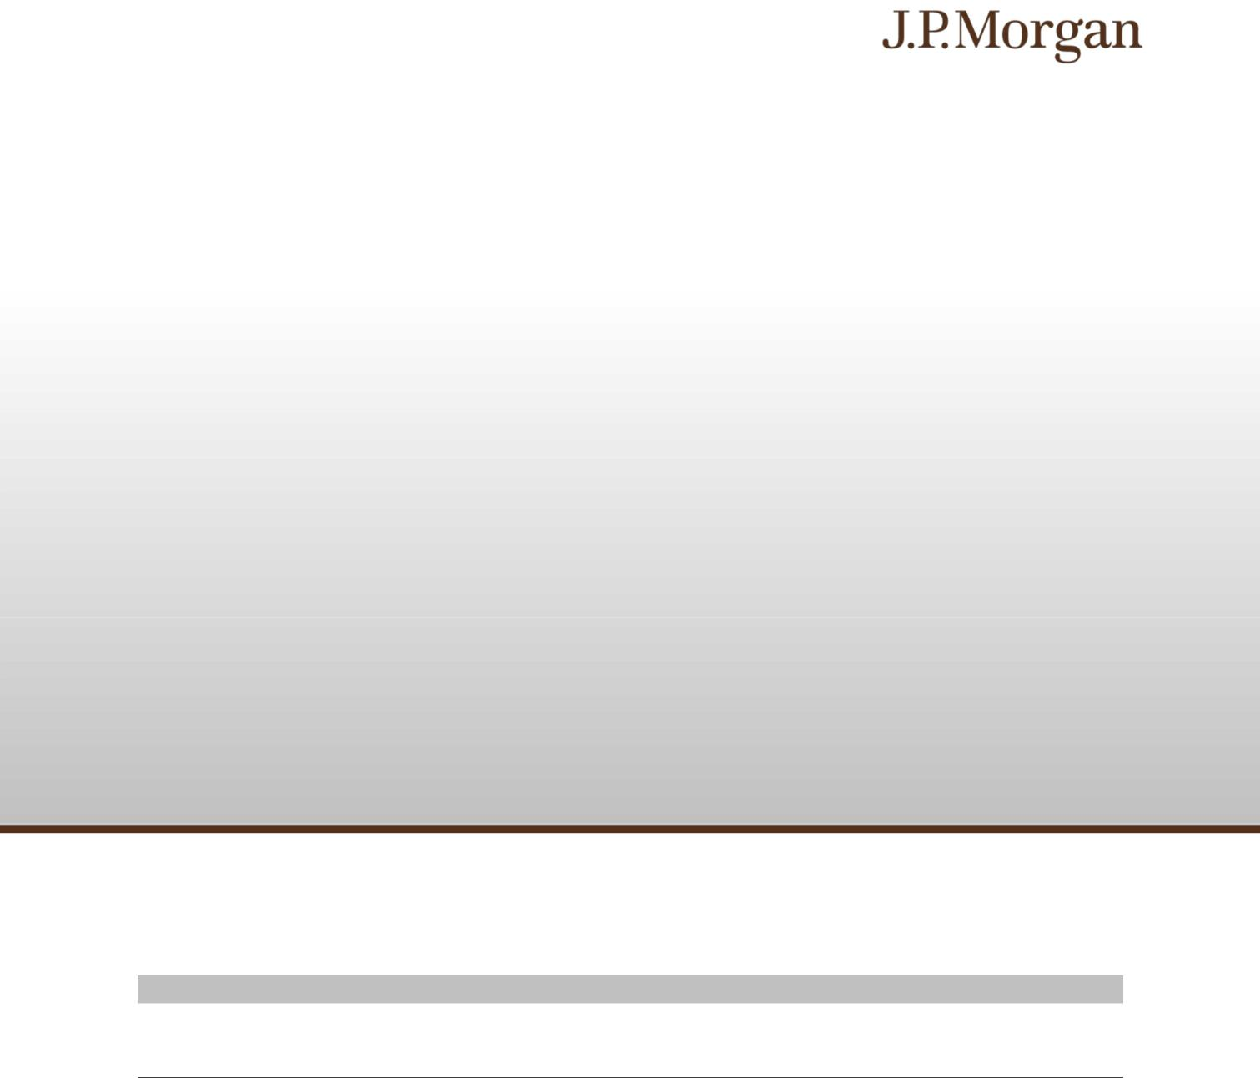

JPMorgan Chase Financial Company LLC

Structured Investments

Auto Callable Yield Notes Linked to the Lesser Performing of the Nasdaq-100 Index® and the Dow Jones Industrial Average® due April 13, 2028

Fully and Unconditionally Guaranteed by JPMorgan Chase & Co.

- The notes are designed for investors who seek a higher interest rate than the yield on a conventional debt security with the same maturity issued by us. The notes will pay at least 7.70% per annum interest over the term of the notes, assuming no automatic call, payable at a rate of at least 3.85% semiannually.

- The notes will be automatically called if the closing level of each of the Nasdaq-100 Index® and the Dow Jones Industrial Average®, which we refer to as the Indices, on any Review Date (other than the final Review Date) is greater than or equal to its Strike Value.

- The earliest date on which an automatic call may be initiated is April 9, 2027.

- Investors should be willing to accept the risk of losing some or all of their principal and be willing to forgo dividend payments, in exchange for Interest Payments.

- The notes are unsecured and unsubordinated obligations of JPMorgan Chase Financial Company LLC, which we refer to as JPMorgan Financial, the payment on which is fully and unconditionally guaranteed by JPMorgan Chase & Co. Any payment on the notes is subject to the credit risk of JPMorgan Financial, as issuer of the notes, and the credit risk of JPMorgan Chase & Co., as guarantor of the notes.

- Payments on the notes are not linked to a basket composed of the Indices. Payments on the notes are linked to the performance of each of the Indices individually, as described below.

- Minimum denominations of $1,000 and integral multiples thereof

- The notes are expected to price on or about October 14, 2026 (the “Pricing Date”) and are expected to settle on or about October 19, 2026. The Strike Value of each Index has been determined by reference to the closing level of that
Index on October 9, 2026 and not by reference to the closing level of that Index on the Pricing Date.

- CUSIP: 46661PQE0

Investing in the notes involves a number of risks. See “Risk Factors” beginning on page S-2 of the accompanying prospectus supplement, “Risk Factors” beginning on page PS-12 of the accompanying product supplement and “Selected Risk Considerations” beginning on page PS-4 of this pricing supplement.

Neither the Securities and Exchange Commission (the “SEC”) nor any state securities commission has approved or disapproved of the notes or passed upon the accuracy or the adequacy of this pricing supplement or the accompanying product supplement, underlying supplement, prospectus supplement and prospectus. Any representation to the contrary is a criminal offense.

 | Price to Public (1) | Fees and Commissions (2) | Proceeds to Issuer
Per note | $1,000 | $ | $
Total | $ | $ | $

- See “Supplemental Use of Proceeds” in this pricing supplement for information about the components of the price to public of the notes.

- J.P. Morgan Securities LLC, which we refer to as JPMS, acting as agent for JPMorgan Financial, will pay all of the selling commissions it receives from us to other affiliated or unaffiliated dealers. In no event will these selling commissions exceed $10.00 per $1,000 principal amount note. See “Plan of Distribution (Conflicts of Interest)” in the accompanying product supplement.

If the notes priced today, the estimated value of the notes would be approximately $982.30 per $1,000 principal amount note. The estimated value of the notes, when the terms of the notes are set, will be provided in the pricing supplement and will not be less than $950.00 per $1,000 principal amount note. See “The Estimated Value of the Notes” in this pricing supplement for additional information.

The notes are not bank deposits, are not insured by the Federal Deposit Insurance Corporation or any other governmental agency and are not obligations of, or guaranteed by, a bank.

Pricing supplement to product supplement no. 3-I dated April 17, 2026, underlying supplement no. 1-I dated April 17, 2026 and the prospectus and prospectus supplement, each dated April 17, 2026

Key Terms
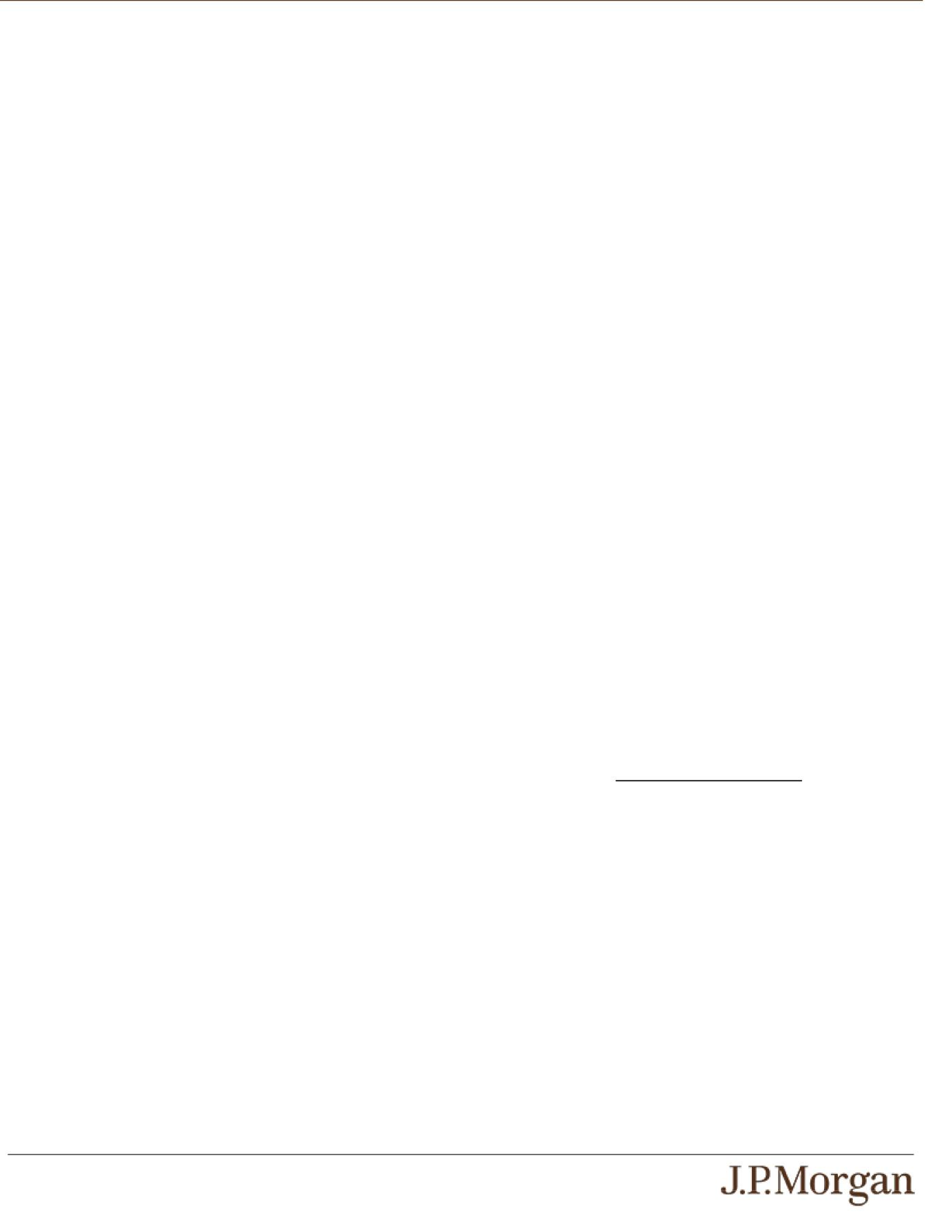

Issuer: JPMorgan Chase Financial Company LLC, a direct, wholly owned finance subsidiary of JPMorgan Chase & Co.

Guarantor: JPMorgan Chase & Co.

Indices: The Nasdaq-100 Index® (Bloomberg ticker: NDX) and
the Dow Jones Industrial Average® (Bloomberg ticker: INDU)

Interest Payments: If the notes have not been automatically called, you will receive on each Interest Payment Date for each $1,000 principal amount note an Interest Payment equal to at least $38.50 (equivalent to an Interest Rate of at least 7.70% per annum, payable at a rate of at least 3.85% semiannually) (to be provided in the pricing supplement).

Interest Rate: At least 7.70% per annum, payable at a rate of at least 3.85% semiannually (to be provided in the pricing supplement)

Buffer Amount: 20.00%

Downside Leverage Factor: An amount equal to 1 / (1 – Buffer Amount), which is 1.25

Strike Date: October 9, 2026

Pricing Date: On or about October 14, 2026

Original Issue Date (Settlement Date): On or about October

19, 2026

Review Dates*: April 9, 2027, October 11, 2027 and April 10, 2028 (final Review Date)

Interest Payment Dates*: April 14, 2027, October 14, 2027 and the Maturity Date

Maturity Date*: April 13, 2028

Call Settlement Date*: If the notes are automatically called on any Review Date (other than the final Review Date), the first Interest Payment Date immediately following that Review Date

- Subject to postponement in the event of a market disruption event and as described under “General Terms of Notes — Postponement

of a Determination Date — Notes Linked to Multiple Underlyings” and “General Terms of Notes — Postponement of a Payment Date” in the accompanying product supplement

PS-1 | Structured Investments

Auto Callable Yield Notes Linked to the Lesser Performing of the Nasdaq-100 Index® and the Dow Jones Industrial Average®

Automatic Call:

If the closing level of each Index on any Review Date (other than the final Review Date) is greater than or equal to its Strike Value, the notes will be automatically called for a cash payment, for each $1,000 principal amount note, equal to (a) $1,000 plus

- the Interest Payment for the Interest Payment Date

occurring on the applicable Call Settlement Date, payable on that Call Settlement Date. No further payments will be made on the notes.

Payment at Maturity:

If the notes have not been automatically called and the Final Value of each Index is greater than or equal to its Strike Value or less than its Strike Value by up to the Buffer Amount, you will receive a cash payment at maturity, for each $1,000 principal amount note, equal to (a) $1,000 plus (b) the Interest Payment applicable to the Maturity Date.

If the notes have not been automatically called and the Final Value of either Index is less than its Strike Value by more than the Buffer Amount, your payment at maturity per $1,000 principal amount note, in addition to the Interest Payment applicable to the Maturity Date, will be calculated as follows:

$1,000 + [$1,000 × (Lesser Performing Index Return + Buffer Amount) × Downside Leverage Factor]
If the notes have not been automatically called and the Final Value of either Index is less than its Strike Value by more than the Buffer Amount, you will lose some or all of your principal amount at maturity.

Lesser Performing Index: The Index with the Lesser Performing Index Return

Lesser Performing Index Return: The lower of the Index Returns of the Indices

Index Return:

With respect to each Index,

(Final Value – Strike Value)

Strike Value

Strike Value: With respect to each Index, the closing level of that Index on the Strike Date, which was 30,883.15 for the Nasdaq-100® Index and 51,654.95 for the Dow Jones Industrial

Average®. The Strike Value of each Index is not the closing level of that Index on the Pricing Date.

Final Value: With respect to each Index, the closing level of that Index on the final Review Date

How the Notes Work
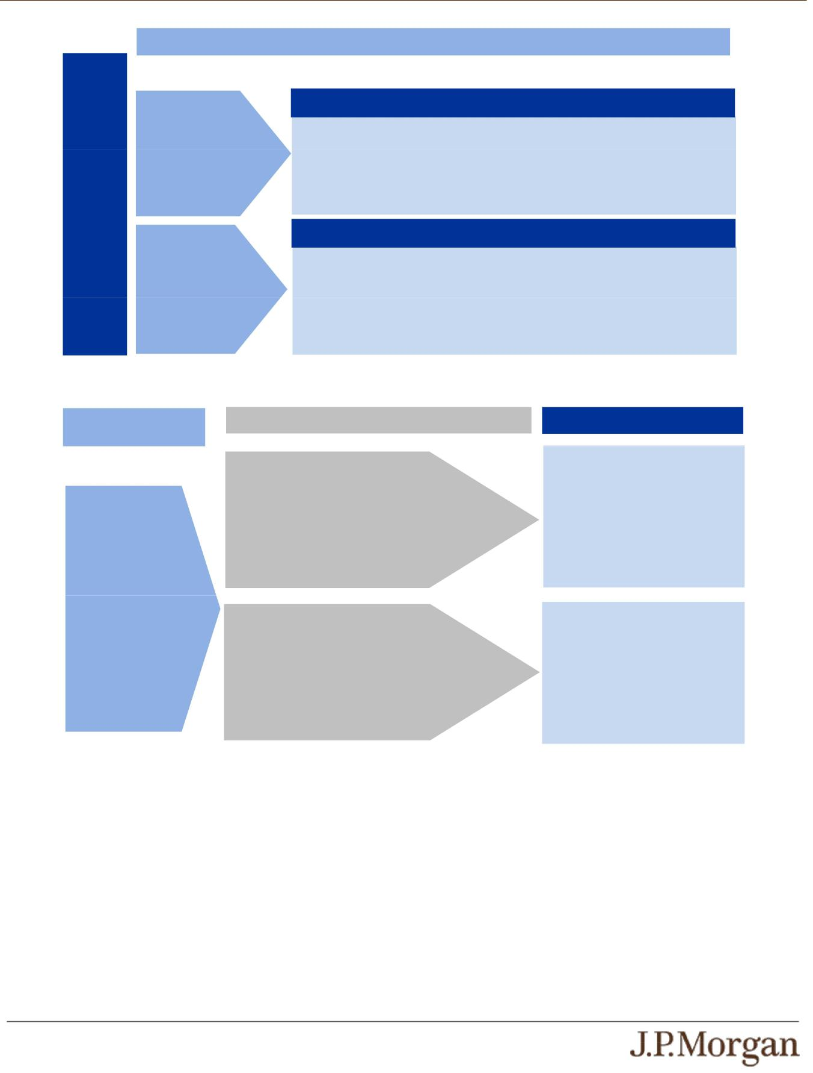

Payments in Connection with Review Dates Preceding the Final Review Date

Review Dates Preceding the Final Review Date

Compare the closing level of each Index to its Strike Value on each Review Date until the final Review Date or any earlier automatic call.

The closing level of

each Index is greater

than or equal to its
Strike Value.

Automatic Call

The notes will be automatically called on the applicable Call Settlement Date and you will receive (a) $1,000 plus (b) the Interest Payment for the Interest Payment Date occurring on that Call Settlement Date.

Strike

Value

The closing level of

either Index is less
than its Strike Value.

No Automatic Call

The notes will not be automatically called. You will receive an Interest Payment on the

immediately following Interest Payment Date.

Proceed to the next Review Date.

Payment at Maturity If the Notes Have Not Been Automatically Called

Review Dates Preceding the
Final Review Date

The notes are not

automatically called.

Final Review Date

The Final Value of each Index is greater than or equal to its Strike Value or less than its Strike Value by up to the Buffer Amount.

Payment at Maturity

You will receive (a) $1,000 plus (b) the Interest Payment applicable to the Maturity Date.

Proceed to maturity

The Final Value of either Index is less than its

Strike Value by more than the Buffer Amount.

You will receive, in addition to the Interest Payment applicable to the
Maturity Date:

$1,000 + [$1,000 × (Lesser Performing Index Return + Buffer Amount) × Downside Leverage Factor]

Under these circumstances, you will lose some or all of your principal amount at maturity.

PS-2 | Structured Investments

Auto Callable Yield Notes Linked to the Lesser Performing of the Nasdaq-100 Index® and the Dow Jones Industrial Average®

Total Interest Payments

The table below illustrates the hypothetical total Interest Payments per $1,000 principal amount note over the term of the notes based on a hypothetical Interest Rate of 7.70% per annum, depending on how many Interest Payments are made prior to automatic call or maturity. If the notes have not been automatically called, the hypothetical total Interest Payments per $1,000 principal amount note over the term of the notes will be equal to the maximum amount shown in the table below. The actual Interest Rate will be provided in the pricing supplement and will be at least 7.70% per annum (payable at a rate of at least 3.85% semiannually).
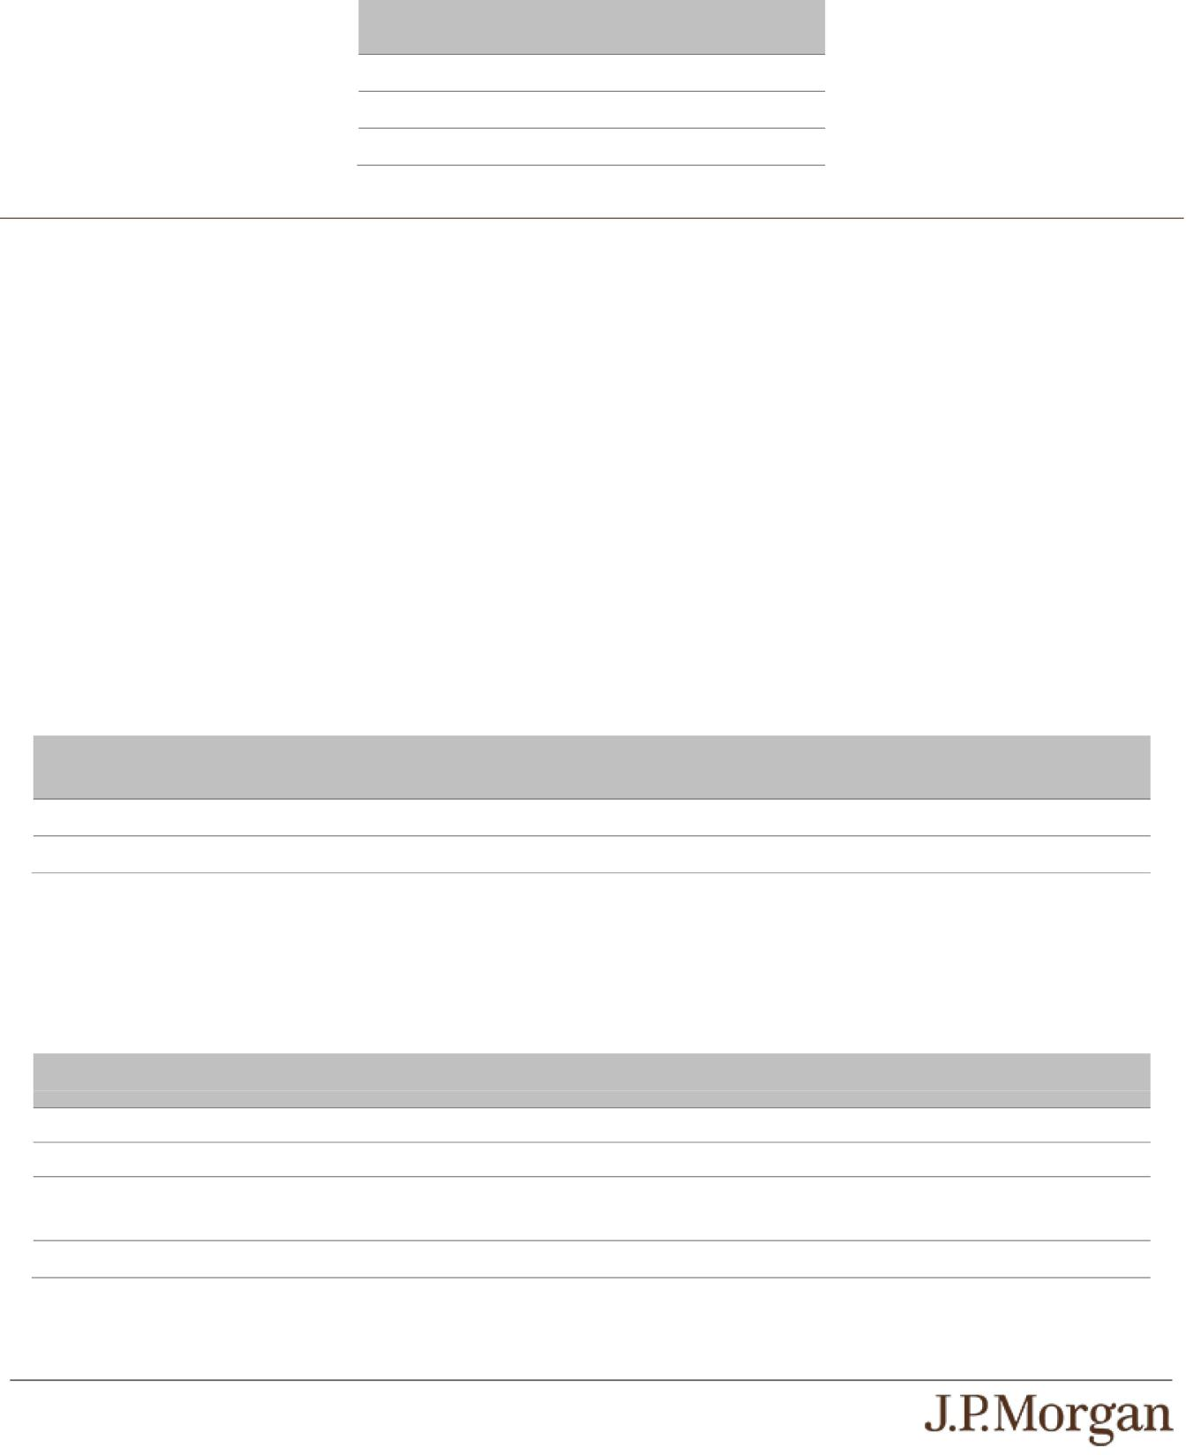

Number of Interest Total Interest

Payments Payments

3 $115.50

2 $77.00

1 $38.50

Hypothetical Payout Examples

The following examples illustrate payments on the notes linked to two hypothetical Indices, assuming a range of performances for the

hypothetical Lesser Performing Index on the Review Dates. Solely for purposes of this section, the Lesser Performing Index with respect to each Review Date is the lesser performing of the Indices determined based on the closing level of each Index on that Review Date compared with its Strike Value.

The hypothetical payments set forth below assume the following:

- a Strike Value for each Index of 100.00;

- a Buffer Amount of 20.00%;

- a Downside Leverage Factor of 1.25; and

- an Interest Rate of 7.70% per annum.

The hypothetical Strike Value of each Index of 100.00 has been chosen for illustrative purposes only and does not represent the actual Strike Value of either Index. The actual Strike Value of each Index is the closing level of that Index on the Strike Date and is specified under “Key Terms — Strike Value” in this pricing supplement. For historical data regarding the actual closing levels of each Index, please see the historical information set forth under “The Indices” in this pricing supplement.

Each hypothetical payment set forth below is for illustrative purposes only and may not be the actual payment applicable to a purchaser of the notes. The numbers appearing in the following examples have been rounded for ease of analysis.

Example 1 — Notes are automatically called on the first Review Date.

Date

Closing Level of Lesser

Performing Index

First Review Date

105.00

Notes are automatically called

Total Payment

$1,038.50 (3.85% return)

Because the closing level of each Index on the first Review Date is greater than or equal to its Strike Value, the notes will be automatically called for a cash payment, for each $1,000 principal amount note, of $1,038.50 (or $1,000 plus the Interest Payment applicable to the corresponding Interest Payment Date), payable on the applicable Call Settlement Date. No further payments will be made on the notes.

Example 2 — Notes have NOT been automatically called and the Final Value of the Lesser Performing Index is less than its Strike Value by up to the Buffer Amount.

Date | Closing Level of Lesser
 | Performing Index
First Review Date | 95.00 | Notes NOT automatically called
Second Review Date | 90.00 | Notes NOT automatically called
Final Review Date | 80.00 | Final Value of Lesser Performing Index is less than its Strike
 |  | Value by up to the Buffer Amount
 | Total Payment | $1,115.50 (11.55% return)

Because the notes have not been automatically called and the Final Value of the Lesser Performing Index is less than its Strike Value by up to the Buffer Amount, the payment at maturity, for each $1,000 principal amount note, will be $1,038.50 (or $1,000 plus the

PS-3 | Structured Investments

Auto Callable Yield Notes Linked to the Lesser Performing of the Nasdaq-
100 Index® and the Dow Jones Industrial Average®

Interest Payment applicable to the Maturity Date). When added to the Interest Payments received with respect to the prior Interest Payment Dates, the total amount paid, for each $1,000 principal amount note, is $1,115.50.

Example 3 — Notes have NOT been automatically called and the Final Value of the Lesser Performing Index is less than its Strike Value by more than the Buffer Amount.
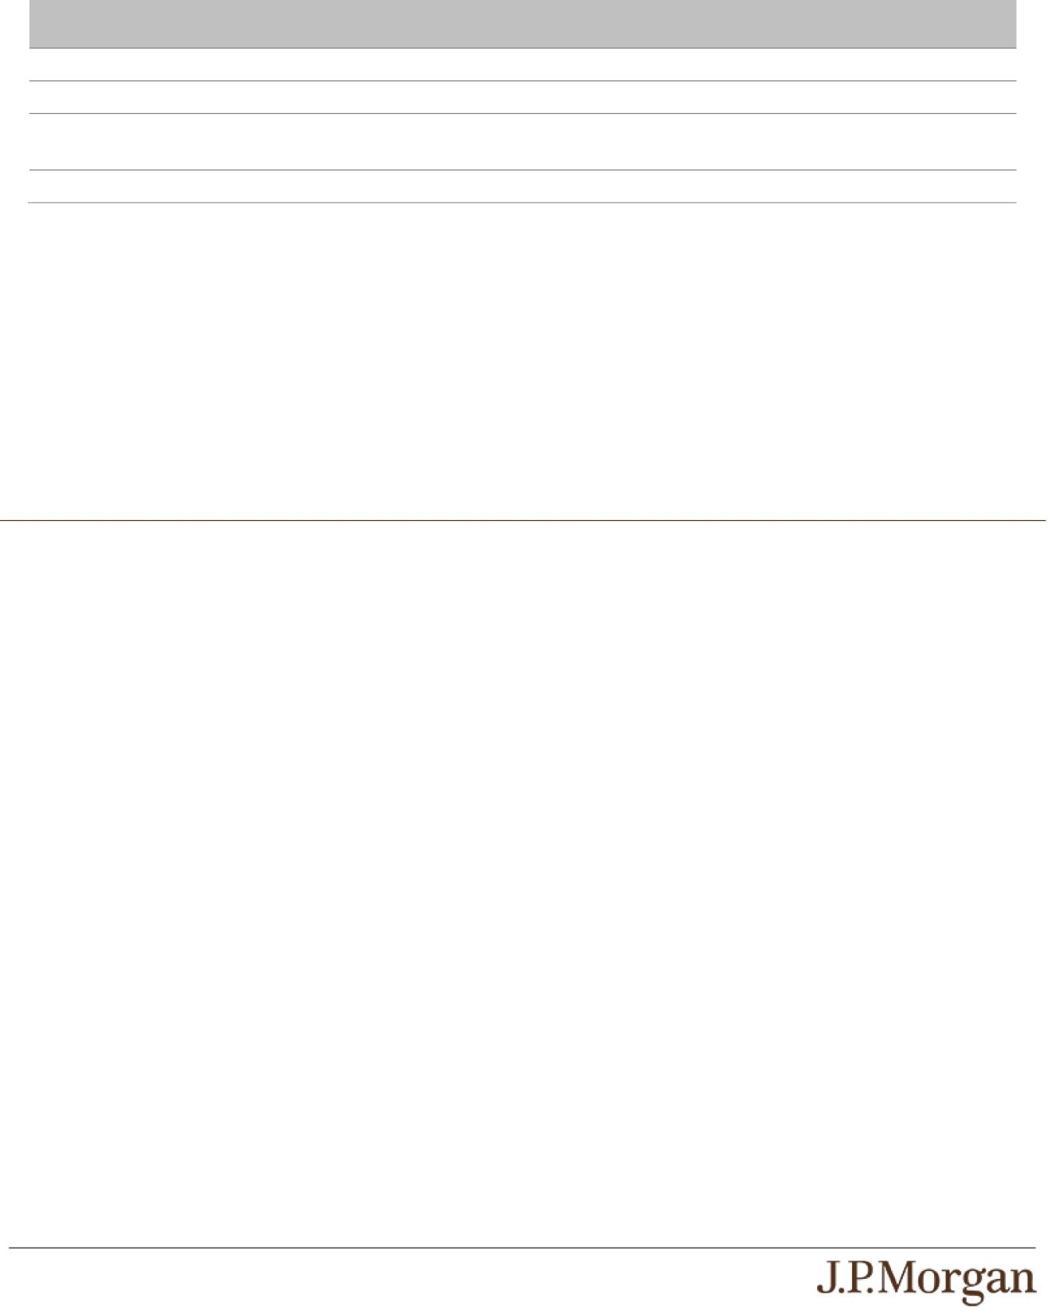
Date | Closing Level of Lesser
 | Performing Index
First Review Date | 80.00 | Notes NOT automatically called
Second Review Date | 70.00 | Notes NOT automatically called
Final Review Date | 40.00 | Final Value of Lesser Performing Index is less than its Strike
 |  | Value by more than the Buffer Amount
 | Total Payment | $615.50 (-38.45% return)

Because the notes have not been automatically called, the Final Value of the Lesser Performing Index is less than its Strike Value by more than the Buffer Amount and the Lesser Performing Index Return is -60.00%, the payment at maturity will be $538.50 per $1,000 principal amount note, calculated as follows:

$1,000 + [$1,000 × (-60.00% + 20.00%) × 1.25] + $38.50 = $538.50.

When added to the Interest Payments received with respect to the prior Interest Payment Dates, the total amount paid, for each $1,000 principal amount note, is $615.50.

The hypothetical returns and hypothetical payments on the notes shown above apply only if you hold the notes for their entire term or until automatically called. These hypotheticals do not reflect the fees or expenses that would be associated with any sale in the secondary market. If these fees and expenses were included, the hypothetical returns and hypothetical payments shown above would likely be lower.

Selected Risk Considerations

An investment in the notes involves significant risks. These risks are explained in more detail in the “Risk Factors” sections of the accompanying prospectus supplement and product supplement.

Risks Relating to the Notes Generally

- YOUR INVESTMENT IN THE NOTES MAY RESULT IN A LOSS —

The notes do not guarantee any return of principal. If the notes have not been automatically called and the Final Value of either Index is less than its Strike Value by more than 20.00%, you will lose 1.25% of the principal amount of your notes for every 1% that the Final Value of the Lesser Performing Index is less than its Strike Value by more than 20.00%. Accordingly, under these circumstances, you will lose some or all of your principal amount at maturity.

- CREDIT RISKS OF JPMORGAN FINANCIAL AND JPMORGAN CHASE & CO. —

Investors are dependent on our and JPMorgan Chase & Co.’s ability to pay all amounts due on the notes. Any actual or potential change in our or JPMorgan Chase & Co.’s creditworthiness or credit spreads, as determined by the market for taking that credit risk, is likely to adversely affect the value of the notes. If we and JPMorgan Chase & Co. were to default on our payment obligations, you may not receive any amounts owed to you under the notes and you could lose your entire investment.

- AS A FINANCE SUBSIDIARY, JPMORGAN FINANCIAL HAS NO INDEPENDENT ACTIVITIES AND HAS LIMITED ASSETS —

As a finance subsidiary of JPMorgan Chase & Co., we have no independent activities beyond the issuance and administration of

our securities and the collection of intercompany obligations. Aside from the initial capital contribution from JPMorgan Chase & Co., substantially all of our assets relate to obligations of JPMorgan Chase & Co. to make payments under loans made by us to JPMorgan Chase & Co. or under other intercompany agreements. As a result, we are dependent upon payments from JPMorgan
Chase & Co. to meet our obligations under the notes. We are not an operating subsidiary of JPMorgan Chase & Co. and in a bankruptcy or resolution of JPMorgan Chase & Co. we are not expected to have sufficient resources to meet our obligations in respect of the notes as they come due. If JPMorgan Chase & Co. does not make payments to us and we are unable to make
payments on the notes, you may have to seek payment under the related guarantee by JPMorgan Chase & Co., and that guarantee will rank pari passu with all other unsecured and unsubordinated obligations of JPMorgan Chase & Co. For more
information, see “Risk Factors — Holders of securities issued by JPMorgan Financial may be subject to losses if JPMorgan Chase & Co. were to enter into a resolution” in the accompanying prospectus supplement.

PS-4 | Structured Investments

Auto Callable Yield Notes Linked to the Lesser Performing of the Nasdaq-
100 Index® and the Dow Jones Industrial Average®

- THE APPRECIATION POTENTIAL OF THE NOTES IS LIMITED TO THE SUM OF THE INTEREST PAYMENTS PAID OVER THE TERM OF THE NOTES,

regardless of any appreciation of either Index, which may be significant. You will not participate in any appreciation of either Index.

- YOU ARE EXPOSED TO THE RISK OF DECLINE IN THE LEVEL OF EACH INDEX —

Payments on the notes are not linked to a basket composed of the Indices and are contingent upon the performance of each individual Index. Poor performance by either of the Indices over the term of the notes may result in the notes not being
automatically called on a Review Date, may negatively affect your payment at maturity and will not be offset or mitigated by positive performance by the other Index.

- YOUR PAYMENT AT MATURITY WILL BE DETERMINED BY THE LESSER PERFORMING INDEX.

- THE AUTOMATIC CALL FEATURE MAY FORCE A POTENTIAL EARLY EXIT —

If your notes are automatically called, the term of the notes may be reduced to as short as approximately six months and you will not receive any Interest Payments after the applicable Call Settlement Date. There is no guarantee that you would be able to
reinvest the proceeds from an investment in the notes at a comparable return and/or with a comparable interest rate for a similar level of risk. Even in cases where the notes are called before maturity, you are not entitled to any fees and commissions described on the front cover of this pricing supplement.

- YOU WILL NOT RECEIVE DIVIDENDS ON THE SECURITIES INCLUDED IN EITHER INDEX OR HAVE ANY RIGHTS WITH RESPECT TO THOSE SECURITIES.

- LACK OF LIQUIDITY —

The notes will not be listed on any securities exchange. Accordingly, the price at which you may be able to trade your notes is likely to depend on the price, if any, at which JPMS is willing to buy the notes. You may not be able to sell your notes. The notes are not designed to be short-term trading instruments. Accordingly, you should be able and willing to hold your notes to maturity.

- THE FINAL TERMS AND VALUATION OF THE NOTES WILL BE PROVIDED IN THE PRICING SUPPLEMENT —

You should consider your potential investment in the notes based on the minimums for the estimated value of the notes and the Interest Rate.

Risks Relating to Conflicts of Interest

- POTENTIAL CONFLICTS —

We and our affiliates play a variety of roles in connection with the notes. In performing these duties, our and JPMorgan Chase & Co.’s economic interests are potentially adverse to your interests as an investor in the notes. It is possible that hedging or trading
activities of ours or our affiliates in connection with the notes could result in substantial returns for us or our affiliates while the value of the notes declines. Please refer to “Risk Factors — Risks Relating to Conflicts of Interest” in the accompanying product supplement.

Risks Relating to the Estimated Value and Secondary Market Prices of the Notes

- THE ESTIMATED VALUE OF THE NOTES WILL BE LOWER THAN THE ORIGINAL ISSUE PRICE (PRICE TO PUBLIC) OF THE NOTES —

The estimated value of the notes is only an estimate determined by reference to several factors. The original issue price of the

notes will exceed the estimated value of the notes because costs associated with selling, structuring and hedging the notes are included in the original issue price of the notes. These costs include the selling commissions, the projected profits, if any, that our affiliates expect to realize for assuming risks inherent in hedging our obligations under the notes, the estimated cost of hedging our
obligations under the notes and the fees, if any, paid for third-party data analytics and/or electronic platform services. See “The Estimated Value of the Notes” in this pricing supplement.

- THE ESTIMATED VALUE OF THE NOTES DOES NOT REPRESENT FUTURE VALUES OF THE NOTES AND MAY DIFFER FROM OTHERS’ ESTIMATES —

See “The Estimated Value of the Notes” in this pricing supplement.

PS-5 | Structured Investments

Auto Callable Yield Notes Linked to the Lesser Performing of the Nasdaq-
100 Index® and the Dow Jones Industrial Average®

- THE ESTIMATED VALUE OF THE NOTES IS DERIVED BY REFERENCE TO AN INTERNAL FUNDING RATE —

The internal funding rate used in the determination of the estimated value of the notes may differ from the market-implied funding

rate for vanilla fixed income instruments of a similar maturity issued by JPMorgan Chase & Co. or its affiliates. Any difference may be based on, among other things, our and our affiliates’ view of the funding value of the notes as well as the higher issuance, operational and ongoing liability management costs of the notes in comparison to those costs for the conventional fixed income
instruments of JPMorgan Chase & Co. This internal funding rate is based on certain market inputs and assumptions, which may prove to be incorrect, and is intended to approximate the prevailing market replacement funding rate for the notes. The use of an
internal funding rate and any potential changes to that rate may have an adverse effect on the terms of the notes and any secondary market prices of the notes. See “The Estimated Value of the Notes” in this pricing supplement.

- THE VALUE OF THE NOTES AS PUBLISHED BY JPMS (AND WHICH MAY BE REFLECTED ON CUSTOMER ACCOUNT STATEMENTS) MAY BE HIGHER THAN THE THEN-CURRENT ESTIMATED VALUE OF THE NOTES FOR A LIMITED TIME PERIOD —

We generally expect that some of the costs included in the original issue price of the notes will be partially paid back to you in connection with any repurchases of your notes by JPMS in an amount that will decline to zero over an initial predetermined period.
See “Secondary Market Prices of the Notes” in this pricing supplement for additional information relating to this initial period. Accordingly, the estimated value of your notes during this initial period may be lower than the value of the notes as published by JPMS (and which may be shown on your customer account statements).

- SECONDARY MARKET PRICES OF THE NOTES WILL LIKELY BE LOWER THAN THE ORIGINAL ISSUE PRICE OF THE NOTES —

Any secondary market prices of the notes will likely be lower than the original issue price of the notes because, among other things, secondary market prices take into account our internal secondary market funding rates for structured debt issuances and, also, because secondary market prices may exclude selling commissions, projected hedging profits, if any, estimated hedging
costs and fees, if any, paid for third-party data analytics and/or electronic platform services that are included in the original issue price of the notes. As a result, the price, if any, at which JPMS will be willing to buy the notes from you in secondary market transactions, if at all, is likely to be lower than the original issue price. Furthermore, if you sell your notes, you will likely be charged
a commission for secondary market transactions, or the price will likely reflect a dealer discount and/or fees for use of an electronic platform to facilitate secondary market activity. Any sale by you prior to the Maturity Date could result in a substantial loss to you.

- SECONDARY MARKET PRICES OF THE NOTES WILL BE IMPACTED BY MANY ECONOMIC AND MARKET FACTORS —

The secondary market price of the notes during their term will be impacted by a number of economic and market factors, which may either offset or magnify each other, aside from the selling commissions, projected hedging profits, if any, estimated hedging
costs and the levels of the Indices. Additionally, independent pricing vendors and/or third party broker-dealers may publish a price for the notes, which may also be reflected on customer account statements. This price may be different (higher or lower) than the
price of the notes, if any, at which JPMS may be willing to purchase your notes in the secondary market. See “Risk Factors — Risks Relating to the Estimated Value and Secondary Market Prices of the Notes — Secondary market prices of the notes will be impacted by many economic and market factors” in the accompanying product supplement.

Risks Relating to the Indices

- JPMORGAN CHASE & CO. IS CURRENTLY ONE OF THE COMPANIES THAT MAKE UP THE DOW JONES INDUSTRIAL AVERAGE®,
but JPMorgan Chase & Co. will not have any obligation to consider your interests in taking any corporate action that might affect the level of the Dow Jones Industrial Average®.

- NON-U.S. SECURITIES RISK WITH RESPECT TO THE NASDAQ-100 INDEX® —

Some of the equity securities included in the Nasdaq-100 Index® have been issued by non-U.S. companies. Investments in securities linked to the value of such non-U.S. equity securities involve risks associated with the home countries of the issuers of those non-U.S. equity securities.
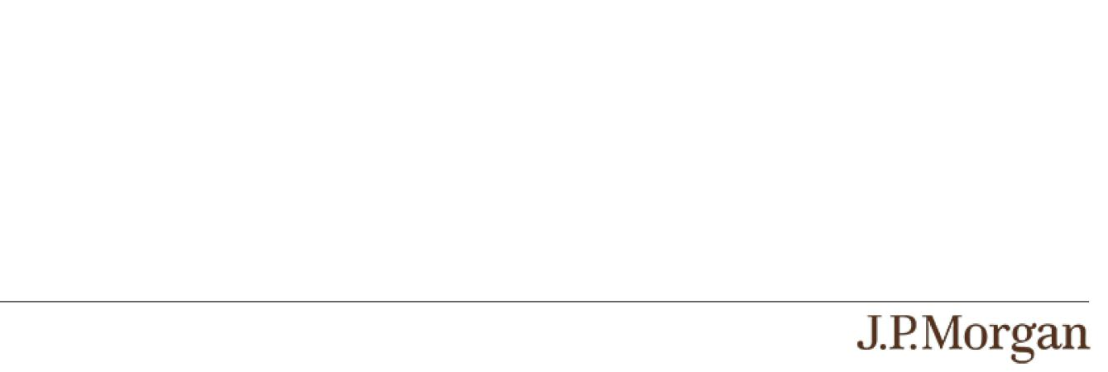

PS-6 | Structured Investments

Auto Callable Yield Notes Linked to the Lesser Performing of the Nasdaq-
100 Index® and the Dow Jones Industrial Average®

The Indices


The Nasdaq-100 Index® is a modified market capitalization-weighted index that is designed to measure the performance of 100 of the largest non-financial companies listed on The Nasdaq Stock Market. For additional information about the Nasdaq-100 Index®, see “Equity Index Descriptions — The Nasdaq-100 Index®” in the accompanying underlying supplement, as supplemented by the following updated information.

Nasdaq, Inc. (“Nasdaq”), the index sponsor of the Nasdaq-100 Index®, recently implemented several changes to the methodology of the Nasdaq-100 Index®, including changes to the determination of market capitalization for purposes of constituent selection and weighting, the introduction of an expedited “Fast Entry” process for certain large companies, the removal of the minimum free float requirement for constituent selection and the introduction of a cap on the share count used to determine the weighting of low-float securities. These changes became effective on May 1, 2026, with certain constituent and rebalancing adjustments first implemented during the June 2026 quarterly review. The information set forth below supersedes the information regarding the Nasdaq-100 Index® included in the accompanying underlying supplement to the extent inconsistent therewith.

Under the updated methodology, Nasdaq uses different measures of market capitalization for constituent selection and constituent weighting. For purposes of constituent selection, Nasdaq now uses “Full Market Capitalization.” For companies with direct (non-ADR) listings and companies represented by an American depositary receipt (“ADR”) that serves as a company’s primary global listing (a “Primary ADR”), Full Market Capitalization includes both listed and unlisted shares. For companies represented by an ADR where the underlying shares serve as the company’s primary global listing and are listed on a foreign exchange (a “Non-Primary ADR”), Full Market Capitalization is based solely on the value of the listed depositary shares, and foreign-listed underlying shares and unlisted shares are excluded. For purposes of constituent weighting, Nasdaq uses “Modified Market Capitalization,” which takes into account only eligible listed share classes and disregards foreign-listed and unlisted shares.

In addition, the updated methodology eliminates the minimum free float requirement for inclusion in the Nasdaq-100 Index®, although the Modified Market Capitalization used for constituent weighting imposes a limitation on the weightings of low-float securities. Specifically, for purposes of determining Modified Market Capitalization, each low-float security’s share count is limited to the lesser of
- its reported total shares outstanding (“TSO”) (or, in the case of an ADR, its listed ADR shares outstanding), and (ii) three times its free-floating shares or free-floating ADR shares, as applicable. Other than as a direct result of corporate actions, the Nasdaq-100 Index® also no longer implements ad-hoc intra-quarter adjustments to a security’s TSO between scheduled rebalancing events.

The updated methodology also introduces a “Fast Entry” process under which newly eligible securities, including both initial public offerings and companies that have recently transferred their listing to an eligible exchange, may be added to the Nasdaq-100 Index® on an expedited basis if their Full Market Capitalization would rank within the top 40 current index constituents and they satisfy the applicable eligibility criteria. A Fast Entry inclusion will not require the removal of an existing constituent and may temporarily increase the number of constituents in the Nasdaq-100 Index® above 100.

The updated methodology further provides for quarterly rebalances in March, June and September. During quarterly rebalances, the index shares of each constituent are adjusted for changes in TSO, index shares of low-float securities are adjusted to reflect changes in float, constituents ranked outside the top 125 by Full Market Capitalization are removed and, if necessary, replaced, and certain additional companies whose Full Market Capitalization ranks within the top 40 of current index constituents may be added without requiring a corresponding removal. Securities added to the Nasdaq-100 Index® between annual reconstitutions, including through the Fast Entry process, as intra-quarter replacements or as part of a March, June or September quarterly rebalance, will have their initial index weightings determined using a linear interpolation process based on their Modified Market Capitalization ranking.

The Dow Jones Industrial Average® is a price-weighted index that seeks to measure of the performance of 30 U.S. blue-chip companies. The Dow Jones Industrial Average® covers all industries with the exception of the transportation industry group and the utilities sector. For additional information about the Dow Jones Industrial Average®, see “Equity Index Descriptions — The Dow Jones Industrial Average®” in the accompanying underlying supplement.

Historical Information

The following graphs set forth the historical performance of each Index based on the weekly historical closing levels from January 8, 2021 through October 9, 2026. The closing level of the Nasdaq-100 Index® on October 9, 2026 was 30,883.15. The closing level of the Dow Jones Industrial Average® on October 9, 2026 was 51,654.95. We obtained the closing levels above and below from the Bloomberg Professional® service (“Bloomberg”), without independent verification.

The historical closing levels of each Index should not be taken as an indication of future performance, and no assurance can be given as to the closing level of either Index on any Review Date. There can be no assurance that the performance of the Indices will result in the return of any of your principal amount.

PS-7 | Structured Investments

Auto Callable Yield Notes Linked to the Lesser Performing of the Nasdaq-
100 Index® and the Dow Jones Industrial Average®

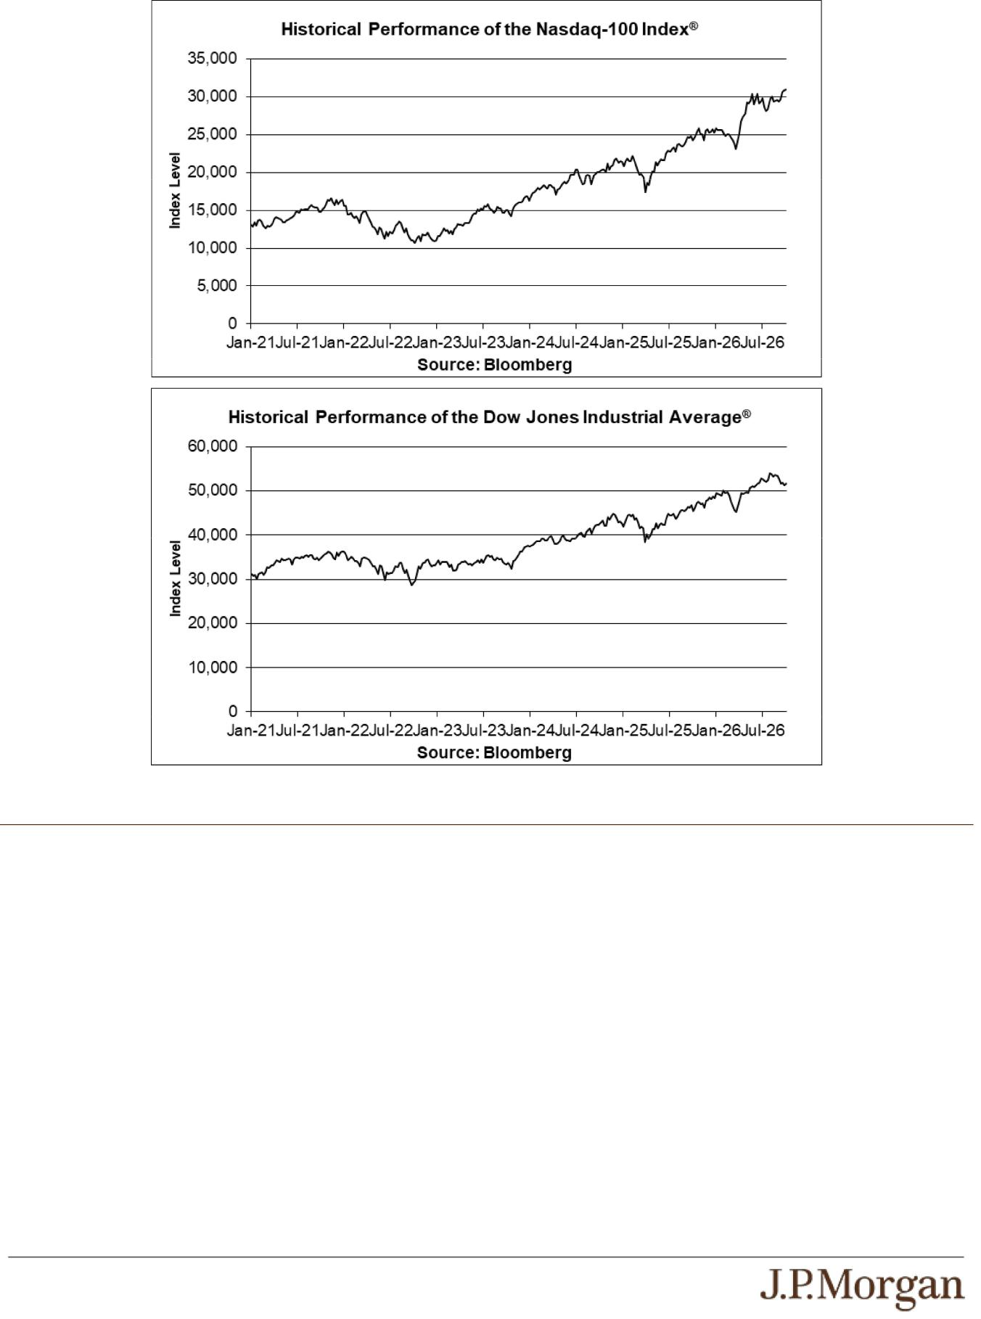

Tax Treatment

You should review carefully the section entitled “United States Federal Taxation” in the accompanying prospectus supplement. Based on the advice of Davis Polk & Wardwell LLP, our special tax counsel, and on current market conditions, in determining our reporting responsibilities we intend to treat the notes for U.S. federal income tax purposes as units each comprising: (x) a cash-settled Put Option written by you that is terminated if an automatic call occurs and that, if not terminated, in circumstances where the payment due at maturity is less than $1,000 (excluding accrued but unpaid interest), requires you to pay us an amount equal to that difference and (y) a Deposit of $1,000 per $1,000 principal amount note to secure your potential obligation under the Put Option, as more fully described in “United States Federal Taxation — Tax Consequences to U.S. Holders — Program Securities Treated as Units Each Comprising a Put Option and a Deposit” in the accompanying prospectus supplement. By purchasing the notes, you agree (in the absence of an administrative determination or judicial ruling to the contrary) to follow this treatment and the allocation described in the following paragraph. However, there are other reasonable treatments that the IRS or a court may adopt, in which case the timing and character of any income or loss on the notes could be materially and adversely affected. In addition, in 2007 Treasury and the IRS released a notice requesting comments on the U.S. federal income tax treatment of “prepaid forward contracts” and similar instruments. The notice focuses on a number of issues, the most relevant of which for investors in the notes are the character of income or loss (including whether the Put Premium might be currently included as ordinary income) and the degree, if any, to which income realized by non-U.S. investors should be subject to withholding tax. While it is not clear whether the notes would be viewed as similar to the typical prepaid forward contract described in the notice, it is possible that any Treasury regulations or other guidance promulgated after consideration of these issues could materially and adversely affect the tax consequences of an investment in the notes, possibly with retroactive effect.

PS-8 | Structured Investments

Auto Callable Yield Notes Linked to the Lesser Performing of the Nasdaq-
100 Index® and the Dow Jones Industrial Average®

We will determine the portion of each Interest Payment on the notes that we will allocate to interest on the Deposit and to Put Premium, respectively, and will provide that allocation in the pricing supplement for the notes. If the notes had priced on October 9, 2026, we would have allocated approximately 65.45% of each Interest Payment to interest on the Deposit and the remainder to Put Premium. The actual allocation that we will determine for the notes may differ from this hypothetical allocation, and will depend upon a variety of factors, including actual market conditions and our borrowing costs for debt instruments of comparable maturities on the Pricing Date. Assuming that the treatment of the notes as units each comprising a Put Option and a Deposit is respected, amounts treated as interest on the Deposit will be taxed as ordinary income, while the Put Premium will not be taken into account prior to sale or settlement, including a settlement following an automatic call.

Section 871(m) of the Code and Treasury regulations promulgated thereunder (“Section 871(m)”) generally impose a 30% withholding tax (unless an income tax treaty applies) on dividend equivalents paid or deemed paid to Non-U.S. Holders with respect to certain financial instruments linked to U.S. equities or indices that include U.S. equities. Section 871(m) provides certain exceptions to this withholding regime, including for instruments linked to certain broad-based indices that meet requirements set forth in the applicable Treasury regulations. Additionally, a recent IRS notice excludes from the scope of Section 871(m) instruments issued prior to January 1, 2029 that do not have a delta of one with respect to underlying securities that could pay U.S.-source dividends for U.S. federal income tax purposes (each an “Underlying Security”). Based on certain determinations made by us, we expect that Section 871(m) will not apply to the notes with regard to Non-U.S. Holders. Our determination is not binding on the IRS, and the IRS may disagree with this determination. Section 871(m) is complex and its application may depend on your particular circumstances, including whether you enter into other transactions with respect to an Underlying Security. If necessary, further information regarding the potential application of Section 871(m) will be provided in the pricing supplement for the notes. You should consult your tax adviser regarding the potential application of Section 871(m) to the notes.

The discussions above and in the accompanying prospectus supplement do not address the consequences to taxpayers subject to special tax accounting rules under Section 451(b) of the Code. You should consult your tax adviser regarding all aspects of the U.S. federal income tax consequences of an investment in the notes, including possible alternative treatments and the issues presented by the 2007 notice. Purchasers who are not initial purchasers of notes at the issue price should also consult their tax advisers with respect to the tax consequences of an investment in the notes, including possible alternative treatments, as well as the allocation of the purchase price of the notes between the Deposit and the Put Option.

The Estimated Value of the Notes
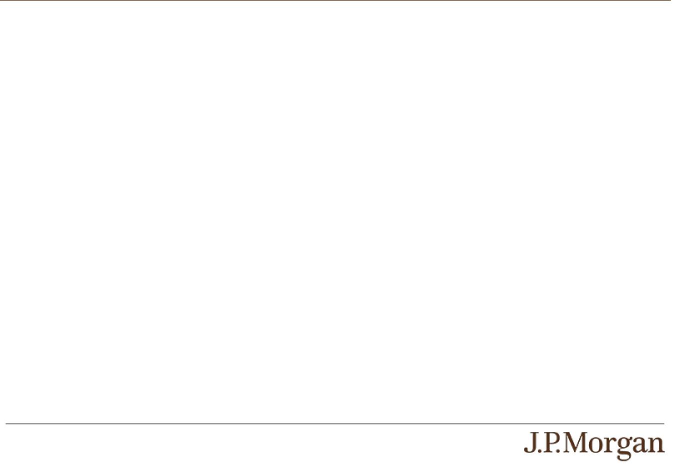

The estimated value of the notes set forth on the cover of this pricing supplement is equal to the sum of the values of the following hypothetical components: (1) a fixed-income debt component with the same maturity as the notes, valued using the internal funding rate described below, and (2) the derivative or derivatives underlying the economic terms of the notes. The estimated value of the notes does not represent a minimum price at which JPMS would be willing to buy your notes in any secondary market (if any exists) at any time. The internal funding rate used in the determination of the estimated value of the notes may differ from the market-implied funding rate for vanilla fixed income instruments of a similar maturity issued by JPMorgan Chase & Co. or its affiliates. Any difference may be based on, among other things, our and our affiliates’ view of the funding value of the notes as well as the higher issuance, operational and ongoing liability management costs of the notes in comparison to those costs for the conventional fixed income instruments of JPMorgan Chase & Co. This internal funding rate is based on certain market inputs and assumptions, which may prove to be incorrect, and is intended to approximate the prevailing market replacement funding rate for the notes. The use of an internal funding rate and any potential changes to that rate may have an adverse effect on the terms of the notes and any secondary market prices of the notes. For additional information, see “Selected Risk Considerations — Risks Relating to the Estimated Value and Secondary Market Prices of the Notes — The Estimated Value of the Notes Is Derived by Reference to an Internal Funding Rate” in this pricing supplement.

The value of the derivative or derivatives underlying the economic terms of the notes is derived from internal pricing models of our affiliates. These models are dependent on inputs such as the traded market prices of comparable derivative instruments and on various other inputs, some of which are market-observable, and which can include volatility, dividend rates, interest rates and other factors, as well as assumptions about future market events and/or environments. Accordingly, the estimated value of the notes is determined when the terms of the notes are set based on market conditions and other relevant factors and assumptions existing at that time.

The estimated value of the notes does not represent future values of the notes and may differ from others’ estimates. Different pricing models and assumptions could provide valuations for the notes that are greater than or less than the estimated value of the notes. In addition, market conditions and other relevant factors in the future may change, and any assumptions may prove to be incorrect. On future dates, the value of the notes could change significantly based on, among other things, changes in market conditions, our or JPMorgan Chase & Co.’s creditworthiness, interest rate movements and other relevant factors, which may impact the price, if any, at which JPMS would be willing to buy notes from you in secondary market transactions.

PS-9 | Structured Investments

Auto Callable Yield Notes Linked to the Lesser Performing of the Nasdaq-
100 Index® and the Dow Jones Industrial Average®

The estimated value of the notes will be lower than the original issue price of the notes because costs associated with selling, structuring and hedging the notes are included in the original issue price of the notes. These costs include the selling commissions paid to JPMS and other affiliated or unaffiliated dealers, the projected profits, if any, that our affiliates expect to realize for assuming risks inherent in hedging our obligations under the notes, the estimated cost of hedging our obligations under the notes and the fees, if any, paid for third-party data analytics and/or electronic platform services. Because hedging our obligations entails risk and may be influenced by market forces beyond our control, this hedging may result in a profit that is more or less than expected, or it may result in a loss. A portion of the profits, if any, realized in hedging our obligations under the notes may be allowed to other affiliated or unaffiliated dealers, and we or one or more of our affiliates will retain any remaining hedging profits. See “Selected Risk Considerations

— Risks Relating to the Estimated Value and Secondary Market Prices of the Notes — The Estimated Value of the Notes Will Be Lower Than the Original Issue Price (Price to Public) of the Notes” in this pricing supplement.

Secondary Market Prices of the Notes


For information about factors that will impact any secondary market prices of the notes, see “Risk Factors — Risks Relating to the Estimated Value and Secondary Market Prices of the Notes — Secondary market prices of the notes will be impacted by many economic and market factors” in the accompanying product supplement. In addition, we generally expect that some of the costs included in the original issue price of the notes will be partially paid back to you in connection with any repurchases of your notes by JPMS in an amount that will decline to zero over an initial predetermined period. These costs can include selling commissions, projected hedging profits, if any, and, in some circumstances, estimated hedging costs, our internal secondary market funding rates for structured debt issuances and the fees paid for third-party data analytics and/or electronic platform services. This initial predetermined time period is intended to be the shorter of six months and one-half of the stated term of the notes. The length of any such initial period reflects the structure of the notes, whether our affiliates expect to earn a profit in connection with our hedging activities, the estimated costs of hedging the notes and when these costs are incurred, as determined by our affiliates. See “Selected Risk Considerations — Risks Relating to the Estimated Value and Secondary Market Prices of the Notes — The Value of the Notes as Published by JPMS (and Which May Be Reflected on Customer Account Statements) May Be Higher Than the Then-Current Estimated Value of the Notes for a Limited Time Period” in this pricing supplement.

Supplemental Use of Proceeds

The notes are offered to meet investor demand for products that reflect the risk-return profile and market exposure provided by the notes. See “How the Notes Work” and “Hypothetical Payout Examples” in this pricing supplement for an illustration of the risk-return profile of the notes and “The Indices” in this pricing supplement for a description of the market exposure provided by the notes.

The original issue price of the notes is equal to the estimated value of the notes plus the selling commissions paid to JPMS and other affiliated or unaffiliated dealers, plus (minus) the projected profits (losses) that our affiliates expect to realize for assuming risks inherent in hedging our obligations under the notes, plus the estimated cost of hedging our obligations under the notes, plus the fees, if any, paid for third-party data analytics and/or electronic platform services.

Additional Terms Specific to the Notes

You may revoke your offer to purchase the notes at any time prior to the time at which we accept such offer by notifying the applicable agent. We reserve the right to change the terms of, or reject any offer to purchase, the notes prior to their issuance. In the event of any changes to the terms of the notes, we will notify you and you will be asked to accept such changes in connection with your purchase. You may also choose to reject such changes, in which case we may reject your offer to purchase.

You should read this pricing supplement together with the accompanying prospectus, as supplemented by the accompanying prospectus supplement relating to our Series A medium-term notes of which these notes are a part, and the more detailed information contained in the accompanying product supplement and the accompanying underlying supplement. This pricing supplement, together with the documents listed below, contains the terms of the notes and supersedes all other prior or contemporaneous oral statements as well as any other written materials including preliminary or indicative pricing terms, correspondence, trade ideas, structures for implementation, sample structures, fact sheets, brochures or other educational materials of ours. You should carefully consider, among other things, the matters set forth in the “Risk Factors” sections of the accompanying prospectus supplement and the accompanying product supplement, as the notes involve risks not associated with conventional debt securities. We urge you to consult your investment, legal, tax, accounting and other advisers before you invest in the notes.

You may access these documents on the SEC website at www.sec.gov as follows (or if such address has changed, by reviewing our filings for the relevant date on the SEC website):

- Product supplement no. 3-I dated April 17, 2026: http://www.sec.gov/Archives/edgar/data/19617/000121390026045198/ea0285802-20_424b2.pdf

PS-10 | Structured Investments

Auto Callable Yield Notes Linked to the Lesser Performing of the Nasdaq-
100 Index® and the Dow Jones Industrial Average®

- Underlying supplement no. 1-I dated April 17, 2026: http://www.sec.gov/Archives/edgar/data/19617/000121390026045209/ea0285802-11_424b2.pdf

- Prospectus supplement and prospectus, each dated April 17, 2026: http://www.sec.gov/Archives/edgar/data/19617/000095010326005889/crt_dp245141-424b2.pdf

Our Central Index Key, or CIK, on the SEC website is 1665650, and JPMorgan Chase & Co.’s CIK is 19617. As used in this pricing supplement, “we,” “us” and “our” refer to JPMorgan Financial.

PS-11 | Structured Investments

Auto Callable Yield Notes Linked to the Lesser Performing of the Nasdaq-
100 Index® and the Dow Jones Industrial Average®

