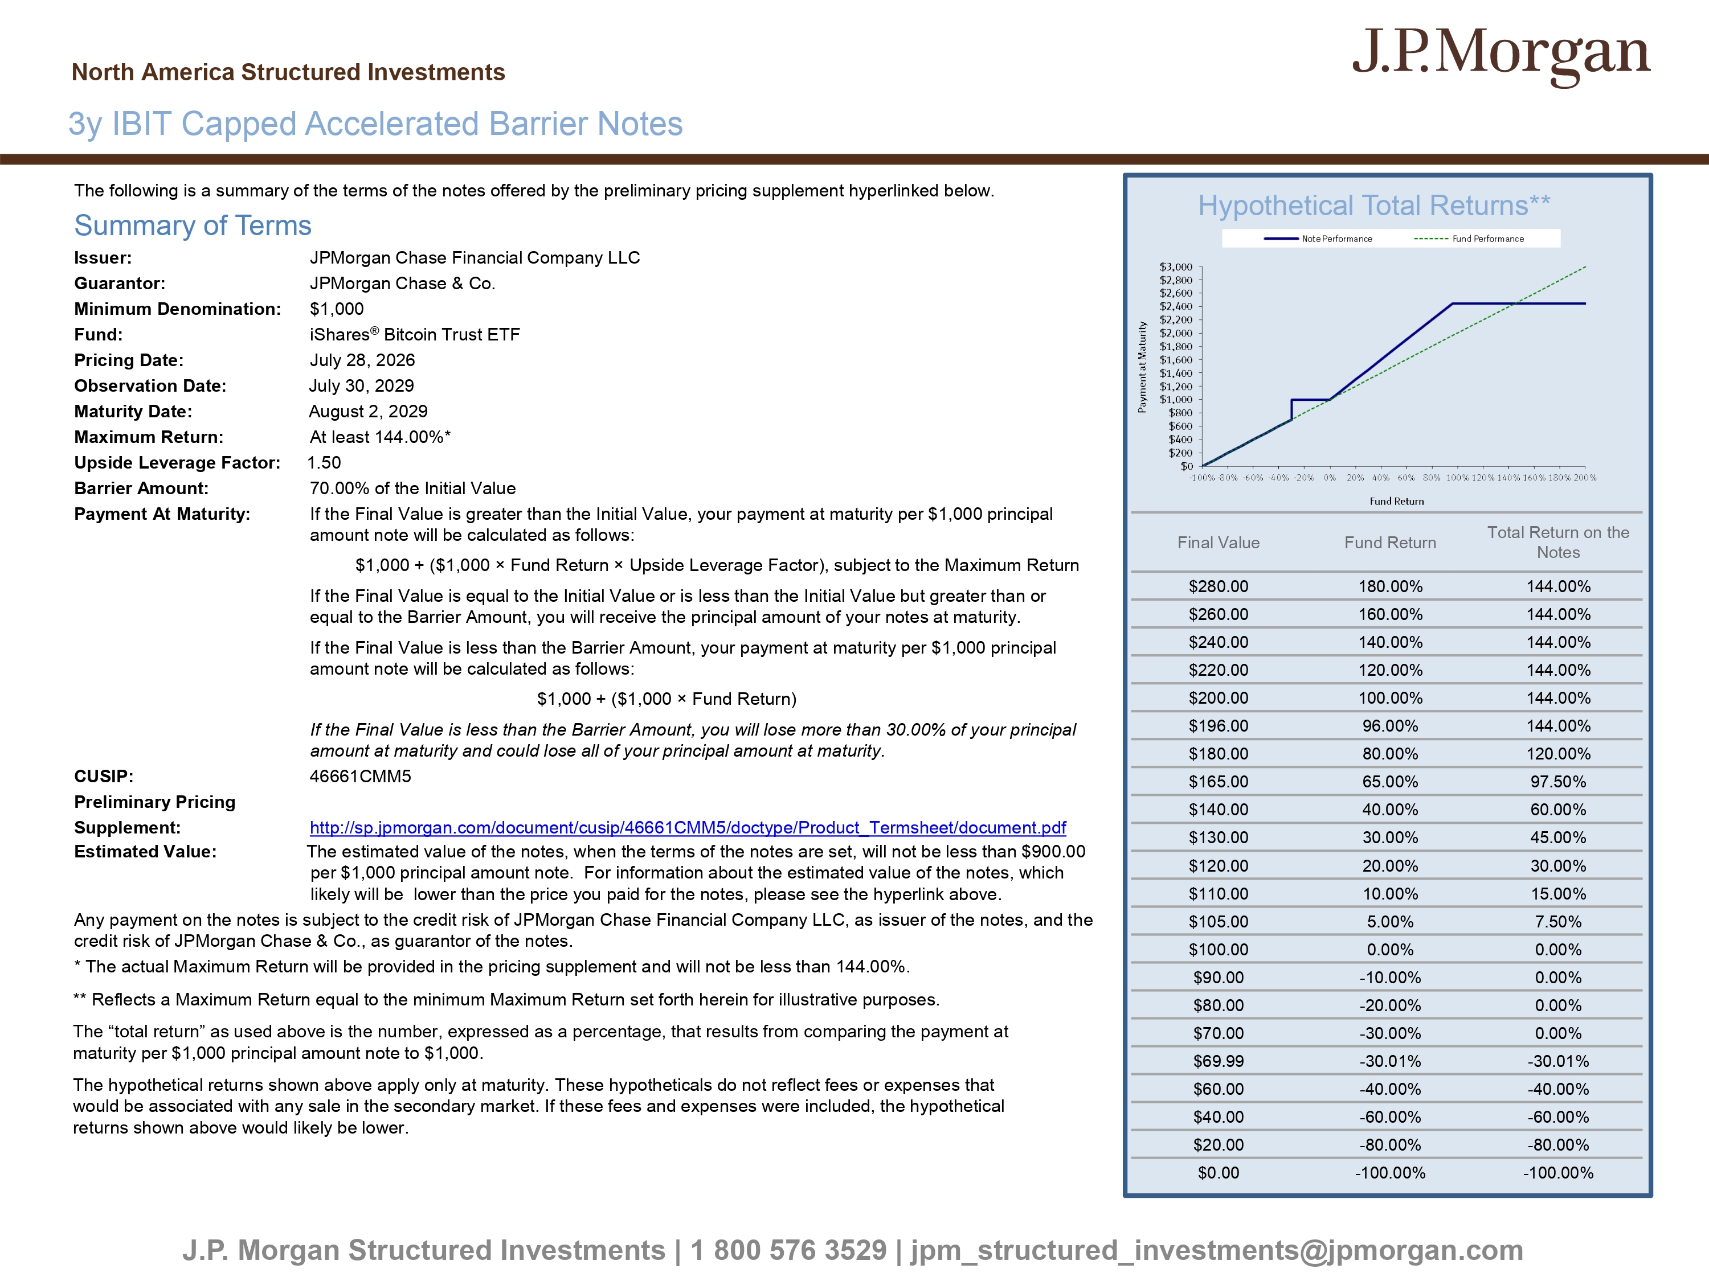
The following is a summary of the terms of the notes offered by the preliminary pricing supplement hyperlinked below. Summary of Terms Issuer: JPMorgan Chase Financial Company LLC Guarantor: JPMorgan Chase & Co. Minimum Denomination: $1,000 Fund: iShares ® Bitcoin Trust ETF Pricing Date: July 28, 2026 Observation Date: July 30, 2029 Maturity Date: August 2, 2029 Maximum Return: At least 144.00%* Upside Leverage Factor: 1.50 Barrier Amount: 70.00% of the Initial Value Payment At Maturity: If the Final Value is greater than the Initial Value, your payment at maturity per $1,000 principal amount note will be calculated as follows: $1,000 + ($1,000 î Fund Return î Upside Leverage Factor), subject to the Maximum Return If the Final Value is equal to the Initial Value or is less than the Initial Value but greater than or equal to the Barrier Amount, you will receive the principal amount of your notes at maturity. If the Final Value is less than the Barrier Amount, your payment at maturity per $1,000 principal amount note will be calculated as follows: $1,000 + ($1,000 î Fund Return) If the Final Value is less than the Barrier Amount, you will lose more than 30.00% of your principal amount at maturity and could lose all of your principal amount at maturity. CUSIP: 46661CMM5 Preliminary Pricing Supplement: http://sp.jpmorgan.com/document/cusip/46661CMM5/doctype/Product_Termsheet/document.pdf Estimated Value: The estimated value of the notes, when the terms of the notes are set, will not be less than $900.00 per $1,000 principal amount note. For information about the estimated value of the notes, which likely will be lower than the price you paid for the notes, please see the hyperlink above. Any payment on the notes is subject to the credit risk of JPMorgan Chase Financial Company LLC, as issuer of the notes, and t he credit risk of JPMorgan Chase & Co., as guarantor of the notes. * The actual Maximum Return will be provided in the pricing supplement and will not be less than 144.00%. Hypothetical Total Returns** J.P. Morgan Structured Investments | 1 800 576 3529 | jpm_structured_investments@jpmorgan.com Total Return on the Notes Fund Return Final Value 144.00% 180.00% $280.00 144.00% 160.00% $260.00 144.00% 140.00% $240.00 144.00% 120.00% $220.00 144.00% 100.00% $200.00 144.00% 96.00% $196.00 120.00% 80.00% $180.00 97.50% 65.00% $165.00 60.00% 40.00% $140.00 45.00% 30.00% $130.00 30.00% 20.00% $120.00 15.00% 10.00% $110.00 7.50% 5.00% $105.00 0.00% 0.00% $100.00 0.00% - 10.00% $90.00 0.00% - 20.00% $80.00 0.00% - 30.00% $70.00 - 30.01% - 30.01% $69.99 - 40.00% - 40.00% $60.00 - 60.00% - 60.00% $40.00 - 80.00% - 80.00% $20.00 - 100.00% - 100.00% $0.00 3y IBIT Capped Accelerated Barrier Notes North America Structured Investments ** Reflects a Maximum Return equal to the minimum Maximum Return set forth herein for illustrative purposes. The “total return” as used above is the number, expressed as a percentage, that results from comparing the payment at maturity per $1,000 principal amount note to $1,000. The hypothetical returns shown above apply only at maturity. These hypotheticals do not reflect fees or expenses that would be associated with any sale in the secondary market. If these fees and expenses were included, the hypothetical returns shown above would likely be lower.
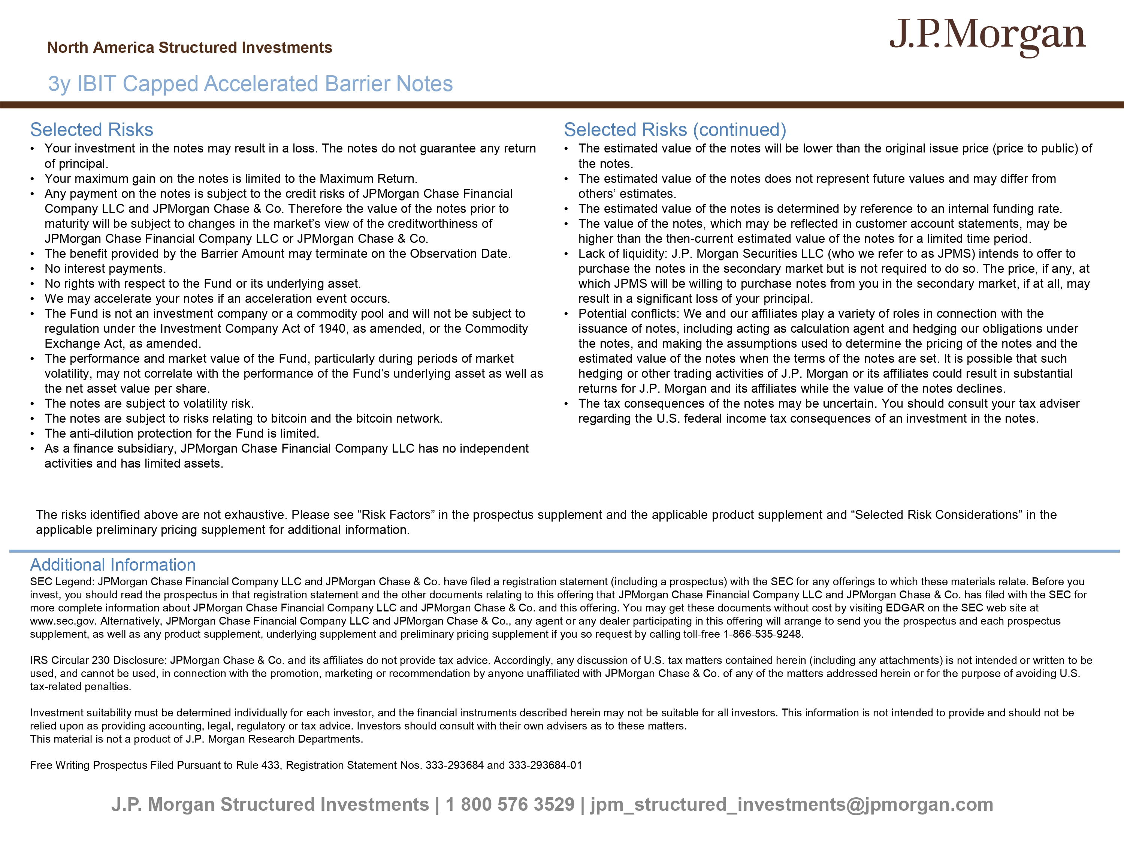
J.P. Morgan Structured Investments | 1 800 576 3529 | jpm_structured_investments@jpmorgan.com Selected Risks • Your investment in the notes may result in a loss. The notes do not guarantee any return of principal. • Your maximum gain on the notes is limited to the Maximum Return. • Any payment on the notes is subject to the credit risks of JPMorgan Chase Financial Company LLC and JPMorgan Chase & Co. Therefore the value of the notes prior to maturity will be subject to changes in the market’s view of the creditworthiness of JPMorgan Chase Financial Company LLC or JPMorgan Chase & Co. • The benefit provided by the Barrier Amount may terminate on the Observation Date. • No interest payments. • No rights with respect to the Fund or its underlying asset. • We may accelerate your notes if an acceleration event occurs. • The Fund is not an investment company or a commodity pool and will not be subject to regulation under the Investment Company Act of 1940, as amended, or the Commodity Exchange Act, as amended. • The performance and market value of the Fund, particularly during periods of market volatility, may not correlate with the performance of the Fund’s underlying asset as well as the net asset value per share. • The notes are subject to volatility risk. • The notes are subject to risks relating to bitcoin and the bitcoin network. • The anti - dilution protection for the Fund is limited. • As a finance subsidiary, JPMorgan Chase Financial Company LLC has no independent activities and has limited assets. Selected Risks (continued) • The estimated value of the notes will be lower than the original issue price (price to public) of the notes. • The estimated value of the notes does not represent future values and may differ from others’ estimates. • The estimated value of the notes is determined by reference to an internal funding rate. • The value of the notes, which may be reflected in customer account statements, may be higher than the then - current estimated value of the notes for a limited time period. • Lack of liquidity: J.P. Morgan Securities LLC (who we refer to as JPMS) intends to offer to purchase the notes in the secondary market but is not required to do so. The price, if any, at which JPMS will be willing to purchase notes from you in the secondary market, if at all, may result in a significant loss of your principal. • Potential conflicts: We and our affiliates play a variety of roles in connection with the issuance of notes, including acting as calculation agent and hedging our obligations under the notes, and making the assumptions used to determine the pricing of the notes and the estimated value of the notes when the terms of the notes are set. It is possible that such hedging or other trading activities of J.P. Morgan or its affiliates could result in substantial returns for J.P. Morgan and its affiliates while the value of the notes declines. • The tax consequences of the notes may be uncertain. You should consult your tax adviser regarding the U.S. federal income tax consequences of an investment in the notes. Additional Information SEC Legend: JPMorgan Chase Financial Company LLC and JPMorgan Chase & Co. have filed a registration statement (including a pr osp ectus) with the SEC for any offerings to which these materials relate. Before you invest, you should read the prospectus in that registration statement and the other documents relating to this offering that JPM organ Chase Financial Company LLC and JPMorgan Chase & Co. has filed with the SEC for more complete information about JPMorgan Chase Financial Company LLC and JPMorgan Chase & Co. and this offering. You may get the se documents without cost by visiting EDGAR on the SEC web site at www.sec.gov. Alternatively, JPMorgan Chase Financial Company LLC and JPMorgan Chase & Co., any agent or any dealer participat ing in this offering will arrange to send you the prospectus and each prospectus supplement, as well as any product supplement, underlying supplement and preliminary pricing supplement if you so request by cal ling toll - free 1 - 866 - 535 - 9248. IRS Circular 230 Disclosure: JPMorgan Chase & Co. and its affiliates do not provide tax advice. Accordingly, any discussion o f U .S. tax matters contained herein (including any attachments) is not intended or written to be used, and cannot be used, in connection with the promotion, marketing or recommendation by anyone unaffiliated with JPMorgan Cha se & Co. of any of the matters addressed herein or for the purpose of avoiding U.S. tax - related penalties. Investment suitability must be determined individually for each investor, and the financial instruments described herein may not be suitable for all investors. This information is not intended to provide and should not be relied upon as providing accounting, legal, regulatory or tax advice. Investors should consult with their own advisers as to the se matters. This material is not a product of J.P. Morgan Research Departments. Free Writing Prospectus Filed Pursuant to Rule 433, Registration Statement Nos. 333 - 293684 and 333 - 293684 - 01 3y IBIT Capped Accelerated Barrier Notes North America Structured Investments The risks identified above are not exhaustive. Please see “Risk Factors” in the prospectus supplement and the applicable prod uct supplement and “Selected Risk Considerations” in the applicable preliminary pricing supplement for additional information.

