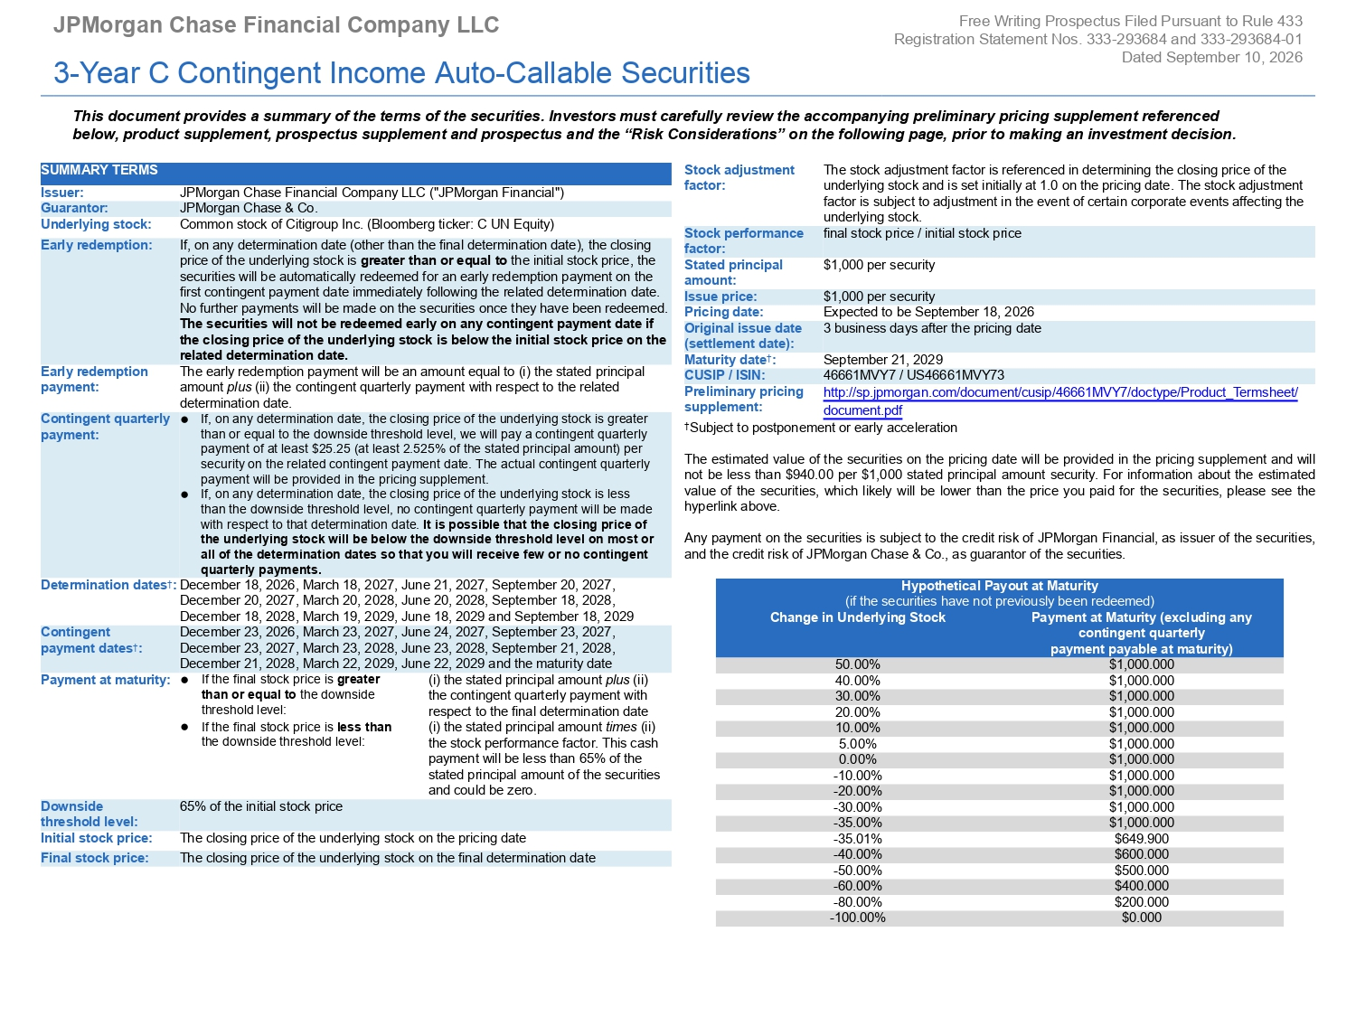
JPMorgan Chase Financial Company LLC 3 - Year C Contingent Income Auto - Callable Securities Free Writing Prospectus Filed Pursuant to Rule 433 Registration Statement Nos. 333 - 293684 and 333 - 293684 - 01 Dated September 10, 2026 This document provides a summary of the terms of the securities. Investors must carefully review the accompanying preliminary pricing supplement referenced below, product supplement, prospectus supplement and prospectus and the “Risk Considerations” on the following page, prior to making an investment decision. SUMMARY TERMS JPMorgan Chase Financial Company LLC ("JPMorgan Financial") Issuer: JPMorgan Chase & Co. Guarantor: Common stock of Citigroup Inc. (Bloomberg ticker: C UN Equity) Underlying stock: Early redemption: If, on any determination date (other than the final determination date), the closing price of the underlying stock is greater than or equal to the initial stock price, the securities will be automatically redeemed for an early redemption payment on the first contingent payment date immediately following the related determination date. No further payments will be made on the securities once they have been redeemed. The securities will not be redeemed early on any contingent payment date if the closing price of the underlying stock is below the initial stock price on the related determination date. Early redemption payment: The early redemption payment will be an amount equal to (i) the stated principal amount plus (ii) the contingent quarterly payment with respect to the related determination date. Contingent quarterly Ɣ If, on any determination date, the closing price of the underlying stock is greater payment: than or equal to the downside threshold level, we will pay a contingent quarterly payment of at least $25.25 (at least 2.525% of the stated principal amount) per security on the related contingent payment date. The actual contingent quarterly payment will be provided in the pricing supplement. ● If, on any determination date, the closing price of the underlying stock is less than the downside threshold level, no contingent quarterly payment will be made with respect to that determination date. It is possible that the closing price of the underlying stock will be below the downside threshold level on most or all of the determination dates so that you will receive few or no contingent quarterly payments. Stock adjustment factor: The stock adjustment factor is referenced in determining the closing price of the underlying stock and is set initially at 1.0 on the pricing date. The stock adjustment factor is subject to adjustment in the event of certain corporate events affecting the underlying stock. Stock performance final stock price / initial stock price factor: Stated principal $1,000 per security amount: Issue price: $1,000 per security Pricing date: Expected to be September 18, 2026 Original issue date 3 business days after the pricing date (settlement date): Maturity date † : September 21, 2029 CUSIP / ISIN: 46661MVY7 / US46661MVY73 Preliminary pricing supplement: http://sp.jpmorgan.com/document/cusip/46661MVY7/doctype/Product_Termsheet/ document.pdf † Subject to postponement or early acceleration The estimated value of the securities on the pricing date will be provided in the pricing supplement and will not be less than $ 940 . 00 per $ 1 , 000 stated principal amount security . For information about the estimated value of the securities, which likely will be lower than the price you paid for the securities, please see the hyperlink above . Any payment on the securities is subject to the credit risk of JPMorgan Financial, as issuer of the securities, and the credit risk of JPMorgan Chase & Co., as guarantor of the securities. Hypothetical Payout at Maturity (if the securities have not previously been redeemed) Change in Underlying Stock Payment at Maturity (excluding any contingent quarterly payment payable at maturity) 50.00% $1,000.000 Determination dates † : December 18, 2026, March 18, 2027, June 21, 2027, September 20, 2027, December 20, 2027, March 20, 2028, June 20, 2028, September 18, 2028, December 18, 2028, March 19, 2029, June 18, 2029 and September 18, 2029 Contingent December 23, 2026, March 23, 2027, June 24, 2027, September 23, 2027, payment dates † : December 23, 2027, March 23, 2028, June 23, 2028, September 21, 2028, December 21, 2028, March 22, 2029, June 22, 2029 and the maturity date $1,000.000 40.00% Payment at maturity: Ɣ If the final stock price is greater (i) the stated principal amount plus (ii) $1,000.000 30.00% than or equal to the downside the contingent quarterly payment with $1,000.000 20.00% threshold level: respect to the final determination date $1,000.000 10.00% ● If the final stock price is less than (i) the stated principal amount times (ii) $1,000.000 5.00% the downside threshold level: the stock performance factor. This cash $1,000.000 0.00% payment will be less than 65% of the $1,000.000 - 10.00% stated principal amount of the securities $1,000.000 - 20.00% and could be zero. $1,000.000 - 30.00% Downside 65% of the initial stock price $1,000.000 - 35.00% threshold level: $649.900 - 35.01% Initial stock price: The closing price of the underlying stock on the pricing date $600.000 - 40.00% Final stock price: The closing price of the underlying stock on the final determination date $500.000 - 50.00% $400.000 - 60.00% $200.000 - 80.00% $0.000 - 100.00%
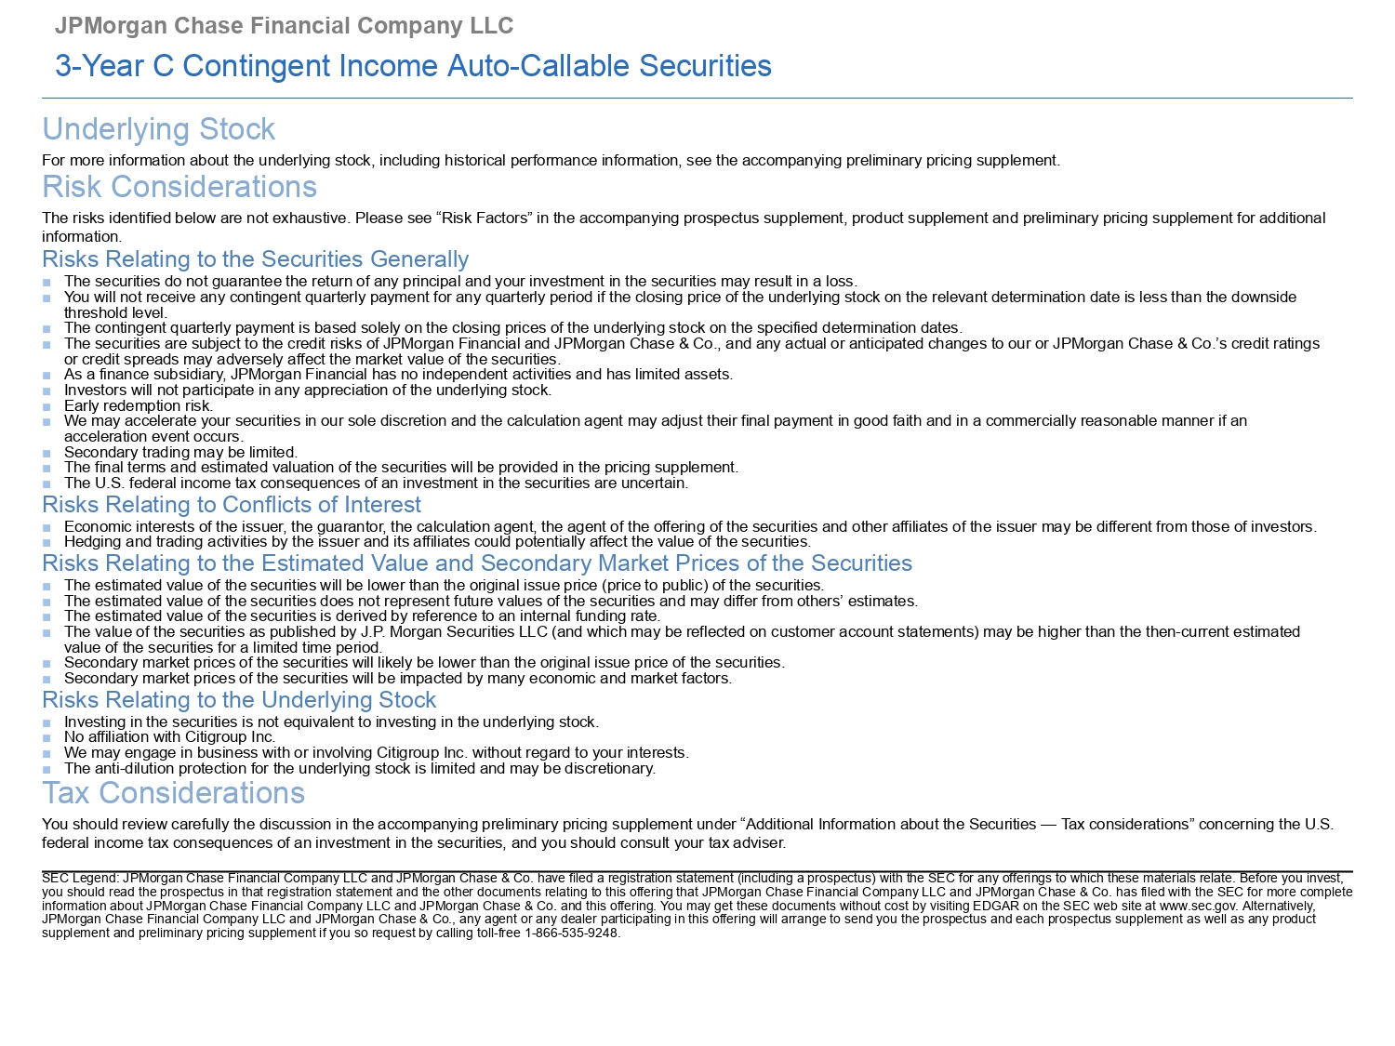
JPMorgan Chase Financial Company LLC 3 - Year C Contingent Income Auto - Callable Securities Underlying Stock For more information about the underlying stock, including historical performance information, see the accompanying preliminary pricing supplement. Risk Considerations The risks identified below are not exhaustive. Please see “Risk Factors” in the accompanying prospectus supplement, product supplement and preliminary pricing supplement for additional information. Risks Relating to the Securities Generally ■ The securities do not guarantee the return of any principal and your investment in the securities may result in a loss. ■ You will not receive any contingent quarterly payment for any quarterly period if the closing price of the underlying stock on the relevant determination date is less than the downside threshold level. ■ The contingent quarterly payment is based solely on the closing prices of the underlying stock on the specified determination dates. ■ The securities are subject to the credit risks of JPMorgan Financial and JPMorgan Chase & Co., and any actual or anticipated changes to our or JPMorgan Chase & Co.’s credit ratings or credit spreads may adversely affect the market value of the securities. ■ As a finance subsidiary, JPMorgan Financial has no independent activities and has limited assets. ■ Investors will not participate in any appreciation of the underlying stock. ■ Early redemption risk. ■ We may accelerate your securities in our sole discretion and the calculation agent may adjust their final payment in good faith and in a commercially reasonable manner if an acceleration event occurs. ■ Secondary trading may be limited. ■ The final terms and estimated valuation of the securities will be provided in the pricing supplement. ■ The U.S. federal income tax consequences of an investment in the securities are uncertain. Risks Relating to Conflicts of Interest ■ Economic interests of the issuer, the guarantor, the calculation agent, the agent of the offering of the securities and other affiliates of the issuer may be different from those of investors. ■ Hedging and trading activities by the issuer and its affiliates could potentially affect the value of the securities. Risks Relating to the Estimated Value and Secondary Market Prices of the Securities ■ The estimated value of the securities will be lower than the original issue price (price to public) of the securities. ■ The estimated value of the securities does not represent future values of the securities and may differ from others’ estimates. ■ The estimated value of the securities is derived by reference to an internal funding rate. ■ The value of the securities as published by J.P. Morgan Securities LLC (and which may be reflected on customer account statements) may be higher than the then - current estimated value of the securities for a limited time period. ■ Secondary market prices of the securities will likely be lower than the original issue price of the securities. ■ Secondary market prices of the securities will be impacted by many economic and market factors. Risks Relating to the Underlying Stock ■ Investing in the securities is not equivalent to investing in the underlying stock. ■ No affiliation with Citigroup Inc. ■ We may engage in business with or involving Citigroup Inc. without regard to your interests. ■ The anti - dilution protection for the underlying stock is limited and may be discretionary. Tax Considerations You should review carefully the discussion in the accompanying preliminary pricing supplement under “Additional Information about the Securities — Tax considerations” concerning the U.S. federal income tax consequences of an investment in the securities, and you should consult your tax adviser. SEC Legend: JPMorgan Chase Financial Company LLC and JPMorgan Chase & Co. have filed a registration statement (including a prospectus) with the SEC for any offerings to which these materials relate. Before you invest, you should read the prospectus in that registration statement and the other documents relating to this offering that JPMorgan Chase Financial Company LLC and JPMorgan Chase & Co. has filed with the SEC for more complete information about JPMorgan Chase Financial Company LLC and JPMorgan Chase & Co. and this offering. You may get these documents without cost by visiting EDGAR on the SEC web site at www.sec.gov . Alternatively, JPMorgan Chase Financial Company LLC and JPMorgan Chase & Co., any agent or any dealer participating in this offering will arrange to send you the prospectus and each prospectus supplement as well as any product supplement and preliminary pricing supplement if you so request by calling toll - free 1 - 866 - 535 - 9248.

