UNITED STATES
SECURITIES AND EXCHANGE COMMISSION
Washington, D.C. 20549
FORM 8-K
CURRENT REPORT
Pursuant to Section 13 or 15(d) of the Securities Exchange Act of 1934
Date of Report (date of earliest event reported): February 23, 2026
JPMorgan Chase & Co.
(Exact name of registrant as specified in its charter)
Delaware |  |  |  |  |  | 1-5805 |  |  |  |  |  | 13-2624428
(State or other jurisdiction of  incorporation or organization) |  |  |  |  |  | (Commission File Number) |  |  |  |  |  | (I.R.S. employer  identification no.)
270 Park Avenue,
New York, |  |  | New York |  |  |  |  |  |  |  |  | 10017
(Address of principal executive offices) |  |  |  |  |  |  |  |  |  |  |  | (Zip Code)
Registrant’s telephone number, including area code: (212) 270-6000
Check the appropriate box below if the Form 8-K filing is intended to simultaneously satisfy the filing obligation of the registrant under any of the following provisions:
☐ |  |  |  |  |  | Written communications pursuant to Rule 425 under the Securities Act (17 CFR 230.425)
☐ |  |  |  |  |  | Soliciting material pursuant to Rule 14a-12 under the Exchange Act (17 CFR 240.14a-12)
☐ |  |  |  |  |  | Pre-commencement communications pursuant to Rule 14d-2(b) under the Exchange Act (17 CFR 240.14d-2(b))
☐ |  |  |  |  |  | Pre-commencement communications pursuant to Rule 13e-4(c) under the Exchange Act (17 CFR 240.13e-4(c))
Securities registered pursuant to Section 12(b) of the Act:
Title of each class |  |  | Trading Symbol(s) |  |  | Name of each exchange on which registered
Common stock |  |  | JPM |  |  | The New York Stock Exchange
Depositary Shares, each representing a one-four hundredth interest in a share of 5.75% Non-Cumulative Preferred Stock, Series DD |  |  | JPM PR D |  |  | The New York Stock Exchange
Depositary Shares, each representing a one-four hundredth interest in a share of 6.00% Non-Cumulative Preferred Stock, Series EE |  |  | JPM PR C |  |  | The New York Stock Exchange
Depositary Shares, each representing a one-four hundredth interest in a share of 4.75% Non-Cumulative Preferred Stock, Series GG |  |  | JPM PR J |  |  | The New York Stock Exchange
Depositary Shares, each representing a one-four hundredth interest in a share of 4.55% Non-Cumulative Preferred Stock, Series JJ |  |  | JPM PR K |  |  | The New York Stock Exchange
Depositary Shares, each representing a one-four hundredth interest in a share of 4.625% Non-Cumulative Preferred Stock, Series LL |  |  | JPM PR L |  |  | The New York Stock Exchange
Depositary Shares, each representing a one-four hundredth interest in a share of 4.20% Non-Cumulative Preferred Stock, Series MM |  |  | JPM PR M |  |  | The New York Stock Exchange
Guarantee of Callable Fixed Rate Notes due June 10, 2032 of JPMorgan Chase Financial Company LLC |  |  | JPM/32 |  |  | The New York Stock Exchange
Guarantee of Alerian MLP Index ETNs due January 28, 2044 of JPMorgan Chase Financial Company LLC |  |  | AMJB |  |  | NYSE Arca, Inc.
Guarantee of Inverse VIX Short-Term Futures ETNs due March 22, 2045 of JPMorgan Chase Financial Company LLC |  |  | VYLD |  |  | NYSE Arca, Inc.
Indicate by check mark whether the registrant is an emerging growth company as defined in Rule 405 of the Securities Act of 1933 (§230.405 of this chapter) or Rule 12b-2 of the Securities Exchange Act of 1934 (§240.12b-2 of this chapter).
Emerging growth company ☐
If an emerging growth company, indicate by check mark if the registrant has elected not to use the extended transition period for complying with any new or revised financial accounting standards provided pursuant to Section 13(a) of the Exchange Act. ☐

Item 7.01 Regulation FD Disclosure
On February 23, 2026, JPMorgan Chase & Co. (“JPMorganChase” or the “Firm”) held a Company Update presentation during which it provided information to investors about the Firm. Exhibits 99.1, 99.2, and 99.3 are copies of the slides furnished at, and posted on the Firm’s website in connection with, the presentation.
The slides are being furnished pursuant to Item 7.01, and the information contained therein shall not be deemed “filed” for purposes of Section 18 of the Securities Exchange Act of 1934, or otherwise subject to the liabilities under that Section. Furthermore, the information contained in the Exhibits hereto shall not be deemed to be incorporated by reference into the filings of the Firm under the Securities Act of 1933.
This Current Report on Form 8-K (including the Exhibits hereto) contains forward-looking statements within the meaning of the Private Securities Litigation Reform Act of 1995. These statements are based on the current beliefs and expectations of JPMorganChase’s management and are subject to significant risks and uncertainties. Actual results may differ from those set forth in the forward-looking statements. Factors that could cause JPMorganChase’s actual results to differ materially from those described in the forward-looking statements can be found in JPMorganChase’s Annual Report on Form 10-K for the year ended December 31, 2025, which has been filed with the Securities and Exchange Commission and is available on JPMorganChase’s website (https://jpmorganchaseco.gcs-web.com/ir/sec-other-filings/overview) and on the Securities and Exchange Commission’s website (www.sec.gov). JPMorganChase does not undertake to update any forward-looking statements.

Item 9.01 Financial Statements and Exhibits

(d) Exhibits
Exhibit No. |  |  |  |  |  | Description of Exhibit
99.1 |  |  |  |  |  | JPMorgan Chase & Co. 2026 Company Update cover page and agenda
99.2 |  |  |  |  |  | JPMorgan Chase & Co. 2026 Company Update presentation slides
99.3 |  |  |  |  |  | JPMorgan Chase & Co. 2026 Company Update speaker biographies
101 |  |  |  |  |  | Pursuant to Rule 406 of Regulation S-T, the cover page is formatted in Inline XBRL (Inline eXtensible Business Reporting Language).
104 |  |  |  |  |  | Cover Page Interactive Data File (embedded within the Inline XBRL document and included in Exhibit 101).

2

SIGNATURE

Pursuant to the requirements of the Securities Exchange Act of 1934, the Registrant has duly caused this report to be signed on its behalf by the undersigned hereunto duly authorized.
JPMorgan Chase & Co.
(Registrant)

By: |  |  | /s/ Elena Korablina
 |  |  | Elena Korablina
 |  |  | Managing Director and Firmwide Controller
 |  |  | (Principal Accounting Officer)

Dated: |  |  | February 23, 2026


3
e 2026 February 23, 2026 Exhibit 99.1


Company Update 2026 3:45 PM - 4:30 PM 4:30 PM - 5:10PM 5:10 PM - 5:55 PM Registration Firm Overview Line of Business Q&A 5:55 PM - 6:05 PM Break 6:05 PM - 6:35 PM 6:35 PM - 7:30 PM Chairman and CEO Q&A Cocktail Hour with Senior Leaders Jeremy Barnum Marianne Lake, Mary Callahan Erdoes, Doug Petno, Troy Rohrbaugh Jamie Dimon


Exhibit 99.2

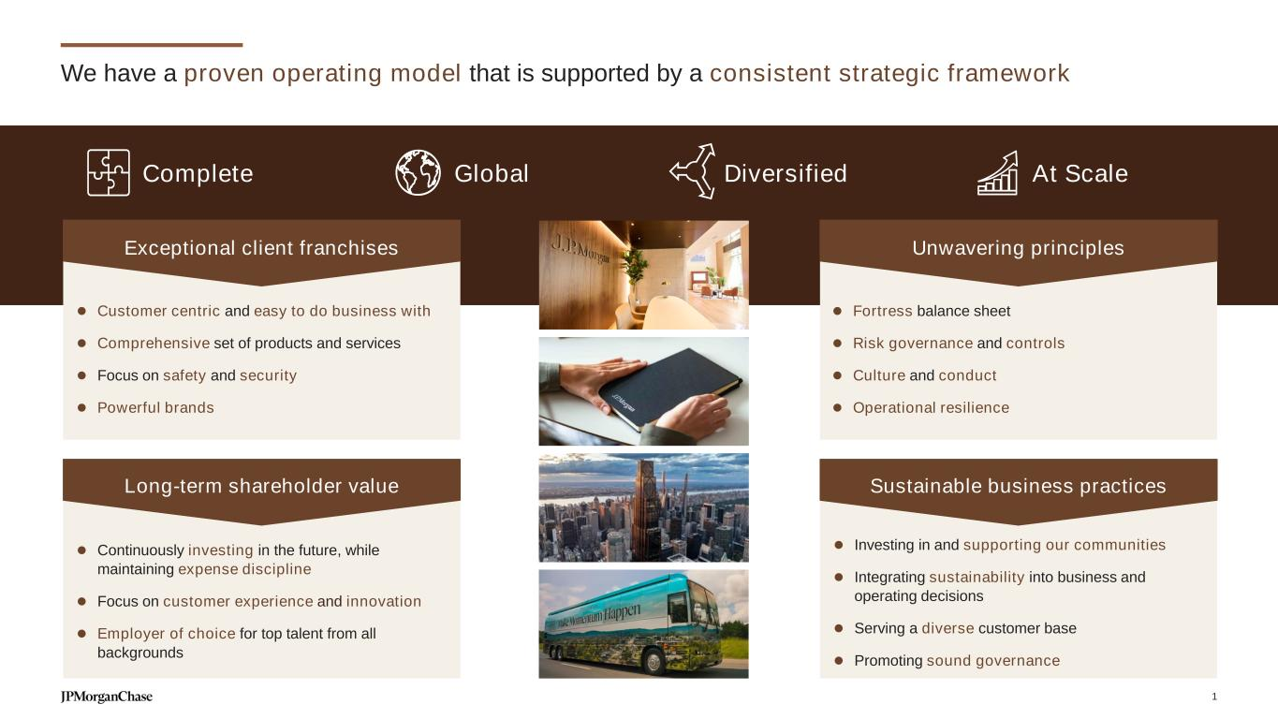
Complete Global Diversified At Scale We have a proven operating model that is supported by a consistent strategic framework ⚫ Continuously investing in the future, while maintaining expense discipline ⚫ Focus on customer experience and innovation ⚫ Employer of choice for top talent from all backgrounds Long-term shareholder value ⚫ Customer centric and easy to do business with ⚫ Comprehensive set of products and services ⚫ Focus on safety and security ⚫ Powerful brands ⚫ Fortress balance sheet ⚫ Risk governance and controls ⚫ Culture and conduct ⚫ Operational resilience Unwavering principles ⚫ Investing in and supporting our communities ⚫ Integrating sustainability into business and operating decisions ⚫ Serving a diverse customer base ⚫ Promoting sound governance Sustainable business practices Exceptional client franchises 1

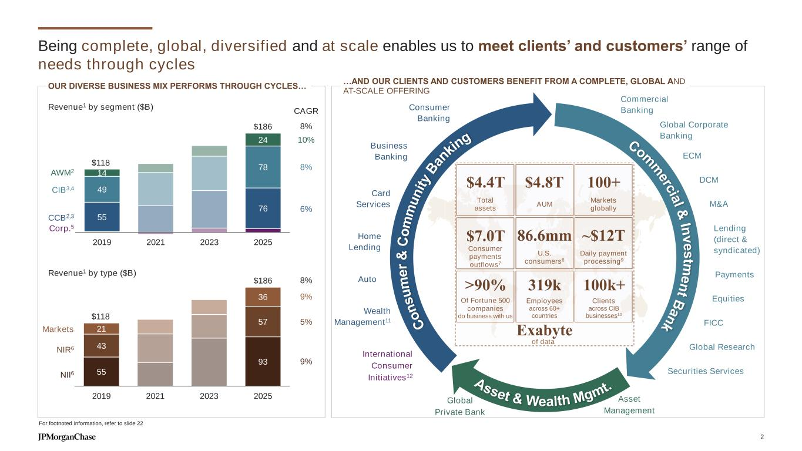
$118 $186 55 76 49 78 14 24 2019 2021 2023 2025 Being complete, global, diversified and at scale enables us to meet clients’ and customers’ range of needs through cycles CCB2,3 CIB3,4 AWM2 Corp.5 Revenue1 by segment ($B) OUR DIVERSE BUSINESS MIX PERFORMS THROUGH CYCLES… 55 93 43 57 21 36 $118 $186 2019 2021 2023 2025 NII6 NIR6 Markets Revenue1 by type ($B) For footnoted information, refer to slide 22 CAGR 10% 8% 6% 9% 5% 9% 8% 8% C o n s u m e r & C o m m u n it y B an ki ng Asset & Wealth Mgmt. Com m erc ia l & In v e s tm e n t B a n k Fill level DCM Lending (direct & syndicated) Payments M&A FICC Equities Global Research ECM Business Banking International Consumer Initiatives12 Wealth Management11 Home Lending Auto Asset Management Securities Services Global Private Bank Card Services Global Corporate Banking Commercial BankingConsumer Banking Total assets AUM U.S. consumers8 Clients across CIB businesses10 Employees across 60+ countries Of Fortune 500 companies do business with us Consumer payments outflows7 Daily payment processing9 Markets globally $4.8T 86.6mm 319k>90% $7.0T ~$12T 100+$4.4T of data Exabyte 100k+ …AND OUR CLIENTS AND CUSTOMERS BENEFIT FROM A COMPLETE, GLOBAL AND AT-SCALE OFFERING 2

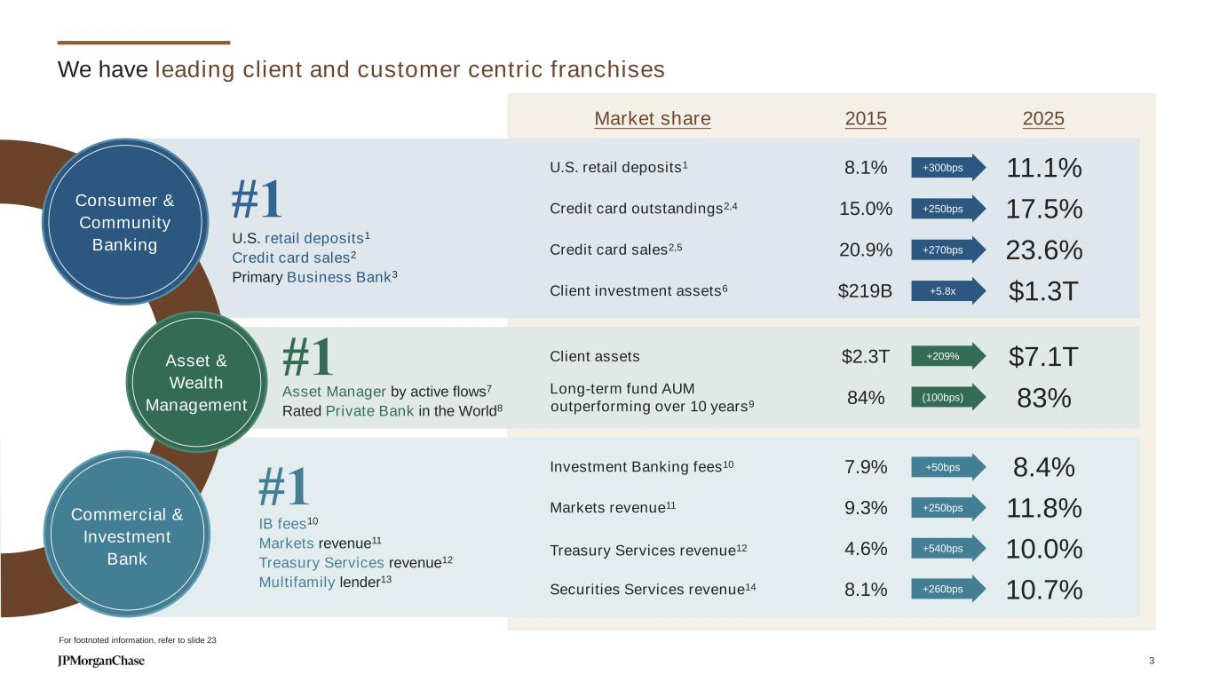
We have leading client and customer centric franchises U.S. retail deposits1 8.1% 11.1% Credit card outstandings2,4 15.0% 17.5% Credit card sales2,5 20.9% 23.6% Client investment assets6 $219B $1.3T Investment Banking fees10 7.9% 8.4% Markets revenue11 9.3% 11.8% Treasury Services revenue12 4.6% 10.0% Securities Services revenue14 8.1% 10.7% Client assets $2.3T $7.1T Long-term fund AUM outperforming over 10 years9 84% 83% +300bps +260bps+250bps +3.5x5.8 +3.5x+209% +3.5x(100bps) +3.5x+50bps +3.5x+250bps +3.5x+540bps +3.5x+260bps For footnoted information, refer to slide 23 #1 IB fees10 Markets revenue11 Treasury Services revenue12 Multifamily lender13 #1 U.S. retail deposits1 Credit card sales2 Primary Business Bank3 #1 Asset Manager by active flows7 Rated Private Bank in the World8 Market share 2015 2025 +3.5x+270bps Consumer & Community Banking Asset & Wealth Management Commercial & Investment Bank 3

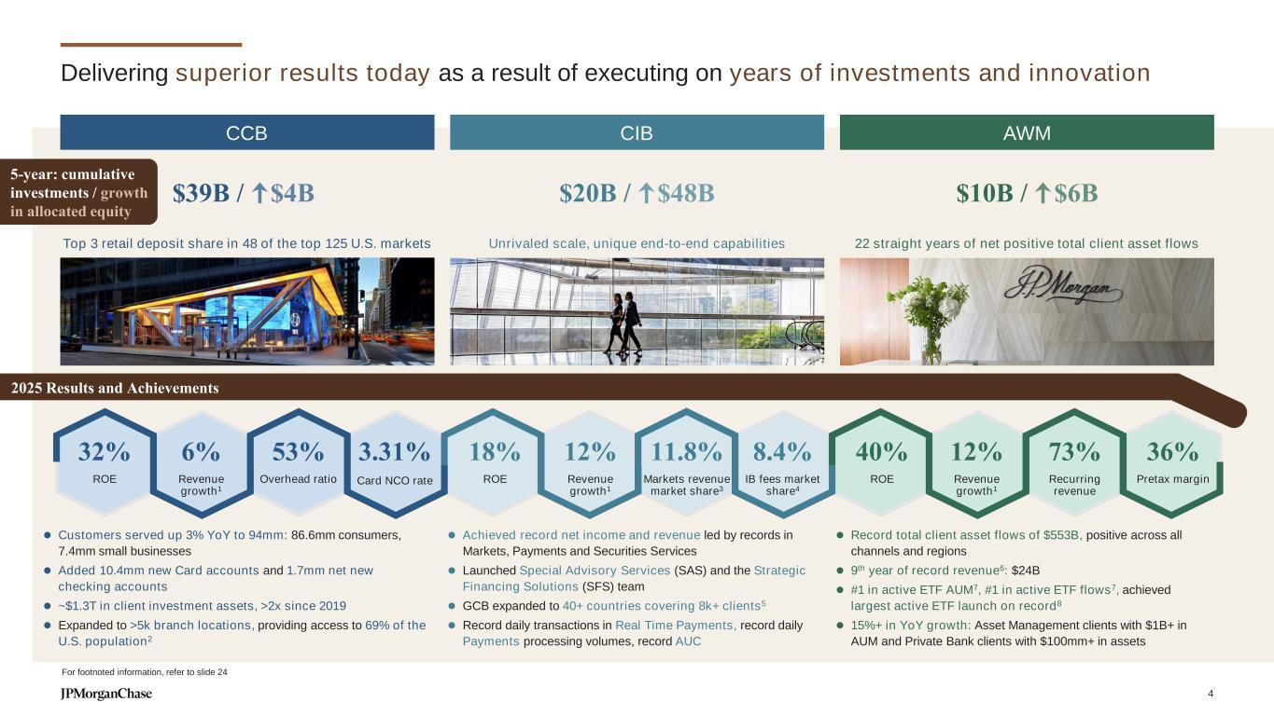
Delivering superior results today as a result of executing on years of investments and innovation ⚫ Achieved record net income and revenue led by records in Markets, Payments and Securities Services ⚫ Launched Special Advisory Services (SAS) and the Strategic Financing Solutions (SFS) team ⚫ GCB expanded to 40+ countries covering 8k+ clients5 ⚫ Record daily transactions in Real Time Payments, record daily Payments processing volumes, record AUC ⚫ Customers served up 3% YoY to 94mm: 86.6mm consumers, 7.4mm small businesses ⚫ Added 10.4mm new Card accounts and 1.7mm net new checking accounts ⚫ ~$1.3T in client investment assets, >2x since 2019 ⚫ Expanded to >5k branch locations, providing access to 69% of the U.S. population2 ⚫ Record total client asset flows of $553B, positive across all channels and regions ⚫ 9th year of record revenue6: $24B ⚫ #1 in active ETF AUM7, #1 in active ETF flows7, achieved largest active ETF launch on record8 ⚫ 15%+ in YoY growth: Asset Management clients with $1B+ in AUM and Private Bank clients with $100mm+ in assets Top 3 retail deposit share in 48 of the top 125 U.S. markets Unrivaled scale, unique end-to-end capabilities 22 straight years of net positive total client asset flows $20B / $48B $10B / $6B 32% ROE 6% Revenue growth1 3.31% Card NCO rate 53% Overhead ratio 18% ROE 12% Revenue growth1 11.8% Markets revenue market share3 8.4% IB fees market share4 40% ROE 12% Revenue growth1 73% Recurring revenue 36% Pretax margin 2025 Results and Achievements For footnoted information, refer to slide 24 $39B / $4B CCB AWMCIB 5-year: cumulative investments / growth in allocated equity 4

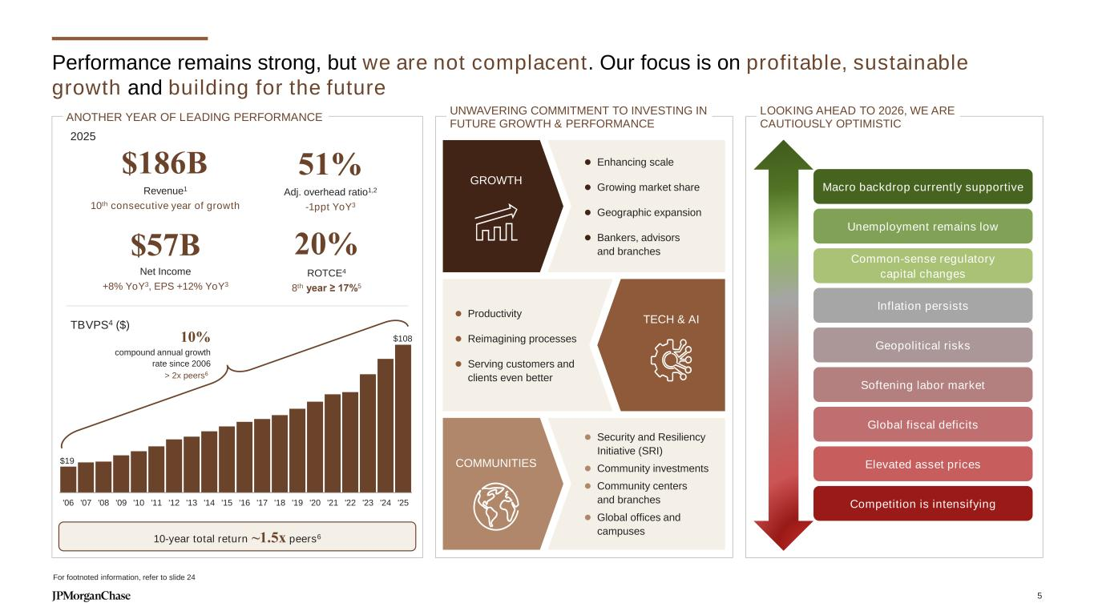
Performance remains strong, but we are not complacent. Our focus is on profitable, sustainable growth and building for the future For footnoted information, refer to slide 24 UNWAVERING COMMITMENT TO INVESTING IN FUTURE GROWTH & PERFORMANCE $108 $19 '06 '07 '08 '09 '10 '11 '12 '13 '14 '15 '16 '17 '18 '19 '20 '21 '22 '23 '24 '25 10% compound annual growth rate since 2006 > 2x peers6 TBVPS4 ($) $186B Revenue1 10th consecutive year of growth 51% Adj. overhead ratio1,2 -1ppt YoY3 $57B Net Income +8% YoY3, EPS +12% YoY3 2025 20% ROTCE4 8th year ≥ 17%5 ANOTHER YEAR OF LEADING PERFORMANCE Macro backdrop currently supportive Unemployment remains low Common-sense regulatory capital changes Competition is intensifying Inflation persists Geopolitical risks Softening labor market Elevated asset prices ⚫ Enhancing scale ⚫ Growing market share ⚫ Geographic expansion ⚫ Bankers, advisors and branches GROWTH ⚫ Productivity ⚫ Reimagining processes ⚫ Serving customers and clients even better TECH & AI ⚫ Security and Resiliency Initiative (SRI) ⚫ Community investments ⚫ Community centers and branches ⚫ Global offices and campuses COMMUNITIES 10-year total return ~1.5x peers6 Global fiscal deficits LOOKING AHEAD TO 2026, WE ARE CAUTIOUSLY OPTIMISTIC 5

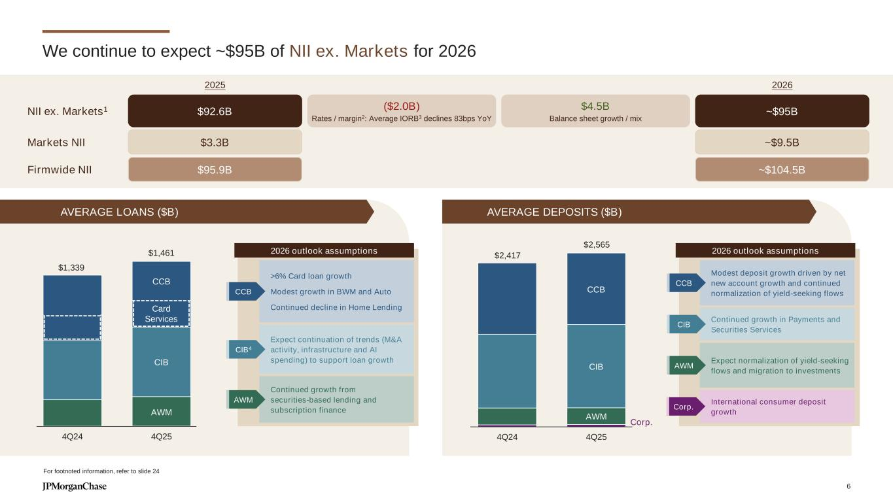
$1,339 $1,461 4Q24 4Q25 $2,417 $2,565 4Q24 4Q25 We continue to expect ~$95B of NII ex. Markets for 2026 For footnoted information, refer to slide 24 CCB AWM 2026 outlook assumptions CCB AWM 2026 outlook assumptions CIB CIB Card Services >6% Card loan growth Modest growth in BWM and Auto Continued decline in Home Lending CCB Expect continuation of trends (M&A activity, infrastructure and AI spending) to support loan growth CIB4 Continued growth from securities-based lending and subscription finance AWM Modest deposit growth driven by net new account growth and continued normalization of yield-seeking flows CCB Continued growth in Payments and Securities Services CIB Expect normalization of yield-seeking flows and migration to investments AWM AVERAGE LOANS ($B) AVERAGE DEPOSITS ($B) Corp. International consumer deposit growth Corp. NII ex. Markets1 $92.6B 2025 ($2.0B) Rates / margin2: Average IORB3 declines 83bps YoY $4.5B Balance sheet growth / mix ~$95B 2026 Markets NII $3.3B ~$9.5B Firmwide NII $95.9B ~$104.5B 6

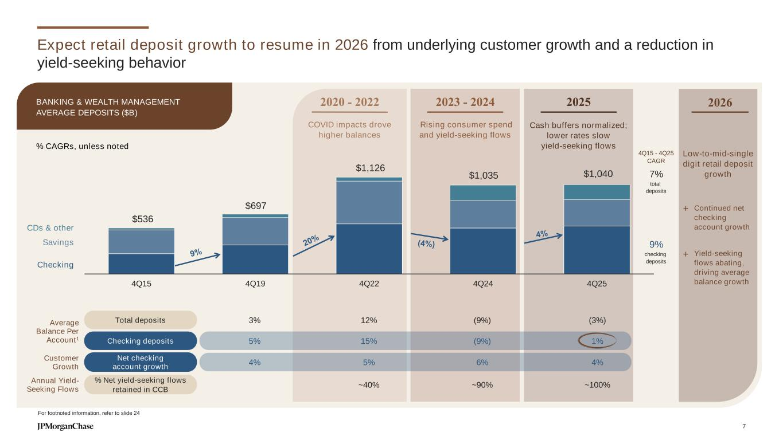
Expect retail deposit growth to resume in 2026 from underlying customer growth and a reduction in yield-seeking behavior $536 $697 $1,126 $1,035 $1,040 4Q15 4Q19 4Q22 4Q24 4Q25 Checking Savings CDs & other 2020 - 2022 2023 - 2024 COVID impacts drove higher balances Rising consumer spend and yield-seeking flows Cash buffers normalized; lower rates slow yield-seeking flows 2025 4Q15 - 4Q25 CAGR 7% total deposits 9% checking deposits 2026 Continued net checking account growth Yield-seeking flows abating, driving average balance growth + + Low-to-mid-single digit retail deposit growth For footnoted information, refer to slide 24 Total deposits Checking deposits 3% 5% 12% 15% (9%) (9%) (3%) 1% Average Balance Per Account1 Net checking account growth 4% 5% 6% 4% Customer Growth % Net yield-seeking flows retained in CCB ~40% ~90% ~100% Annual Yield- Seeking Flows BANKING & WEALTH MANAGEMENT AVERAGE DEPOSITS ($B) % CAGRs, unless noted 7

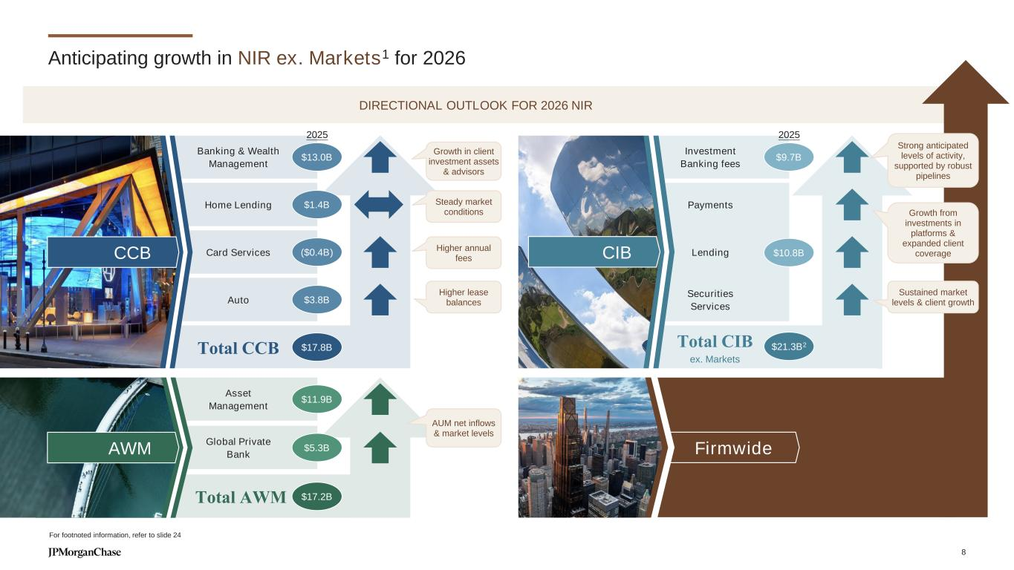
Investment Banking fees Payments Total CIB ex. Markets Lending Securities Services Firmwide Total CCB Banking & Wealth Management Auto Home Lending Card Services Total AWM Asset Management Global Private Bank Anticipating growth in NIR ex. Markets1 for 2026 DIRECTIONAL OUTLOOK FOR 2026 NIR Higher lease balances AUM net inflows & market levels $13.0B $1.4B ($0.4B) $3.8B $11.9B $5.3B $9.7B Growth in client investment assets & advisors AWM CIBCCB Steady market conditions For footnoted information, refer to slide 24 $17.8B $17.2B $10.8B $21.3B2 2025 2025 Sustained market levels & client growth Strong anticipated levels of activity, supported by robust pipelines Growth from investments in platforms & expanded client coverage Higher annual fees 8

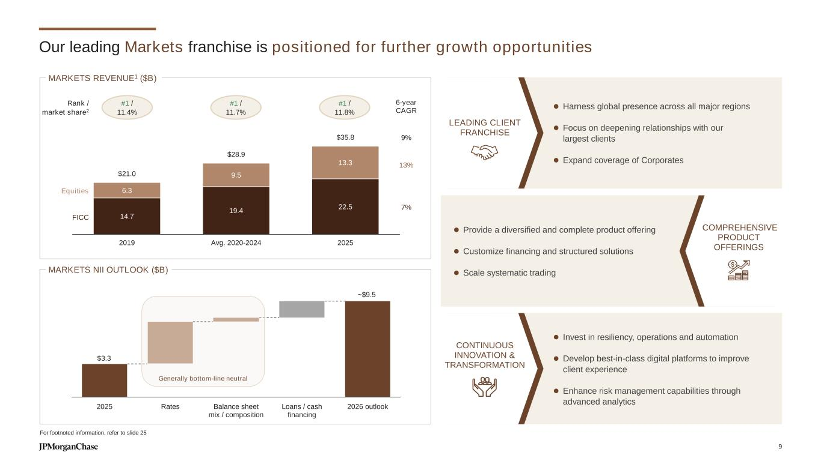
14.7 19.4 22.5 6.3 9.5 13.3 $21.0 $28.9 $35.8 2019 Avg. 2020-2024 2025 Our leading Markets franchise is positioned for further growth opportunities MARKETS REVENUE1 ($B) Equities FICC Rank / market share2 #1 / 11.8% 6-year CAGR 13% 7% 9% #1 / 11.4% #1 / 11.7% MARKETS NII OUTLOOK ($B) For footnoted information, refer to slide 25 ⚫ Provide a diversified and complete product offering ⚫ Customize financing and structured solutions ⚫ Scale systematic trading ⚫ Invest in resiliency, operations and automation ⚫ Develop best-in-class digital platforms to improve client experience ⚫ Enhance risk management capabilities through advanced analytics ⚫ Harness global presence across all major regions ⚫ Focus on deepening relationships with our largest clients ⚫ Expand coverage of Corporates LEADING CLIENT FRANCHISE COMPREHENSIVE PRODUCT OFFERINGS CONTINUOUS INNOVATION & TRANSFORMATION $3.3 2025 Rates Balance sheet mix / composition Loans / cash financing 2026 outlook ~$9.5 Generally bottom-line neutral 9

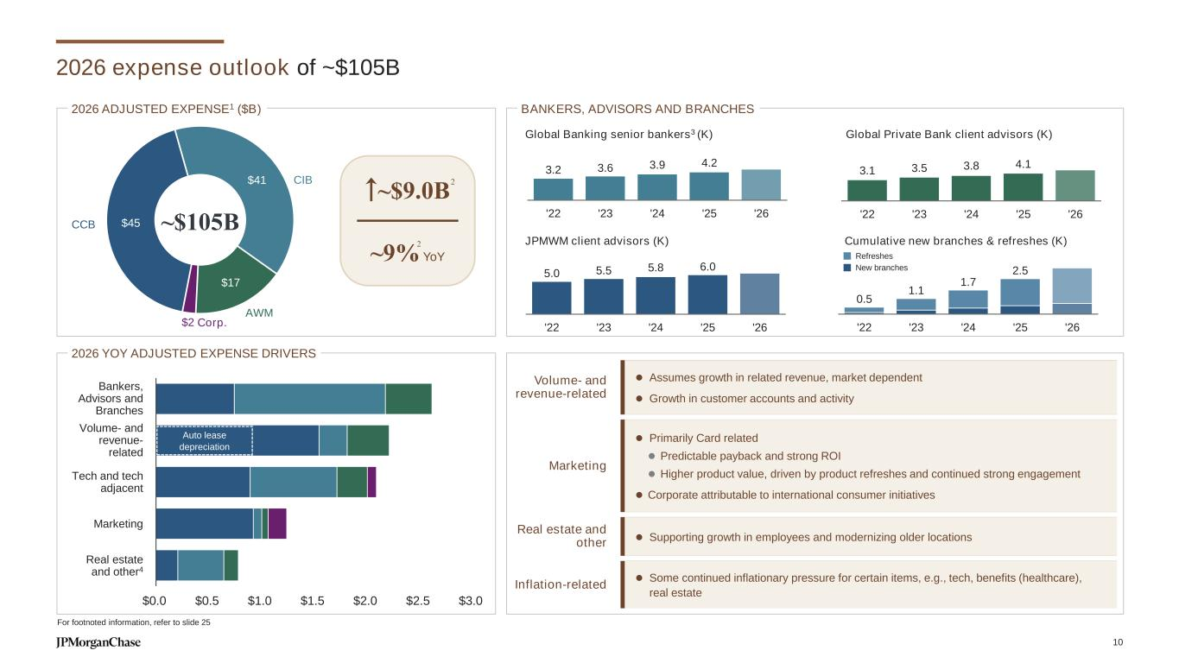
2026 expense outlook of ~$105B CIB AWM Corp. CCB ~$105B$45 $41 $17 $2 $0.0 $0.5 $1.0 $1.5 $2.0 $2.5 $3.0 Auto lease depreciation 2026 YOY ADJUSTED EXPENSE DRIVERS ~$9.0B ~9% YoY BANKERS, ADVISORS AND BRANCHES 5.0 5.5 5.8 6.0 '22 '23 '24 '25 '26 3.2 3.6 3.9 4.2 '22 '23 '24 '25 '26 3.1 3.5 3.8 4.1 '22 '23 '24 '25 '26 0.5 1.1 1.7 2.5 '22 '23 '24 '25 '26 Cumulative new branches & refreshes (K) Global Private Bank client advisors (K) JPMWM client advisors (K) Global Banking senior bankers3 (K) Volume- and revenue-related ⚫ Assumes growth in related revenue, market dependent ⚫ Growth in customer accounts and activity Marketing ⚫ Primarily Card related ⚫ Predictable payback and strong ROI ⚫ Higher product value, driven by product refreshes and continued strong engagement ⚫ Corporate attributable to international consumer initiatives Real estate and other ⚫ Supporting growth in employees and modernizing older locations Inflation-related ⚫ Some continued inflationary pressure for certain items, e.g., tech, benefits (healthcare), real estate Volume- and revenue- related Bankers, Advisors and Branches Tech and tech adjacent Marketing Real estate and other4 2026 ADJUSTED EXPENSE1 ($B) 2 Refreshes New branches 2 For footnoted information, refer to slide 25 10

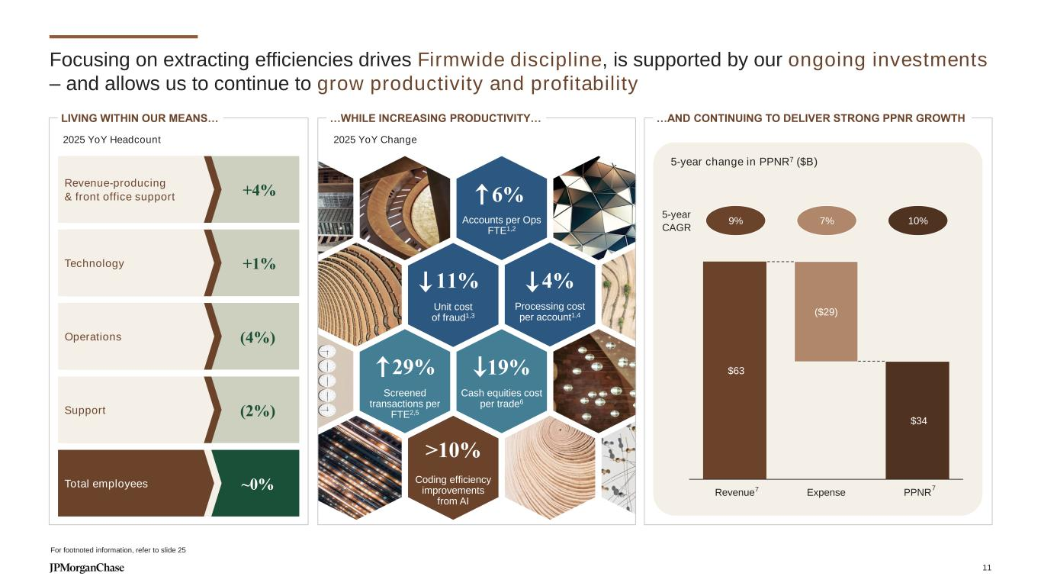
2025 YoY Change Accounts per Ops FTE1,2 Cash equities cost per trade6 Screened transactions per FTE2,5 Coding efficiency improvements from AI Focusing on extracting efficiencies drives Firmwide discipline, is supported by our ongoing investments – and allows us to continue to grow productivity and profitability For footnoted information, refer to slide 25 …AND CONTINUING TO DELIVER STRONG PPNR GROWTH 5-year change in PPNR7 ($B) 7 $63 $34 ($29) Revenue Expense PPNR 5-year CAGR 9% 7% 10% 7 29% 2025 YoY Headcount +4% Revenue-producing & front office support (4%)Operations (2%)Support ~0%Total employees LIVING WITHIN OUR MEANS… +1%Technology …WHILE INCREASING PRODUCTIVITY… Unit cost of fraud1,3 Processing cost per account1,4 11% 4% 19% >10% 6% 11

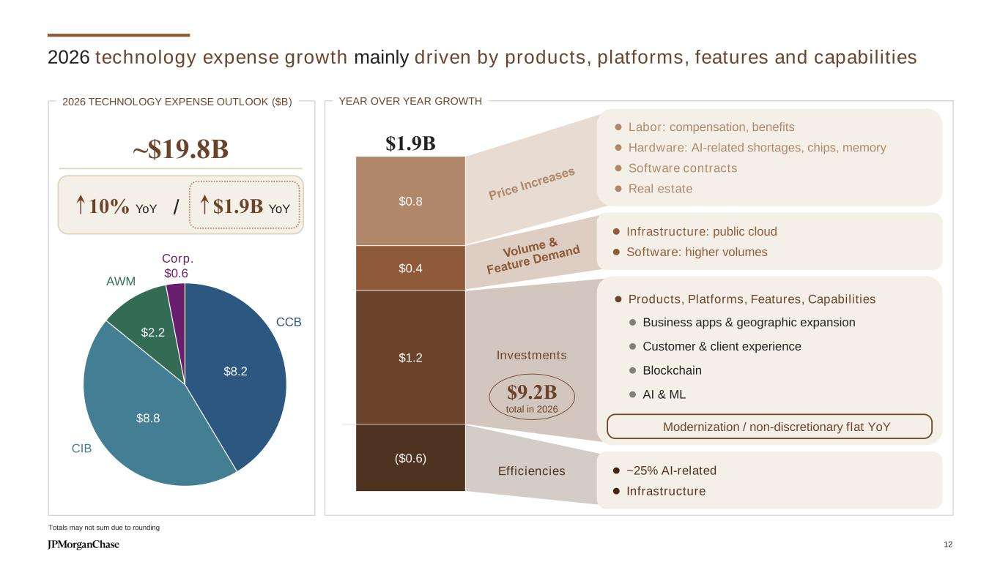
$8.2 $8.8 $2.2 $0.6 ⚫ Products, Platforms, Features, Capabilities ⚫ Business apps & geographic expansion ⚫ Customer & client experience ⚫ Blockchain ⚫ AI & ML 2026 technology expense growth mainly driven by products, platforms, features and capabilities Totals may not sum due to rounding ⚫ Labor: compensation, benefits ⚫ Hardware: AI-related shortages, chips, memory ⚫ Software contracts ⚫ Real estate ⚫ Infrastructure: public cloud ⚫ Software: higher volumes ⚫ ~25% AI-related ⚫ Infrastructure $1.9B Investments 2026 TECHNOLOGY EXPENSE OUTLOOK ($B) ~$19.8B /10% YoY $1.9B YoY $9.2B total in 2026 $1.2 $0.4 $0.8 ($0.6) Efficiencies YEAR OVER YEAR GROWTH Modernization / non-discretionary flat YoY CIB CCB AWM Corp. 12

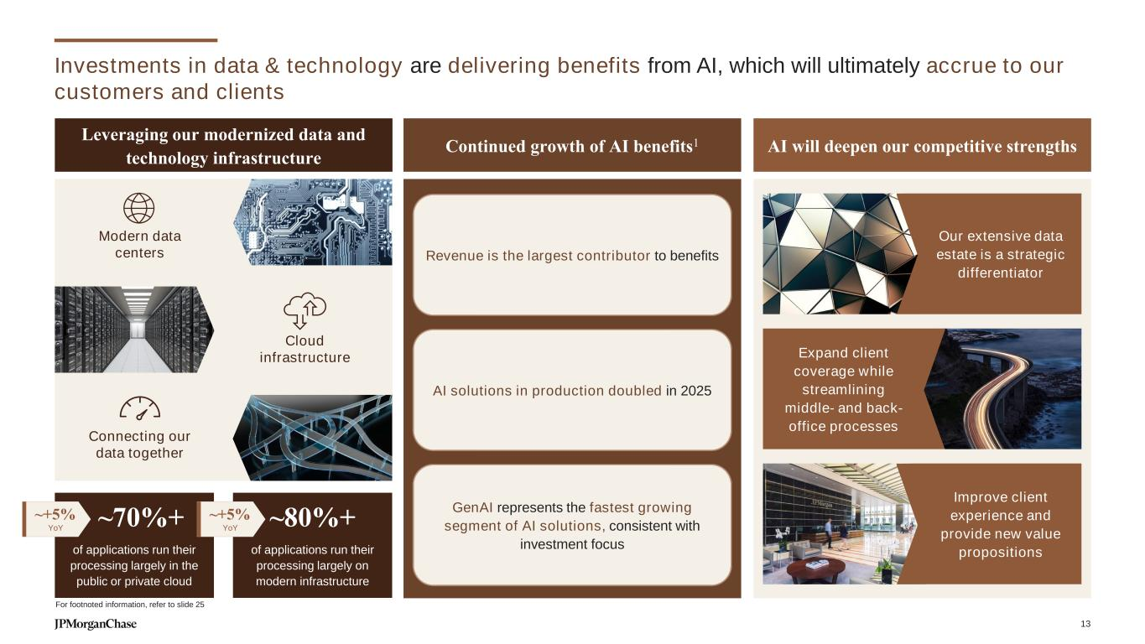
Investments in data & technology are delivering benefits from AI, which will ultimately accrue to our customers and clients Leveraging our modernized data and technology infrastructure AI will deepen our competitive strengthsContinued growth of AI benefits1 of applications run their processing largely on modern infrastructure ~80%+ of applications run their processing largely in the public or private cloud ~70%+~+5% YoY ~+5% YoY Expand client coverage while streamlining middle- and back- office processes Our extensive data estate is a strategic differentiator Improve client experience and provide new value propositions AI solutions in production doubled in 2025 Revenue is the largest contributor to benefits GenAI represents the fastest growing segment of AI solutions, consistent with investment focus Modern data centers Cloud infrastructure Connecting our data together For footnoted information, refer to slide 25 13

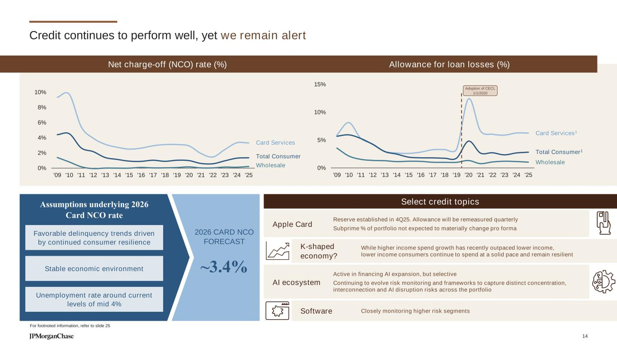
-2% 0% 2% 4% 6% 8% 10% '09 '10 '11 '12 '13 '14 '15 '16 '17 '18 '19 '20 '21 '22 '23 '24 '25 Credit continues to perform well, yet we remain alert Net charge-off (NCO) rate (%) Card Services Total Consumer 2026 CARD NCO FORECAST ~3.4% Favorable delinquency trends driven by continued consumer resilience Assumptions underlying 2026 Card NCO rate Stable economic environment Wholesale Allowance for loan losses (%) 0% 5% 10% 15% '09 '10 '11 '12 '13 '14 '15 '16 '17 '18 '19 '20 '21 '22 '23 '24 '25 Card Services1 Total Consumer1 Wholesale Reserve established in 4Q25. Allowance will be remeasured quarterly Subprime % of portfolio not expected to materially change pro forma Apple Card While higher income spend growth has recently outpaced lower income, lower income consumers continue to spend at a solid pace and remain resilient K-shaped economy? Closely monitoring higher risk segmentsSoftware Active in financing AI expansion, but selective Continuing to evolve risk monitoring and frameworks to capture distinct concentration, interconnection and AI disruption risks across the portfolio AI ecosystem Unemployment rate around current levels of mid 4% Adoption of CECL 1/1/2020 Select credit topics For footnoted information, refer to slide 25 14

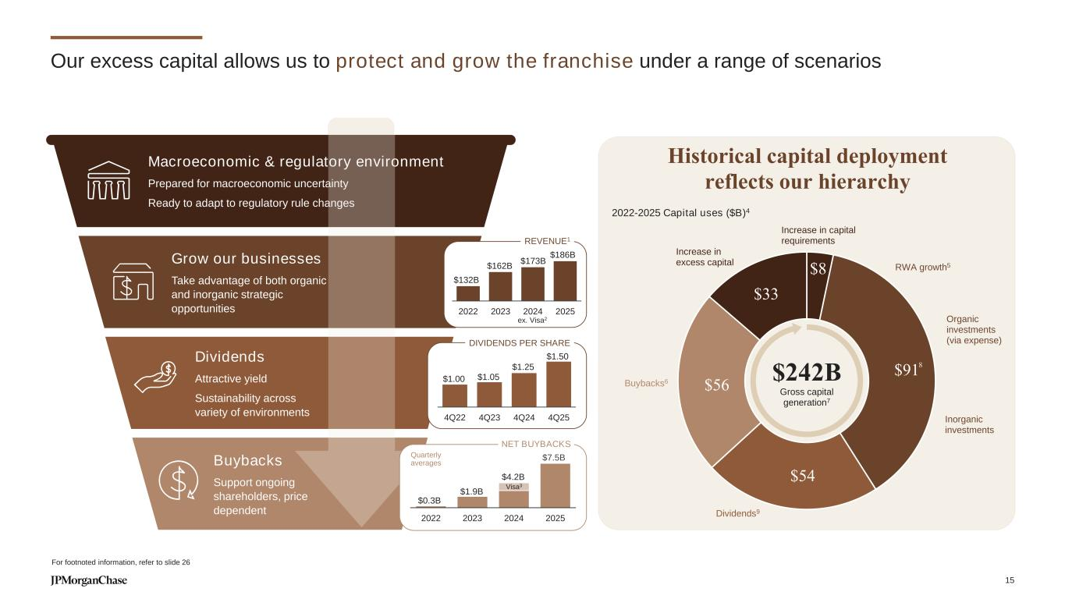
Our excess capital allows us to protect and grow the franchise under a range of scenarios Historical capital deployment reflects our hierarchy $132B $162B $173B $186B 2022 2023 2024 2025 REVENUE1 Buybacks Support ongoing shareholders, price dependent Grow our businesses Take advantage of both organic and inorganic strategic opportunities Macroeconomic & regulatory environment Prepared for macroeconomic uncertainty Ready to adapt to regulatory rule changes Dividends Attractive yield Sustainability across variety of environments $1.00 $1.05 $1.25 $1.50 4Q22 4Q23 4Q24 4Q25 DIVIDENDS PER SHARE NET BUYBACKS Quarterly averages $0.3B $1.9B $7.5B 2022 2023 2024 2025 $4.2B Visa3 ex. Visa2 $8 $91 $54 $56 $33 Organic investments (via expense) Dividends9 Buybacks6 Increase in excess capital Increase in capital requirements $242B Gross capital generation7 Inorganic investments RWA growth5 For footnoted information, refer to slide 26 2022-2025 Capital uses ($B)4 8 15

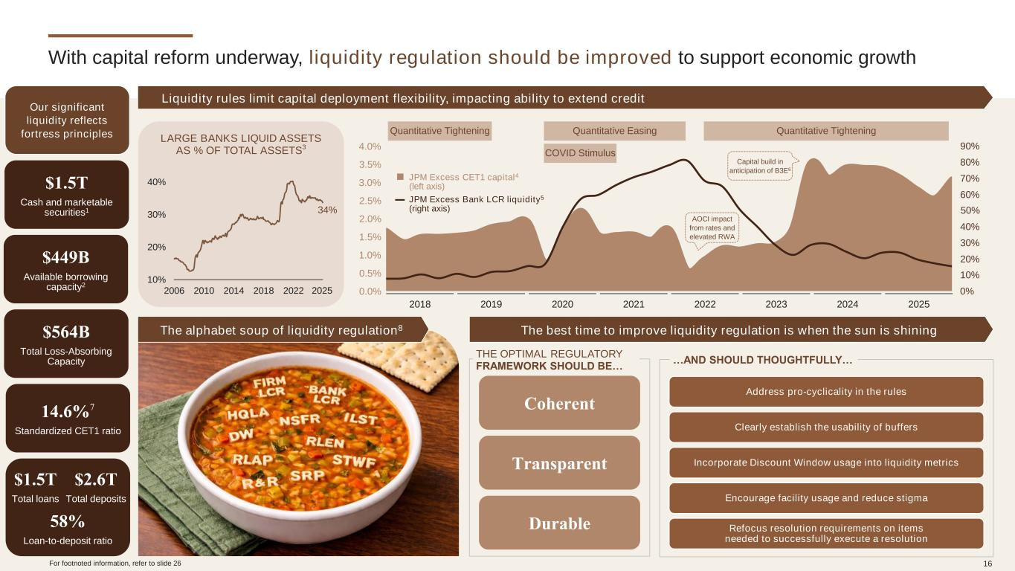
With capital reform underway, liquidity regulation should be improved to support economic growth Liquidity rules limit capital deployment flexibility, impacting ability to extend credit …AND SHOULD THOUGHTFULLY… THE OPTIMAL REGULATORY FRAMEWORK SHOULD BE… Coherent Transparent Durable JPM Excess Bank LCR liquidity5 (right axis) JPM Excess CET1 capital4 (left axis) 34% 10% 20% 30% 40% 2006 2010 2014 2018 2022 2025 Address pro-cyclicality in the rules Clearly establish the usability of buffers Incorporate Discount Window usage into liquidity metrics Encourage facility usage and reduce stigma Refocus resolution requirements on items needed to successfully execute a resolution LARGE BANKS LIQUID ASSETS AS % OF TOTAL ASSETS3 Quantitative Tightening Quantitative Tightening COVID Stimulus Quantitative Easing AOCI impact from rates and elevated RWA Capital build in anticipation of B3E6 Our significant liquidity reflects fortress principles $449B Available borrowing capacity2 $1.5T Cash and marketable securities1 $564B Total Loss-Absorbing Capacity 14.6%7 Standardized CET1 ratio $2.6T Total deposits $1.5T Total loans 58% Loan-to-deposit ratio For footnoted information, refer to slide 26 3.5% 3.0% 2.5% 2.0% 1.5% 1.0% 0.5% 0.0% 90% 80% 70% 60% 50% 40% 30% 20% 10% 0% 4.0% 2018 2019 2020 2021 2022 2023 2024 2025 The alphabet soup of liquidity regulation8 The best time to improve liquidity regulation is when the sun is shining 16

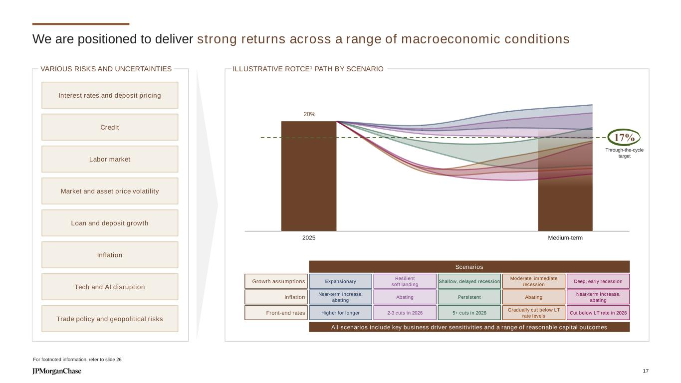
2025 Medium-term We are positioned to deliver strong returns across a range of macroeconomic conditions For footnoted information, refer to slide 26 ILLUSTRATIVE ROTCE1 PATH BY SCENARIO Scenarios All scenarios include key business driver sensitivities and a range of reasonable capital outcomes Front-end rates Inflation Growth assumptions Shallow, delayed recession 5+ cuts in 2026 Persistent Moderate, immediate recession Gradually cut below LT rate levels Abating Resilient soft landing 2-3 cuts in 2026 Abating Expansionary Higher for longer Near-term increase, abating 17% Through-the-cycle target 20% Deep, early recession Cut below LT rate in 2026 Near-term increase, abating Interest rates and deposit pricing Credit Inflation Labor market Trade policy and geopolitical risks Loan and deposit growth Tech and AI disruption Market and asset price volatility VARIOUS RISKS AND UNCERTAINTIES 17

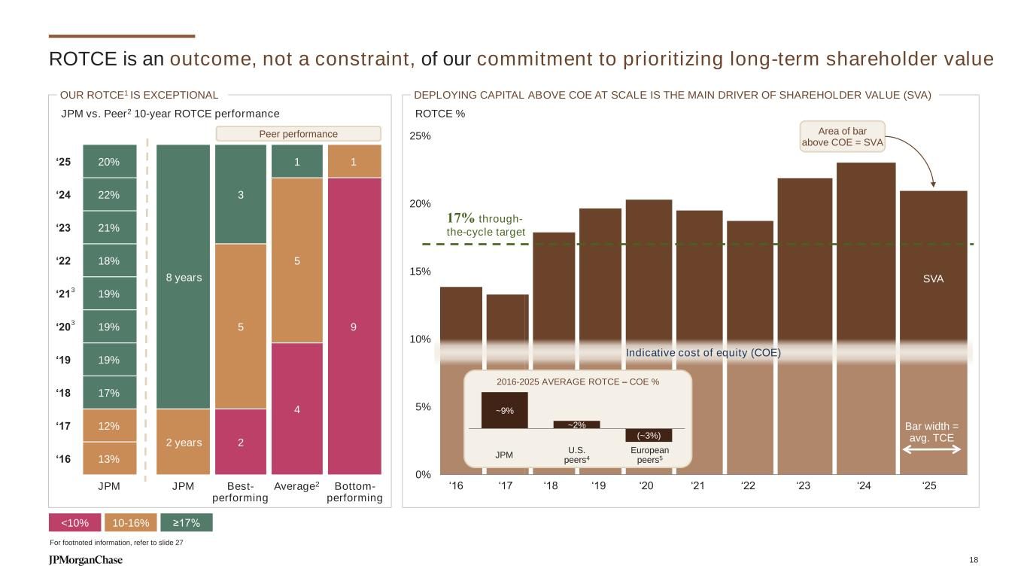
0% 5% 10% 15% 20% 25% ROTCE is an outcome, not a constraint, of our commitment to prioritizing long-term shareholder value Bar width = avg. TCE For footnoted information, refer to slide 27 8 years 3 1 1 5 95 4 2 years 2 ≥17%<10% 10-16% ‘16 ‘17 ‘18 ‘19 ‘20 ‘21 ‘22 ‘23 ‘24 ‘25 17% through- the-cycle target ROTCE % Indicative cost of equity (COE) DEPLOYING CAPITAL ABOVE COE AT SCALE IS THE MAIN DRIVER OF SHAREHOLDER VALUE (SVA) 2016-2025 AVERAGE ROTCE – COE % ~9% ~2% (~3%) European peers5 U.S. peers4JPM SVA Area of bar above COE = SVA ‘25 20% ‘24 22% ‘23 21% ‘22 18% ‘21 19% ‘20 19% ‘19 19% ‘18 17% ‘17 12% ‘16 13% JPM JPM Best- performing Bottom- performing Average2 JPM vs. Peer2 10-year ROTCE performance 3 3 OUR ROTCE1 IS EXCEPTIONAL Peer performance 18

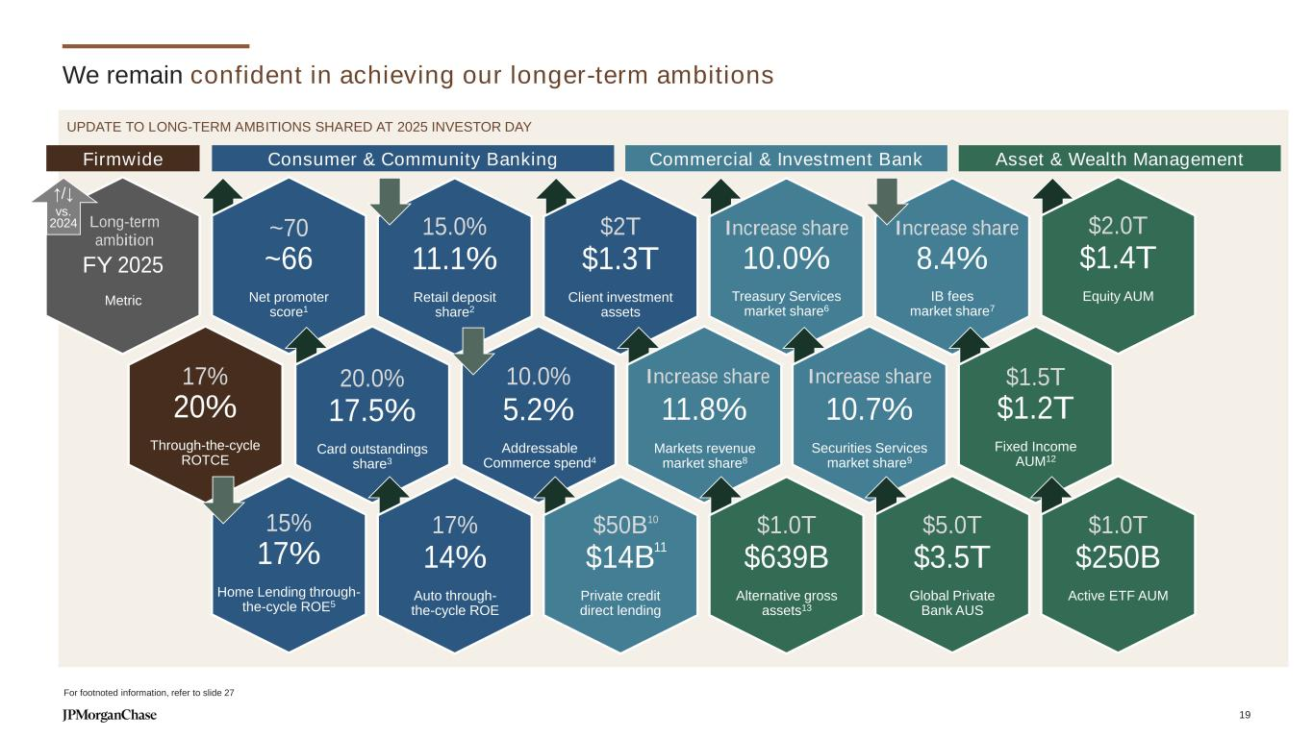
We remain confident in achieving our longer-term ambitions ~70 ~66 Net promoter score1 $2T $1.3T Client investment assets 15.0% 11.1% Retail deposit share2 8.4%10.0% $2.0T $1.4T Equity AUM . 20.0% 17.5% Card outstandings share3 (incl. `FRC) 11.8% 10.7% $1.5T $1.2T Fixed Income AUM12 $1.0T $250B Active ETF AUM . deployed15% 17% Home Lending through- the-cycle ROE5 17% 14% Auto through- the-cycle ROE $1.0T $639B Alternative gross assets13 $50B $14B Private credit direct lending $5.0T $3.5T Global Private Bank AUS Consumer & Community Banking Commercial & Investment Bank Asset & Wealth ManagementFirmwide UPDATE TO LONG-TERM AMBITIONS SHARED AT 2025 INVESTOR DAY For footnoted information, refer to slide 27 17% 20% Through-the-cycle ROTCE Metric Long-term ambition FY 2025 ↑/↓ vs. 2024 Increase share Treasury Services market share6 10.0% Increase share IB fees market share7 Increase share Markets revenue market share8 Increase share Securities Services market share9 11 5.2% Addressable Commerce spend4 10 19

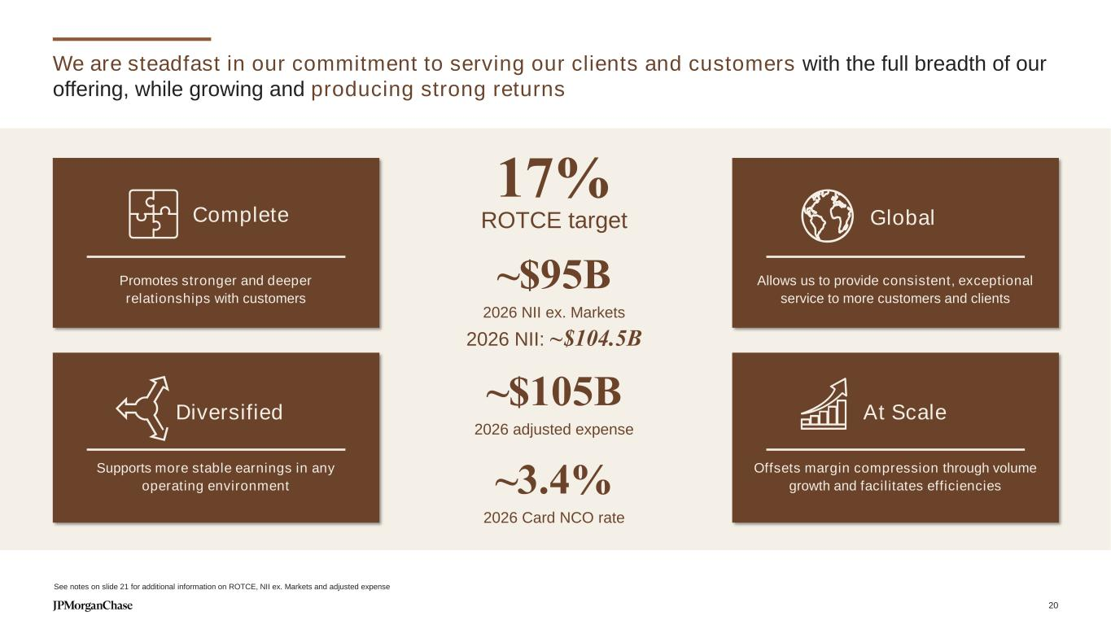
We are steadfast in our commitment to serving our clients and customers with the full breadth of our offering, while growing and producing strong returns Promotes stronger and deeper relationships with customers Allows us to provide consistent, exceptional service to more customers and clients Supports more stable earnings in any operating environment Offsets margin compression through volume growth and facilitates efficiencies Complete Global Diversified At Scale See notes on slide 21 for additional information on ROTCE, NII ex. Markets and adjusted expense ~$95B 2026 NII ex. Markets 2026 NII: ~$104.5B ~$105B 2026 adjusted expense 17% ROTCE target ~3.4% 2026 Card NCO rate 20

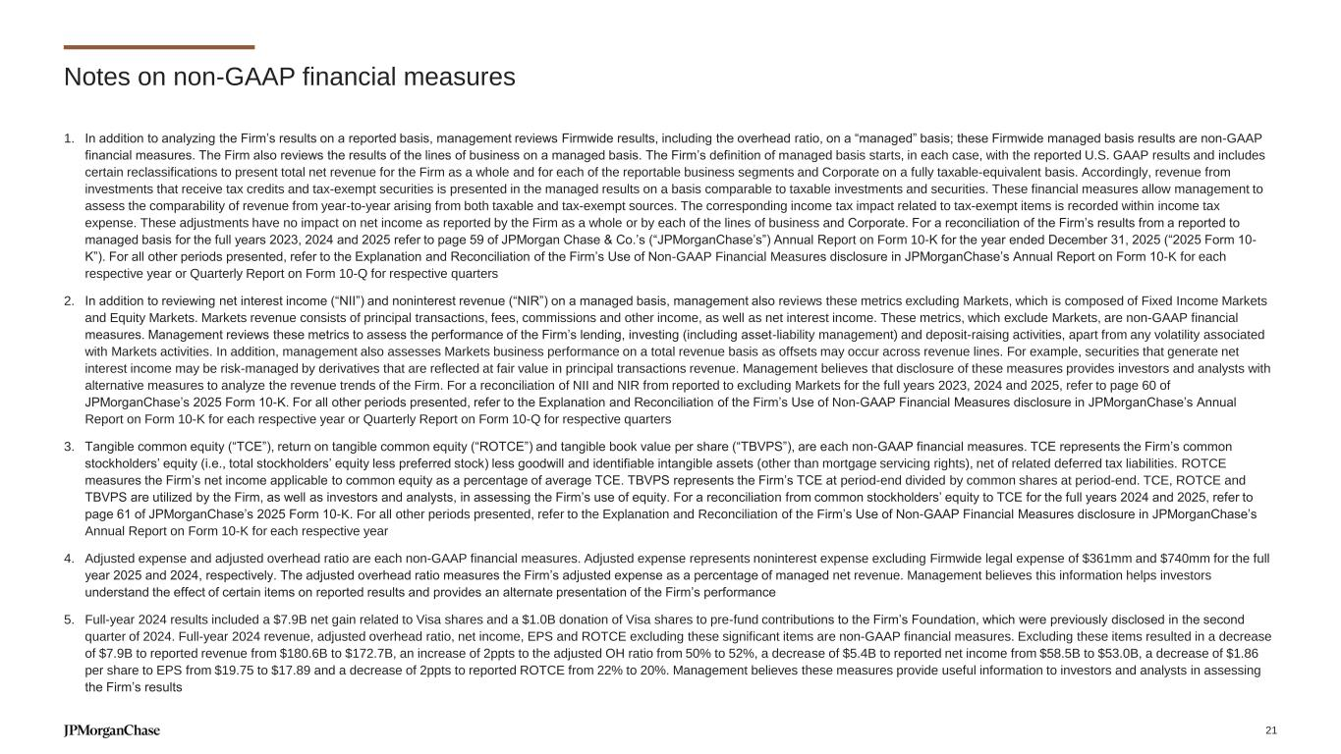
Notes on non-GAAP financial measures 1. In addition to analyzing the Firm’s results on a reported basis, management reviews Firmwide results, including the overhead ratio, on a “managed” basis; these Firmwide managed basis results are non-GAAP financial measures. The Firm also reviews the results of the lines of business on a managed basis. The Firm’s definition of managed basis starts, in each case, with the reported U.S. GAAP results and includes certain reclassifications to present total net revenue for the Firm as a whole and for each of the reportable business segments and Corporate on a fully taxable-equivalent basis. Accordingly, revenue from investments that receive tax credits and tax-exempt securities is presented in the managed results on a basis comparable to taxable investments and securities. These financial measures allow management to assess the comparability of revenue from year-to-year arising from both taxable and tax-exempt sources. The corresponding income tax impact related to tax-exempt items is recorded within income tax expense. These adjustments have no impact on net income as reported by the Firm as a whole or by each of the lines of business and Corporate. For a reconciliation of the Firm’s results from a reported to managed basis for the full years 2023, 2024 and 2025 refer to page 59 of JPMorgan Chase & Co.’s (“JPMorganChase’s”) Annual Report on Form 10-K for the year ended December 31, 2025 (“2025 Form 10- K”). For all other periods presented, refer to the Explanation and Reconciliation of the Firm’s Use of Non-GAAP Financial Measures disclosure in JPMorganChase’s Annual Report on Form 10-K for each respective year or Quarterly Report on Form 10-Q for respective quarters 2. In addition to reviewing net interest income (“NII”) and noninterest revenue (“NIR”) on a managed basis, management also reviews these metrics excluding Markets, which is composed of Fixed Income Markets and Equity Markets. Markets revenue consists of principal transactions, fees, commissions and other income, as well as net interest income. These metrics, which exclude Markets, are non-GAAP financial measures. Management reviews these metrics to assess the performance of the Firm’s lending, investing (including asset-liability management) and deposit-raising activities, apart from any volatility associated with Markets activities. In addition, management also assesses Markets business performance on a total revenue basis as offsets may occur across revenue lines. For example, securities that generate net interest income may be risk-managed by derivatives that are reflected at fair value in principal transactions revenue. Management believes that disclosure of these measures provides investors and analysts with alternative measures to analyze the revenue trends of the Firm. For a reconciliation of NII and NIR from reported to excluding Markets for the full years 2023, 2024 and 2025, refer to page 60 of JPMorganChase’s 2025 Form 10-K. For all other periods presented, refer to the Explanation and Reconciliation of the Firm’s Use of Non-GAAP Financial Measures disclosure in JPMorganChase’s Annual Report on Form 10-K for each respective year or Quarterly Report on Form 10-Q for respective quarters 3. Tangible common equity (“TCE”), return on tangible common equity (“ROTCE”) and tangible book value per share (“TBVPS”), are each non-GAAP financial measures. TCE represents the Firm’s common stockholders’ equity (i.e., total stockholders’ equity less preferred stock) less goodwill and identifiable intangible assets (other than mortgage servicing rights), net of related deferred tax liabilities. ROTCE measures the Firm’s net income applicable to common equity as a percentage of average TCE. TBVPS represents the Firm’s TCE at period-end divided by common shares at period-end. TCE, ROTCE and TBVPS are utilized by the Firm, as well as investors and analysts, in assessing the Firm’s use of equity. For a reconciliation from common stockholders’ equity to TCE for the full years 2024 and 2025, refer to page 61 of JPMorganChase’s 2025 Form 10-K. For all other periods presented, refer to the Explanation and Reconciliation of the Firm’s Use of Non-GAAP Financial Measures disclosure in JPMorganChase’s Annual Report on Form 10-K for each respective year 4. Adjusted expense and adjusted overhead ratio are each non-GAAP financial measures. Adjusted expense represents noninterest expense excluding Firmwide legal expense of $361mm and $740mm for the full year 2025 and 2024, respectively. The adjusted overhead ratio measures the Firm’s adjusted expense as a percentage of managed net revenue. Management believes this information helps investors understand the effect of certain items on reported results and provides an alternate presentation of the Firm’s performance 5. Full-year 2024 results included a $7.9B net gain related to Visa shares and a $1.0B donation of Visa shares to pre-fund contributions to the Firm’s Foundation, which were previously disclosed in the second quarter of 2024. Full-year 2024 revenue, adjusted overhead ratio, net income, EPS and ROTCE excluding these significant items are non-GAAP financial measures. Excluding these items resulted in a decrease of $7.9B to reported revenue from $180.6B to $172.7B, an increase of 2ppts to the adjusted OH ratio from 50% to 52%, a decrease of $5.4B to reported net income from $58.5B to $53.0B, a decrease of $1.86 per share to EPS from $19.75 to $17.89 and a decrease of 2ppts to reported ROTCE from 22% to 20%. Management believes these measures provide useful information to investors and analysts in assessing the Firm’s results 21


Notes on slide 2 Slide 2 – Being complete, global, diversified and at scale enables us to meet clients’ and customers’ range of needs through cycles 1. Totals may not sum due to rounding. See note 1 on slide 21 2. In the fourth quarter of 2020, the Firm realigned certain Wealth Management clients from Asset & Wealth Management to Consumer & Community Banking. Prior-period amounts have been revised to conform with the current presentation 3. In the first quarter of 2023, the allocations of revenue and expense to CCB associated with a Merchant Services revenue sharing agreement were discontinued and are now retained in Payments in CIB. Prior-period amounts have been revised to conform with the current presentation 4. Sum of heritage CB and heritage CIB 5. Corporate revenue of $1B and $7B for 2019 and 2025, respectively 6. Ex. Markets. See note 2 on slide 21 7. Total payments transaction volume includes debit and credit card sales volume and gross outflows of ACH, ATM, teller, wires, BillPay, PayChase, Zelle, person-to-person and checks 8. Does not include small businesses 9. Based on regulatory reporting guidelines prescribed by the Federal Reserve for U.S. Title 1 planning purposes; includes internal settlements, global payments to and through third-party processors and banks, and other internal transfers 10. Count of ultimate parent clients with CIB non-zero revenue over 24 months rolling as of December 31, 2025 11. Refers to J.P. Morgan Wealth Management (“JPMWM”) 12. International Consumer Initiatives is included in Corporate 22

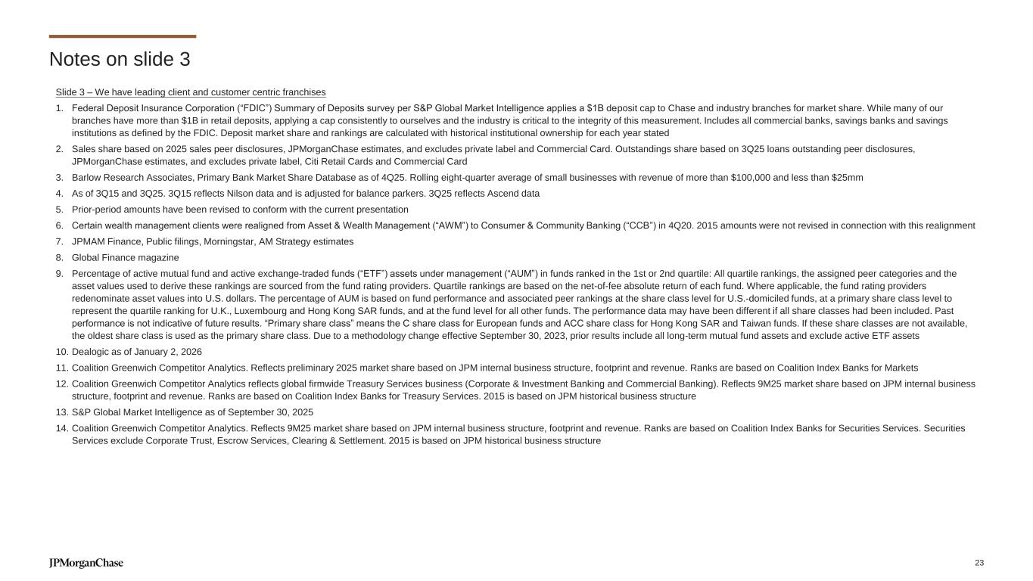
Notes on slide 3 Slide 3 – We have leading client and customer centric franchises 1. Federal Deposit Insurance Corporation (“FDIC”) Summary of Deposits survey per S&P Global Market Intelligence applies a $1B deposit cap to Chase and industry branches for market share. While many of our branches have more than $1B in retail deposits, applying a cap consistently to ourselves and the industry is critical to the integrity of this measurement. Includes all commercial banks, savings banks and savings institutions as defined by the FDIC. Deposit market share and rankings are calculated with historical institutional ownership for each year stated 2. Sales share based on 2025 sales peer disclosures, JPMorganChase estimates, and excludes private label and Commercial Card. Outstandings share based on 3Q25 loans outstanding peer disclosures, JPMorganChase estimates, and excludes private label, Citi Retail Cards and Commercial Card 3. Barlow Research Associates, Primary Bank Market Share Database as of 4Q25. Rolling eight-quarter average of small businesses with revenue of more than $100,000 and less than $25mm 4. As of 3Q15 and 3Q25. 3Q15 reflects Nilson data and is adjusted for balance parkers. 3Q25 reflects Ascend data 5. Prior-period amounts have been revised to conform with the current presentation 6. Certain wealth management clients were realigned from Asset & Wealth Management (“AWM”) to Consumer & Community Banking (“CCB”) in 4Q20. 2015 amounts were not revised in connection with this realignment 7. JPMAM Finance, Public filings, Morningstar, AM Strategy estimates 8. Global Finance magazine 9. Percentage of active mutual fund and active exchange-traded funds (“ETF”) assets under management (“AUM”) in funds ranked in the 1st or 2nd quartile: All quartile rankings, the assigned peer categories and the asset values used to derive these rankings are sourced from the fund rating providers. Quartile rankings are based on the net-of-fee absolute return of each fund. Where applicable, the fund rating providers redenominate asset values into U.S. dollars. The percentage of AUM is based on fund performance and associated peer rankings at the share class level for U.S.-domiciled funds, at a primary share class level to represent the quartile ranking for U.K., Luxembourg and Hong Kong SAR funds, and at the fund level for all other funds. The performance data may have been different if all share classes had been included. Past performance is not indicative of future results. “Primary share class” means the C share class for European funds and ACC share class for Hong Kong SAR and Taiwan funds. If these share classes are not available, the oldest share class is used as the primary share class. Due to a methodology change effective September 30, 2023, prior results include all long-term mutual fund assets and exclude active ETF assets 10. Dealogic as of January 2, 2026 11. Coalition Greenwich Competitor Analytics. Reflects preliminary 2025 market share based on JPM internal business structure, footprint and revenue. Ranks are based on Coalition Index Banks for Markets 12. Coalition Greenwich Competitor Analytics reflects global firmwide Treasury Services business (Corporate & Investment Banking and Commercial Banking). Reflects 9M25 market share based on JPM internal business structure, footprint and revenue. Ranks are based on Coalition Index Banks for Treasury Services. 2015 is based on JPM historical business structure 13. S&P Global Market Intelligence as of September 30, 2025 14. Coalition Greenwich Competitor Analytics. Reflects 9M25 market share based on JPM internal business structure, footprint and revenue. Ranks are based on Coalition Index Banks for Securities Services. Securities Services exclude Corporate Trust, Escrow Services, Clearing & Settlement. 2015 is based on JPM historical business structure 23

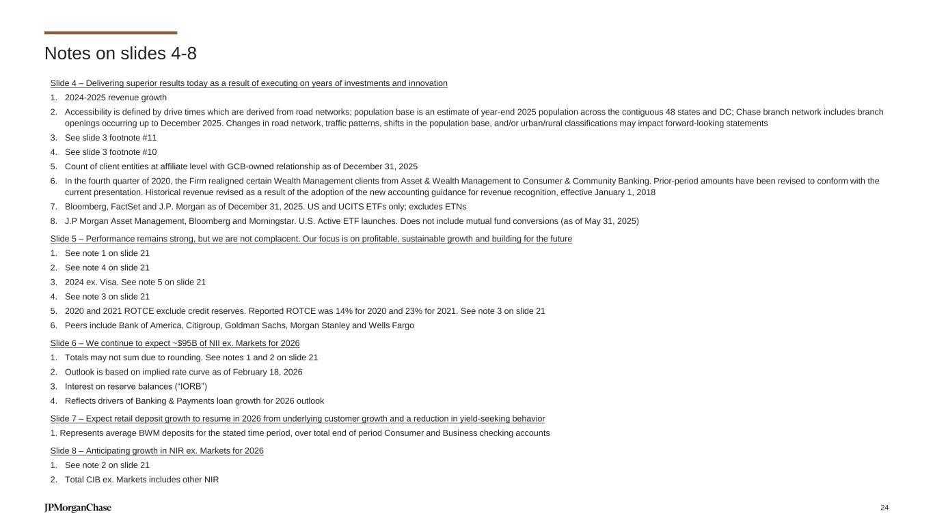
Notes on slides 4-8 Slide 4 – Delivering superior results today as a result of executing on years of investments and innovation 1. 2024-2025 revenue growth 2. Accessibility is defined by drive times which are derived from road networks; population base is an estimate of year-end 2025 population across the contiguous 48 states and DC; Chase branch network includes branch openings occurring up to December 2025. Changes in road network, traffic patterns, shifts in the population base, and/or urban/rural classifications may impact forward-looking statements 3. See slide 3 footnote #11 4. See slide 3 footnote #10 5. Count of client entities at affiliate level with GCB-owned relationship as of December 31, 2025 6. In the fourth quarter of 2020, the Firm realigned certain Wealth Management clients from Asset & Wealth Management to Consumer & Community Banking. Prior-period amounts have been revised to conform with the current presentation. Historical revenue revised as a result of the adoption of the new accounting guidance for revenue recognition, effective January 1, 2018 7. Bloomberg, FactSet and J.P. Morgan as of December 31, 2025. US and UCITS ETFs only; excludes ETNs 8. J.P Morgan Asset Management, Bloomberg and Morningstar. U.S. Active ETF launches. Does not include mutual fund conversions (as of May 31, 2025) Slide 5 – Performance remains strong, but we are not complacent. Our focus is on profitable, sustainable growth and building for the future 1. See note 1 on slide 21 2. See note 4 on slide 21 3. 2024 ex. Visa. See note 5 on slide 21 4. See note 3 on slide 21 5. 2020 and 2021 ROTCE exclude credit reserves. Reported ROTCE was 14% for 2020 and 23% for 2021. See note 3 on slide 21 6. Peers include Bank of America, Citigroup, Goldman Sachs, Morgan Stanley and Wells Fargo Slide 6 – We continue to expect ~$95B of NII ex. Markets for 2026 1. Totals may not sum due to rounding. See notes 1 and 2 on slide 21 2. Outlook is based on implied rate curve as of February 18, 2026 3. Interest on reserve balances (“IORB”) 4. Reflects drivers of Banking & Payments loan growth for 2026 outlook Slide 7 – Expect retail deposit growth to resume in 2026 from underlying customer growth and a reduction in yield-seeking behavior 1. Represents average BWM deposits for the stated time period, over total end of period Consumer and Business checking accounts Slide 8 – Anticipating growth in NIR ex. Markets for 2026 1. See note 2 on slide 21 2. Total CIB ex. Markets includes other NIR 24

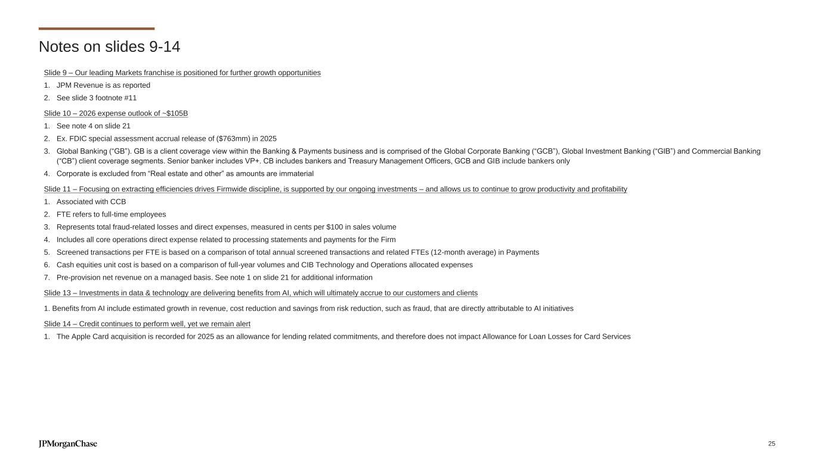
Notes on slides 9-14 Slide 9 – Our leading Markets franchise is positioned for further growth opportunities 1. JPM Revenue is as reported 2. See slide 3 footnote #11 Slide 10 – 2026 expense outlook of ~$105B 1. See note 4 on slide 21 2. Ex. FDIC special assessment accrual release of ($763mm) in 2025 3. Global Banking (“GB”). GB is a client coverage view within the Banking & Payments business and is comprised of the Global Corporate Banking (“GCB”), Global Investment Banking (“GIB”) and Commercial Banking (“CB”) client coverage segments. Senior banker includes VP+. CB includes bankers and Treasury Management Officers, GCB and GIB include bankers only 4. Corporate is excluded from “Real estate and other” as amounts are immaterial Slide 11 – Focusing on extracting efficiencies drives Firmwide discipline, is supported by our ongoing investments – and allows us to continue to grow productivity and profitability 1. Associated with CCB 2. FTE refers to full-time employees 3. Represents total fraud-related losses and direct expenses, measured in cents per $100 in sales volume 4. Includes all core operations direct expense related to processing statements and payments for the Firm 5. Screened transactions per FTE is based on a comparison of total annual screened transactions and related FTEs (12-month average) in Payments 6. Cash equities unit cost is based on a comparison of full-year volumes and CIB Technology and Operations allocated expenses 7. Pre-provision net revenue on a managed basis. See note 1 on slide 21 for additional information Slide 13 – Investments in data & technology are delivering benefits from AI, which will ultimately accrue to our customers and clients 1. Benefits from AI include estimated growth in revenue, cost reduction and savings from risk reduction, such as fraud, that are directly attributable to AI initiatives Slide 14 – Credit continues to perform well, yet we remain alert 1. The Apple Card acquisition is recorded for 2025 as an allowance for lending related commitments, and therefore does not impact Allowance for Loan Losses for Card Services 25

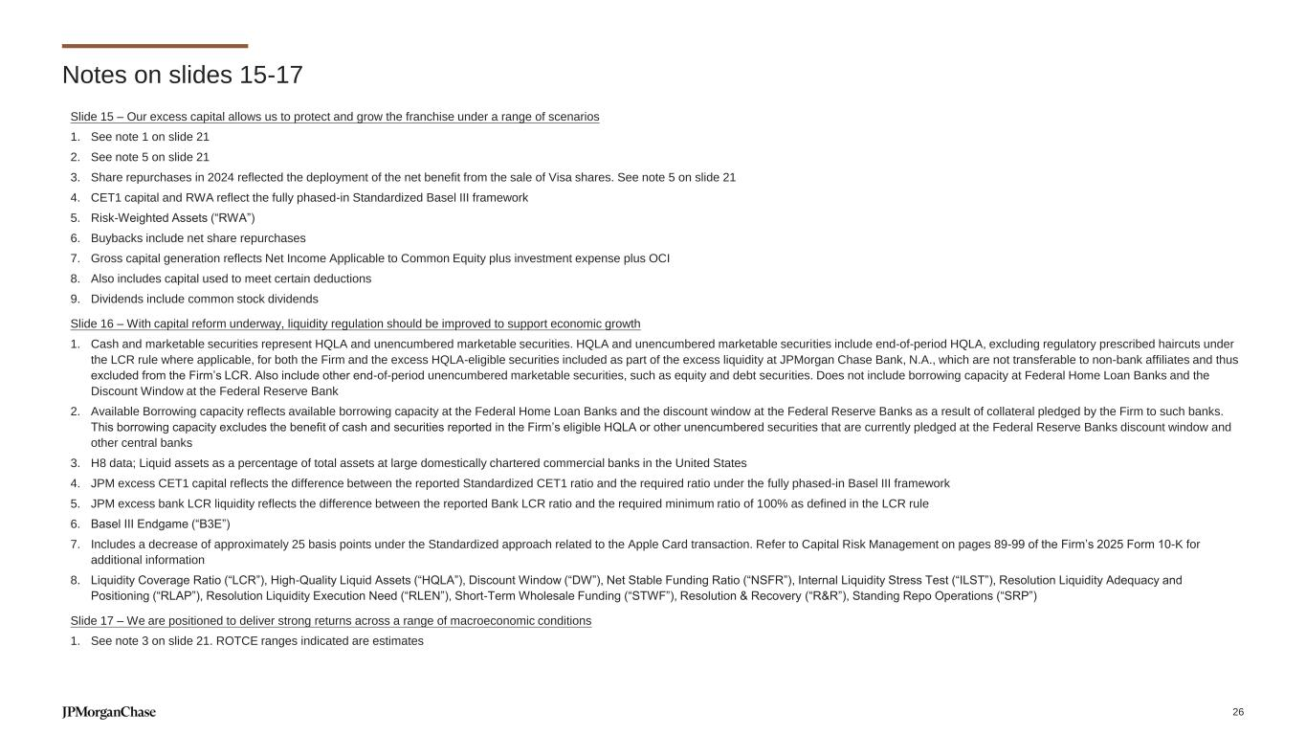
Notes on slides 15-17 Slide 15 – Our excess capital allows us to protect and grow the franchise under a range of scenarios 1. See note 1 on slide 21 2. See note 5 on slide 21 3. Share repurchases in 2024 reflected the deployment of the net benefit from the sale of Visa shares. See note 5 on slide 21 4. CET1 capital and RWA reflect the fully phased-in Standardized Basel III framework 5. Risk-Weighted Assets (“RWA”) 6. Buybacks include net share repurchases 7. Gross capital generation reflects Net Income Applicable to Common Equity plus investment expense plus OCI 8. Also includes capital used to meet certain deductions 9. Dividends include common stock dividends Slide 16 – With capital reform underway, liquidity regulation should be improved to support economic growth 1. Cash and marketable securities represent HQLA and unencumbered marketable securities. HQLA and unencumbered marketable securities include end-of-period HQLA, excluding regulatory prescribed haircuts under the LCR rule where applicable, for both the Firm and the excess HQLA-eligible securities included as part of the excess liquidity at JPMorgan Chase Bank, N.A., which are not transferable to non-bank affiliates and thus excluded from the Firm’s LCR. Also include other end-of-period unencumbered marketable securities, such as equity and debt securities. Does not include borrowing capacity at Federal Home Loan Banks and the Discount Window at the Federal Reserve Bank 2. Available Borrowing capacity reflects available borrowing capacity at the Federal Home Loan Banks and the discount window at the Federal Reserve Banks as a result of collateral pledged by the Firm to such banks. This borrowing capacity excludes the benefit of cash and securities reported in the Firm’s eligible HQLA or other unencumbered securities that are currently pledged at the Federal Reserve Banks discount window and other central banks 3. H8 data; Liquid assets as a percentage of total assets at large domestically chartered commercial banks in the United States 4. JPM excess CET1 capital reflects the difference between the reported Standardized CET1 ratio and the required ratio under the fully phased-in Basel III framework 5. JPM excess bank LCR liquidity reflects the difference between the reported Bank LCR ratio and the required minimum ratio of 100% as defined in the LCR rule 6. Basel III Endgame (“B3E”) 7. Includes a decrease of approximately 25 basis points under the Standardized approach related to the Apple Card transaction. Refer to Capital Risk Management on pages 89-99 of the Firm’s 2025 Form 10-K for additional information 8. Liquidity Coverage Ratio (“LCR”), High-Quality Liquid Assets (“HQLA”), Discount Window (“DW”), Net Stable Funding Ratio (“NSFR”), Internal Liquidity Stress Test (“ILST”), Resolution Liquidity Adequacy and Positioning (“RLAP”), Resolution Liquidity Execution Need (“RLEN”), Short-Term Wholesale Funding (“STWF”), Resolution & Recovery (“R&R”), Standing Repo Operations (“SRP”) Slide 17 – We are positioned to deliver strong returns across a range of macroeconomic conditions 1. See note 3 on slide 21. ROTCE ranges indicated are estimates 26

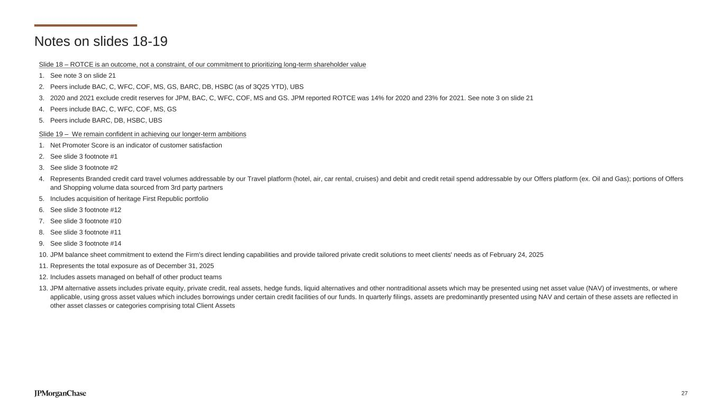
Notes on slides 18-19 Slide 18 – ROTCE is an outcome, not a constraint, of our commitment to prioritizing long-term shareholder value 1. See note 3 on slide 21 2. Peers include BAC, C, WFC, COF, MS, GS, BARC, DB, HSBC (as of 3Q25 YTD), UBS 3. 2020 and 2021 exclude credit reserves for JPM, BAC, C, WFC, COF, MS and GS. JPM reported ROTCE was 14% for 2020 and 23% for 2021. See note 3 on slide 21 4. Peers include BAC, C, WFC, COF, MS, GS 5. Peers include BARC, DB, HSBC, UBS Slide 19 – We remain confident in achieving our longer-term ambitions 1. Net Promoter Score is an indicator of customer satisfaction 2. See slide 3 footnote #1 3. See slide 3 footnote #2 4. Represents Branded credit card travel volumes addressable by our Travel platform (hotel, air, car rental, cruises) and debit and credit retail spend addressable by our Offers platform (ex. Oil and Gas); portions of Offers and Shopping volume data sourced from 3rd party partners 5. Includes acquisition of heritage First Republic portfolio 6. See slide 3 footnote #12 7. See slide 3 footnote #10 8. See slide 3 footnote #11 9. See slide 3 footnote #14 10. JPM balance sheet commitment to extend the Firm's direct lending capabilities and provide tailored private credit solutions to meet clients' needs as of February 24, 2025 11. Represents the total exposure as of December 31, 2025 12. Includes assets managed on behalf of other product teams 13. JPM alternative assets includes private equity, private credit, real assets, hedge funds, liquid alternatives and other nontraditional assets which may be presented using net asset value (NAV) of investments, or where applicable, using gross asset values which includes borrowings under certain credit facilities of our funds. In quarterly filings, assets are predominantly presented using NAV and certain of these assets are reflected in other asset classes or categories comprising total Client Assets 27

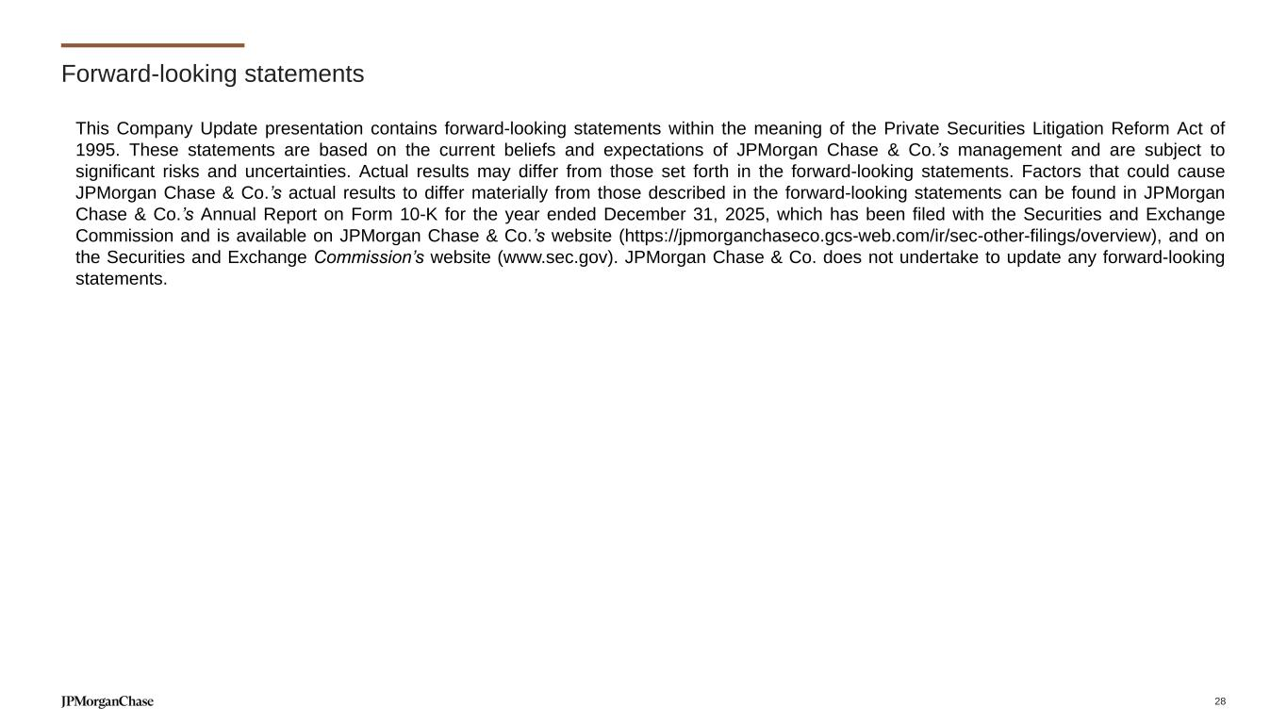
Forward-looking statements This Company Update presentation contains forward-looking statements within the meaning of the Private Securities Litigation Reform Act of 1995. These statements are based on the current beliefs and expectations of JPMorgan Chase & Co.’s management and are subject to significant risks and uncertainties. Actual results may differ from those set forth in the forward-looking statements. Factors that could cause JPMorgan Chase & Co.’s actual results to differ materially from those described in the forward-looking statements can be found in JPMorgan Chase & Co.’s Annual Report on Form 10-K for the year ended December 31, 2025, which has been filed with the Securities and Exchange Commission and is available on JPMorgan Chase & Co.’s website (https://jpmorganchaseco.gcs-web.com/ir/sec-other-filings/overview), and on the Securities and Exchange Commission’s website (www.sec.gov). JPMorgan Chase & Co. does not undertake to update any forward-looking statements. 28


Speal<er Biographies Company Update 2026 Exhibit 99.3


Jamie Dimon Chairman of the Board and Chief Executive Officer Jamie Dimon is Chairman of the Board and Chief Executive Officer of JPMorganChase, a global financial services firm with assets of $4.4 trillion and operations worldwide. The Firm is a leader in investment banking, financial services for consumers and small businesses, commercial banking, financial transaction processing and asset management. Dimon became CEO on January 1, 2006 and one year later also became Chairman of the Board. He was named President and Chief Operating Officer upon the company’s merger with Bank One on July 1, 2004. Dimon joined Bank One as Chairman and CEO in 2000. Dimon began his career at American Express. Next, he served as Chief Financial Officer and then President at Commercial Credit, which made numerous acquisitions and divestitures, including acquiring Primerica Corporation in 1987 and The Travelers Corporation in 1993. Dimon served as President and Chief Operating Officer of Travelers from 1990 through 1998 while concurrently serving as Chief Operating Officer of its Smith Barney subsidiary before becoming Co-Chairman and Co-CEO of the combined brokerage following the 1997 merger of Smith Barney and Salomon Brothers. In 1998, Dimon was named President of Citigroup, the global financial services company formed by the combination of Travelers Group and Citicorp. Dimon earned his bachelor’s degree from Tufts University and holds an MBA from Harvard Business School. He serves on the boards of directors of a number of non-profit institutions including the Business Roundtable, Bank Policy Institute and Harvard Business School. Additionally, he serves on the executive committee of the Partnership for New York City, and is a member of the Financial Services Forum, The Business Council and Council on Foreign Relations. 1


Jeremy Barnum Chief Financial Officer Jeremy Barnum is the Chief Financial Officer for JPMorganChase. As CFO, Jeremy is responsible for the overall financial management of the Firm, including core finance, business management, investor relations, treasury, and several other corporate teams. Since joining the Firm in 1994, Jeremy has held a number of leadership roles, including Head of Global Research for the Corporate & Investment Bank (CIB) and Chief Financial Officer of the CIB from 2013 to 2021. Jeremy graduated from Harvard College with a degree in Chemistry. He lives in New York and is married with two daughters. 2

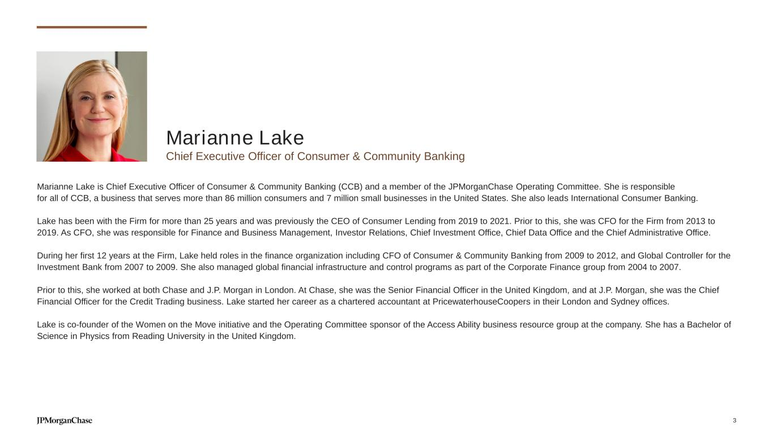
Marianne Lake Chief Executive Officer of Consumer & Community Banking Marianne Lake is Chief Executive Officer of Consumer & Community Banking (CCB) and a member of the JPMorganChase Operating Committee. She is responsible for all of CCB, a business that serves more than 86 million consumers and 7 million small businesses in the United States. She also leads International Consumer Banking. Lake has been with the Firm for more than 25 years and was previously the CEO of Consumer Lending from 2019 to 2021. Prior to this, she was CFO for the Firm from 2013 to 2019. As CFO, she was responsible for Finance and Business Management, Investor Relations, Chief Investment Office, Chief Data Office and the Chief Administrative Office. During her first 12 years at the Firm, Lake held roles in the finance organization including CFO of Consumer & Community Banking from 2009 to 2012, and Global Controller for the Investment Bank from 2007 to 2009. She also managed global financial infrastructure and control programs as part of the Corporate Finance group from 2004 to 2007. Prior to this, she worked at both Chase and J.P. Morgan in London. At Chase, she was the Senior Financial Officer in the United Kingdom, and at J.P. Morgan, she was the Chief Financial Officer for the Credit Trading business. Lake started her career as a chartered accountant at PricewaterhouseCoopers in their London and Sydney offices. Lake is co-founder of the Women on the Move initiative and the Operating Committee sponsor of the Access Ability business resource group at the company. She has a Bachelor of Science in Physics from Reading University in the United Kingdom. 3


Mary Callahan Erdoes Chief Executive Officer of Asset & Wealth Management 4 Mary Callahan Erdoes is Chief Executive Officer of JPMorganChase's Asset & Wealth Management (AWM) line of business – one of the largest and most respected investment managers and private banks in the world, with over $7 trillion in client assets and a 200-year-old legacy as a trusted fiduciary to corporations, governments, institutions and individuals. Since joining the Firm over 25 years ago, Erdoes has held senior roles across AWM before becoming its CEO in 2009 and joining the JPMorganChase Operating Committee, the Firm's most senior management team. Erdoes earned her undergraduate degree in Mathematics at Georgetown University. She serves on the Global Advisory Council of Harvard University, where she earned her MBA, the board of Harvard Management Company, and the U.S.-China Business Council. Erdoes resides in New York City and has three daughters.

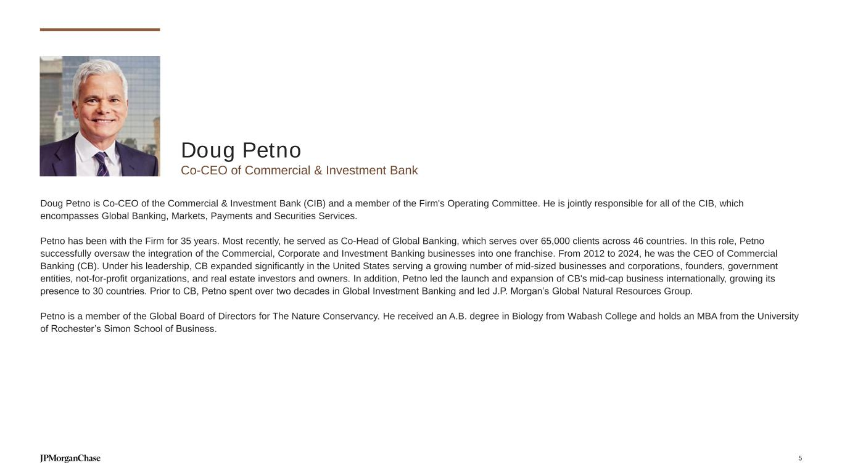
Doug Petno Co-CEO of Commercial & Investment Bank 5 Doug Petno is Co-CEO of the Commercial & Investment Bank (CIB) and a member of the Firm's Operating Committee. He is jointly responsible for all of the CIB, which encompasses Global Banking, Markets, Payments and Securities Services. Petno has been with the Firm for 35 years. Most recently, he served as Co-Head of Global Banking, which serves over 65,000 clients across 46 countries. In this role, Petno successfully oversaw the integration of the Commercial, Corporate and Investment Banking businesses into one franchise. From 2012 to 2024, he was the CEO of Commercial Banking (CB). Under his leadership, CB expanded significantly in the United States serving a growing number of mid-sized businesses and corporations, founders, government entities, not-for-profit organizations, and real estate investors and owners. In addition, Petno led the launch and expansion of CB's mid-cap business internationally, growing its presence to 30 countries. Prior to CB, Petno spent over two decades in Global Investment Banking and led J.P. Morgan’s Global Natural Resources Group. Petno is a member of the Global Board of Directors for The Nature Conservancy. He received an A.B. degree in Biology from Wabash College and holds an MBA from the University of Rochester’s Simon School of Business.


Troy Rohrbaugh Co-CEO of Commercial & Investment Bank Troy Rohrbaugh is Co-CEO for the Commercial & Investment Bank (CIB) as well as a member of the Firm's Operating Committee. Prior to his current role, Troy was Co-Head of Markets & Securities Services and previously the Head of Macro Markets, which includes the Rates, Foreign Exchange, Emerging Markets and Commodities businesses. Troy has worked in the financial industry for more than 32 years and has managed businesses in New York, London and Asia. During his career, he has taken active roles in key industry organizations, including as the Chair of the New York Federal Reserve Foreign Exchange Committee. He has also served as the chair of the Global Financial Markets Association’s (GFMA) Foreign Exchange Group and as a member of the Bank of England’s Joint Standing Committee. Troy joined J.P. Morgan in 2005 as a managing director and global head of Foreign Exchange Derivatives. He began his career on the Philadelphia Stock Exchange, trading options for CooperNeff, a specialist firm acquired by Banque Nationale in 1995. He led Banque Nationale’s Asia Foreign Exchange Options business before joining Goldman Sachs, where he managed the North American Foreign Exchange Options business. Troy graduated from Johns Hopkins University in 1992 with a B.A. in Political Science. He is a member of the Johns Hopkins University Krieger School of Arts and Sciences Advisory Board, a member of the Board of Trustees of the Gilman School and a Founding member and Advisory Board member of The Frannie Foundation. Troy lives in New York with his wife and their two sons. 6

