JPMorgan Chase Financial Company LLC  Fully and Unconditionally Guaranteed by JPMorgan Chase & Co.  Market Linked Securities | Filed Pursuant to Rule 433  Registration Statement Nos. 333-293684 and 333-293684-01
 | 
Market Linked Securities—Auto-Callable with Contingent Coupon with Memory Feature and Contingent Downside
Principal at Risk Securities Linked to the Lowest Performing of the Common Stock of SoFi Technologies, Inc., Class A Common Stock of CrowdStrike Holdings, Inc. and the Common Stock of Marvell Technology, Inc. due October 3, 2029
Fact Sheet dated September 28, 2026 to Preliminary Pricing Supplement dated September 28, 2026
The securities have complex features and investing in the securities involves risks not associated with an investment in conventional debt securities. See “Risk Factors” in the accompanying prospectus supplement and the accompanying product supplement and “Selected Risk Considerations” in the accompanying preliminary pricing supplement.
Summary of Terms
Issuer: | JPMorgan Chase Financial Company LLC, a direct, wholly owned finance subsidiary of JPMorgan Chase & Co.
Guarantor: | JPMorgan Chase & Co.
Underlying Stocks: | The common stock of SoFi Technologies, Inc. (Bloomberg ticker: SOFI), Class A common stock of CrowdStrike Holdings, Inc. (Bloomberg ticker: CRWD) and the common stock of Marvell Technology, Inc. (Bloomberg ticker: MRVL)
Pricing Date1: | September 29, 2026
Issue Date1: | October 2, 2026
Stated Maturity Date1, 2: | October 3, 2029
Principal Amount: | $1,000 per security (100% of par)
Contingent Coupon Payment: | On each contingent coupon payment date, you will receive a contingent coupon payment at a per annum rate equal to the contingent coupon rate if, and only if, the stock closing price of the lowest performing Underlying Stock on the related calculation day is greater than or equal to its threshold price. In addition, if the stock closing price of the lowest performing Underlying Stock on one or more calculation days is less than its threshold price and, on a subsequent calculation day, the stock closing price of the lowest performing Underlying Stock is greater than or equal to its threshold price, on the contingent coupon payment date related to that subsequent calculation day, you will receive the contingent coupon payment due for that subsequent calculation day plus all previously unpaid contingent coupon payments (without interest on amounts previously unpaid). Each “contingent coupon payment,” if any, will be calculated per security as follows:  ($1,000 × contingent coupon rate) / 12.
Contingent Coupon Payment Dates1, 2: | Monthly, on the third business day following each calculation day, provided that the contingent coupon payment date with respect to the final calculation day will be the stated maturity date
Contingent Coupon Rate: | At least 23.05% per annum (to be provided in the pricing supplement)
Automatic Call: | If the stock closing price of the lowest performing Underlying Stock on any of the calculation days from March 2027 to August 2029, inclusive, is greater than or equal to its starting price, the securities will be automatically called, and on the related call settlement date you will be entitled to receive a cash payment per security in U.S. dollars equal to the principal amount per security plus a final contingent coupon payment and any previously unpaid contingent coupon payments.
Calculation Days1, 2: | Monthly, on the 28th day of each month, commencing October 2026 and ending September 2029. We refer to September 28, 2029 as the “final calculation day.”
Call Settlement Date1, 2: | Three business days after the applicable calculation day
Maturity Payment Amount (per Security): | If the securities are not automatically called:  • If the ending price of the lowest performing Underlying Stock on the final calculation day is greater than or equal to its threshold price: $1,000; or  • If the ending price of the lowest performing Underlying Stock on the final calculation day is less than its threshold price:  $1,000 + ($1,000 × stock return of the lowest performing Underlying Stock on the final calculation day)
Lowest Performing Underlying Stock: | For any calculation day, the “lowest performing Underlying Stock” will be the Underlying Stock with the lowest stock return on that calculation day.

Summary of Terms (continued)
Starting Price: | For each Underlying Stock, its stock closing price on the pricing date
Ending Price: | For each Underlying Stock, its stock closing price on the final calculation day
Stock Return: | For each Underlying Stock on any calculation day, (stock closing price on that calculation day – starting price) / starting price
Threshold Price: | For each Underlying Stock, 45% of its starting price
Calculation Agent: | J.P. Morgan Securities LLC (“JPMS”)
Denominations: | $1,000 and any integral multiple of $1,000
CUSIP: | 46661P2X4
Fees and Commissions: | Up to 2.325% for Wells Fargo Securities, LLC (“WFS”); WFS has advised us that dealers, including Wells Fargo Advisors (“WFA”), may receive 1.75% of WFS’s fee, and WFA may also receive a distribution expense fee of 0.075%. In addition, in respect of certain securities sold in this offering, JPMS may pay a fee of up to 0.30% to selected dealers in consideration for marketing and other services in connection with the distribution of the securities to other dealers.
Tax Considerations: | See the preliminary pricing supplement.
1 Subject to change
2 Subject to postponement
Hypothetical Payout Profile (Maturity Payment Amount)
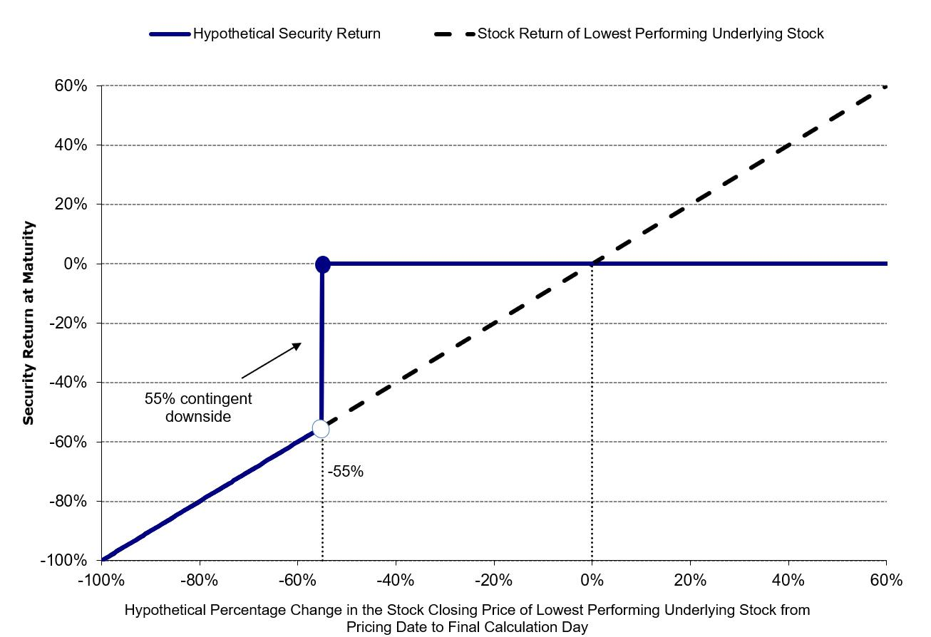
If the securities are not automatically called prior to maturity and the ending price of the lowest performing Underlying Stock on the final calculation day is less than its threshold price, you will lose more than 55%, and possibly all, of the principal amount of your securities at maturity.
Any return on the securities will be limited to the sum of your contingent coupon payments, if any. You will not participate in any appreciation of any Underlying Stock, but you will have full downside exposure to the lowest performing Underlying Stock on the final calculation day if its ending price is less than its threshold price.
The securities are unsecured and unsubordinated obligations of JPMorgan Chase Financial Company LLC, which we refer to as JPMorgan Financial, the payment on which is fully and unconditionally guaranteed by JPMorgan Chase & Co. Any payment on the securities is subject to the credit risk of JPMorgan Financial, as issuer of the securities, and the credit risk of JPMorgan Chase & Co., as guarantor of the securities.
If the securities priced on the date of the accompanying preliminary pricing supplement, the estimated value of the securities would be approximately $932.30 per security. The estimated value of the securities, when the terms of the securities are set, will be provided in the pricing supplement and will not be less than $900.00 per security. See “The Estimated Value of the Securities” in the preliminary pricing supplement for additional information.
Preliminary Pricing Supplement: http://www.sec.gov/Archives/edgar/data/19617/000121390026104497/
ea0307036-01_424b2.htm
The securities are not bank deposits, are not insured by the Federal Deposit Insurance Corporation or any other governmental agency and are not obligations of, or guaranteed by, a bank.
THIS FACT SHEET DOES NOT PROVIDE ALL OF THE INFORMATION THAT AN INVESTOR SHOULD CONSIDER PRIOR TO MAKING AN INVESTMENT DECISION. This fact sheet should be read in conjunction with the accompanying preliminary pricing supplement, prospectus, prospectus supplement and product supplement.
Selected Risk Considerations
The risks set forth below are discussed in detail in the “Selected Risk Considerations” section in the accompanying preliminary pricing supplement and the “Risk Factors” sections in the accompanying prospectus supplement and product supplement. Please review the risk disclosure carefully.
• If the Securities Are Not Automatically Called and the Ending Price of the Lowest Performing Underlying Stock on the Final Calculation Day Is Less Than Its Threshold Price, You Will Lose More Than 55%, and Possibly All, of the Principal Amount of Your Securities at Maturity.  • The Securities Do Not Guarantee the Payment of Interest and May Not Pay Any Interest at All.  • The Potential Return on the Securities Is Limited to the Sum of Any Contingent Coupon Payments and You Will Not Participate in Any Appreciation of Any Underlying Stock.  • You Will Be Subject to Reinvestment Risk.  • The Securities Are Subject to the Credit Risks of JPMorgan Financial and JPMorgan Chase & Co.  • As a Finance Subsidiary, JPMorgan Financial Has No Independent Activities and Has Limited Assets.  • You Are Exposed to the Risk of Decline in the Price of Each Underlying Stock.  • Your Maturity Payment Amount Will Be Determined by the Lowest Performing Underlying Stock.  • You Will Be Subject to Risks Resulting from the Relationship Among the Underlying Stocks.  • Higher Contingent Coupon Rates Are Associated with Greater Risk.  • The Benefit Provided by the Threshold Price May Terminate on the Final Calculation Day.  • No Dividend Payments or Voting Rights  • Lack of Liquidity  • The Final Terms and Estimated Valuation of the Securities Will Be Provided in the Pricing Supplement.  • The U.S. Federal Tax Consequences of the Securities Are Uncertain, and May Be Adverse to a Holder of the Securities.  • Potential Conflicts  • The Estimated Value of the Securities Will Be Lower Than the Original Issue Price (Price to Public) of the Securities. | • The Estimated Value of the Securities Does Not Represent Future Values of the Securities and May Differ from Others’ Estimates.  • The Estimated Value of the Securities Is Derived by Reference to an Internal Funding Rate.  • The Value of the Securities as Published by JPMS (and Which May Be Reflected on Customer Account Statements) May Be Higher Than the Then-Current Estimated Value of the Securities for a Limited Time Period.  • Secondary Market Prices of the Securities Will Likely Be Lower Than the Original Issue Price of the Securities.  • Many Economic and Market Factors Will Impact the Value of the Securities.  • No Affiliation with Any Underlying Stock Issuer  • Limited Trading History with Respect to the Common Stock of SoFi Technologies, Inc. and the Common Stock of Marvell Technology, Inc.  • The Anti-Dilution Protection Is Limited and May Be Discretionary.  • Any Payment on the Securities Will Depend upon the Performance of Each Underlying Stock and Therefore the Securities Are Subject to the Risks Associated with Each Underlying Stock, Each as Discussed in the Accompanying Preliminary Pricing Supplement and Product Supplement.

SEC Legend: JPMorgan Chase Financial Company LLC and JPMorgan Chase & Co. have filed a registration statement (including a prospectus) with the SEC for any offerings to which these materials relate. Before you invest, you should read the prospectus in that registration statement and the other documents relating to this offering that JPMorgan Chase Financial Company LLC and JPMorgan Chase & Co. has filed with the SEC for more complete information about JPMorgan Chase Financial Company LLC and JPMorgan Chase & Co. and this offering. You may get these documents without cost by visiting EDGAR on the SEC web site at www.sec.gov. Alternatively, JPMorgan Chase Financial Company LLC and JPMorgan Chase & Co., any agent or any dealer participating in this offering will arrange to send you the prospectus and each prospectus supplement as well as any product supplement and preliminary pricing supplement if you so request by calling toll-free 1-866-535-9248.
As used in this fact sheet, “we,” “us” and “our” refer to JPMorgan Financial Company LLC. Wells Fargo Advisors is a trade name used by Wells Fargo Clearing Services, LLC and Wells Fargo Advisors Financial Network, LLC, members SIPC, separate registered broker-dealers and non-bank affiliates of Wells Fargo & Company.

