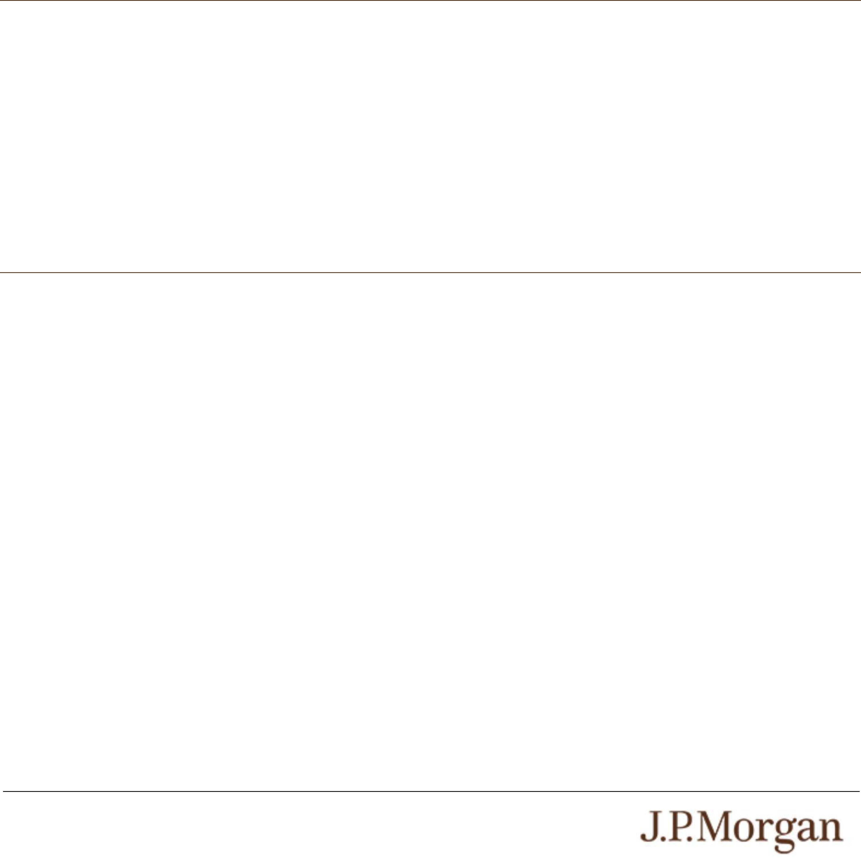
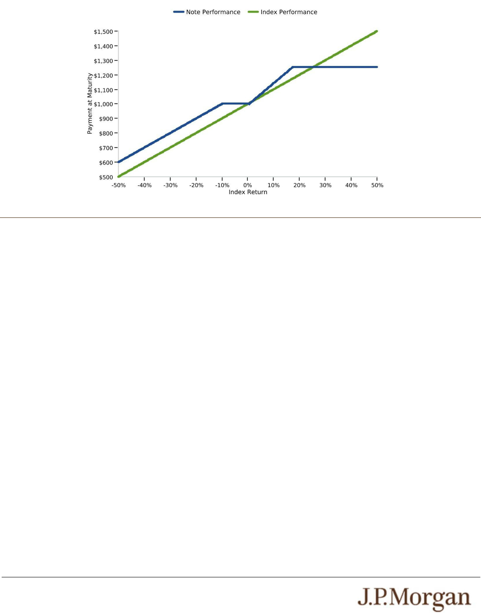
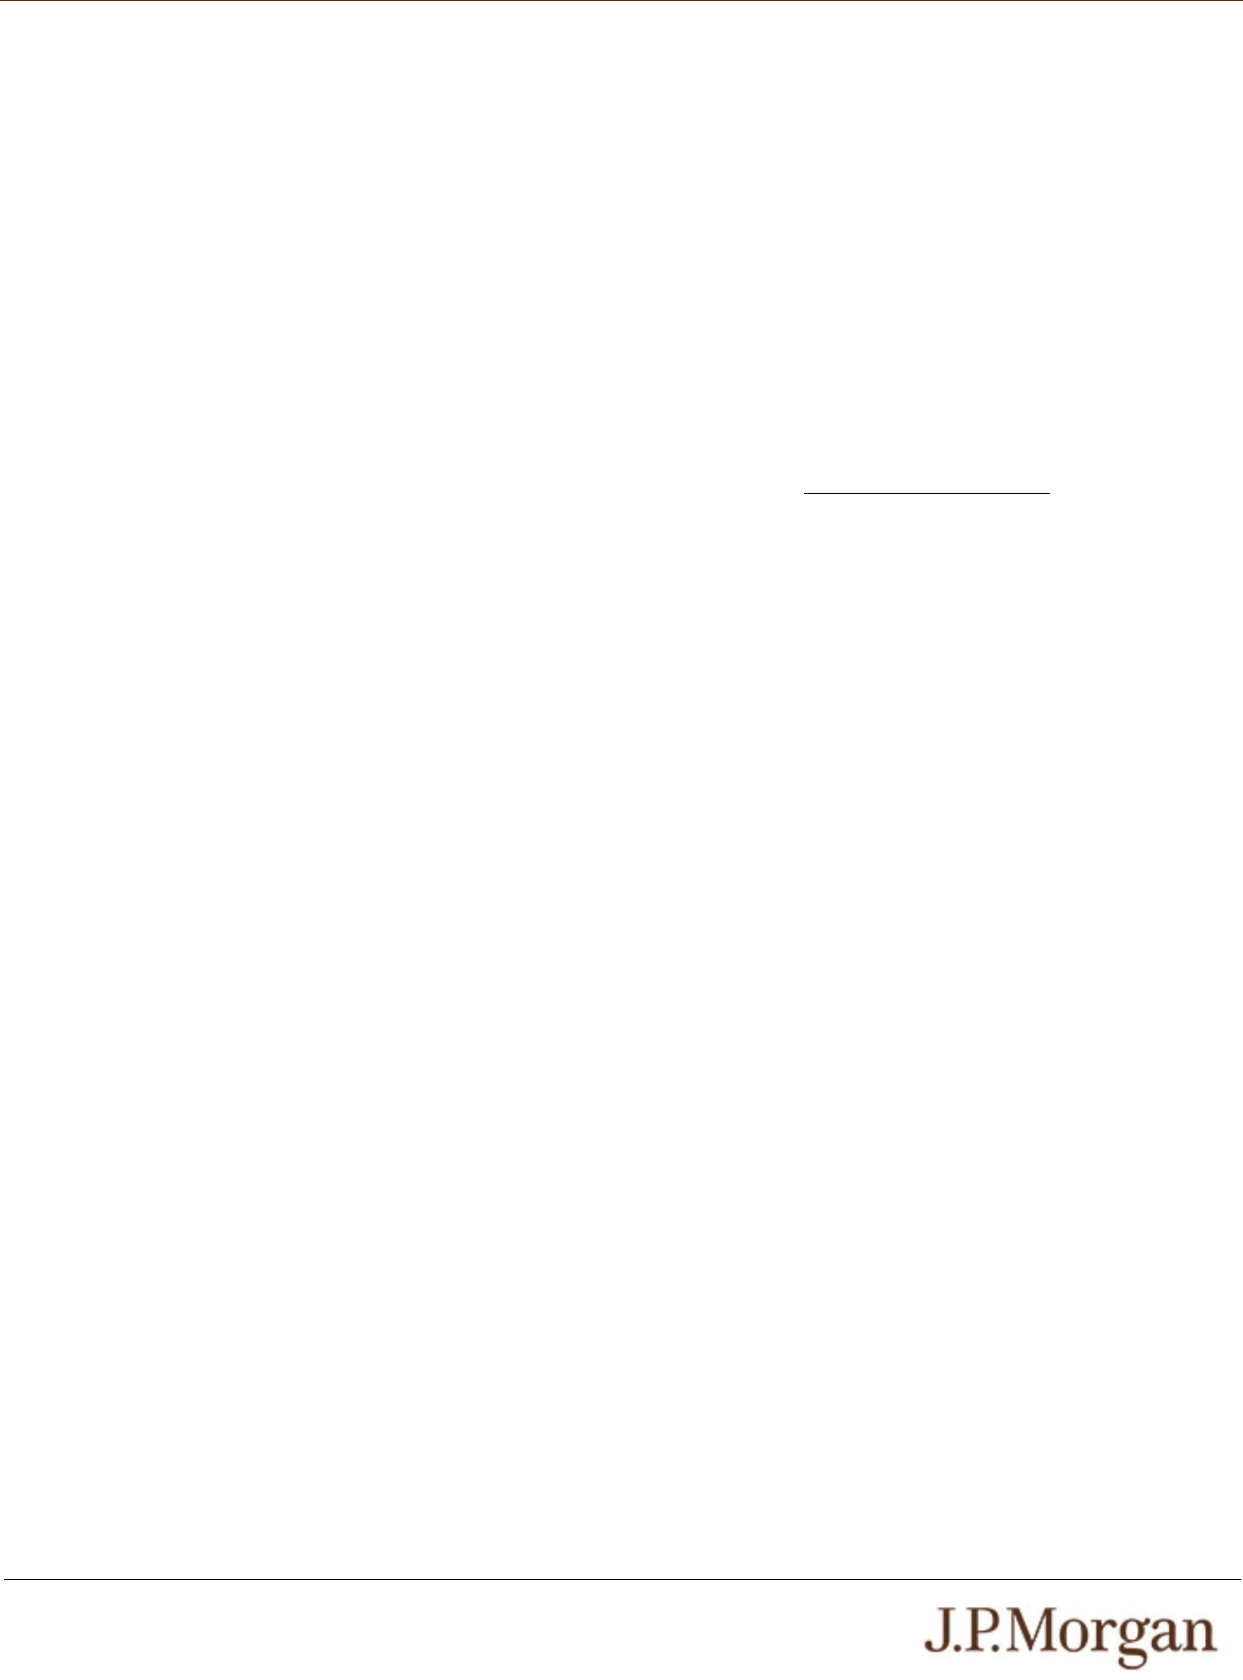
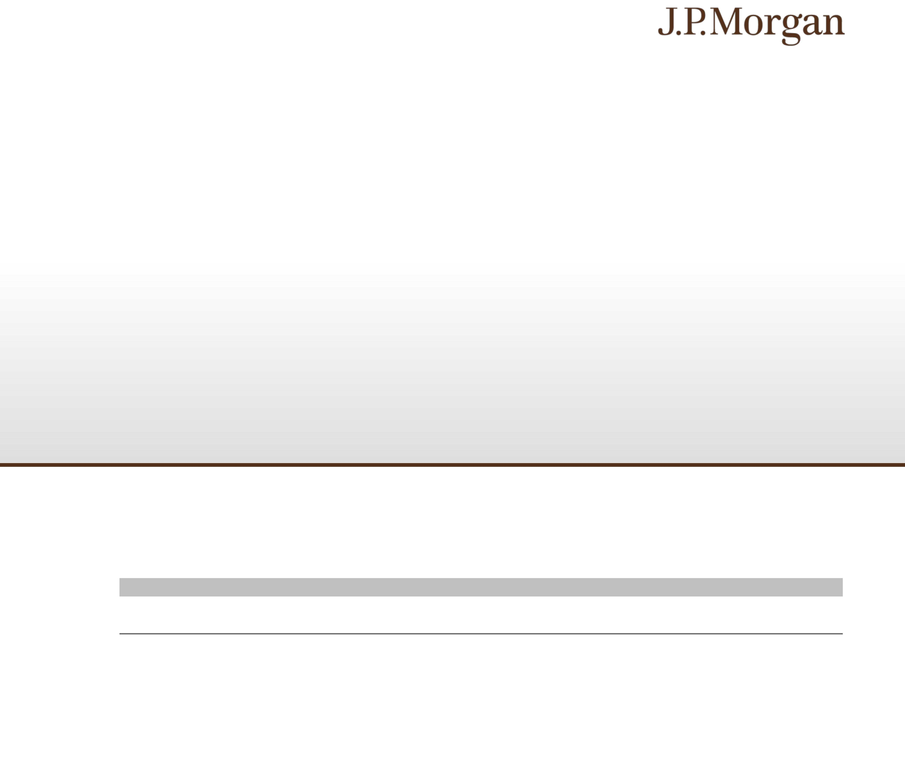

PS-9 | Structured Investments
Capped Buffered Return Enhanced Notes Linked to the Russell 2000® Index

Validity of the Notes and the Guarantee
In the opinion of Davis Polk & Wardwell LLP, as special products counsel to JPMorgan Financial and JPMorgan Chase & Co., when the
notes offered by this pricing supplement have been issued by JPMorgan Financial pursuant to the indenture, the trustee and/or paying
agent has made, in accordance with the instructions from JPMorgan Financial, the appropriate entries or notations in its records relating
to the master global note that represents such notes (the “master note”), and such notes have been delivered against payment as
contemplated herein, such notes will be valid and binding obligations of JPMorgan Financial and the related guarantee will constitute a
valid and binding obligation of JPMorgan Chase & Co., enforceable in accordance with their terms, subject to applicable bankruptcy,
insolvency and similar laws affecting creditors’ rights generally, concepts of reasonableness and equitable principles of general
applicability (including, without limitation, concepts of good faith, fair dealing and the lack of bad faith), provided that such counsel
expresses no opinion as to (x)(i) the effect of fraudulent conveyance, fraudulent transfer or similar provision of applicable law on the
conclusions expressed above or (ii) any provision of the indenture that purports to avoid the effect of fraudulent conveyance, fraudulent
transfer or similar provision of applicable law by limiting the amount of JPMorgan Chase & Co.’s obligation under the related guarantee
or (y) the validity, legally binding effect or enforceability of any provision that permits holders to collect any portion of the stated principal
amount upon acceleration of the notes to the extent determined to constitute unearned interest. This opinion is given as of the date
hereof and is limited to the laws of the State of New York, the General Corporation Law of the State of Delaware and the Delaware
Limited Liability Company Act, except that such counsel expresses no opinion as to (i) any law, rule or regulation that is applicable to
JPMorgan Financial or JPMorgan Chase & Co., the indenture, the notes, the related guarantee (together with the indenture and the
notes, the “Documents”) or such transactions solely because such law, rule or regulation is part of a regulatory regime applicable to any
party to any of the Documents or any of its affiliates due to the specific assets or business of such party or such affiliate or (ii) any law,
rule or regulation relating to national security. In addition, this opinion is subject to customary assumptions about the trustee’s
authorization, execution and delivery of the indenture and its authentication of the master note and the validity, binding nature and
enforceability of the indenture with respect to the trustee, all as stated in the letter of such counsel dated February 24, 2026, which was
filed as an exhibit to the Registration Statement on Form S-3 by JPMorgan Financial and JPMorgan Chase & Co. on February 24,
2026.
Additional Terms Specific to the Notes
You should read this pricing supplement together with the accompanying prospectus, as supplemented by the accompanying
prospectus supplement relating to our Series A medium-term notes of which these notes are a part, and the more detailed information
contained in the accompanying product supplement and the accompanying underlying supplement. This pricing supplement, together
with the documents listed below, contains the terms of the notes and supersedes all other prior or contemporaneous oral statements as
well as any other written materials including preliminary or indicative pricing terms, correspondence, trade ideas, structures for
implementation, sample structures, fact sheets, brochures or other educational materials of ours. This pricing supplement amends
and restates and supersedes the original pricing supplement related hereto dated August 13, 2026 in its entirety. You should
not rely on the original pricing supplement related hereto dated August 13, 2026 in making your decision to invest in the
notes. You should carefully consider, among other things, the matters set forth in the “Risk Factors” sections of the accompanying
prospectus supplement and the accompanying product supplement, as the notes involve risks not associated with conventional debt
securities. We urge you to consult your investment, legal, tax, accounting and other advisers before you invest in the notes.
You may access these documents on the SEC website at www.sec.gov as follows (or if such address has changed, by reviewing
our filings for the relevant date on the SEC website):
● Product supplement no. 3-I dated April 17, 2026:
http://www.sec.gov/Archives/edgar/data/19617/000121390026045198/ea0285802-20_424b2.pdf
● Underlying supplement no. 1-I dated April 17, 2026:
http://www.sec.gov/Archives/edgar/data/19617/000121390026045209/ea0285802-11_424b2.pdf
● Prospectus supplement and prospectus, each dated April 17, 2026:
http://www.sec.gov/Archives/edgar/data/19617/000095010326005889/crt_dp245141-424b2.pdf
Our Central Index Key, or CIK, on the SEC website is 1665650, and JPMorgan Chase & Co.’s CIK is 19617. As used in this pricing
supplement, “we,” “us” and “our” refer to JPMorgan Financial.

PS-8 | Structured Investments
Capped Buffered Return Enhanced Notes Linked to the Russell 2000® Index

The estimated value of the notes does not represent future values of the notes and may differ from others’ estimates. Different pricing
models and assumptions could provide valuations for the notes that are greater than or less than the estimated value of the notes. In
addition, market conditions and other relevant factors in the future may change, and any assumptions may prove to be incorrect. On
future dates, the value of the notes could change significantly based on, among other things, changes in market conditions, our or
JPMorgan Chase & Co.’s creditworthiness, interest rate movements and other relevant factors, which may impact the price, if any, at
which JPMS would be willing to buy notes from you in secondary market transactions.
The estimated value of the notes is lower than the original issue price of the notes because costs associated with structuring and
hedging the notes are included in the original issue price of the notes. These costs include the projected profits, if any, that our affiliates
expect to realize for assuming risks inherent in hedging our obligations under the notes, the estimated cost of hedging our obligations
under the notes and the fees, if any, paid for third-party data analytics and/or electronic platform services. Because hedging our
obligations entails risk and may be influenced by market forces beyond our control, this hedging may result in a profit that is more or
less than expected, or it may result in a loss. A portion of the profits, if any, realized in hedging our obligations under the notes may be
allowed to other affiliated or unaffiliated dealers, and we or one or more of our affiliates will retain any remaining hedging profits. See
“Selected Risk Considerations — The Estimated Value of the Notes Is Lower Than the Original Issue Price (Price to Public) of the
Notes” in this pricing supplement.
Secondary Market Prices of the Notes
For information about factors that will impact any secondary market prices of the notes, see “Risk Factors — Risks Relating to the
Estimated Value and Secondary Market Prices of the Notes — Secondary market prices of the notes will be impacted by many
economic and market factors” in the accompanying product supplement. In addition, we generally expect that some of the costs
included in the original issue price of the notes will be partially paid back to you in connection with any repurchases of your notes by
JPMS in an amount that will decline to zero over an initial predetermined period. These costs can include projected hedging profits, if
any, and, in some circumstances, estimated hedging costs, our internal secondary market funding rates for structured debt issuances
and the fees paid for third-party data analytics and/or electronic platform services. This initial predetermined time period is intended to
be the shorter of six months and one-half of the stated term of the notes. The length of any such initial period reflects the structure of
the notes, whether our affiliates expect to earn a profit in connection with our hedging activities, the estimated costs of hedging the
notes and when these costs are incurred, as determined by our affiliates. See “Selected Risk Considerations — The Value of the Notes
as Published by JPMS (and Which May Be Reflected on Customer Account Statements) May Be Higher Than the Then-Current
Estimated Value of the Notes for a Limited Time Period” in this pricing supplement.
Supplemental Use of Proceeds
The notes are offered to meet investor demand for products that reflect the risk-return profile and market exposure provided by the
notes. See “Hypothetical Payout Profile” and “How the Notes Work” in this pricing supplement for an illustration of the risk-return profile
of the notes and “The Index” in this pricing supplement for a description of the market exposure provided by the notes.
The original issue price of the notes is equal to the estimated value of the notes plus (minus) the projected profits (losses) that our
affiliates expect to realize for assuming risks inherent in hedging our obligations under the notes, plus the estimated cost of hedging our
obligations under the notes, plus the fees, if any, paid for third-party data analytics and/or electronic platform services.

PS-7 | Structured Investments
Capped Buffered Return Enhanced Notes Linked to the Russell 2000® Index

Tax Treatment
You should review carefully the section entitled “United States Federal Taxation” in the accompanying prospectus supplement. The
following discussion, when read in combination with that section, constitutes the full opinion of our special tax counsel, Davis Polk &
Wardwell LLP, regarding the material U.S. federal income tax consequences of owning and disposing of notes.
Based on current market conditions, in the opinion of our special tax counsel it is reasonable to treat the notes as “open transactions”
that are not debt instruments for U.S. federal income tax purposes, as more fully described in “United States Federal Taxation — Tax
Consequences to U.S. Holders — Program Securities Treated as Prepaid Financial Contracts That are Open Transactions” in the
accompanying prospectus supplement. Assuming this treatment is respected, the gain or loss on your notes should be treated as long-
term capital gain or loss if you hold your notes for more than a year, whether or not you are an initial purchaser of notes at the issue
price. However, the IRS or a court may not respect this treatment, in which case the timing and character of any income or loss on the
notes could be materially and adversely affected. In addition, in 2007 Treasury and the IRS released a notice requesting comments on
the U.S. federal income tax treatment of “prepaid forward contracts” and similar instruments. The notice focuses in particular on
whether to require investors in these instruments to accrue income over the term of their investment. It also asks for comments on a
number of related topics, including the character of income or loss with respect to these instruments; the relevance of factors such as
the nature of the underlying property to which the instruments are linked; the degree, if any, to which income (including any mandated
accruals) realized by non-U.S. investors should be subject to withholding tax; and whether these instruments are or should be subject
to the “constructive ownership” regime, which very generally can operate to recharacterize certain long-term capital gain as ordinary
income and impose a notional interest charge. While the notice requests comments on appropriate transition rules and effective dates,
any Treasury regulations or other guidance promulgated after consideration of these issues could materially and adversely affect the
tax consequences of an investment in the notes, possibly with retroactive effect. You should consult your tax adviser regarding the
U.S. federal income tax consequences of an investment in the notes, including possible alternative treatments and the issues
presented by this notice.
Section 871(m) of the Code and Treasury regulations promulgated thereunder (“Section 871(m)”) generally impose a 30% withholding
tax (unless an income tax treaty applies) on dividend equivalents paid or deemed paid to Non-U.S. Holders with respect to certain
financial instruments linked to U.S. equities or indices that include U.S. equities. Section 871(m) provides certain exceptions to this
withholding regime, including for instruments linked to certain broad-based indices that meet requirements set forth in the applicable
Treasury regulations. Additionally, a recent IRS notice excludes from the scope of Section 871(m) instruments issued prior to January
1, 2027 that do not have a delta of one with respect to underlying securities that could pay U.S.-source dividends for U.S. federal
income tax purposes (each an “Underlying Security”). Based on certain determinations made by us, our special tax counsel is of the
opinion that Section 871(m) should not apply to the notes with regard to Non-U.S. Holders. Our determination is not binding on the IRS,
and the IRS may disagree with this determination. Section 871(m) is complex and its application may depend on your particular
circumstances, including whether you enter into other transactions with respect to an Underlying Security. You should consult your tax
adviser regarding the potential application of Section 871(m) to the notes.
The Estimated Value of the Notes
The estimated value of the notes set forth on the cover of this pricing supplement is equal to the sum of the values of the following
hypothetical components: (1) a fixed-income debt component with the same maturity as the notes, valued using the internal funding
rate described below, and (2) the derivative or derivatives underlying the economic terms of the notes. The estimated value of the notes
does not represent a minimum price at which JPMS would be willing to buy your notes in any secondary market (if any exists) at any
time. The internal funding rate used in the determination of the estimated value of the notes may differ from the market-implied funding
rate for vanilla fixed income instruments of a similar maturity issued by JPMorgan Chase & Co. or its affiliates. Any difference may be
based on, among other things, our and our affiliates’ view of the funding value of the notes as well as the higher issuance, operational
and ongoing liability management costs of the notes in comparison to those costs for the conventional fixed income instruments of
JPMorgan Chase & Co. This internal funding rate is based on certain market inputs and assumptions, which may prove to be incorrect,
and is intended to approximate the prevailing market replacement funding rate for the notes. The use of an internal funding rate and
any potential changes to that rate may have an adverse effect on the terms of the notes and any secondary market prices of the notes.
For additional information, see “Selected Risk Considerations — The Estimated Value of the Notes Is Derived by Reference to an
Internal Funding Rate” in this pricing supplement.
The value of the derivative or derivatives underlying the economic terms of the notes is derived from internal pricing models of our
affiliates. These models are dependent on inputs such as the traded market prices of comparable derivative instruments and on various
other inputs, some of which are market-observable, and which can include volatility, dividend rates, interest rates and other factors, as
well as assumptions about future market events and/or environments. Accordingly, the estimated value of the notes is determined when
the terms of the notes are set based on market conditions and other relevant factors and assumptions existing at that time.

PS-6 | Structured Investments
Capped Buffered Return Enhanced Notes Linked to the Russell 2000® Index

The Index
The Russell 2000® Index measures the capitalization-weighted price performance of 2,000 U.S. small-capitalization stocks listed on
eligible U.S. exchanges and is designed to track the performance of the small-capitalization segment of the U.S. equity market. The
companies included in the Russell 2000® Index are the middle 2,000 of the companies that form the Russell 3000ETM Index, which is
composed of the 4,000 largest U.S. companies as determined by total market capitalization and represents approximately 99% of the
U.S. equity market. For additional information about the Russell 2000® Index, see “Equity Index Descriptions — The Russell Indices” in
the accompanying underlying supplement.
Historical Information
The following graph sets forth the historical performance of the Index based on the weekly historical closing levels of the Index from
January 8, 2021 through August 7, 2026. The closing level of the Index on August 13, 2026 was 3,052.847. We obtained the closing
levels above and below from the Bloomberg Professional® service (“Bloomberg”), without independent verification.
The historical closing levels of the Index should not be taken as an indication of future performance, and no assurance can be given as
to the closing level of the Index on the Observation Date. There can be no assurance that the performance of the Index will result in the
return of any of your principal amount in excess of $100.00 per $1,000 principal amount note, subject to the credit risks of JPMorgan
Financial and JPMorgan Chase & Co.
Historical Performance of the Russell 2000® Index
Source: Bloomberg

PS-5 | Structured Investments
Capped Buffered Return Enhanced Notes Linked to the Russell 2000® Index

● THE ESTIMATED VALUE OF THE NOTES IS DERIVED BY REFERENCE TO AN INTERNAL FUNDING RATE —
The internal funding rate used in the determination of the estimated value of the notes may differ from the market-implied funding
rate for vanilla fixed income instruments of a similar maturity issued by JPMorgan Chase & Co. or its affiliates. Any difference may
be based on, among other things, our and our affiliates’ view of the funding value of the notes as well as the higher issuance,
operational and ongoing liability management costs of the notes in comparison to those costs for the conventional fixed income
instruments of JPMorgan Chase & Co. This internal funding rate is based on certain market inputs and assumptions, which may
prove to be incorrect, and is intended to approximate the prevailing market replacement funding rate for the notes. The use of an
internal funding rate and any potential changes to that rate may have an adverse effect on the terms of the notes and any
secondary market prices of the notes. See “The Estimated Value of the Notes” in this pricing supplement.
● THE VALUE OF THE NOTES AS PUBLISHED BY JPMS (AND WHICH MAY BE REFLECTED ON CUSTOMER ACCOUNT
STATEMENTS) MAY BE HIGHER THAN THE THEN-CURRENT ESTIMATED VALUE OF THE NOTES FOR A LIMITED TIME
PERIOD —
We generally expect that some of the costs included in the original issue price of the notes will be partially paid back to you in
connection with any repurchases of your notes by JPMS in an amount that will decline to zero over an initial predetermined period.
See “Secondary Market Prices of the Notes” in this pricing supplement for additional information relating to this initial period.
Accordingly, the estimated value of your notes during this initial period may be lower than the value of the notes as published by
JPMS (and which may be shown on your customer account statements).
● SECONDARY MARKET PRICES OF THE NOTES WILL LIKELY BE LOWER THAN THE ORIGINAL ISSUE PRICE OF THE
NOTES —
Any secondary market prices of the notes will likely be lower than the original issue price of the notes because, among other
things, secondary market prices take into account our internal secondary market funding rates for structured debt issuances and,
also, because secondary market prices may exclude projected hedging profits, if any, estimated hedging costs and fees, if any,
paid for third-party data analytics and/or electronic platform services that are included in the original issue price of the notes. As a
result, the price, if any, at which JPMS will be willing to buy the notes from you in secondary market transactions, if at all, is likely to
be lower than the original issue price. Furthermore, if you sell your notes, you will likely be charged a commission for secondary
market transactions, or the price will likely reflect a dealer discount and/or fees for use of an electronic platform to facilitate
secondary market activity. Any sale by you prior to the Maturity Date could result in a substantial loss to you.
● SECONDARY MARKET PRICES OF THE NOTES WILL BE IMPACTED BY MANY ECONOMIC AND MARKET FACTORS —
The secondary market price of the notes during their term will be impacted by a number of economic and market factors, which
may either offset or magnify each other, aside from the projected hedging profits, if any, estimated hedging costs and the level of
the Index. Additionally, independent pricing vendors and/or third party broker-dealers may publish a price for the notes, which may
also be reflected on customer account statements. This price may be different (higher or lower) than the price of the notes, if any,
at which JPMS may be willing to purchase your notes in the secondary market. See “Risk Factors — Risks Relating to the
Estimated Value and Secondary Market Prices of the Notes — Secondary market prices of the notes will be impacted by many
economic and market factors” in the accompanying product supplement.

PS-4 | Structured Investments
Capped Buffered Return Enhanced Notes Linked to the Russell 2000® Index

Selected Risk Considerations
An investment in the notes involves significant risks. These risks are explained in more detail in the “Risk Factors” sections of the
accompanying prospectus supplement and product supplement.
● YOUR INVESTMENT IN THE NOTES MAY RESULT IN A LOSS —
The notes do not guarantee any return of principal. If the Final Value is less than the Initial Value by more than 10.00%, you will
lose 1% of the principal amount of your notes for every 1% that the Final Value is less than the Initial Value by more than 10.00%.
Accordingly, under these circumstances, you will lose up to 90.00% of your principal amount at maturity.
● YOUR MAXIMUM GAIN ON THE NOTES IS LIMITED TO THE MAXIMUM RETURN,
regardless of any appreciation of the Index, which may be significant.
● CREDIT RISKS OF JPMORGAN FINANCIAL AND JPMORGAN CHASE & CO. —
Investors are dependent on our and JPMorgan Chase & Co.’s ability to pay all amounts due on the notes. Any actual or potential
change in our or JPMorgan Chase & Co.’s creditworthiness or credit spreads, as determined by the market for taking that credit
risk, is likely to adversely affect the value of the notes. If we and JPMorgan Chase & Co. were to default on our payment
obligations, you may not receive any amounts owed to you under the notes and you could lose your entire investment.
● AS A FINANCE SUBSIDIARY, JPMORGAN FINANCIAL HAS NO INDEPENDENT ACTIVITIES AND HAS LIMITED ASSETS —
As a finance subsidiary of JPMorgan Chase & Co., we have no independent activities beyond the issuance and administration of
our securities and the collection of intercompany obligations. Aside from the initial capital contribution from JPMorgan Chase & Co.,
substantially all of our assets relate to obligations of JPMorgan Chase & Co. to make payments under loans made by us to
JPMorgan Chase & Co. or under other intercompany agreements. As a result, we are dependent upon payments from JPMorgan
Chase & Co. to meet our obligations under the notes. We are not an operating subsidiary of JPMorgan Chase & Co. and in a
bankruptcy or resolution of JPMorgan Chase & Co. we are not expected to have sufficient resources to meet our obligations in
respect of the notes as they come due. If JPMorgan Chase & Co. does not make payments to us and we are unable to make
payments on the notes, you may have to seek payment under the related guarantee by JPMorgan Chase & Co., and that
guarantee will rank pari passu with all other unsecured and unsubordinated obligations of JPMorgan Chase & Co. For more
information, see “Risk Factors — Holders of securities issued by JPMorgan Financial may be subject to losses if JPMorgan Chase
& Co. were to enter into a resolution” in the accompanying prospectus supplement.
● POTENTIAL CONFLICTS —
We and our affiliates play a variety of roles in connection with the notes. In performing these duties, our and JPMorgan Chase &
Co.’s economic interests are potentially adverse to your interests as an investor in the notes. It is possible that hedging or trading
activities of ours or our affiliates in connection with the notes could result in substantial returns for us or our affiliates while the
value of the notes declines. Please refer to “Risk Factors — Risks Relating to Conflicts of Interest” in the accompanying product
supplement.
● THE NOTES DO NOT PAY INTEREST.
● YOU WILL NOT RECEIVE DIVIDENDS ON THE SECURITIES INCLUDED IN THE INDEX OR HAVE ANY RIGHTS WITH
RESPECT TO THOSE SECURITIES.
● AN INVESTMENT IN THE NOTES IS SUBJECT TO RISKS ASSOCIATED WITH SMALL CAPITALIZATION STOCKS —
Small capitalization companies may be less able to withstand adverse economic, market, trade and competitive conditions relative
to larger companies. Small capitalization companies are less likely to pay dividends on their stocks, and the presence of a dividend
payment could be a factor that limits downward stock price pressure under adverse market conditions.
● LACK OF LIQUIDITY —
The notes will not be listed on any securities exchange. Accordingly, the price at which you may be able to trade your notes is likely
to depend on the price, if any, at which J.P. Morgan Securities LLC, which we refer to as JPMS, is willing to buy the notes. You
may not be able to sell your notes. The notes are not designed to be short-term trading instruments. Accordingly, you should be
able and willing to hold your notes to maturity.
● THE ESTIMATED VALUE OF THE NOTES IS LOWER THAN THE ORIGINAL ISSUE PRICE (PRICE TO PUBLIC) OF THE
NOTES —
The estimated value of the notes is only an estimate determined by reference to several factors. The original issue price of the
notes exceeds the estimated value of the notes because costs associated with structuring and hedging the notes are included in
the original issue price of the notes. These costs include the projected profits, if any, that our affiliates expect to realize for
assuming risks inherent in hedging our obligations under the notes, the estimated cost of hedging our obligations under the notes
and the fees, if any, paid for third-party data analytics and/or electronic platform services. See “The Estimated Value of the Notes”
in this pricing supplement.
● THE ESTIMATED VALUE OF THE NOTES DOES NOT REPRESENT FUTURE VALUES OF THE NOTES AND MAY DIFFER
FROM OTHERS’ ESTIMATES —
See “The Estimated Value of the Notes” in this pricing supplement.

PS-3 | Structured Investments
Capped Buffered Return Enhanced Notes Linked to the Russell 2000® Index

The following graph demonstrates the hypothetical payments at maturity on the notes for a range of Index Returns (-50% to 50%).
There can be no assurance that the performance of the Index will result in the return of any of your principal amount in excess of
$100.00 per $1,000 principal amount note, subject to the credit risks of JPMorgan Financial and JPMorgan Chase & Co.
How the Notes Work
Upside Scenario:
If the Final Value is greater than the Initial Value, investors will receive at maturity the $1,000 principal amount plus a return equal to
1.50 times the Index Return, subject to the Maximum Return of 25.15%. An investor will realize the maximum payment at maturity at a
Final Value at or above approximately 116.7667% of the Initial Value.
● If the closing level of the Index increases 5.00%, investors will receive at maturity a return of 7.50%, or $1,075.00 per $1,000
principal amount note.
● If the closing level of the Index increases 40.00%, investors will receive at maturity a return equal to the Maximum Return of
25.15%, or $1,251.50 per $1,000 principal amount note, which is the maximum payment at maturity.
Par Scenario:
If the Final Value is equal to the Initial Value or is less than the Initial Value by up to the Buffer Amount of 10.00%, investors will receive
at maturity the principal amount of their notes.
Downside Scenario:
If the Final Value is less than the Initial Value by more than the Buffer Amount of 10.00%, investors will lose 1% of the principal amount
of their notes for every 1% that the Final Value is less than the Initial Value by more than the Buffer Amount.
● For example, if the closing level of the Index declines 50.00%, investors will lose 40.00% of their principal amount and receive only
$600.00 per $1,000 principal amount note at maturity.
The hypothetical returns and hypothetical payments on the notes shown above apply only if you hold the notes for their entire term.
These hypotheticals do not reflect the fees or expenses that would be associated with any sale in the secondary market. If these fees
and expenses were included, the hypothetical returns and hypothetical payments shown above would likely be lower.
85.0000
-40.0000%
60.0000
$800.00
-20.00%
-30.0000%
70.0000
$900.00
-10.00%
-20.0000%
80.0000
$950.00
-5.00%
-15.0000%
-30.00%
$1,000.00
0.00%
-10.0000%
90.0000
$1,000.00
0.00%
-5.0000%
95.0000
$1,000.00
0.00%
0.0000%
100.0000
$400.00

$100.00
-90.00%
-100.0000%
0.0000
$200.00
-80.00%
-90.0000%
10.0000
$300.00
-70.00%
-80.0000%
20.0000
$1,015.00
-60.00%
-70.0000%
30.0000
$500.00
-50.00%
-60.0000%
40.0000
$600.00
-40.00%
-50.0000%
50.0000
$700.00
$1,251.50
140.0000
$1,251.50
25.15%
50.0000%
150.0000
$1,251.50
25.15%
60.0000%
160.0000
$1,251.50
25.15%
70.0000%
170.0000
40.0000%
25.15%
80.0000%
180.0000
Payment at Maturity
Total Return on the Notes
Index Return
Final Value
Hypothetical Payout Profile
The following table and graph illustrate the hypothetical total return and payment at maturity on the notes linked to a hypothetical Index.
The “total return” as used in this pricing supplement is the number, expressed as a percentage, that results from comparing the
payment at maturity per $1,000 principal amount note to $1,000. The hypothetical total returns and payments set forth below assume
the following:
● an Initial Value of 100.00;
● a Maximum Return of 25.15%;
● an Upside Leverage Factor of 1.50; and
● a Buffer Amount of 10.00%.
The hypothetical Initial Value of 100.00 has been chosen for illustrative purposes only and does not represent the actual Initial Value.
The actual Initial Value is the closing level of the Index on the Pricing Date and is specified under “Key Terms – Initial Value” in this
pricing supplement. For historical data regarding the actual closing levels of the Index, please see the historical information set forth
under “The Index” in this pricing supplement.
Each hypothetical total return or hypothetical payment at maturity set forth below is for illustrative purposes only and may not be the
actual total return or payment at maturity applicable to a purchaser of the notes. The numbers appearing in the following table and
graph have been rounded for ease of analysis.

PS-2 | Structured Investments
Capped Buffered Return Enhanced Notes Linked to the Russell 2000® Index

25.15%
1.50%
1.0000%
101.0000
$1,075.00
7.50%
5.0000%
105.0000
$1,150.00
15.00%
10.0000%
110.0000
$1,251.50
16.7667%
116.7667
$1,251.50
25.15%
20.0000%
120.0000
$1,251.50
25.15%
30.0000%
130.0000
$1,251.50
25.15%

PS-1 | Structured Investments
Capped Buffered Return Enhanced Notes Linked to the Russell 2000® Index

Key Terms
Issuer: JPMorgan Chase Financial Company LLC, a direct,
wholly owned finance subsidiary of JPMorgan Chase & Co.
Guarantor: JPMorgan Chase & Co.
Index: The Russell 2000® Index (Bloomberg ticker: RTY)
Maximum Return: 25.15% (corresponding to a maximum
payment at maturity of $1,251.50 per $1,000 principal
amount note)
Upside Leverage Factor: 1.50
Buffer Amount: 10.00%
Pricing Date: August 13, 2026
Original Issue Date (Settlement Date): On or about August
18, 2026
Observation Date*: January 13, 2028
Maturity Date*: January 19, 2028
* Subject to postponement in the event of a market disruption
event as described under “General Terms of Notes —
Postponement of a Determination Date — Notes Linked to a
Single Underlying — Notes Linked to a Single Underlying
(Other Than a Commodity Index)” and “General Terms of
Notes — Postponement of a Payment Date” in the
accompanying product supplement

Payment at Maturity: If the Final Value is greater than the
Initial Value, your payment at maturity per $1,000 principal
amount note will be calculated as follows:
$1,000 + ($1,000 × Index Return × Upside Leverage Factor),
subject to the Maximum Return
If the Final Value is equal to the Initial Value or is less than the
Initial Value by up to the Buffer Amount, you will receive the
principal amount of your notes at maturity.
If the Final Value is less than the Initial Value by more than the
Buffer Amount, your payment at maturity per $1,000 principal
amount note will be calculated as follows:
$1,000 + [$1,000 × (Index Return + Buffer Amount)]
If the Final Value is less than the Initial Value by more than the
Buffer Amount, you will lose some or most of your principal
amount at maturity.
Index Return:
(Final Value – Initial Value)
Initial Value
Initial Value: The closing level of the Index on the Pricing
Date, which was 3,052.847
Final Value: The closing level of the Index on the Observation
Date

$1,000
The estimated value of the notes, when the terms of the notes were set, was $996.90 per $1,000 principal amount note. See
“The Estimated Value of the Notes” in this pricing supplement for additional information.
The notes are not bank deposits, are not insured by the Federal Deposit Insurance Corporation or any other governmental agency
and are not obligations of, or guaranteed by, a bank.
*This pricing supplement amends and restates and supersedes the original pricing supplement related hereto dated August 13, 2026
to product supplement no. 3-I in its entirety (the original pricing supplement is available on the SEC website at
https://www.sec.gov/Archives/edgar/data/19617/000191870426023908/form424b2.htm).
(2) All sales of the notes will be made to certain fee-based advisory accounts for which an affiliated or unaffiliated broker-dealer is an
investment adviser. These broker-dealers will forgo any commissions related to these sales. See “Plan of Distribution (Conflicts of Interest)”
in the accompanying product supplement.
(1) See “Supplemental Use of Proceeds” in this pricing supplement for information about the components of the price to public of the notes.
$890,000
—
$890,000
Total
$1,000
—
Per note
Proceeds to Issuer
Fees and Commissions (2)
Price to Public (1)

Pricing supplement to product supplement no. 3-I dated April 17, 2026, underlying supplement no. 1-I dated April 17, 2026, the prospectus and
prospectus supplement, each dated April 17, 2026
JPMorgan Chase Financial Company LLC
Structured Investments
$890,000
Capped Buffered Return Enhanced Notes Linked to
the Russell 2000® Index due January 19, 2028
Fully and Unconditionally Guaranteed by JPMorgan Chase & Co.
● The notes are designed for investors who seek a return of 1.50 times any appreciation of the Russell 2000® Index, up to a
maximum return of 25.15%, at maturity.
● Investors should be willing to forgo interest and dividend payments and be willing to lose up to 90.00% of their principal
amount at maturity.
● The notes are unsecured and unsubordinated obligations of JPMorgan Chase Financial Company LLC, which we refer to as
JPMorgan Financial, the payment on which is fully and unconditionally guaranteed by JPMorgan Chase & Co. Any
payment on the notes is subject to the credit risk of JPMorgan Financial, as issuer of the notes, and the credit risk
of JPMorgan Chase & Co., as guarantor of the notes.
● Minimum denominations of $1,000 and integral multiples thereof
● The notes priced on August 13, 2026 and are expected to settle on or about August 18, 2026.
● CUSIP: 46661KHU5
Investing in the notes involves a number of risks. See “Risk Factors” beginning on page S-2 of the accompanying
prospectus supplement, “Risk Factors” beginning on page PS-12 of the accompanying product supplement and “Selected
Risk Considerations” beginning on page PS-4 of this pricing supplement.
Neither the Securities and Exchange Commission (the “SEC”) nor any state securities commission has approved or disapproved of
the notes or passed upon the accuracy or the adequacy of this pricing supplement or the accompanying product supplement,
underlying supplement, prospectus supplement and prospectus. Any representation to the contrary is a criminal offense.
Registration Statement Nos. 333-293684 and 333-293684-01; Rule 424(b)(8)
August 18, 2026*

Calculation of Filing Fee Tables
S-3
JPMORGAN CHASE & CO
Narrative Disclosure
The maximum aggregate offering price of the securities to which the prospectus relates is $550,000. The prospectus is a final prospectus for the related offering.

