Registration Statement No. 333-130051

File Pursuant to Rule 433


The J.P. Morgan U.S. Franchise List Sub-Basket

The collective turbulence from the seizure in credit markets, weakening economic outlook, and battered equity markets have most likely put fundamental analysis on the back burner for many investors. However, for investors with investment horizons that stretch beyond the current turmoil in the markets, J.P. Morgan’s North America Equity Research believes that fundamental analysis remains an important component of an investment framework.

The J.P. Morgan U.S. Franchise List Basket (the “U.S. Franchise List Basket”) is a select group of stocks that J.P. Morgan North America Equity Research sees as core investments over the next 12-18 months. The J.P. Morgan U.S. Franchise List Sub-Basket (the “Sub-Basket”) is a subset of fifteen stocks from the U.S. Franchise List Basket and is equally-weighted. The selection of the U.S. Franchise List Basket was based on a combination of quantitative analysis and fundamental analysis (which is qualitative and subjective). To be included in this basket, companies (1) must possess a combination of stable financial characteristics as measured by several quantitative factors developed by our equity research analysts and (2) must be viewed by our equity research analysts as outperformers during the global weakness envisioned over the next year. The process for selecting the stocks in the U.S. Franchise List Basket is outlined below.

The stocks in the U.S. Franchise List Basket were selected based on the following criteria: Universe of stocks
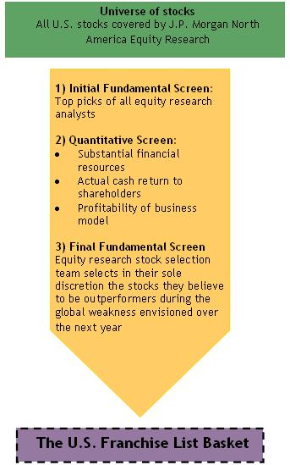

Substantial financial resources. Limited financial risk as measured by low leverage. Companies were ranked on net current assets (as a percentage of stock price) and debt to equity, and limited to those ranking in the top deciles among 1,200 U.S. stocks.

Actual cash return to shareholders. Companies were ranked on either dividend yield or stock buyback yield and the selection was limited to companies whose cash return was in the top deciles.

Profitability of business model. The margin profile of companies is key. The focus was on companies with high free cash yields as well as high net income margins and those selected ranked in the top deciles.

Outperforming in a weakening global economy. Our equity research analysts provided companies that they viewed as capable of outperforming a weakening global economy. These companies needed some combination of pricing power, market dominance, counter-cyclical profile, revenue visibility, or a secular story outweighing the cyclical. In other words, our equity research analysts needed to have conviction on the fundamental story for the stock.

The Composition of the J.P. Morgan U.S. Franchise List Sub-Basket

The J.P. Morgan U.S. Franchise List Sub-Basket (the “Sub-Basket”) is a subset of fifteen stocks from the U.S. Franchise List Basket and is equally-weighted. The table below shows the 15 components of the Sub-Basket and the sectors and industries to which the components belong. The following pie charts show the breakdown of the Sub-Basket by sector and industry.

Ticker Name Sector Industry Group

 | MMM | 3M Company | Industrials | Capital Goods
 | BAX | Baxter International Inc. | Healthcare | Healthcare Equipment & Service
 | CA | CA, Inc. | Technology | Software & Services
 | CL | Colgate-Palmolive Company | Consumer Staples | Household & Personal Products
 | DVN | Devon Energy Corporation | Energy | Energy
 | GIS | General Mills, Inc. | Consumer Staples | Food & Beverage & Tobacco
 | GILD | Gilead Sciences, Inc. | Healthcare | Pharmaceuticals, Biotechnology
 | GOOG | Google Inc. | Technology | Software & Services
 | HPQ | Hewlett-Packard Company | Technology | Technology Hardware & Equipment
 | MCD | McDonald’s Corporation | Discretionary | Consumer Services
 | MRK | Merck & Co., Inc. | Healthcare | Pharmaceuticals, Biotechnology
 | MON | Monsanto Company | Materials | Materials
 | NUE | Nucor Corporation | Materials | Materials
 | PM | Philip Morris International Inc. | Consumer Staples | Food & Beverage & Tobacco
 | UNP | Union Pacific Corporation | Industrials | Transportation

All the stocks in the Sub-Basket were rated “Overweight” by J.P. Morgan Securities, Inc. as of October 17, 2008.
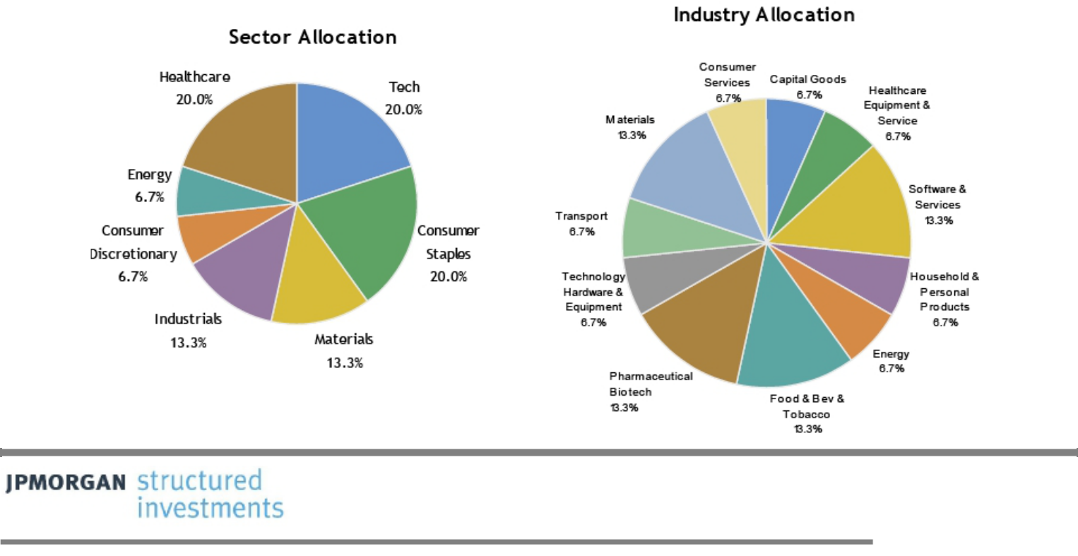

Select Risk Factors

J.P. Morgan research analysts will conduct research and provide recommendations without regard to your interests

J.P. Morgan research analysts conduct research and provide recommendations with respect to all of the U.S. Franchise List Basket and Sub-Basket stocks. They will do so without regard to the interests of any investors in any securities linked to the U.S. Franchise List Basket or Sub-Basket and without regard to the impact such research or recommendations may have on the value of any such securities. Changes in J.P. Morgan’s research recommendations at any time, including decisions to downgrade any or all of the U.S. Franchise List Basket or the Sub-Basket stocks, may adversely affect the market price of any such U.S. Franchise List Basket or Sub-Basket stocks and any such securities.

We cannot predict the performance of the U.S. Franchise List Basket or the Sub-Basket

The stocks included in the U.S. Franchise List Basket and the Sub-Basket are identified by J.P. Morgan North America Equity Research as core investments for the current market environment. These stocks are selected based on both quantitative and qualitative criteria. There is a discretionary and subjective component in this selection process by J.P. Morgan North America Equity Research. J.P. Morgan cannot predict whether the U.S. Franchise List Basket or the Sub-Basket will outperform in a weakening global economy.

While the process for selecting the U.S. Franchise List Sub-Basket would be expected to identify different stocks if applied at different times, the Sub-Basket will be a static basket and will not change over the term of the securities

The stocks comprising the Sub-Basket will be set on or before the pricing date of any securities. However, the application of the quantitative and fundamental analysis used to select the Sub-Basket would be expected to identify different stocks when applied at other times. Therefore, you should base any investment decision solely on your assessment of the components of the Sub-Basket at the time you purchase any securities. The composition of the Sub-Basket, upon which the performance of any securities is based, will remain static for the entire term of any such securities, except in limited circumstances relating to corporate events affecting the components of the Sub-Basket. The Sub-Basket will not change to reflect any additions to or deletions from its components that would have been made if the fundamental and quantitative analysis were applied at a different time or using different assumptions, or if there were variations to the fundamental or quantitative methodology.

The Sub-Basket is currently relatively concentrated in specific sectors of the economy

The companies included in the Sub-Basket as of October 20, 2008 are relatively concentrated in certain sectors of the economy, including Healthcare, Technology, Consumer Staples, Industrials and Materials. Consequently, the value of any securities linked to the Sub-Basket may be subject to greater volatility and be more adversely affected by a single economic, political or regulatory occurrence.

No ownership rights in the Sub-Basket stocks

As a holder of any securities linked to the Sub-Basket stocks, you will not have any ownership interest or rights in any of the Sub-Basket stocks, such as voting rights or dividend payments. In addition, the issuers of the Sub-Basket stocks will not have any obligation to consider your interests as a holder of any such securities in taking any corporate action that might affect the value of the relevant Sub-Basket stocks and any such securities.

J.P. Morgan is not affiliated with the issuers of the Sub-Basket stocks

J.P. Morgan is not affiliated with any of the issuers of the Sub-Basket stocks and the issuers of the Sub-Basket stocks are not involved in the creation of the U.S. Franchise List Basket or the Sub-Basket in any way. Consequently, J.P. Morgan has no ability to control the actions of the issuers of the Sub-Basket stocks, including any corporate actions of the type that would require any adjustment to the weighting of the Sub-Basket stocks. The issuers of the Sub-Basket stocks have no obligation to consider the interests of an investor in any securities linked to the U.S. Franchise List Basket or Sub-Basket in taking any corporate actions that might affect the value of any such securities.

J.P. Morgan may engage in business with or involving one or more of the issuers of the Sub-Basket stocks without regard to your interests

J.P. Morgan or its affiliates may presently or from time to time engage in business with one or more of the issuers of the Sub-Basket stocks without regard to the interests of investors in any securities linked to the U.S. Franchise List Basket or Sub-Basket, including extending loans to, or making equity investments in, one or more of the issuers of the Sub-Basket stocks or their affiliates or subsidiaries or providing advisory services to one or more of the issuers of the Sub-Basket stocks, such as merger and acquisition advisory services. In the course of J.P. Morgan’s business, it or its affiliates may acquire non-public information about one or more of the issuers of the Sub-Basket stocks. Neither J.P. Morgan nor any of its affiliates undertakes to disclose any such information to you. In addition, J.P. Morgan or its affiliates from time to time have published and in the future may publish research reports with respect to the Sub-Basket stocks. These research reports may or may not recommend that investors buy or hold the Sub-Basket stocks. Furthermore, the composition of the Sub-Basket will not be affected by any change that J.P. Morgan or its affiliates may make in its recommendations or decisions to begin or discontinue coverage of any of the issuers of the Sub-Basket stocks in its research reports.

Changes in the value of one or more of the Sub-Basket stocks may offset each other

Price movements in the Sub-Basket stocks may not correlate with each other. At a time when the value of one or more of the Sub-Basket stocks increases, the value of one or more of the other Sub-Basket stocks may not increase as much or may decline in value. Therefore, in calculating the daily performance of the Sub-Basket, increases in the value of one or more of the Sub-Basket stocks may be moderated, or wholly offset, by lesser increases or declines in the value of other Sub-Basket stocks.

SEC Legend: JPMorgan Chase & Co. has filed a registration statement (including a prospectus) with the SEC for any offerings to which these materials relate. Before you invest, you should read the prospectus in that registration statement and the other documents relating to this offering that JPMorgan Chase & Co. has filed with the SEC for more complete information about

JPMorgan Chase & Co. and this offering. You may get these documents without cost by visiting EDGAR on the SEC Web site at www.sec.gov. Alternatively, JPMorgan Chase & Co., any agent or any dealer participating in the this offering will arrange to send you the prospectus and each prospectus supplement as well as any product supplement and term sheet if you so request by calling toll-free 866-535-9248.

IRS Circular 230 Disclosure: JPMorgan Chase & Co. and its affiliates do not provide tax advice. Accordingly, any discussion of U.S. tax matters contained herein (including any attachments) is not intended or written to be used, and cannot be used, in connection with the promotion, marketing or recommendation by anyone unaffiliated with JPMorgan Chase & Co. of any of the matters addressed herein or for the purpose of avoiding U.S. tax-related penalties.

Investment suitability must be determined individually for each investor, and the financial instruments described herein may not be suitable for all investors. The products described herein should generally be held to maturity as early unwinds could result in lower than anticipated returns. This information is not intended to provide and should not be relied upon as providing accounting, legal, regulatory or tax advice. Investors should consult with their own advisors as to these matters.

This material is not a product of J.P. Morgan Research Departments. Structured Investments may involve a high degree of risk, and may be appropriate investments only for sophisticated investors who are capable of understanding and assuming the risks involved. J.P. Morgan and its affiliates may have positions (long or short), effect transactions or make markets in securities or financial instruments mentioned herein (or options with respect thereto), or provide advice or loans to, or participate in the underwriting or restructuring of the obligations of, issuers mentioned herein. J.P. Morgan is the marketing name for JPMorgan Chase & Co. and its subsidiaries and affiliates worldwide. J.P. Morgan Securities Inc. is a member of NASD, NYSE and SIPC. Clients should contact their salespersons at, and execute transactions through, a J.P. Morgan entity qualified in their home jurisdiction unless governing law permits otherwise.

