Term Sheet | Term Sheet to
To prospectus dated November 14, 2011, | Product Supplement No. 4-I
prospectus supplement dated November 14, 2011 and | Registration Statement No. 333-177923
product supplement no. 4-I dated November 14, 2011 | Dated April 22, 2013; Rule 433

Structured


Investments

General

$

Return Notes Linked to an Equally Weighted Basket of 15 Reference Stocks due May 14, 2014

- The notes are designed for investors who seek exposure to the performance of an equally weighted basket of 15 Reference Stocks, subject to the Basket Adjustment Factor. Investors should be willing to forgo interest and dividend payments and, if the Basket declines or if the Ending Basket Level is not greater than the Starting Basket Level by at least approximately 1.01%, be willing to lose some or all of their principal. Any payment on the notes is subject to the credit risk of JPMorgan Chase & Co.
- Unsecured and unsubordinated obligations of JPMorgan Chase & Co. maturing May 14, 2014*

- Minimum denominations of $10,000 and integral multiples of $1,000 in excess thereof

- The notes are expected to price on or about April 26, 2013 and are expected to settle on or about May 1, 2013.
Key Terms
Basket: | The Basket consists of 15 common stocks or American Depositary Shares (“ADSs”) (each, a “Reference Stock” and
 | collectively, the “Reference Stocks”). The issuers of the Reference Stocks and the Bloomberg ticker symbol, the
 | relevant exchange, the Stock Weight and the Initial Stock Price of each Reference Stock are set forth under “The
 | Basket” on page TS-1 of this term sheet.
Payment at Maturity: | Payment at maturity will reflect the performance of the Basket, subject to the Basket Adjustment
 | Factor. Accordingly, at maturity, you will receive an amount per $1,000 principal amount note calculated as follows:
 |  | $1,000 × (1 + Basket Return) × Basket Adjustment Factor
 | Because the Basket Adjustment Factor is 99.00%, you will lose some or all of your investment at maturity if
 | the Basket Return is less than approximately 1.01%. For more information on how the Basket Adjustment
 | Factor can impact your payment at maturity, please see “What Is the Total Return on the Notes at Maturity,
 | Assuming a Range of Performances for the Basket?” in this term sheet.
Basket Return: | Ending Basket Level – Starting Basket Level
Basket Adjustment |  | Starting Basket Level
Factor: | 99.00%
Starting Basket Level: | Set equal to 100 on the pricing date
Ending Basket Level: | The Basket Closing Level on the Observation Date
Basket Closing Level: | The Basket Closing Level will be calculated as follows:
 | 100 × [1 + sum of (Stock Return of each Reference Stock × 1/15)]
Stock Return: | Final Stock Price – Initial Stock Price
 |  | Initial Stock Price
Initial Stock Price: | With respect to each Reference Stock, the closing price of one share of that Reference Stock on the pricing date,
 | as specified in “The Basket” on page TS-1 of this term sheet, divided by the applicable Stock Adjustment Factor
Final Stock Price: | With respect to each Reference Stock, the closing price of one share of that Reference Stock on the Observation
 | Date
Stock Adjustment Factor: | With respect to each Reference Stock, set initially at 1.0 on the pricing date and subject to adjustment under certain
 | circumstances. See “General Terms of Notes — Additional Reference Stock Provisions — A. Anti-Dilution
 | Adjustments” in the accompanying product supplement no. 4-I for further information.
Observation Date*: | May 9, 2014
Maturity Date*: | May 14, 2014
CUSIP: | 48126D2P3
- Subject to postponement in the event of a market disruption event and as described under “Description of Notes — Payment at Maturity” and “Description of Notes — Postponement of a Determination Date — B. Notes Linked to a Basket” in the accompanying product supplement no. 4-I

Investing in the Return Notes involves a number of risks. See “Risk Factors” beginning on page PS-21 of the accompanying product supplement no. 4-I and “Selected Risk Considerations” beginning on page TS-3 of this term sheet.

Neither the Securities and Exchange Commission (the “SEC”) nor any state securities commission has approved or disapproved of the notes or passed upon the accuracy or the adequacy of this term sheet or the accompanying product supplement, prospectus supplement and prospectus. Any representation to the contrary is a criminal offense.

 | Price to Public (1) | Fees and Commissions (2) | Proceeds to Issuer
Per note | $1,000 | $ | $
Total | $ | $ | $
- See “Supplemental Use of Proceeds” in this term sheet for information about the components of the price to public of the notes.
- J.P. Morgan Securities LLC, which we refer to as JPMS, acting as agent for JPMorgan Chase & Co., will pay all of the selling commissions it receives from us to other affiliated or unaffiliated dealers. In no event will these selling commissions exceed $10.00 per $1,000 principal amount note. See “Plan of Distribution (Conflicts of Interest)” beginning on page PS-77 of the accompanying product supplement no. 4-I.

If the notes priced today, the estimated value of the notes as determined by JPMS would be approximately $970.00 per $ 1,000 principal amount note. JPMS’s estimated value of the notes, when the terms of the notes are set, will be provided by JPMS in the pricing supplement and will not be less than $965.00 per $1,000 principal amount note. See “JPMS’s Estimated Value of the Notes” in this term sheet for additional information.

The notes are not bank deposits and are not insured by the Federal Deposit Insurance Corporation or any other governmental agency, nor are they obligations of, or guaranteed by, a bank.

April 22, 2013

Additional Terms Specific to the Notes

JPMorgan Chase & Co. has filed a registration statement (including a prospectus) with the SEC for the offering to which this term sheet relates. Before you invest, you should read the prospectus in that registration statement and the other documents relating to this offering that JPMorgan Chase & Co. has filed with the SEC for more complete information about JPMorgan Chase & Co. and this offering. You may get these documents without cost by visiting EDGAR on the SEC website at www.sec.gov. Alternatively, JPMorgan Chase & Co., any agent or any dealer participating in this offering will arrange to send you the prospectus, the prospectus supplement, product supplement no. 4-I and this term sheet if you so request by calling toll-free 866-535-9248.

You may revoke your offer to purchase the notes at any time prior to the time at which we accept such offer by notifying the applicable agent. We reserve the right to change the terms of, or reject any offer to purchase, the notes prior to their issuance. In the event of any changes to the terms of the notes, we will notify you and you will be asked to accept such changes in connection with your purchase. You may also choose to reject such changes, in which case we may reject your offer to purchase.

You should read this term sheet together with the prospectus dated November 14, 2011, as supplemented by the prospectus supplement dated November 14, 2011 relating to our Series E medium-term notes of which these notes are a part, and the more detailed information contained in product supplement no. 4-I dated November 14, 2011 This term sheet, together with the documents listed below, contains the terms of the notes and supersedes all other prior or contemporaneous oral statements as well as any other written materials including preliminary or indicative pricing terms, correspondence, trade ideas, structures for implementation, sample structures, fact sheets, brochures or other educational materials of ours. You should carefully consider, among other things, the matters set forth in “Risk Factors” in the accompanying product supplement no. 4-I, as the notes involve risks not associated with conventional debt securities. We urge you to consult your investment, legal, tax, accounting and other advisers before you invest in the notes.

You may access these documents on the SEC website at www.sec.gov as follows (or if such address has changed, by reviewing our filings for the relevant date on the SEC website):

- Product supplement no. 4-I dated November 14, 2011: http://www.sec.gov/Archives/edgar/data/19617/000089109211007593/e46160_424b2.pdf

- Prospectus supplement dated November 14, 2011: http://www.sec.gov/Archives/edgar/data/19617/000089109211007578/e46180_424b2.pdf

- Prospectus dated November 14, 2011: http://www.sec.gov/Archives/edgar/data/19617/000089109211007568/e46179_424b2.pdf

Our Central Index Key, or CIK, on the SEC website is 19617. As used in this term sheet, the “Company,” “we,” “us” and “our” refer to JPMorgan Chase & Co.

The Basket

The issuers of the Reference Stocks and the Bloomberg ticker symbol, the relevant exchange on which each Reference Stock is listed and the

Stock Weight of each Reference Stock are set forth below:

Ticker
Symbol | Reference Stock Issuer | Relevant Exchange | Stock Weight | Initial Stock Price*
AAPL | Apple Inc. | The NASDAQ Stock Market | 1/15 | $
 |  | (NASDAQ)
C | Citigroup Inc. | New York Stock Exchange | 1/15 | $
 |  | (NYSE)
YUM | Yum! Brands, Inc. | NYSE | 1/15 | $
GM | General Motors Company | NYSE | 1/15 | $
KO | The Coca-Cola Company | NYSE | 1/15 | $
COH | Coach, Inc. | NYSE | 1/15 | $
SBUX | Starbucks Corporation | NASDAQ | 1/15 | $
MJN | Mead Johnson Nutrition Company | NYSE | 1/15 | $
NKE | NIKE, Inc. (Class B Common Stock) | NYSE | 1/15 | $
MDLZ | Mondelēz International, Inc. (Class A Common Stock) | NASDAQ | 1/15 | $
WYNN | Wynn Resorts, Limited | NASDAQ | 1/15 | $
HOT | Starwood Hotels & Resorts Worldwide, Inc. | NYSE | 1/15 | $
TEVA | Teva Pharmaceutical Industries Limited. (ADS) | NYSE | 1/15 | $
BRCM | Broadcom Corporation (Class A Common Stock) | NASDAQ | 1/15 | $
HBC | HSBC Holdings plc (ADS) | NYSE | 1/15 | $

* The Initial Stock Price of each Reference Stock will be determined on the pricing date and is subject to adjustments.

JPMorgan Structured Investments — | TS-1
Return Notes Linked to an Equally Weighted Basket of 15 Reference Stocks

What Is the Total Return on the Notes at Maturity, Assuming a Range of Performances for the Basket?

The following table and examples illustrate the hypothetical total return or payment at maturity on the notes. The “total return” as used in this term sheet is the number, expressed as a percentage, that results from comparing the payment at maturity per $1,000 principal amount note to $1,000. Each hypothetical total return or payment at maturity set forth below reflects the Basket Adjustment Factor of 99.00% and the Starting Basket Level of 100. Each hypothetical total return or payment at maturity set forth below is for illustrative purposes only and may not be the actual total return or payment at maturity applicable to a purchaser of the notes. The numbers appearing in the following table and examples have been rounded for ease of analysis.

Ending Basket Level | Basket Return | Total Return
200.00 | 100.00% | 98.00%
190.00 | 90.00% | 88.10%
180.00 | 80.00% | 78.20%
170.00 | 70.00% | 68.30%
160.00 | 60.00% | 58.40%
150.00 | 50.00% | 48.50%
140.00 | 40.00% | 38.60%
130.00 | 30.00% | 28.70%
120.00 | 20.00% | 18.80%
110.00 | 10.00% | 8.90%
105.00 | 5.00% | 3.95%
101.01 | 1.01% | 0.00%
100.50 | 0.50% | -0.51%
100.00 | 0.00% | -1.00%
95.00 | -5.00% | -5.95%
90.00 | -10.00% | -10.90%
80.00 | -20.00% | -20.80%
70.00 | -30.00% | -30.70%
60.00 | -40.00% | -40.60%
50.00 | -50.00% | -50.50%
40.00 | -60.00% | -60.40%
30.00 | -70.00% | -70.30%
20.00 | -80.00% | -80.20%
10.00 | -90.00% | -90.10%
0.00 | -100.00% | -100.00%

Hypothetical Examples of Amounts Payable at Maturity

The following examples illustrate how the payment at maturity in different hypothetical scenarios is calculated.

Example 1: The level of the Basket increases from the Starting Basket Level of 100 to an Ending Basket Level of 105. Because the Ending Basket Level of 105 is greater than the Starting Basket Level of 100, the investor receives a payment at maturity of $1,039.50 per $1,000 principal amount note, calculated as follows:

$1,000 × (1 + 5%) × 99.00% = $1,039.50

Example 2: The Level of the Basket increases from the Starting Basket Level of 100 to an Ending Basket Level of 100.50. Although the Ending Basket Level of 100.50 is greater than the Starting Basket Level of 100, because of the adverse effect of the Basket Adjustment Factor, the investor receives a payment at maturity of $994.95 per $1,000 principal amount, calculated as follows:

$1,000 × (1 + 0.50%) × 99.00% = $994.95

Example 3: The level of the Basket decreases from the Starting Basket Level of 100 to an Ending Basket Level of 80. Because the Ending Basket Level of 80 is less than the Starting Basket Level of 100, the investor receives a payment at maturity of $792 per $1,000 principal amount note, calculated as follows:

$1,000 × (1 + -20%) × 99.00% = $792

The hypothetical returns and hypothetical payments on the notes shown above do not reflect fees or expenses that would be associated with any sale in the secondary market. If these fees and expenses were included, the hypothetical returns and hypothetical payments shown above would likely be lower.

JPMorgan Structured Investments — | TS-2
Return Notes Linked to an Equally Weighted Basket of 15 Reference Stocks

Selected Purchase Considerations

- UNCAPPED INVESTMENT EXPOSURE TO THE PERFORMANCE OF THE BASKET — The notes provide uncapped exposure to the performance of the Basket, subject to the Basket Adjustment Factor. Because the notes are our unsecured and unsubordinated obligations, payment of any amount at maturity is subject to our ability to pay our obligations as they become due.

- RETURN LINKED TO AN EQUALLY WEIGHTED BASKET OF 15 REFERENCE STOCKS — The return on the notes is linked to the performance of an equally weighted Basket that consists of 15 Reference Stocks as set forth under “The Basket” on page TS-1 of this term sheet.

- CAPITAL GAINS TAX TREATMENT — You should review carefully the section entitled “Material U.S. Federal Income Tax Consequences” in the accompanying product supplement no. 4-I. The following discussion, when read in combination with that section, constitutes the full opinion of our special tax counsel, Davis Polk & Wardwell LLP, regarding the material U.S. federal income tax consequences of owning and disposing of notes.

Based on current market conditions, in the opinion of our special tax counsel it is reasonable to treat the notes as “open transactions” that are not debt instruments for U.S. federal income tax purposes. Assuming this treatment is respected, the gain or loss on your notes should be treated as long-term capital gain or loss if you hold your notes for more than a year, whether or not you are an initial purchaser of notes at the issue price. However, the Internal Revenue Service (the “IRS”) or a court may not respect this treatment of the notes, in which case the timing and character of any income or loss on the notes could be materially and adversely affected. In addition, in 2007 Treasury and the IRS released a notice requesting comments on the U.S. federal income tax treatment of “prepaid forward contracts” and similar instruments. The notice focuses in particular on whether to require investors in these instruments to accrue income over the term of their investment. It also asks for comments on a number of related topics, including the character of income or loss with respect to these instruments; the relevance of factors such as the nature of the underlying property to which the instruments are linked; the degree, if any, to which income (including any mandated accruals) realized by non-U.S. investors should be subject to withholding tax; and whether these instruments are or should be subject to the “constructive ownership” regime, which very generally can operate to recharacterize certain long-term capital gain as ordinary income and impose a notional interest charge. While the notice requests comments on appropriate transition rules and effective dates, any Treasury regulations or other guidance promulgated after consideration of these issues could materially and adversely affect the tax consequences of an investment in the notes, possibly with retroactive effect. You should consult your tax adviser regarding the U.S. federal income tax consequences of an investment in the notes, including possible alternative treatments and the issues presented by this notice.

Non-U.S. Holders – Additional Tax Consideration

Non-U.S. Holders should note that recently proposed Treasury regulations, if finalized in their current form, could impose a withholding tax at a rate of 30% (subject to reduction under an applicable income tax treaty) on amounts attributable to U.S.-source dividends (including, potentially, adjustments to account for extraordinary dividends) that are paid or “deemed paid” after December 31, 2013 under certain financial instruments, if certain other conditions are met. While significant aspects of the application of these proposed regulations to the notes are uncertain, if these proposed regulations were finalized in their current form, we (or other withholding agents) might determine that withholding is required with respect to notes held by a Non-U.S. Holder or that the Non-U.S. Holder must provide information to establish that withholding is not required. Non-U.S. Holders should consult their tax advisers regarding the potential application of these proposed regulations. If withholding is required, we will not be required to pay any additional amounts with respect to amounts so withheld.

Selected Risk Considerations

An investment in the notes involves significant risks. Investing in the notes is not equivalent to investing directly in the Basket or any of the Reference Stocks. These risks are explained in more detail in the “Risk Factors” section of the accompanying product supplement no. 4-I dated November 14, 2011.

- YOUR INVESTMENT IN THE NOTES MAY RESULT IN A LOSS — The notes do not guarantee any return of your principal. The amount payable at maturity, if any, will reflect the performance of the Reference Stocks, subject to a reduction by the Basket Adjustment Factor. Because the Basket Adjustment Factor reduces the payment at maturity, if the Ending Basket Level is not greater than the Starting Basket Level by at least approximately 1.01%, you will lose some or all of your investment in the notes.

- THE BASKET ADJUSTMENT FACTOR WILL DIMINISH ANY INCREASE IN THE VALUE OF THE BASKET AND MAGNIFY ANY DECLINE IN THE VALUE OF BASKET — If the Basket Return is negative or is less than approximately 1.01%, at maturity, you will lose some or all of your investment. In addition, the Basket Adjustment Factor will diminish any increase in the value of the Basket and magnify any decline in the value of the Basket. For each 1% that the Ending Basket Level is greater than the Starting Basket Level, the return on your investment will increase by less than 1%. In addition, for each 1% that the Ending Basket Level is less than the Starting Basket Level, you will lose more than 1% of your investment in the notes, provided that the payment at maturity will not be less than zero.

- CREDIT RISK OF JPMORGAN CHASE & CO. — The notes are subject to the credit risk of JPMorgan Chase & Co., and our credit ratings and credit spreads may adversely affect the market value of the notes. Investors are dependent on JPMorgan Chase & Co.’s ability to pay all amounts due on the notes. Any actual or potential change in our

JPMorgan Structured Investments — | TS-3
Return Notes Linked to an Equally Weighted Basket of 15 Reference Stocks

creditworthiness or credit spreads, as determined by the market for taking our credit risk, is likely to adversely affect the value of the notes. If we were to default on our payment obligations, you may not receive any amounts owed to you under the notes and you could lose your entire investment.

- POTENTIAL CONFLICTS — We and our affiliates play a variety of roles in connection with the issuance of the notes, including acting as calculation agent and as an agent of the offering of the notes, hedging our obligations under the notes and making the assumptions used to determine the pricing of the notes and the estimated value of the notes when the terms of the notes are set, which we refer to as JPMS’s estimated value. In performing these duties, our economic interests and the economic interests of the calculation agent and other affiliates of ours are potentially adverse to your interests as an investor in the notes. In addition, JPMorgan Chase Bank, National Association, our affiliate, serves as depositary for the ADSs of Teva Pharmaceuticals Industries Limited. As a result, JPMorgan Chase Bank, National Association’s interests, as depositary for the ADSs, may be adverse to your interests as a holder of the

notes. Furthermore, our business activities, including hedging and trading activities, could cause our economic interests to be adverse to yours and could adversely affect any payment on the notes and the value of the notes. It is possible that hedging or trading activities of ours or our affiliates in connection with the notes could result in substantial returns for us or our affiliates while the value of the notes declines. Please refer to “Risk Factors — Risks Relating to the Notes Generally” in the accompanying product supplement no. 4-I for additional information about these risks.

We and/or our affiliates may also currently or from time to time engage in business with the Reference Stock issuers, including extending loans to, or making equity investments in, the Reference Stock issuers or providing advisory services to the Reference Stock issuers. In addition, one or more of our affiliates may publish research reports or otherwise express opinions with respect to the Reference Stock issuers, and these reports may or may not recommend that investors buy or hold the Reference Stocks. As a prospective purchaser of the notes, you should undertake an independent investigation of the Reference Stock issuers that in your judgment is appropriate to make an informed decision with respect to an investment in the notes.

- JPMS’S ESTIMATED VALUE OF THE NOTES WILL BE LOWER THAN THE ORIGINAL ISSUE PRICE (PRICE TO PUBLIC) OF THE NOTES — JPMS’s estimated value is only an estimate using several factors. The original issue price of the notes will exceed JPMS’s estimated value because costs associated with selling, structuring and hedging the notes are included in the original issue price of the notes. These costs include the selling commissions, the projected profits that our affiliates expect to realize for assuming risks inherent in hedging our obligations under the notes and the estimated cost of hedging our obligations under the notes. See “JPMS’s Estimated Value of the Notes” in this term sheet.

- JPMS’S ESTIMATED VALUE DOES NOT REPRESENT FUTURE VALUES OF THE NOTES AND MAY DIFFER FROM OTHERS’ ESTIMATES — JPMS’s estimated value of the notes is determined by reference to JPMS’s internal pricing models when the terms of the notes are set. This estimated value is based on market conditions and other relevant factors existing at that time and JPMS’s assumptions about market parameters, which can include volatility, dividend rates, interest rates and other factors. Different pricing models and assumptions could provide valuations for notes that are greater than or less than JPMS’s estimated value. In addition, market conditions and other relevant factors in the future may change, and any assumptions may prove to be incorrect. On future dates, the value of the notes could change significantly based on, among other things, changes in market conditions, our creditworthiness, interest rate movements and other relevant factors, which may impact the price, if any, at which JPMS would be willing to buy notes from you in secondary market transactions. See “JPMS’s Estimated Value of the Notes” in this term sheet.

- JPMS’S ESTIMATED VALUE IS NOT DETERMINED BY REFERENCE TO CREDIT SPREADS FOR OUR CONVENTIONAL FIXED-RATE DEBT — The internal funding rate used in the determination of JPMS’s estimated value generally represents a discount from the credit spreads for our conventional fixed-rate debt. If JPMS were to use the interest rate implied by our conventional fixed-rate credit spreads, we would expect the economic terms of the notes to be more favorable to you. Consequently, our use of an internal funding rate would have an adverse effect on the terms of the notes and any secondary market prices of the notes. See “JPMS’s Estimated Value of the Notes” in this term sheet.

- THE VALUE OF THE NOTES AS PUBLISHED BY JPMS (AND WHICH MAY BE REFLECTED ON CUSTOMER ACCOUNT STATEMENTS) WILL LIKELY BE HIGHER THAN JPMS’S THEN-CURRENT ESTIMATED VALUE OF THE NOTES FOR A LIMITED TIME PERIOD — We generally expect that some of the costs included in the original issue price of the notes will be partially paid back to you in connection with any repurchases of your notes by JPMS in an amount that will decline to zero over an initial predetermined period. These costs can include projected hedging profits and, in some circumstances, estimated hedging costs and our secondary market credit spreads for structured debt issuances. See “Secondary Market Prices of the Notes” in this term sheet for additional information relating to this initial period. Accordingly, the estimated value of your notes during this initial period will likely be lower than the value of the notes as published by JPMS (and which may be shown on your customer account statements).

- SECONDARY MARKET PRICES OF THE NOTES WILL LIKELY BE LOWER THAN THE ORIGINAL ISSUE PRICE OF THE NOTES

— Any secondary market prices of the notes will likely be lower than the original issue price of the notes because, among other things, secondary market prices take into account our secondary market credit spreads for structured debt issuances and, also, because secondary market prices (a) exclude selling commissions and (b) may exclude projected hedging profits and estimated hedging costs that are included in the original issue price of the notes. As a result, the price, if any, at which JPMS will be willing to buy notes from you in secondary market transactions, if at all, is likely to be lower than the original issue

JPMorgan Structured Investments — | TS-4
Return Notes Linked to an Equally Weighted Basket of 15 Reference Stocks

price. Any sale by you prior to the maturity date could result in a substantial loss to you. See the immediately following risk consideration for information about additional factors that will impact any secondary market prices of the notes.

The notes are not designed to be short-term trading instruments. Accordingly, you should be able and willing to hold your notes to maturity. See “— Lack of Liquidity” below.

- SECONDARY MARKET PRICES OF THE NOTES WILL BE IMPACTED BY MANY ECONOMIC AND MARKET FACTORS — The secondary market price of the notes during their term will be impacted by a number of economic and market factors, which may either offset or magnify each other, aside from the selling commissions, projected hedging profits, estimated hedging costs and the closing price of one share of each Reference Stock, including:

  - any actual or potential change in our creditworthiness or credit spreads;

  - customary bid-ask spreads for similarly sized trades;

  - secondary market credit spreads for structured debt issuances;

  - the actual and expected volatility in the price of each Reference Stock;

  - the time to maturity of the notes;

  - the correlation (or lack of correlation) in price movements among the Reference Stocks;

  - the dividend rate on each Reference Stock;

  - the occurrence of certain events affecting the issuer of a Reference Stock that may or may not require an adjustment to the applicable Stock Adjustment Factor, including a merger or acquisition;
  - interest and yield rates in the market generally; and

  - a variety of other economic, financial, political, regulatory and judicial events.

Additionally, independent pricing vendors and/or third party broker-dealers may publish a price for the notes, which may also be reflected on customer account statements. This price may be different (higher or lower) than the price of the notes, if any, at which JPMS may be willing to purchase your notes in the secondary market.

- CORRELATION (OR LACK OF CORRELATION) OF THE REFERENCE STOCKS — The notes are linked to an equally weighted Basket consisting of 15 Reference Stocks. Price movements and performances in the Reference Stocks may or may not be correlated with each other. At a time when the value of one or more of the Reference Stocks increases, the value of the other Reference Stocks may not increase as much or may even decline. Therefore, in calculating the Ending Basket Level, increases in the value of one or more of the Reference Stocks may be moderated, or more than offset, by the lesser increases or declines in the value of the other Reference Stocks. In addition, high correlation of movements in the values of the Reference Stocks during periods of negative returns among the Reference Stocks could have an adverse effect on the payment at maturity on the notes. There can be no assurance that the Ending Basket Level will be higher than the Starting Basket Level.

- NO OWNERSHIP OR DIVIDEND RIGHTS IN THE REFERENCE STOCKS — As a holder of the notes, you will not have any ownership interest or rights in any of the Reference Stocks, such as voting rights or dividend payments. In addition, the issuers of the Reference Stocks will not have any obligation to consider your interests as a holder of the notes in taking any corporate action that might affect the value of the relevant Reference Stocks and the notes. Because the Basket Adjustment Factor always reduces the Payment at
Maturity, your return from an investment in the notes may be less than the return from a direct investment in the Reference Stocks.

- NO AFFILIATION WITH THE REFERENCE STOCK ISSUERS — We are not affiliated with the issuers of the Reference Stocks. We have not independently verified any of the information about the Reference Stock issuers contained in this term sheet. You should undertake your own investigation into the Reference Stocks and their issuers. We are not responsible for the Reference Stock issuers’ public disclosure of information, whether contained in SEC filings or otherwise.

- NO INTEREST PAYMENTS — As a holder of the notes, you will not receive any interest payments.

  - LACK OF LIQUIDITY — The notes will not be listed on any securities exchange. JPMS intends to offer to purchase the notes in the secondary market but is not required to do so. Even if there is a secondary market, it may not provide enough liquidity to allow you to trade or sell the notes easily. Because other dealers are not likely to make a secondary market for the notes, the price at which you may be able to trade your notes is likely to depend on the price, if any, at which JPMS is willing to buy the notes.

  - HEDGING AND TRADING IN THE REFERENCE STOCKS — While the notes are outstanding, we or any of our affiliates may carry out hedging activities related to the notes, including in the Reference Stocks or instruments related to the Reference Stocks. We or our affiliates may also trade in the Reference Stocks or instruments related to the Reference Stocks from time to time. Any of these hedging or trading activities as of the pricing date and during the term of the notes could adversely affect our payment to you at maturity. It is possible that such hedging or trading activities could result in substantial returns for us or our affiliates while the value of the notes declines.

- THE ANTI-DILUTION PROTECTION FOR THE REFERENCE STOCKS IS LIMITED AND MAY BE DISCRETIONARY — The calculation agent will make adjustments to the Stock Adjustment Factor for each Reference Stock for certain corporate events affecting that Reference Stock. However, the calculation agent will not make an adjustment in response to all events that could affect each Reference Stock. If an event occurs that does not require the calculation agent to make an adjustment, the value of the notes may be materially and adversely affected. You should also be aware that the calculation agent may make adjustments in response to events that are not described in the accompanying product supplement to account for any diluting or concentrative effect, but the calculation agent is under no obligation to do so or to consider your interests as a holder of the notes in making these determinations.

JPMorgan Structured Investments — | TS-5
Return Notes Linked to an Equally Weighted Basket of 15 Reference Stocks

- RISKS ASSOCIATED WITH NON-U.S. COMPANIES — An investment in the notes, which are linked in part to the ADSs representing interests in the ordinary shares of Teva Pharmaceutical Industries Limited. (which we refer to as “Teva”), which are issued by an Israeli issuer, or HSBC Holdings plc (which we refer to as “HSBC”), which are issued by a U.K. issuer, involves risks associated with the home countries of Teva and HSBC. The ADSs of Teva and HSBC, which are quoted and traded in U.S. dollars on the New York Stock Exchange, may trade differently from the ordinary shares of Teva quoted and traded in Israeli new shekels on the Tel Aviv Stock Exchange and from the ordinary shares of HSBC quoted and traded in pounds sterling on the London Stock Exchange and in the relevant currencies on other stock exchanges. Non-U.S. companies, such as those in Israel and the United Kingdom, are generally subject to accounting, auditing and financial reporting standards and requirements, and securities trading rules different from those applicable to U.S. reporting companies. Generally, non-U.S. securities markets may be more volatile than U.S. securities markets, and market developments may affect non-U.S. markets differently from U.S. securities markets. Direct or indirect government intervention to stabilize these non-U.S. markets, as well as cross shareholdings in non-U.S. companies, may affect trading prices and volumes in those markets. The prices of securities issued by non-U.S. companies may be affected by political, economic, financial and social factors in the home country of the non-U.S. issuer ( i.e. , Israel or the United Kingdom), including changes in that country’s government, economic and fiscal policies, currency exchange laws or other laws or restrictions. Moreover, the economy of that country may differ favorably or unfavorably from the economy of the United States in such respects as growth of gross national product, rate of inflation, capital reinvestment, resources and self-sufficiency. Such country may be subjected to different and, in some cases, more adverse economic environments.

- THERE ARE IMPORTANT DIFFERENCES BETWEEN THE RIGHTS OF HOLDERS OF ADSs OF TEVA AND HSBC AND THE RIGHTS OF HOLDERS OF THE ORDINARY SHARES OF TEVA AND HSBC — You should be aware that your return on the notes is linked in part to the price of the ADSs and not the ordinary shares of Teva or the ordinary shares of HSBC. There are important differences between the rights of holders of ADSs and the rights of holders of the ordinary shares. Each ADS is a security evidenced by American depositary receipts that represents one ordinary share of Teva or five ordinary shares of HSBC, as applicable. The ADSs are issued pursuant to a deposit agreement, which sets forth the rights and responsibilities of the ADS depositary, Teva or HSBC (as applicable), and holders of the ADSs, which may be different from the rights of holders of the ordinary shares. For example, each may make distributions in respect of the ordinary shares that are not passed on to the holders of its ADSs. Any such differences between the rights of holders of the ADSs and the rights of holders of the ordinary shares of Teva or HSBC may be significant and may materially and adversely affect the value of the ADSs and, as a result, the notes.

- THE NOTES ARE SUBJECT TO CURRENCY EXCHANGE RATE RISK — Because the ADSs of Teva and HSBC are quoted and traded in U.S. dollars on the New York Stock Exchange, the ordinary shares of Teva are quoted and traded in Israeli new shekels on the Tel Aviv Stock Exchange and the ordinary shares of HSBC are quoted and traded in British pounds sterling on the London Stock Exchange and in the relevant currencies on other stock exchanges, fluctuations in the exchange rate between currencies in which the relevant ordinary shares are quoted and traded and the U.S. dollar will likely affect the relative value of the ADSs of Teva and the ordinary shares of Teva, and the ADSs of HSBC and the ordinary shares of HSBC, as applicable, in the different currencies, and, as a result, will likely affect the market price of the ADSs trading on the New York Stock Exchange. These trading differences and currency exchange rates may affect the closing prices of the ADSs of Teva and HSBC and accordingly, the market value of the notes. Most foreign currencies, including the Israeli new shekel and the British pound sterling, have been subject to significant fluctuations against the U.S. dollar in the past, and may be subject to significant fluctuations in the future. Previous fluctuations or periods of relative stability in the exchange rates between the Israeli new shekel, the British pound sterling and the U.S. dollar are not necessarily indicative of fluctuations or periods of relative stability in those rates that may occur over the term of the notes. The exchange rates between the currencies in which the relevant ordinary shares are quoted and traded and the U.S. dollar are the result of the supply of, and the demand for, those currencies. Changes in the exchange rate result over time from the interaction of many factors directly or indirectly affecting economic and political conditions in Israel, the United Kingdom, the originating countries of the other currencies in which the ordinary shares of HSBC are quoted and traded and the United States, including economic and political developments in other countries. Of particular importance are rates of inflation, interest rate levels, the balance of payments, any political, civil or military unrest and the extent of governmental surpluses or deficits in these countries, all of which are in turn sensitive to the monetary, fiscal and trade policies pursued by these countries and other jurisdictions important to international trade and finance.

- THE TERMS AND VALUATION OF THE NOTES WILL BE PROVIDED IN THE PRICING SUPPLEMENT — The final terms of the notes will be based on relevant market conditions when the terms of the notes are set and will be provided in the pricing supplement. In particular, JPMS’s estimated value will be provided in the pricing supplement and may be as low as the minimum value for JPMS’s estimated value set forth on the cover of this term sheet. Accordingly, you should consider your potential investment in the notes based on the minimum value for JPMS’s estimated value.

JPMorgan Structured Investments — | TS-6
Return Notes Linked to an Equally Weighted Basket of 15 Reference Stocks

The Reference Stocks

Public Information

All information contained herein on the Reference Stocks and on the Reference Stock issuers is derived from publicly available sources, without independent verification. Companies with securities registered under the Securities Exchange Act of 1934, as amended, which we refer to as the Exchange Act, are required to periodically file certain financial and other information specified by the SEC. Information provided to or filed with the SEC by a Reference Stock issuer pursuant to the Exchange Act can be located by reference to the SEC file number provided below and can be accessed through www.sec.gov. We do not make any representation that these publicly available documents are accurate or complete.

Historical Information Regarding the Reference Stocks and the Basket

Except as noted below, the graphs contained in this term sheet set forth the historical performance of the Reference Stocks from January 4, 2008 through April 19, 2013. The graph of the historical Basket performance is based on the historical performance of the Reference Stocks from November 19, 2010 through April 19, 2013 and assumes the Basket Closing Level on November 19, 2010 was 100 and the Stock Weights were as specified under “The Basket” in this term sheet. We obtained the closing prices in this term sheet from Bloomberg Financial Markets, without independent verification. The closing prices may be adjusted by Bloomberg Financial Markets for corporate actions such as stock splits, public offerings, mergers and acquisitions, spin-offs, delistings and bankruptcy.

Since the commencement of trading of each Reference Stock, the price of that Reference Stock has experienced significant fluctuations. The historical performance of each Reference Stock and the historical performance of the Basket should not be taken as an indication of future performance, and no assurance can be given as to the closing prices of each Reference Stock or the levels of the Basket on the pricing date or the Observation Date. We cannot give you assurance that the performance of each Reference Stock will result in the return of any of your initial investment at maturity. We make no representation as to the amount of dividends, if any, that each Reference Stock issuer will pay in the future. In any event, as an investor in the notes, you will not be entitled to receive dividends, if any, that may be payable on each Reference Stock.

Historical Information Regarding the Basket

The following graph sets forth the historical performance of the Basket based on the weekly Basket Closing Level from November 19, 2010 through April 19, 2013. The following graph assumes the Basket Closing Level on November 19, 2010 was 100 and the Stock Weights were as specified under “The Basket” in this term sheet.
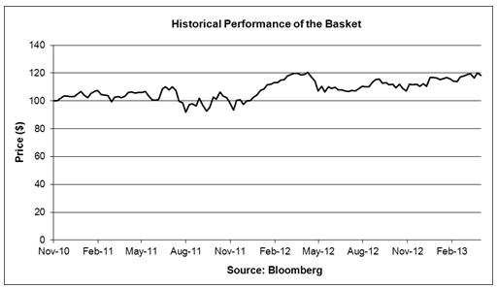

JPMorgan Structured Investments — | TS-7
Return Notes Linked to an Equally Weighted Basket of 15 Reference Stocks

Apple Inc. (“Apple”)

According to its publicly available filings with the SEC, Apple designs, manufactures and markets mobile communication and media devices, personal computers and portable digital music players and sells a variety of related software, services, peripherals, networking solutions and third-party digital content and applications. The common stock of Apple, no par value, is listed on The NASDAQ Stock Market, which we refer to as the relevant exchange for purposes of Apple in the accompanying product supplement no. 4-I. Apple’s SEC file number is 000-10030.

Historical Information Regarding the Common Stock of Apple

The following graph sets forth the historical performance of the common stock of Apple based on the weekly closing price of one share of the common stock of Apple from January 4, 2008 through April 19, 2013. The closing price of one share of the common stock of Apple on April 19, 2013 was $390.50.
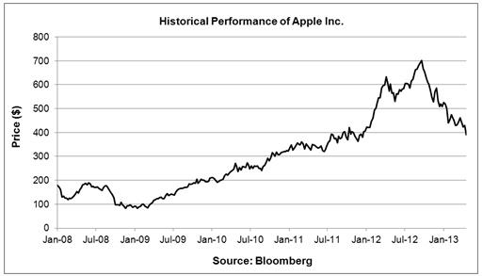

Citigroup Inc. (“Citigroup”)

According to its publicly available filings with the SEC, Citigroup is a global diversified financial services holding company whose businesses provide consumers, companies, governments and institutions with a range of financial products and services, including consumer banking, and credit, corporate and investment banking, securities brokerage, transaction services and wealth management. The common stock of Citigroup, par value $0.01 per share, is listed on the New York Stock Exchange, which we refer to as the relevant exchange for purposes of Citigroup in the accompanying product supplement no. 4-I. Citigroups’ SEC file number is 001-09924.

Historical Information Regarding the Common Stock of Citigroup

The following graph sets forth the historical performance of the common stock of Citigroup based on the weekly closing price of one share of the common stock of Citigroup from January 4, 2008 through April 19, 2013. The closing price of one share of the common stock of Citigroup on April 19, 2013 was $45.03.

JPMorgan Structured Investments — | TS-8
Return Notes Linked to an Equally Weighted Basket of 15 Reference Stocks

Yum! Brands, Inc. (“Yum”)

According to its publicly available filings with the SEC, Yum is a quick service restaurant company that develops, operates, franchises and licenses a worldwide system of restaurants, which prepare, package and sell a menu of competitively priced food items. The common stock of Yum, no par value, is lis ted on the New York Stock Exchange, which we refer to as the relevant exchange for purposes of Yum in the accompanying product supplement no. 4-I. Yum’s SEC file number is 001-13163.

Historical Information Regarding the Common Stock of Yum

The following graph sets forth the historical performance of the common stock of Yum based on the weekly closing price of one share of the common stock of Yum from January 4, 2008 through April 19, 2013. The closing price of one share of the common stock of Yum on April 19, 2013 was $65.04.
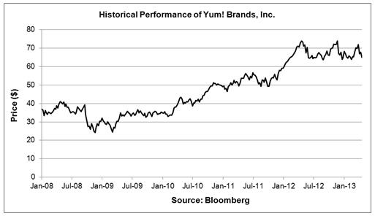

General Motors Company (“General Motors”)

According to its publicly available filings with the SEC, General Motors designs, builds and sells cars, trucks and automobile parts worldwide and provides automotive financing services. The common stock of General Motors, par value $0.01 per share, is listed on the New York Stock Exchange, which we refer to as the relevant exchange for purposes of General Motors in the accompanying product supplement no. 4-I. General Motors’ SEC file number is 001-34960.

Historical Information Regarding the Common Stock of General Motors

The following graph sets forth the historical performance of the common stock of General Motors based on the weekly closing price of one share of the common stock of General Motors from November 19, 2010 through April 19, 2013. The common stock of General Motors commenced trading on the New York Stock Exchange on November 18, 2010. The closing price of one share of the common stock of General Motors on April 19, 2013 was $29.15.
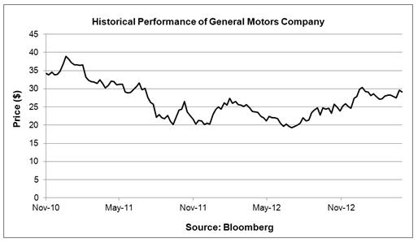

JPMorgan Structured Investments — | TS-9
Return Notes Linked to an Equally Weighted Basket of 15 Reference Stocks

The Coca-Cola Company (“Coca-Cola”)

According to its publicly available filings with the SEC, Coca-Cola is a beverage company that owns or licenses nonalcoholic beverage brands, primarily sparkling beverages but also a variety of still beverages such as waters, enhanced waters, juices and juice drinks, ready-to-drink teas and coffees, and energy and sports drinks. The common stock of Coca-Cola, par value $0.25 per share, is listed on the New York Stock Exchange, which we refer to as the relevant exchange for purposes of Coca-Cola in the accompanying product supplement no. 4-I. Coca-Cola’s SEC file number is 001-02217.

Historical Information of the Common Stock of Coca-Cola

The following graph sets forth the historical performance of the common stock of Coca-Cola based on the weekly closing price of one share of the common stock of Coca-Cola from January 4, 2008 through April 19, 2013. The closing price of one share of the common stock of Coca-Cola on April 19, 2013 was $42.66.
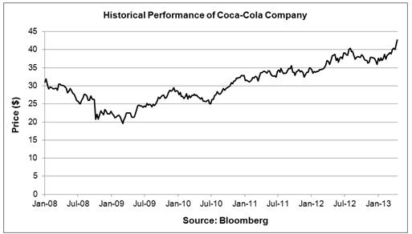

Coach, Inc. (“Coach”)

According to its publicly available filings with the SEC, Coach is a marketer of fine accessories and gifts for women and men. The common stock of Coach, par value $0.01 per share, is listed on the New York Stock Exchange, which we refer to as the relevant exchange for purposes of Coach in the accompanying product supplement no. 4-I. Coach’s SEC file number is 001-16153.

Historical Information Regarding the Common Stock of Coach

The following graph sets forth the historical performance of the common stock of Coach based on the weekly closing price of one share of the common stock of Coach from January 4, 2008 through April 19, 2013. The closing price of one share of the common stock of Coach on April 19, 2013 was $51.20.
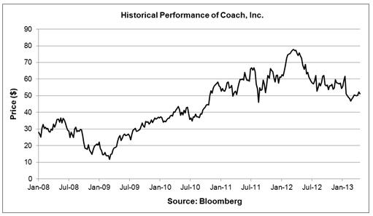

JPMorgan Structured Investments — | TS-10
Return Notes Linked to an Equally Weighted Basket of 15 Reference Stocks

Starbucks Corporation (“Starbucks”)

According to its publicly available filings with the SEC, Starbucks is a roaster, marketer and retailer of specialty coffee. The common stock of Starbucks, par value $0.001 per share, is listed on The NASDAQ Stock Market, which we refer to as the relevant exchange for purposes of Starbucks in the accompanying product supplement no. 4-I. Starbucks’ SEC file number is 000-20322.

Historical Information Regarding the Common Stock of Starbucks

The following graph sets forth the historical performance of the common stock of Starbucks based on the weekly closing price of one share of the common stock of Starbucks from January 4, 2008 through April 19, 2013. The closing price of one share of the common stock of Starbucks on April 19, 2013 was $58.41.
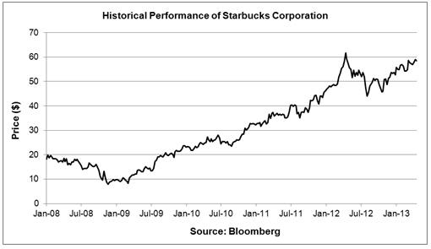

Mead Johnson Nutrition Company (“Mead Johnson”)

According to its publicly available filings with the SEC, Mead Johnson manufactures, distributes and sells infant formulas, children’s nutrition and other nutritional products. The common stock of Mead Johnson, par value $0.01 per share, is listed on the New York Stock Exchange, which we refer to as the relevant exchange for purposes of Mead Johnson in the accompanying product supplement no. 4-I. Mead Johnson’s SEC file number is 001-34251.

Historical Information Regarding the Common Stock of Mead Johnson

The following graph sets forth the historical performance of the common stock of Mead Johnson based on the weekly closing price of one share of the common stock of Mead Johnson from February 13, 2009 through April 19, 2013. The common stock of Mead Johnson commenced trading on the New York Stock Exchange on February 11, 2009. The closing price of one share of the common stock of Mead Johnson on April 19, 2013 was $81.13.
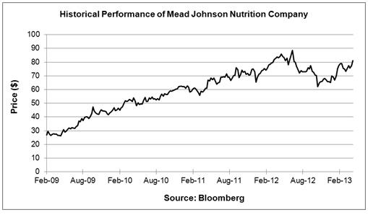

JPMorgan Structured Investments — | TS-11
Return Notes Linked to an Equally Weighted Basket of 15 Reference Stocks

NIKE, Inc. (“NIKE”)

According to its publicly available filings with the SEC, NIKE’s primary business activity is the design, development and worldwide marketing and selling of footwear, apparel, equipment, accessories and services. The Class B common stock of NIKE, no par value, is listed on the New York Stock Exchange, which we refer to as the relevant exchange for purposes of NIKE in the accompanying product supplement no. 4-I. NIKE’s SEC file number is 001-10635.

Historical Information Regarding the Class B Common Stock of NIKE

The following graph sets forth the historical performance of the Class B common stock of NIKE based on the weekly closing price of one share of the Class B common stock of NIKE from January 4, 2008 through April 19, 2013. The closing price of one share of the Class B common stock of NIKE on April 19, 2013 was $60.92.
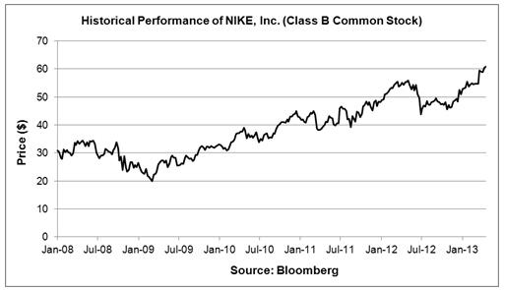

Mondelēz International Inc. (“Mondelēz”)

According to its publicly available filings with the SEC, Mondelēz is a snack company that manufactures and markets food and beverage products. The Class A common stock of Mondelēz, no par value, is listed on The NASDAQ Stock Market, which we refer to as the relevant exchange for purposes of Mondelēz in the accompanying product supplement no. 4-I. Mondelēz’s SEC file number is 001-16483.

Historical Information Regarding the Class A Common Stock of Mondelēz

The following graph sets forth the historical performance of the Class A common stock of Mondelēz based on the weekly closing price of one

share of the Class A common stock of Mondelēz from January 4, 2008 through April 19, 2013. The Class A common stock of Mondelēz
commenced trading on The NASDAQ Stock Market on June 26, 2012. Prior to June 26, 2012, the Class A common stock of Mondelēz was
traded on the New York Stock Exchange. The closing price of one share of the Class A common stock of Mondelēz on April 19, 2013 was
$31.68. The historical performance of the Class A common stock of Mondelēz prior to October 1, 2012 has been adjusted to take into account
the spin-off of Mondelēz’s North American grocery operations.
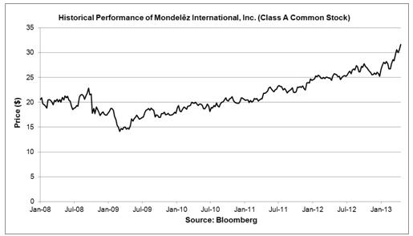

JPMorgan Structured Investments — | TS-12
Return Notes Linked to an Equally Weighted Basket of 15 Reference Stocks

Wynn Resorts, Limited (“Wynn Resorts”)

According to its publicly available filings with the SEC, Wynn Resorts is a developer, owner and operator of destination casino resorts. The common stock of Wynn Resorts, par value $0.01 per share, is listed on The NASDAQ Stock Market, which we refer to as the relevant exchange for purposes of Wynn Resorts in the accompanying product supplement no. 4-I. Wynn Resorts’ SEC file number is 000-50028.

Historical Information Regarding the Common Stock of Wynn Resorts

The following graph sets forth the historical performance of the common stock of Wynn Resorts based on the weekly closing price of one share of the common stock of Wynn Resorts from January 4, 2008 through April 19, 2013. The closing price of one share of the common stock of Wynn Resorts on April 19, 2013 was $127.56.
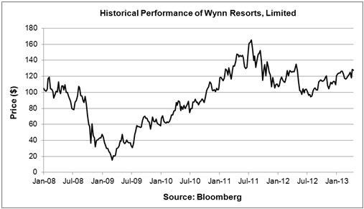

Starwood Hotels & Resorts Worldwide, Inc. (“Starwood”)

According to its publicly available filings with the SEC, Starwood is a hotel and leisure company which focuses on the global operation of hotels and resorts, primarily in the luxury and upscale segments of the lodging industry. Starwood is also a provider of vacation experiences through villa-style reorts and privileged access to Starwood brands. The common stock of Starwood, par value $0.01 per share, is listed on the New York Stock Exchange, which we refer to as the relevant exchange for purposes of Starwood in the accompanying product supplement no. 4-I. Starwood’s SEC file number is 001-07959.

Historical Information Regarding the Common Stock of Starwood

The following graph sets forth the historical performance of the common stock of Starwood based on the weekly closing price of one share of the common stock of Starwood from January 4, 2008 through April 19, 2013. The closing price of one share of the common stock of Starwood on April 19, 2013 was $61.23.
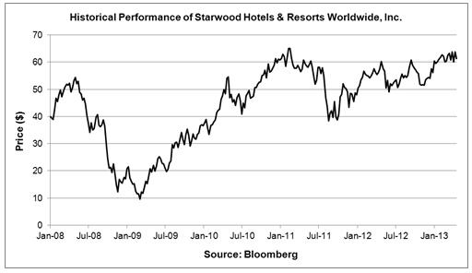

JPMorgan Structured Investments — | TS-13
Return Notes Linked to an Equally Weighted Basket of 15 Reference Stocks

Teva Pharmaceutical Industries Limited (“Teva”)

According to its publicly available filings with the SEC, Teva, an Israeli company, is a global pharmaceutical company whose business includes three primary areas: generic, specialty and over-the-counter medications. The ADSs of Teva, each representing one ordinary share of Teva, par value ILS 0.10 per share, are listed on the New York Stock Exchange, which we refer to as the relevant exchange for purposes of Teva in the accompanying product supplement no. 4-I. Teva’s SEC file number is 000-16174.

Historical Information Regarding the ADSs of Teva

The following graph sets forth the historical performance of the ADSs of Teva based on the weekly closing price of one ADS of Teva from January 4, 2008 through April 19, 2013. The ADSs of Teva commenced trading on the New York Stock Exchange on May 30, 2012. Prior to May 30, 2012, the ADSs of Teva were traded on The NASDAQ Stock Market. The closing price of one ADS of Teva on April 19, 2013 was $37.90.
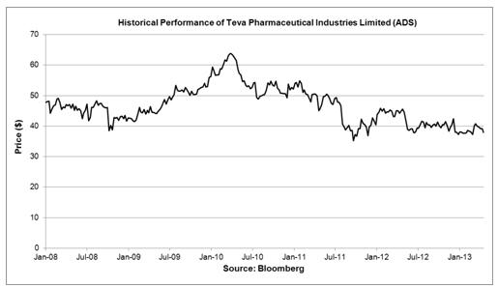

Broadcom Corporation (“Broadcom”)

According to its publicly available filings with the SEC, Broadcom is a provider of semiconductor solutions for wired and wireless communications. The Class A common stock of Broadcom, par value $0.0001 per share, is listed on The NASDAQ Stock Market, which we refer to as the relevant exchange for purposes of Broadcom in the accompanying product supplement no. 4-I. Broadcom’ SEC file number is 000-23993.

Historical Information Regarding the Class A Common Stock of Broadcom

The following graph sets forth the historical performance of the Class A common stock of Broadcom based on the weekly closing price of one share of the Class A common stock of Broadcom from January 4, 2008 through April 19, 2013. The closing price of one share of the Class A common stock of Broadcom on April 19, 2013 was $31.89.
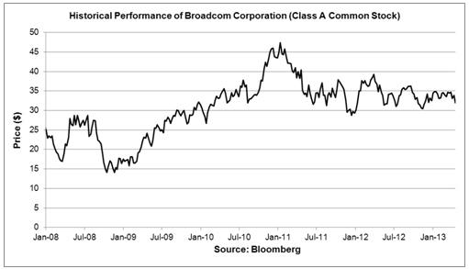

JPMorgan Structured Investments — | TS-14
Return Notes Linked to an Equally Weighted Basket of 15 Reference Stocks

HSBC Holdings plc (“HSBC”)

According to its publicly available filings with the SEC, HSBC, a United Kingdom company, is a banking and financial services organization, serving its customers through four global businesses: Retail Banking and Wealth Management, Commercial Banking, Global Banking and Markets and Global Private Banking. The ADSs of HSBC, each representing five ordinary shares of HSBC, par value $0.50 per share, are listed on the New York Stock Exchange, which we refer to as the relevant exchange for purposes of HSBC in the accompanying product supplement no. 4-I. HSBC’s SEC file number is 001-14930.

Historical Information of the ADS of HSBC

The following graph sets forth the historical performance of the ADSs of HSBC based on the weekly closing price of one ADS of HSBC from January 4, 2008 through April 19, 2013. The closing price of one ADS of HSBC on April 19, 2013 was $51.91.
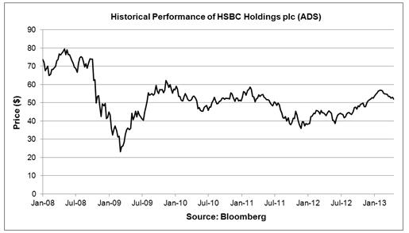

JPMS’s Estimated Value of the Notes

JPMS’s estimated value of the notes set forth on the cover of this term sheet is equal to the sum of the values of the following hypothetical components: (1) a fixed-income debt component with the same maturity as the notes, valued using our internal funding rate for structured debt described below, and (2) the derivative or derivatives underlying the economic terms of the notes. JPMS’s estimated value does not represent a minimum price at which JPMS would be willing to buy your notes in any secondary market (if any exists) at any time. The internal funding rate used in the determination of JPMS’s estimated value generally represents a discount from the credit spreads for our conventional fixed-rate debt. The discount is based on, among other things, our view of the funding value of the notes as well as the higher issuance, operational and ongoing liability management costs of the notes in comparison to those costs for our conventional fixed-rate debt. For additional information, see “Selected Risk Considerations — JPMS’s Estimated Value Is Not Determined by Reference to Credit Spreads for Our Conventional Fixed-Rate Debt.” The value of the derivative or derivatives underlying the economic terms of the notes is derived from JPMS’s internal pricing

models. These models are dependent on inputs such as the traded market prices of comparable derivative instruments and on various other inputs, some of which are market-observable, and which can include volatility, dividend rates, interest rates and other factors, as well as assumptions about future market events and/or environments. Accordingly, JPMS’s estimated value of the notes is determined when the terms of the notes are set based on market conditions and other relevant factors and assumptions existing at that time. See “Selected Risk Considerations — JPMS’s Estimated Value Does Not Represent Future Values of the Notes and May Differ from Others’ Estimates.”

JPMS’s estimated value of the notes will be lower than the original issue price of the notes because costs associated with selling, structuring and hedging the notes are included in the original issue price of the notes. These costs include the selling commissions paid to JPMS and other affiliated or unaffiliated dealers, the projected profits that our affiliates expect to realize for assuming risks inherent in hedging our obligations under the notes and the estimated cost of hedging our obligations under the notes. Because hedging our obligations entails risk and may be influenced by market forces beyond our control, this hedging may result in a profit that is more or less than expected, or it may result in a

loss. We or one or more of our affiliates will retain any profits realized in hedging our obligations under the notes. See “Selected Risk Considerations — JPMS’s Estimated Value of the Notes Will Be Lower Than the Original Issue Price (Price to Public) of the Notes” in this term sheet.

Secondary Market Prices of the Notes

For information about factors that will impact any secondary market prices of the notes, see “Selected Risk Considerations — Secondary Market Prices of the Notes Will Be Impacted by Many Economic and Market Factors” in this term sheet. In addition, we generally expect that some of the costs included in the original issue price of the notes will be partially paid back to you in connection with any repurchases of your notes by JPMS in an amount that will decline to zero over an initial predetermined period that is intended to be the shorter of six months and one-half of the stated term of the notes. The length of this initial period reflects the structure of the

JPMorgan Structured Investments — | TS-15
Return Notes Linked to an Equally Weighted Basket of 15 Reference Stocks

notes, the estimated costs of hedging the notes and when these costs are incurred, as determined by JPMS. See “Selected Risk Considerations

— The Value of the Notes as Published by JPMS (and Which May Be Reflected on Customer Account Statements) Will Likely Be Higher Than JPMS’s Then-Current Estimated Value of the Notes for a Limited Time Period.”

Supplemental Use of Proceeds

The net proceeds we receive from the sale of the notes will be used for general corporate purposes and, in part, by us or one or more of our affiliates in connection with hedging our obligations under the notes.

The notes are offered to meet investor demand for products that reflect the risk-return profile and market exposure provided by the notes. See “What Is the Total Return on the Notes at Maturity, Assuming a Range of Performances for the Basket?” in this term sheet for an illustration of the risk-return profile of the notes and “Selected Purchase Considerations — Return Linked to an Equally Weighted Basket of 15 Reference Stocks” in this term sheet for a description of the market exposure provided by the notes.

The original issue price of the notes is equal to JPMS’s estimated value of the notes plus the selling commissions paid to JPMS and other affiliated or unaffiliated dealers, the projected profits that our affiliates expect to realize for assuming risks inherent in hedging our obligations under the notes and the estimated cost of hedging our obligations under the notes.

For purposes of the notes offered by this term sheet, the first and second paragraph of the section entitled “Use of Proceeds and Hedging” on page PS-48 of the accompanying product supplement no. 4-I are deemed deleted in their entirety. Please refer instead to the discussion set forth above.

JPMorgan Structured Investments — | TS-16
Return Notes Linked to an Equally Weighted Basket of 15 Reference Stocks

