UNITED STATES
SECURITIES AND EXCHANGE COMMISSION
Washington, D.C. 20549
FORM 8-K
CURRENT REPORT
Pursuant to Section 13 or 15(d) of the Securities Exchange Act of 1934
Date of Report (date of earliest event reported): October 13, 2026
JPMorgan Chase & Co.
(Exact name of registrant as specified in its charter)
Delaware |  |  |  |  |  | 1-5805 |  |  |  |  |  | 13-2624428
(State or other jurisdiction of  incorporation or organization) |  |  |  |  |  | (Commission File Number) |  |  |  |  |  | (I.R.S. employer  identification no.)
270 Park Avenue,
New York, |  |  | New York |  |  |  |  |  |  |  |  | 10017
(Address of principal executive offices) |  |  |  |  |  |  |  |  |  |  |  | (Zip Code)
Registrant’s telephone number, including area code: (212) 270-6000
Check the appropriate box below if the Form 8-K filing is intended to simultaneously satisfy the filing obligation of the registrant under any of the following provisions:
☐ |  |  |  |  |  | Written communications pursuant to Rule 425 under the Securities Act (17 CFR 230.425)
☐ |  |  |  |  |  | Soliciting material pursuant to Rule 14a-12 under the Exchange Act (17 CFR 240.14a-12)
☐ |  |  |  |  |  | Pre-commencement communications pursuant to Rule 14d-2(b) under the Exchange Act (17 CFR 240.14d-2(b))
☐ |  |  |  |  |  | Pre-commencement communications pursuant to Rule 13e-4(c) under the Exchange Act (17 CFR 240.13e-4(c))
Securities registered pursuant to Section 12(b) of the Act:
Title of each class |  |  | Trading Symbol(s) |  |  | Name of each exchange on which registered
Common stock |  |  | JPM |  |  | The New York Stock Exchange
Depositary Shares, each representing a one-four hundredth interest in a share of 5.75% Non-Cumulative Preferred Stock, Series DD |  |  | JPM PR D |  |  | The New York Stock Exchange
Depositary Shares, each representing a one-four hundredth interest in a share of 6.00% Non-Cumulative Preferred Stock, Series EE |  |  | JPM PR C |  |  | The New York Stock Exchange
Depositary Shares, each representing a one-four hundredth interest in a share of 4.75% Non-Cumulative Preferred Stock, Series GG |  |  | JPM PR J |  |  | The New York Stock Exchange
Depositary Shares, each representing a one-four hundredth interest in a share of 4.55% Non-Cumulative Preferred Stock, Series JJ |  |  | JPM PR K |  |  | The New York Stock Exchange
Depositary Shares, each representing a one-four hundredth interest in a share of 4.625% Non-Cumulative Preferred Stock, Series LL |  |  | JPM PR L |  |  | The New York Stock Exchange
Depositary Shares, each representing a one-four hundredth interest in a share of 4.20% Non-Cumulative Preferred Stock, Series MM |  |  | JPM PR M |  |  | The New York Stock Exchange
Guarantee of Callable Fixed Rate Notes due June 10, 2032 of JPMorgan Chase Financial Company LLC |  |  | JPM/32 |  |  | The New York Stock Exchange
Guarantee of Alerian MLP Index ETNs due January 28, 2044 of JPMorgan Chase Financial Company LLC |  |  | AMJB |  |  | NYSE Arca, Inc.
Guarantee of Inverse VIX Short-Term Futures ETNs due March 22, 2045 of JPMorgan Chase Financial Company LLC |  |  | VYLD |  |  | NYSE Arca, Inc.
Indicate by check mark whether the registrant is an emerging growth company as defined in Rule 405 of the Securities Act of 1933 (§230.405 of this chapter) or Rule 12b-2 of the Securities Exchange Act of 1934 (§240.12b-2 of this chapter).
Emerging growth company ☐
If an emerging growth company, indicate by check mark if the registrant has elected not to use the extended transition period for complying with any new or revised financial accounting standards provided pursuant to Section 13(a) of the Exchange Act. ☐

Item 7.01 Regulation FD Disclosure
On October 13, 2026, JPMorgan Chase & Co. (“JPMorganChase” or the “Firm”) held an investor presentation to review 2026 third quarter earnings.
Exhibit 99 is a copy of slides furnished for, and posted on the Firm’s website in connection with, the presentation. The slides are being furnished pursuant to Item 7.01, and the information contained therein shall not be deemed to be “filed” for purposes of Section 18 of the Securities Exchange Act of 1934, or otherwise subject to the liabilities under that Section. Furthermore, the information contained in Exhibit 99 shall not be deemed to be incorporated by reference into the filings of the Firm under the Securities Act of 1933.
This Current Report on Form 8-K (including the Exhibit hereto) contains forward-looking statements within the meaning of the Private Securities Litigation Reform Act of 1995. These statements are based on the beliefs and expectations of JPMorganChase’s management, speak only as of the date on which they were made, and are subject to significant risks and uncertainties. Actual results may differ from those set forth in the forward-looking statements. Factors that could cause JPMorganChase’s actual results to differ materially from those described in the forward-looking statements can be found in JPMorganChase’s Annual Report on Form 10-K for the year ended December 31, 2025 and Quarterly Reports on Form 10-Q for the quarters ended March 31, 2026 and June 30, 2026, which have been filed with the Securities and Exchange Commission and are available on JPMorganChase’s website (https://jpmorganchaseco.gcs-web.com/ir/sec-other-filings/overview) and on the Securities and Exchange Commission’s website (www.sec.gov). JPMorganChase does not undertake to update any forward-looking statements.

Item 9.01 Financial Statements and Exhibits

(d) Exhibit
Exhibit No. |  |  |  |  |  | Description of Exhibit
99 |  |  |  |  |  | JPMorgan Chase & Co. Earnings Presentation Slides – Financial Results – 3Q26
101 |  |  |  |  |  | Pursuant to Rule 406 of Regulation S-T, the cover page is formatted in Inline XBRL (Inline eXtensible Business Reporting Language).
104 |  |  |  |  |  | Cover Page Interactive Data File (embedded within the Inline XBRL document and included in Exhibit 101).

2

SIGNATURE

Pursuant to the requirements of the Securities Exchange Act of 1934, the Registrant has duly caused this report to be signed on its behalf by the undersigned hereunto duly authorized.
JPMorgan Chase & Co.
(Registrant)

By: |  |  | /s/ Elena Korablina
 |  |  | Elena Korablina
 |  |  | Managing Director and Firmwide Controller
 |  |  | (Principal Accounting Officer)

Dated: |  |  | October 13, 2026

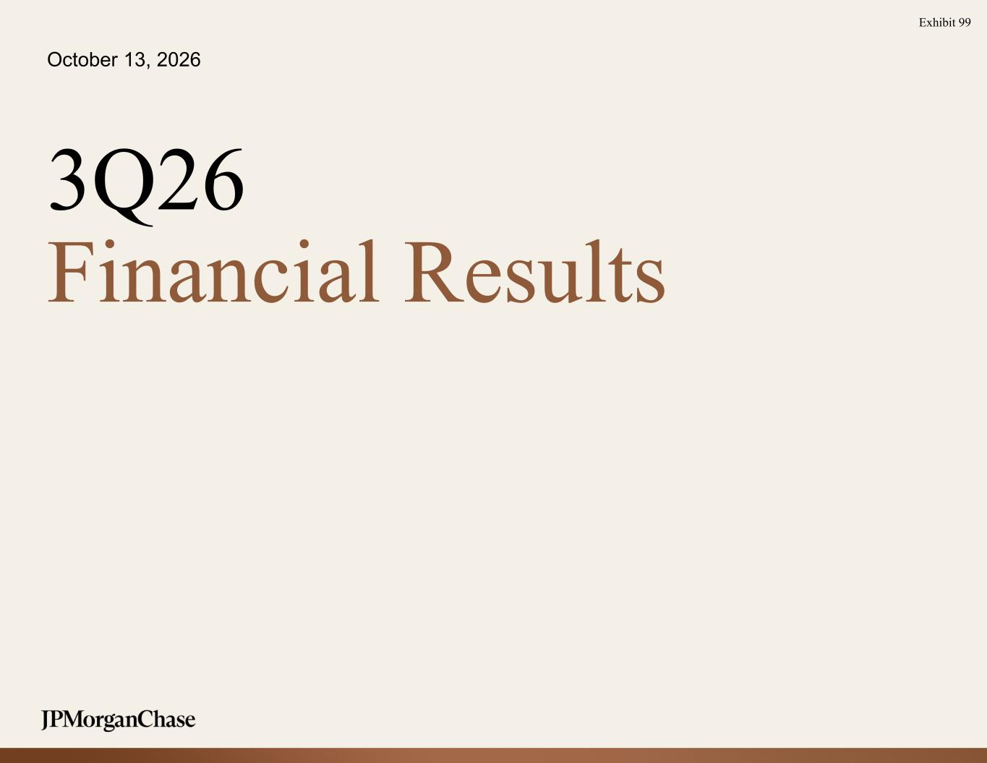
3
October 13, 2026 3Q26 Financial Results Exhibit 99

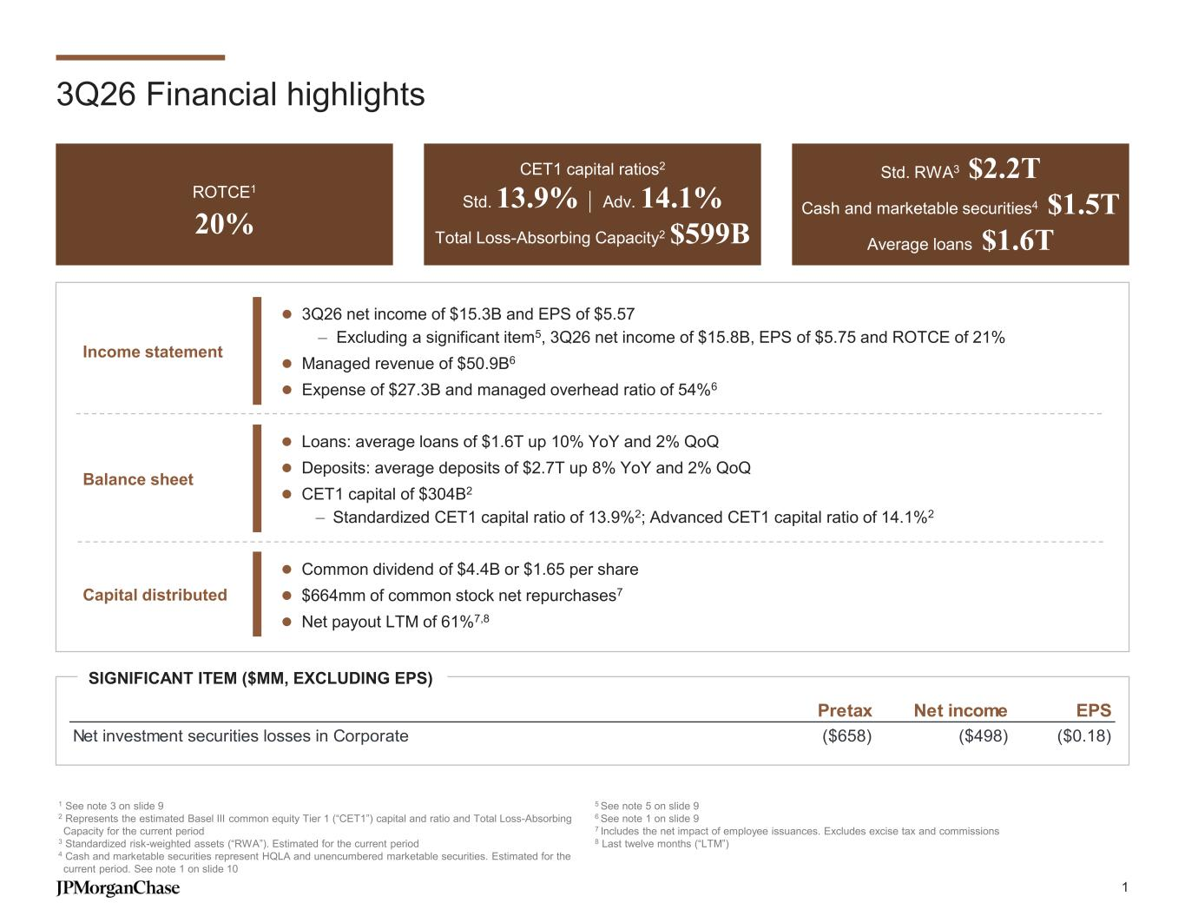
3Q26 Financial highlights ROTCE1 20% CET1 capital ratios2 Std. 13.9% | Adv. 14.1% Total Loss-Absorbing Capacity2 $599B Std. RWA3 $2.2T Cash and marketable securities4 $1.5T Average loans $1.6T 1 See note 3 on slide 9 2 Represents the estimated Basel III common equity Tier 1 (“CET1”) capital and ratio and Total Loss-Absorbing Capacity for the current period 3 Standardized risk-weighted assets (“RWA”). Estimated for the current period 4 Cash and marketable securities represent HQLA and unencumbered marketable securities. Estimated for the current period. See note 1 on slide 10 5 See note 5 on slide 9 6 See note 1 on slide 9 7 Includes the net impact of employee issuances. Excludes excise tax and commissions 8 Last twelve months (“LTM”) ⚫ Common dividend of $4.4B or $1.65 per share ⚫ $664mm of common stock net repurchases7 ⚫ Net payout LTM of 61%7,8 ⚫ Loans: average loans of $1.6T up 10% YoY and 2% QoQ ⚫ Deposits: average deposits of $2.7T up 8% YoY and 2% QoQ ⚫ CET1 capital of $304B2 – Standardized CET1 capital ratio of 13.9%2; Advanced CET1 capital ratio of 14.1%2 ⚫ 3Q26 net income of $15.3B and EPS of $5.57 – Excluding a significant item5, 3Q26 net income of $15.8B, EPS of $5.75 and ROTCE of 21% ⚫ Managed revenue of $50.9B6 ⚫ Expense of $27.3B and managed overhead ratio of 54%6 Balance sheet Capital distributed Income statement SIGNIFICANT ITEM ($MM, EXCLUDING EPS) Pretax Net income EPS Net investment securities losses in Corporate ($658) ($498) ($0.18) 1

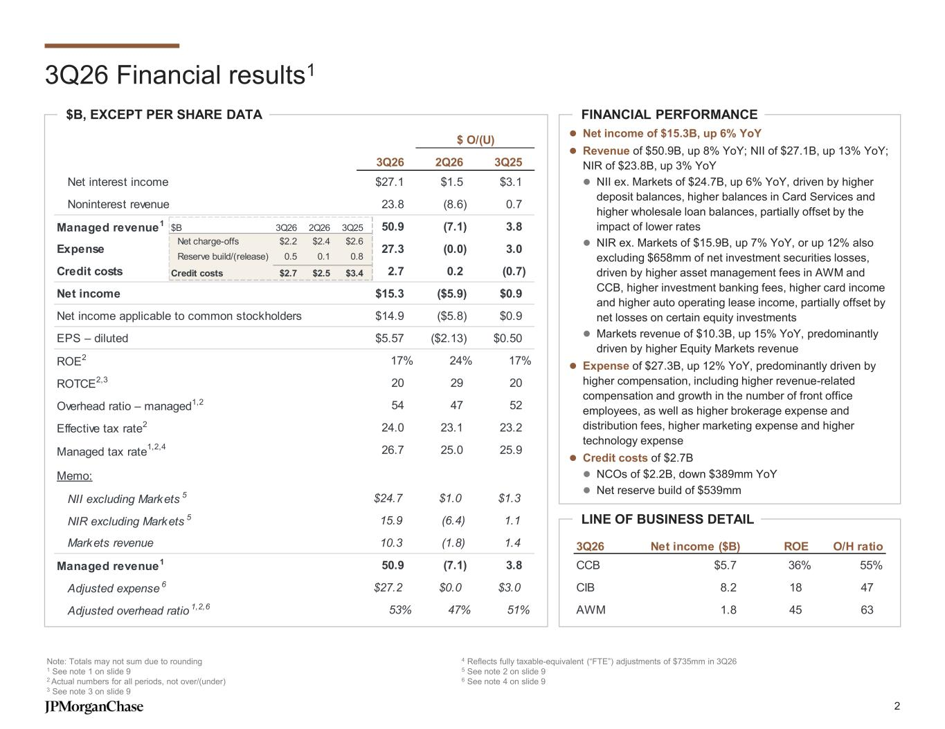
3Q26 2Q26 3Q25 Net interest income $27.1 $1.5 $3.1 Noninterest revenue 23.8 (8.6) 0.7 Managed revenue1 50.9 (7.1) 3.8 Expense 27.3 (0.0) 3.0 Credit costs 2.7 0.2 (0.7) Net income $15.3 ($5.9) $0.9 Net income applicable to common stockholders $14.9 ($5.8) $0.9 EPS – diluted $5.57 ($2.13) $0.50 ROE2 17% 24% 17% ROTCE2,3 20 29 20 Overhead ratio – managed1,2 54 47 52 Effective tax rate2 24.0 23.1 23.2 Managed tax rate 1,2,4 26.7 25.0 25.9 Memo: NII excluding Markets 5 $24.7 $1.0 $1.3 NIR excluding Markets 5 15.9 (6.4) 1.1 Markets revenue 10.3 (1.8) 1.4 Managed revenue1 50.9 (7.1) 3.8 Adjusted expense 6 $27.2 $0.0 $3.0 Adjusted overhead ratio 1,2,6 53% 47% 51% $ O/(U) 3Q26 Financial results1 Note: Totals may not sum due to rounding 1 See note 1 on slide 9 2 Actual numbers for all periods, not over/(under) 3 See note 3 on slide 9 4 Reflects fully taxable-equivalent (“FTE”) adjustments of $735mm in 3Q26 5 See note 2 on slide 9 6 See note 4 on slide 9 FINANCIAL PERFORMANCE LINE OF BUSINESS DETAIL $B, EXCEPT PER SHARE DATA ⚫ Net income of $15.3B, up 6% YoY ⚫ Revenue of $50.9B, up 8% YoY; NII of $27.1B, up 13% YoY; NIR of $23.8B, up 3% YoY ⚫ NII ex. Markets of $24.7B, up 6% YoY, driven by higher deposit balances, higher balances in Card Services and higher wholesale loan balances, partially offset by the impact of lower rates ⚫ NIR ex. Markets of $15.9B, up 7% YoY, or up 12% also excluding $658mm of net investment securities losses, driven by higher asset management fees in AWM and CCB, higher investment banking fees, higher card income and higher auto operating lease income, partially offset by net losses on certain equity investments ⚫ Markets revenue of $10.3B, up 15% YoY, predominantly driven by higher Equity Markets revenue ⚫ Expense of $27.3B, up 12% YoY, predominantly driven by higher compensation, including higher revenue-related compensation and growth in the number of front office employees, as well as higher brokerage expense and distribution fees, higher marketing expense and higher technology expense ⚫ Credit costs of $2.7B ⚫ NCOs of $2.2B, down $389mm YoY ⚫ Net reserve build of $539mm 3Q26 Net income ($B) ROE O/H ratio CCB $5.7 36% 55% CIB 8.2 18 47 AWM 1.8 45 63 $B 3Q26 2Q26 3Q25 Net charge-offs $2.2 $2.4 $2.6 Reserve build/(release) 0.5 0.1 0.8 Credit costs $2.7 $2.5 $3.4 2

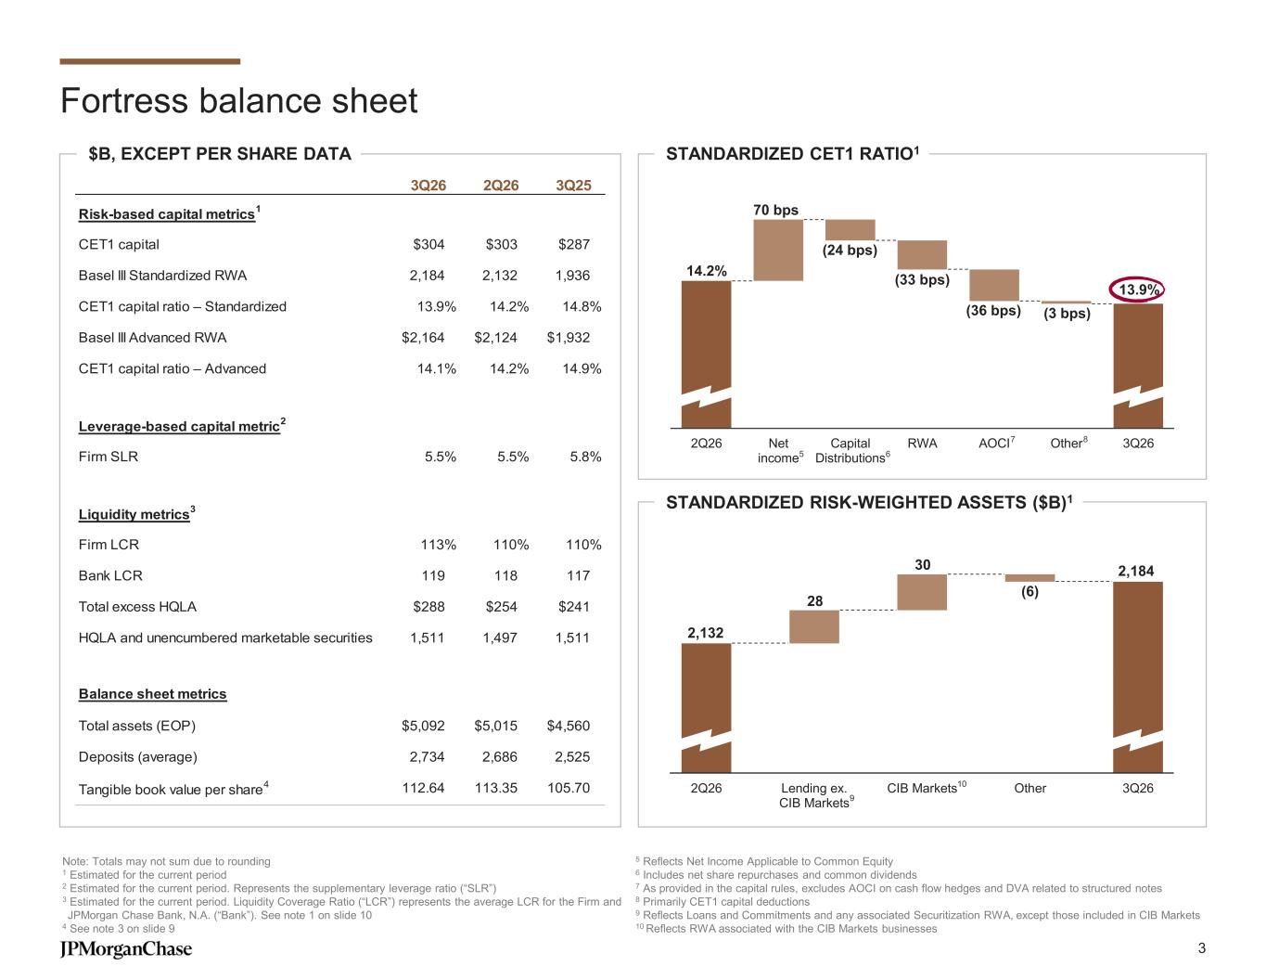
Fortress balance sheet $B, EXCEPT PER SHARE DATA Note: Totals may not sum due to rounding 1 Estimated for the current period 2 Estimated for the current period. Represents the supplementary leverage ratio (“SLR”) 3 Estimated for the current period. Liquidity Coverage Ratio (“LCR”) represents the average LCR for the Firm and JPMorgan Chase Bank, N.A. (“Bank”). See note 1 on slide 10 4 See note 3 on slide 9 5 Reflects Net Income Applicable to Common Equity 6 Includes net share repurchases and common dividends 7 As provided in the capital rules, excludes AOCI on cash flow hedges and DVA related to structured notes 8 Primarily CET1 capital deductions 9 Reflects Loans and Commitments and any associated Securitization RWA, except those included in CIB Markets 10 Reflects RWA associated with the CIB Markets businesses STANDARDIZED CET1 RATIO1 STANDARDIZED RISK-WEIGHTED ASSETS ($B)1 3Q26 2Q26 3Q25 Risk-based capital metrics 1 CET1 capital $304 $303 $287 Basel III Standardized RWA 2,184 2,132 1,936 CET1 capital ratio – Standardized 13.9% 14.2% 14.8% Basel III Advanced RWA $2,164 $2,124 $1,932 CET1 capital ratio – Advanced 14.1% 14.2% 14.9% Leverage-based capital metric 2 Firm SLR 5.5% 5.5% 5.8% Liquidity metrics 3 Firm LCR 113% 110% 110% Bank LCR 119 118 117 Total excess HQLA $288 $254 $241 HQLA and unencumbered marketable securities 1,511 1,497 1,511 Balance sheet metrics Total assets (EOP) $5,092 $5,015 $4,560 Deposits (average) 2,734 2,686 2,525 Tangible book value per share 4 112.64 113.35 105.70 14.2% 13.9% (24 bps) (33 bps) (36 bps) (3 bps) 70 bps 2Q26 Net income Capital Distributions RWA AOCI Other 3Q26 65 7 8 2,132 (6) 28 30 2Q26 Lending ex. CIB Markets CIB Markets Other 3Q26 2,184 9 10 3

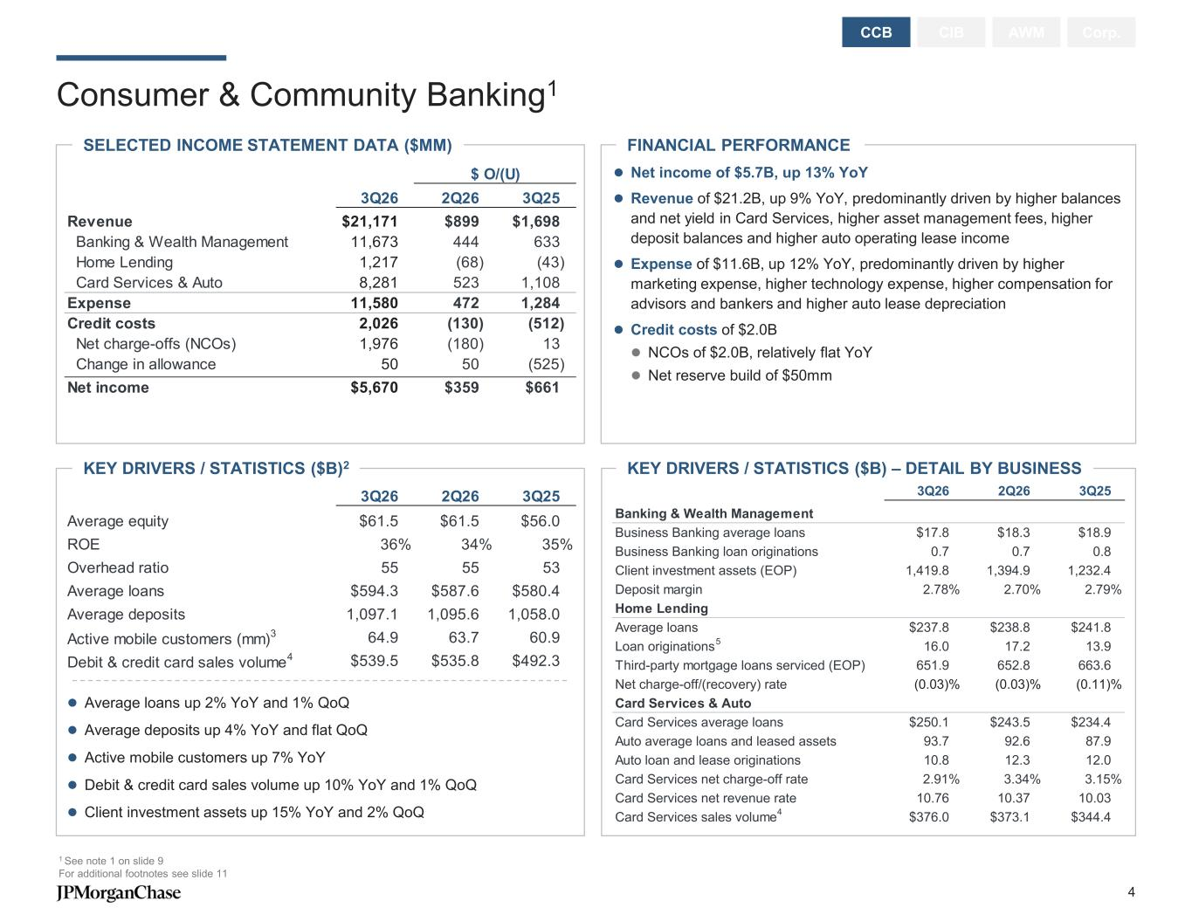
Consumer & Community Banking1 CIB AWM Corp.CCB ⚫ Average loans up 2% YoY and 1% QoQ ⚫ Average deposits up 4% YoY and flat QoQ ⚫ Active mobile customers up 7% YoY ⚫ Debit & credit card sales volume up 10% YoY and 1% QoQ ⚫ Client investment assets up 15% YoY and 2% QoQ KEY DRIVERS / STATISTICS ($B) – DETAIL BY BUSINESS FINANCIAL PERFORMANCESELECTED INCOME STATEMENT DATA ($MM) KEY DRIVERS / STATISTICS ($B)2 1 See note 1 on slide 9 For additional footnotes see slide 11 ⚫ Net income of $5.7B, up 13% YoY ⚫ Revenue of $21.2B, up 9% YoY, predominantly driven by higher balances and net yield in Card Services, higher asset management fees, higher deposit balances and higher auto operating lease income ⚫ Expense of $11.6B, up 12% YoY, predominantly driven by higher marketing expense, higher technology expense, higher compensation for advisors and bankers and higher auto lease depreciation ⚫ Credit costs of $2.0B ⚫ NCOs of $2.0B, relatively flat YoY ⚫ Net reserve build of $50mm $ O/(U) 3Q26 2Q26 3Q25 Revenue $21,171 $899 $1,698 Banking & Wealth Management 11,673 444 633 Home Lending 1,217 (68) (43) Card Services & Auto 8,281 523 1,108 Expense 11,580 472 1,284 Credit costs 2,026 (130) (512) Net charge-offs (NCOs) 1,976 (180) 13 Change in allowance 50 50 (525) Net income $5,670 $359 $661 3Q26 2Q26 3Q25 Average equity $61.5 $61.5 $56.0 ROE 36% 34% 35% Overhead ratio 55 55 53 Average loans $594.3 $587.6 $580.4 Average deposits 1,097.1 1,095.6 1,058.0 Active mobile customers (mm) 3 64.9 63.7 60.9 Debit & credit card sales volume 4 $539.5 $535.8 $492.3 3Q26 2Q26 3Q25 Banking & Wealth Management Business Banking average loans $17.8 $18.3 $18.9 Business Banking loan originations 0.7 0.7 0.8 Client investment assets (EOP) 1,419.8 1,394.9 1,232.4 Deposit margin 2.78% 2.70% 2.79% Home Lending Average loans $237.8 $238.8 $241.8 Loan originations 16.0 17.2 13.9 Third-party mortgage loans serviced (EOP) 651.9 652.8 663.6 Net charge-off/(recovery) rate (0.03)% (0.03)% (0.11)% Card Services & Auto Card Services average loans $250.1 $243.5 $234.4 Auto average loans and leased assets 93.7 92.6 87.9 Auto loan and lease originations 10.8 12.3 12.0 Card Services net charge-off rate 2.91% 3.34% 3.15% Card Services net revenue rate 10.76 10.37 10.03 Card Services sales volume $376.0 $373.1 $344.4 5 4 4

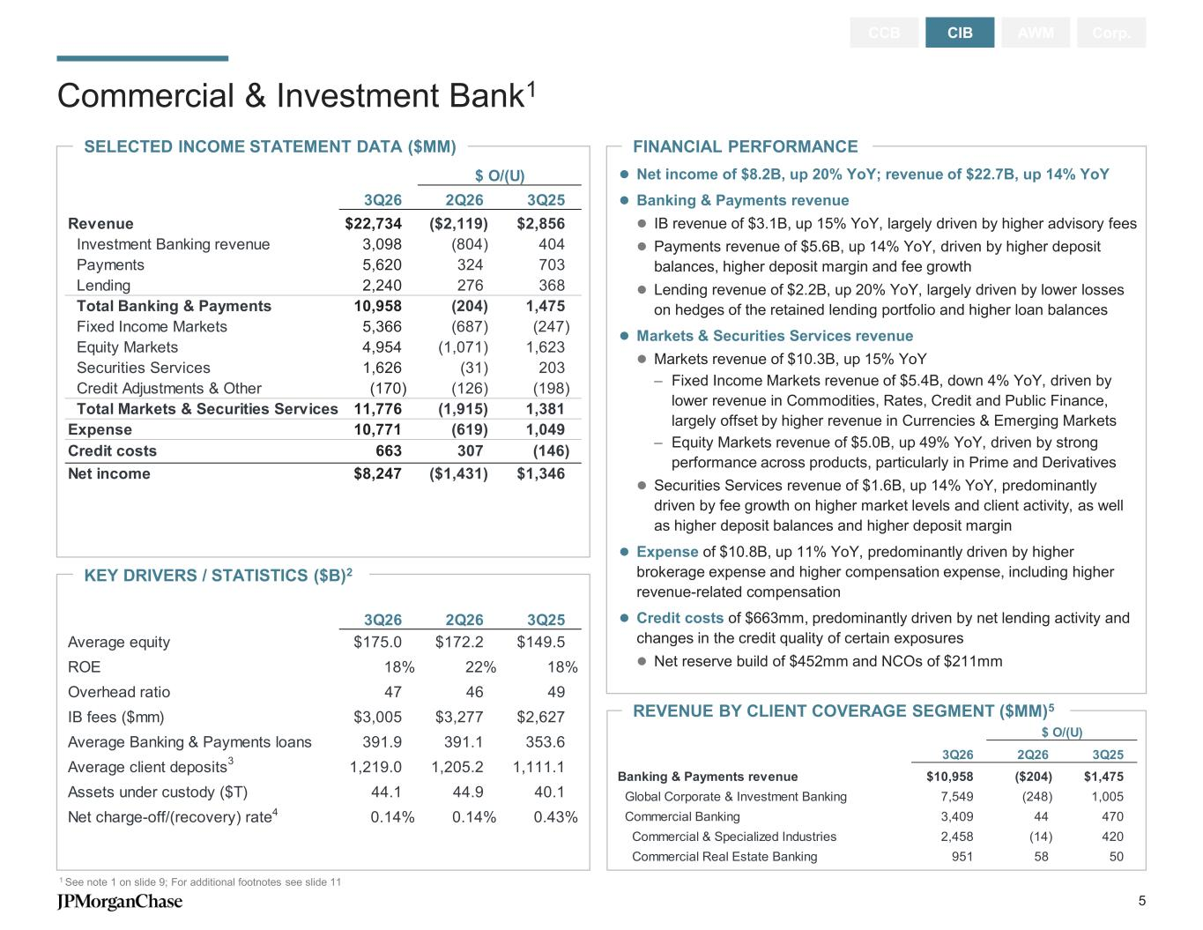
KEY DRIVERS / STATISTICS ($B)2 FINANCIAL PERFORMANCE Commercial & Investment Bank1 1 See note 1 on slide 9; For additional footnotes see slide 11 CCB CIB AWM Corp. SELECTED INCOME STATEMENT DATA ($MM) ⚫ Net income of $8.2B, up 20% YoY; revenue of $22.7B, up 14% YoY ⚫ Banking & Payments revenue ⚫ IB revenue of $3.1B, up 15% YoY, largely driven by higher advisory fees ⚫ Payments revenue of $5.6B, up 14% YoY, driven by higher deposit balances, higher deposit margin and fee growth ⚫ Lending revenue of $2.2B, up 20% YoY, largely driven by lower losses on hedges of the retained lending portfolio and higher loan balances ⚫ Markets & Securities Services revenue ⚫ Markets revenue of $10.3B, up 15% YoY – Fixed Income Markets revenue of $5.4B, down 4% YoY, driven by lower revenue in Commodities, Rates, Credit and Public Finance, largely offset by higher revenue in Currencies & Emerging Markets – Equity Markets revenue of $5.0B, up 49% YoY, driven by strong performance across products, particularly in Prime and Derivatives ⚫ Securities Services revenue of $1.6B, up 14% YoY, predominantly driven by fee growth on higher market levels and client activity, as well as higher deposit balances and higher deposit margin ⚫ Expense of $10.8B, up 11% YoY, predominantly driven by higher brokerage expense and higher compensation expense, including higher revenue-related compensation ⚫ Credit costs of $663mm, predominantly driven by net lending activity and changes in the credit quality of certain exposures ⚫ Net reserve build of $452mm and NCOs of $211mm REVENUE BY CLIENT COVERAGE SEGMENT ($MM)5 $ O/(U) 3Q26 2Q26 3Q25 Revenue $22,734 ($2,119) $2,856 Investment Banking revenue 3,098 (804) 404 Payments 5,620 324 703 Lending 2,240 276 368 Total Banking & Payments 10,958 (204) 1,475 Fixed Income Markets 5,366 (687) (247) Equity Markets 4,954 (1,071) 1,623 Securities Services 1,626 (31) 203 Credit Adjustments & Other (170) (126) (198) Total Markets & Securities Services 11,776 (1,915) 1,381 Expense 10,771 (619) 1,049 Credit costs 663 307 (146) Net income $8,247 ($1,431) $1,346 3Q26 2Q26 3Q25 Average equity $175.0 $172.2 $149.5 ROE 18% 22% 18% Overhead ratio 47 46 49 IB fees ($mm) $3,005 $3,277 $2,627 Average Banking & Payments loans 391.9 391.1 353.6 Average client deposits 1,219.0 1,205.2 1,111.1 Assets under custody ($T) 44.1 44.9 40.1 Net charge-off/(recovery) rate 0.14% 0.14% 0.43%4 3 $ O/(U) 3Q26 2Q26 3Q25 Banking & Payments revenue $10,958 ($204) $1,475 Global Corporate & Investment Banking 7,549 (248) 1,005 Commercial Banking 3,409 44 470 Commercial & Specialized Industries 2,458 (14) 420 Commercial Real Estate Banking 951 58 50 5

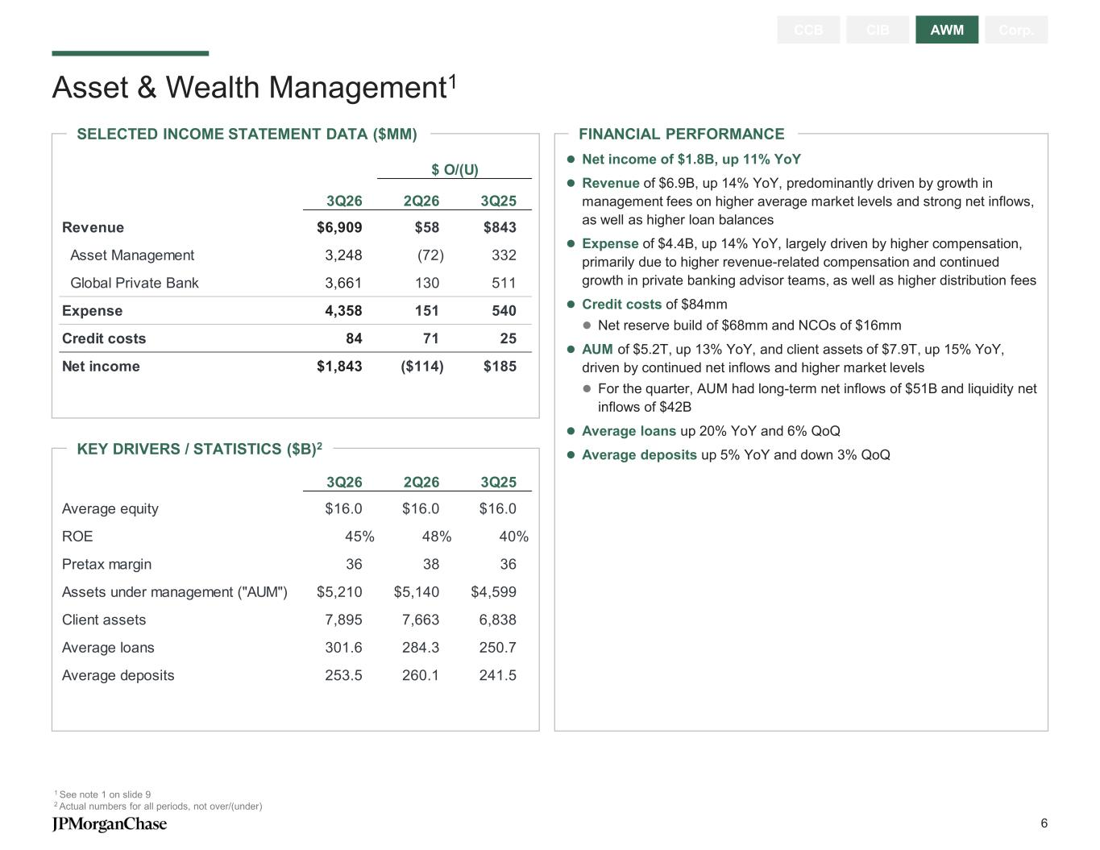
FINANCIAL PERFORMANCESELECTED INCOME STATEMENT DATA ($MM) Asset & Wealth Management1 1 See note 1 on slide 9 2 Actual numbers for all periods, not over/(under) CCB CIB AWM Corp. KEY DRIVERS / STATISTICS ($B)2 ⚫ Net income of $1.8B, up 11% YoY ⚫ Revenue of $6.9B, up 14% YoY, predominantly driven by growth in management fees on higher average market levels and strong net inflows, as well as higher loan balances ⚫ Expense of $4.4B, up 14% YoY, largely driven by higher compensation, primarily due to higher revenue-related compensation and continued growth in private banking advisor teams, as well as higher distribution fees ⚫ Credit costs of $84mm ⚫ Net reserve build of $68mm and NCOs of $16mm ⚫ AUM of $5.2T, up 13% YoY, and client assets of $7.9T, up 15% YoY, driven by continued net inflows and higher market levels ⚫ For the quarter, AUM had long-term net inflows of $51B and liquidity net inflows of $42B ⚫ Average loans up 20% YoY and 6% QoQ ⚫ Average deposits up 5% YoY and down 3% QoQ $ O/(U) 3Q26 2Q26 3Q25 Revenue $6,909 $58 $843 Asset Management 3,248 (72) 332 Global Private Bank 3,661 130 511 Expense 4,358 151 540 Credit costs 84 71 25 Net income $1,843 ($114) $185 3Q26 2Q26 3Q25 Average equity $16.0 $16.0 $16.0 ROE 45% 48% 40% Pretax margin 36 38 36 Assets under management ("AUM") $5,210 $5,140 $4,599 Client assets 7,895 7,663 6,838 Average loans 301.6 284.3 250.7 Average deposits 253.5 260.1 241.5 6

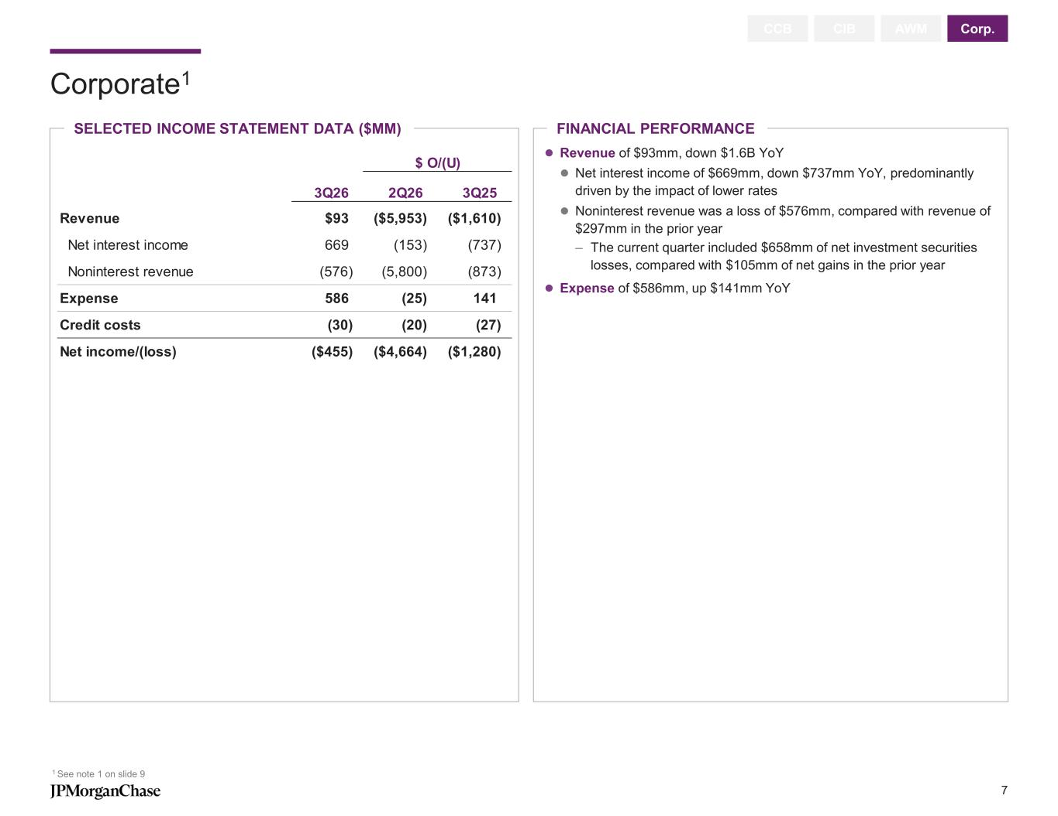
Corporate1 1 See note 1 on slide 9 CCB CIB AWM Corp. SELECTED INCOME STATEMENT DATA ($MM) FINANCIAL PERFORMANCE ⚫ Revenue of $93mm, down $1.6B YoY ⚫ Net interest income of $669mm, down $737mm YoY, predominantly driven by the impact of lower rates ⚫ Noninterest revenue was a loss of $576mm, compared with revenue of $297mm in the prior year – The current quarter included $658mm of net investment securities losses, compared with $105mm of net gains in the prior year ⚫ Expense of $586mm, up $141mm YoY $ O/(U) 3Q26 2Q26 3Q25 Revenue $93 ($5,953) ($1,610) Net interest income 669 (153) (737) Noninterest revenue (576) (5,800) (873) Expense 586 (25) 141 Credit costs (30) (20) (27) Net income/(loss) ($455) ($4,664) ($1,280) 7

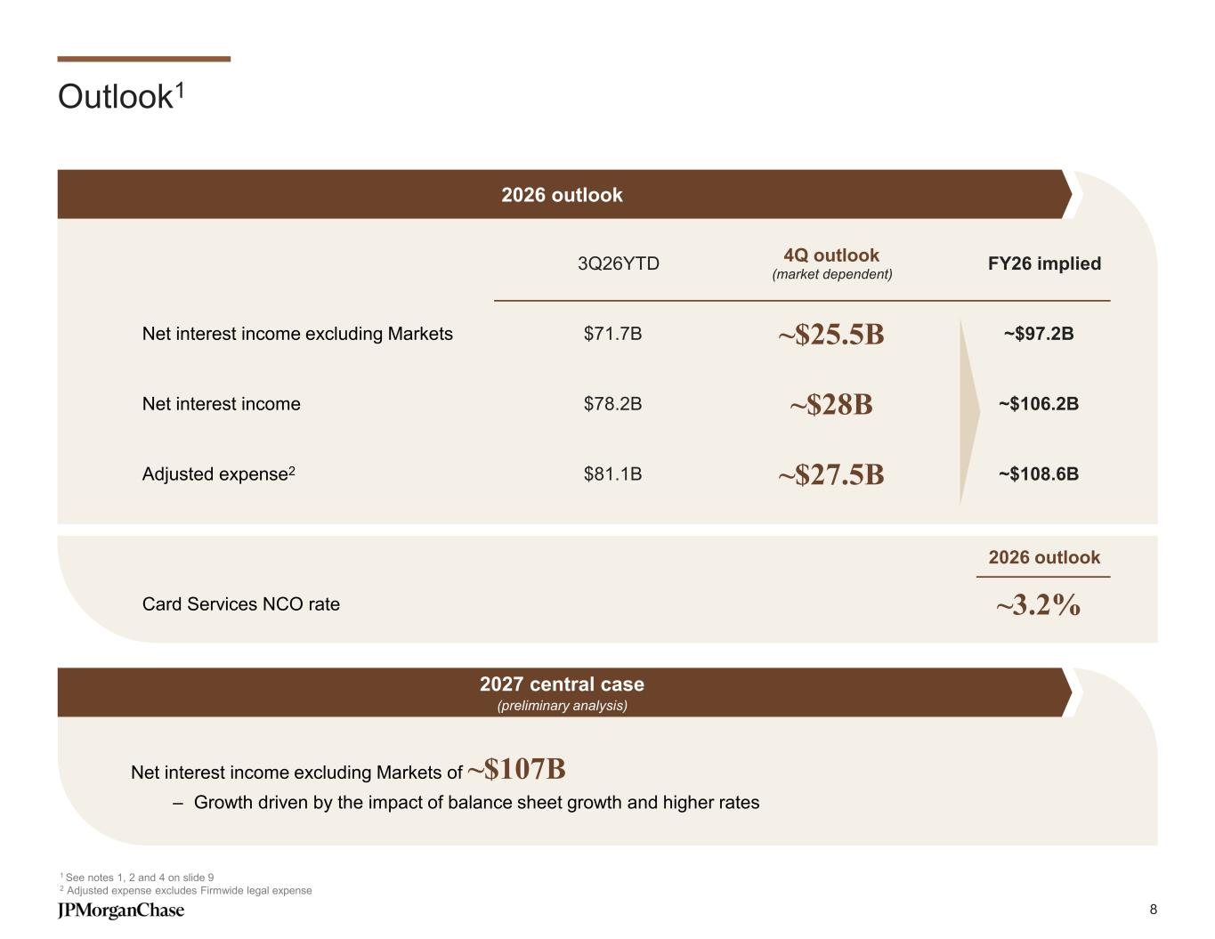
Net interest income excluding Markets of ~$107B – Growth driven by the impact of balance sheet growth and higher rates Outlook1 1 See notes 1, 2 and 4 on slide 9 2 Adjusted expense excludes Firmwide legal expense 3Q26YTD 4Q outlook (market dependent) FY26 implied Net interest income excluding Markets $71.7B ~$25.5B ~$97.2B Net interest income $78.2B ~$28B ~$106.2B Adjusted expense2 $81.1B ~$27.5B ~$108.6B 2026 outlook 2027 central case (preliminary analysis) 2026 outlook Card Services NCO rate ~3.2% 8

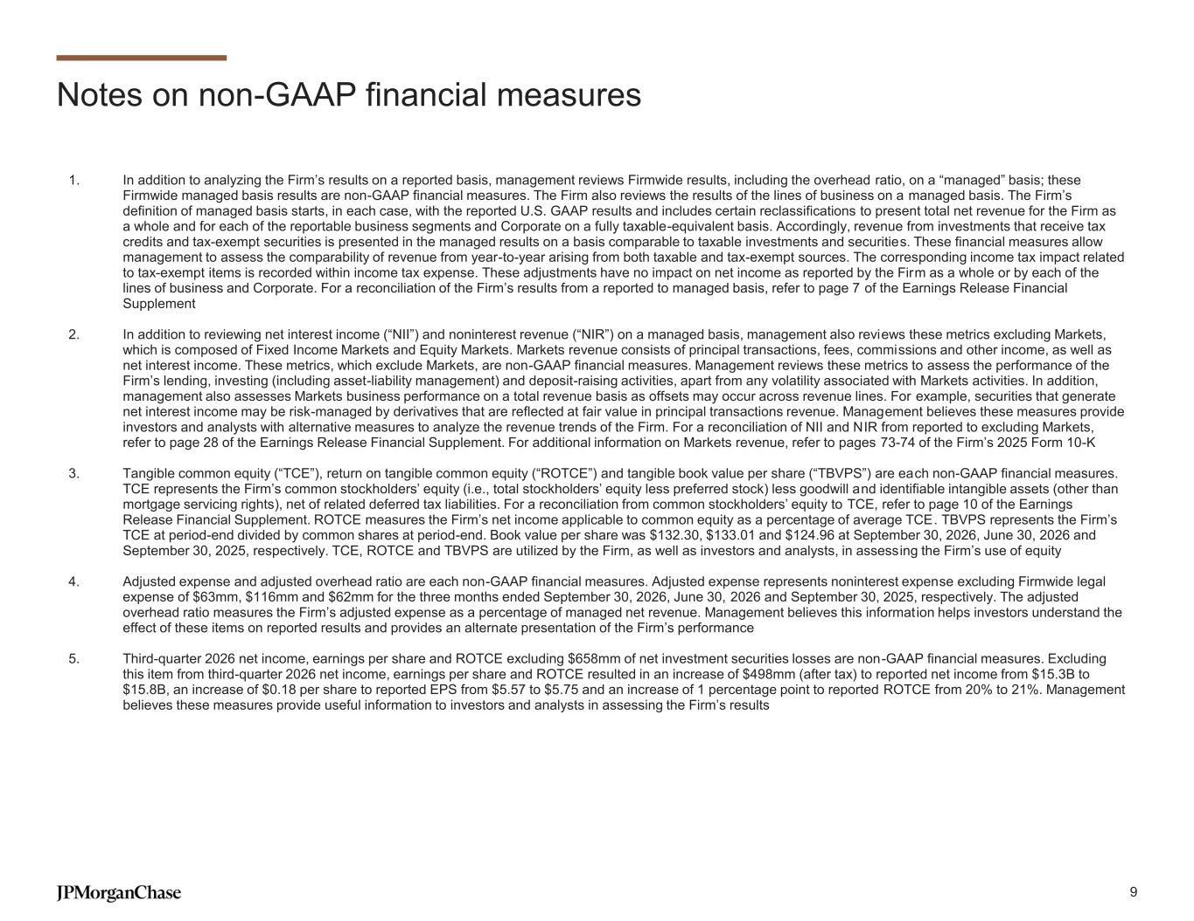
Notes on non-GAAP financial measures 1. In addition to analyzing the Firm’s results on a reported basis, management reviews Firmwide results, including the overhead ratio, on a “managed” basis; these Firmwide managed basis results are non-GAAP financial measures. The Firm also reviews the results of the lines of business on a managed basis. The Firm’s definition of managed basis starts, in each case, with the reported U.S. GAAP results and includes certain reclassifications to present total net revenue for the Firm as a whole and for each of the reportable business segments and Corporate on a fully taxable-equivalent basis. Accordingly, revenue from investments that receive tax credits and tax-exempt securities is presented in the managed results on a basis comparable to taxable investments and securities. These financial measures allow management to assess the comparability of revenue from year-to-year arising from both taxable and tax-exempt sources. The corresponding income tax impact related to tax-exempt items is recorded within income tax expense. These adjustments have no impact on net income as reported by the Firm as a whole or by each of the lines of business and Corporate. For a reconciliation of the Firm’s results from a reported to managed basis, refer to page 7 of the Earnings Release Financial Supplement 2. In addition to reviewing net interest income (“NII”) and noninterest revenue (“NIR”) on a managed basis, management also reviews these metrics excluding Markets, which is composed of Fixed Income Markets and Equity Markets. Markets revenue consists of principal transactions, fees, commissions and other income, as well as net interest income. These metrics, which exclude Markets, are non-GAAP financial measures. Management reviews these metrics to assess the performance of the Firm’s lending, investing (including asset-liability management) and deposit-raising activities, apart from any volatility associated with Markets activities. In addition, management also assesses Markets business performance on a total revenue basis as offsets may occur across revenue lines. For example, securities that generate net interest income may be risk-managed by derivatives that are reflected at fair value in principal transactions revenue. Management believes these measures provide investors and analysts with alternative measures to analyze the revenue trends of the Firm. For a reconciliation of NII and NIR from reported to excluding Markets, refer to page 28 of the Earnings Release Financial Supplement. For additional information on Markets revenue, refer to pages 73-74 of the Firm’s 2025 Form 10-K 3. Tangible common equity (“TCE”), return on tangible common equity (“ROTCE”) and tangible book value per share (“TBVPS”) are each non-GAAP financial measures. TCE represents the Firm’s common stockholders’ equity (i.e., total stockholders’ equity less preferred stock) less goodwill and identifiable intangible assets (other than mortgage servicing rights), net of related deferred tax liabilities. For a reconciliation from common stockholders’ equity to TCE, refer to page 10 of the Earnings Release Financial Supplement. ROTCE measures the Firm’s net income applicable to common equity as a percentage of average TCE. TBVPS represents the Firm’s TCE at period-end divided by common shares at period-end. Book value per share was $132.30, $133.01 and $124.96 at September 30, 2026, June 30, 2026 and September 30, 2025, respectively. TCE, ROTCE and TBVPS are utilized by the Firm, as well as investors and analysts, in assessing the Firm’s use of equity 4. Adjusted expense and adjusted overhead ratio are each non-GAAP financial measures. Adjusted expense represents noninterest expense excluding Firmwide legal expense of $63mm, $116mm and $62mm for the three months ended September 30, 2026, June 30, 2026 and September 30, 2025, respectively. The adjusted overhead ratio measures the Firm’s adjusted expense as a percentage of managed net revenue. Management believes this informat ion helps investors understand the effect of these items on reported results and provides an alternate presentation of the Firm’s performance 5. Third-quarter 2026 net income, earnings per share and ROTCE excluding $658mm of net investment securities losses are non-GAAP financial measures. Excluding this item from third-quarter 2026 net income, earnings per share and ROTCE resulted in an increase of $498mm (after tax) to reported net income from $15.3B to $15.8B, an increase of $0.18 per share to reported EPS from $5.57 to $5.75 and an increase of 1 percentage point to reported ROTCE from 20% to 21%. Management believes these measures provide useful information to investors and analysts in assessing the Firm’s results 9


Additional notes 1. Total excess high-quality liquid assets (“HQLA”) represent the average eligible unencumbered liquid assets that are in excess of what is required to meet the estimated Firm and Bank total net cash outflows over a prospective 30 calendar-day period of significant stress under the LCR rule. HQLA and unencumbered marketable securities include end-of-period HQLA, excluding regulatory prescribed haircuts under the LCR rule where applicable, for both the Firm and the excess HQLA-eligible securities included as part of the excess liquidity at JPMorgan Chase Bank, N.A., which are not transferable to non-bank affiliates and thus excluded from the Firm’s LCR. Also include other end-of-period unencumbered marketable securities, such as equity and debt securities. Does not include borrowing capacity at Federal Home Loan Banks and the discount window at the Federal Reserve Bank. Refer to Liquidity Risk Management on pages 52-58 of the Firm’s Quarterly Report on Form 10-Q for the quarterly period ended June 30, 2026 and pages 100-107 of the Firm’s 2025 Form 10-K for additional information 10


Additional notes on slides 4-5 Slide 4 – Consumer & Community Banking 2. Actual numbers for all periods, not over/(under) 3. Users of all mobile platforms who have logged in within the past 90 days 4. Excludes Commercial Card 5. Firmwide mortgage origination volume was $20.4B, $21.2B and $16.9B for the three months ended September 30, 2026, June 30, 2026 and September 30, 2025, respectively Slide 5 – Commercial & Investment Bank 2. Actual numbers for all periods, not over/(under) 3. Client deposits and other third-party liabilities (“client deposits”) pertain to the Payments and Securities Services businesses 4. Loans held-for-sale and loans at fair value were excluded when calculating the net charge-off/(recovery) rate 5. Refer to page 70 of the Firm’s Annual Report on Form 10-K for the year ended December 31, 2025 for a description of each of the client coverage segments 11

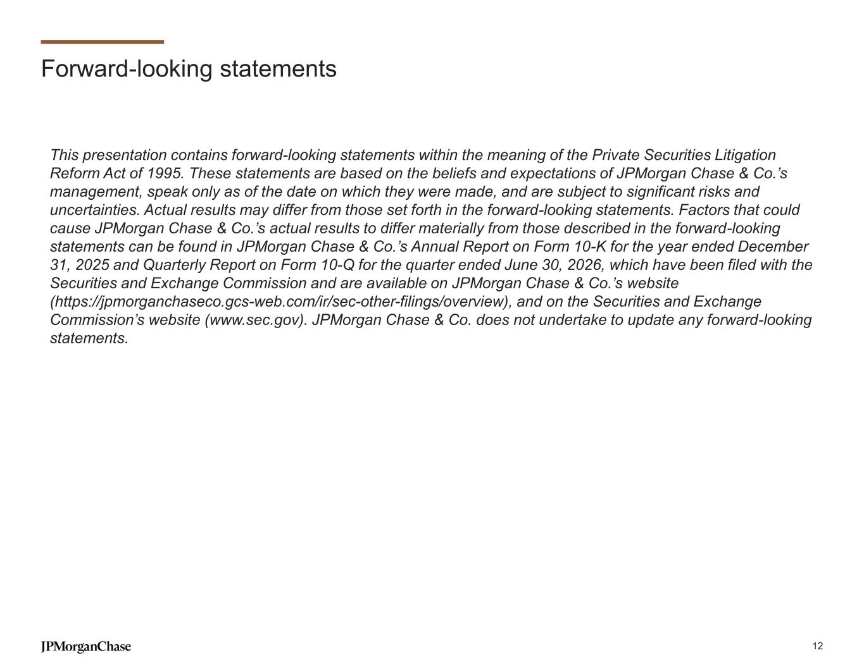
Forward-looking statements This presentation contains forward-looking statements within the meaning of the Private Securities Litigation Reform Act of 1995. These statements are based on the beliefs and expectations of JPMorgan Chase & Co.’s management, speak only as of the date on which they were made, and are subject to significant risks and uncertainties. Actual results may differ from those set forth in the forward-looking statements. Factors that could cause JPMorgan Chase & Co.’s actual results to differ materially from those described in the forward-looking statements can be found in JPMorgan Chase & Co.’s Annual Report on Form 10-K for the year ended December 31, 2025 and Quarterly Report on Form 10-Q for the quarter ended June 30, 2026, which have been filed with the Securities and Exchange Commission and are available on JPMorgan Chase & Co.’s website (https://jpmorganchaseco.gcs-web.com/ir/sec-other-filings/overview), and on the Securities and Exchange Commission’s website (www.sec.gov). JPMorgan Chase & Co. does not undertake to update any forward-looking statements. 12

