JPMorgan Chase Financial Company LLC
Free Writing Prospectus Filed Pursuant to Rule 433
Registration Statement Nos. 333-293684 and 333-293684-01
Dated September 2, 2026
15-Month SPX Enhanced Buffered Jump Securities
This document provides a summary of the terms of the securities. Investors must carefully review the accompanying preliminary pricing supplement referenced below, product supplement, underlying supplement, prospectus supplement and prospectus and the “Risk Considerations” on the following page, prior to making an investment decision.
SUMMARY TERMS
Issuer: | JPMorgan Chase Financial Company LLC (“JPMorgan Financial”)
Guarantor: | JPMorgan Chase & Co.
Underlying index: | S&P 500® Index (Bloomberg ticker: SPX Index)
Payment at maturity: | If the final index value is greater than or equal to the buffer threshold level, you will receive at maturity a cash payment per $1,000 stated principal amount security equal to:  $1,000 + upside payment  If the final index value is less than the buffer threshold level, you will receive at maturity a cash payment per $1,000 stated principal amount security equal to:  $1,000 + [$1,000 × (index return + buffer amount) × downside factor]  This amount will be less than the stated principal amount of $1,000 per $1,000 stated principal amount security and could be zero.
Upside payment: | At least $77.50 per $1,000 stated principal amount security (at least 7.75% of the stated principal amount)
Buffer threshold level: | 85% of the initial index value
Buffer amount: | 15%
Downside factor: | 1.17647
Index return: | (final index value – initial index value) / initial index value
Initial index value: | The closing level of the underlying index on the pricing date
Final index value: | The closing level of the underlying index on the valuation date
Stated principal amount: | $1,000 per security
Issue price: | $1,000 per security
Pricing date: | Expected to be September 16, 2026
Original issue date (settlement date): | 3 business days after the pricing date
Valuation date†: | December 16, 2027
Maturity date†: | December 21, 2027
CUSIP / ISIN: | 46661MQM9 / US46661MQM90
Preliminary pricing supplement: | http://www.sec.gov/Archives/edgar/data/  19617/000121390026096635/ea0304448-01_424b2.htm
†Subject to postponement
The estimated value of the securities on the pricing date will be provided in the pricing supplement and will not be less than $950.00 per $1,000 stated principal amount security. For information about the estimated value of the securities, which likely will be lower than the price you paid for the securities, please see the hyperlink above.
Any payment on the securities is subject to the credit risk of JPMorgan Financial, as issuer of the securities, and the credit risk of JPMorgan Chase & Co., as guarantor of the securities.
Enhanced Buffered Jump Securities Payoff Diagram*

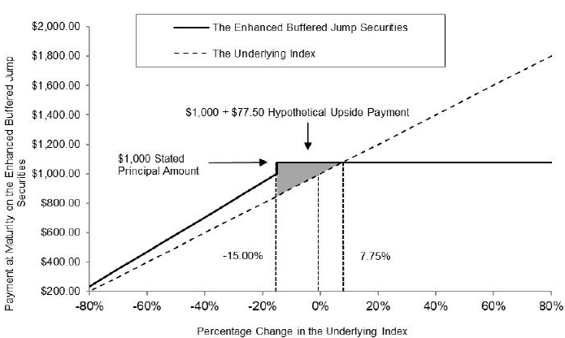

*The actual upside payment will be provided in the pricing supplement and will not be less than $77.50 per security.
Change in Underlying Index | Return on the Securities*
80.00% | 7.75000%
70.00% | 7.75000%
60.00% | 7.75000%
50.00% | 7.75000%
40.00% | 7.75000%
30.00% | 7.75000%
20.00% | 7.75000%
10.00% | 7.75000%
7.75% | 7.75000%
5.00% | 7.75000%
1.00% | 7.75000%
0.00% | 7.75000%
-10.00% | 7.75000%
-15.00% | 7.75000%
-20.00% | -5.88235%
-30.00% | -17.64705%
-40.00% | -29.41175%
-50.00% | -41.17645%
-60.00% | -52.94115%
-80.00% | -76.47055%
-100.00% | -100.00000%
*Assumes an upside payment of 7.75% of the stated principal amount

JPMorgan Chase Financial Company LLC
15-Month SPX Enhanced Buffered Jump Securities
Underlying Index
For more information about the underlying index, including historical performance information, see the accompanying preliminary pricing supplement.
Risk Considerations
The risks identified below are not exhaustive. Please see “Risk Factors” in the accompanying prospectus supplement, product supplement and preliminary pricing supplement for additional information.
Risks Relating to the Securities Generally
 | § | The securities do not pay interest or guarantee the return of any principal and your investment in the securities may result in a loss.
 | § | Appreciation potential is fixed and limited.
 | § | Your ability to receive the upside payment may terminate on the valuation date.
 | § | The securities are subject to the credit risks of JPMorgan Financial and JPMorgan Chase & Co., and any actual or anticipated changes to our or JPMorgan Chase & Co.’s credit ratings or credit spreads may adversely affect the market value of the securities.
 | § | As a finance subsidiary, JPMorgan Financial has no independent activities and has limited assets.
 | § | Secondary trading may be limited.
 | § | The final terms and estimated valuation of the securities will be provided in the pricing supplement.
 | § | The tax consequences of an investment in the securities are uncertain.
Risks Relating to Conflicts of Interest
 | § | Economic interests of the issuer, the guarantor, the calculation agent, the agent of the offering of the securities and other affiliates of the issuer may be different from those of investors.
 | § | Hedging and trading activities by the issuer and its affiliates could potentially affect the value of the securities.
Risks Relating to the Estimated Value and Secondary Market Prices of the Securities
 | § | The estimated value of the securities will be lower than the original issue price (price to public) of the securities.
 | § | The estimated value of the securities does not represent future values of the securities and may differ from others’ estimates.
 | § | The estimated value of the securities is derived by reference to an internal funding rate.
 | § | The value of the securities as published by J.P. Morgan Securities LLC (and which may be reflected on customer account statements) may be higher than the then-current estimated value of the securities for a limited time period.
 | § | Secondary market prices of the securities will likely be lower than the original issue price of the securities.
 | § | Secondary market prices of the securities will be impacted by many economic and market factors.
Risks Relating to the Underlying Index
 | § | JPMorgan Chase & Co. is currently one of the companies that make up the underlying index.
 | § | Investing in the securities is not equivalent to investing in the underlying index.
 | § | Adjustments to the underlying index could adversely affect the value of the securities.
Tax Considerations
You should review carefully the discussion in the accompanying preliminary pricing supplement under “Additional Information about the Securities — Tax considerations” concerning the U.S. federal income tax consequences of an investment in the securities, and you should consult your tax adviser.

SEC Legend: JPMorgan Chase Financial Company LLC and JPMorgan Chase & Co. have filed a registration statement (including a prospectus) with the SEC for any offerings to which these materials relate. Before you invest, you should read the prospectus in that registration statement and the other documents relating to this offering that JPMorgan Chase Financial Company LLC and JPMorgan Chase & Co. has filed with the SEC for more complete information about JPMorgan Chase Financial Company LLC and JPMorgan Chase & Co. and this offering. You may get these documents without cost by visiting EDGAR on the SEC web site at www.sec.gov. Alternatively, JPMorgan Chase Financial Company LLC and JPMorgan Chase & Co., any agent or any dealer participating in this offering will arrange to send you the prospectus and each prospectus supplement as well as any product supplement, underlying supplement and preliminary pricing supplement if you so request by calling toll-free 1-866-535-9248.

