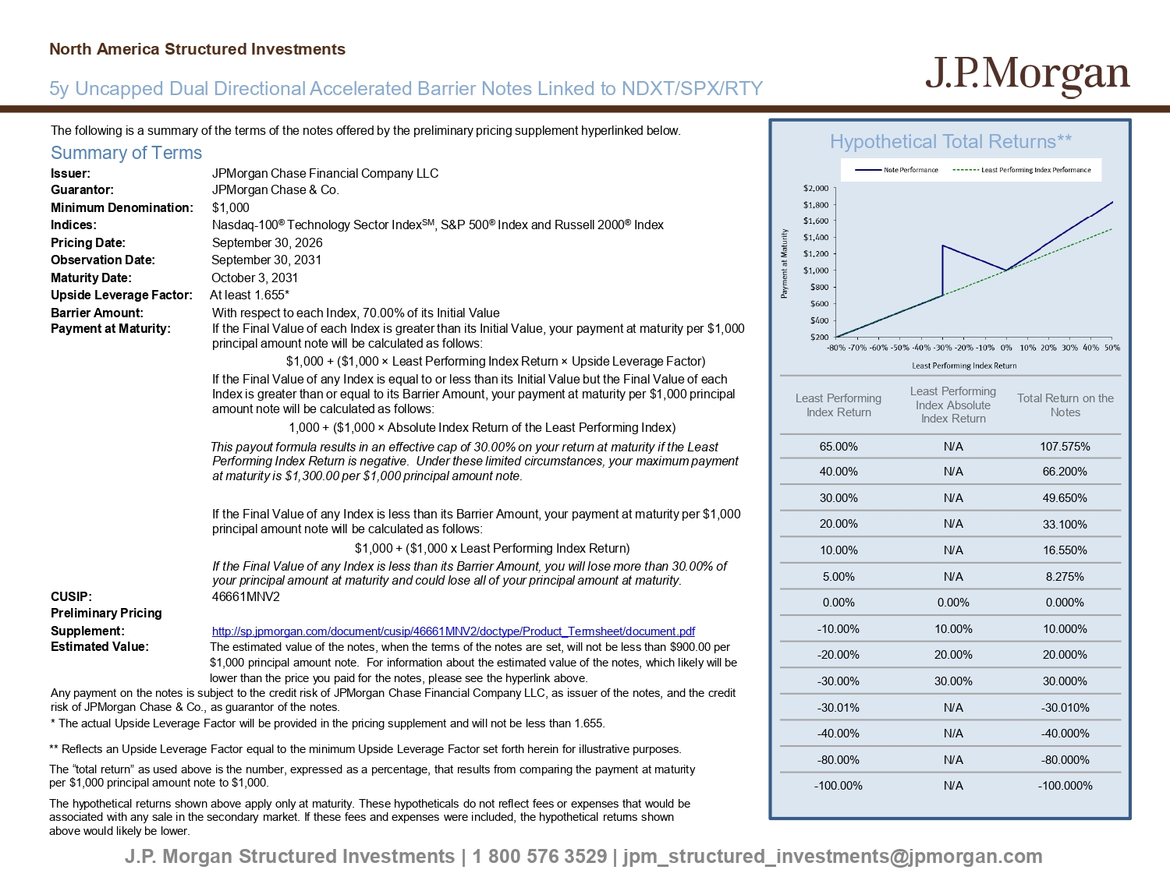
The following is a summary of the terms of the notes offered by the preliminary pricing supplement hyperlinked below. Summary of Terms Issuer: JPMorgan Chase Financial Company LLC Guarantor: JPMorgan Chase & Co. Minimum Denomination: $1,000 Indices: Nasdaq - 100 ® Technology Sector Index SM , S&P 500 ® Index and Russell 2000 ® Index Pricing Date: September 30, 2026 Observation Date: September 30, 2031 Maturity Date: October 3, 2031 Upside Leverage Factor: At least 1.655* Barrier Amount: With respect to each Index, 70.00% of its Initial Value Payment at Maturity: If the Final Value of each Index is greater than its Initial Value, your payment at maturity per $1,000 principal amount note will be calculated as follows: $1,000 + ($1,000 î Least Performing Index Return î Upside Leverage Factor) If the Final Value of any Index is equal to or less than its Initial Value but the Final Value of each Index is greater than or equal to its Barrier Amount, your payment at maturity per $1,000 principal amount note will be calculated as follows: 1,000 + ($1,000 î Absolute Index Return of the Least Performing Index) This payout formula results in an effective cap of 30.00% on your return at maturi ty if the Least Performing Index Return is negative. Under these limited circumstances, your maximum payment at maturity is $1,300.00 per $1,000 principal amount note. If the Final Value of any Index is less than its Barrier Amount, your payment at maturity per $1,000 principal amount note will be calculated as follows: $1,000 + ($1,000 x Least Performing Index Return) If the Final Value of any Index is less than its Barrier Amount, you will lose more than 30.00% of your principal amount at maturity and could lose all of your principal amount at maturity. CUSIP: 46661MNV2 Preliminary Pricing Supplement: http://sp.jpmorgan.com/document/cusip/46661MNV2/doctype/Product_Termsheet/document.pdf Estimated Value: The estimated value of the notes, when the terms of the notes are set, will not be less than $900.00 per $1,000 principal amount note. For information about the estimated value of the notes, which likely will be lower than the price you paid for the notes, please see the hyperlink above. Any payment on the notes is subject to the credit risk of JPMorgan Chase Financial Company LLC, as issuer of the notes, and t he credit risk of JPMorgan Chase & Co., as guarantor of the notes. * The actual Upside Leverage Factor will be provided in the pricing supplement and will not be less than 1.655. Hypothetical Total Returns** J.P. Morgan Structured Investments | 1 800 576 3529 | jpm_structured_investments@jpmorgan.com Total Return on the Notes Least Performing Index Absolute Index Return Least Performing Index Return 107.575% N/A 65.00% 66.200% N/A 40.00% 49.650% N/A 30.00% 33.100% N/A 20.00% 16.550% N/A 10.00% 8.275% N/A 5.00% 0.000% 0.00% 0.00% 10.000% 10.00% - 10.00% 20.000% 20.00% - 20.00% 30.000% 30.00% - 30.00% - 30.010% N/A - 30.01% - 40.000% N/A - 40.00% - 80.000% N/A - 80.00% - 100.000% N/A - 100.00% 5y Uncapped Dual Directional Accelerated Barrier Notes Linked to NDXT/SPX/RTY North America Structured Investments ** Reflects an Upside Leverage Factor equal to the minimum Upside Leverage Factor set forth herein for illustrative purposes. The “total return” as used above is the number, expressed as a percentage, that results from comparing the payment at maturit y per $1,000 principal amount note to $1,000. The hypothetical returns shown above apply only at maturity. These hypotheticals do not reflect fees or expenses that would b e associated with any sale in the secondary market. If these fees and expenses were included, the hypothetical returns shown above would likely be lower.
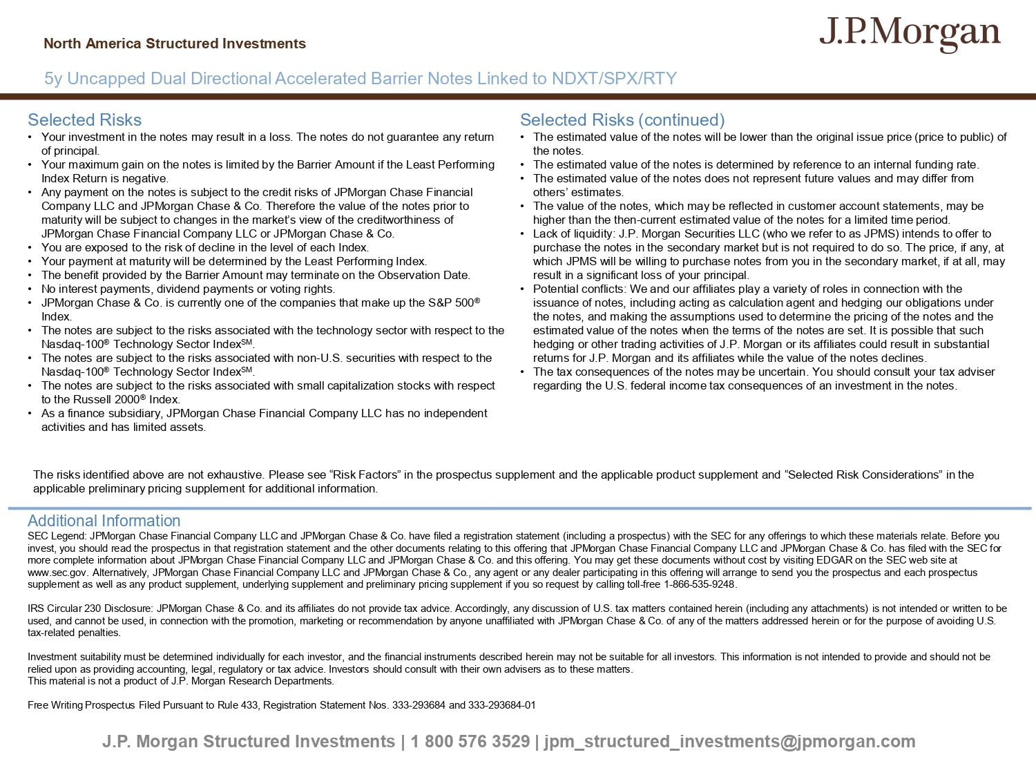
J.P. Morgan Structured Investments | 1 800 576 3529 | jpm_structured_investments@jpmorgan.com Selected Risks • Your investment in the notes may result in a loss. The notes do not guarantee any return of principal. • Your maximum gain on the notes is limited by the Barrier Amount if the Least Performing Index Return is negative. • Any payment on the notes is subject to the credit risks of JPMorgan Chase Financial Company LLC and JPMorgan Chase & Co. Therefore the value of the notes prior to maturity will be subject to changes in the market’s view of the creditworthiness of JPMorgan Chase Financial Company LLC or JPMorgan Chase & Co. • You are exposed to the risk of decline in the level of each Index. • Your payment at maturity will be determined by the Least Performing Index. • The benefit provided by the Barrier Amount may terminate on the Observation Date. • No interest payments, dividend payments or voting rights. • JPMorgan Chase & Co. is currently one of the companies that make up the S&P 500 ® Index. • The notes are subject to the risks associated with the technology sector with respect to the Nasdaq - 100 ® Technology Sector Index SM . • The notes are subject to the risks associated with non - U.S. securities with respect to the Nasdaq - 100 ® Technology Sector Index SM . • The notes are subject to the risks associated with small capitalization stocks with respect to the Russell 2000 ® Index . • As a finance subsidiary, JPMorgan Chase Financial Company LLC has no independent activities and has limited assets. Selected Risks (continued) • The estimated value of the notes will be lower than the original issue price (price to public) of the notes. • The estimated value of the notes is determined by reference to an internal funding rate. • The estimated value of the notes does not represent future values and may differ from others’ estimates. • The value of the notes, which may be reflected in customer account statements, may be higher than the then - current estimated value of the notes for a limited time period. • Lack of liquidity: J.P. Morgan Securities LLC (who we refer to as JPMS) intends to offer to purchase the notes in the secondary market but is not required to do so. The price, if any, at which JPMS will be willing to purchase notes from you in the secondary market, if at all, may result in a significant loss of your principal. • Potential conflicts: We and our affiliates play a variety of roles in connection with the issuance of notes, including acting as calculation agent and hedging our obligations under the notes, and making the assumptions used to determine the pricing of the notes and the estimated value of the notes when the terms of the notes are set. It is possible that such hedging or other trading activities of J.P. Morgan or its affiliates could result in substantial returns for J.P. Morgan and its affiliates while the value of the notes declines. • The tax consequences of the notes may be uncertain. You should consult your tax adviser regarding the U.S. federal income tax consequences of an investment in the notes. Additional Information SEC Legend: JPMorgan Chase Financial Company LLC and JPMorgan Chase & Co. have filed a registration statement (including a pr osp ectus) with the SEC for any offerings to which these materials relate. Before you invest, you should read the prospectus in that registration statement and the other documents relating to this offering that JPM organ Chase Financial Company LLC and JPMorgan Chase & Co. has filed with the SEC for more complete information about JPMorgan Chase Financial Company LLC and JPMorgan Chase & Co. and this offering. You may get the se documents without cost by visiting EDGAR on the SEC web site at www.sec.gov. Alternatively, JPMorgan Chase Financial Company LLC and JPMorgan Chase & Co., any agent or any dealer participat ing in this offering will arrange to send you the prospectus and each prospectus supplement as well as any product supplement, underlying supplement and preliminary pricing supplement if you so request by c all ing toll - free 1 - 866 - 535 - 9248. IRS Circular 230 Disclosure: JPMorgan Chase & Co. and its affiliates do not provide tax advice. Accordingly, any discussion o f U .S. tax matters contained herein (including any attachments) is not intended or written to be used, and cannot be used, in connection with the promotion, marketing or recommendation by anyone unaffiliated with JPMorgan Cha se & Co. of any of the matters addressed herein or for the purpose of avoiding U.S. tax - related penalties. Investment suitability must be determined individually for each investor, and the financial instruments described herein may not be suitable for all investors. This information is not intended to provide and should not be relied upon as providing accounting, legal, regulatory or tax advice. Investors should consult with their own advisers as to the se matters. This material is not a product of J.P. Morgan Research Departments. Free Writing Prospectus Filed Pursuant to Rule 433, Registration Statement Nos. 333 - 293684 and 333 - 293684 - 01 5y Uncapped Dual Directional Accelerated Barrier Notes Linked to NDXT/SPX/RTY North America Structured Investments The risks identified above are not exhaustive. Please see “Risk Factors” in the prospectus supplement and the applicable prod uct supplement and “Selected Risk Considerations” in the applicable preliminary pricing supplement for additional information.

