Table of Contents

UNITED STATES

SECURITIES AND EXCHANGE COMMISSION
Washington, D.C. 20549

SCHEDULE 14A

Proxy Statement Pursuant to Section 14(a) of the

Securities Exchange Act of 1934 (Amendment No. )

Filed by the Registrant ☒ Filed by a Party other than the Registrant ☐

Check the appropriate box:

- Preliminary Proxy Statement

- Confidential, for Use of the Commission Only (as permitted by Rule 14a-6(e)(2))

- Definitive Proxy Statement

- Definitive Additional Materials

- Soliciting Material Pursuant to §240.14a -12

JPMorgan Chase & Co.

(Name of Registrant as Specified In Its Charter)

(Name of Person(s) Filing Proxy Statement, if other than the Registrant)

Payment of Filing Fee (Check the appropriate box):

- No fee required.

- Fee computed on table below per Exchange Act Rules 14a-6(i)(1) and 0-11.

  - Title of each class of securities to which the transaction applies:

  - Aggregate number of securities to which the transaction applies:

  - Per unit price or other underlying value of the transaction computed pursuant to Exchange Act Rule 0-11 (set forth the amount on which the filing fee is calculated and state how it was determined):

  - Proposed maximum aggregate value of the transaction:

  - Total fee paid:

- Fee paid previously with preliminary materials.

- Check box if any part of the fee is offset as provided by Exchange Act Rule 0-11(a)(2) and identify the filing for which the offsetting fee was paid previously. Identify the previous filing by registration statement number, or the Form or Schedule and the date of its filing.

  - Amount Previously Paid:

  - Form, Schedule or Registration Statement No.:

  - Filing Party:

  - Date Filed:

Table of Contents


Table of Contents

JPMorgan Chase & Co.

383 Madison Avenue

New York, New York 10179-0001

April 6, 2020

Dear fellow shareholders:

We are pleased to invite you to attend the annual meeting of
shareholders to be held in a virtual meeting format only, via the
Internet, on May 19, 2020 at 10:00 a.m. Eastern Time. This forum
provides shareholders with the opportunity to ask questions about
topics of importance to the Firm’s business and affairs, to consider
matters described in the proxy statement and to receive an update
on the Firm’s activities and performance.

We hope that you will attend the meeting. We encourage you to
designate the persons named as proxies on the proxy card to vote
your shares even if you are planning to attend. This will ensure that

your common stock is represented at the meeting.

This proxy statement explains more about the matters to be voted on

at the annual meeting, about proxy voting, and other information
about how to participate. Please read it carefully. We look forward to

your participation.

Sincerely,


James Dimon

Chairman and Chief Executive Officer

Table of Contents

A Letter from Jamie Dimon, Our Chairman and CEO, and Lee R. Raymond, Our Lead Independent Director

Dear fellow shareholders:

As the public health response to COVID-19 continues, our thoughts remain with the communities and individuals most deeply hit by the pandemic. The Board is overseeing the Firm’s work to help those who are most affected, at our company and in our communities. And, while the markets are volatile, our fortress balance sheet is built for times like these, and we remain steadfast in helping customers and clients in a rapidly changing market. And, recognizing the impact of this crisis on the communities we serve, the Firm recently made a $50 million philanthropic commitment to help those most vulnerable, including small businesses and underserved communities.

As we respond to the immediate needs and the economic challenges posed by the global COVID-19 pandemic, the Board is also maintaining its focus on our long-term goals and key responsibilities. Looking back at 2019, we are pleased to report that it was a solid year for the Firm, where we achieved many records, including strong revenue and net income, and continued to invest in and grow our businesses and make large investments in products, people and technology. At the same time, the Firm maintained its strong, healthy culture, and continued to build long-term value for our shareholders. Throughout the year, your Board remained focused on these matters, a few of which we would like to highlight for you.

A Great Team and Culture

One of our highest priorities is having an excellent management team in place. Successful management succession planning and leadership development are key to ensuring a bright future for the Firm. The Board regularly reviews succession planning for the CEO and other members of the Operating Committee, and we meet formally and informally with many other high-potential members of senior management. In 2019, the Firm appointed Jennifer Piepszak Chief Financial Officer of the company and Marianne Lake CEO of Consumer Lending. In addition, over the past two years, Co-Presidents and Chief Operating Officers Daniel Pinto and Gordon Smith have been working hand-in-hand with Jamie and the Board. And, last month, the Board asked Daniel and Gordon to lead the company, as Jamie recuperated from heart surgery. These moves demonstrate the strength of our management team and our ongoing commitment to providing growth opportunities for our leaders.

April 6, 2020

Oversight of the Firm’s culture and reputation are also key Board responsibilities. We are steadfast in our belief that we must be cultural guardians in everything we do for each of our stakeholders

- our clients and customers, employees, shareholders and the communities we serve. We also know we excel when we foster inclusive and diverse environments. We always strive to create a culture of respect, where discrimination in any form is not tolerated.

Exceptional Client Service and Operational Excellence

The Board holds management accountable to prepare for the future by providing oversight of the strategy planning process. Guided by the Firm’s Business Principles, this year the Operating Committee deployed a Strategic Framework designed to reinforce the Firm’s drive to be complete, global, diversified and at scale, so we can best serve clients at home and across the globe. Within this framework, there is a strong focus on the technology that will be key to the Firm’s future success, including initiatives that will allow the Firm to reduce risk and fraud, upgrade customer service, make it easier to access products and services, improve underwriting and enhance resiliency.

With respect to resilience, the response to COVID-19 has tested the Firm’s resiliency plans. The Board is closely overseeing the Firm’s response, as we adjust to fluid circumstances. We are coordinating with clients, customers, vendors and industry parties, among others, and striving for seamless and consistent execution during times of increased uncertainty and volatility.

Your Board

As always, the Board is also focused on its own succession planning and the need to have a Board that represents experience in executive fields relevant to the Firm’s businesses and operations and a diversity of experience, perspectives and viewpoints.

We would like to take this opportunity to thank James Bell and Laban Jackson who will be retiring from our Board immediately prior to the annual meeting. We have benefited greatly from their insights on financial and accounting matters and their respective service as Chair of the Audit Committee. Labe also made important contributions as a director of J.P. Morgan Securities plc.

Table of Contents

We will miss their perspective, commitment and all that they have to offer as directors, and trusted advisors.

We also are pleased to nominate for election to the Board, Virginia Rometty, who will become Executive Chairman of IBM on April 6. We are confident she will bring to the Board an impressive combination of skills, experience and personal qualities that will serve our shareholders, the Firm and the Board well.

Lastly, Lee has advised that, while it has been an honor to serve as the Board’s Lead Independent Director and he is continuing to serve in that role, he has asked the Board to start a formal process to identify his successor.

We look forward to continuing to deliver value to our customers, shareholders and communities. On behalf of all our colleagues on the Board, we are grateful for your support of our Board and the Firm.

James Dimon

Chairman and Chief Executive Officer


Lee R. Raymond

Lead Independent Director

Table of Contents

Notice of 2020 Annual Meeting of Shareholders and Proxy Statement

DATE Tuesday, May 19, 2020

TIME 10:00 a.m. Eastern Time

ACCESS In light of the coronavirus, or COVID-19, outbreak, for the safety of all of our people, including our shareholders, and taking into account recent federal, state and local guidance that has been issued, we have determined that the 2020 Annual Meeting will be held in a virtual meeting format only, via the Internet, with no physical in-person meeting. If you plan to participate in the virtual meeting, please see “Information about the annual shareholder meeting.” Shareholders will be able to attend, vote, examine the stockholders list, and submit questions (both before, and for a portion of, the meeting) from any location via the Internet. Shareholders may participate online by logging in at www.virtualshareholdermeeting.com/JPM2020.

As always, we encourage you to submit your proxy prior to the annual meeting.

RECORD DATE March 20, 2020

MATTERS TO BE • Election of Directors

VOTED ON • Advisory resolution to approve executive compensation

• Ratification of PricewaterhouseCoopers LLP as our independent registered public accounting firm for 2020

• Shareholder proposals, if they are properly introduced at the meeting

• Any other matters that may properly be brought before the meeting

By order of the Board of Directors

Molly Carpenter

Secretary

April 6, 2020

YOUR VOTE IS IMPORTANT TO US. PLEASE VOTE PROMPTLY.

JPMorgan Chase & Co. uses the Securities and Exchange Commission (“SEC”) rule permitting companies to furnish proxy materials to their shareholders on the Internet. In accordance with this rule, on or about April 6, 2020, we sent to shareholders of record at the close of business on March 20, 2020, a Notice of Internet Availability of Proxy Materials (“Notice”), which includes instructions on how to access our 2020 Proxy Statement and 2019 Annual Report online, and how to vote online for the 2020 Annual Shareholder Meeting.

If you received a Notice and would like to receive a printed copy of our proxy materials, please follow the instructions for requesting such materials included in the Notice.

To be admitted to the annual meeting at www.virtualshareholdermeeting.com/JPM2020, you must enter the control number found on your proxy card, voting instruction form or Notice you previously received. See “Information about the annual shareholder meeting” on

page 107. At the virtual meeting site, you may follow the instructions to vote, access the stockholders list, and ask questions during the meeting.

If you hold your shares through a broker, your shares will not be voted unless (i) you provide voting instructions or (ii) the matter is one for which brokers have discretionary authority to vote. Of the matters to be voted on at the annual meeting, the only one for which brokers have discretionary authority to vote is Proposal 3, the ratification of the independent registered public accounting firm. See “What is the voting requirement to approve each of the proposals?” on page 110.

Table of Contents

Table of Contents

2020 Proxy summary

Corporate Governance

Proposal 1: Election of Directors

Key factors for shareholder consideration Director nominees
Board business

Board oversight

Board engagement

Director compensation

Other corporate governance policies and practices

Executive Compensation

Proposal 2: Advisory resolution to approve executive compensation

Executive summary

2019 Say on pay and shareholder engagement Compensation Discussion and Analysis

- How we think about pay decisions

- How we performed against our business strategy

- How performance determined pay in 2019

Compensation & Management Development

Committee report

Executive compensation tables

I. Summary compensation table

II. 2019 Grants of plan-based awards

- Outstanding equity awards at fiscal year-end 2019 IV. 2019 Option exercises and stock vested table
V. 2019 Pension benefits

VI. 2019 Non-qualified deferred compensation

VII. 2019 Potential payments upon termination or change in control

CEO pay ratio disclosure

Security ownership of directors and executive officers

1

11

12

22

28

30

32

34

38

39

40

41

54

65

72

73

73

75

76

78

78

79

80

83

84

RECOMMENDATIONS

Audit Matters

Proposal 3: Ratification of independent registered public
 |  | accounting firm
Executive summary |  |  |  |  |  |  |  |  |  |  | 87
Audit Committee approval policies and procedures |  |  |  |  |  |  |  |  |  |  | 89
Audit Committee report |  |  |  |  |  |  |  |  |  |  | 90
 | Shareholder Proposals
4. |  |  |  |  | Independent board chairman |  |  |  |  |  | 93
5. |  |  |  |  | Oil and gas company and project financing related to the
 |  |  |  | Arctic and the Canadian oil sands |  |  |  |  |  |  | 95
6. |  |  |  |  | Climate change risk reporting |  |  |  |  |  | 97
7. |  |  |  |  | Amend shareholder written consent provisions |  |  |  |  |  | 100
8. |  |  |  |  | Charitable contributions disclosure |  |  |  |  |  | 102
9. |  |  |  |  | Gender/Racial pay equity |  |  |  |  |  | 104
Information about the annual shareholder meeting |  |  |  |  |  |  |  |  |  |  | 107
Shareholder proposals and nominations for the
 |  | 2021 annual meeting |  |  |  |  |  |  |  |  | 112
Notes on Non-GAAP financial measures |  |  |  |  |  |  |  |  |  |  | 114
Glossary of selected terms and acronyms |  |  |  |  |  |  |  |  |  |  | 116

This proxy statement contains forward-looking statements. These statements can be identified by the fact that they do not relate strictly to historical or current facts. Forward-looking statements often use words such as “anticipate,” “target,” “expect,” “estimate,” “intend,” “plan,” “goal,” “believe” or other words of similar meaning. Forward-looking statements provide JPMorgan Chase & Co.’s (“JPMorgan Chase” or the “Firm”) current expectations or forecasts of future events, circumstances, results or aspirations, and are subject to significant risks and uncertainties. These risks and uncertainties could cause the Firm’s actual results to differ materially from those set forth in such forward-looking statements. Certain of such risks and uncertainties are described in JPMorgan Chase’s Annual Report on Form 10-K for the year ended December 31, 2019. JPMorgan Chase does not undertake to update the forward-looking statements included in this proxy statement to reflect the impact of circumstances or events that may arise after the date the forward-looking statements were made.

No websites that are cited or referred to in this proxy statement shall be deemed to form part of, or to be incorporated by reference into, this proxy statement.

Table of Contents

PROXY SUMMARY

2020 Proxy summary

This summary highlights information in this proxy statement. This summary does not contain all the information you should consider, and you should read the entire proxy statement carefully before voting. Terms not defined in the text of this proxy statement can be found in the “Glossary of selected terms and acronyms” on page 116.

Your vote is important. For more information on voting and attending the annual meeting, see “Information about the annual shareholder meeting” on page 107. This proxy statement has been prepared by our management and approved by the Board of Directors, and is being sent or made available to our shareholders on or about April 6, 2020.

Annual meeting overview: Matters to be voted on

MANAGEMENT PROPOSALS

The Board of Directors recommends you vote FOR each director nominee and FOR the following proposals (for more information see page referenced):

1. | Election of Directors | 10
2. | Advisory resolution to approve executive compensation | 37
3. | Ratification of independent registered public accounting firm | 86

SHAREHOLDER PROPOSALS (if they are properly introduced at the meeting)

The Board of Directors recommends you vote AGAINST each of the following shareholder proposals (for more information see page referenced):

4. | Independent board chairman | 93
5. | Oil and gas company and project financing related to the Arctic and the Canadian oil sands | 95
6. | Climate change risk reporting | 97
7. | Amend shareholder written consent provisions | 100
8. | Charitable contributions disclosure | 102
9. | Gender/Racial pay equity | 104
 | 1

Table of Contents

PROXY SUMMARY

The Firm demonstrated strong financial performance in 2019

In 2019, the Firm reported record net income of $ 36.4 billion, or $10.72 per share, with return on common equity (“ROE”) of 15% and return on tangible common equity (“ROTCE”)1 of 19%, and returned capital to shareholders of $ 34.0 billion (including common dividends and net share repurchases). We gained market share in many of our businesses, demonstrated strong expense discipline, continued to achieve high customer satisfaction scores, and maintained a fortress balance sheet.

JPMORGAN CHASE & CO.


$36.4B |  | $10.72 |  | 15%
RECORD |  | RECORD EARNINGS |  | ROE
NET INCOME |  | PER SHARE (“EPS”)
p 12% |  | p 19%

19% $75.98
ROTCE¹ BOOK VALUE
PER SHARE

(“BVPS”)

$60.98 |  | $34.0B
TANGIBLE |  | NET CAPITAL
BOOK VALUE |  | DISTRIBUTIONS²
PER SHARE
(“TBVPS”)¹

CONSUMER &

COMMUNITY BANKING
$16.6B 31%
NET INCOME | ROE

- Record net income on revenue3 of $55.9B

- Average deposits of $693.6B (up 3%); average loans of $464.3B (down 3%)

- #1 in U.S. card sales volume and #1 in credit card outstandings

- Continued credit outperformance with Consumer Lending 30+ day delinquency rates well below industry benchmarks

CORPORATE &

INVESTMENT BANK
$11.9B 14%
NET INCOME | ROE

- Record net income on record revenue3 of $38.3B

- #1 in global Markets revenue; #1 in global Investment Banking (“IB”) fees for 11 consecutive years

- #2 custodian globally with $27T in assets under custody (“AUC”), up 16%

- #1 in USD Payments volume

COMMERCIAL

BANKING
$3.9B 17%
NET INCOME | ROE

- Revenue3 of $9.0B

- Record gross IB revenue of $2.7B (up 10%), including record years for both Middle Market Banking & Specialized Industries (“MMBSI”) and Corporate Client Banking & Specialized Industries (“CCBSI”)

- Record Middle Market expansion market revenue of $723M (up 12%)

- Strong credit performance with a net charge-off ratio of 0.08%

ASSET & WEALTH
MANAGEMENT
$2.8B 26%
NET INCOME | ROE
- Record revenue3 of $14.3B; pre-tax margin of 26%

- Assets under management (“AUM”) of $2.4T and client assets of $3.2T, up 19% and 18% respectively

- 88% of 10-year long-term mutual fund AUM performing above peer median

- Average deposits of $140B (up 2%); record average loans of $150B (up 8%)

 | EXCEPTIONAL CLIENT FRANCHISES |  | FORTRESS BALANCE SHEET & PRINCIPLES |  | LONG-TERM SHAREHOLDER VALUE

- ROTCE and TBVPS are each non-GAAP financial measures; refer to Note 1 on page 114 for a further discussion of these measures.

2 Refer to Note 2 on page 40.

3 The Firm reviews the results of the lines of business on a managed basis. Refer to Additional notes, Note 1, on page 115 for a definition of managed basis.

2

Table of Contents

PROXY SUMMARY

The Firm has demonstrated sustained, strong financial performance over time

We have generated strong financial results over time, more than doubling net income over the past 10 years while adding substantial capital. Over this period we increased average common equity by over 40% to $233 billion and average tangible common equity (“TCE”)1 by over 65% to $187 billion to support growth in the businesses and maintain a fortress balance sheet. With our net income growth outpacing capital growth, we have maintained strong ROE and ROTCE1 over time, including peer-leading results in 2019.
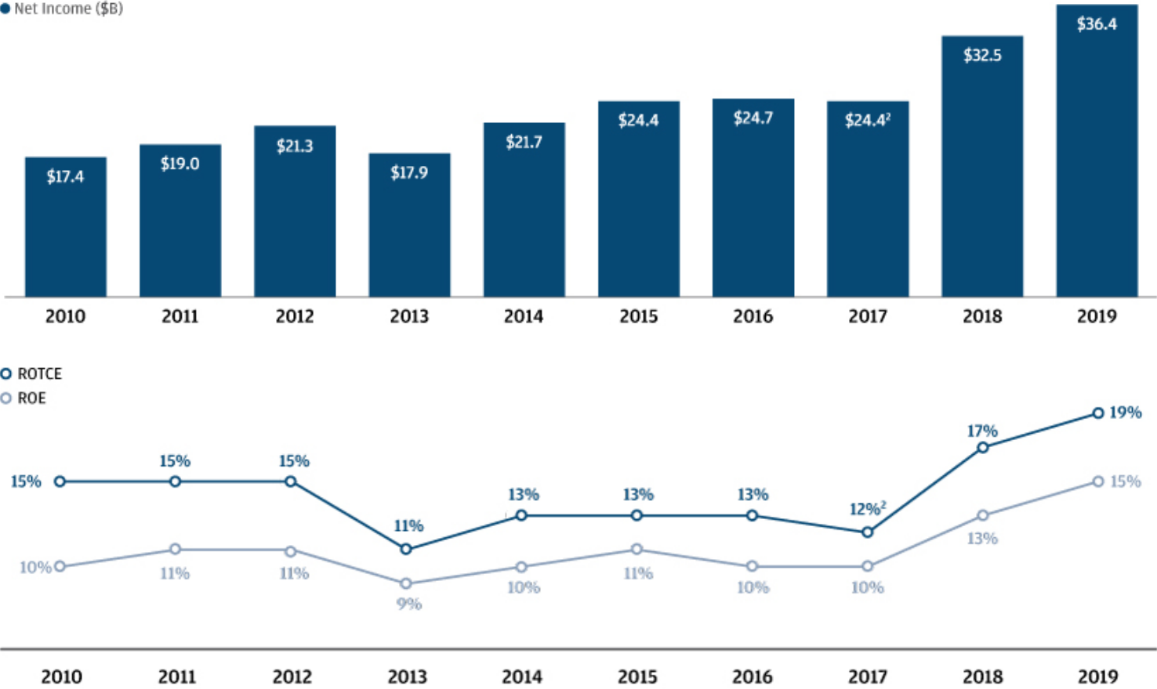

We have also delivered sustained growth in EPS, BVPS, and TBVPS1 over the past 10 years, reflecting compound annual growth rates of 12%, 7% and 8%, respectively over the period.
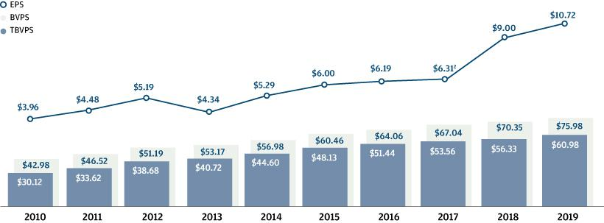

- Average TCE, ROTCE, and TBVPS are each non-GAAP financial measures; refer to Note 1 on page 114 for a further discussion of these measures.

- Excluding the impact of the enactment of the Tax Cuts and Jobs Act (“TCJA”) of $(2.4) billion and a legal benefit of $406 million (after-tax) in 2017, adjusted net income would have been $26.5 billion, adjusted ROTCE would have been 13% and adjusted EPS would have been $6.87. Adjusted net income, adjusted ROTCE and adjusted EPS are each non-GAAP financial measures; refer to Notes on non-GAAP financial measures, Note 2, on page 114 for a further discussion of these measures.

3

Table of Contents

PROXY SUMMARY

Total shareholder return (“TSR”)

TSR1 was 47% in 2019, following a TSR of (7)% in 2018 and 27% in 2017, for a combined three-year TSR of 74%. The graph below shows our TSR expressed as the cumulative return to shareholders over the past decade. As illustrated, a $100 investment in JPMorgan Chase common stock on December 31, 2009 would be valued at $426 as of December 31, 2019, which significantly outperformed the financial services industry over the period, as measured by the S&P Financials Index and the KBW Bank Index.
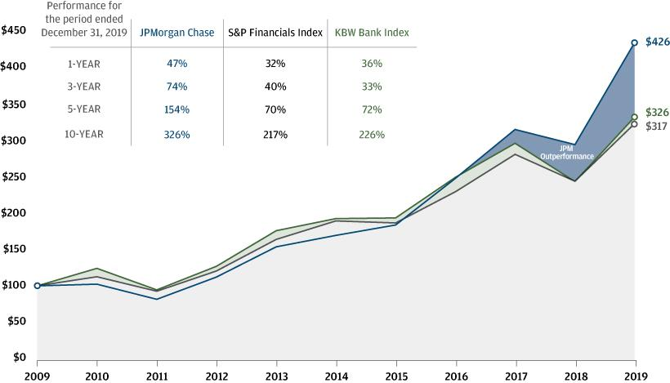

- TSR shows the actual return of the stock price, with dividends reinvested.

4

Table of Contents

PROXY SUMMARY

We are committed to commonsense corporate governance practices

Our Board reviews its composition for the right mix of experience, refreshment, skills and diversity

- We seek directors with experience and demonstrated success in executive fields relevant to the Firm’s businesses and operations who contribute to the Board’s effective oversight of management and its diversity across a full spectrum of attributes

- Three new directors have been nominated to the Board in the last four years, including Virginia M. Rometty, who is nominated for election at our annual meeting

A strong Lead Independent Director role facilitates independent Board oversight of management

- The Firm’s Corporate Governance Principles (“Governance Principles”) require the independent directors to appoint a Lead Independent Director if the role of the Chairman is combined with that of the CEO

- The Board reviews its leadership structure annually as part of its self-assessment process

- Responsibilities of the Lead Independent Director include:

presides at Board meetings in the Chairman’s absence or when otherwise appropriate

acts as liaison between independent directors and the Chairman/CEO

provides advice and guidance to the CEO on executing long-term strategy

advises the CEO of the Board’s information needs

meets one-on-one with the Chairman/CEO following executive sessions of independent directors

has the authority to call for a Board meeting or a meeting of independent directors

approves agendas and adds agenda items for Board meetings and meetings of independent directors

presides over executive sessions of independent directors

engages and consults with major shareholders and other constituencies, where appropriate

guides the annual performance review of the Chairman/CEO

guides the annual independent director consideration of Chairman/CEO compensation

guides the full Board in its consideration of CEO succession guides the self-assessment of the Board

Our Board provides independent oversight of the Firm’s business and affairs

- Sets the cultural “tone at the top”

- Reviews the Firm’s strategic objectives and plans

- Evaluates the CEO’s performance and oversees talent management for other senior executives

We actively engage with shareholders

- Oversees the Firm’s financial performance and condition

- Oversees the Firm’s risk management and internal control frameworks

- We have regular and ongoing discussions with shareholders throughout the year on a wide variety of topics, such as financial performance, strategy, competitive environment, regulatory landscape and environmental, social and governance (“ESG”) matters

- In 2019, our shareholder engagement initiatives included:

  - Shareholder Outreach: We received feedback on strategy, financial performance, governance, executive compensation, and environmental and social matters, among others, from shareholders representing approximately 45% of the Firm’s outstanding common stock across more than 60 engagements

  - Investor Day: Senior management presented on the Firm’s strategy and financial performance at our Investor Day

  - Meetings/Conferences: Senior management hosted more than 50 investor meetings and presented at 12 investor conferences

  - Annual Shareholder Meeting: Our CEO and Lead Independent Director presented to shareholders at the Firm’s 2019 annual meeting

Our governance practices promote Board effectiveness and shareholder interests

• Annual Board and committee assessment | • Majority voting for all director elections
• Robust shareholder rights: | • Stock ownership requirements for directors
- proxy access | • 100% committee independence
- right to call a special meeting | • Executive sessions of independent directors at each regular Board
- right to act by written consent | meeting

5

Table of Contents

PROXY SUMMARY

Proposal 1: Election of Directors – page 10

The Board of Directors has nominated the 10 individuals listed below. All are independent other than our CEO. If elected at our annual meeting, all nominees are expected to serve until next year’s annual meeting.

Nominee/Director of |  |  | Other Public
JPMorgan Chase since¹ | Age | Principal Occupation | Company Boards (#) | Committee Membership²
Linda B. Bammann | 64 | Retired Deputy Head of Risk | 0 | Risk (Chair)
Director since 2013 |  | Management of JPMorgan Chase &
 |  | Co.³
Stephen B. Burke | 61 | Chairman of NBCUniversal, | 1 | Corporate Governance & Nominating
 |  |  |  | (Chair);
Director since 2004 |  | LLC |  | (Chair);
Director since 2004 |  | LLC |  | Compensation & Management
 |  |  |  | Development
Todd A. Combs | 49 | Investment Officer at Berkshire | 0 | Compensation & Management
Director since 2016 |  | Hathaway Inc. |  | Development; Corporate Governance
 |  |  |  | & Nominating; Public Responsibility
James S. Crown | 66 | Chairman and Chief Executive | 1 | Risk
Director since 2004 |  | Officer of Henry Crown and
 |  | Company
James Dimon | 64 | Chairman and Chief Executive | 0
Director since 2004 |  | Officer of JPMorgan Chase & Co.
Timothy P. Flynn | 63 | Retired Chairman and Chief | 3 | Public Responsibility (Chair);
Director since 2012 |  | Executive Officer of KPMG |  | Audit
Mellody Hobson | 51 | Co-CEO and President of Ariel | 1 | Public Responsibility;
Director since 2018 |  | Investments, LLC |  | Risk
Michael A. Neal | 67 | Retired Vice Chairman of | 0 | Risk
Director since 2014 | 67 | General Electric Company and | 0 | Risk
 |  | Retired Chairman and Chief
 |  | Executive Officer of GE Capital
Lee R. Raymond | 81 | Retired Chairman and Chief | 0 | Compensation & Management
(Lead Independent Director) |  | Executive Officer of Exxon Mobil |  | Development (Chair); Corporate
Director since 2001 |  | Corporation |  | Governance & Nominating
Virginia M. Rometty | 62 | Chairman, President and Chief | 1
Nominated in 2020 |  | Executive Officer of International
 |  | Business Machines Corporation



- Director of a heritage company of the Firm as follows: Bank One Corporation: Mr. Burke (2003–2004), Mr. Crown (1996–2004), Mr. Dimon, Chairman of the Board (2000–2004); First Chicago
Corp.: Mr. Crown (1991–1996); and J.P. Morgan & Co. Incorporated: Mr. Raymond (1987–2000)
- Principal standing committee

- Retired from JPMorgan Chase & Co. in 2005

6

Table of Contents

PROXY SUMMARY

Proposal 2: Advisory resolution to approve executive compensation – page 37

We are submitting an advisory resolution to approve the compensation of our Named Executive Officers (“NEOs”).

2019 shareholder engagement and enhancements made to our executive compensation program

As a result of the 72% support our Say on Pay resolution received in 2019, we expanded the usual scope of our shareholder outreach to obtain specific feedback regarding executive compensation-related matters.

A comprehensive summary of this feedback was reviewed by the Compensation & Management Development Committee (“CMDC”) in making its 2019 Operating Committee (“OC”) member pay determinations. In addition, the CMDC made several enhancements to our 2019 performance share unit (“PSU”) awards and our executive compensation disclosures that are responsive to the key areas of the feedback we received, as summarized in the chart below.
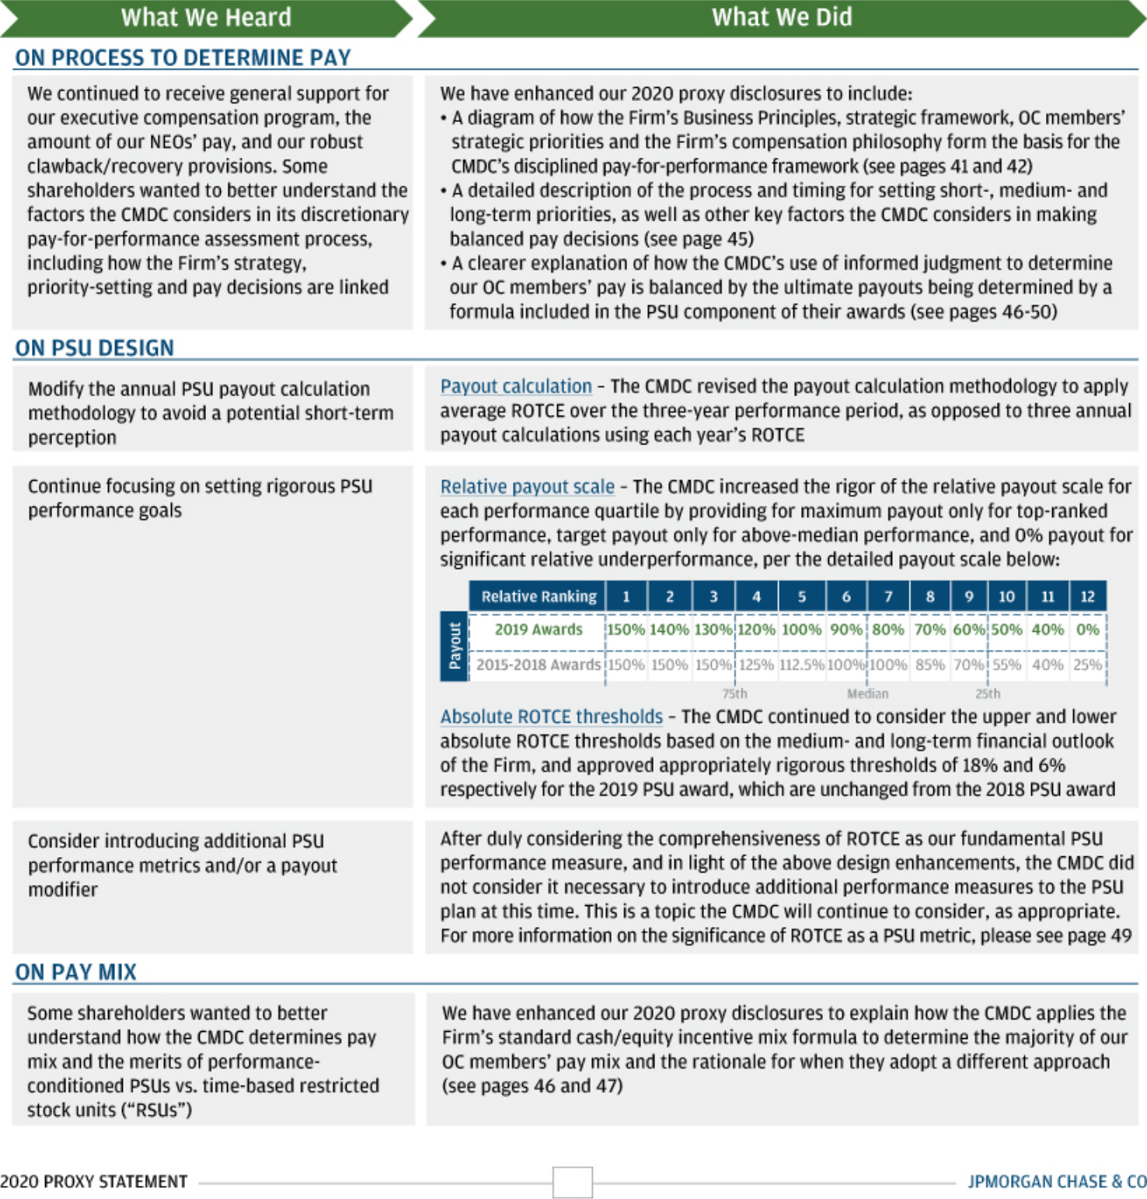

7

Table of Contents

PROXY SUMMARY

In addition to the enhancements discussed on the prior page, we believe shareholders should consider three key factors in their evaluation of this year’s proposal:

1. How we think about pay decisions

The Firm’s Business Principles and strategic framework form the basis of our OC members’ strategic priorities. The CMDC references those strategic priorities and the Firm’s compensation philosophy to assess OC members’ performance and to determine their respective total compensation levels and pay mix.

2. How we performed against our business strategy

We continued to deliver strong multi-year financial performance, invest in our future, strengthen our risk and control environment, and reinforce our culture and values, including our long-standing commitment to serve our customers, employees and communities, and conduct business in a responsible way to drive inclusive growth.

3. How performance determined pay in 2019

In determining OC member pay, the CMDC took into account performance across four broad performance dimensions: Business Results; Risk, Controls & Conduct; Client/Customer/Stakeholder; and Teamwork & Leadership. CEO pay is strongly aligned to the Firm’s short-, medium- and long-term performance, with approximately 83% of the CEO’s variable pay deferred into equity, of which 100% is in at-risk PSUs. Other NEO pay is also strongly aligned to Firm and LOB performance, with a majority of variable pay deferred into equity, of which 50% is in at-risk PSUs.

Disciplined performance assessment process to determine pay

The CMDC uses a balanced discretionary approach to determine annual compensation by assessing performance against the aforementioned four broad dimensions over a sustained period of time.

In its assessment of the Operating Committee’s 2019 performance as a whole, the CMDC took into account that the Firm achieved record financial performance across several measures and continued to execute well on its long-term business strategy, among other factors. Consideration of such strong performance in isolation could have justified significantly increasing the OC members’ 2019 total compensation awards. However, in making their ultimate OC member pay decisions, the CMDC and the Board further considered that rationale against other determinants that included a balanced assessment of the strong progress that was made against Firmwide initiatives, reinforcing our culture and values, addressing issues and enhancing controls, as well as the value of each individual OC member’s respective seat and the competitiveness of their respective pay levels.

The table below summarizes the salary and incentive compensation awarded to our NEOs for 2019 performance.

 |  |  | Incentive Compensation
 |  |  | Restricted |  | Performance
Name and principal position | Salary | Cash | stock units |  | share units | Total
James Dimon | $ 1,500,000 | $ 5,000,000 | $ | — | $ 25,000,000 | $ 31,500,000
Chairman and CEO
Daniel Pinto¹
Co-President and Co-Chief Operating Officer; | 8,239,222 | — |  | 7,130,389 | 7,130,389 | 22,500,000
CEO Corporate & Investment Bank | 8,239,222 | — |  | 7,130,389 | 7,130,389 | 22,500,000
Gordon Smith
Co-President and Co-Chief Operating Officer; | 750,000 | 8,700,000 |  | 6,525,000 | 6,525,000 | 22,500,000
CEO Consumer & Community Banking | 750,000 | 8,700,000 |  | 6,525,000 | 6,525,000 | 22,500,000
Mary Callahan Erdoes | 750,000 | 8,100,000 |  | 6,075,000 | 6,075,000 | 21,000,000
CEO Asset & Wealth Management | 750,000 | 8,100,000 |  | 6,075,000 | 6,075,000 | 21,000,000
Marianne Lake
CEO Consumer Lending; | 750,000 | 5,840,000 |  | 4,380,000 | 4,380,000 | 15,350,000
Former Chief Financial Officer | 750,000 | 5,840,000 |  | 4,380,000 | 4,380,000 | 15,350,000
Jennifer Piepszak
Chief Financial Officer | 666,667 | 3,733,333 |  | 2,800,000 | 2,800,000 | 10,000,000

- Mr. Pinto, who is based in the U.K., received a fixed allowance of $7,635,000 paid in British pound sterling and a salary of £475,000.

8

Table of Contents

PROXY SUMMARY

Proposal 3: Ratification of Firm’s independent registered public accounting firm – page 86

The Audit Committee has appointed PricewaterhouseCoopers LLP (“PwC”) as the Firm’s independent registered public accounting firm to audit the Consolidated Financial Statements of JPMorgan Chase and its subsidiaries for the year ending December 31, 2020. A resolution is being presented to our shareholders requesting ratification of PwC’s appointment.

9

Table of Contents

Corporate Governance

Proposal 1: Election of Directors

Our Board of Directors has nominated 10 directors, who, if elected by shareholders at our annual meeting, will be expected to serve until next year’s annual meeting.

RECOMMENDATION:

Vote FOR all nominees

10

Table of Contents

CORPORATE GOVERNANCE | ELECTION OF DIRECTORS

Key factors for shareholder consideration
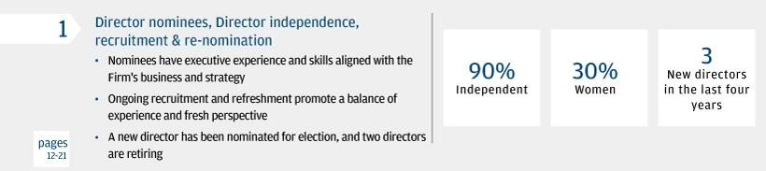
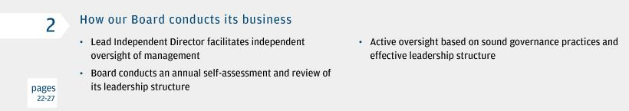
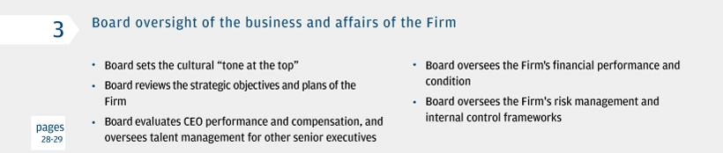
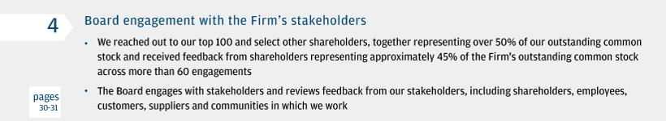

11

Table of Contents

ELECTION OF DIRECTORS | CORPORATE GOVERNANCE

1. Director nominees

Our Directors

JPMorgan Chase seeks director candidates who uphold the highest standards, are committed to the Firm’s values and are strong independent stewards of the long-term interests of shareholders, employees, customers, suppliers and communities in which we work. The Board, including the Corporate Governance & Nominating Committee (“Governance Committee”), considers Board composition holistically and on an ongoing basis, with a focus on recruiting directors who have the qualities required to effectively oversee the Firm, including its present and future strategy. The Board seeks directors with experience in executive fields relevant to the Firm’s businesses and operations who will come together to effectively challenge and provide independent oversight of management. The Board looks for candidates with a diversity of experience, perspectives and viewpoints, including diversity with respect to gender, race, ethnicity and nationality.

The individuals presented on the following pages have been nominated for election because they possess the skills, experience, personal attributes, and tenure needed to guide the Firm’s strategy, and to effectively oversee the Firm’s risk management and internal control framework, and management’s execution of its responsibilities.

In the biographical information about our director nominees that follows, the ages indicated are as of May 19, 2020, and the other information is as of the date

of this proxy statement. There are no family relationships among the director nominees or between the director nominees and any executive officer. Unless otherwise stated, all nominees have been continuously employed by their present employers for more than five years.

James A. Bell, who has served as a director of the Firm since 2011, and Laban P. Jackson, Jr., who has served as a director of the Firm since 2004, have decided to retire from the Board and are not standing for re-election when their terms expire on the eve of this year’s annual meeting.

Virginia M. Rometty is a new nominee who, if elected, will join the Board following the annual meeting on May 19, 2020. All of the other nominees are currently directors of the Firm, and each was elected to the Board by our shareholders at our 2019 annual meeting.

Each nominee has agreed to be named in this proxy statement and, if elected, to serve a one-year term expiring at our 2021 annual meeting.

Directors are expected to attend our annual shareholder meetings. Ten of the 11 directors serving on our Board at the time of the 2019 annual meeting attended the meeting. One director was unable to attend due to a prior professional obligation.

COMPOSITION OF BOARD NOMINEES
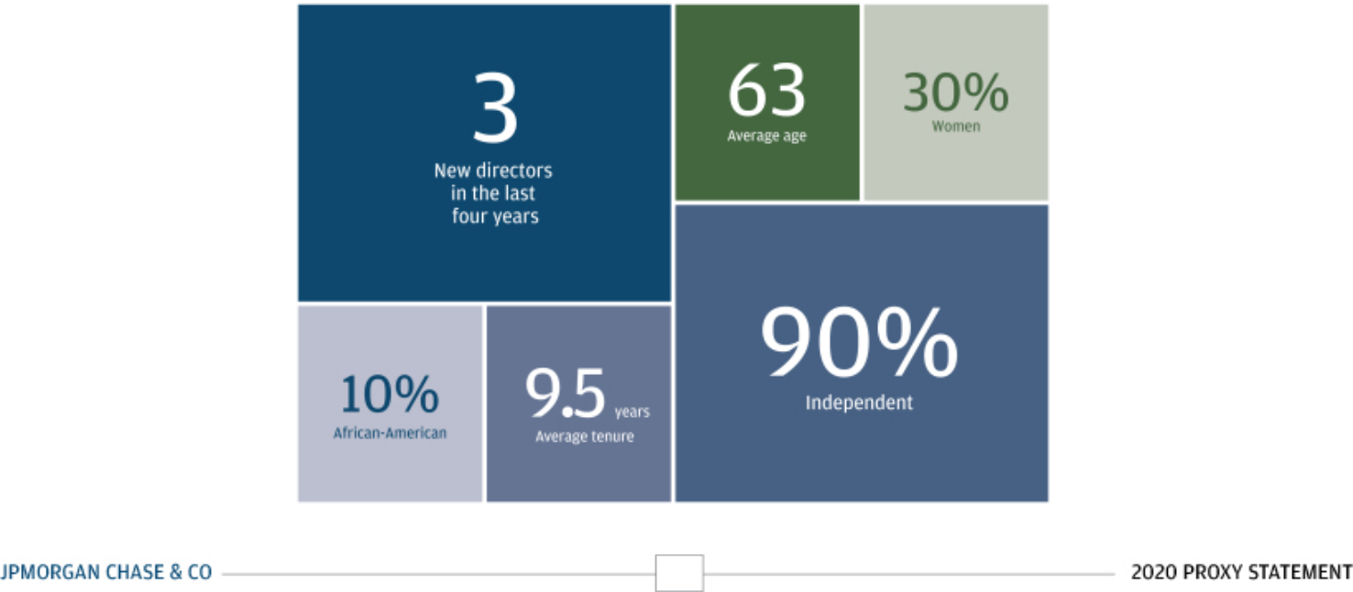

12

Table of Contents

CORPORATE GOVERNANCE | ELECTION OF DIRECTORS

ATTRIBUTES AND SKILLS OF THE NOMINEES

When selecting and recruiting candidates, the Board considers a wide range of attributes, executive experience and skills.


FINANCIAL AND ACCOUNTING


FINANCIAL SERVICES


INTERNATIONAL BUSINESS OPERATIONS


LEADERSHIP OF A LARGE, COMPLEX

- Knowledge of or experience in accounting, financial reporting or auditing processes and standards is important to effectively oversee the Firm’s financial position and condition and the accurate reporting thereof, and to assess the Firm’s strategic objectives from a financial perspective

- Experience in or with the financial services industry, including investment banking, global financial markets or consumer products and services, allows Board members to evaluate the Firm’s business model, strategies and the industry in which we compete

- Experience in diverse geographic, political and regulatory environments enables the Board to effectively oversee the Firm as it serves customers and clients across the globe

- Executive experience managing business operations and strategic planning allows Board members to effectively oversee the Firm’s complex worldwide operations

- Nominees

9 Nominees

7 Nominees

ORGANIZATION


MANAGEMENT

DEVELOPMENT,
SUCCESSION PLANNING,
AND

COMPENSATION

 | 9 Nominees
• Experience in senior executive development, succession planning, and compensation
matters helps the Board to effectively oversee the Firm’s efforts to recruit, retain and
develop key talent and provide valuable insight in determining compensation of the | 8 Nominees
CEO and other executive officers | 8 Nominees

PUBLIC COMPANY GOVERNANCE

TECHNOLOGY


REGULATED INDUSTRIES AND REGULATORY ISSUES


RISK MANAGEMENT AND CONTROLS

• | Knowledge of public company governance matters, policies and best practices assists
 | the Board in considering and adopting applicable corporate governance practices,
 | interacting with stakeholders and understanding the impact of various policies on the | 10 Nominees
 | Firm’s functions | 10 Nominees
• | Experience with or oversight of innovative technology, cybersecurity, information
 | systems/data management, fintech or privacy is important in overseeing the security
 | of the Firm’s operations, assets and systems as well as the Firm’s ongoing investment | 7 Nominees
 | in and development of innovative technology | 7 Nominees
• | Experience with regulated businesses, regulatory requirements and relationships with
 | global regulators is important because the Firm operates in a heavily regulated
 | industry | 10 Nominees
• | Skills and experience in assessment and management of business and financial risk
 | factors allow the Board to effectively oversee risk management and understand the
 | most significant risks facing the Firm | 10 Nominees

13

Table of Contents

ELECTION OF DIRECTORS | CORPORATE GOVERNANCE
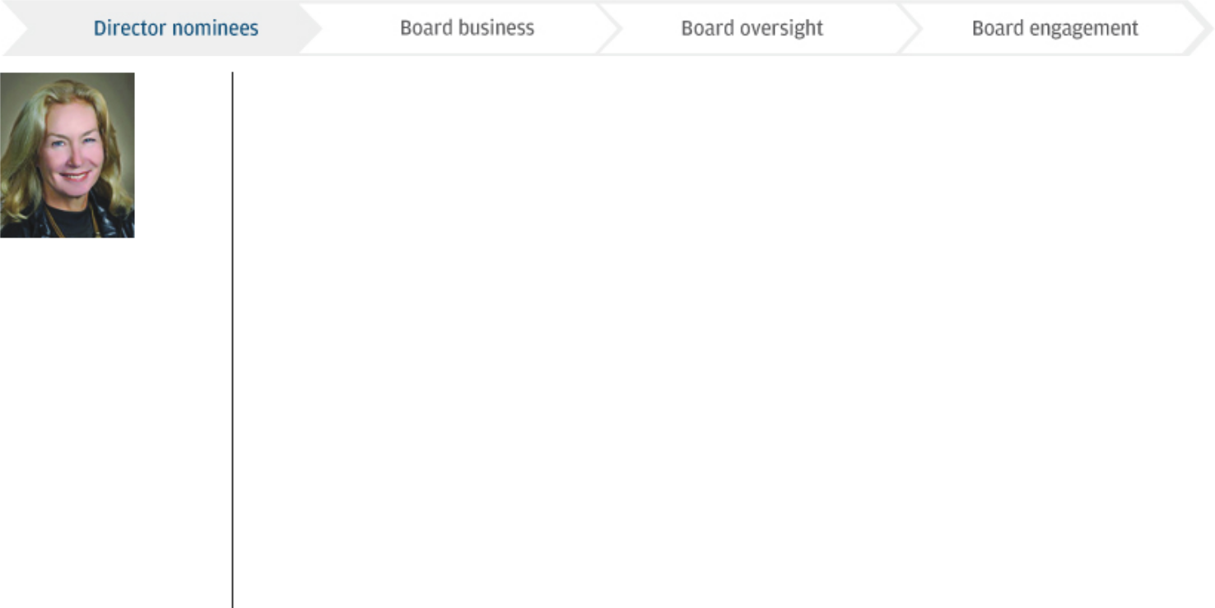

Age: 64

Director since: 2013

Committees:

Risk Committee (Chair)

Linda B. Bammann

Retired Deputy Head of Risk Management of JPMorgan Chase & Co.

Through her service on other boards, including as Chair of the Business and Risk Committee of the Federal Home Loan Mortgage Corporation, and her management tenure at JPMorgan Chase and Bank One Corporation, Ms. Bammann has developed insight and wide-ranging experience in financial services and extensive expertise in risk management and regulatory issues.

Director Qualification Highlights:

Financial services

Regulated industries and regulatory issues

Risk management and controls


Career Highlights

JPMorgan Chase & Co., a financial services company (merged with Bank One Corporation in July 2004)

- Deputy Head of Risk Management (2004–2005)

- Chief Risk Management Officer and Executive Vice President, Bank One Corporation (2001–2004)

- Senior Managing Director, Banc One Capital Markets (2000–2001)

Other Public Company Directorships

- Federal Home Loan Mortgage Corporation (2008–2013)

- Manulife Financial Corporation (2009–2012)

Other Experience

- Former Board Member, Risk Management Association

- Former Chair, Loan Syndications and Trading Association

Education

- Graduate of Stanford University

- M.A., Public Policy, University of Michigan

Age: 61

Director since: 2004 and Director of Bank One Corporation from 2003 to 2004

Committees:

Stephen B. Burke

Chairman of NBCUniversal, LLC

Mr. Burke’s roles at Comcast Corporation and his prior work at other large global media corporations have given him broad exposure to the challenges associated with managing large and diverse businesses. In these roles, he has dealt with a variety of issues including audit and financial reporting, risk management, executive compensation, sales and marketing, technology, and operations. These experiences have also provided Mr. Burke a background in regulated industries and international business. Mr. Burke will retire from his positions at NBCUniversal and Comcast in August 2020.

Corporate Governance & Nominating Committee (Chair)

Compensation & Management Development Committee

Director Qualification Highlights:

Financial and accounting

Leadership of a large, complex organization

Management development and succession planning

Regulated industries and regulatory issues

Career Highlights

Comcast Corporation/NBCUniversal, LLC, leading providers of entertainment, information and communication products and services

- Chairman of NBCUniversal, LLC and NBCUniversal Media, LLC (since 2020)

- Senior executive officer of Comcast Corporation (since 2011)

- Chief Executive Officer and President of NBCUniversal, LLC and NBCUniversal Media, LLC (2011-2019)

- Chief Operating Officer, Comcast (2004–2011)

- President, Comcast Cable Communications Inc. (1998– 2010)

Other Public Company Directorships

- Berkshire Hathaway Inc. (since 2009)

Education

- Graduate of Colgate University

- M.B.A., Harvard Business School

14

Table of Contents

CORPORATE GOVERNANCE | ELECTION OF DIRECTORS
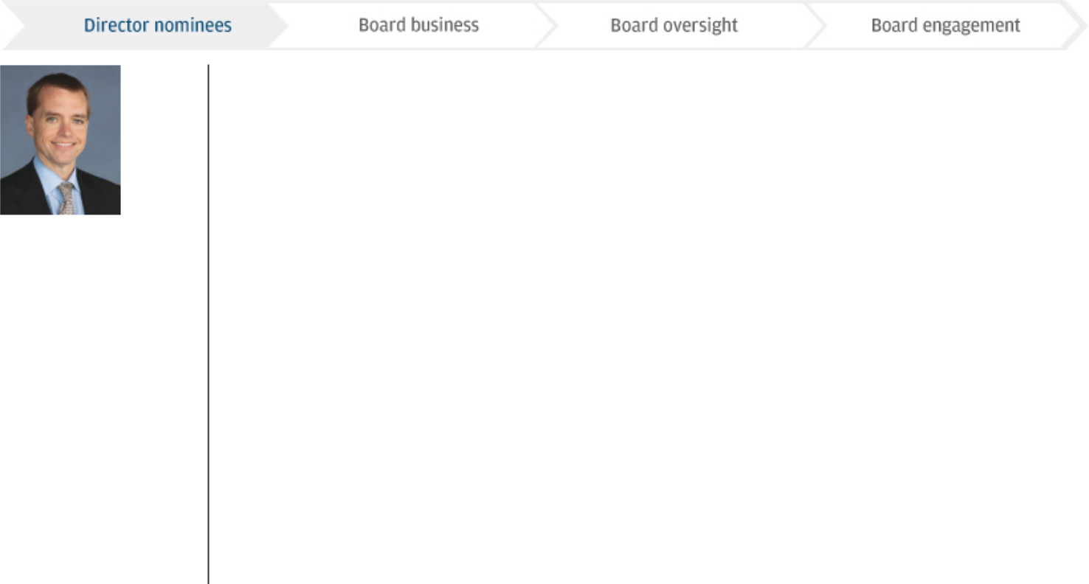

Age: 49

Director since: 2016

Todd A. Combs

Investment Officer at Berkshire Hathaway Inc.

Mr. Combs’ roles have provided him with extensive experience in financial markets, risk assessment and regulatory matters. His service on three of Berkshire Hathaway’s subsidiary boards has given him expertise and insight into matters such as corporate governance, strategy, succession planning and compensation.

Committees:

Compensation & Management Development Committee

Corporate Governance & Nominating Committee

Public Responsibility Committee

Director Qualification Highlights:

Financial services

Regulated industries and regulatory issues

Risk management and controls


Career Highlights

Berkshire Hathaway Inc., a holding company whose subsidiaries engage in a number of diverse business activities including finance, insurance and reinsurance, utilities and energy, freight rail transportation, manufacturing, retailing and other services

- President and CEO, GEICO (since 2020)

- Investment Officer (since 2010)

Castle Point Capital Management

- CEO and Managing Member (2005–2010)

Other Public Company Directorships

- None

Education

- Graduate of Florida State University

- M.B.A., Columbia Business School

Age: 66

Director since: 2004 and Director of Bank One Corporation from

James S. Crown

Chairman and Chief Executive Officer of Henry Crown and Company

Mr. Crown’s position with Henry Crown and Company and his service on other public company boards have given him extensive experience with risk management, audit and financial reporting, investment management, capital markets activity and executive compensation matters.

1991 to 2004

Committees:

Risk Committee

Director Qualification Highlights:

Financial services

Management development and succession planning

Risk management and controls

Career Highlights

Henry Crown and Company, a privately owned investment company that invests in public and private securities, real estate, and operating companies

- Chairman and Chief Executive Officer (since 2018)

- President (2002–2017)

- Vice President (1985–2002)

Other Public Company Directorships

- General Dynamics (since 1987) — Lead Director since 2010

- Sara Lee Corporation (1998-2012)

Other Experience

- Chairman of the Board of Trustees, Aspen Institute

- Trustee, Museum of Science and Industry

- Trustee, University of Chicago

- Member, American Academy of Arts and Sciences

- Former member, President’s Intelligence Advisory Board

Education

- Graduate of Hampshire College

- J.D., Stanford University Law School

15

Table of Contents

ELECTION OF DIRECTORS | CORPORATE GOVERNANCE
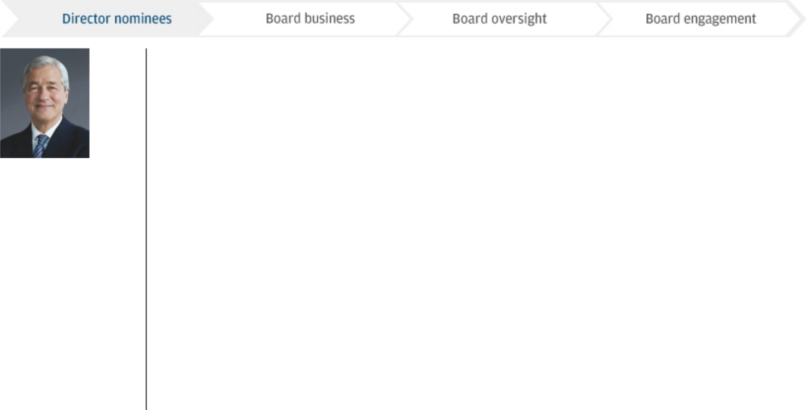

Age: 64

Director since: 2004 and Chairman of the Board of Bank One

James Dimon

Chairman and Chief Executive Officer of JPMorgan Chase & Co.

Mr. Dimon is an experienced leader in the financial services industry and has extensive international business expertise. As CEO, he is knowledgeable about all aspects of the Firm’s business activities. His work has given him substantial insight into the regulatory process.

Corporation from 2000 to 2004

Director Qualification Highlights:

Financial services

Leadership of a large, complex organization

Management development and succession planning

Regulated industries and regulatory issues

Career Highlights

JPMorgan Chase & Co., a financial services company (merged with Bank One Corporation in July 2004)

- Chairman of the Board (since 2006) and Director (since 2004); Chief Executive Officer (since 2005)

- President (2004–2018)

- Chief Operating Officer (2004–2005)

- Chairman and Chief Executive Officer at Bank One Corporation (2000–2004)

Other Public Company Directorships

- None

Other Experience

- Member of Board of Deans, Harvard Business School

- Director, Catalyst

- Member, Business Roundtable

- Member, Business Council

- Trustee, New York University School of Medicine

Education

- Graduate of Tufts University

- M.B.A., Harvard Business School

Age: 63


Director since: 2012

Timothy P. Flynn

Retired Chairman and Chief Executive Officer of KPMG

Through his leadership positions at KPMG, Mr. Flynn gained perspective on the evolving business and regulatory environment, expertise in many of the issues facing complex, global companies, and extensive experience in financial services, auditing matters and risk management.

Committees:

Public Responsibility Committee (Chair)

Audit Committee

Director Qualification Highlights:

Financial services

Financial and

accounting

Leadership of a large, complex organization

Risk management and controls

Career Highlights

KPMG International, a global professional services organization providing audit, tax and advisory services

- Chairman, KPMG International (2007–2011)

- Chairman, KPMG LLP (2005–2010)

- Chief Executive Officer, KPMG LLP (2005–2008)

- Vice Chairman, Audit and Risk Advisory Services, KPMG LLP (2001–2005)

Other Public Company Directorships

- United Healthcare (since 2017)

- Alcoa Corporation (since 2016)

- Wal-Mart Stores, Inc. (since 2012)

- Chubb Corporation (2013–2016)

Other Experience

- Member of Board of Trustees, The University of St. Thomas

- Former Trustee, Financial Accounting Standards Board

- Former Member, World Economic Forum’s International Business Council

- Former Board Member, International Integrated Reporting Council

Education

- Graduate of The University of St. Thomas

16

Table of Contents

CORPORATE GOVERNANCE | ELECTION OF DIRECTORS
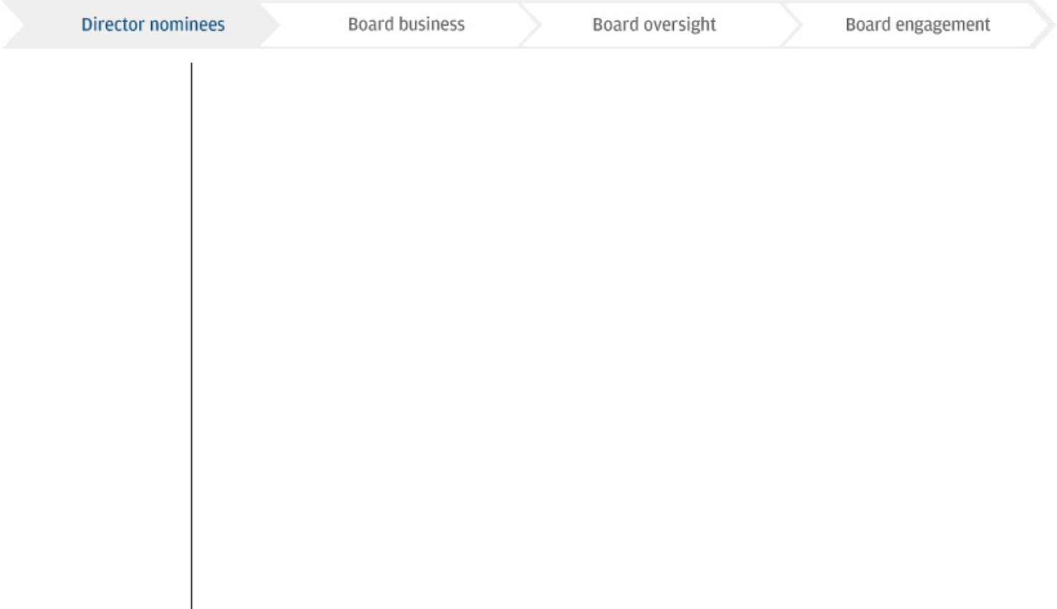

Age: 51



Director since: 2018

Mellody Hobson

Co-CEO and President of Ariel Investments, LLC

Ms. Hobson’s roles at Ariel Investments, LLC, as well as on public company boards, have provided her with significant experience in financial services and financial markets, corporate governance, strategic planning, operations, regulatory issues and international business.

Committees:

Public Responsibility Committee

Risk Committee

Director Qualification Highlights:

Financial services

Management development and succession planning

Regulated industries and regulatory issues


Career Highlights

Ariel Investments, LLC, an investment management firm

- Co-CEO (since 2019)

- President and Director (since 2000)

- Chairman of the Board of Trustees of Ariel Investment Trust, a registered investment company (since 2006)

Regular contributor and analyst on finance, the markets and economic trends for CBS News

Michael A. Neal

Other Public Company Directorships

- Starbucks Corporation (since 2005) — Vice Chair since 2018

- DreamWorks Animation SKG, Inc. (2004–2016)

- The Estée Lauder Companies Inc. (2005–2018)

Other Experience

- Chair, After School Matters

- Ex Officio / Former Chair, The Economic Club of Chicago

- Executive Committee of the Board of Governors, Investment Company Institute

- Vice Chair, World Business Chicago

Education

- Graduate of the Woodrow Wilson School of International Relations and Public Policy at Princeton University

Age: 67

Director since: 2014

Committees:

Risk Committee

Director Qualification Highlights:

Retired Vice Chairman of General Electric Company and Retired Chairman and Chief Executive Officer of GE Capital

Mr. Neal has extensive experience managing large, complex businesses in regulated industries around the world. During his career with General Electric and GE Capital, Mr. Neal oversaw the provision of financial services and products to consumers and businesses of all sizes globally. His professional background has provided him with extensive expertise and insight in risk management, strategic planning and operations, finance and financial reporting, government and regulatory relations, and management development and succession planning.

Financial services

International business operations

Leadership of large, complex organization

Technology

Career Highlights

General Electric Company, a global industrial and financial services company

- Vice Chairman (2005–2013)

- Chairman and Chief Executive Officer, GE Capital (2007– 2013)

Other Public Company Directorships

- None

Other Experience

- Trustee, The GT Foundation of the Georgia Institute of Technology

Education

- Graduate of the Georgia Institute of Technology

17

Table of Contents

ELECTION OF DIRECTORS | CORPORATE GOVERNANCE
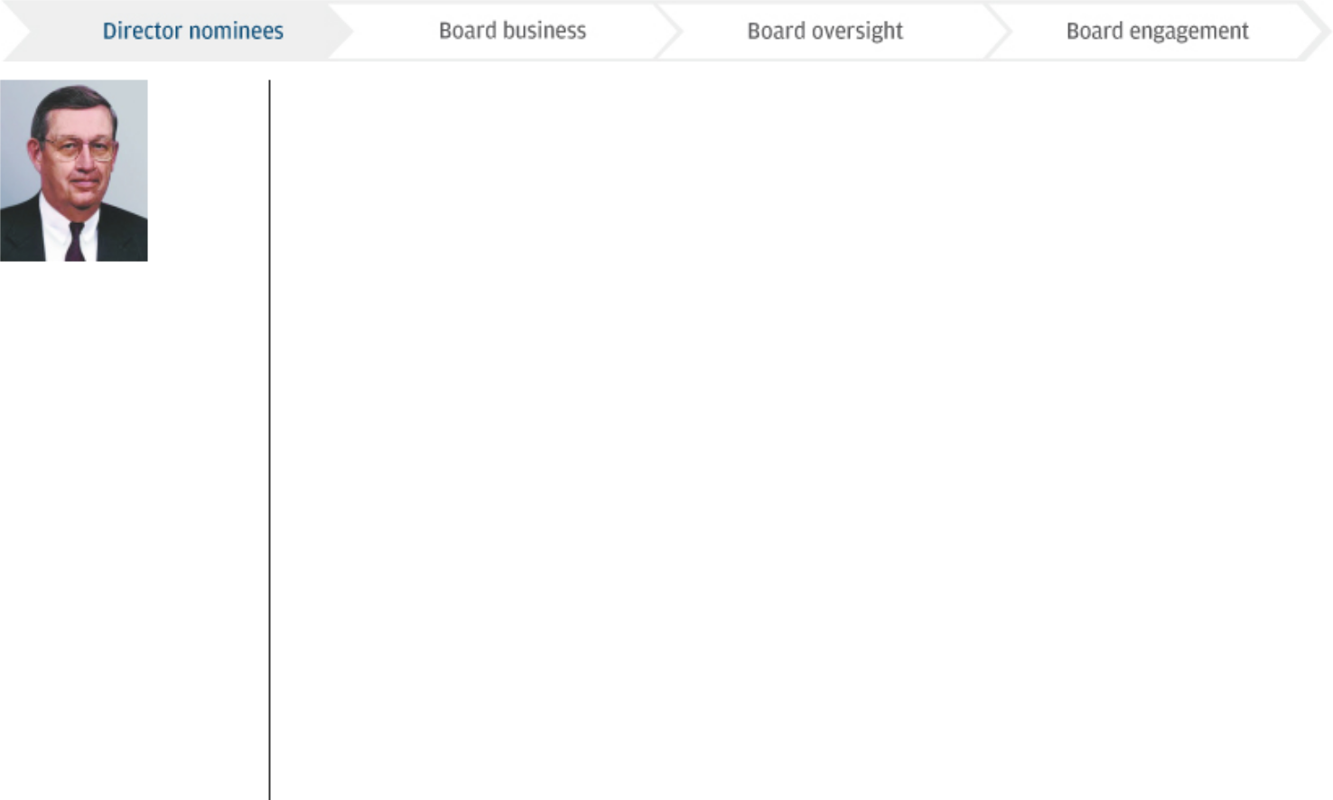

Age: 81

Director since: 2001 and Director of J.P. Morgan & Co. Incorporated from 1987 to 2000

Committees: Compensation & Management Development Committee (Chair)

Corporate Governance & Nominating Committee

Director Qualification Highlights: Leadership of a large, complex organization

Management development and succession planning

Public company

governance

Technology


Lee R. Raymond (Lead Independent Director)

Retired Chairman and Chief Executive Officer of Exxon Mobil Corporation

During his tenure at ExxonMobil and its predecessors, Mr. Raymond gained experience in all aspects of business management, including audit and financial reporting, risk management, executive compensation, marketing and operating in a regulated industry. He also has extensive international business expertise.

Career Highlights | Other Public Company Directorships
ExxonMobil, an international oil and gas company | Other Public Company Directorships
• Chairman and Chief Executive Officer of ExxonMobil | • None
(1999–2005) | Other Experience
• Chairman and Chief Executive Officer of Exxon | Other Experience
• Chairman and Chief Executive Officer of Exxon | • Member, Council on Foreign Relations
Corporation (1993–1999) | • Emeritus Trustee, Mayo Clinic
 | • Member, National Academy of Engineering
 | • Member and past Chairman, National Petroleum
 | Council
 | Education
 | • Graduate of the University of Wisconsin
 | • Ph.D., Chemical Engineering, University of Minnesota

Age: 62

Nominated in: 2020

Director Qualification Highlights: Leadership of a large, complex organization

Management development and succession planning

Public company

governance

Technology

Virginia M. Rometty

Chairman, President and Chief Executive Officer of International Business Machines Corporation (“IBM”)

During her tenure spanning four decades at IBM, Mrs. Rometty has gained extensive expertise in technology, and experience in all aspects of leading a complex global business, including succession planning, public company governance, as well as operational and regulatory issues. Mrs. Rometty will retire from the President and Chief Executive Officer roles at IBM on April 6, 2020 and will continue as Executive Chairman of the Board.

Career Highlights | Other Public Company Directorships
IBM, a global information technology company | • IBM (since 2012)
• Chairman, President and Chief Executive Officer of IBM | Other Experience
(since 2012) | Other Experience
(since 2012) | • Member, Business Roundtable
 | • Member, Council on Foreign Relations
 | • Member, Peterson Institute for International Economics
 | • Board of Trustees, Northwestern University
 | • Board of Overseers and Managers, Memorial Sloan-
 | Kettering Cancer Center
 | • Former Member, President’s Export Council
 | Education
 | • Graduate of Northwestern University

18

Table of Contents

CORPORATE GOVERNANCE | ELECTION OF DIRECTORS

Director independence

All of the Firm’s non-management Board members and the new director nominee are independent, under both the NYSE corporate governance listing standards and the Firm’s independence standards as set forth in its Governance Principles.

To be considered independent, a director must have no disqualifying relationships as defined by the NYSE, and the Board must have affirmatively determined that he or she has no material relationships with JPMorgan Chase, either directly or as a partner, shareholder or officer of another organization that has a relationship with the Firm.

In assessing the materiality of relationships with the Firm, the Board considers relevant facts and circumstances. Given the nature and broad scope of the products and services provided by the Firm, there are from time to time ordinary course of business transactions between the Firm and a director, his or her immediate family members, or principal business affiliations. These may include, among other relationships: extensions of credit; provision of other financial and financial advisory products and services; business transactions for property or services; and charitable contributions made by the JPMorgan Chase Foundation or the Firm to a nonprofit organization of which a director is an officer. The Board reviews these relationships to assess their materiality and determine if any such relationship would impair the independence and judgment of the relevant director.

The relationships and transactions the Board considered in evaluating each director’s and director nominee’s independence were as follows:

- Consumer credit: a line of credit provided to director Jackson; and credit cards issued to directors Bammann, Bell, Crown, Flynn, Jackson, Neal, and Raymond, and their immediate family members

- Wholesale credit: extensions of credit and other financial and financial advisory products and services provided to: NBCUniversal, LLC and Comcast Corporation, for which

Mr. Burke is Chairman and a senior executive, respectively, and their subsidiaries; Berkshire Hathaway Inc., for which

Mr. Combs is an Investment Officer, and its subsidiaries; Henry Crown and Company, for which Mr. Crown is Chairman and Chief Executive Officer, and other Crown family-owned entities; Ariel Investments, LLC, for which Ms. Hobson is

Co-Chief Executive Officer and President, and its subsidiaries and funds; certain entities wholly-owned by Ms. Hobson’s spouse; portfolio companies that have among its principal shareholders funds managed by The Energy & Minerals Group, for which a son of Mr. Raymond is the Chief Executive Officer; and International Business Machines Corporation, for which Mrs. Rometty is the Chairman, President and Chief Executive Officer, and its subsidiaries

- Goods and services: commercial office space leased by the Firm from subsidiaries of companies in which Mr. Crown and members of his immediate family have indirect ownership interests; national, local and digital media placements with NBCUniversal and Comcast outlets; telecom data circuits purchased from Comcast; purchases from Berkshire Hathaway subsidiaries of private aviation services, professional services related to the Firm’s corporate-owned aircraft, merchandising fixtures, and fixtures for employee workstations; and purchases from IBM of hardware, software, hardware maintenance services and professional services

- Other relationship: Haven, the joint health care initiative formed by the Firm, Amazon and Berkshire Hathaway to address ways to improve health care and reduce costs for U.S. employees of the three companies

The Board, having reviewed the above-described relationships between the Firm and each director and nominee, determined, in accordance with the NYSE’s listing standards and the Firm’s independence standards, that each non-management director and nominee (Linda B. Bammann, James A. Bell, Stephen B. Burke, Todd A. Combs, James S. Crown, Timothy P. Flynn, Mellody Hobson, Laban P. Jackson, Jr., Michael A. Neal, Lee R. Raymond and Virginia M. Rometty) had only immaterial relationships with JPMorgan Chase and accordingly is independent. William C. Weldon, who retired in May 2019, had only immaterial relationships with JPMorgan Chase and accordingly was an independent director.

All directors who served on the Audit and Compensation & Management Development Committees of the Board were also determined to meet the additional independence and qualitative criteria of the NYSE listing standards applicable to directors serving on those committees. For more information about the committees of the Board, see pages 24-26.

19

Table of Contents

ELECTION OF DIRECTORS | CORPORATE GOVERNANCE

Director recruitment

The Governance Committee oversees the ongoing evaluation of candidates for Board membership and the candidate nomination process.
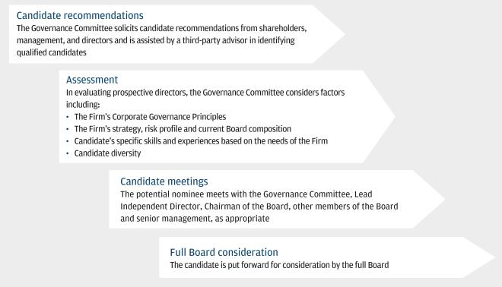

Our By-laws also permit a shareholder group of up to 20 shareholders who have continuously owned at least 3% of the Firm’s outstanding shares for at least three years to nominate up to 20% of the Board (but in any event at least two directors). For further information, see page 112. All candidates recommended to the Governance Committee are evaluated based on the same standards.

Since our last annual shareholders meeting, the Governance Committee, using the process described above and taking into account, among other factors, shareholders’ interest in board refreshment and specifically adding directors with experience in technology and leadership of large, complex organizations, nominated Virginia M. Rometty for election to the Board at this year’s annual meeting.

Mrs. Rometty has been among a select group of individuals considered as part of the Governance Committee’s evaluation of prospective Board members in recent years. After Mr. Dimon, Mr. Raymond and the members of the Governance Committee met with Mrs. Rometty, and after the Governance Committee reviewed her qualifications, including her experience in public company governance, leadership, technology, operational and regulatory issues, as well as her constructive personal attributes and her independence, Mrs. Rometty was nominated for election to the Board. For information on Mrs. Rometty’s qualifications, see page 18.

20

Table of Contents

CORPORATE GOVERNANCE | ELECTION OF DIRECTORS

Director re-nomination

The Governance Committee also oversees the re-nomination process. In considering whether to re-nominate a director for election at our annual meeting, the Governance Committee reviews each director, considering such factors as:
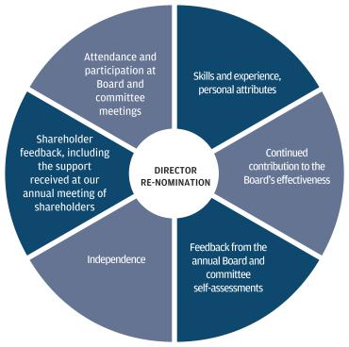

Retirement Policy

Our Governance Principles require a non-management director to offer not to stand for re-election in each calendar year following a year in which the director will be 72 or older. The Board (other than the affected director) then determines whether to accept the offer. The Board believes that the appropriate mix of experience and fresh perspectives is an important consideration in assessing Board composition, and the best interests of the Firm are served by taking advantage of all available talent, and evaluations as to director candidacy should not be determined solely on age.

Consistent with our Governance Principles, one of our director nominees, Lee R. Raymond, offered not to stand for re-election this year. The Board reviewed his offer, taking into account his contributions, the results of the annual Board and committee self-assessment, ongoing succession planning for the Board and the other factors listed above. The Board noted that Mr. Raymond continues to receive high levels of shareholder support, having received the support of more than 93.7% of the votes cast by shareholders at our 2019 annual meeting. The Board believes that Mr. Raymond’s skills and experience complement those of the Board’s Chair. The

Board determined that Mr. Raymond possesses the capability, judgment, and other skills and attributes the Board looks for in a director. The Board also considered his leadership as Lead Independent Director and Chair of the CMDC as well as his contributions as a member of the Governance Committee. In addition, the Board noted his broad experience both within and outside the Firm, particularly in the areas of management development and succession planning, and concluded that he continues to be of great value to the Board, and that his continued service as a director is in the best interests of the Firm’s shareholders.

Following its review, the Board determined (with Mr. Raymond abstaining) that Mr. Raymond should be re-nominated for election as a director and therefore did not accept his offer not to stand for re-election. For specific information on Mr. Raymond’s qualifications and his individual contributions to the Board, including his Board committee roles, see page 18. For information regarding

Mr. Raymond’s appointment as Lead Independent Director, see page 22. For a description of the annual Board and committee self-assessment process, see page 27.

21

Table of Contents

ELECTION OF DIRECTORS | CORPORATE GOVERNANCE

2. Board business

Sound governance practices

Our Board is guided by the Firm’s Governance Principles, and we adhere to the Commonsense Corporate Governance Principles and the
Investor Stewardship Group’s Corporate Governance Principles for U.S. Listed Companies. Our sound governance practices include:

Annual election of all directors by majority vote

100% committee independence

Lead Independent Director with clearly-defined responsibilities

Executive sessions of independent directors at each regular Board meeting

Annual Board and committee self-assessment guided by Lead Independent Director

No poison pill


Ongoing director education

Robust shareholder engagement process, including participation by our Lead Independent Director

Semi-annual Board review of investor feedback

Ongoing consideration of Board composition and refreshment, including diversity in director succession

Each director attended 75% or more of total meetings of the Board and committees on which he or she served during 2019

Stock ownership requirements for directors


Board oversight of corporate responsibility/environmental, social and governance (“ESG”) matters

Robust anti-hedging and anti-pledging policies Direct Board access to management


Our Board’s leadership structure

The Board’s leadership structure is designed to promote Board effectiveness and to appropriately allocate authority and responsibility between the Board and management.

The Board believes it is important to retain flexibility to determine its leadership structure based on the particular composition of the Board, the individuals serving in leadership positions, the needs and opportunities of the Firm as they change over time and the additional factors described below. The Board has separated the Chairman and CEO positions in the past and may do so again in the future if it believes that doing so would be in the best interest of the Firm and its shareholders.

Currently, our CEO serves as Chairman of the Board, and a non-management director serves as the Board’s Lead Independent Director. The Board believes the present structure provides the Firm and the Board with strong leadership, appropriate independent oversight of management and continuity of experience that complements ongoing Board refreshment. A combined CEO and Chairman allows the Firm to communicate its business and strategy to shareholders, clients, employees, regulators and the public in a single voice.

The Firm’s Governance Principles require the independent directors to appoint a Lead Independent Director if the

role of the Chairman is combined with that of the CEO. Our Lead Independent Director focuses on the Board’s priorities and processes, facilitates independent oversight of management and promotes open dialogue among the independent directors during Board meetings, at executive sessions without the presence of the CEO and between Board meetings.

Based on consideration of the factors described on the following page, our Board has determined that combining the roles of Chairman and CEO continues to be the most effective leadership structure for the Board.

Following review, the independent directors concluded that
Mr. Raymond continues to use his independent judgment, his in-depth knowledge of the Firm and its business, and his strong leadership skills to serve as an effective intermediary for the independent directors of the Board and counterbalance to the Chairman, and elected Mr. Raymond to continue to serve as Lead Independent Director.

While Mr. Raymond has agreed to serve in that role, at his request, the Governance Committee has started a formal process to identify his successor.

22

Table of Contents

CORPORATE GOVERNANCE | ELECTION OF DIRECTORS

Factors the Board considers in reviewing its leadership structure

The Board reviews its leadership structure not less than annually, and conducted its most recent review in March 2020, considering the following factors:

- The current composition of the Board

- The respective responsibilities for the positions of Chairman and Lead Independent Director (see table below for detailed information)

- The people currently in the roles of Chairman and Lead Independent Director and their record of strong leadership and performance in their roles, and other strong leadership of the Firm, including its Co-Presidents and Chief Operating Officers

- The policies and practices in place to provide independent Board oversight of management (including Board oversight of CEO performance and compensation, regular executive sessions of the independent directors, Board input into agendas and meeting materials, and Board self-assessment)

- The Firm’s circumstances, including its financial performance

- The views of our stakeholders, including shareholders, customers, employees, suppliers and the communities in which we work

- Trends in corporate governance, including practices at other public companies, and studies on the impact of leadership structures on shareholder value

- Such other factors as the Board determines

Respective duties and responsibilities of the Chairman and Lead Independent Director

CHAIRMAN OF |  | calls Board and shareholder meetings
THE BOARD:
 |  | presides at Board and shareholder meetings
 |  | approves Board meeting schedules, agendas and materials, subject to the approval of the Lead Independent Director

LEAD
INDEPENDENT

DIRECTOR:

presides at Board meetings in the Chairman’s absence or when otherwise appropriate

acts as liaison between independent directors and the Chairman/CEO

presides over executive sessions of independent directors

engages and consults with major shareholders and other constituencies, where appropriate

provides advice and guidance to the CEO on executing long-term strategy

guides the annual performance review of the Chairman/CEO

advises the CEO of the Board’s information needs

guides the annual independent director consideration of Chairman/CEO compensation

meets one-on-one with the Chairman/CEO following executive sessions of independent directors

guides the Board in its consideration of CEO succession

has the authority to call for a Board meeting or a meeting of independent directors

guides the self-assessment of the Board

approves agendas and adds agenda items for Board meetings and meetings of independent directors

23

Table of Contents

ELECTION OF DIRECTORS | CORPORATE GOVERNANCE

Board meetings

10 | 8 | 42 | 22
Board Meetings | Executive sessions of | Meetings of Principal | Meetings of Specific
Communication between | independent directors | Standing Committees | Purpose Committees
meetings as appropriate | Led by Lead Independent Director


The Board conducts its business as a group and through a well-developed committee structure in adherence to our Governance Principles. The Board has established practices and processes to actively manage its information flow, set meeting agendas and make sound, well-informed decisions.

Board members have direct access to management and regularly receive information from and engage with management during and outside of formal Board meetings.

In addition, the Board and each committee has the authority and resources to seek legal or other expert advice from sources independent of management.

The full Board met 10 times in 2019. In 2019, all of the members of our Board (other than Mr. Dimon) served on and/or chaired the principal standing committees and specific purpose committees of the Board. For more information on committees, see below. Each director attended 75% or more of the total meetings of the Board and the committees on which he or she served in 2019.

Committees of the Board

A significant portion of our Board’s oversight responsibilities is carried out through its five independent, principal standing committees: Audit Committee, CMDC, Governance Committee, Public Responsibility Committee and Risk Committee. Allocating responsibilities among committees increases the amount of attention that can be devoted to the Board’s oversight of the business and affairs of the Firm.

Committees meet regularly in conjunction with scheduled Board meetings and hold additional meetings as needed. Each committee reviews reports from senior management and reports its actions to, and discusses its recommendations with, the full Board.

Each principal standing committee operates pursuant to a written charter. These charters are available on our website at jpmorganchase.com/committee-charters. Each charter is reviewed at least annually as part of the Board’s and each respective committee’s self-assessment.

The Governance Committee annually reviews the allocation of responsibility among the committees as part of the Board and committee self-assessment. For more information about the self-assessment process, see page 27.

Each committee has oversight of specific areas of business activities and risk, and engages with the Firm’s senior management responsible for those areas.

All committee chairs are appointed annually by our Board.
Committee chairs are responsible for:

- Calling meetings of their committees

- Approving agendas for their committee meetings

- Presiding at meetings of their committees

- Serving as a liaison between committee members and the Board, and between committee members and senior management, including the CEO

- Working directly with the senior management responsible for committee mandates

The Board determined each member of the Audit Committee in 2019 (James A. Bell, Timothy P. Flynn, Mellody Hobson and Laban P. Jackson, Jr.) to be an audit committee financial expert in accordance with the definition established by the SEC, and that Ms. Bammann, the chair of the Risk Committee, has experience in identifying, assessing and managing risk exposures of large, complex financial firms in accordance with rules issued by the Board of Governors of the Federal Reserve System (“Federal Reserve”).

24

Table of Contents

CORPORATE GOVERNANCE | ELECTION OF DIRECTORS

Key oversight responsibilities

BOARD OF DIRECTORS


Audit

CMDC

Risk

Public Responsibility

Governance

15 meetings in 2019

Oversees:

- The independent registered public accounting firm’s qualifications and independence

- The performance of the internal audit function and the independent public accounting firm

- Management’s responsibilities to assure that there is an effective system of controls

- Internal control framework

- Integrity of financial statements

- Compliance with the Firm’s
ethical standards, policies, plans and procedures, and with laws and regulations

- Reputational risks and conduct risks within its scope of responsibility

6 meetings in 2019

Oversees:

- Development of and succession for key executives

- Compensation principles and practices

- Compensation and benefit programs

- Operating Committee performance assessments and compensation

- Firm’s Business Principles, culture and significant employee conduct issues and any related actions

- Reputational risks and conduct risks within its scope of responsibility

8 meetings in 2019

Oversees:

- Management’s responsibility to implement an effective global risk management framework reasonably designed to identify, assess and manage the Firm’s risks, including:

- Strategic risk

- Market risk

- Credit and investment risk

- Operational risk

- Applicable primary risk management policies

- Risk appetite results and breaches

- The Firm’s capital and liquidity planning and analysis

- Reputational risks and conduct risks within its scope of responsibility

6 meetings in 2019

Oversees:

- Community investing and fair lending practices

- Political contributions, major lobbying priorities and principal trade association memberships related to public policy

- Sustainability, including ESG policies and activities

- Consumer practices, including consumer experience, consumer complaint resolution and consumer issues related to disclosures, fees or the introduction of major new products

- Reputational risks and conduct risks within its scope of responsibility

7 meetings in 2019

Oversees:

- Proposed nominees for election to the Board

- Corporate governance practices applicable to the Firm

- The framework for

the Board’s self-

evaluation

- Shareholder matters

- Board composition and nominees

- Reputational risks and conduct risks within its scope of responsibility

For more information about committee responsibilities, see Committee Charters available at: jpmorganchase.com/committee-charters.

Other Standing Committees

The Board has two additional standing committees:

Stock Committee: The committee is responsible for implementing the declaration of dividends, authorizing the issuance of stock, administering the dividend reinvestment plan and implementing share repurchase plans. The committee acts within Board-approved limitations and capital plans.

Executive Committee: The committee may exercise all the powers of the Board that lawfully may be delegated, but with the expectation that it would not take material actions absent special circumstances.

The Board may establish additional standing committees as needed.

Specific Purpose Committees

The Board establishes Specific Purpose Committees as appropriate to address specific issues. The Board currently has two such committees, the Markets Compliance Committee and the Omnibus Committee.

The Markets Compliance Committee provides oversight in connection with certain orders (“Consent Orders”) issued by, and agreements with, the Firm’s regulators and oversight of certain government inquiries, as well as related conduct and controls. It oversees and provides guidance to management with respect to particular aspects of our control agenda and oversees and monitors progress under action plans developed by management with respect to these matters.

25

Table of Contents

ELECTION OF DIRECTORS | CORPORATE GOVERNANCE

The Omnibus Committee reviews matters delegated by the Board.

As the Firm achieves its objectives in a specific area, the work of the relevant Specific Purpose Committee will be concluded and, subject to regulatory consent where applicable, the committee will be disbanded. In 2019, the work of the following committees was completed, and the committees were disbanded:

Current Board committee membership

- BSA/AML (Bank Secrecy Act/Anti-Money Laundering) Compliance Committee

- Trading Compliance Committee

There were 22 meetings of the Specific Purpose Committees in 2019. Additional Specific Purpose Committees may be established from time to time in the future to address particular issues.

 |  | Compensation & | Corporate
 |  | Management | Governance & | Public |  | Specific
Director | Audit | Development | Nominating | Responsibility | Risk | Purpose¹
Linda B. Bammann |  |  |  |  | Chair | D
James A. Bell ² | Chair |  |  |  |  | A
Stephen B. Burke |  | Member | Chair
Todd A. Combs |  | Member | Member | Member
James S. Crown |  |  |  |  | Member
James Dimon
Timothy P. Flynn | Member |  |  | Chair |  | A
Mellody Hobson |  |  |  | Member | Member
Laban P. Jackson, Jr. ³ | Member |  |  |  |  | A,B,C,D
Michael A. Neal |  |  |  |  | Member | D
Lee R. Raymond ⁴ |  | Chair | Member |  |  | B,C,D

- The Board’s Specific Purpose Committees in 2019 were:
A – BSA/AML (Bank Secrecy Act/Anti-Money Laundering) Compliance Committee (disbanded in 2019)
B – Markets Compliance Committee
C – Trading Compliance Committee (disbanded in 2019)
D – Omnibus Committee
- Mr. Bell is not standing for re-election when his term expires on the eve of this year’s annual meeting. A new Chair of the Audit Committee will be elected by the Board following the annual meeting.

- Mr. Jackson is not standing for re-election when his term expires on the eve of this year’s annual meeting. A new member of the Audit Committee will be appointed by the Board following the annual meeting.

- Lead Independent Director

All of the directors of the Firm were elected in 2019 and comprise the full Boards of JPMorgan Chase Bank, National Association (the “Bank”) and an intermediate holding company, JPMorgan Chase Holdings LLC (the “IHC”). Mr. Burke is the non-management Chairman of the Board of the Bank; IHC does not have a Chairman of the Board.

26

Table of Contents

CORPORATE GOVERNANCE | ELECTION OF DIRECTORS

Board and Committee self-assessment

The Board conducts an annual self-assessment aimed at enhancing its effectiveness. Through regular assessment of its policies, procedures and performance, the Board identifies areas for further consideration and improvement. In assessing itself, the Board takes a multi-year perspective. The Board self-assessment is guided by the Lead Independent Director and is conducted in phases.
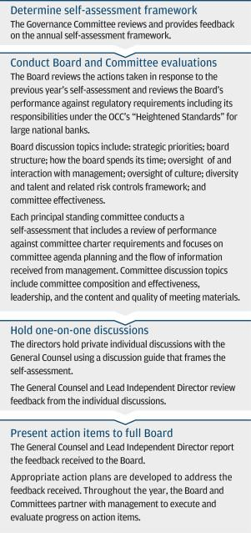

Director education

Our director education program assists Board members in fulfilling their responsibilities. The director education program commences with an orientation program when a new director joins the Board.

Ongoing education is provided through “deep dive” presentations from lines of business, discussions and presentations by subject matter experts and other opportunities, including events that take directors out of the boardroom and provide client, employee and other perspectives that can have a significant impact on the Firm. The program provides education on the Firm’s products, services and lines of business; cybersecurity and technology; significant and emerging risks; and relevant laws, regulations and supervisory requirements and other topics identified by the Board, including ESG-related issues.

27

Table of Contents

ELECTION OF DIRECTORS | CORPORATE GOVERNANCE

3. Board oversight

The Board is responsible for oversight of the business and affairs of the Firm. It is also responsible for setting the cultural “tone at the top.” Among its core responsibilities, the Board oversees:

Strategy

The Board of Directors oversees management’s formulation and implementation of the Firm’s strategic initiatives. Annual strategic plans include evaluation of performance against the prior year’s initiatives, assessment of the current operating environment, refinement of existing strategies and development of new strategic initiatives. Throughout the year, the CEO and CFO provide updates on the Firm’s overall strategic direction, and senior management provides updates on the strategic opportunities, priorities and implementation strategies in their respective LOBs and Corporate Functions. These management presentations and financial plans are the foundation of active dialogue with, and feedback from, the Board about the strategic risks and opportunities facing the Firm and its businesses.

Executive performance and talent management

The CMDC reviews the Firm’s performance periodically during the course of the year, and formally, at least annually. The CMDC’s review of the CEO’s performance is presented to the Board in connection with the Board’s review of executive officer annual compensation.

Succession planning for the CEO and other members of the Operating Committee is considered at least annually. The CMDC also discusses at least annually the talent pipeline for specific critical roles. The Board has numerous opportunities to meet with, and assess development plans for, members of the Operating Committee and other high potential senior management leaders. This occurs through various means, including informal meetings, presentations to the Board and its committees, and Board dinners. For further information, see Compensation discussion and analysis (“CD&A”) on page 37.

Financial performance and condition

Throughout the year, the Board reviews the Firm’s financial performance and condition, including overseeing management’s execution against the Firm’s capital, liquidity, strategic and financial operating plans.

Reports on the Firm’s financial performance and condition are presented at each regularly scheduled Board meeting. The Firm’s annual Comprehensive Capital Analysis and Review (“CCAR”) submission, which contains the Firm’s proposed plans to make capital distributions, such as dividend payouts, stock repurchases and other capital actions, is reviewed and approved prior to its submission to the Federal Reserve. In addition, the Audit Committee assists the Board in the oversight of the Firm’s financial statements and internal control framework. The Audit Committee also assists the Board in the appointment, retention, compensation, evaluation and oversight of the Firm’s independent registered public accounting firm. For further information, see “Risk management and internal control framework” below.

Risk management and internal control framework

Risk is an inherent part of JPMorgan Chase’s business activities. When the Firm extends a consumer or wholesale loan, advises customers and clients on their investment decisions, makes markets in securities or offers other products or services, the Firm takes on some degree of risk. The Firm’s overall objective is to manage its businesses, and the associated risks, in a manner that balances serving the interests of its clients, customers and investors and protects the safety and soundness of the Firm.

The key risk areas of the Firm are managed on a Firmwide basis. Certain risks, such as strategic risk, are overseen by the full Board. Board committees support the Board’s oversight responsibility by overseeing the risk categories related to such committee’s specific area of focus.

Committee chairs report significant matters discussed at committee meetings to the full Board. Issues escalated to the full Board may be dealt with in several ways, as appropriate: oversight of risk may remain with the particular principal standing committee of the Board, the Board may establish or direct a Specific Purpose Committee to oversee management’s addressing of such risk matters, or the Board may ask management to present more frequently to the full Board on the issue.

Oversight of conduct risk is shared by multiple Board committees. Conduct risk is the risk that any action or inaction by an employee or employees could lead to unfair client or customer outcomes, impact the integrity of the markets in which the Firm operates or compromise the Firm’s reputation. Each LOB and Corporate Function is accountable for identifying and managing its conduct risk

28

Table of Contents

CORPORATE GOVERNANCE | ELECTION OF DIRECTORS

to promote a culture consistent with the Firm’s How We Do Business Principles (the “Business Principles”). The full set of Business Principles is included in “How We Do Business — The Report,” which is posted on our website at jpmorganchase.com/governance.

For more information about the Firm’s risk management, see the “Firmwide risk management” section of the Firm’s Annual Report on Form 10-K for the year ended December 31, 2019 (“2019 Form 10-K”).

Environmental, social and governance matters

The Board oversees a range of matters pertaining to ESG topics, including: the Firm’s governance-related policies and practices; our systems of risk management and controls; our investment in our employees; the manner in

which we serve our customers and support our communities; and how we advance sustainability in our businesses and operations. In particular, the Board’s Public Responsibility Committee provides oversight of the Firm’s positions and practices on community investment, fair lending, consumer practices, sustainability— including matters such as the Firm’s approach to climate change— and other public policy issues that reflect the Firm’s values and impact its reputation among all of its stakeholders.

The Firm is committed to being transparent about how we do business and reporting on our efforts. One way we do this is by publishing an annual ESG Report, which provides information on how we are addressing the ESG matters that we and our stakeholders view as among the most important to our business. The Firm’s ESG report is available on our website at jpmorganchase.com/esg.

29

Table of Contents

ELECTION OF DIRECTORS | CORPORATE GOVERNANCE

4. Board engagement

The Board, as a group or as a subset of one or more directors, meets periodically throughout the year with the Firm’s shareholders, employees, regulators, community and business leaders, and other persons interested in our strategy, business practices, governance, culture and performance. For more information, see the CD&A on pages 37-71.

To contact our Board of Directors, any Board member, including the Lead Independent Director, any committee chair, or the independent directors as a group, mail correspondence to: JPMorgan Chase & Co., Attention (name of Board member(s)), Office of the Secretary, 4 New York Plaza, New York, NY 10004-2413, or email the Office of the Secretary at corporate.secretary@jpmchase.com.

Shareholders and other interested parties

We have an active and ongoing approach to engagement on a wide variety of topics (e.g., strategy, performance, competitive environment, governance) throughout the year. We interact with and receive feedback from our shareholders and other interested parties. Our shareholder engagement efforts are outlined below.
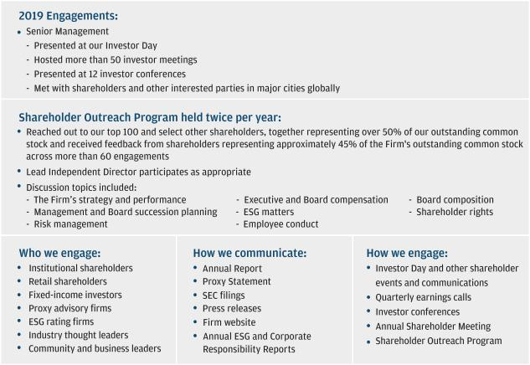

Employees

Our Board is committed to maintaining a strong corporate culture that instills and enhances a sense of personal accountability on the part of all of the Firm’s employees.

In addition to discussions at Board meetings with senior management about these efforts, our directors participate

in meetings with employees to emphasize this commitment. These meetings include employee town halls, lines of business and leadership team events, annual senior leaders’ meetings and informal sessions with members of the Operating Committee and other senior leaders.

30

Table of Contents

CORPORATE GOVERNANCE | ELECTION OF DIRECTORS

Regulators

Our Board and senior leaders commit significant time to meeting with regulators. Frequent interaction helps us learn first-hand from regulators about matters of importance to them and their expectations of us. It also gives the Board and management a forum for keeping our regulators well-informed about the Firm’s performance and business practices.

Stakeholders

We share a fundamental commitment to all of our stakeholders, including our shareholders, employees and regulators as well as our customers, suppliers and the communities in which we work. As we strive to deliver value to all of our stakeholders, we engage with them on a range of issues in a variety of ways. These may include Advisory panels, Town Halls, and senior executive meetings with policy groups and nonprofit organizations. Management shares insights and feedback from these relationships and engagements with the Board, providing the Board with valuable insights.

31

Table of Contents

DIRECTOR COMPENSATION | CORPORATE GOVERNANCE

Director compensation

The Governance Committee is responsible for reviewing director compensation and making recommendations to the Board. In making its recommendations, the Governance Committee annually reviews the Board’s responsibilities and the compensation practices of peer firms, which include the same group of peer firms referenced with respect to the compensation of our NEOs. For more information see “Evaluating market practices” on page 46.

The Board believes a best practice is to link director compensation to the Firm’s performance; therefore, a significant portion of director compensation is paid in common stock.

The Firm’s Amended and Restated Long-Term Incentive Plan (“LTIP”), which includes our non-management director compensation plan, was last approved by shareholders on May 15, 2018. The Board has made no changes to non-management director compensation since approval of the LTIP.

Annual compensation

For 2019, each non-management director received an annual cash retainer of $ 100,000 and an annual grant, made when annual employee incentive compensation was paid, of deferred stock units valued at $250,000 on the date of grant. Additional cash compensation was paid for certain committee and other service as described below.

Each deferred stock unit included in the annual grant to directors represents the right to receive one share of the Firm’s common stock and dividend equivalents payable in deferred stock units for any dividends paid. Deferred stock units have no voting rights. In January of the year immediately following a director’s termination of service, deferred stock units are distributed in shares of the Firm’s common stock in either a lump sum or in annual installments for up to 15 years as elected by the director.

The following table summarizes the 2019 annual compensation for non-management directors for service on the Boards of the Firm, the Bank, and J.P. Morgan Securities plc. There is no additional compensation paid for service on the Boards of Chase Bank USA, National Association, which was merged into the Bank in 2019, or IHC.

Compensation | Amount ($)
Board retainer | $ 100,000
Lead Independent Director retainer | 30,000
Audit and Risk Committee chair retainer | 25,000
Audit and Risk Committee member retainer | 15,000
All other committees chair retainer | 15,000
Deferred stock unit grant | 250,000
Bank Board retainer | 15,000
Bank Board’s chair retainer | 25,000
J.P. Morgan Securities plc Board retainer | 110,000

The Board may periodically ask directors to serve on one or more Specific Purpose Committees or other committees that are not one of the Board’s principal standing committees or to serve on the board of directors of a subsidiary of the Firm. Any compensation for such service is included in the “2019 Director compensation table” on the next page.

32

Table of Contents

CORPORATE GOVERNANCE | DIRECTOR COMPENSATION

2019 Director compensation table

The following table shows the compensation for each non-management director in 2019.

 | Fees earned or |  | Other
 | Fees earned or | 2019 Stock | fees earned or
Director | paid in cash ($)¹ | award ($)² | paid in cash ($)³ | Total ($)
Linda B. Bammann | $ 140,000 | $ 250,000 | $ 15,000 | $ 405,000
James A. Bell | 140,000 | 250,000 | 22,500 | 412,500
Stephen B. Burke | 109,190 | 250,000 | 45,316 | 404,506
Todd A. Combs | 105,810 | 250,000 | 15,000 | 370,810
James S. Crown | 115,000 | 250,000 | 15,000 | 380,000
Timothy P. Flynn | 130,000 | 250,000 | 22,500 | 402,500
Mellody Hobson | 115,000 | 250,000 | 35,000 | 400,000
Laban P. Jackson, Jr. | 115,000 | 250,000 | 170,000 | 535,000
Michael A. Neal | 115,000 | 250,000 | 15,000 | 380,000
Lee R. Raymond | 145,000 | 250,000 | 52,500 | 447,500
William C. Weldon⁴ | 44,547 | 250,000 | 28,356 | 322,903

- Includes fees earned, whether paid in cash or deferred, for service on the Board of Directors. For additional information on each director’s service on committees of JPMorgan Chase, see “Committees of the Board” on pages 24-26.

- On January 15, 2019, each director received an annual grant of deferred stock units equal to $250,000, based on a grant date fair market value of the Firm’s common stock of $100.54 per share. The aggregate number of stock and option awards outstanding at December 31, 2019, for each current director is included in the “Security ownership of directors and executive officers” table on page 84 under the columns “SARs/Options exercisable within 60 days” and “Additional underlying stock units,” respectively. All such awards are vested.

- Includes fees paid to the non-management directors for their service on the Board of Directors of the Bank or who are members of one or more Specific Purpose Committees. A fee of $2,500 is paid for each Specific Purpose Committee meeting attended (with the exception of the Omnibus Committee). Also includes for Mr. Jackson, $110,000 in compensation during 2019 in consideration of his service as a director of J.P. Morgan Securities plc, the Firm’s principal operating subsidiary outside the U.S. and a subsidiary of the Bank.

- Mr. Weldon retired from the Board in May 2019 on the eve of the 2019 annual meeting. Retainers for Board and committee service were pro-rated. Other fees paid to Mr. Weldon include an amount intended to cover taxes for a commemorative item for his service on the Board.

Stock ownership: no sales, no hedging, no pledging

As stated in the Governance Principles and further described in “Anti-hedging/anti-pledging provisions” on page 51, each director agrees to retain all shares of the Firm’s common stock he or she purchased on the open market or received pursuant to his or her service as a Board member for as long as he or she serves on our Board.

Shares held personally by a director may not be held in margin accounts or otherwise pledged as collateral, nor may the economic risk of such shares be hedged.

As detailed on page 84 under “Security ownership of directors and executive officers,” Mr. Crown has ownership of certain shares attributed to him that arise from the business of Henry Crown and Company, an investment company where Mr. Crown serves as Chairman and CEO, and trusts of which Mr. Crown serves as trustee (the “Attributed Shares”). Mr. Crown disclaims beneficial ownership of such Attributed Shares, except to the extent of his pecuniary interest. The Attributed Shares are distinct from shares Mr. Crown or his spouse own individually, or shares held in trusts for the benefit of his children (the “Crown Personally Held Shares”). The Firm has reviewed the potential pledging of the Attributed Shares with Mr. Crown, recognizes Mr. Crown’s distinct obligations with respect to Henry Crown and Company and the trusts, and believes such Attributed Shares may be

prudently pledged or held in margin loan accounts. Crown Personally Held Shares are not and may not be held in margin accounts or otherwise pledged as collateral, nor may the economic risk of such shares be hedged.

Deferred compensation

Each year, non-management directors may elect to defer all or part of their cash compensation. A director’s right to receive future payments under any deferred compensation arrangement is an unsecured claim against JPMorgan Chase’s general assets. Cash amounts may be deferred into various investment equivalents, including deferred stock units. Upon retirement from the Board, compensation deferred into stock units will be distributed in stock; all other deferred cash compensation will be distributed in cash. Deferred compensation will be distributed in either a lump sum or in annual installments for up to 15 years as elected by the director commencing in January of the year following the director’s retirement from the Board.

Reimbursements and insurance

The Firm reimburses directors for their expenses in connection with their Board service or pays such expenses directly. The Firm also pays the premiums on directors’ and officers’ liability insurance policies and on travel accident insurance policies covering directors as well as employees of the Firm.

33

Table of Contents

OTHER CORPORATE GOVERNANCE POLICIES AND PRACTICES | CORPORATE GOVERNANCE

Other corporate governance policies and practices

Shareholder rights

The Firm’s Certificate of Incorporation and By-laws provide shareholders with important rights, including:

- Proxy access, which enables eligible shareholders to include their nominees for election as directors in the Firm’s proxy statement. For further information, see page 112, “Shareholder proposals and nominations for the 2021 annual meeting.”

- The ability to call a special meeting by shareholders holding at least 20% of the outstanding shares of our common stock (net of hedges)

- The ability of shareholders holding at least 20% of the outstanding shares of our common stock (net of hedges) to seek a corporate action by written consent without a meeting on terms substantially similar to the terms applicable to call special meetings

- Majority election of directors

- No “poison pill” in effect

- No super-majority vote requirements in our Certificate of Incorporation or By-laws

The Firm’s Certificate of Incorporation and By-laws are available on our website at jpmorganchase.com/governance.

Policies and procedures for approval of related party transactions

The Firm has adopted a written Transactions with Related Persons Policy (“Policy”), which sets forth the Firm’s policies and procedures for reviewing and approving transactions with related persons – basically our directors, executive officers, their respective immediate family members and 5% shareholders. The transactions covered by the Policy include any financial transaction, arrangement or relationship in which the Firm is a participant, the related person has or will have a direct or indirect material interest and the aggregate amount involved will or may be expected to exceed $120,000 in any fiscal year.

After becoming aware of any transaction which may be subject to the Policy, the related person is required to report all relevant facts with respect to the transaction to the General Counsel of the Firm. Upon determination by the General Counsel that a transaction requires review under the Policy, the material facts of the transaction and the related person’s interest in the transaction are provided to the Governance Committee. The transaction is then reviewed by the disinterested members of the Governance Committee, who determine whether approval

or ratification of the transaction shall be granted. In reviewing a transaction, the Governance Committee considers facts and circumstances that it deems relevant to its determination, such as: management’s assessment of the commercial reasonableness of the transaction; the materiality of the related person’s direct or indirect interest in the transaction; whether the transaction may involve an actual, or the appearance of, a conflict of interest; and, if the transaction involves a director, the impact of the transaction on the director’s independence.

Certain types of transactions are pre-approved in accordance with the terms of the Policy. These include transactions in the ordinary course of business involving financial products and services provided by, or to, the Firm, including loans, provided such transactions are in compliance with the Sarbanes-Oxley Act of 2002, Federal Reserve Board Regulation O and other applicable laws and regulations.

Transactions with directors, executive officers and 5% shareholders

Our directors and executive officers, and some of their immediate family members and affiliated entities, and BlackRock and Vanguard, beneficial owners of more than 5% of our outstanding common stock, were customers of, or had transactions with or involving, JPMorgan Chase or our banking or other subsidiaries in the ordinary course of business during 2019. Additional transactions may be expected to take place in the future.

Any outstanding loans to the foregoing persons and entities and any other transactions involving the Firm’s financial products and services (such as banking, brokerage, investment, investment banking, and financial advisory products and services) provided to such persons and entities: (i) were made in the ordinary course of business, (ii) were made on substantially the same terms (including interest rates and collateral (where applicable)), as those prevailing at the time for comparable transactions with persons and entities not related to the Firm (or, where eligible with respect to executive officers, immediate family members and affiliated entities, on such terms as are available under our employee benefits or compensation programs), and (iii) did not involve more than the normal risk of collectibility or present other unfavorable features.

The fiduciary committees for the JPMorgan Chase Retirement Plan and for the JPMorgan Chase 401(k) Savings Plan (each, a “Plan”) entered into agreements with BlackRock giving it discretionary authority to manage certain assets on behalf of each Plan. Pursuant to these agreements, fees of approximately $3.6 million were paid

34

Table of Contents

CORPORATE GOVERNANCE | OTHER CORPORATE GOVERNANCE POLICIES AND PRACTICES

by the Plans to BlackRock in 2019. Subsidiaries of the Firm have subscribed to information services and received consulting services from BlackRock, including and related to select market data, analytics and modeling, and paid BlackRock approximately $730,000 in 2019 for the services. JPMorgan Chase paid BlackRock approximately $5.3 million in 2019 to access its Aladdin® platform.

Certain J.P. Morgan mutual funds and subsidiaries entered into a sub-transfer agency agreement with Vanguard and paid Vanguard approximately $410,000 in 2019 for services rendered, primarily accounting, recordkeeping and administrative services.

In January 2019, the Firm entered into agreements for the sale and redevelopment of a retail bank branch property in California to modernize the branch and monetize excess development rights. Following a solicitation and review of proposals from several major real estate developers, a company not affiliated with the Firm or its directors or executive officers was selected to lead the project. The development company is expected to make the purchase through an existing legal entity as a result of which Director James Crown and members of his immediate family are expected to hold indirect equity interests in the property which in the aggregate would exceed 10%. The purchase price will depend upon the development rights attained and is anticipated to exceed $32 million. The transaction has not been consummated and closing is subject to completion of the development entitlements process and satisfaction of other contractual conditions precedent. The transaction is not material to the overall investment holdings of Mr. Crown and members of his immediate family, and it was negotiated with the unaffiliated development company in the ordinary course of business.

Compensation & Management Development Committee interlocks and insider participation

The members of the CMDC are listed on page 26. No member of the CMDC is or ever was a JPMorgan Chase officer or employee. No JPMorgan Chase executive officer is, or was during 2019, a member of the board of directors or compensation committee (or other committee serving an equivalent function) of another company that has, or had during 2019, an executive officer serving as a member of our Board or the CMDC. All of the members of the CMDC, and/or some of their immediate family members and affiliated entities, were customers of, or had transactions with or involving, JPMorgan Chase or our banking or other subsidiaries in the ordinary course of business during 2019. Additional transactions may be

expected to take place in the future. Any outstanding loans to the directors serving on the CMDC and their immediate family members and affiliated entities, and any transactions involving other financial products and services provided by the Firm to such persons and entities, were made in accordance with the standards stated above for transactions with directors, executive officers and 5% shareholders.

Political activities and lobbying

JPMorgan Chase believes that responsible corporate citizenship demands a commitment to a healthy and informed democracy through civic and community involvement. Because of the potential impact public policy can have on our businesses, employees, communities and customers, we engage with policymakers in order to advance and protect the long-term interests of the Firm.

The Public Responsibility Committee oversees the Firm’s significant policies and practices regarding political contributions, major lobbying priorities and principal trade association memberships that relate to the Firm’s public policy objectives.

The Firm’s policies and practices related to political activities:

- Prohibit contributions of corporate funds to candidates, political party committees and political action committees

- Provide that the Firm restrict U.S. trade organizations and groups organized under Section 501(c)(4) of the Internal Revenue Code of which it is a member from using the Firm’s dues payments for any election-related activity

- Prohibit corporate funds from being used to make contributions to SuperPACs and political committees organized under Section 527 of the Internal Revenue Code to promote the election or defeat of candidates for office

- Prohibit the use of corporate funds to make independent political expenditures, including electioneering communications

The Firm discloses on its website contributions made by the Firm’s Political Action Committees and contributions of corporate funds made in connection with ballot initiatives.

For further information regarding the Firm’s policy engagement, political contributions and lobbying activity, see our website at jpmorganchase.com/policy-engagement.

35

Table of Contents

OTHER CORPORATE GOVERNANCE POLICIES AND PRACTICES | CORPORATE GOVERNANCE

Code of Conduct

The Code of Conduct is a collection of rules and principles intended to assist employees and directors in making decisions about their conduct in relation to the Firm’s business.

Employees and directors are periodically trained on the principles, obligations, and requirements under the Code of Conduct. They must annually affirm that they have read, understand, and are in compliance with the Code of Conduct. They are required to raise concerns about misconduct and report any potential or actual violations of the Code of Conduct, any internal Firm policy, or any law or regulation applicable to the Firm’s business. We also provide guidelines to employees in our Human Resources, Global Security & Investigations and Legal departments regarding the review and treatment of employee-initiated complaints, including the proper escalation of potential or actual violations of the Code of Conduct, other Firm policy, regulations or the law. The Code of Conduct prohibits intimidation or retaliation against anyone who raises an issue or concern in good faith or assists with an investigation.

Employees and directors can report any potential or actual violations of the Code of Conduct to management, Human Resources, the Office of the General Counsel or General Auditor, or via the Code of Conduct Reporting Hotline, either by phone or the Internet. The Hotline is anonymous, except in certain non-U.S. jurisdictions where laws prohibit anonymous reporting, and is available 24/7 globally, with translation services. It is maintained by a third party service provider. Suspected violations of the Code of Conduct, other Firm policy or the law are investigated by the Firm and may result in an employee being cleared of the suspected violation or in an escalating range of actions, including termination of employment, depending upon the facts and circumstances. Compliance and Human Resources report periodically to the Audit Committee on the Code of Conduct program. The CMDC periodically reviews reports from management regarding significant conduct issues and any related employee actions.

Code of Ethics for Finance Professionals

The Code of Ethics for Finance Professionals, a supplement to the Code of Conduct, applies to the CEO, CFO, Chairman, Controller and all other professionals of the Firm worldwide serving in a finance, accounting, treasury, tax or investor relations role. The purpose of our Code of Ethics is to promote honest and ethical conduct and adherence with the law in connection with the maintenance of the Firm’s financial books and records and the preparation of our financial statements. It also addresses the reporting of potential conflicts of interest and any suspected violations or other matters that would compromise the integrity of the Firm’s financial statements.

Supplier Code of Conduct

The Supplier Code of Conduct outlines the Firm’s expectation that suppliers demonstrate the highest standards of business conduct, integrity and adherence to the law. The Supplier Code of Conduct applies to our suppliers, vendors, consultants, contractors and other third parties working on behalf of the Firm, as well as to the owners, officers, directors, employees and contractors of these supplier organizations and entities. The Supplier Code provides specific guidance regarding the Firm’s Business Principles, suppliers’ responsibility to comply with all laws and regulations and to have policies ensuring such compliance, their duty to escalate concerns, handle information properly and maintain accurate records, address potential conflicts of interest, and operate responsibly with respect to competition laws, taxes, anti-corruption, political activity, environmental, social and human rights, and other matters.

36

Table of Contents

Executive Compensation

Proposal 2: Advisory resolution to approve executive compensation

Approve the Firm’s compensation practices and principles and their implementation for 2019 for the compensation of the Firm’s Named Executive Officers as discussed and disclosed in the Compensation Discussion and Analysis, the compensation tables, and any related material contained in this proxy statement.

RECOMMENDATION:


Vote FOR approval of this advisory resolution to approve executive compensation

37

Table of Contents


EXECUTIVE SUMMARY

We believe our compensation philosophy promotes an equitable and well-governed, long-term approach to compensation, including pay-for-performance practices that attract and retain top talent, are responsive to and aligned with shareholders, and encourage a shared success culture in support of our Business Principles and strategic framework

OUR LONG-TERM APPROACH TO EXECUTIVE COMPENSATION:

DISCIPLINED PERFORMANCE ASSESSMENT TO DETERMINE PAY

The Firm’s Board of Directors believes that JPMorgan Chase’s long-term success as a premier financial services firm depends in large measure on the talents of our employees and a proper alignment of their compensation with performance and sustained shareholder value. The Firm’s compensation programs play a significant role in our ability to attract, retain and properly motivate the highest quality workforce.

The foundations of our compensation practices are a focus on performance within a well-controlled environment, alignment with the interests of shareholders, sensitivity to the relevant marketplace and a long-term view consistent with our Business Principles and strategic framework.

The Compensation Discussion and Analysis that follows describes our compensation philosophy and pay-for-performance framework, and discusses how compensation for the Firm’s Named Executive Officers is aligned with the Firm’s long-term performance and with our shareholders’ interests.

PROPOSAL 2 – ADVISORY RESOLUTION TO APPROVE EXECUTIVE COMPENSATION

As required by Section 14A of the Securities Exchange Act of 1934, as amended, this proposal seeks a shareholder advisory vote to approve the compensation of our Named Executive Officers as disclosed pursuant to Item 402 of Regulation S-K through the following resolution:

“Resolved, that shareholders approve the Firm’s compensation practices and principles and their implementation for 2019 for the compensation of the Firm’s Named Executive Officers as discussed and disclosed in the Compensation Discussion and Analysis, the compensation tables, and any related material contained in this proxy statement.”

This advisory vote will not be binding upon the Board of Directors. However, the Compensation & Management Development Committee will take into account the outcome of the vote when considering future executive compensation arrangements.

38

Table of Contents

EXECUTIVE COMPENSATION

2019 Say on pay and shareholder engagement

After three years of consistently strong (91%+) shareholder support since the CMDC introduced the PSU program in 2015, our Say on Pay resolution received only 72% support at our annual meeting of shareholders in May 2019.

As a consequence of this result, the CMDC instructed management to broaden the usual scope of our shareholder outreach, with a heightened focus on obtaining specific feedback regarding executive compensation-related matters. After reaching out to our top 100 shareholders representing over 50% of the Firm’s outstanding common stock, we expanded our shareholder outreach to solicit feedback from additional shareholders who, according to public filings, changed their vote from “for” in 2018 to “against” in 2019. The effect of our comprehensive shareholder outreach program in 2019 was that we received feedback from shareholders representing approximately 45% of the Firm’s outstanding common stock across more than 60 engagements.

A comprehensive summary of this feedback was reviewed by the CMDC in making its 2019 OC member pay determinations, and as a result, the CMDC made several enhancements to our 2019 PSU awards and our executive compensation disclosures that are responsive to the key areas of the feedback we received, as summarized in the chart below.
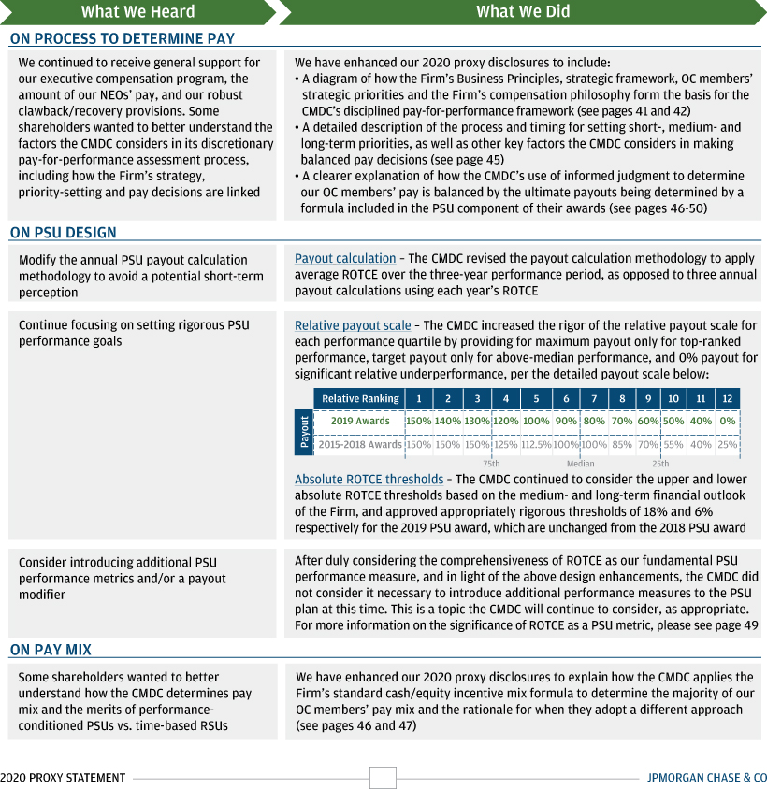

39

Table of Contents

COMPENSATION DISCUSSION AND ANALYSIS | EXECUTIVE COMPENSATION

Compensation Discussion and Analysis

The following CD&A is organized around three key factors for shareholders to consider:
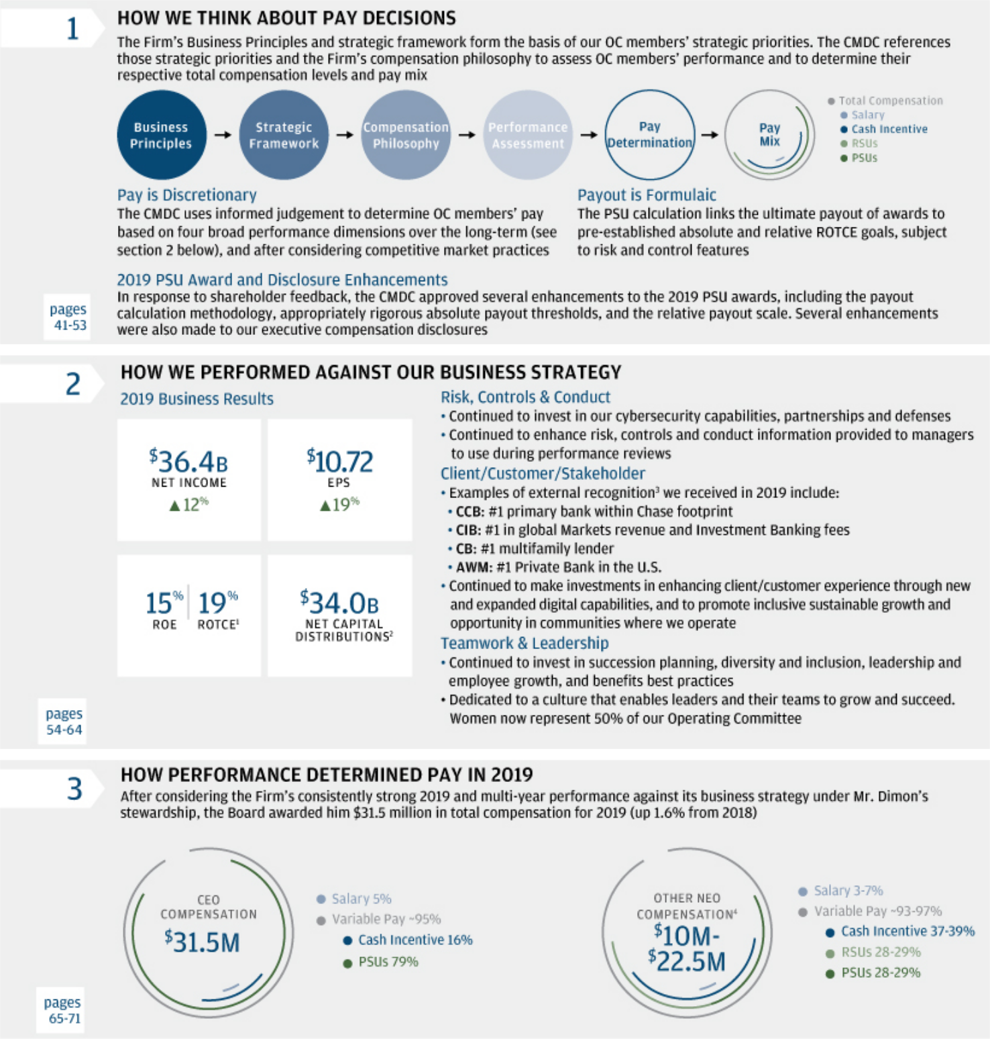

- ROTCE is a non-GAAP financial measure; refer to Note 1 on page 114 for a further discussion of this measure.

2 Reflects common dividends and common stock repurchases, net of common stock issued to employees.

3 For external recognition sources for CCB, CIB and AWM, refer to pages 67-69; CB recognition is from S&P Global Market Intelligence as of December 31, 2019.

4 Total compensation range for Other NEOs includes Mr. Pinto. Pay mix components for Other NEOs exclude Mr. Pinto. The terms and conditions of Mr. Pinto’s compensation reflect the requirements of E.U. and U.K. regulations. Refer to Note 1 on page 47 for additional information on Mr. Pinto’s pay mix.

40

Table of Contents

EXECUTIVE COMPENSATION | COMPENSATION DISCUSSION AND ANALYSIS


How we think about pay decisions

The Firm’s Business Principles and strategic framework form the basis of our OC members’ strategic priorities. The CMDC references those strategic priorities and the Firm’s compensation philosophy to assess OC members’ performance and to determine their respective total compensation levels and pay mix.


The Firm’s Business Principles and culture are fundamental to our success in the way we do business over the long-term.
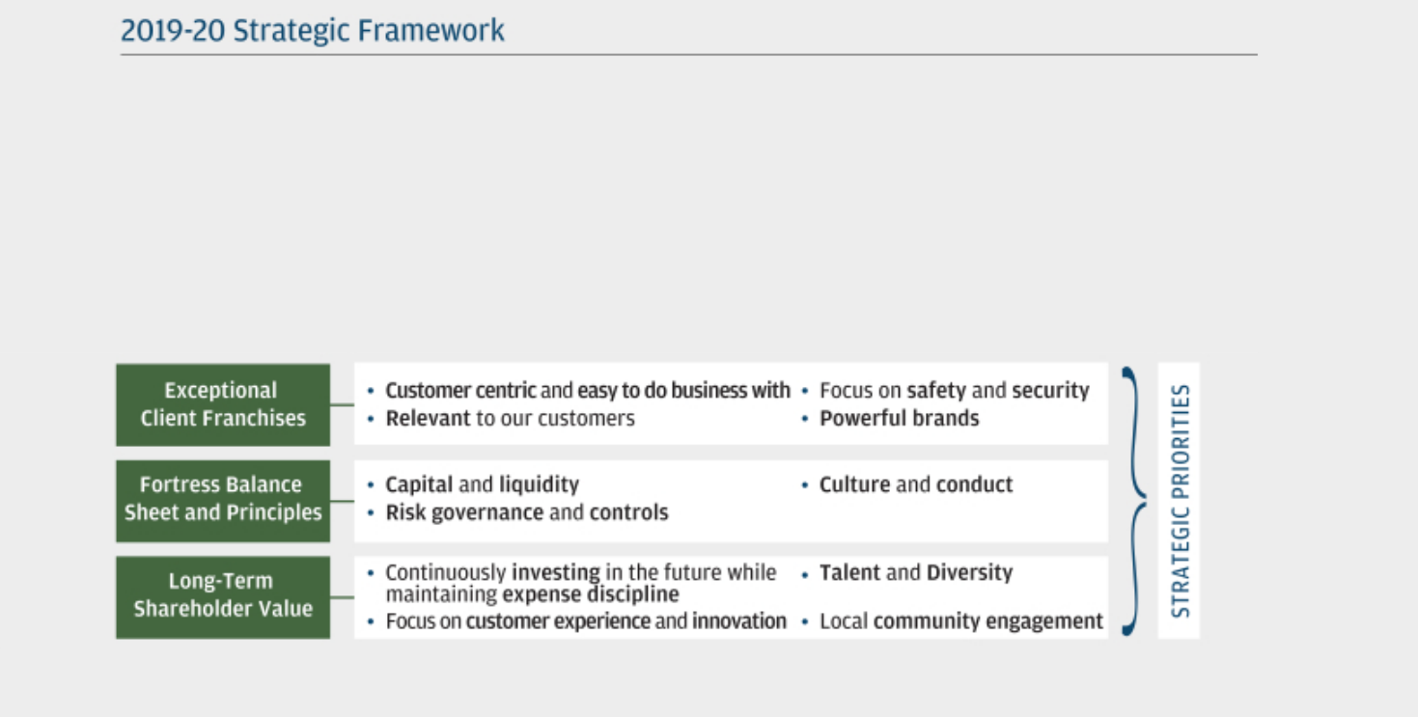

Guided by our Business Principles, our strategic framework provides holistic direction for the Firm and focuses on three primary strategic tenets:
- Operating exceptional client franchises;
- Maintaining our fortress balance sheet and principles; and
- Adding long-term shareholder value.

Each year, the Operating Committee reviews the strategic framework to consider enhancements to the framework and its underlying tenets and priorities, and to adapt to changes in the competitive and market landscape if necessary, by considering the Firm’s strengths and challenges and the Firm’s performance over the prior year. In 2019, the CMDC approved the Firm’s 2019-20 strategic framework as the priorities of the Operating Committee, including the 11 strategic priorities in the bullets listed below.

Businesses and functions develop strategic initiatives that map to the strategic framework and are designed to reinforce the Firm’s operating principles to be complete, global, diversified, and at scale.

41

Table of Contents

COMPENSATION DISCUSSION AND ANALYSIS | EXECUTIVE COMPENSATION
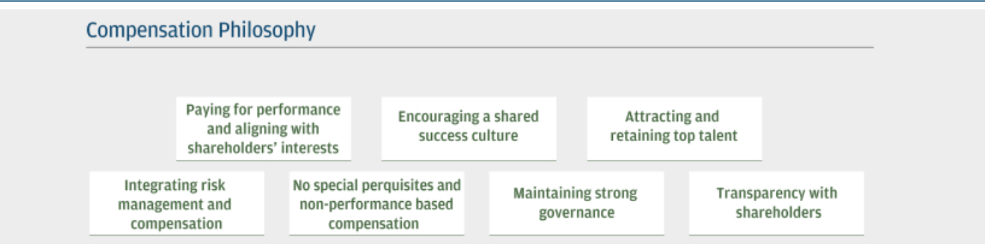

Also guided by our Business Principles, our compensation philosophy is fundamental to our goal to attract, retain, and motivate our workforce in a competitive market.
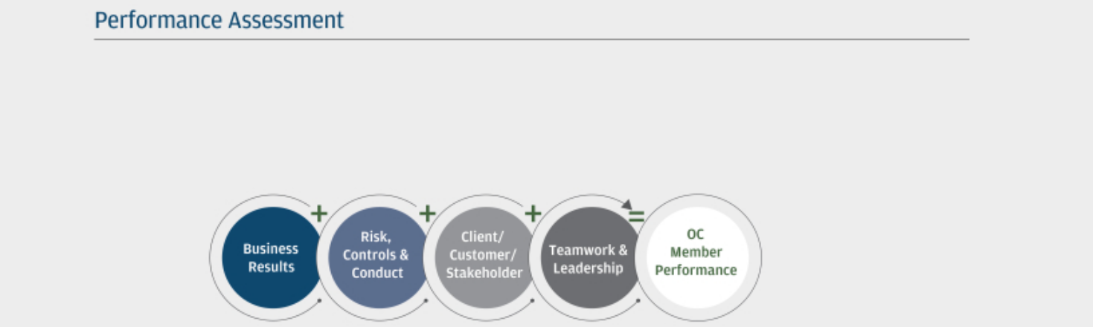

In accordance with our compensation philosophy, the CMDC uses a balanced discretionary approach to assess OC member performance throughout the year against four broad dimensions:
- Business Results
- Risk, Controls & Conduct, including feedback received from the Firm’s risk and control professionals
- Client/Customer/Stakeholder, including our engagement in communities
- Teamwork & Leadership, including creating a diverse, inclusive and respectful environment and developing employees, managers and leaders
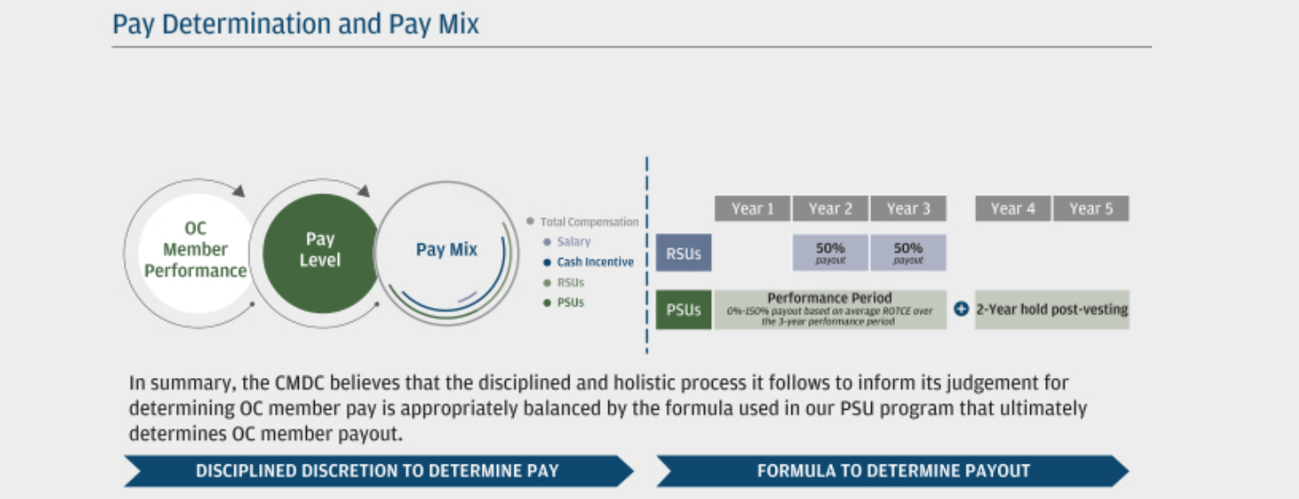

Following the performance assessment process, the CMDC determines the total compensation for each OC member, as well as their respective pay mix. Pay mix may include salary, cash incentive, RSUs and formula-based PSUs. Pay levels and pay mix are determined in the context of competitive market practices.

42

Table of Contents

EXECUTIVE COMPENSATION | COMPENSATION DISCUSSION AND ANALYSIS

Our compensation philosophy, pay practices and governance process

Our pay-for-performance compensation program is designed to align the long-term interests of our employees with those of our shareholders by emphasizing sustained value and reinforcing personal accountability.

COMPENSATION PHILOSOPHY

Our compensation philosophy provides the guiding principles that drive compensation-related decisions across all levels of the Firm. We believe our compensation philosophy promotes an equitable and well-governed approach to compensation, which includes pay-for-performance practices that attract and retain top talent in a competitive market, is responsive to and aligned with shareholders, reinforces our culture and Business Principles, and integrates risk, controls and conduct considerations.


PAYING FOR PERFORMANCE AND ALIGNING WITH SHAREHOLDERS’ INTERESTS


- In making compensation-related decisions, we focus on risk-adjusted performance (the Firm’s risk and control professionals help contextualize the risk taken to achieve the return) and reward behaviors that generate sustained value for the Firm. This means that compensation should not be overly formulaic, rigid or focused on the short-term.

- A majority of OC member incentive compensation should be in equity that vests over multiple years to align with sustained performance.

ENCOURAGING A SHARED SUCCESS CULTURE

- Teamwork and leadership should be encouraged and rewarded to foster a culture that supports our Business Principles.
- Contributions should be considered across the Firm, within business units, and at an individual level when evaluating an employee’s performance.

ATTRACTING AND RETAINING TOP TALENT


- Our long-term success depends on the talents of our employees. Our compensation philosophy plays a significant role in our ability to attract, properly motivate and retain top talent.
- Competitive and reasonable compensation should help attract and retain the best talent to grow and sustain our business.

INTEGRATING RISK MANAGEMENT AND COMPENSATION


- Risk management, compensation recovery, and repayment policies should be robust and designed to encourage behaving with the standards of integrity that are required by our culture and Business Principles. Excessive risk-taking should be deterred.

- HR Control Forums should discuss actual or potential misconduct of individuals involved in matters that create material risk, controls and conduct concerns.
- Recoupment policies should include recovery of cash and equity compensation.

- Our pay practices must comply with applicable rules and regulations, both in the U.S. and globally.

NO SPECIAL
PERQUISITES AND
NON-PERFORMANCE
BASED

COMPENSATION

- Compensation should be straightforward and consist primarily of cash and equity incentives.

- We do not have special supplemental retirement or other special benefits just for executives, nor do we have any change-in-control agreements, golden parachutes, merger bonuses, or other special severance benefit arrangements for executives.

MAINTAINING STRONG GOVERNANCE

- Strong corporate governance is fostered by independent Board oversight of our executive compensation program by the CMDC, including defining the Firm’s compensation philosophy, reviewing and approving the Firm’s overall incentive compensation pools, and approving compensation for our OC, including the terms of compensation awards; CEO compensation is subject to full Board ratification.

- We have a rigorous process in place to review risk, control and conduct issues at the Firm, line of business, functional, and regional levels, which have impacted compensation pools as well as reduced compensation at the individual level, in addition to other employee actions.

TRANSPARENCY WITH | • Transparency to shareholders regarding our executive compensation program is important. We disclose all
SHAREHOLDERS | material terms of our executive pay program and any actions on our part in response to significant events, as
SHAREHOLDERS | appropriate.
 | 43

Table of Contents

COMPENSATION DISCUSSION AND ANALYSIS | EXECUTIVE COMPENSATION

The effectiveness of our compensation program is dependent upon the alignment of sound pay-for-performance practices with our compensation philosophy. Highlighted below are pay practices that are integral to our compensation program, as well as certain pay practices that we chose not to implement.

WE ADOPT SOUND PAY PRACTICES


Principles-based compensation philosophy – Guiding principles | Competitive benchmarking – We benchmark pay levels and pay
that drive compensation-related decision-making across all levels of | practices against relevant market data
the Firm
Robust anti-hedging/anti-pledging provisions – Strict prohibition | Responsible use of equity – We used less than 1% of weighted
on hedging and pledging of unvested awards and shares owned | average diluted shares in 2019 for employee compensation
outright
Strong clawback provisions – Comprehensive recovery provisions | Risk, controls and conduct impact pay – We consider material
that enable us to cancel or reduce unvested awards and require | risk, controls and conduct issues and make adjustments to
repayment of previously awarded compensation, if appropriate | compensation, if appropriate
Pay at risk – OC member compensation is predominantly “at-risk” | Strong share holding requirements – OC members are required
and contingent on the achievement of performance goals that are | to retain significant portions of net shares received from awards to
integrally linked to shareholder value and safety and soundness | increase ownership over the long-term
Majority of variable pay is in deferred equity – Most OC member | Robust shareholder engagement – Each year we provide the
variable compensation is deferred in the form of PSUs and RSUs that | Board with feedback from our shareholders on a variety of topics,
vest over three years¹ | including our compensation programs and practices

WE AVOID POOR PAY PRACTICES

No golden parachute agreements – We do not provide additional | No guaranteed bonuses – We do not provide guaranteed bonuses,
payments or benefits as a result of a change-in-control event | except for select individuals at hire
No special severance – We do not provide special severance. | No special executive benefits
All employees, including OC members, participate at the same level of | • No private club dues or tax gross-ups for benefits
severance, based on years of service, capped at 52 weeks up to a | • No 401(k) Savings Plan matching contribution
maximum credited salary | • No special health or medical benefits
 | • No special pension credits

GOVERNANCE RESPONSIBILITIES OF THE CMDC

The CMDC oversees our compensation programs throughout the year, which enables the programs to be proactive in addressing both current and emerging developments or challenges. Key committee responsibilities related to compensation programs include:

- Periodically reviewing and approving a statement of the Firm’s compensation philosophy, principles and practices

- Reviewing the Firm’s compensation practices and the relationship among risk, risk management and compensation (including safety and soundness and avoiding practices that could encourage excessive risk-taking)

- Adopting pay practices and approving any necessary formulas, performance metrics or pool calculations in compliance with applicable U.S. and global regulatory, statutory or governance requirements

- Reviewing and approving overall incentive compensation pools (including equity/cash mix)

- Reviewing the business-aligned incentive compensation plan governance, design and evaluation framework

- Reviewing over multiple meetings and approving compensation for our OC and, for the CEO, making a compensation recommendation to the Board for consideration and ratification by the independent directors

- Reviewing compensation for employees who are material risk-takers identified under Federal Reserve standards (“Tier 1 employees”) and/or European Union standards (“Identified Staff”), collectively “Designated Employees”

- Reviewing and approving the design and terms of compensation awards, including recovery/clawback provisions

The CMDC continues to retain the discretion to make awards and pay amounts that may not qualify as tax deductible.

- PSUs are also subject to a two-year hold after each vesting for a combined holding period of five years. The terms and conditions of Mr. Pinto’s compensation reflect the requirements of E.U. and U.K. regulations. Refer to Note 1 on page 47 for additional information on Mr. Pinto’s pay mix.

44

Table of Contents

EXECUTIVE COMPENSATION | COMPENSATION DISCUSSION AND ANALYSIS

Performance assessment starts with planning and priority-setting

The CMDC uses a disciplined pay-for-performance framework to make decisions about the compensation of our OC members, so that their compensation is commensurate with the overall performance of the Firm, their respective businesses, and their individual performance. The cycle starts with establishing strategic plans, budgets and priorities at those same levels, with the key elements and timing summarized below:
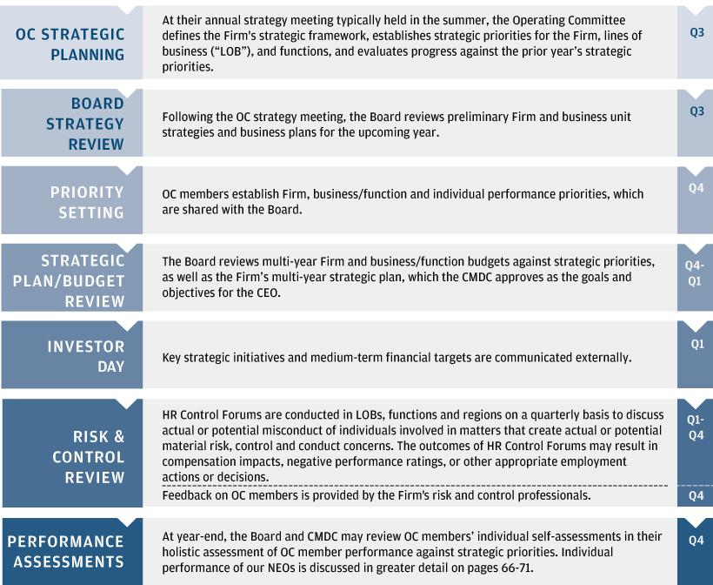

Throughout the performance assessment process, the Board and CMDC engage in regular discussions with the CEO and the Head of HR about individual OC members’ performance, as appropriate.

This approach (rather than determining pay levels during a single year-end process) enables the CMDC and the Board to make balanced and informed OC member pay decisions that are aligned with long-term performance against four broad dimensions, which consider short-, medium- and long-term priorities that drive sustained shareholder value, while accounting for risk, controls and conduct objectives:

Business Results |  | Risk, Controls & |  | Client / Customer / |  | Teamwork &
Business Results |  | Conduct |  | Stakeholder |  | Leadership

To promote a proper pay-for-performance alignment, the CMDC does not assign relative weightings to these dimensions, and also considers other relevant factors, including market practices.

45

Table of Contents

COMPENSATION DISCUSSION AND ANALYSIS | EXECUTIVE COMPENSATION

Pay determination and pay mix

EVALUATING MARKET PRACTICES

In order to effectively attract, properly motivate and retain our senior executives, the CMDC periodically reviews market data relating to pay levels, pay mix and pay practices.

In evaluating market data for OC members, the CMDC benchmarks against our primary financial services peer group, which consists of large financial services companies with which the Firm directly competes for both talent and business. The following companies comprise our primary financial services peer group, which remains unchanged from last year:

• | American Express | • | Goldman Sachs
• | Bank of America | • | Morgan Stanley
• | Citigroup | • | Wells Fargo

Given the diversity of the Firm’s businesses, the CMDC may also periodically reference the pay plans and practices of other financial services companies as well as leading large, global firms across multiple industries. The CMDC considers the size, presence, brand and reputation of the companies, and the nature and mix of their businesses in using this data. These companies include, but are not limited to: 3M, AT&T, Barclays, BlackRock, BNY Mellon, Boeing, Capital One Financial, Chevron, Coca-Cola, Comcast, Credit Suisse, CVS Health, Deutsche Bank, ExxonMobil, General Electric, HSBC, IBM, Johnson & Johnson, Merck, Oracle, PepsiCo, Pfizer, Procter & Gamble, UBS, United Technologies, Verizon, Wal-Mart and Walt Disney. Although these reference companies are not part of our primary financial services peer group, we believe that their practices can provide a relevant point of reference for maintaining a competitive talent and compensation program.

DISCIPLINED PROCESS TO DETERMINE PAY

Pay level

In determining total compensation levels for individual OC members, the CMDC evaluates various pay scenarios in light of the following considerations to inform their judgment:

- Performance, based on the four broad assessment dimensions as discussed on pages 54-64, including risk and control

- Value of the position to the organization and shareholders over time (i.e., “value of seat”)

- Leadership and the example they set for others by acting with integrity and strengthening the Firm’s culture

- External talent market (i.e., market data)

While market data provides the CMDC with useful information regarding our competitors, the CMDC does not target specific positioning (e.g., 50th percentile), nor does it use a formulaic approach in determining competitive pay levels. Instead, the CMDC uses a range of data as a reference, which is considered in the context of each executive’s performance over a multi-year period, and the CMDC’s assessment of the value the individual delivers to the Firm.

In its assessment of the Operating Committee’s 2019 performance as a whole, the CMDC took into account that the Firm achieved record financial performance across several measures and continued to execute well on its long-term business strategy, among other factors. Consideration of such strong performance in isolation could have justified significantly increasing the OC members’ 2019 total compensation awards. However, in making their ultimate OC member pay decisions, the CMDC and Board further considered that rationale against other determinants that included a balanced assessment of the strong progress that was made against Firmwide initiatives, reinforcing our culture and values, addressing issues and enhancing controls, as well as the value of each individual OC member’s respective seat, and the competitiveness of their respective pay levels.

Pay mix

Once the CMDC determines OC members’ total incentive compensation, it then establishes the appropriate pay mix between an annual cash incentive and long-term equity, including PSUs and RSUs.

For OC members other than the CEO and Mr. Pinto, consistent with prior years, the CMDC continued to apply the Firm’s standard cash/equity incentive mix formula to each of their 2019 incentive compensation awards. For the CEO, also consistent with prior years, the Board continued to override the standard cash/equity formula to maintain a lower cash allocation of $5 million, so that a larger majority of his incentive compensation would be comprised of shareholder-aligned equity, with 100% of it in the form of performance-conditioned PSUs. PSUs are 100% at-risk and will result in no payout unless a threshold performance level is achieved.

46

Table of Contents

EXECUTIVE COMPENSATION | COMPENSATION DISCUSSION AND ANALYSIS

For OC members other than the CEO, the CMDC determined that a 50%/50% mix of time-based RSUs and at-risk PSUs would continue to provide an appropriate balance to their equity exposure. Per the Firm’s standard cash/equity incentive mix formula, the majority of these OC members were awarded 60% of their incentive compensation in long-term equity (30% in PSUs and 30% in RSUs), with the remaining 40% paid in cash.

The CMDC believes that this significant weighting of pay mix to equity encourages OC members to focus on the long-term success of the Firm while mitigating excessive risk-taking, and provides a competitive annual cash incentive opportunity. The CMDC has established a different pay mix for Mr. Pinto (including a fixed allowance) due to local E.U. and U.K. regulations for Identified Staff under the Capital Requirements Directive IV. For further details on Mr. Pinto’s pay mix, see Note 1 below.

Summary of pay elements

Our compensation program provides for an appropriate mix between base salary, cash and equity incentives that vest over time. The table below summarizes the elements of compensation for the 2019 performance year.

 | % of Variable
 | Other |  |  | Subject to
Elements | CEO NEOs¹ | Description | Vesting Period | Clawback²

Fixed

Salary

Variable

N/A

N/A

- Fixed portion of total pay that enables us to attract and retain talent

- Only fixed source of cash compensation

- N/A

N/A

Cash | ~17% | 40% | • Provides a competitive annual cash incentive opportunity | • Immediately vested
Incentive |  |  | • Payout determined and awarded in the year following the performance year
 |  |  | • Represents less than half of variable compensation
RSUs | 0% | 30% | • RSUs serve as a strong retention tool | • Generally over three
 |  |  | • Dividend equivalents are paid on RSUs at the time actual dividends are paid | years:
 |  |  |  | ¡ 50% after two years, with
 |  |  | • RSUs and PSUs do not carry voting rights, and are subject to protection- | ¡ 50% after two years, with
 |  |  |  | the remaining 50% after
 |  |  | based vesting and the OC stock ownership/retention policy | the remaining 50% after
 |  |  | based vesting and the OC stock ownership/retention policy | three years
 |  |  | • RSUs and PSUs provide a competitive mix of time-based and performance- | three years
PSUs | ~83% | 30% | conditioned equity awards that are aligned with long-term shareholder | • Combined period of
 |  |  | interests as the value of payout fluctuates with stock price performance | approximately five years
 |  |  | • PSUs reinforce accountability by linking objective targets to a formulaically | prior to availability:
 |  |  | determined payout based on absolute and relative ROTCE | ¡ Award cliff-vests at the
 |  |  | • PSU performance goals are the same for the entire award term | end of the three-year
 |  |  | • PSU payout ranges from 0–150% and is settled in shares | performance period
 |  |  | • Dividend equivalents accrue on PSUs and are subject to the same vesting, | ¡ Subject to a two-year
 |  |  | performance and clawback provisions as the underlying PSUs | hold after vesting

- Excludes Mr. Pinto who is located in the U.K. Due to local regulations, Mr. Pinto receives a fixed allowance (which is not subject to clawback), did not receive a cash incentive, and both his RSUs and PSUs are subject to: (i) extended seven-year vesting period (commencing ratably on the third year anniversary of grant); (ii) additional U.K. clawback/recovery provisions; and (iii) a minimum twelve-month hold after each vesting, and are not eligible for payment/accrual of dividend equivalents. In addition, as it relates to Mr. Pinto’s PSUs, the CMDC may use its discretion, as appropriate, to downward adjust payout based on his performance against qualitative criteria and priorities during the performance period, including performance against his local regulatory responsibilities as a U.K. “Senior Manager” under the Senior Managers & Certification Regime. Local regulators review compensation structures for Identified Staff periodically and may require
future adjustments. Additional information on the composition of Mr. Pinto’s compensation is on page 65.
- Additional information on recovery and clawback provisions is provided on page 53.

47

Table of Contents

COMPENSATION DISCUSSION AND ANALYSIS | EXECUTIVE COMPENSATION

Performance share unit program

FORMULAIC PROCESS TO DETERMINE PAYOUT

As part of the design of the PSU award program, the ultimate number of PSUs paid out at vesting is determined by a pre-established formula determined at the time of the award based on the Firm’s absolute and relative ROTCE performance over the subsequent three years, with the value of the payout ranging from 0% to 150%, subject to risk and control features. Similar to RSUs, the value upon vesting of PSUs is also directly tied to the Firm’s performance through its stock price. The CMDC believes that the PSU design continues to appropriately incentivize strong performance by our OC members, does not encourage excessive risk-taking and is aligned with long-term shareholder interests. Since the PSUs were first introduced in 2015, we have received positive shareholder support for this aspect of our executive compensation program. For the 2019 PSU award granted in January 2020, the CMDC maintained the key features of our PSU design, while making several modifications described below that are designed to further strengthen alignment with the long-term interests of shareholders. Additionally, the Committee calibrated the upper and lower absolute ROTCE thresholds to 18% and 6% respectively, based on the current forecast of the Firm’s future performance.

ENHANCEMENTS TO 2019 PSU AWARDS

In response to shareholder feedback, the CMDC approved several enhancements to the 2019 PSU awards. Specific enhancements included:

- Changing the payout calculation methodology to be based on the Firm’s three-year average ROTCE performance on both an absolute and relative basis. Previously, payout was calculated annually for one-third of the awarded units.

- Increasing the rigor of the relative payout scale to further differentiate payout for outperformance, median performance and underperformance, as summarized below:

  - Top quartile relative performance no longer pays out at 150% for all three ranks;

  - Target (100%) payout now requires above median performance;

  - Below median performance now pays out at a maximum of 80%; and

  - Bottom relative performance now pays out at 0%.

The chart below provides a detailed comparison of the relative performance payout levels for 2019 PSUs vs. PSUs awarded in prior years:
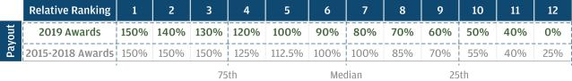

48

Table of Contents

EXECUTIVE COMPENSATION | COMPENSATION DISCUSSION AND ANALYSIS

KEY FEATURES OF OUR 2019 PSU PROGRAM

Apart from the shareholder responsive enhancements described on the prior page, the key features of our 2019 PSUs are substantially unchanged and are summarized below:
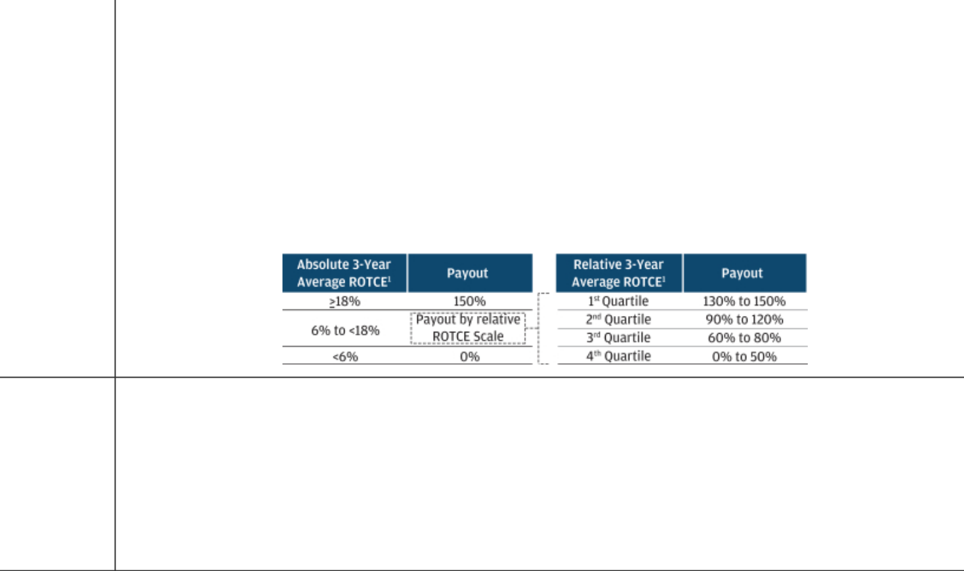

Plan Feature | Performance Year 2019 PSU Award Description
Vehicle | • Value of units moves with stock price during performance period; units are settled in shares at vesting.
Time Horizon | • Three-year cliff-vesting, plus an additional two-year holding period (for a combined five-year holding period).
Performance | • The CMDC selected ROTCE, a comprehensive performance metric that measures the Firm’s net income applicable to common
Measure | equity as a percentage of average tangible common equity. ROTCE is used by the Firm, as well as investors and analysts, in
 | assessing the earnings power of common shareholders’ equity capital and is a useful metric for comparing the profitability of the
 | Firm with that of competitors.
Payout Scale | • Payout under the PSU plan is calculated at the end of the three-year performance period based on absolute and relative average
 | ROTCE¹, per the payout scale below. The use of both absolute and relative ROTCE helps promote a reasonable outcome for
 | both shareholders and participants. In addition to making the aforementioned changes to the relative scale, the CMDC set the
 | absolute ROTCE thresholds for the 2019 PSU award as follows: (1) maximum payout at 18% or greater, (vs. 14% in 2015 and
 | 2016, 17% in 2017, and 18% in 2018); and (2) zero payout at less than 6%, no change from prior years.

PSU | • In determining companies to include in the relative ROTCE scale, the CMDC selected competitors with business activities that
Performance | overlap with at least 30% of the Firm’s revenue mix. These are unchanged from prior years and include Bank of America,
Companies | Barclays, Capital One Financial, Citigroup, Credit Suisse, Deutsche Bank, Goldman Sachs, HSBC, Morgan Stanley, UBS and
 | Wells Fargo.
Minimum Risk- | • If the Firm’s common equity Tier 1 (“CET1”) capital ratio² is less than 7.5% at any year-end, then up to one-third of unvested
based Hurdle | PSUs will be subject to downward adjustment by the CMDC for each such year. The CET1 feature was first introduced with the
 | 2017 PSU award.
Narrow | • The CMDC may make adjustments (up or down) to maintain the intended economics of the award in light of changed
Adjustment | circumstances (e.g., change in accounting rules/policies or changes in capital structure). The CMDC may also make additional
Provision | downward adjustments in relation to Mr. Pinto’s PSUs (refer to Note 1 on page 47).

PERFORMANCE SHARE UNITS — 5-YEAR TIME HORIZON
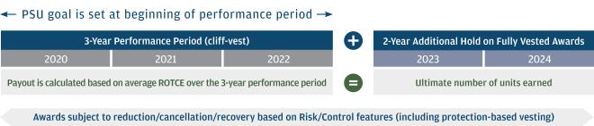

- Average ROTCE is calculated over the three-year performance period using unadjusted reported data as set forth in public financial disclosures.

2 The CET1 ratio is a key regulatory capital measure; refer to Additional notes, Note 2, on page 115, for additional information on this measure.

49

Table of Contents

COMPENSATION DISCUSSION AND ANALYSIS | EXECUTIVE COMPENSATION

DETERMINING ABSOLUTE AND RELATIVE PSU PERFORMANCE GOALS

- Each year the CMDC sets the absolute ROTCE goal and minimum threshold for that year’s PSU award by reviewing the Firm’s historical performance and a reasonable range of possible net income and capital outcomes over the next three years. For the 2019 PSU award granted in January 2020, these outcomes were considered in the context of (among other things) the expected impacts of: regulatory capital requirements; annual stress tests; interest rates; and the U.S. and global economic environment, all of which affect the range of ROTCE outcomes in the medium-term.

- Consistent with the Firm’s pay-for-performance philosophy, in setting the relative ROTCE performance goals for the 2019 PSU award, the CMDC determined that payout above target should be limited to instances in which the Firm outperforms the majority of its competitors on a relative basis, with below target payout occurring in instances of underperformance. Achievement of median relative performance results in below-target payout. Outstanding relative performance, which results in a payout of 150%, is limited to achieving a top ranking.

PSUS AWARDED FOR PERFORMANCE YEARS 2016, 2017 AND 2018

- The Firm reported ROTCE of 12%, 17%, and 19% in 2017, 2018, and 2019 respectively, resulting in first quartile relative performance and an expected payout of 150% for each tranche of the 2016, 2017, and 2018 PSU awards referencing those years. In assessing the Firm’s 2017 and 2018 ROTCE performance against the absolute goal established in the 2016 PSU award, the CMDC reviewed information related to the estimated impact of the enactment of the Tax Cuts and Jobs Act on the Firm’s performance and determined that no adjustment was required to the ultimate payout of that award in order to maintain its intended economics. On March 25, 2020, the 2016 PSU award vested at 150%.

50

Table of Contents

EXECUTIVE COMPENSATION | COMPENSATION DISCUSSION AND ANALYSIS

Rigorous ownership & accountability support our compensation philosophy

STOCK OWNERSHIP GUIDELINE AND RETENTION REQUIREMENTS

The CMDC believes it is important to align the interests of the OC members with those of our shareholders. To meet this objective, OC members are subject to a stock ownership guideline and retention policy.

While on the Operating Committee, each member is required to accumulate either:

- A minimum of between 200,000 and 400,000 shares (1 million shares for the CEO); or

- A minimum fixed dollar value of shares of between $10 million and $30 million ($75 million for the CEO).

Shares credited for purposes of satisfying the above ownership levels include shares owned outright, as well as 50% of unvested RSUs and PSUs, but do not include stock appreciation rights or stock options.

The stock ownership guideline must be met within six years of the later of the effective date of the policy or appointment to the Operating Committee. If the stock ownership guidelines are subsequently increased, the higher ownership guideline must be satisfied within six years of such revision, unless otherwise determined by the CEO and CMDC.

Prior to reaching their designated share ownership guideline, OC members are required to retain 75% of all net shares received from equity awards. Once they have met their ownership guideline, the policy requires OC members to continue retaining 50% of all net shares received from awards (75% for the CEO) as summarized below:


Retention Requirement

Before Guideline Met | After Guideline Met
75% of net shares until | 50% of net shares for the
stock ownership guideline is met | duration of their service on the
 | Operating Committee
 | (75% for the CEO)

Because OC members are required to continue accumulating shares even after having met their share ownership guideline, the resulting increase of share ownership over time further strengthens their interests with those of our shareholders.

ANTI-HEDGING/ANTI-PLEDGING PROVISIONS

All employees are prohibited from hedging or pledging unvested RSUs and PSUs, and unexercised stock appreciation rights or stock options. In addition:

- Hedging any shares owned outright or through deferred compensation by an OC member is prohibited

- Shares held directly by an OC or Board member may not be held in margin accounts or otherwise pledged

For information on the hedging/pledging restrictions applicable to our directors, please see “Director compensation” on pages 32 and 33.

INTEGRATING RISK WITH COMPENSATION

The CMDC holds an annual joint session with the Risk Committee to review Firmwide HR and compensation practices, including:

- How we integrate risk, controls and conduct considerations into key HR practices including performance development, compensation, promotion and succession planning

- Compensation features and elements designed to discourage imprudent risk-taking (e.g., multi-year vesting, clawbacks, prohibition on hedging, etc.)

- Annual incentive pool processes for LOBs and functions

- Regulatory updates which have impacted or may impact HR practices in the future

The committees are also provided with information on our performance development process, a summary of risk, controls and conduct feedback, and updates regarding HR Control Forum issues.

STRONG ACCOUNTABILITY AND RECOVERY PROVISIONS

Our executive compensation program is designed to hold executives accountable, when appropriate, for meaningful actions or issues that negatively impact business performance or the Firm’s reputation in current or future years.

Issues that may warrant recovery determinations can be raised at any time, including in meetings of the Firm’s risk committees, HR Control Forums, annual assessments of employee performance and when Designated Employees resign or their employment is terminated by the Firm. Under the Firm’s process to govern these determinations:

- We have established a process for reviewing compensation or other employee actions following a determination that the cause and materiality of a risk-related loss, issue or other set of facts and circumstances warrants such a review of accountability

- The CMDC is responsible for determinations involving OC members (determinations involving the CEO are subject to ratification by independent members of the Board). The CMDC has delegated authority for determinations involving other employees to the Head of Human Resources or his or her designee, usually through the HR Control Forum process described on page 52.

51

Table of Contents

COMPENSATION DISCUSSION AND ANALYSIS | EXECUTIVE COMPENSATION

We maintain review processes to evaluate risk, controls and conduct issues and to identify individuals who may be subject to remedial actions such as impacts to compensation and/or termination.

RISK, CONTROLS & CONDUCT REVIEW PROCESS HOLDING INDIVIDUALS ACCOUNTABLE
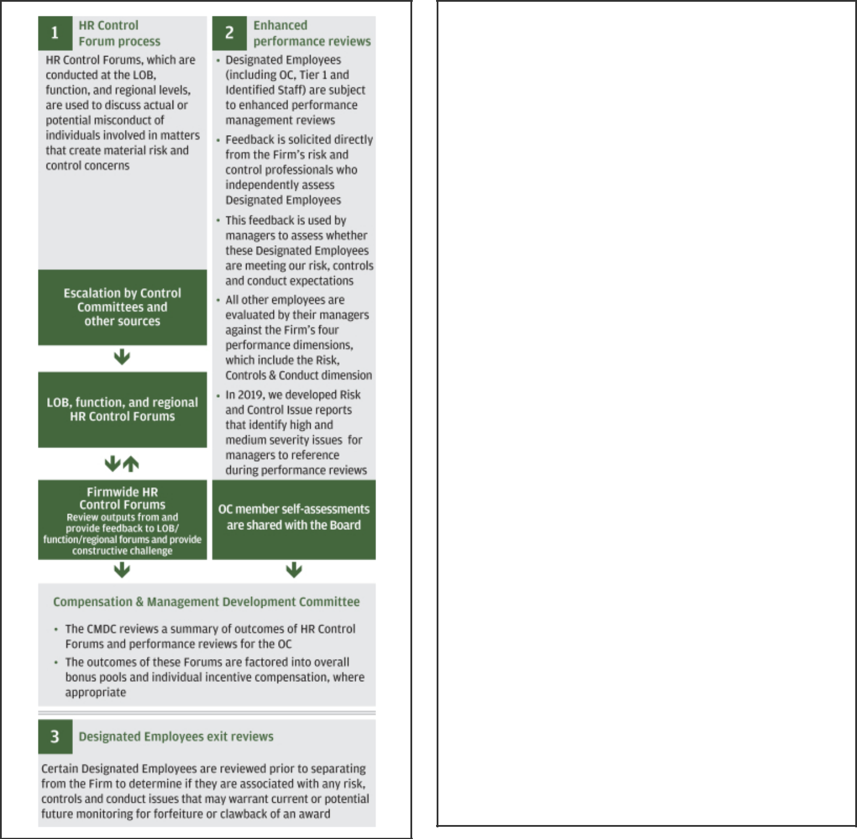

To hold individuals responsible for taking risks inconsistent with the Firm’s risk appetite and to discourage future imprudent behavior, the Firm has policies and procedures that enable it to take prompt and proportionate actions with respect to accountable individuals, including:

I. Reduce or altogether eliminate annual incentive compensation; II. Cancel unvested awards (in full or in part);
III. Clawback/Recover previously paid compensation (cash and/or equity)

Summary of Cancellation & Clawbacks

Trigger | Vested | Unvested
Restatement | ✓ | ✓
Misconduct | ✓ | ✓
Risk-related | ✓ | ✓
Protection-based |  | ✓

IV. Demotion, negative performance rating or other appropriate employment actions;

V. Termination of employment

The precise actions we take with respect to accountable individuals are based on the relevant circumstances, including the nature of their involvement, the magnitude of the event and the impact on the Firm

Clawback Disclosure Policy

During 2019, we did not take any actions to recover or clawback any incentive compensation from the OC members or the Firmwide Controller

52

Table of Contents

EXECUTIVE COMPENSATION | COMPENSATION DISCUSSION AND ANALYSIS

CLAWBACK/RECOVERY PROVISIONS

We maintain clawback/recovery provisions on both cash incentives and equity awards which enable us to reduce or cancel unvested awards and recover previously paid compensation in certain situations. While incentive awards are intended and expected to vest according to their terms, the Firm’s strong recovery provisions permit recovery of incentive compensation awards in appropriate circumstances.

The following table provides details on the clawback provisions that apply to our OC members and the Firmwide Controller.

EQUITY CLAWBACK REVIEW PROVISIONS 1

 |  |  |  | Award Type
Category | Trigger |  | Vested | Unvested
Restatement | • In the event of a material restatement of the Firm’s financial results for the
 | relevant period
 | • This provision also applies to cash incentives
Misconduct | • If the employee engaged in conduct detrimental to the Firm that causes material
 | financial or reputational harm to the Firm, or engaged in knowing and willful misconduct
 | related to employment
 | • If the award was based on material misrepresentation by the employee
 | • If the employee is terminated for cause
Risk-related | • If the employee improperly or with gross negligence failed to identify, raise or assess,
and Other | in a timely manner and as reasonably expected, issues and/or concerns with respect to
 | risks material to the Firm
 | • If the award was based on materially inaccurate performance metrics, whether or not
 | the employee was responsible for the inaccuracy
Protection-Based | • If performance in relation to the priorities for their position, or the Firm’s performance
2 | in relation to the priorities for which they share responsibility as a member of the
Vesting | Operating Committee, has been unsatisfactory for a sustained period of time
 | • If awards granted to participants in a LOB for which the Operating Committee member
 | exercised responsibility were in whole or in part cancelled because the LOB did not
 | meet its annual LOB financial threshold
 | • If, for any one calendar year during the vesting period, pre-tax pre-provision income is
 | negative, as reported by the Firm
 | • If, for the three calendar years preceding the third year vesting date, the Firm does not
 | meet a 15% cumulative ROTCE

- In accordance with U.K. regulations, the Firm has a local Malus and Clawback Policy which, for relevant Identified Staff, enables the Firm to cancel and/or recover incentive compensation for a minimum period of seven years following the date of the award in certain circumstances. The policy was updated for the 2017 performance year to reflect new guidelines from the European Banking Authority. Incentive compensation awards made to relevant Identified Staff on or after January 1, 2015, including Mr. Pinto’s incentive compensation awards, are subject to this Malus and Clawback Policy in addition to the recovery provisions in the table above.

- Provisions apply to PSUs and to RSUs granted after 2011 to the Operating Committee and may result in cancellation of up to a total of 50% of the award.

53

Table of Contents

EXECUTIVE COMPENSATION | COMPENSATION DISCUSSION AND ANALYSIS


How we performed against our business strategy

We continued to deliver strong multi-year financial performance, invest in our future, strengthen our risk and control environment, and reinforce our culture and values, including our long-standing commitment to serve our customers, employees and communities, and conduct business in a responsible way to drive inclusive growth.

In assessing the Firm’s performance in 2019, the CMDC considered the following factors in the context of the Firm’s Business Principles and strategic framework:

Business Results |  | Risk, Controls & |  | Client / Customer / |  | Teamwork &
Business Results |  | Conduct |  | Stakeholder |  | Leadership

Business results

2019 KEY HIGHLIGHTS

In 2019, the Firm reported record net income of $36.4 billion, or $10.72 per share, with ROE of 15% and ROTCE1 of 19%, and returned capital to shareholders of $34.0 billion (including common dividends and net share repurchases). We gained market share in many of our businesses, demonstrated strong expense discipline, continued to achieve high customer satisfaction scores, and maintained a fortress balance sheet.

JPMORGAN CHASE & CO.


$36.4B $10.72 15%
RECORD RECORD EPS ROE NET INCOME

19% |  | $75.98 | $60.98 |  | $34.0B
ROTCE¹ |  | BVPS | TBVPS¹ |  | NET CAPITAL
DISTRIBUTIONS²

CONSUMER &

COMMUNITY BANKING
$16.6B 31%
NET INCOME | ROE

- Record net income on revenue3 of $55.9B

- Average deposits of $693.6B (up 3%); average loans of $464.3B (down 3%)

- #1 in U.S. card sales volume and #1 in credit card outstandings

- Continued credit outperformance with Consumer Lending 30+ day delinquency rates well below industry benchmarks

CORPORATE &
INVESTMENT BANK
$11.9B 14%
NET INCOME | ROE

- Record net income on record revenue3 of $38.3B

- #1 in global Markets revenue; #1 in global IB fees for 11 consecutive years

- #2 custodian globally with $27T in assets under custody, up 16%

- #1 in USD Payments volume

COMMERCIAL
BANKING
$3.9B 17%
NET INCOME | ROE

- Revenue3 of $9.0B

- Record gross IB revenue of $2.7B (up 10%), including record years for both MMBSI and CCBSI

- Record Middle Market expansion market revenue of $723M (up 12%)

- Strong credit performance with a net charge-off ratio of 0.08%

ASSET & WEALTH
MANAGEMENT
$2.8B 26%
NET INCOME | ROE
- Record revenue3 of $14.3B; pre-tax margin of 26%

- Assets under management of $2.4T and client assets of $3.2T, up 19% and 18% respectively

- 88% of 10-year long-term mutual fund AUM performing above peer median

- Average deposits of $140B (up 2%); record average loans of $150B (up 8%)

 | EXCEPTIONAL CLIENT FRANCHISES |  | FORTRESS BALANCE SHEET & PRINCIPLES |  | LONG-TERM SHAREHOLDER VALUE

- ROTCE and TBVPS are each non-GAAP financial measures; refer to Note 1 on page 114 for a further discussion of these measures.

2 Refer to Note 2 on page 40.

3 The Firm reviews the results of the lines of business on a managed basis. Refer to Additional notes, Note 1, on page 115 for a definition of managed basis.

54

Table of Contents

EXECUTIVE COMPENSATION | COMPENSATION DISCUSSION AND ANALYSIS

LONG-TERM FINANCIAL PERFORMANCE

We have generated strong financial results over time, more than doubling net income over the past 10 years while adding substantial capital. Over this period we increased average common equity by over 40% to $ 233 billion and average TCE1 by over 65% to $187 billion to support growth in the businesses and maintain a fortress balance sheet. With our net income growth outpacing capital growth, we have maintained strong ROE and ROTCE1 over time, including peer-leading results in 2019.

We have also delivered sustained growth in EPS, BVPS, and TBVPS1 over the past 10 years, reflecting compound annual growth rates of 12%, 7% and 8%, respectively over the period.

- Average TCE, ROTCE, and TBVPS are each non-GAAP financial measures; refer to Note 1 on page 114 for a further discussion of these measures.

- Excluding the impact of the enactment of the TCJA of $(2.4) billion and a legal benefit of $406 million (after-tax) in 2017, adjusted net income would have been $26.5 billion, adjusted ROTCE would have been 13% and adjusted EPS would have been $6.87. Adjusted net income, adjusted ROTCE and adjusted EPS are each non-GAAP financial measures; refer to Notes on non-GAAP financial measures, Note 2, on page 114 for a further discussion of these measures.

55

Table of Contents

COMPENSATION DISCUSSION AND ANALYSIS | EXECUTIVE COMPENSATION

TOTAL SHAREHOLDER RETURN

TSR1 was 47% in 2019, following a TSR of (7)% in 2018 and 27% in 2017, for a combined three-year TSR of 74%. The graph below shows our TSR expressed as the cumulative return to shareholders over the past decade. As illustrated, a $100 investment in JPMorgan Chase common stock on December 31, 2009 would be valued at $426 as of December 31, 2019, which significantly outperformed the financial services industry over the period, as measured by the S&P Financials Index and the KBW Bank Index.

- TSR shows the actual return of the stock price, with dividends reinvested.

Risk, controls & conduct

We believe a strong control environment is fundamental to the success of our Firm. We continue to invest in strengthening our controls and infrastructure as part of our commitment to operate an effective and efficient risk, controls and conduct environment. The LOBs, Risk Management and Compliance, Finance, Legal, and Internal Audit continue to focus on identifying our risks and enhancing our control environment. We are also continuing to work on becoming more effective and efficient in addressing risks and controls while improving the client and customer experience.

CYBERSECURITY

The Firm devotes significant resources to protecting and continuing to improve the security of our computer systems, software, networks and other technology assets. We continue to make significant investments in enhancing our cyberdefense capabilities and to strengthen our partnerships with the appropriate government and law enforcement agencies and other businesses in order to

understand the full spectrum of cybersecurity risks in the operating environment, enhance defenses and improve resiliency against cybersecurity threats.

Globally, thousands of employees focus on cybersecurity — working across the Firm and with many partners to maintain our defenses and enhance our resiliency to threats. Three global security operations centers monitor our systems 24 hours a day, seven days a week.

The Firm’s Security Awareness Program includes training that reinforces the Firm’s Information Technology Risk and Security Management policies, standards and practices, as well as the expectation that employees comply with these policies. The Security Awareness Program engages personnel through training on how to identify potential cybersecurity risks and protect the Firm’s resources and information. This training is mandatory for all employees globally on a periodic basis, and it is supplemented by Firmwide testing initiatives, including periodic phishing tests. Finally, the Firm’s Global Privacy Program requires all employees to take periodic

56

Table of Contents

EXECUTIVE COMPENSATION | COMPENSATION DISCUSSION AND ANALYSIS

awareness training on data privacy. This privacy-focused training includes information about confidentiality and security, as well as responding to unauthorized access to or use of information.

The Audit Committee of the Board of Directors is updated periodically on the Firm’s Information Security Program and any recommended changes, cybersecurity policies and practices, ongoing efforts to improve security, as well as on our efforts regarding significant cybersecurity events.

CONTINUED FOCUS ON CULTURE AND CONDUCT RISK MANAGEMENT

We continue to reinforce our culture and remain focused on managing employee conduct end-to-end. Our “How We Do Business” principles are embedded throughout the employee lifecycle, starting with the onboarding process and extending to training, compensation, promoting and rewarding employees; and our performance development and compensation processes are designed to hold employees accountable for their conduct, where appropriate.

We strive to clearly and frequently communicate our expectations that all employee conduct must adhere to the highest ethical standards encompassed by our Business Principles; including through town hall meetings and senior leadership messages and by including culture and conduct related themes in our employee surveys.

In 2019, we created a global Employee Engagement, Culture and Conduct organization within HR, focused on strategic efforts to deliver a positive employee experience and develop best-in-class people practices that reinforce our culture.

The Firm endeavors to promote a culture of respect that allows every employee to feel safe and empowered at work. To that end, the Firm has in place employee training and protocols for preventing, reporting and addressing sexual, discriminatory or other misconduct and prohibits retaliation against an individual because the person reported a concern or assisted with any inquiry or investigation.

We remain focused on our anti-harassment and culture of respect efforts across the company. Building on the enhancements made in 2018, we have taken a deeper approach to reinforce our culture by increasing awareness and education through engagement, communication and training while adhering to policy and regulatory requirements. Our periodic Code of Conduct and Culture of Respect trainings were refreshed and assigned as mandatory training to all employees.

Our Business Conduct training, which is complementary to the Code of Conduct training, was launched for approximately 119,000 in-scope employees and is intended

to educate employees, provide a forum to discuss a wide range of real-life, conduct-related questions, and instill best practices for staying true to our Business Principles in all of our dealings.

Management teams are expected to drive culture activities and initiatives that are consistent with our Business Principles and to escalate issues when appropriate.

The actual or potential misconduct of individuals who may be involved in material risk and control issues is escalated through the HR Control Forum process. In 2019, we implemented several enhancements to this process, including issuing comprehensive written procedures that provide more consistent guidance on the types of issues that should be escalated to the HR Control Forums, as well as clarifying roles and responsibilities, and accountability for escalation and decision-making. The HR Control Forum process is discussed in further detail on page 52.

Client/customer/stakeholder

Our performance reflects our ongoing commitment to invest in our employees and businesses, further strengthen the market leadership of our franchises, generate long-term value for our shareholders, and help strengthen the broader economy.

Our future success rests on our commitment to deliver value to our customers in meeting or exceeding expectations; deal fairly and ethically with our suppliers as good partners to help us meet our missions; support the communities in which we work, and protect the environment by embracing sustainable practices across our businesses.

ENHANCING OUR CUSTOMER AND CLIENT EXPERIENCE

The customer is at the center of everything we do. We strive to deliver value by offering our customers and clients choice through a full set of products and services, security by protecting their data and transactions, ease of doing business in a fast and simple way, and personalization through tailored customer solutions and integrated experiences. Our LOBs are able to leverage the unique scale advantage of our Firm in order to benefit our customers and clients, as illustrated in the examples below.

Consumer & Community Banking (“CCB”)

- Built digital solutions to drive customer engagement, such as: My Chase Loan to use existing credit lines to finance purchases customers otherwise would not be able to put on their cards; Autosave; and additional features in Chase MyHome, including a service and advice platform

57

Table of Contents

COMPENSATION DISCUSSION AND ANALYSIS | EXECUTIVE COMPENSATION

- Expanded our branch footprint in areas of strategic opportunity, opening over 70 new branches in 16 new markets in 2019, placing points of convenience where our customers live, work and shop

- Introduced new products and pricing in Credit Card, including branded and co-branded product launches, targeted rate promotion offers and credit line increases, to continue to meet customers’ borrowing needs

- Extended “already approved” offers to approximately 10 million eligible customers, based on their full Chase relationship

Corporate & Investment Bank (“CIB”)

- Created the Wholesale Payments business unit, which combines Treasury Services and Merchant Services to deliver a comprehensive offering to clients

- Acquired InstaMed, which broadens the Firm’s capabilities in healthcare payments

- Received regulatory approval that allows J.P. Morgan’s majority-owned securities company in China to commence operations

- Continued to expand and enhance the end-to-end digital offering for our clients

- Maintained high client satisfaction levels while growing the franchise

- Continued to execute on our Brexit strategy to be ready for a minimally disruptive outcome

Commercial Banking (“CB”)

- Continued to develop new treasury services solutions and functionality for clients across all sizes and segments

- Established teams in ten new international geographies to provide differentiated capabilities to multinational companies for their cross-border needs

- Enhanced digital platforms across the CB; completed the full transition from a legacy platform to our Chase Connect platform with more than 9,000 active Chase Connect clients

- Improved end-to-end processes to drive efficiency; reduced U.S. account opening time by approximately 25%

Asset & Wealth Management (“AWM”)

- Launched the Singapore Trust Company, which expands our international Trusts & Estates footprint in Asia for the first time

- Constant innovation of the You Invest platform, which included launching You Invest Portfolios and introducing options trading

- Continued to refine our client solutions product offering by launching new, innovative strategies and by rationalizing strategies with lower traction

- Focused on technology investments to enable better client and employee experience with 50% of total spend on growth initiatives

INVESTING IN OUR COMMUNITIES

We endeavor to promote inclusive economic growth and opportunity in communities where we operate. We also work to advance environmental sustainability within our business activities and facilities.

Highlights of our work include:

- Driving inclusive growth – The Firm continues to make progress toward its commitment to invest $1.75 billion by 2023 focused on breaking down barriers to opportunity and creating an economy that works for more people. Our efforts focus on four pillars of opportunity: jobs and skills, small business expansion, neighborhood revitalization and financial health. We are combining our business and policy expertise, sustainable business practices, data, capital and global presence to advance solutions that create economic opportunity for our customers, employees and the communities we serve. In 2019, we launched the JPMorgan Chase PolicyCenter, which aims to develop and advance sustainable, evidence-based policy solutions to drive inclusive growth in the U.S. and around the world. The first focus area for the PolicyCenter is advocating for federal and state policy changes to remove barriers to employment for people with criminal backgrounds. Also in 2019, we bolstered our strategy and renewed our commitment to prepare people for the future of work. We are investing $350 million over the next five years to develop, test and scale innovative efforts that prepare individuals with the skills they need to be successful in a rapidly changing economy.

- Advancing clean finance – One of the key ways we help our clients achieve their sustainability efforts is through our financing activities. In 2017, the Firm set a target to facilitate $200 billion in clean financing by 2025, and we expect to reach this goal ahead of schedule. In 2019 alone, we facilitated nearly $50 billion in clean financing. In 2020, we are expanding our financing commitment to include other efforts that address climate change and further promote sustainable development.

- Improving operational sustainability - In addition to offsetting 100% of carbon emissions from employee air travel each year, we are on track to meet our goal to source renewable energy for 100% of our global power needs across our buildings, branches, and data centers

58

Table of Contents

EXECUTIVE COMPENSATION | COMPENSATION DISCUSSION AND ANALYSIS

by the end of 2020 - and to do so in a way that maximizes the
impact through efforts that bring more renewable energy online.

- Supporting environmental, social and governance disclosure – We have served as a member of the Task Force for Climate-related Financial Disclosures since it was established, and in 2019 we published a voluntary report about how we are addressing climate-related risks and opportunities. In 2020, we plan to complement our annual Environmental, Social and Governance (“ESG”) Report with an index that aligns to the Sustainability Accounting Standards Board (“SASB”).

- Supporting military veterans - Since establishing the Office of Military and Veterans Affairs in 2011, our Firm has hired more than 15,000 U.S. military veterans across all lines of business and donated over 1,000 mortgage-free homes to veterans through our Military Home Awards program.

- Providing skills and expertise - In 2019, nearly 73,000 of our employees volunteered more than 467,000 hours of their time. Through the JPMorgan Chase Service Corps, a program that leverages the energy and skills of top talent to assist nonprofit partners, 325 employee volunteers from offices in 14 countries have contributed nearly 20,000 hours to help 69 nonprofit organizations address critical needs.

Reporting on our efforts

Each spring we publish a dedicated ESG Report, which summarizes our efforts and performance on ESG matters that we and our stakeholders view as among the most important to our business. This report and other resources, including our Corporate Responsibility Report, are available on our website at jpmorganchase.com/esg.

59

Table of Contents

COMPENSATION DISCUSSION AND ANALYSIS | EXECUTIVE COMPENSATION

Teamwork & leadership

Our employees’ effectiveness, career development and ability to adapt to a changing landscape enables continued delivery of sustained shareholder value. In order to attract and retain the highest quality talent, we develop key talent and succession plans, invest in Firmwide diversity and inclusion initiatives, and provide well-paid jobs with strong benefits and wellness programs.

SUCCESSION PLANNING

Succession planning is a top priority for the Board and the Firm’s senior leadership, with the objective of having a pipeline of diverse leaders for today and the future. To achieve this objective, the Board and management take a proactive approach. We have established a disciplined talent management and succession planning process at the senior level, including each OC member holding a talent review discussion with their management teams, and identifying successors to their direct reports.

The CMDC reviews the succession plan for the CEO followed by discussion with the non-executive directors of the Board led by the Lead Independent Director. The CMDC also reviews the succession plan for members of the Operating Committee other than the CEO, which is then discussed by the Board of Directors. These processes enable the Board to address both long-term planned occurrences, such as retirement or change in roles, as well as short-term unexpected events. Similar processes, led by the relevant management team, occur within each LOB and function.

We have continued to enhance our talent data and reporting capabilities to drive manager engagement and accountability in processes such as identifying mobility opportunities and monitoring the promotion pipeline for Managing Directors and Executive Directors.

DIVERSITY AND INCLUSION

Diversity and inclusion are of strategic importance to the Firm. We are committed to a culture of respect and believe that all individuals should have the opportunity to succeed. We believe a diverse and inclusive environment fosters innovation, creativity and productivity, which is critical to our success. We are committed to hiring and retaining employees from all races, ethnicities, genders, sexual orientations, abilities, backgrounds, experiences and locations.

We are focused on being an employer of choice for all talent, where employees can feel like they belong. As a firm, we strive to embed diversity, inclusion and accessibility into the way we do business every day. While we are proud of the industry recognition our Firm and leaders have received, we continue to be deliberate about our investment in women, the Black community, those with disabilities, our veterans, the LGBT+ community, the Asian community and the Hispanic community.

We continue to invest significant time and effort toward executing diversity and inclusion best practices Firmwide. Our Business Resource Groups (“BRGs”) are groups of employees who volunteer to advance our Firm’s position in the global marketplace and diversity and inclusion strategies by leveraging the unique perspectives of their members. Our 10 BRGs are an essential part of the foundation that helps create an inclusive environment, with approximately 43% of our employees being a member of at least one BRG. Overall, our BRGs focus on providing support for various communities:

- Access Ability (employees with disabilities)

- Adelante (Hispanic/Latino)

- AsPIRE (Asian/Pacific Islander)

- BOLD (Black)

- NextGen (early career professionals)

- Pride (LGBT+)

- Sage (administrative professionals)

- VETS (military, veterans, and their families)

- Women on the Move Interactive Network

- Working Families Network

60

Table of Contents

EXECUTIVE COMPENSATION | COMPENSATION DISCUSSION AND ANALYSIS

In addition to our BRGs, we have developed other strategies as well as created senior level forums to promote diversity and inclusion:


WOMEN ON THE MOVE (“WOTM”)

- Our WOTM is a global, Firmwide effort designed to support women in their personal and professional lives

- We continue to focus on our three strategic pillars: expand women-run businesses, improve women’s financial health, and empower women’s career growth

- In 2019, we extended approximately $4 billion in credit to women-owned small businesses, more than a third of the way toward our goal of providing $10 billion in credit to female small business owners by the end of 2021

- We announced a goal to sign up 1 million women for Autosave, and we have already enrolled over 500,000 women

- We launched a national sponsorship with Girls Inc. to educate 20,000 girls in the U.S. by providing programs that focus on lifelong skills to sustain financial health

- We hosted our annual Women on the Move Leadership Day in 2019 with over 2,000 in-person attendees and over 20,000 watching remotely

ADVANCING | • Our ABL is a Firmwide commitment to increasing representation of Black talent across the Firm
BLACK | • We marked the best year on record of Black Managing Director promotions in 2019
LEADERS | • We expanded our strategy to include the EMEA region and as a result, Black Managing Director headcount in the region more
(“ABL”) & | than doubled from 2018 to 2019
ADVANCING | • ABP was launched in 2019 as part of our Firm’s commitment to develop and hire Black talent, invest in Black businesses and
BLACK | households, and to improve the financial health of Black communities around the world
PATHWAYS | • ABP complements our other diversity and inclusion and corporate responsibility initiatives with a focus on three key areas:
(“ABP”) | wealth, education and careers; the program contributed to a strong improvement to the Firm’s consumer sentiment score,
 | which increased by 41% following the program’s launch
 | • Key ABP accomplishments include:
 | ¡ | Engaged with more than 16,000 Black women in financial health education through our Currency Conversations partnership
 |  | with Essence Communications
 | ¡ | Delivered mandatory financial health education to over 4,000 students, including more than 1,500 summer interns
 | ¡ | Launched the ABP Apprentice Program for 50 rising college sophomores and juniors to provide exposure and skills that lead
 |  | to internships and entry-level roles after graduation
 | ¡ | Hired over 1,000 Black students to support the target of 4,000 hires by 2024; achieving 25% of the five-year target in the first
 |  | year
 | ¡ | Supported the creation of the Firm’s new Financial Advisor training program for employees; 20% of whom are Black
 | • The Black Executive Forum (“BEF”), a consortium of Managing Directors of Black heritage across all lines of businesses and
 | functions, supports the ABL diversity strategy and ABP initiative and regularly engages with the BOLD BRG to serve as a
 | senior collective voice for the Black community


OFFICE OF DISABILITY INCLUSION (“ODI”)

- Our ODI drives consistent accessibility processes and standards across the Firm so employees can receive the reasonable accommodations they need to perform their jobs

- Our centralized process - MyAccessibility Hub - handled increasingly more employee requests for reasonable accommodations in the U.S. and the Philippines in 2019, with expansion to other countries starting in 2020

- We provided managers and team leaders with resources to recruit, hire and advance people with disabilities

- We hired over 1,000 people with disabilities globally in 2019

MILITARY | • Our Office of Military & Veterans Affairs drives Firmwide initiatives to position veterans, service members and their families for
AND | long-term, post-military success
VETERANS | • We have hired more than 15,000 U.S. veterans since 2011, and over 1,200 in 2019 with 65% from self-identified diverse
AFFAIRS | backgrounds
PROGRAMS | • We expanded our efforts to empower the military community with access to employment and entrepreneurship opportunities
 | with a continued focus on influencing the private sector on the business value of veteran talent and on driving modern
 | workforce readiness for transitioning service members
 | 61

Table of Contents

COMPENSATION DISCUSSION AND ANALYSIS | EXECUTIVE COMPENSATION


LGBT+

EXECUTIVE FORUM & COMMUNITY


- Our LGBT+ Executive Forum is a group of Out LGBT+ Managing Directors and Executive Directors across 13 countries to drive increased engagement and visibility of our LGBT+ senior leaders and advance important topics of our LGBT+ community

- Our employees who have self-identified as LGBT+ increased by more than 46% over the last year

- Our global PRIDE BRG has nearly 24,000 employees (9% of all employees globally) and grew by approximately 35% over the last year

- In 2019, we signed public statements in support of marriage equality in Japan and Hong Kong, signed onto a pledge in Singapore that HIV status alone is not grounds for a person’s dismissal from employment, signed onto a United States Supreme Court amicus brief in support of LGBT+ workers seeking to be protected from discrimination under existing federal civil rights laws, and signed a charter in Warsaw, Poland, to reaffirm our commitment to LGBT+ equality and acceptance

- We have taken strides to improve LGBT+ family planning benefits and medical benefits for transgender employees (including gender reassignment surgery coverage in India), rolled out same-sex partner benefits, and formed a global transgender working group with employee representatives from the U.S., United Kingdom and the Philippines

- We are also engaged with external LGBT+ organizations, evidenced by our financial support of 22 LGBT+ focused not-for-profit organizations across 5 countries, with a number of these relationships dating back two decades

ASIAN • Our AEF is a consortium of Managing Directors of Asian heritage across all lines of business and functions to represent the

EXECUTIVE Firm’s strong commitment to the promotion and advancement of Asian Americans and Pacific Islanders
FORUM • We launched an ‘Adopt-a-Chapter’ initiative to understand and address any issues to ensure the AsPIRE BRG leadership

(“AEF”) & teams are set up for growth and stability and increased Managing Director membership and participation in the AsPIRE BRG
COMMUNITY • We provide support to newly promoted or hired Asian Managing Directors by establishing an immediate sense of community and providing a solid network of professionally diverse peers

- We mentor and develop rising Asian talent through professional skills development, career guidance and leadership development programs

HISPANIC | • Our HEF is a group of Managing Directors of Hispanic and Latino heritage across all lines of businesses and functions, and
EXECUTIVE | serves as a senior collective voice for the community and regularly engages with the Adelante BRG and other Hispanic
FORUM | leadership forums across the Firm
(“HEF”) & | • Our HEF engagement has led to an increase in Managing Director membership and participation in the Adelante BRG as well
COMMUNITY | as enhanced partnerships with other Hispanic and Latino organizations
 | • We reach out to newly promoted or hired Hispanic and Latino Managing Directors to enhance their experience in their new
 | roles, establish an immediate sense of community and provide a solid network of professionally diverse peers
 | • We have high participation of HEF representatives who volunteer in the Firm’s Hispanic recruiting programs as well as mentor
 | Hispanic summer interns
 | 62

Table of Contents

EXECUTIVE COMPENSATION | COMPENSATION DISCUSSION AND ANALYSIS

External recognition

We are proud of the external recognition we received in 2019, some of which is listed below:

- Aequales: Best Financial Institution with Gender Equality initiatives

- Black Enterprise Magazine: 50 Best Companies for Diversity

- CAREERS & the disABLED: Top 50 Employer (ranked #2)

- Community Business on LGBT+ (Asia Pacific): Gold Standard status on Inclusion Index

- Dave Thomas Foundation for Adoption: 100 Best Adoption Friendly Workplace

- Disability Equality Index: A Best Place to work for Disability Inclusion

- Fortune Magazine: Change the World; World’s Most Admired Companies

- Human Rights Campaign: Perfect score on Corporate Equality Index (for 17th year)

- Latina Style 50: Top 50 Best Companies for Latinas to Work for in the U.S. (ranked #2)

- Military Times: Best for Vets

- National Business Inclusion Consortium/National LGBT Chamber of Commerce: Best of the Best

- Springboard Consulting (European Conference): Disability Matters Award

- United Negro College: Keepers of the Flame Legacy Award

- Women’s Business Enterprise National Council: America’s Top Corporations for Women’s Business Enterprises

- Working Mother Media: Best Company for Multicultural Women

- Year Up: Dedicated Partner Award

EMPLOYEE GROWTH

We are dedicated to a culture that enables leaders and their teams to grow and succeed throughout their careers while encouraging them to uphold a standard of excellence. To do so, we make substantial investments in tools and training programs to help employees build their knowledge, skills and experience, and to guide their career advancement.


LEADERSHIP DEVELOPMENT


- Our global leadership development program, Leadership Edge, enables leaders at all levels to grow and succeed through their careers. Leaders are expected to set clear expectations and standards for their teams and further embed our Business Principles

- Most of our current managers have attended at least one Leadership Edge program since its inception in May 2015

- We achieved global attendance of nearly 22,000 across Leadership Edge programs in 2019

- Over 4,000 managers attended our 24-hour global leadership event (LEAD24) in 2019, which focused on the importance of fighting bureaucracy

EMPLOYEE

LEARNING

- Our learning agenda is designed to enable our employees to succeed in their careers while navigating the digital transformation occurring in our economy

- Over 9.9 million hours of training were delivered in 2019 across our global organization

- We provide a culture of continuous learning by training our employees on emerging topics such as Agile, Robotic Process Automation and Machine Learning in an effort to further
accelerate digital fluency and enhance how we serve customers

63

Table of Contents

COMPENSATION DISCUSSION AND ANALYSIS | EXECUTIVE COMPENSATION

EMPLOYEE BENEFITS & WELLNESS

We are committed to providing compensation and benefits programs and policies that support the needs and lifestyles of our employees and their families. Our benefits and wellness strategy is based on three key components: Health (physical well-being), Balance (emotional well-being and social connectedness) and Finances (financial well-being).

We offer a comprehensive benefits and wellness package to our employees and their families, including healthcare coverage, retirement benefits, life and disability insurance, on-site health and wellness centers, employee assistance programs, competitive vacation and leave policies, backup child care arrangements, tuition reimbursement programs and more.
_{HEALTH} • Our U.S. medical plan covers over 293,000 individuals, including 137,000 employees, 105,000 children and 51,000 spouses


- We have an integrated wellness program with a focus on biometric wellness screenings, with approximately 550 onsite events across the U.S. and 87% employee engagement

- We introduced a Simplified Medical Plan and Simplified Wellness Program for 2020 to employees living in select locations in the U.S. The plan was developed with goals of being simpler and easier to understand, displaying and resulting in predictable prices, simplifying and personalizing wellness incentives, and incentivizing for high-value care, such as primary care and mental health care

- We introduced a pilot to provide direct access to convenient primary care to employees in a select location in the U.S.


BALANCE • We increased the amount of paid leave provided to non-primary parental caregivers following the birth or adoption placement of a child, to a minimum of six weeks, up from two weeks (primary parental caregivers receive 16 weeks)

- We expanded fertility benefits in the U.S. to individuals without a medical diagnosis of infertility, in recognition of the diversity of our workforce and our commitment to helping our employees build families in a variety of ways

- We continued to focus on mental health by expanding the “This is Me - A Dialogue on Mental Health” campaign, which features employees sharing their experiences on how they are dealing with and overcoming mental health issues

FINANCES | • Our minimum wage for U.S.-based overtime-eligible employees ranges from $15 to $18 per hour depending on the local cost of
 | living
 | • We provide comprehensive retirement benefits in the U.S., including a competitive 5% dollar-for-dollar 401(k) match plus
 | additional non-matching retirement contributions of 3% - 5% of pay
 | • We made a $750 special award to employees earning less than $60,000 through 401(k) contributions in the U.S. and cash
 | awards outside of the U.S.
 | • We expanded National Savings Week to National Savings Month, and from a U.S.-based campaign to a global campaign
 | 64

Table of Contents

EXECUTIVE COMPENSATION | COMPENSATION DISCUSSION AND ANALYSIS


How performance determined pay in 2019

CEO pay is strongly aligned to the Firm’s short-, medium- and long-term performance, with approximately 83% of the CEO’s variable pay deferred into equity, of which 100% is in at-risk PSUs. Other NEO pay is also strongly aligned to Firm and LOB performance, with a majority of their variable pay deferred into equity, of which 50% is in at-risk PSUs.

The table below sets forth salary and incentive compensation awarded to our NEOs for 2019 performance. The pages that follow summarize the performance of individual NEOs that drove the CMDC’s 2019 pay decisions.

NEO compensation table

 |  |  | Annual Compensation (For Performance Year)
 |  |  | Incentive Compensation
Name and principal position | Year | Salary | Cash |  | RSUs |  | PSUs¹ | Total
James Dimon | 2019 | $ 1,500,000 | $ 5,000,000 | $ | - | $ | 25,000,000 | $ 31,500,000
Chairman and Chief Executive Officer | 2018 | 1,500,000 | 5,000,000 |  | - |  | 24,500,000 | 31,000,000
 | 2017 | 1,500,000 | 5,000,000 |  | - |  | 23,000,000 | 29,500,000
Daniel Pinto² | 2019 | 8,239,222 | - |  | 7,130,389 |  | 7,130,389 | 22,500,000
Co-President and Co-Chief Operating | 2018 | 8,276,026 | - |  | 6,861,987 |  | 6,861,987 | 22,000,000
Officer; Chief Executive Officer | 2018 | 8,276,026 | - |  | 6,861,987 |  | 6,861,987 | 22,000,000
Officer; Chief Executive Officer | 2017 | 8,238,628 | - |  | 6,380,686 |  | 6,380,686 | 21,000,000
Corporate & Investment Bank | 2017 | 8,238,628 | - |  | 6,380,686 |  | 6,380,686 | 21,000,000
Gordon Smith | 2019 | 750,000 | 8,700,000 |  | 6,525,000 |  | 6,525,000 | 22,500,000
Co-President and Co-Chief Operating | 2018 | 750,000 | 8,500,000 |  | 6,375,000 |  | 6,375,000 | 22,000,000
Officer; Chief Executive Officer | 2018 | 750,000 | 8,500,000 |  | 6,375,000 |  | 6,375,000 | 22,000,000
Officer; Chief Executive Officer |  | 750,000 | 7,700,000 |  | 5,775,000 |  | 5,775,000 | 20,000,000
Consumer & Community Banking | 2017 | 750,000 | 7,700,000 |  | 5,775,000 |  | 5,775,000 | 20,000,000
Mary Callahan Erdoes | 2019 | 750,000 | 8,100,000 |  | 6,075,000 |  | 6,075,000 | 21,000,000
Chief Executive Officer | 2018 | 750,000 | 7,900,000 |  | 5,925,000 |  | 5,925,000 | 20,500,000
Asset & Wealth Management | 2017 | 750,000 | 7,500,000 |  | 5,625,000 |  | 5,625,000 | 19,500,000
Marianne Lake | 2019 | 750,000 | 5,840,000 |  | 4,380,000 |  | 4,380,000 | 15,350,000
Chief Executive Officer | 2018 | 750,000 | 5,700,000 |  | 4,275,000 |  | 4,275,000 | 15,000,000
Consumer Lending; | 2018 | 750,000 | 5,700,000 |  | 4,275,000 |  | 4,275,000 | 15,000,000
Consumer Lending; |  | 750,000 | 5,100,000 |  | 3,825,000 |  | 3,825,000 | 13,500,000
Former Chief Financial Officer | 2017 | 750,000 | 5,100,000 |  | 3,825,000 |  | 3,825,000 | 13,500,000
Jennifer Piepszak³ | 2019 | 666,667 | 3,733,333 |  | 2,800,000 |  | 2,800,000 | 10,000,000
Chief Financial Officer

- Reflects the grant date fair value. Actual amounts of PSUs received by NEOs upon vesting may range from 0% to 150% of the target shares (excluding accrued dividends), depending upon the Firm’s performance.

- Mr. Pinto’s fixed allowance of $7,635,000, which is paid in British pound sterling, and his salary of £475,000 are both unchanged from 2018 to 2019. For the purposes of determining the number of RSUs and PSUs granted to Mr. Pinto in 2020 for 2019 performance, the Firm established a grant date fair value per unit that takes into account that these awards do not carry the right to dividends or dividend equivalents prior to vesting, in accordance with local regulations.

- Ms. Piepszak was not a NEO in 2017 and 2018.

INTERPRETING 2019 NEO COMPENSATION
The table above is presented to show how the CMDC and Board viewed compensation awarded for 2019 performance. It differs from how compensation is reported in the “Summary Compensation Table” (“SCT”) on page 73, which is required by the SEC, and is not intended as a substitute for the SCT. There are two principal differences between the SCT and the table above:

- The Firm grants both cash and equity incentive compensation after a performance year is completed. In both the table above and the SCT, cash incentive compensation paid in 2020 for 2019 performance is shown as 2019 compensation. In the table above, the equity awards (RSUs and PSUs) granted in 2020 for 2019 performance are shown as 2019 compensation. In contrast, the SCT reports the value of equity awards in the year in which they are granted. As a result, awards granted in 2019 for 2018 performance are shown in the SCT as 2019 compensation.

- The SCT reports the change in pension value and nonqualified deferred compensation and all other compensation. These amounts are not shown above.

65

Table of Contents

COMPENSATION DISCUSSION AND ANALYSIS | EXECUTIVE COMPENSATION

2019 CEO compensation is aligned with multi-year performance James Dimon

CHAIRMAN & CHIEF EXECUTIVE OFFICER

In determining Mr. Dimon’s compensation, independent members of the Board took into account Mr. Dimon’s achievements across four broad performance dimensions: Business Results; Risk, Controls & Conduct; Client/Customer/Stakeholder; and Teamwork & Leadership.

2019 Performance

Business The Board considered that under Mr. Dimon’s stewardship, the Firm continued to build upon its strong financial momentum from Results prior years. In 2019, the Firm delivered record net income of $36.4 billion, record EPS of $10.72, and ROTCE¹ of 19% on average


tangible common equity of $187 billion. We distributed $34.0 billion of net capital² to shareholders. During 2019, the Firm continued to make large investments in technology, including artificial intelligence, cloud, digital and payments, as well as other investments in innovation, talent, security and risk controls. The Firm gained market share in many of its businesses, demonstrated strong expense discipline, continued to achieve high customer satisfaction scores, and maintained a fortress balance sheet.

Risk, The Board recognized that under Mr. Dimon’s leadership, the Firm continues to invest in our future, strengthen our risk and control Controls & environment, reinforce the importance of our culture and values, deliver on our long-standing commitment to serve our

Conduct communities and conduct business in a responsible way to drive inclusive growth.

Client / Mr. Dimon has guided the Firm’s focus on accelerating investments to help our customers, employees and communities. In 2019, Customer/ the Firm added over 70 new branches in 16 new markets, continued its Commercial Banking international expansion, and became

Stakeholder the first U.S. bank to be approved for a majority-owned securities business in China.

Teamwork & Mr. Dimon’s stewardship over the Firm’s Teamwork & Leadership agenda has led to a highly effective succession and Leadership management development program, a robust pipeline of leaders across the organization and a diversity and inclusion strategy that


attracts, motivates and retains top talent. In 2019, Marianne Lake was appointed as the CEO of Consumer Lending, and was succeeded by Jennifer Piepszak as the Firm’s CFO. Women now represent 50% of our Operating Committee, and women executives manage many of the Firm’s core businesses and functions.


In addition to assessing Mr. Dimon’s performance, the CMDC and the

independent members of our Board also considered the CEO pay of

our primary financial services peers and other companies as a reference,

and concluded that increasing Mr. Dimon’s 2019 compensation was

appropriate, particularly in light of the Firm’s strong absolute and relative

performance over multiple years.

After considering these factors, the Board awarded Mr. Dimon $31.5 million (up 1.6% from 2018).

The chart alongside compares Mr. Dimon’s compensation to that of the CEOs of our financial services peers based on three-year average total compensation expressed as a percentage of net income.

- ROTCE is a non-GAAP financial measure. On a comparable U.S. GAAP basis, 2019 ROE was 15%. Refer to Note 1 on page 114 for a further discussion on this measure.

2 Refer to Note 2 on page 40.

3 Total compensation is comprised of base salary, cash bonus paid and long-term incentive compensation (target value) in connection with the performance year, which may be different from amounts reported in the SCT. The most recently used peer compensation data is from 2018 since not all our financial services peers will have filed proxy statements containing 2019 compensation data before the preparation of this proxy statement. The percentage of profits paid is equal to three-year average CEO compensation divided by three-year average net income. Source: 2017-2019 proxy statements; 2016-2018 10-K filings.

66

Table of Contents

EXECUTIVE COMPENSATION | COMPENSATION DISCUSSION AND ANALYSIS

2019 NEO pay-for-performance summaries

Below are summaries of our NEOs’ achievements against the Firm’s four broad performance dimensions, including: Business Results; Risk, Controls & Conduct; Client/Customer/Stakeholder; and Teamwork & Leadership.

Daniel Pinto

CO-PRESIDENT & CO-COO; CEO: CORPORATE & INVESTMENT BANK

Mr. Pinto was appointed Co-President and Co-Chief Operating Officer of the Firm in January 2018, in addition to serving as CEO of the CIB since March 2014. In 2017, Mr. Pinto and Mr. Smith assumed responsibility for Global Technology. Mr. Pinto previously served as Co-CEO of the CIB since 2012.

2019 Performance

Business


Results

- CIB achieved record net income of $11.9B on record revenue² of $38.3B, with a market leading ROE of 14%
- Expanded share of industry wallets in IB fees, Fixed Income and Equity Markets as well as Securities Services

- Ranked #1 in Total Markets with 12.0%³ wallet share (#1 in Fixed Income; Co-#1 in Equities)
- Ranked #1 in global IB fees for the 11th consecutive year and increased wallet share to 9.0%⁴ (#1 in IB fees in North America, EMEA and Latin America)
- The CIB participated in all of the top 5 fee paying deals in 2019⁴
- As Co-President & Co-COO, continued to drive day-to-day operations across the Firm, including strategy planning, business & budget reviews, organizational and talent initiatives and oversight of support functions

Risk,

Controls &

Conduct

- Oversaw the Brexit strategy to be ready for a minimally disruptive outcome for the Firm and its clients

- Continued to maintain strong risk discipline across all business activities with a focus on addressing issues and enhancing controls in key areas

- Continued to make progress in addressing regulatory and enforcement matters affecting the business

Client / Customer / Stakeholder


- Consolidated CIB Management team and created a unified Markets business and Wholesale Payments business

- Continued executing on a multi-year technology transformation program supporting improved business delivery and internal efficiencies

- Significant investments in key growth areas, including China; partnership with Commercial Banking in its international expansion; and completed acquisition of InstaMed

Teamwork & • Continued to develop talent at the most senior level and created new or expanded roles to accelerate the development of top

Leadership talent

- Continued to advance hiring through the ReEntry Program and Military & Veterans Intern Program

- Continued sponsorship of the Women’s Leadership Acceleration Program (“LeAP”), executive sponsor of the Adelante BRG, and provided additional support for Hispanic Heritage Month, as well as events hosted by Advancing Black Leaders and Women on the Move

- Refer to Note 2 on page 65.

- The Firm reviews the results of the lines of business on a managed basis. Refer to Additional notes, Note 1, on page 115 for a definition of managed basis.

- Coalition, preliminary 2019 market share analysis reflects JPMorgan Chase’s share of the global industry revenue pool and is based on JPMorgan Chase’s business structure. FY19 analysis is based on preliminary results and peer-set BAC, BARC, BNPP, CITI, CS, DB, GS, HSBC, JPM, MS, SG, & UBS.

- Dealogic as of January 2, 2020.

67

Table of Contents

COMPENSATION DISCUSSION AND ANALYSIS | EXECUTIVE COMPENSATION

Gordon Smith

CO-PRESIDENT & CO-COO; CEO: CONSUMER & COMMUNITY BANKING

Mr. Smith was appointed Co-President and Co-Chief Operating Officer of the Firm in January

2018, in addition to serving as CEO of CCB since December 2012. In 2017, Mr. Smith and

Mr. Pinto assumed responsibility for Global Technology. Mr. Smith previously served as CEO of

the Card, Merchant Services and Auto Finance businesses.

2019 Performance

Business

Results

- CCB achieved record net income of $16.6B on revenue¹ of $55.9B, with ROE of 31%
- Average deposits of $693.6B, up 3% from 2018; average loans of $464.3B, down 3% from 2018

- Maintained relationships with approximately 63 million U.S. households, including 4.3 million small businesses

- Largest active digital and mobile customer base among U.S. banks²; active digital and mobile customers³ increased by 6% and 12% from 2018, respectively

- #1 primary bank within Chase footprint⁴; all time high Net Promoter Score
- #2 in overall customer satisfaction in the J.D. Power 2019 National Banking Study

- As Co-President & Co-COO, continued to drive day-to-day operations across the Firm, including strategy planning, business & budget reviews, organizational and talent initiatives and oversight of support functions

Risk,

Controls &
Conduct

- Continued proactive cybersecurity and controls monitoring through business innovation, new technologies (e.g., machine learning), and addressing elevated and emerging risks

- Delivered secure One Chase experiences that provide choice, ease, personalization and integrated payments

- Continued to make significant progress in addressing regulatory matters affecting the business, as well as addressing issues and enhancing controls

Client / Customer / Stakeholder


- Continued to execute on market expansion, opening over 70 new branches in 16 new markets in 2019, while transforming the branch network to drive innovation and growth

- Announced Advancing Black Pathways to expand economic opportunity for Black Americans through access to education and training, growing careers and building wealth

- Sponsored the first StartupBus solely for Black entrepreneurs through a joint effort by Chase for Business and ABP

- Continued to enhance the You Invest platform in partnership with AWM; launched You Invest Portfolios as an easy, smart and low-cost online investment tool

Teamwork & • Continued to make progress against CCB’s diversity and inclusion strategy to improve female and U.S. ethnic minority
Leadership representation at the Vice President level and above; OC co-sponsor of the Access Ability BRG; support for all BRG-sponsored diversity events throughout the year

- Implemented hiring plans to enhance entry-level diverse pipeline hires, as well as other strategies to further the culture and experience of employees in CCB

- Internal talent and succession planning resulted in openings on the CCB Leadership team being filled internally

- The Firm reviews the results of the lines of business on a managed basis. Refer to Additional notes, Note 1, on page 115 for a definition of managed basis.

2 Based on 4Q19 peer disclosure for JPM’s CCB, BAC’s Consumer Banking, WFC’s Community Banking and Citi’s North America GCB segments.

3 Active digital customers are users of web and/or mobile platforms who have logged in within the past 90 days; mobile active customers are users of all mobile platforms who have logged in within the past 90 days.

- Based on Kantar 2019 Retail Banking Monitor. Data is based on Chase footprint, excluding recent expansion markets.

68

Table of Contents

EXECUTIVE COMPENSATION | COMPENSATION DISCUSSION AND ANALYSIS

Mary Callahan Erdoes

CEO: ASSET & WEALTH MANAGEMENT

Ms. Erdoes was appointed Chief Executive Officer of Asset & Wealth Management in September 2009. She previously served as CEO of Wealth Management from 2005 to 2009.

2019 Performance

Business • Achieved net income of $2.8B on record revenue¹ of $14.3B; ROE of 26%; and pre-tax margin of 26% Results • AUM of $2.4T and client assets of $3.2T, up 19% and 18% respectively


- Over a 60% increase in average You Invest balances and approximately 90% of clients are first time investors with Chase

- #1 Private Bank in the U.S. (Euromoney)

- Asset Management Company of the Year for Asia (The Asset)

Risk,

Controls &

Conduct

- Accountable for deepening the Firm’s fiduciary culture, including leading efforts to strengthen governance, oversight, and training with consistent expectations and accountability

- Continued to evolve the business organization to identify and address emerging risk management practices consistent with regulatory expectations

- Implemented a risk management function and model to specifically address and ensure Brexit readiness for Asset & Wealth Management businesses

Client / Customer / Stakeholder


- 88% of 10-year long-term mutual fund AUM performing above peer median

- Continued to enhance the You Invest platform in partnership with CCB, generating approximately 16,000 new deposit clients; launched You Invest Portfolios, expanding the reach of the business to first-time investors with Chase; and launched options trading

- Expanded reach in U.S. and Europe, and launched Singapore Trust Company, making the first footprint for international Trusts & Estates business expansion into Asia

Teamwork & • Retained over 95% of top talent and focused on development of high-performing talent

Leadership • Continued to drive the Firmwide diversity agenda, including programs like Re-Entry; executive sponsor of the NextGen BRG

- 39% of Asset Management AUM managed by female portfolio managers

- Best Private Bank for Diversity, Education and Training (Financial Times - Private Wealth Management)

- The Firm reviews the results of the lines of business on a managed basis. Refer to Additional notes, Note 1, on page 115 for a definition of managed basis.

69

Table of Contents

COMPENSATION DISCUSSION AND ANALYSIS | EXECUTIVE COMPENSATION

Marianne Lake

CEO: CONSUMER LENDING
FORMER CHIEF FINANCIAL OFFICER (January 2013-April 2019)

Ms. Lake was appointed CEO of Consumer Lending in May 2019. She previously served as the Chief Financial Officer for the Firm from January 2013 to April 2019. Ms. Lake served as the CFO of CCB from 2009 through 2012 and as Global Controller for the IB from 2007 to 2009.

2019 Performance

Business | • Transitioned from CFO to CEO of Consumer Lending, which is comprised of Card Services, Home Lending and Auto Finance;
Results | performed strongly and generated a combined $29.4B¹ of revenue in 2019
 | • More than 50% of new to Chase households came through Consumer Lending relationships
 | • #1 credit card issuer in terms of sales and outstandings, up 10% and 7% from 2018, respectively
 | • #2 mortgage servicer based on loans serviced; 30+ day servicing delinquency rate down 106 basis points from 2018
 | ¡ Home Lending origination volume was up 32% from 2018
 | • #3 bank auto lender based on loans and leases
 | ¡ Auto loan and lease originations were up 7% from 2018

Risk,
Controls &

Conduct

- Continued to make significant progress in addressing regulatory matters affecting the business

- Maintained proactive controls monitoring through business innovation, new technologies (e.g., machine learning), and addressing elevated and emerging risks

- Completed Chase Bank credit card legal entity simplification into JPMorgan Chase Bank, which improved overall capital structure, increased liquidity and reduced reporting requirements

Client / Customer / Stakeholder


- Continued to deliver Credit Journey, allowing customers to keep track of their credit score and history with approximately 22 million Credit Journey enrollees as of December 2019

- Provided customers with incremental value through Chase Offers - over 160 million have been activated to date since launch

- Ultimate Rewards loyalty platform tied at #1 in assessed value for customers

- Fully rolled out Chase MyHome, which by the end of 2019 was leveraged for 80% of funded mortgage loans

- Launched Chase Auto Preferred and MyCar

Teamwork & Leadership


- Executive sponsor of Women on the Move and Parents@JPMC

- Continued to be an ambassador for women by hosting and/or presenting at many events focused on women

- Continued to focus on developing and attracting top talent for succession at senior levels, while also focusing on the talent across the organization as a whole; continued focus on diverse representation across the business

- The Firm reviews the results of the lines of business on a managed basis. Refer to Additional notes, Note 1, on page 115 for a definition of managed basis. Includes Home Lending, Card, Merchant Services and Auto as of December 31, 2019.

70

Table of Contents

EXECUTIVE COMPENSATION | COMPENSATION DISCUSSION AND ANALYSIS

Jennifer Piepszak

CHIEF FINANCIAL OFFICER

Ms. Piepszak was appointed Chief Financial Officer on May 1, 2019. She previously served as the CEO for Card Services from 2017 to April 2019. Prior to that, Ms. Piepszak served as CEO of Business Banking and CFO for Mortgage Banking.

2019 Performance

Business | • As CEO of Card Services, set and executed on clear strategy to scale, engage, and deepen relationships with customers
Results | to drive strong sales and loan growth, which included introducing new product offerings (e.g., Tap to Pay, Chase Offers)
 | • As newly appointed CFO, took on responsibility for a number of areas, including Global Finance and Business
 | Management, Treasury & Chief Investment Office, Chief Administrative Office, and Control Management, as well as
 | management oversight for Corporate Strategy and Strategic Investments, and successfully managed the organization
 | through leadership transition
 | • Continued execution of Firmwide workforce and real estate strategy
 | • Received CCAR results, leading to the authorization to repurchase up to $29.4B of the Firm’s common equity
 | • As CFO, participated in constructive and active engagement and advocacy with key regulators
Risk,
Controls & | • Implemented an updated Firmwide risk and control framework used by all lines of defense
Conduct | • Continued to maintain strong risk discipline across the organization with a focus on addressing issues, enhancing
 | controls, and reinforcing culture and conduct principles
 | • As CEO of Card Services, continued to deepen relationships and attract new customers with a focus on innovation,
Client /
Customer / | experience and efficiency
Stakeholder | • As CFO, participated in 80+ events globally, continuing strong engagement, both internally and externally
 | • Established relationships as new CFO with a broad range of important stakeholders - investors, regulators, research
 | analysts, and other industry members
 | • Continued focus on advancing our infrastructure, technology and automation agendas to enhance and optimize our
 | workforce and processes

Teamwork & • As CEO of Card Services, continued to expand depth of leadership pipeline

Leadership • As CFO, focused on continuing to improve diverse representation, succession planning and cultivating development opportunities for key senior leaders

- Delivered strong results on key training and engagement initiatives encompassing technical skills, finance fundamentals, regulatory reporting, manager effectiveness, and skills of the future

- Champion of Firmwide diversity initiatives, including active member of the Women on the Move steering committee

71

Table of Contents

COMPENSATION DISCUSSION AND ANALYSIS | EXECUTIVE COMPENSATION

Compensation & Management

Development Committee report

The Compensation & Management Development Committee has
reviewed the Compensation Discussion and Analysis and

discussed that analysis with management.

Based on such review and discussion with management, the
Compensation & Management Development Committee
recommended to the Board of Directors that the Compensation
Discussion and Analysis be included in this proxy statement and
our Annual Report on Form 10-K for the year ended
December 31, 2019. This report is provided as of March 17, 2020,
by the following independent directors, who comprise the

Compensation & Management Development Committee:

Lee R. Raymond (Chair)

Stephen B. Burke

Todd A. Combs


The Compensation Discussion and Analysis is intended to

describe our 2019 performance, the compensation
decisions for our Named Executive Officers and the Firm’s
philosophy and approach to compensation. The following
tables on pages 73-82 present additional information
required in accordance with SEC rules, including the
Summary Compensation Table.

72

Table of Contents

EXECUTIVE COMPENSATION | EXECUTIVE COMPENSATION TABLES

Executive compensation tables

I. SUMMARY COMPENSATION TABLE (SCT)

The following table and related narratives present the compensation for our Named Executive Officers in the format specified by the SEC. The table below reflects equity awards made in 2019 for 2018 performance. The “NEO Compensation” table on page 65 shows how the CMDC viewed compensation actions for 2019 performance.

 |  |  |  |  | Change in
 |  |  |  |  | pension
 |  |  |  |  | value
 |  |  |  |  | and non-
 |  |  |  |  | qualified
 |  |  |  |  | deferred | All other
 |  |  | Bonus | Stock | compensation | compen-
Name and principal position | Year | Salary ($)¹ | ($)² | awards ($)³ | earnings ($)⁴ | sation ($)⁵ | Total ($)
James Dimon⁶ | 2019 | $ 1,500,000 | $ 5,000,000 | $ 24,500,000 | $ 34,370 | $ 578,246⁷ | $ 31,612,616
Chairman and CEO | 2018 | 1,500,000 | 5,000,000 | 23,000,000 | 13,905 | 519,840 | 30,033,745
 | 2017 | 1,500,000 | 5,000,000 | 21,500,000 | 35,509 | 286,228 | 28,321,737
Daniel Pinto | 2019 | 8,239,222⁸ | — | 13,723,974 | — | 72,246⁹ | 22,035,442
Co-President and Co-COO; CEO CIB | 2018 | 8,276,026 | — | 12,761,372 | — | 68,548 | 21,105,946
 | 2017 | 8,238,628 | — | 10,696,766 | — | 80,384 | 19,015,778
Gordon Smith | 2019 | 750,000 | 8,700,000 | 12,750,000 | 9,071 | — | 22,209,071
Co-President and Co-COO; CEO CCB | 2018 | 750,000 | 8,500,000 | 11,550,000 | 4,089 | — | 20,804,089
 | 2017 | 750,000 | 7,700,000 | 10,950,000 | 6,985 | — | 19,406,985
Mary Callahan Erdoes | 2019 | 750,000 | 8,100,000 | 11,850,000 | 54,269 | — | 20,754,269
CEO AWM | 2018 | 750,000 | 7,900,000 | 11,250,000 | — | — | 19,900,000
 | 2017 | 750,000 | 7,500,000 | 10,950,000 | 42,152 | — | 19,242,152
Marianne Lake | 2019 | 750,000 | 5,840,000 | 8,550,000 | — | 58,165¹⁰ | 15,198,165
CEO Consumer Lending | 2018 | 750,000 | 5,700,000 | 7,650,000 | — | 60,501 | 14,160,501
 | 2017 | 750,000 | 5,100,000 | 7,050,000 | — | 60,969 | 12,960,969
Jennifer Piepszak¹¹ | 2019 | 666,667 | 3,733,333 | 3,300,000 | 46,527 | — | 7,746,527
Chief Financial Officer

- Salary reflects the actual amount paid in each year.

- Includes amounts awarded, whether paid or deferred. Cash incentive compensation reflects compensation earned in connection with the performance year shown, which was awarded in January of the following year.

- Includes amounts awarded during the year shown. Amounts are the fair value on the grant date in accordance with applicable accounting guidance (i.e., at target for PSUs awarded in 2019). At the maximum level of performance, the value of PSUs awarded in 2019 would be: $36,750,000 for Mr. Dimon; $10,292,980 for Mr. Pinto; $9,562,500 for Mr. Smith; $8,887,500 for Ms. Erdoes; and $6,412,500 for Ms. Lake. Ms. Piepszak did not receive a PSU award in 2019. The Firm’s accounting for employee stock-based incentives is described in Note 9 to the Firm’s Consolidated Financial Statements in the 2019 Annual Report on pages 206-207, which may be accessed on our website at jpmorganchase.com, under Investor Relations. No SARs or stock options were granted to NEOs in 2019.

- Amounts for years 2019, 2018 and 2017 are the aggregate change in the actuarial present value of the accumulated benefits under all defined benefit pension plans (including supplemental plans). Amounts shown also include earnings in excess of 120% of the applicable federal rate on deferred compensation balances where the rate of return is not calculated in the same or in a similar manner as earnings on hypothetical investments available under the Firm’s qualified plans. For all NEOs this amount was $0 for each of 2019, 2018 and 2017.

- “All other compensation” includes the cost, if any, for a named executive officer’s spouse to attend business-related events where spousal attendance is expected or customary. This did not exceed the greater of $25,000 or 10% of the named executive officer’s total perquisites and personal benefits except as specifically noted in the footnotes that follow.

- Mr. Dimon’s 2019 reported compensation in the SCT ($31.6 million) differs from the NEO Compensation table on page 65 ($31.5 million) partially due to a change in his year-over-year pay being delivered in equity. Pursuant to SEC rules, equity received for performance year 2018 ($24.5 million), which was granted in January 2019, is included in the 2019 SCT. For performance year 2019, Mr. Dimon’s equity compensation ($25 million, which was granted in January 2020), will be reported in the 2020 SCT. A portion of Mr. Dimon’s performance year 2019 compensation was not awarded in equity ($5 million was awarded in the form of a cash incentive with no year-over-year change), and is therefore included in the 2019 SCT. The SCT also includes the Change in Pension Value and Non-Qualified Deferred Compensation Earnings of $34,370 and the value of All Other Compensation of $578,246.

- The “All other compensation” column for Mr. Dimon includes: $280,800 filing fee and related accounting fees paid by the Firm on Mr. Dimon’s behalf in order for Mr. Dimon to maintain his stock ownership in the Firm in compliance with the Hart-Scott-Rodino Antitrust Improvements Act of 1976 (this amount was imputed as income to Mr. Dimon); $201,632 for personal use of corporate aircraft; $38,032 for personal use of corporate cars; and $56,766 for the cost of residential, personal travel, and related security paid by the Firm. Mr. Dimon’s personal use of corporate aircraft and cars, and certain related security, is required pursuant to security measures approved by the Board.

Incremental costs are determined as follows:

¡

¡

Aircraft: operating cost per flight hour for the aircraft type used, developed by an independent reference source, including fuel, fuel additives and lubricants; landing and parking fees; crew
expenses; small supplies and catering; maintenance, labor and parts; engine restoration costs; and a maintenance service plan.
Cars: annual lease valuation of the assigned cars; annual insurance premiums; fuel expense; estimated annual maintenance; other miscellaneous expense; and annual drivers’
compensation, including salary, overtime, benefits and bonus. The resulting total is allocated between personal and business use based on mileage.

73

Table of Contents

EXECUTIVE COMPENSATION TABLES | EXECUTIVE COMPENSATION

- Since Mr. Pinto is located in the U.K., the terms and composition of his compensation reflect the requirements of local regulations, including changes that came into effect in 2014 to comply with the Capital Requirements Directive IV. These requirements include that at least 60% of his incentive compensation is deferred, and that his incentive compensation is not more than twice his fixed compensation in respect of any given performance year. Mr. Pinto’s fixed compensation is comprised of salary and an annual cash fixed allowance, which from June 2017, has been payable in equal monthly installments. Mr. Pinto’s salary of £475,000 is denominated and paid in British pound sterling (“GBP”) and his fixed allowance of $7,635,000 is denominated in USD and paid in GBP. Both are unchanged since 2016. The CMDC elected to defer 100% of Mr. Pinto’s variable compensation into equity – 50% into RSUs and 50% into PSUs – in order to maintain a comparable deferred equity portion to similarly situated Firm employees. For the purposes of this table, a blended applicable rate of 1.27205 U.S. dollars per GBP, which was based on a

10-month average rate, has been used to convert Mr. Pinto’s salary to U.S. dollars for 2019. The blended applicable rates used to convert Mr. Pinto’s salary for 2018 and 2017 were 1.34953 and 1.27079 U.S. dollars per GBP, respectively.

- The “All other compensation” column for Mr. Pinto includes $20,218 in employer contributions to a non-U.S. defined contribution plan; $18,461 in tax compliance assistance for non-U.K. business travel; $7,358 for personal use of cars; and $26,209 for spousal travel related to business events.

- The “All other compensation” column for Ms. Lake includes $21,523 in employer contributions to a non-U.S. defined contribution plan and $36,642 for tax settlement payments made on behalf of Ms. Lake in connection with her international assignment at the Firm’s request and consistent with the Firm’s policy for employees working on international assignments. The Firm’s expatriate assignment policy provides that the Firm will be responsible for any incremental U.S. and state income taxes due on home-country employer-provided benefits that would not otherwise be taxable to the employee in their home country.

- Ms. Piepszak was not a NEO in 2017 and 2018.

74

Table of Contents

EXECUTIVE COMPENSATION | EXECUTIVE COMPENSATION TABLES

II. 2019 GRANTS OF PLAN-BASED AWARDS1

The following table shows grants of plan-based awards made in 2019 for the 2018 performance year.

 |  | Estimated Future Payout Under Equity
 |  | Incentive Plan Awards (PSUs)² |  |  |  | Stock awards (RSUs)³
 |  |  |  |  |  | Number of shares of
 |  |  |  |  |  | restricted | Grant date
Name | Grant date | Threshold (#) | Target (#) | Maximum (#) |  | stock or units (#) | fair value ($)⁴
James Dimon | 1/15/2019 | — | 243,697 | 365,546 |  | — | $ 24,500,000
Daniel Pinto | 1/15/2019 | — | — | — |  | 83,586 | 6,861,987
 | 1/15/2019 | — | 78,140 | 117,210 |  | — | 6,861,987
Gordon Smith | 1/15/2019 | — | — | — |  | 63,411 | 6,375,000
 | 1/15/2019 | — | 63,411 | 95,117 |  | — | 6,375,000
Mary Callahan Erdoes | 1/15/2019 | — | — | — |  | 58,935 | 5,925,000
 | 1/15/2019 | — | 58,935 | 88,403 |  | — | 5,925,000
Marianne Lake | 1/15/2019 | — | — | — |  | 42,523 | 4,275,000
 | 1/15/2019 | — | 42,523 | 63,785 |  | — | 4,275,000
Jennifer Piepszak | 1/15/2019 | — | — | — |  | 32,825 | 3,300,000

- Equity grants are awarded as part of the annual compensation process and as part of employment offers for new hires. Grants made as part of the annual incentive compensation process are generally awarded in January after fourth quarter earnings are released. RSUs and PSUs carry no voting rights.
On January 21, 2020, the Firm awarded RSU and PSU awards as part of the 2019 annual incentive compensation. Because these awards were granted in 2020, they do not appear in this table, which is required to include only equity awards actually granted during 2019. These 2020 awards are however reflected in the “NEO Compensation” table on page 65. No SARs have been awarded since 2013.

- For NEOs other than Mr. Pinto, PSUs vest on March 25, 2022, and are subject to a two-year holding period post-vesting. In accordance with U.K. regulations, for Mr. Pinto, PSUs vest in five equal installments on March 25, 2022, 2023, 2024, 2025 and 2026, and are subject to: (i) a twelve-month holding period for all installments post-vesting, (ii) a two-year holding period for the installment vesting on March 25, 2022, with the holding periods associated with (i) and (ii) above running concurrently. Each PSU represents the right to receive one share of common stock on the vesting date.

The ultimate number of PSUs that will vest will be determined by the Firm’s performance for each applicable performance year, and for NEOs other than Mr. Pinto, will include any accumulated reinvested dividend equivalent shares. The dividend equivalent shares, if any, will be based on: (1) the number of PSUs earned at vesting; and (2) on dividends that would have been paid on the Firm’s common stock during the vesting period as of each dividend payment date, if any. Under rules applicable in the U.K., for Mr. Pinto, the PSUs are not eligible for reinvested dividend equivalent shares and an assessment is also made of his qualitative performance in determining the ultimate number of PSUs that will vest.

- For NEOs other than Mr. Pinto, RSUs vest in two equal installments on January 13, 2021 and 2022. Each RSU represents the right to receive one share of common stock on the vesting date and non-preferential dividend equivalents, payable in cash, equal to any dividends paid on the Firm’s common stock during the vesting period.
Under rules applicable in the U.K., for Mr. Pinto, RSUs vest in five equal installments on January 13, 2022, 2023, 2024, 2025 and 2026, and are subject to a twelve-month holding period post-vesting. Mr. Pinto’s RSUs are not eligible for dividend equivalents.

- Represents the aggregate grant date fair value for RSUs and PSUs. For NEOs other than Mr. Pinto, the aggregate grant date fair value is based on the average of the high and the low prices of JPMorgan Chase common stock on the grant date multiplied by the number of shares granted (for RSUs) or target number of PSUs. For Mr. Pinto, the grant date fair value takes into account that these awards do not carry the right to dividends or dividend equivalents prior to vesting, in accordance with local regulations.

75

Table of Contents

EXECUTIVE COMPENSATION TABLES | EXECUTIVE COMPENSATION

III. OUTSTANDING EQUITY AWARDS AT FISCAL YEAR-END 2019

The following table shows the number of shares of the Firm’s common stock underlying (i) exercisable SARs and (ii) RSUs and PSUs that had not yet vested held by the Firm’s Named Executive Officers on December 31, 2019.

 |  |  | Option awards |  |  |  |  |  | Stock awards
 |  |  |  |  |  |  |  |  |  |  |  | Number of
 |  | Number of |  |  |  |  |  |  |  |  |  | unearned
 |  | securities |  |  |  |  |  |  | Number of |  |  | performance
 | Option/ | underlying |  |  | Option |  | Option |  | shares or units |  |  | shares or units
 | Option/ | unexercised |  |  |  |  |  |  | of stock that |  |  | of stock that
 | stock award | options: # |  |  | exercise |  | expiration |  | have not |  |  | have
Name | grant date¹ | exercisable^{1,2,3} |  |  | price ($) |  | date |  | vested^{1,3} |  |  | not vested^{1,3,4}
James Dimon
 | 2/16/2011 |  | 367,377 ª |  | $47.73 |  | 2/16/2021 |  | — |  |  | —
 | 1/18/2012 |  | 562,430 ª |  |  | 35.61 | 1/18/2022 |  | — |  |  | —
 | 1/17/2017 ⁵ |  | — |  |  | — | — |  | 409,467 |  | b | —
 | 1/16/2018 |  | — |  |  | — | — |  | — |  |  | 321,786 |  | b
 | 1/15/2019 |  | — |  |  | — | — |  | — |  |  | 373,289 ^{b}
Total awards (#) |  |  | 929,807 |  |  |  |  |  | 409,467 |  |  | 695,075
Market value ($)⁶
Market value ($)⁶ |  | $ | 92,052,059 |  |  |  |  |  | $57,079,700 |  |  | $96,893,455
Daniel Pinto
 | 1/19/2011 |  | 75,000 ª |  | $44.29 |  | 1/19/2021 |  | — |  |  | —
 | 1/18/2012 |  | 82,115 ª |  |  | 35.61 | 1/18/2022 |  | — |  |  | —
 | 1/17/2013 |  | 104,603 ª |  |  | 46.58 | 1/17/2023 |  | — |  |  | —
 | 1/17/2017 ⁵ |  | — |  |  | — | — |  | 101,861 |  | c | —
 | 1/17/2017 |  | — |  |  | — | — |  | 63,483 ^{d} |  |  | —
 | 1/16/2018 |  | — |  |  | — | — |  | 63,680 ^{d} |  |  | 97,614 ^{d}
 | 1/15/2019 |  | — |  |  | — | — |  | 83,586 ^{d} |  |  | 117,210 ^{d}
Total awards (#) |  |  | 261,718 |  |  |  |  |  | 312,610 |  |  | 214,824
Market value ($)⁶
Market value ($)⁶ |  | $ | 25,365,216 |  |  |  |  |  | $43,577,834 |  |  | $29,946,466
Gordon Smith
 | 1/17/2017 ⁵ |  | — |  | $ | — | — |  | 104,273 |  | b | —
 | 1/17/2017 |  | — |  |  | — | — |  | 32,493 |  | e | —
 | 1/16/2018 |  | — |  |  | — | — |  | 51,448 |  | e | 80,797 |  | b
 | 1/15/2019 |  | — |  |  | — | — |  | 63,411 ^{e} |  |  | 97,132 |  | b
Total awards (#) |  |  | — |  |  |  |  |  | 251,625 |  |  | 177,929
Market value ($)⁶
Market value ($)⁶ |  | $ | — |  |  |  |  |  | $35,076,525 |  |  | $24,803,303
 |  |  | 76

Table of Contents

EXECUTIVE COMPENSATION | EXECUTIVE COMPENSATION TABLES

 |  |  | Option awards |  |  |  |  |  |  | Stock awards
 |  |  |  |  |  |  |  |  |  |  |  |  | Number of
 |  | Number of |  |  |  |  |  |  |  |  |  |  | unearned
 |  | securities |  |  |  |  |  |  | Number of |  |  |  | performance
 | Option/ | underlying |  |  | Option |  | Option |  | shares or units |  |  |  | shares or units
 | Option/ | unexercised |  |  |  |  |  |  | of stock that |  |  |  | of stock that
 | stock award | options: # |  |  | exercise |  | expiration |  | have not |  |  |  |  | have
Name | grant date¹ | exercisable^{1,2,3} |  |  | price ($) |  | date |  | vested^{1,3} |  |  |  | not vested^{1,3,4}
Mary Callahan Erdoes
 | 1/17/2013 |  | 105,143 ª |  | $46.58 |  | 1/17/2023 |  |  | — |  |  |  | —
 | 1/17/2017 ⁵ |  | — |  |  | — | — |  |  | 104,273 ^{b} |  |  |  | —
 | 1/17/2017 |  | — |  |  | — | — |  |  | 32,493 ^{e} |  |  |  | —
 | 1/16/2018 |  | — |  |  | — | — |  |  | 50,112 ^{e} |  |  |  | 78,699 ^{b}
 | 1/15/2019 |  |  |  |  |  |  |  |  | 58,935 |  | e |  | 90,276 |  | b
Total awards (#) |  |  | 105,143 |  |  |  |  |  |  | 245,813 |  |  |  | 168,975
Market value ($)⁶
Market value ($)⁶ |  | $ | 9,759,373 |  |  |  |  |  | $ | 34,266,332 |  |  | $ | 23,555,115
Marianne Lake
 | 1/17/2017 ⁵ |  | — |  | $ | — | — |  |  | 67,134 |  | b |  | —
 | 1/17/2017 |  | — |  |  | — | — |  |  | 20,920 ^{e} |  |  |  | —
 | 1/16/2018 |  | — |  |  | — | — |  |  | 34,076 ^{e} |  |  |  | 53,515 ^{b}
 | 1/15/2019 |  | — |  |  | — | — |  |  | 42,523 |  | e |  | 65,136 ^{b}
Total awards (#) |  |  | — |  |  |  |  |  |  | 164,653 |  |  |  | 118,651
Market value ($)⁶
Market value ($)⁶ |  | $ | — |  |  |  |  |  | $ | 22,952,628 |  |  | $ | 16,539,949
Jennifer Piepszak
 | 9/8/2016 |  | — |  | $ | — | — |  |  | 6,497 |  | f |  | —
 | 1/17/2017 |  | — |  |  | — | — |  |  | 5,935 |  | e |  | —
 | 1/16/2018 |  | — |  |  | — | — |  |  | 17,818 |  | e |  | —
 | 1/15/2019 |  | — |  |  | — | — |  |  | 32,825 |  | e |  | —
Total awards (#) |  |  | — |  |  |  |  |  |  | 63,075 |  |  |  | —
Market value ($)⁶
Market value ($)⁶ |  | $ | — |  |  |  |  |  | $ | 8,792,655 |  |  | $ | —
- The awards set forth in the table were granted with the following vesting schedules: a SARs vest in five equal installments, in years one, two, three, four and five
b PSUs vest in year three including any dividends that are reinvested over the vesting period

c PSUs vest in five equal installments, in years three, four, five, six and seven including any dividends that are reinvested over the vesting period

- PSUs and RSUs vest in five equal installments, in years three, four, five, six and seven e RSUs vest in two equal installments, in years two and three
f RSUs vest in four equal installments, in years one, two, three and four

- All outstanding SARs were exercisable as of December 31, 2019.

- Value based on $139.40, which was the closing price per share of our common stock on December 31, 2019.

- Represents the maximum number of shares that NEOs may receive over the vesting period in connection with PSU awards granted and accumulated reinvested dividend equivalent shares as of December 31, 2019.

- Represents PSU awards for which the performance period ended on December 31, 2019. The CMDC certified the applicable performance criteria for the PSUs on March 17, 2020; the PSUs subsequently vested on March 25, 2020 as noted in the applicable footnotes b and c.

- For option awards, this represents the market value of in-the-money SARs; for stock awards it represents the value of unearned PSUs or RSUs that have not vested.

77

Table of Contents

EXECUTIVE COMPENSATION TABLES | EXECUTIVE COMPENSATION

IV. 2019 OPTION EXERCISES AND STOCK VESTED TABLE

The following table shows the number of shares acquired and the value realized during 2019 upon the exercise of stock options and the vesting of PSUs and RSUs previously granted to each of the Named Executive Officers.

 | Option awards |  |  | Stock awards
 | Number of
 | shares acquired | Value |  | Number of | Value
 | on exercise | realized on |  | shares acquired | realized on
Name | (#) | exercise ($)¹ |  | on vesting (#) | vesting ($)²
James Dimon | 563,562 | $ 43,281,562 |  | 578,091 | $57,421,802
Daniel Pinto | 85,000 | 6,565,400 |  | 214,513 | 21,319,275
Gordon Smith | 480,304 | 32,805,198 |  | 212,550 | 21,129,864
Mary Callahan Erdoes | 104,063 | 8,662,724 |  | 223,630 | 22,231,064
Marianne Lake | 341,842 | 20,085,781 |  | 134,495 | 13,370,459
Jennifer Piepszak | — | — |  | 22,424 | 2,480,863

- Values were determined by multiplying the number of shares of our common stock, to which the exercise of the options related, by the difference between the per-share fair market value of our common stock on the date of exercise and the exercise price of the options.

- Values were determined by multiplying the number of PSUs and RSUs, as applicable, that vested by the per-share fair market value of our common stock on the vesting date.

V. 2019 PENSION BENEFITS

The table below sets forth the retirement benefits expected to be paid to our Named Executive Officers under the Firm’s retirement plans.
The terms of the plans are described below the table. No payments were made under these plans during 2019 to our NEOs.

 |  | Number of years of |  | Present value of
Name | Plan name | credited service (#) | accumulated benefit ($)
James Dimon | Retirement Plan | 19 | $ | 187,389
 | Excess Retirement Plan | 19 |  | 445,872
Daniel Pinto | — | — |  | —
Gordon Smith | Retirement Plan | 12 |  | 62,301
 | Excess Retirement Plan | 12 |  | 11,418
Mary Callahan Erdoes | Retirement Plan | 23 |  | 360,912
 | Excess Retirement Plan | 23 |  | 31,956
Marianne Lake | — | — |  | —
Jennifer Piepszak | Retirement Plan | 25 |  | 292,036
 | Excess Retirement Plan | 25 |  | 599

Retirement Plan — The JPMorgan Chase Retirement Plan is a qualified noncontributory U.S. defined benefit pension plan that provides benefits to substantially all U.S. employees. Benefits to participants are based on their salary and years of service, with the Plan employing a cash balance formula (in the form of pay and interest credits) to determine amounts at retirement. Pay credits are equal to a percentage (ranging from 3% to 5%) of base salary, bonus and incentive pay up to $100,000, based on years of service. Employees begin to accrue plan benefits after completing one year of service, and benefits generally vest after three years of service. Interest credits generally equal the yield on one-year U.S. Treasury bills plus 1% (subject to a minimum of 4.5%). Account balances include the value of benefits earned under prior heritage company plans, if any. Benefits are payable as an actuarially equivalent lifetime annuity with survivorship rights (if married) or optionally under a variety of other payment forms, including a single-sum distribution. The

plan was frozen effective January 1, 2020 (January 1, 2019 for new hires); pay credits are now directed to the U.S. defined contribution plan, and interest credits continue to accrue. Employees became fully vested in the value of their plan benefits as a result of this change. During 2019, the NEOs earned the following pay credits: Mr. Dimon, 4%; Mr. Smith, 4%; Ms. Erdoes, 5%; and Ms. Piepszak, 5%. Mr. Pinto and Ms. Lake are not eligible to participate in the U.S. defined benefit plans.

Excess Retirement Plan — Benefits were determined under the same terms and conditions as the Retirement Plan, but reflecting base salary in excess of IRS limits up to $1 million and benefit amounts in excess of IRS limits. Benefits are generally payable in a lump sum in the year following termination. The plan is closed to new participants and accruals under the plan were discontinued as of May 1, 2009.

78

Table of Contents

EXECUTIVE COMPENSATION | EXECUTIVE COMPENSATION TABLES

Present value of accumulated benefits — The valuation method and all material assumptions used to calculate the amounts above are consistent with those reflected in Note 8 to the Firm’s Consolidated Financial Statements in the 2019 Form 10-K on pages 199-205. Key assumptions include the discount rate
(3.30%); interest rates (4.75% crediting to project cash balances; 2.53% to convert annuities to lump sums and lump sums to annuities) and mortality rates (for the present value of annuities, the Pri-2012 (white-collar) projected generational mortality table with projection scale MP2019; for lump sums, the UP94

mortality table projected to 2002, with 50%/50% male/female weighting). We assumed benefits would commence at normal retirement date or unreduced retirement date, if earlier. Benefits paid from the Retirement Plan were assumed to be paid either as single-sum distributions (with probability of 85%) or life annuities (with probability of 15%). Benefits from the Excess Retirement Plan are paid as single-sum distributions. No death or other separation from service was assumed prior to retirement date.

VI. 2019 NON-QUALIFIED DEFERRED COMPENSATION

The Deferred Compensation Plan allows eligible participants to defer their annual cash incentive compensation awards on a before-tax basis up to a maximum of $1 million. A lifetime $10 million cap applies to deferrals of cash made after 2005. No deferral elections have been permitted relative to equity awards since 2006. During 2019, there were no contributions made by the Firm nor contributions made or withdrawals or distributions received by the Named Executive Officers.

 | Aggregate earnings | Aggregate
 | (loss) in last | balance at last
Name | fiscal year ($)¹ | fiscal year–end ($)
James Dimon | $ 3,704 | $ 149,706
Daniel Pinto | 758 | 23,406
Gordon Smith | — | —
Mary Callahan Erdoes | — | —
Marianne Lake | — | —
Jennifer Piepszak | 16 | 480

- The Deferred Compensation Plan allows participants to direct their deferrals among several investment choices, including JPMorgan Chase common stock; an interest income fund based 50% on a weighted average of returns by Hartford Investment Management Company SVA Bond Index Division and 50% by Newport Group designated set of general account life insurance policies owned by JPMorgan Chase; Hartford funds indexed to fixed income, bond, balanced, S&P 500, Russell 2000 and international portfolios; and Hartford investments in Vanguard Variable Insurance Fund high-yield bond, mid-cap and REIT index. In addition, there are balances in deemed investment choices from heritage company plans that are no longer open to new deferrals. Investment returns in 2019 for the following investment choices were: Short-Term Fixed Income, 3.36%; Interest Income, 3.35%; Barclays Capital U.S. Aggregate Bond Index, 8.72%; High-Yield, 15.67%; Balanced Portfolio, 19.87%; S&P 500 Index, 31.45%; Mid-Cap Index, 30.87%; Russell 2000 Index, 25.43%; REIT Index, 28.81%; International, 31.22%; and JPMorgan Chase common stock, including dividend equivalents, 47.27%.

Beginning with deferrals credited January 2005 under the Deferred Compensation Plan, participants were required to elect to receive distribution of the deferral balance beginning either following retirement or termination or in a specific year but no earlier than the second anniversary of the date the deferral would otherwise have been paid. If retirement or termination were elected, payments will commence during the calendar year following retirement or termination. Participants may elect the distribution to be lump sum or annual installments for a maximum of 15 years. With respect to deferrals made after December 31, 2004, under the Deferred Compensation Plan, account balances are automatically paid as a lump sum in the year following termination if employment terminates prior to the participant attaining 15 years of service. With respect to deferrals made after December 31, 2017, account balances are automatically paid as a lump sum in the year following termination if employment terminates prior to the participant attaining 5 years of service.

The Supplemental Savings and Investment Plan (“SSIP”) is a heritage plan applicable to former Bank One employees which is closed to new participants and does not permit new deferrals. It functions similarly to the Deferred Compensation Plan. The investment return in 2019 for the following investment choice was: Short-Term Fixed Income, 2.54%. With respect to the SSIP, account balances are automatically paid as a lump sum in the year following termination unless an installment option is elected prior to termination of employment.

79

Table of Contents

EXECUTIVE COMPENSATION TABLES | EXECUTIVE COMPENSATION

VII. 2019 POTENTIAL PAYMENTS UPON TERMINATION OR CHANGE IN CONTROL

We believe our pay practices relating to termination events, summarized below, illustrate our commitment to sound corporate governance, are consistent with best practices and are aligned with the interests of shareholders.

TERMINATION POLICIES ALIGNED WITH SHAREHOLDER INTERESTS

No golden parachute agreements

No employment agreements

No special cash severance

No special executive benefits

- NEOs are not entitled to any accelerated cash/equity payments or special benefits upon a change in control

- All of the U.S. based NEOs are “at will” employees and are not covered by employment agreements

- Mr. Pinto and Ms. Lake have terms of employment that reflect applicable U.K. legal standards

- Severance amounts for NEOs are capped at one-year salary, not to exceed $400,000 (or £275,000 in the case of Mr. Pinto and Ms. Lake)

- NEOs are not entitled to any special benefits upon termination

Standard, broad-based severance

Mr. Dimon, Mr. Smith, Ms. Erdoes and Ms. Piepszak are covered under the Firm’s broad-based U.S. Severance Pay Plan. Benefits under the U.S. Severance Pay Plan are based on an employee’s base salary and length of service on termination of employment. Employees remain eligible for coverage at active employee rates under certain of the Firm’s employee welfare plans (such as medical and dental) for up to six months after their employment terminates. Mr. Pinto and Ms. Lake are covered under the Firm’s U.K. Discretionary Redundancy Policy, which provides for a lump sum payment on termination based on base salary and length of service and subject to a cap of £275,000. In addition, in the event of termination by the Firm for reasons other than cause, employees may be considered, at the discretion of the Firm, for a cash payment in lieu of an annual incentive compensation award, taking into consideration all circumstances the Firm deems relevant, including the circumstances of the employee’s leaving and the employee’s contributions to the Firm over his or her career. Severance benefits and any such discretionary payment are subject to execution of a release in favor of the Firm and certain post-termination restrictions.

The table on the following page sets forth the benefits and compensation which the Named Executive Officers would have received if their employment had terminated on December 31, 2019. The amounts shown in the table on the following page do not include other payments and benefits available generally to salaried employees upon termination of employment, such as accrued vacation pay, distributions from the 401(k) Savings Plan, pension and

deferred compensation plans, or any death, disability or post-retirement welfare benefits available under broad-based employee plans. For information on the pension and deferred compensation plans, see “Table V: 2019 Pension benefits” on page 78 and “Table VI: 2019 Non-qualified deferred compensation” on page 79. Such tables also do not show the value of vested SARs, which are listed In “Table III: Outstanding equity awards at fiscal year-end 2019” on pages 76 and 77. There are no unvested SARs outstanding on December 31, 2019.

NEOs are not entitled to any additional equity awards in connection with a potential termination. Rather, under certain termination scenarios including disability, death, termination without cause, or resignation (if full-career eligible), NEOs’ outstanding equity awards continue to vest in accordance with their terms (or accelerate in the event of death). The table on the following page shows the value of these unvested RSUs and PSUs based on the closing price of our common stock on December 31, 2019.

Government Office provision

Employees with applicable awards, including NEOs, are covered under the Firm’s Government Office provision which allows for continued vesting of equity awards if the employee resigns to accept a covered government office. For such employees who are full-career eligible, outstanding performance year awards continue to vest in accordance with their terms whether they leave the Firm to enter government service or otherwise, so the Government Office provision does not provide any benefit to employees who are full-career eligible. All NEOs meet the full-career eligibility provision of their applicable awards.1

- Refer to Notes 4 and 5 on page 82.

80

Table of Contents

EXECUTIVE COMPENSATION | EXECUTIVE COMPENSATION TABLES

For employees who are not full-career eligible, the value of awards that would continue to vest as a result of the Government Office provision of our equity plan would equal a percentage of the unvested stock awards shown in Table III ranging from 0% prior to three years of employment by the Firm to 50% after three years of employment increasing to 100% after five years.

The Firm’s Government Office provision allows for accelerated vesting of the awards otherwise eligible for continued vesting, as described above, only if government ethics or conflicts of interest laws require divestiture of unvested awards and do not allow continued vesting. Notwithstanding acceleration of any awards, the former employee remains subject to the applicable terms of the award agreement as if the award had remained outstanding for the duration of the original vesting period, including the clawback provisions and post-employment obligations.

Any awards not eligible for continued vesting under the terms of the plan are forfeited and they do not accelerate.

In 2019, no current or former OC member received any benefits under the Government Office provision.

81

Table of Contents

EXECUTIVE COMPENSATION TABLES | EXECUTIVE COMPENSATION

2019 POTENTIAL PAYMENTS UPON TERMINATION OR CHANGE IN CONTROL

 |  |  |  |  | Termination reason¹
 |  |  |  |  |  | Resignation per |  | Resignation per
 |  |  | Involuntary | Death/Disability |  |  | Full-Career | Government |  | Change in
 |  | without cause |  |  |  |  | Eligibility | Office | provision
Name |  |  | ($)² |  | ($)³ |  | provision ($)⁴ |  | ($)⁵ | control ($)
James Dimon | Severance and other | $ | 400,000 | $ | — | $ | — | $ | — | $ | —
 | Stock awards |  | — |  | — |  | — |  | — |  | —
 | Performance share units⁶ |  | 137,425,243 |  | 137,425,243 |  | 137,425,243 |  | — |  | —
Daniel Pinto | Severance and other |  | 360,264 |  | — |  | — |  | — |  | —
 | Stock awards |  | 29,378,411 |  | 29,378,411 |  | 29,378,411 |  | — |  | —
 | Performance share units⁶ |  | 39,003,021 |  | 39,003,021 |  | 39,003,021 |  | — |  | —
Gordon Smith | Severance and other |  | 300,000 |  | — |  | — |  | — |  | —
 | Stock awards |  | 20,540,869 |  | 20,540,869 |  | 20,540,869 |  | — |  | —
 | Performance share units⁶ |  | 35,078,368 |  | 35,078,368 |  | 35,078,368 |  | — |  | —
Mary Callahan Erdoes | Severance and other |  | 400,000 |  | — |  | — |  | — |  | —
 | Stock awards |  | 19,730,676 |  | 19,730,676 |  | 19,730,676 |  | — |  | —
 | Performance share units⁶ |  | 34,075,020 |  | 34,075,020 |  | 34,075,020 |  | — |  | —
Marianne Lake | Severance and other |  | 360,264 |  | — |  | — |  | — |  | —
 | Stock awards |  | 13,594,149 |  | 13,594,149 |  | 13,594,149 |  | — |  | —
 | Performance share units⁶ |  | 23,051,672 |  | 23,051,672 |  | 23,051,672 |  | — |  | —
Jennifer Piepszak | Severance and other |  | 400,000 |  | — |  | — |  | — |  | —
 | Stock awards |  | 8,792,655 |  | 8,792,655 |  | 7,886,973 |  | 905,682 |  | —
 | Performance share units⁶ |  | — |  | — |  | — |  | — |  | —

- “Stock awards” and “Performance share units” refer to previously granted, outstanding equity awards. NEOs are not entitled to any additional equity awards in connection with a potential termination.

- Involuntary terminations without cause include involuntary terminations due to redundancies and involuntary terminations without alternative employment. For “Severance and other”, amounts shown represent severance under the Firm’s broad-based U.S. Severance Pay Plan, or the U.K. Discretionary Redundancy Policy in the case of Mr. Pinto and Ms. Lake. Base salary greater than $400,000 per year, or £275,000 in the case of Mr. Pinto and Ms. Lake, is disregarded for purposes of determining severance amounts. The rate used to convert Mr. Pinto’s and Ms. Lake’s eligible severance to U.S. dollars was the blended spot rate for the month of December 2019, which was $1.31005 U.S. dollars per British pound sterling.

- Vesting restrictions on stock awards and PSU awards lapse immediately upon death. In the case of disability, stock awards continue to vest pursuant to their original vesting schedule.

- For employees in good standing who have resigned and have met full-career eligibility or other acceptable criteria, awards continue to vest over time on their original schedule, provided that the employees, for the remainder of the vesting period, do not perform services for a financial services company or work in their profession (whether or not for a financial services company); provided that employees may work for a government, education or not-for-profit organization. The awards shown represent RSUs and PSUs that would continue to vest because the Named Executive Officers have met the full-career eligibility criteria. The awards are subject to continuing post-employment obligations to the Firm during this period.

- The Government Office provision of an award does not provide any benefit to employees who have met the full-career eligibility provision of that same award. Therefore, under the terms of the Government Office provision, Named Executive Officers would generally not receive any benefit upon termination since they meet the full-career eligibility provision entitling them to continued vesting of their equity awards (see preceding Note 4). As of December 31, 2019, Ms. Piepszak had 6,497 outstanding RSUs from an award that did not contain a full-career eligibility provision. These RSUs are therefore eligible to vest under the Government Office provision of that same award.
- Represents the value of PSUs granted on January 17, 2017, January 16, 2018 and January 15, 2019, assuming: (a) maximum payout related to 2017, 2018 and 2019 performance years;
(b) target payout related to 2020 and 2021 performance years; and (c) accumulated reinvested dividend equivalent shares as of December 31, 2019. Ms. Piepszak did not have any outstanding PSUs.

82

Table of Contents

EXECUTIVE COMPENSATION | CEO PAY RATIO DISCLOSURE

CEO pay ratio disclosure

We are providing the following information about the relationship of the annual total compensation of our estimated median employee and the annual total compensation of Mr. Dimon, our Chairman and CEO.

CEO PAY RATIO
For the year ended December 31, 2019:

- The annual total compensation of Mr. Dimon was $31,619,2661, including Firm-paid employee benefits

- The annual total compensation of our estimated median employee was $80,431, including Firm-paid employee benefits2 and change in pension value

- This represents a ratio of 393 to 1

IDENTIFYING OUR MEDIAN EMPLOYEE
For our disclosure in the 2019 proxy statement, we identified our estimated median employee using gross taxable payroll compensation as reported to our employees’ respective national governments for the year ended December 31, 2017, i.e., Form W-2 gross taxable wages Box 1 for U.S. employees. We annualized the salary portion of the compensation for employees who were hired during 2017; however we did not make any full-time equivalent adjustments to part-time, temporary and seasonal employees. We did not apply any cost-of-living adjustments as part of the calculation. In determining the scope of our employees (other than our CEO), we included our Top 10 most populous countries, representing 246,485 employees or 97% of our 253,500 global3 full-time, part-time, temporary and seasonal employees who were employed as of December 31, 2017.

The estimated median employee we identified for last year’s disclosure received a significantly higher increase in 2019 base salary than what would typically be expected for most employees. Therefore, for this year’s disclosure, we have substituted that employee with another employee who was determined using the same methodology and the same 2017 employee population as last year’s estimated median employee. Apart from that, we believe there were no other changes in our employee population or employee compensation arrangements that would have resulted in a material change to our CEO pay ratio disclosure.

COMPARABILITY
We believe the ratio above is a reasonable estimate, based on the methodology we have described. Given the different methodologies, exclusions, estimates and assumptions other companies may use to calculate their respective CEO pay ratios, as well as differences in employment and compensation practices between companies, the estimated ratio reported above may not be comparable to that reported by other companies.

- For purposes of the CEO pay ratio disclosure, Mr. Dimon’s annual total compensation includes the amount reported in the “Total” column of the 2019 Summary Compensation Table on page 73, plus the value of Firm-paid healthcare benefits applicable to Mr. Dimon.

- The median employee’s Firm-paid employee benefits include healthcare benefits and 401(k) retirement plan contributions.

- In 2017, the Firm employed people in 62 countries globally. Each of our Top 10 most populous countries employed 981 or more employees: United States; India; United Kingdom; Philippines; Hong Kong; Singapore; Argentina; Switzerland; Japan; and Australia. The 7,015 employees in the remaining 52 countries comprised less than 5% of our global employee population and were excluded. Five of the excluded countries employed between 500 and 1,000 employees: Brazil; China; Canada; Luxembourg; and Taiwan. Four of the excluded countries employed between 250 and 499 employees: Ireland; Germany; Mexico; and Republic of Korea. The remaining 43 countries employed up to 249 employees: France; Spain; Malaysia; Italy; South Africa; Russia; Chile; Bahamas; Indonesia; Thailand; Colombia; United Arab Emirates; Saudi Arabia; Israel; Turkey; Sweden; Netherlands; Vietnam; Peru; Belgium; Bahrain; Denmark; Norway; Poland; Jersey; New Zealand; Egypt; Austria; Nigeria; Pakistan; Finland; Guernsey; Mauritius; Lebanon; Portugal; Kazakhstan; Bangladesh; Panama; Sri Lanka; Uzbekistan; Venezuela; Greece; and Qatar.

83

Table of Contents

SECURITY OWNERSHIP OF DIRECTORS AND EXECUTIVE OFFICERS | EXECUTIVE COMPENSATION

Security ownership of directors and executive officers

Our share retention policies require share ownership for directors and executive officers, as described on pages 33 and 51, respectively.

The following table shows the number of shares of common stock and common stock equivalents beneficially owned by each director, the current executive officers named in the SCT, and all directors and executive officers as a group as of February 29, 2020. Shares beneficially owned include shares that could have been acquired within 60 days after

that date through the exercise of stock options or SARs, and additional underlying stock units as described in Note 2 to the table. Unless otherwise indicated, each individual and member of the group has sole voting power and sole investment power with respect to shares owned. The number of shares beneficially owned, as defined by Rule 13d-3 under the Securities Exchange Act of 1934 — as of February 29, 2020, by all directors and executive officers as a group and by each director and NEO individually — is less than 1% of our outstanding common stock.

SECURITY OWNERSHIP

 |  | Beneficial ownership
 |  | SARs/Options |  |  | Additional
 | Common | exercisable within |  | Total beneficial | underlying stock
Name | Stock (#)¹ | 60 days (#) |  | ownership (#) | units (#)² | Total (#)
Linda B. Bammann | 65,986 | — |  | 65,986 | 23,440 | 89,426
James A. Bell | 135 | — |  | 135 | 33,747 | 33,882
Stephen B. Burke | 32,107 | — |  | 32,107 | 116,192 | 148,299
Todd A. Combs | 13,016 | — |  | 13,016 | 9,933 | 22,949
James S. Crown³ | 12,279,989 | — |  | 12,279,989 | 189,497 | 12,469,486
James Dimon⁴ | 7,859,738 | 929,807 |  | 8,789,545 | 749,122 | 9,538,667
Mary Callahan Erdoes⁵ | 458,658 | 105,143 |  | 563,801 | 311,607 | 875,408
Timothy P. Flynn | 10,000 | — |  | 10,000 | 42,438 | 52,438
Mellody Hobson | 127,869 | — |  | 127,869 | 6,664 | 134,533
Laban P. Jackson, Jr. | 32,290 | — |  | 32,290 | 166,639 | 198,929
Marianne Lake | 119,793 | — |  | 119,793 | 216,137 | 335,930
Michael A. Neal | 9,050 | — |  | 9,050 | 32,279 | 41,329
Jennifer Piepszak | 6,470 | — |  | 6,470 | 68,613 | 75,083
Daniel Pinto | 458,209 | 261,718 |  | 719,927 | 328,032 | 1,047,959
Lee R. Raymond⁶ | 1,850 | — |  | 1,850 | 254,081 | 255,931
Virginia M. Rometty | 200 | — |  | 200 | — | 200
Gordon Smith | 464,998 | — |  | 464,998 | 326,036 | 791,034
All directors and current executive officers as a
group (23 persons) ^{3, 5, 6} | 22,481,407 | 1,323,992 |  | 23,805,199 | 3,564,007 | 27,369,406

- Shares owned outright, except as otherwise noted. Directors agree to retain all shares of common stock of JPMorgan Chase purchased on the open market or received pursuant to their service as a Board member for as long as they serve on the Board.

- Amounts include for directors and executive officers, shares or deferred stock units, receipt of which has been deferred under deferred compensation plan arrangements. For executive officers, amounts also include unvested RSUs and unvested PSUs (including accumulated reinvested dividend equivalent shares), as well as share equivalents attributable under the JPMorgan Chase 401(k) Savings Plan. The ultimate number of PSUs earned at vesting is formulaically determined, with potential payout value ranging from 0% to 150%. Additional details on the PSU program are provided on pages 48-49.

- Includes 165,719 shares Mr. Crown owns individually; 36,537 shares owned by Mr. Crown’s spouse; and 38,140 shares held in trusts for the benefit of his children. None of such shares are pledged or held in margin accounts.
Also includes 12,039,593 shares owned by entities as to which Mr. Crown disclaims beneficial ownership, except to the extent of his pecuniary interest therein. Of such shares (and for all directors and current executive officers as a group) 11,106,493 shares may be pledged or held by brokers in margin loan accounts, whether or not there are loans outstanding.

- Includes 115,800 shares owned by entities as to which Mr. Dimon disclaims beneficial ownership, except to the extent of his pecuniary interest therein.

- As of February 29, 2020, Ms. Erdoes held 51,000 depositary shares, each representing a one-tenth interest in a share of JPMorgan Chase’s Fixed-to-Floating Rate Non-Cumulative Perpetual Preferred Stock, Series HH (“Series HH Preferred”). Ms. Erdoes is the only director or executive officer who owns shares of the Series HH Preferred.

- As of February 29, 2020, Mr. Raymond held 1,435 depositary shares, each representing a one-tenth interest in a share of JPMorgan Chase’s Fixed-to-Floating Rate Non-Cumulative Perpetual Preferred Stock, Series I (“Series I Preferred”). Mr. Raymond is the only director or executive officer who owns shares of the Series I Preferred.

84

Table of Contents

EXECUTIVE COMPENSATION | SECURITY OWNERSHIP OF DIRECTORS AND EXECUTIVE OFFICERS

Pursuant to SEC filings, the companies included in the table below were the beneficial owners of more than 5% of our outstanding common stock as of December 31, 2019.

 |  | Common stock | Percent
Name of beneficial owner | Address of beneficial owner | owned (#) | owned (%)
The Vanguard Group¹ | 100 Vanguard Blvd.
 | Malvern, PA 19355 | 246,807,787 | 7.86
BlackRock, Inc.² | 55 East 52nd Street
 | New York, NY 10055 | 209,532,587 | 6.70

- The Vanguard Group owns the above holdings in its capacity as an investment advisor in accordance with SEC Rule 13d-1(b)(1)(ii)(E). According to the Schedule 13G dated February 12, 2020, filed with the SEC, in the aggregate, Vanguard and the affiliated entities included in the Schedule 13G (“Vanguard”) have sole dispositive power over 241,524,570 shares, shared dispositive power over 5,283,217 shares, sole voting power over 4,672,787 shares, and shared voting power over 898,434 shares of our common stock.

- BlackRock, Inc. owns the above holdings in its capacity as a parent holding company or control person in accordance with SEC Rule 13d-1(b)(1)(ii)(G). According to the Schedule 13G dated February 7, 2020, filed with the SEC, in the aggregate, BlackRock and the affiliated entities included in the Schedule 13G (“BlackRock”) have sole dispositive power over 209,532,587 shares, and sole voting power over 180,525,876 shares of our common stock.

85

Table of Contents

Audit Matters

Proposal 3: Ratification of independent registered public accounting firm

The Audit Committee has appointed PwC as the Firm’s | RECOMMENDATION:
independent registered public accounting firm for the year ending | Vote FOR ratification of PwC
December 31, 2020. | Vote FOR ratification of PwC

86

Table of Contents

AUDIT MATTERS | EXECUTIVE COMPENSATION

Executive Summary

The Audit Committee is responsible for the appointment, retention, compensation, evaluation and oversight of the Firm’s independent registered public accounting firm. It is also responsible for assisting the Board in its oversight of the Firm’s Internal Audit function and of management’s responsibilities to assure that there is an effective system of controls in place reasonably designed to safeguard the assets and income of the Firm, assure the integrity of the Firm’s financial statements and maintain compliance with the Firm’s ethical standards and with laws and regulations. The Report of the Audit Committee on these matters can be found on pages 90-91.

The Audit Committee has appointed PwC as the Firm’s independent registered public accounting firm to audit the Consolidated Financial Statements of JPMorgan Chase and its subsidiaries for the year ending December 31, 2020. A resolution will be presented to our shareholders at the annual meeting requesting them to ratify PwC’s appointment. For more information on this resolution, see page 88. If the shareholders do not ratify the appointment of PwC, the Audit Committee will consider the appointment of another independent registered public accounting firm.

87

Table of Contents

RATIFICATION OF INDEPENDENT REGISTERED PUBLIC ACCOUNTING FIRM | AUDIT MATTERS

Proposal 3 — Ratification of independent registered public accounting firm

Engagement of independent registered public accounting firm

The Audit Committee is responsible for the appointment, retention, compensation, evaluation and oversight of the Firm’s independent registered public accounting firm.

The Audit Committee has appointed PwC as the Firm’s independent registered public accounting firm to audit the Consolidated Financial Statements of JPMorgan Chase and its subsidiaries for the year ending December 31, 2020.

The Audit Committee annually reviews PwC’s qualifications, performance and independence in connection with its determination as to whether to retain PwC. For information on the factors reviewed by the Audit Committee, see the Audit Committee Report on pages 90-91.

The members of the Audit Committee and the Board believe that continued retention of PwC as the Firm’s independent external auditor is in the best interests of JPMorgan Chase and its shareholders. PwC and its predecessors have acted as our independent registered public accounting firm since 1965. The Board believes the Firm receives significant benefits from the extensive history PwC has with the Firm. These benefits include:

- the high quality of their audit work and accounting advice, as a result of their institutional knowledge of our businesses, global operations, key risks, accounting policies, financial systems and internal control framework

- their audit efficiency and effectiveness, which results in a lower fee structure due to their history and familiarity with our businesses

- the time and expense that would be avoided by management and staff in order to onboard a new auditor, and

- their commitment to maintaining their independence from the Firm

A member of PwC will be present at the annual meeting and will have the opportunity to make a statement and respond to appropriate questions from shareholders.

Board oversight of PwC

The Audit Committee held seven private sessions with PwC during 2019.

The Audit Committee assesses PwC’s independence throughout the year. This includes reviewing with PwC its practices for maintaining its independence. The Audit Committee has also established policies and procedures for approving services provided by PwC. It is JPMorgan Chase’s policy to use PwC only for audit and audit-related services, and tax services in certain circumstances. For more information see Audit Committee Approval Policies and Procedures on page 89.

No member of PwC’s audit team may be hired by the Firm for a period of one year after such person transferred from the Firm’s audit engagement to another role at PwC, or has terminated employment with PwC. Further, no former PwC employee who was a manager or partner may be hired by the Firm as the CFO, Principal Accounting Officer, General Auditor, Treasurer, Head of Tax or CFO of a LOB for a period of two years following his or her termination of employment with PwC.

In accordance with SEC rules and PwC policies, audit partners are subject to rotation requirements to limit the number of consecutive years of service an individual partner may provide audit services to our Firm. The lead audit partner and quality review partner may provide services to our Firm for a maximum of five consecutive years. The current lead audit partner is expected to serve in this capacity through the end of the 2020 audit. The Audit Committee was directly involved in the selection of the lead audit partner.

88

Table of Contents

AUDIT MATTERS | RATIFICATION OF INDEPENDENT REGISTERED PUBLIC ACCOUNTING FIRM

Fees paid to PricewaterhouseCoopers LLP

The Audit Committee is responsible for negotiating the terms and fees associated with the Firm’s retention of PwC, including the annual integrated audit of the Firm’s Consolidated Financial Statements.

Aggregate fees for professional services rendered by PwC for JPMorgan Chase and its subsidiaries for the years ended December 31, 2019 and 2018, were:

Year ended December 31,
($ in millions) |  | 2019 |  | 2018
Audit | $ | 76.9 | $ | 64.8
Audit-related |  | 24.7 |  | 30.2
Tax |  | 3.2 |  | 2.0
Total | $ | 104.8 | $ | 97.0

The amounts reported in the table above exclude all fees paid to PwC by investment companies and asset management funds (e.g., private equity, mutual and exchange-traded funds, and collective investment funds), and special purpose vehicles that are sponsored, managed or advised by subsidiaries of JPMorgan Chase but are not consolidated with the Firm.

Audit fees

For the years ended December 31, 2019 and 2018, fees for the annual integrated audit of the Firm’s Consolidated Financial Statements and of the Firm’s internal control over financial reporting, and quarterly reviews of the Firm’s Consolidated Financial Statements, were $40.2 million and $41.7 million, respectively. Fees for services related to statutory/subsidiary audits, attestation reports required by statute or regulation, and comfort letters and consents related to SEC filings and other similar filings with non-U.S. authorities were $36.7 million and $23.1 million, respectively. The increase in audit fees is predominantly attributable to additional work related to Brexit for certain European and UK entities.

Audit-related fees

Audit-related fees comprise assurance and related services that are traditionally performed by the independent registered public accounting firm. These services include attestation and agreed-upon procedures which address accounting, reporting and control matters relating to fiduciary, transaction processing, investment management and servicing activities; reviews related to investment and lending processes, and technology systems; and due diligence reviews related to acquisitions and divestitures. These services are normally provided in connection with the recurring audit engagement. The decrease in audit-related fees is predominantly due to consolidation of procedures across control reviews and a lower number of engagements.

Tax fees

Fees for the years ended December 31, 2019 and 2018, for tax compliance and tax return preparation services were $2.6 million and $1.5 million, respectively. Fees for other tax services, including tax advisory and consultation on tax matters, were $0.6 million and $0.5 million, respectively.

Audit Committee approval policies and procedures

The Audit Committee’s policies and procedures require the Audit Committee to pre-approve a list of specified audit, audit-related and tax services, and review and approve the terms and fees for the annual integrated audit of the Consolidated Financial Statements. All requests for audit, audit-related and tax services that are not on the pre-approved list of specified services must be approved by the Audit Committee. JPMorgan Chase’s pre-approval policy does not provide for a de minimis exception under which the pre-approval requirement may be waived.

Pre-approved services to be performed by PwC with estimated costs in excess of $250,000 are approved by the Chair of the Audit Committee; and pre-approved services with estimated costs less than or equal to $ 250,000 are delegated to the Firmwide Controller’s office for approval.

89

Table of Contents

AUDIT COMMITTEE REPORT | AUDIT MATTERS

Audit Committee report

The Audit Committee of the Board of Directors of JPMorgan Chase is comprised of three non-management directors. The Board has determined that each member of our committee has no material relationship with the Firm under the Board’s director independence standards and that each member is independent under the listing standards of the NYSE, where the Firm’s securities are listed, and under the SEC’s standards relating to the independence of audit committees. The Board has also determined that each member is financially literate and is an audit committee financial expert as defined by the SEC.

Charter

The Audit Committee operates under a written charter adopted by the Board, which is available on our website at jpmorganchase.com/audit-charter, under the heading “Audit Committee” located under Board Committees, which is in the Governance section of the About Us tab. We annually review our charter and our practices. We have determined that our charter and practices are consistent with the listing standards of the NYSE and the provisions of the Sarbanes-Oxley Act of 2002. The purpose of the Audit Committee is to assist the Board in its oversight of:

- the independent registered public accounting firm’s qualifications and independence,

- the performance of the internal audit function and the independent registered public accounting firm, and

- management’s responsibilities to assure that there is in place an effective system of controls reasonably designed to safeguard the assets and income of the Firm; assure the integrity of the Firm’s financial statements; and maintain compliance with the Firm’s ethical standards, policies, plans and procedures, and with laws and regulations.

Audit communications and fees

We discussed with PwC the matters required to be discussed by Public Company Accounting Oversight Board (“PCAOB”) Auditing Standard No. 1301, Communications with Audit Committees, including PwC’s overall audit scope and audit approach as set forth in the terms of their engagement letter; PwC’s overall audit strategy for significant audit risks identified by them; and the nature and extent of the specialized skills necessary to perform the planned audit. We have established procedures to receive and track the handling of issues regarding accounting and reporting, internal control and auditing matters. In addition, we monitor the audit, audit-related and tax services provided by PwC. The Audit Committee has also evaluated and concluded that audit-related and tax services provided by PwC do not impair PwC’s independence.

Details of the fees paid to PwC for its services, as well as the Audit Committee’s “pre-approval policy” for such services, can be found on page 89.

Assessment of PwC

The Audit Committee annually reviews PwC’s qualifications, performance and independence in connection with its determination as to whether to retain PwC. In conducting our review we considered, among other things:

- the professional qualifications of PwC, and that of the lead audit partner, quality review partner and other key engagement partners;

- PwC’s current and historical performance on the Firm’s audit, including the extent and quality of its communications with the Audit Committee and the Firm’s management;

- PwC’s demonstrated professional skepticism and objectivity, including fresh perspectives brought through the required periodic rotation of the lead audit partner, the quality review partner and other partners who play a significant role in the audit engagement;

- PwC’s demonstrated capability, expertise and efficiency in which it handles the breadth and complexity of the Firm’s global operations, including the use of technology, specialists, and subject matter experts;

- PwC’s depth of institutional knowledge and understanding of the Firm’s global businesses, operations and systems, the financial services industry, including the global regulatory environment, U.S. and international accounting standards, the potential effect on the financial statements of the significant risks and exposures facing the Firm, and the Firm’s internal control over financial reporting;

- external data relating to PwC’s audit quality and performance, including recent PCAOB reports on PwC (including its global network of firms), and the results of peer review and self-review examinations;

- an analysis of PwC’s known legal risks and significant proceedings that could impair PwC’s ability to perform the Firm’s annual audit;

- PwC’s tenure as the Firm’s independent auditor;

- the appropriateness of PwC’s fees, both on an absolute basis and as compared with fees paid by certain peer banking firms; and

- the advisability and potential impact of selecting a different independent registered public accounting firm, including the additional costs and inefficiencies associated with hiring a new independent registered public accounting firm.

90

Table of Contents

AUDIT MATTERS | AUDIT COMMITTEE REPORT

PwC provided us the written disclosures and the letter required by PCAOB’s Ethics and Independence Rule 3526, Communications with Audit Committees Concerning Independence, and we discussed and confirmed with PwC their independence.

As a result of this evaluation, we believe PwC has the capability to provide the necessary expertise, independence and professional skepticism to continue to audit the Firm’s businesses on a global basis, and we approved the appointment of PwC as JPMorgan Chase’s independent registered public accounting firm for 2020, subject to shareholder ratification.

Management is responsible for the Firm’s internal control over financial reporting, the financial reporting process and JPMorgan Chase’s Consolidated Financial Statements. PwC is responsible for performing an independent audit of JPMorgan Chase’s Consolidated Financial Statements and of the effectiveness of internal control over financial reporting in accordance with auditing standards promulgated by the PCAOB. The Firm’s Internal Audit function, under the direction of the General Auditor, is independent of the Firm’s businesses and the Independent Risk Management function. Internal Audit reports directly to the Audit Committee (and administratively to the Firm’s CEO) and is responsible for preparing an annual audit plan and conducting internal audits intended to independently test and evaluate the Firm’s governance, risk management and internal controls. The members of the Audit Committee are not professionally engaged in the practice of accounting or auditing; as noted above, the Audit Committee’s responsibility is to monitor and oversee these processes.

The Audit Committee regularly meets and holds discussions with the Firm’s management, internal auditors and with PwC, and also holds private sessions with the General Auditor and with PwC without members of

management present. These discussions include issues encountered during the audit, the Firm’s quarterly earnings materials, and Quarterly and Annual Reports on Form 10-Q and Form 10-K, respectively, prior to filing with the SEC; as well as actions the Audit Committee has taken during the prior year.

Management represented to us that JPMorgan Chase’s Consolidated Financial Statements were prepared in accordance with accounting principles generally accepted in the United States of America (“U.S. GAAP”). We reviewed and discussed JPMorgan Chase’s Consolidated Financial Statements with management, the General Auditor and PwC. We also reviewed and discussed with PwC the quality of the Firm’s significant accounting principles, the reasonableness of critical accounting estimates and judgments, critical audit matters PwC identified during the audit, and the disclosures in JPMorgan Chase’s Consolidated Financial Statements, including disclosures relating to significant accounting policies. We relied, without independent verification, on the information provided to us and on the representations made by management, internal auditors and the independent auditor. Based on our review of the reports given to us by PwC and our discussions with the Firm’s management, internal auditors and PwC, as well as their respective representations to us, we recommended to the Board, and the Board approved, inclusion of the audited Consolidated Financial Statements in the 2019 Annual Report on Form 10-K, as filed with the SEC.

Dated as of March 17, 2020

Audit Committee

James A. Bell (Chair)

Timothy P. Flynn

Laban P. Jackson, Jr.

91

Table of Contents

Shareholder proposals1:

 | PROPOSAL 4:
 | Independent board chairman |  | 93
 | PROPOSAL 5:
 | Oil and gas company and project financing
 | related to the Arctic and the Canadian oil sands |  | 95
 | PROPOSAL 6:
 | Climate change risk reporting |  | 97
 | PROPOSAL 7:
 | Amend shareholder written consent provisions |  | 100
 | PROPOSAL 8:
 | Charitable contributions disclosure |  | 102
 | PROPOSAL 9:
 | Gender/Racial pay equity |  | 104


RECOMMENDATION:

Vote AGAINST shareholder proposals, if presented

- The names, addresses and beneficial holdings of the proponents and any co-sponsors to a proposal are available to shareholders upon request by writing to the Secretary at the address listed on page 113.

92

Table of Contents

SHAREHOLDER PROPOSALS

Proposal 4 – Independent board chairman

John Chevedden, on behalf of Kenneth Steiner, has advised us that he intends to introduce the following resolution:

Shareholders request our Board of Directors adopt as policy, and amend our governing documents as necessary, to require that the Chairman of the Board be an independent member of the Board whenever possible. Although it would be better to have an immediate transition to an independent Board Chairman, the Board would have the discretion to phase in this policy for the next Chief Executive Officer transition.

If the Board determines that a Chairman, who was independent when selected is no longer independent, the Board shall select a new Chairman who satisfies the requirements of the policy within a reasonable amount of time. Compliance with this policy is waived in the unlikely event no independent director is available and willing to serve as Chairman under the succession-planning program of JPM.

This proposal topic won 50%-plus support at 5 major U.S. companies in one-year including 73%-support at Netflix. These 5 majority votes would have been still higher if more shareholders had access to independent proxy voting advice.

It is more important to have an independent Chairman of the Board since our Lead Director, Lee Raymond, at age 81, has 19-years long-tenure. Long-tenure in a director is the opposite of independence and independence can be the most important attribute for a director – especially a Lead Director. Plus

Mr. Raymond serves on no other major Board of Directors to keep his skills up to date. Shareholders may becoming impatient with Mr. Raymond since he received the second highest negative votes at the 2019 JPM annual meeting.

Stephen Burke received the highest negative votes at the 2019 JPM annual meeting which may be a negative reflection on his chairmanship of the JPM director refreshment committee.

The roles of Chairman and CEO are fundamentally different and should be held by 2 directors, a CEO and a Chairman who is completely independent of the CEO and our company – particularly at a company as large and powerful as JPM.

Please vote yes:

Independent Board Chairman – Proposal 4

Board Response to Proposal 4

The Board of Directors recommends that shareholders vote
AGAINST this proposal for the following reasons:


- In exercising its fiduciary duty to act in the best interests of shareholders, the Board believes it is important to retain the flexibility to determine the leadership structure that will best serve those interests.

- The Board annually reviews and evaluates its leadership structure. For 2020, the Board determined to maintain a combined role of Chairman and CEO.

- The Lead Independent Director role allows the Firm to maintain the unified leadership of a combined Chair-CEO while providing an independent counterbalance to the Chairman. For example, the Lead Independent Director presides over executive sessions of the independent directors at which the CEO is not present, approves and adds items to the agenda for Board meetings, and guides the annual performance review of the CEO.

- The Board’s leadership structure is consistent with that of the majority of top U.S. public companies; this supports the Board’s view that it should retain the flexibility to determine the leadership structure that is most appropriate for the Firm’s circumstances.

The Board believes its responsibilities to shareholders are best fulfilled by retaining the flexibility to determine the right leadership structure for any particular set of circumstances, a view expressed in engagements with shareholders and reflected in repeated votes against proposals that would mandate the Firm’s leadership structure and eliminate Board discretion. The decision to separate the positions of Chairman and CEO should not be mechanical; it should be contextual and based on the composition of the Board, the individual then serving or selected to serve as CEO and the needs and opportunities of the Firm as they change over time. Our shareholders look to the Board to use its experience, knowledge, and judgment, and to consider ongoing feedback from shareholders, to make the most well-informed decision regarding its leadership structure. The proposed policy would restrict the Board from performing this critical task and limit the Board’s ability to choose its leadership structure and the person best suited to serve as Chairman at a particular time.

93

Table of Contents

SHAREHOLDER PROPOSALS

The Firm’s corporate governance structure provides strong
independent Board oversight. The Firm’s Corporate Governance
Principles require that the independent directors of the Board
annually, and in connection with succession planning and the
selection of a new CEO, review and determine whether the
Chairman and CEO positions should be held by the same
individual. If, following its review, the independent directors
conclude that an independent Chairman is in the best interests of
our shareholders, the independent directors will appoint one. The
Board has separated the Chairman and CEO positions in the past
and will do so in the future if it believes that doing so is in the best
interests of our shareholders.

Early in 2020, the independent directors again reviewed the
Board’s leadership structure and determined that, at the present
time, Mr. Dimon’s combined role as Chairman and CEO, with a
robust Lead Independent Director role, provides the Board with
strong leadership and independent oversight of management and
serves to protect shareholder interests. This leadership structure
allows the Firm to maintain the unified leadership of a combined
Chairman and CEO role while providing an independent
counterbalance to the Chairman. In addition to the factors
described on page 23, the Board considered the significant
authority and responsibilities of the Lead Independent Director
with respect to the operation and functioning of the Board as
detailed on page 23. The Board also considered the Firm’s
governance practices which include executive sessions of
independent directors as part of each regularly scheduled Board
meeting, all committees of the Board being comprised of
independent directors, regular formal and informal discussions
among the independent Board members and between the
independent Board members and senior management (other than
the CEO), and the Board and committee self-evaluation process.

The Board’s belief in the importance of retaining the flexibility to
determine the best leadership structure is consistent with the
policies and practices at other large companies. According to
Shearman & Sterling’s 2019 Corporate Governance & Executive
Compensation Survey, of the top 100 U.S. public companies, 62
have a combined chair and CEO. At the 38 companies where the
chair and CEO positions are not combined, 11 chairs are not
independent. Further, at more than 80% of the companies where
the chair and CEO positions are not combined, the board retains
discretion to determine its leadership structure. These statistics
support the Board’s view that it should retain the flexibility to
determine the leadership structure that will best serve the

interests of the Firm and its shareholders.


The Board of Directors recommends a
vote AGAINST this proposal.

94

Table of Contents

SHAREHOLDER PROPOSALS

Proposal 5 — Oil and gas company and project financing related to the Arctic and the Canadian oil sands

Trillium Asset Management LLC, as agent for Oneida Trust Minors, has advised us that it intends to introduce the following resolution:

Whereas:

Climate change is a global challenge that continues to gain widespread attention for its numerous, significant environmental and social impacts. Particular subsectors of fossil fuels, including Arctic and Canadian tar sands (also referred to as oil sands), have become hot button political issues, because of their particular impacts on the climate, the local environment, and Indigenous rights. Protests surrounding the Keystone XL and Line 3 pipelines and opposition to drilling in the Arctic are among the high-profile concerns. JPMorgan is reportedly the largest global lender and underwriter to the top 30 companies operating in Arctic oil and gas, and the top U.S. lender and underwriter to the top 34 tar sands companies, which has led to JPMorgan being the target of significant protests - often led by Indigenous peoples.

According to a poll conducted in 2017 by Yale and George Mason University, 70% of American voters oppose drilling in the Arctic National Wildlife Refuge.[1] In September 2019, the U.S. House of Representatives voted 225-193 to reinstate a ban on drilling the refuge. August 2019 reporting revealed that in reality, ANWR may not contain very much oil amid accusations that boosters in Washington are exaggerating the extent of the resource, thus supporting this activity is likely far riskier than previously thought.

- Beyond ANWR, drilling anywhere in the Arctic threatens Indigenous rights and impacts a fragile ecosystem.

While JPMorgan has an enhanced due diligence process for transactions related to Arctic oil and gas, HSBC, BNP Paribas, and Société Générale have made commitments to restrict financing for oil and gas production in the Arctic.[3] For example, BNP Paribas prohibits all financing for all Arctic oil and gas projects, and commits to phase out some financing for and/or exclude some Arctic oil and gas companies.

Similarly, tar sands production and transport is becoming increasingly controversial and economically unviable, as multinational oil firms are rapidly exiting the industry. Recently, Kinder Morgan, ConocoPhillips, Devon, and Equinor have sold out of their oil sands projects.[4]

In August 2019, JPMorgan’s CEO Jamie Dimon led 180 other members of the Business Roundtable in expressing his commitment to deliver value to all of the company’s stakeholders. Specifically, he committed to delivering value to customers, employees, suppliers, communities, embracing sustainable practices across its businesses, and generating long-term value for shareholders.

Resolved: shareholders request that the Board of Directors issue a report (at reasonable expense, within a reasonable time, and omitting confidential or propriety information) describing how JPMorgan Chase plans to respond to rising reputational risks for the Company and questions about its role in society related to involvement in Canadian oil sands production, oil sands pipeline companies, and Arctic oil and gas exploration and production.

- https://climatecommunication.yale.edu/publications/americans-oppose-drilling-arctic-national-wildlife-refuge/

- https://www.nytimes.com/2019/08/21/us/oil-drilling-arctic.html? action=click&module=Top%20Stories&pgtype =Homepage

- https://www.banktrack.org/campaign/banks_that_ended_

direct_finance_for_arctic_oil_andor_gas projects# and https://www.ran.org/wp-content/uploads/2019/03/Banking_on_ Climate_Change_2019_vFINAL1.pdf

- https://www.eenews.net/energywire/2019/08/23/stories/1061035363

Board Response to Proposal 5

The Board of Directors recommends that shareholders vote
AGAINST this proposal for the following reasons:


- JPMorgan Chase is committed to supporting companies that are working to transition to a lower carbon economy and expanding our financing for companies focused on low-carbon technologies and solutions.

- In February 2020, we announced a prohibition on project financing where the proceeds will be used for new oil and gas development in the Arctic, and expanded our restrictions on financing for coal mining and coal-fired power.

- We also announced a new commitment to finance $200 billion in 2020 for sustainable development.

- JPMorgan Chase already considers environmental and human rights issues within our client selection process. The Canadian oil sands and the Arctic are identified as sensitive sectors, and any transaction in those sectors requires enhanced review by our Global Environmental and Social Risk Management team.

- We provide transparent disclosure of our approach to and performance on environmental, social and governance (ESG) topics through multiple channels, and we share information on our website and in direct engagements with stakeholders.

95

Table of Contents

SHAREHOLDER PROPOSALS

Climate change presents global challenges and risks, and businesses must play a leadership role in creating solutions that protect the environment and drive inclusive economic growth. JPMorgan Chase’s objective is to support companies that are working strategically to transition to a lower carbon economy and that are managing environmental and social risks in a responsible manner. We are also focused on expanding our financing for those companies focused on low-carbon technologies and solutions.

We made several recent announcements in support of these objectives:

- A prohibition on project financing and other forms of asset-specific financing where the proceeds will be used for new upstream, midstream or downstream oil and gas development in the Arctic, including the Arctic National Wildlife Refuge.

- An expansion of our restrictions on financing for coal mining and coal-fired power to support the market demand for, and transition to, cleaner sources of energy.

- A new commitment to finance $200 billion in 2020 for sustainable development, including climate action and other efforts that advance the United Nations Sustainable Development Goals. This expands on our previous efforts, including our target to source renewable energy for 100 percent of global power needs by the end of 2020. We also offset 100 percent of carbon emissions from employee air travel.

In addition, JPMorgan Chase considers environmental and human rights issues in our client selection process. Any transaction involving the Canadian oil sands or the Arctic

is subject to an enhanced review, which involves an assessment of a range of issues, including a company’s operational practices, regulatory compliance, and how issues such as water use and discharge, impacts to biodiversity and engagement with indigenous communities are managed. A dedicated team within our Risk Management organization - Global Environmental and Social Risk Management - conducts these enhanced reviews, which are integrated into our Firmwide risk management efforts.

JPMorgan Chase strives to be transparent about our approach to and performance on ESG topics, and we share information on our website, in our 2020 Investor Day presentations, and in direct engagement with our stakeholders. For example, the financing restrictions and criteria for enhanced reviews described above are included in our Environmental and Social Policy Framework. The Firm’s Annual Report on Form 10-K discusses climate change as a risk factor and how it could impact the Firm’s business operations, clients and customers. In 2019, we published “Understanding Our Climate-Related Risk and Opportunities”, a report that aligns to the guidelines of the Task Force for Climate-Related Financial Disclosures. We also publish an Environmental, Social and Governance Report annually. These reports are publicly available at jpmorganchase.com/corporate/About-JPMC/esg. In light of the Firm’s robust and transparent existing disclosures, the proposed report would be redundant and would not enhance shareholder value.


The Board of Directors recommends a vote AGAINST this proposal.

96

Table of Contents

SHAREHOLDER PROPOSALS

Proposal 6 – Climate change risk reporting

As You Sow, on behalf of Brian Patrick Kariger Revocable Trust, has advised us that it intends to introduce the following resolution:

Whereas:

Banks can play a critical role in meeting the Paris Agreement’s goal of limiting global temperature rise to well below 2 degrees Celsius. Limiting global warming below 1.5 degrees versus 2 degrees will save $ 20 trillion globally by 2100.1 Yet, the Bank of England notes that the global financial system is currently supporting carbon-producing projects that will cause global temperature rise of over 4 degrees Celsius – more than double the limit necessary to avoid catastrophic warming.2 Recently, 215 global companies reported almost $1 trillion at risk from climate impacts, with many likely to occur within five years.3

JPMorgan Chase’s funding contributes substantially to global climate change. The company is the largest source of financing to fossil fuel companies globally, averaging $65 billion annually since the Paris Agreement was signed.4 This funding creates systemic portfolio risks to the global economy, investors, and its own operations. Recognizing this, the European Investment Bank, the biggest multilateral lender in the world, will stop funding fossil fuel projects in 2021.5

In contrast to JPMorgan, peer banks are beginning to responsibly address their greenhouse gas contributions by developing carbon measurement tools -- including the Paris Agreement Capital Transition Assessment and the Partnership for Carbon Accounting Financials6 -- and setting carbon limits on their financing. HSBC has committed to set a Science-Based Target.7 ING, BNP Paribas, Standard Chartered, and other banks have committed to measure the climate alignment of their lending portfolios against Paris goals.8 Some have abandoned high risk sectors including Arctic drilling and tar sands.9 Citibank joined the Principles for Responsible Banking, committing to align its business strategy with the Paris Agreement’s global climate goals.

While JPMorgan has increased its ‘clean’ financing, recognises climate change, and is sourcing renewable energy for its operations,10 its annual $22 billion in clean financing over 9 years is substantially outweighed by its fossil fuel funding activities.11 JPMorgan does not yet measure or disclose its full carbon footprint, nor has it adopted targets to reduce its lending related greenhouse gas (GHG) emissions. Banks that finance carbon intensive, fossil fuel activities through their lending are putting themselves and society at risk of catastrophic climate impacts.

Resolved: Shareholders request that JPMorgan Chase issue a report, at reasonable cost and omitting proprietary information, outlining if and how it intends to reduce the GHG emissions associated with its lending activities in alignment with the Paris Agreement’s goal of maintaining global temperature rise below 1.5 degrees Celsius.

Supporting Statement: Shareholders recommend the report disclose, among other issues, at board and management discretion:

- Any actions JPMorgan is taking to measure and disclose its full carbon footprint (Scope 1-3 emissions, including GHG emissions associated with its lending activities);

- Whether the bank is considering setting targets, and on what timeline, to reduce the carbon footprint of its lending activities.

- https://www.nature.com/articles/s41586-018-0071-9.epdf? referrer_access_token=eELbUpZu30ES9BZ5nW-IO9RgN0 jAjWel9jnR3ZoTv0OskypFEzLGji1pAcPpJpRUaGWQE4lx7 PFk7egARc69rHFdME6PJOQVMoys1HbEajGubYyh-cFm3MRhg2s_I4sq46QiSTTapLjDvV_ZfQ9KGWA8erEPxe WaOCy4qkvcpBhNc54Z8P42aBjGNCzAlbvv5yke0J5kD-S maMHFGX5BldaEIsLdP99o9n2q_t7mKL6bo-HzTh6kQ7M sxZ2fBRfoJOUWNOr9sPf0BIa_bvKByEeRaGlJGmvTt7OhA lFSl4IPK9yTGpptmAc2gdnMSzTNYhlU5LjqY5JMkXschCd YMQ%3D%3D&tracking_referrer=www.theguardian.com

- https://www.theguardian.com/business/2019/oct/15/bank-of-england-boss-warns-global-finance-it-is-funding-climate-crisis? CMP=Share_iOSApp_Other

- https://www.cdp.net/en/articles/media/worlds-biggest-companies-face-1-trillion-in-climate-change-risks

- https://www.ran.org/wp-content/uploads/2019/03/ Banking_on_Climate_Change_2019_vFINAL1.pdf

- https://www.nytimes.com/reuters/2019/11/14/business/14reuters-climate-europe-eib.html

- http://news.bostoncommonasset.com/wp-content/uploads/2019/11/Banking-on-a-Low-Carbon-Future-2019-11.pdf
- https://sciencebasedtargets.org/companies-taking-action/

- https://www.ingwb.com/insights/news/2018/banks-join-ing-in-aligning-loan-portfolios-to-fight-climate-change

- https://www.environmental-finance.com/content/analysis/banking-on-a-changing-climate.html

- https://www.jpmorganchase.com/corporate/Corporate-Responsibility/environment.htm

- https://www.wri.org/finance/banks-sustainable-finance-commitments/

97

Table of Contents

SHAREHOLDER PROPOSALS

Board Response to Proposal 6

The Board of Directors recommends that shareholders vote
AGAINST this proposal for the following reasons:


- JPMorgan Chase is prioritizing its commitment to finance sustainable development. Our objective is to support companies that are working to strategically transition to a lower carbon economy and that are managing environmental and social risks responsibly.

- In February 2020, the Firm announced a new commitment to finance $200 billion in 2020 for sustainable development.

- We are expanding the focus and capabilities of our services to meet client demand for advice and capital to address climate change and promote inclusive growth.

- We have expanded our restrictions on financing for coal mining and coal-fired power, and prohibited project financing where the proceeds will be used for new oil and gas development in the Arctic.

- We are on track to meet our goal to source renewable energy for 100 percent of our global power needs by the end of 2020.

- The Firm supports public sector leadership to drive carbon emissions reductions on a global scale, including through its public support of the Paris Agreement, participation in the Climate Leadership Council and Climate Action 100+, and reporting in alignment with the guidelines of the Task Force for Climate-Related Financial Disclosures.

- We provide transparent disclosure of our approach to and performance on environmental, social and governance (ESG) topics through multiple channels, and we share information on our website and in direct engagements with stakeholders.

Climate change presents global challenges and risks, and businesses must play a leadership role in creating solutions that protect the environment and drive inclusive economic growth. JPMorgan Chase’s objective is to support companies that are working to strategically transition to a lower carbon economy and that are managing environmental and social risks in a responsible manner. We are also focused on expanding our financing for those companies focused on low-carbon technologies and solutions.

This year, JPMorgan Chase announced a new commitment to finance $ 200 billion in 2020 for sustainable development, including climate action and other efforts that advance the United Nations Sustainable Development Goals. This expands on our previous efforts, including our target to source renewable energy for 100 percent of

global power needs by the end of 2020, which we are on track to meet. We also offset 100 percent of carbon emissions from employee air travel.

In support of our new commitment, and to support growing demand from our clients, the Firm has expanded its efforts to provide advice and capital to address climate change and promote inclusive growth. For example, we launched the J.P. Morgan Development Finance Institution (DFI), which focuses on scaling up finance for developing countries. The DFI has also identified activities that it will not finance due to environmental and social considerations, such as coal mining and coal-fired power. In its Corporate and Investment Bank, the Firm has assembled a new Energy Transition team to provide strategic and financial advice to corporate clients on M&A transactions that support their carbon optimization objectives. JPMorgan Chase has also established an Environmental, Social and Governance (ESG) Solutions group to advise clients on reducing their carbon emissions and respond to increased interest in ESG investing.

To support the market demand for, and transition to, cleaner sources of energy, this year, we expanded our restrictions on financing for coal mining and coal-fired power, and prohibited project financing and other forms of asset-specific financing where the proceeds will be used for new upstream, midstream or downstream oil and gas development in the Arctic, including the Arctic National Wildlife Refuge. This follows restrictions announced previously on coal, including mountaintop mining.

While businesses have a role to play in creating solutions that advance the transition to a lower-carbon economy and drive inclusive economic growth, public-sector leadership is needed to drive substantial carbon emission reductions on a global scale. This is why the Firm has publicly supported the Paris Agreement and recently joined Climate Action 100+ as well as the Climate Leadership Council, an organization that is promoting a bipartisan roadmap for a revenue neutral carbon tax-and-dividend framework for the United States.

JPMorgan Chase strives to be transparent about our approach to and performance on ESG topics, including climate change, and we share information on our website and in direct engagement with our stakeholders. For example, the financing restrictions and criteria for enhanced reviews described above are articulated in our Environmental and Social Policy Framework. The Firm’s 2019 Annual Report on Form 10-K discusses climate change as a risk factor and how it could impact the Firm’s business operations, clients and customers. In 2019, we published “Understanding Our Climate-Related Risk and Opportunities”, a report following the guidelines of the Task Force for Climate-Related Financial Disclosures. We also publish an Environmental, Social and Governance Report annually, which includes information about our

98

Table of Contents

SHAREHOLDER PROPOSALS

greenhouse gas footprint from our direct operations, purchased
electricity, and employee air travel. These reports are publicly
available at jpmorganchase.com/corporate/About-JPMC/esg.
Given the reports and disclosures the Firm already makes, the
Board believes the requested report would not enhance
shareholder value.

The Board of Directors recommends a
vote AGAINST this proposal.

99

Table of Contents

SHAREHOLDER PROPOSALS

Proposal 7 – Amend shareholder written consent provisions

John Chevedden has advised us that he intends to introduce the following resolution:

Shareholders request that our board of directors take the steps necessary to add these words to our bylaws: “Any stockholder of record, seeking to have the stockholders authorize or take corporate action by written consent without a meeting shall, by written notice delivered to the secretary of the corporation, request the board of directors to fix a record date.”

This proposal includes making each change in our governing documents necessary to be consistent with the above text. The above quoted words are from the bylaws of a $60 Billion company.

When JPMorgan adopted a shareholder right to act by written consent in it put in a hurdle to make written consent not a meaningful right. Our directors made it necessary for 20% of JPM shares to request a record date. In other words shareholders need the backing of $80 Billion of JPM shares to simply ask for a record date.

And once the owners of $80 Billion of JPM stock provide management with their direct contact information then JPM management can pressure the owners of $80 Billion of JPM stock to revoke their written consents using the unlimited deep pocket of JPM. It is like it would take the backing of $80 Billion of JPM stock to just get a ticket to the parking lot of the ballpark. JPM has a history of not hesitating to spend shareholder money to oppose shareholder proposals that ask JPM to be more accountable to its shareholders.

The above $60 Billion company did not ask that 20% of shares request a record date.

It makes no sense to require 20% of shares ($80 Billion of JPM shares) to just get started to act by written consent when 3% of JPM shares can put a proxy access candidate on our annual meeting ballot.

Please vote yes:

Initiate Meaningful Shareholder Written Consent – Proposal 7

Board Response to Proposal 7

The Board of Directors recommends that shareholders vote
AGAINST this proposal for the following reasons:


- JPMorgan Chase already provides shareholders the ability to take action by written consent while protecting the Firm and all of our shareholders against misuse of the right.

- Allowing any single shareholder to initiate action by written consent, as the Proposal requests, would subject the Firm and all of its shareholders to potential misuse and may cause confusion, disruption and unnecessary expense.

- Our existing written consent provisions promote transparency, limit opportunities for misuse, and were approved by 97% of votes cast. Our existing ownership threshold required to request action by written consent is consistent with market practice. The requested amendment to our written consent provisions would be inadvisable for a company of the Firm’s size and complexity, and with a shareholder base similar to that of the Firm.

- Our commitment to strong corporate governance and shareholder engagement ensures Board accountability and promotes long-term shareholder value.

The Board does not believe that a small minority of shareholders — much less, a single shareholder — should be able to use written consent, thereby causing disruption and incurring unnecessary expense, to pursue interests that may not be shared more broadly by the Firm’s shareholders. The Firm already provides shareholders who own at least 20% of our outstanding shares of common stock net of hedges and who satisfy the other requirements set forth in the Certificate of Incorporation with the ability to seek corporate action by written consent (the “Written Consent Provisions”). The Firm’s Written Consent Provisions strike the right balance between enabling our shareholders to initiate corporate action and protecting our shareholders from being subject to written consent solicitations that may only be relevant to particular constituencies, or indeed, a single individual.

This proposal requests a bylaw amendment, and references changes to our governing documents, to allow any single shareholder to initiate action by written consent. Allowing a single shareholder to begin the written consent process would be inconsistent with the feedback we received at the time our Written Consent Provisions were adopted and overwhelmingly approved by our shareholders. Our Board evaluated a number of factors in adopting our Written Consent Provisions,

100

Table of Contents

SHAREHOLDER PROPOSALS

including the interests of the Firm and those of our shareholders, the time and resources required to affect action by written consent, and the opportunities shareholders otherwise have to engage with the Board and senior management. Our Written Consent Provisions were approved by 97% of votes cast, and include features that promote transparency, permit due consideration and avoid shareholder disenfranchisement. These features reflect the feedback we received from shareholders about the need for appropriate procedural safeguards when adopting written consent.

Further, our Written Consent Provisions continue to compare favorably to the market. The 20% ownership threshold is a common threshold for written consent rights at public companies, among those companies that provide for this right. The requested amendment to our Written Consent Provisions would be inadvisable for a company of the Firm’s size and complexity, and with a shareholder base similar to that of the Firm.

The Board believes that the current Written Consent Provisions should also be considered in the context of the Firm’s overall corporate governance practices, including the shareholder rights available under its Certificate of Incorporation and By-Laws, and applicable law, and the Firm’s commitment to shareholder engagement. Our Firm’s corporate governance practices allow shareholders to engage directly with our Board, hold the Board

accountable and, if necessary, take action to support their interests. In addition, the Firm holds formal shareholder outreach programs twice a year that cover a wide range of issues with a broad group of shareholders. The Firm also provides that any shareholder may contact our entire Board, any individual Board member, including the Lead Independent Director, any committee chair, or the independent directors as a group. For additional information about our shareholder engagement, see page 30. The Firm also provides shareholders with strong rights, including the right to proxy access, the ability to call a special meeting, and the annual majority election of directors. For more information about shareholder rights, see page 34.

Shareholders are well served by the existing right to act by written consent which provides appropriate protection against the risk of subjecting shareholders to the disruption and expense of a written consent solicitation by a single individual. The Board believes that this proposal is both unnecessary and harmful to the structural balance that has been established given shareholders’ existing right to act by written consent and the Firm’s strong corporate governance practices.

The Board of Directors recommends a vote AGAINST this proposal.

101

Table of Contents

SHAREHOLDER PROPOSALS

Proposal 8 – Charitable contributions disclosure

Thomas Strobhar has advised us that he intends to introduce the following resolution:

Whereas, the Company’s charitable contributions, properly managed, are likely to enhance the reputation of the Company:

Whereas, increased disclosure regarding appropriate charitable contributions is expected to create goodwill for our company.

Whereas, making the benefits of our Company’s philanthropic programs broadly known is likely to promote the Company’s interests:

Whereas, transparency and corresponding feedback from shareholders, the philanthropic community and others, could be useful in guiding the Company’s future charitable decision making:

Resolved: The Proponent requests that the Board of Directors disclose on the Company website any recipient which receives $1,000 or more of direct contributions, excluding employee matching gifts.

Supporting Statement

Absent a system of accountability and transparency, some charitable contributions may be handled unwisely, potentially harming the Company’s reputation and shareholder value. Corporate charitable contributions should be given as much exposure as possible, lest their intended impact on goodwill is diminished. For example, if we gave to the American Cancer Society potentially thousands of our stakeholders might approve of our interest in challenging this disease. Likewise, our support of Planned Parenthood could win the praise of millions of Americans who have had an abortion at one of their facilities. Educational organizations, like the Southern Poverty Law Center, have seen an increase in their funding since they included several conservative Christian organizations on their list of hate groups. Our stakeholders and customers might be similarly enthused if we supported them. Be it the Girl Scouts, American Heart Association, Boys and Girls Club of America, Red Cross or countless other possible recipients; our support should be publicly noted. Those who might disagree with our decisions can play a valuable role also.

Fuller disclosure would provide enhanced feedback opportunities from which our Company could make more fruitful decisions. Decisions regarding corporate philanthropy should be transparent to serve the interests of shareholders better.

Board Response to Proposal 8

The Board of Directors recommends that shareholders vote
AGAINST this proposal for the following reasons:


- JPMorgan Chase is committed to philanthropic efforts that focus on strategic drivers of inclusive growth.

- The Firm regularly reports its philanthropic efforts to shareholders and the public through its annual Corporate Responsibility Report, quarterly newsletters and other channels.

- The Firm’s charitable Foundation complies with IRS regulations to annually disclose grants it has made over the year along with information on governance and investment matters; this and other publicly available information renders the requested publication redundant.

JPMorgan Chase has combined its business and policy expertise, capital and data to advance four universal pillars of opportunity: jobs and skills, small business expansion, neighborhood revitalization and financial health. Our model for impact reflects what we believe are the essential ingredients for creating lasting impact for our communities, customers and employees. We put this model into action through significant, long-term and data-driven investments in communities around the world. In 2018, the Firm and its Foundation gave nearly $255 million to nonprofit organizations across the U.S. and in 38 countries around the world, and has committed to invest $1.75 billion by 2023. In addition, last year, 59,000 JPMorgan Chase employees provided 389,000 hours of volunteer service in the communities where they live and work.

The Firm uses rigorous approval and oversight processes to make grants. These start with the identification of nonprofit institutions whose work is strongly aligned with the Firm’s philanthropic strategy and who have demonstrated excellence in achieving measurable and sustainable impact in the Firm’s defined focus areas. Once the Foundation has identified a potential grantee and project, it conducts a series of grant and due diligence reviews, tailored to the size and complexity of each proposal, that assess the quality of a grantee’s work and its alignment with the Firm’s strategy. A typical grant is reviewed for programmatic alignment, legal, compliance and organizational capacity. In addition, the Firm’s governance processes require its grantmaking to be nonpartisan.

The Firm requires grantees to complete regular impact reports that provide both quantitative and qualitative measures of the grantee’s progress in meeting agreed-upon goals and deliverables; it also requires final reports

102

Table of Contents

SHAREHOLDER PROPOSALS

to document a grantee’s performance over the term of the grant. These tools assist with the continued due diligence and allow the Firm to monitor the grantee’s use of funds and completion of deliverables. They also give the Firm the data it needs to evaluate impact and further develop its strategies to advance economic opportunity.

The Firm recognizes its obligation to provide shareholders, employees and customers with information about our strategies, grantmaking and monitoring, and impact evaluation efforts. The Firm reports regularly to shareholders and the general public about its philanthropic efforts on its website, in its annual Corporate Responsibility Report, in quarterly newsletters and frequently through press releases, social media and other channels. The JPMorgan Chase Foundation (“Foundation”), as a private foundation, files with the U.S.

Internal Revenue Service annually, Form 990-PF. Form 990-PF is a public document that contains a full list of grants made in each fiscal year. In addition, detailed information about the Firm’s philanthropic giving is readily available online. For example, the JPMorgan Chase Foundation’s annual tax filing is available at www.guidestar.org; it includes information about each individual contribution made by the Foundation and lists the names of the Foundation’s officers, directors and trustees. As a result, the Board believes that the requested publication would be redundant and would not add shareholder value.

The Board of Directors recommends a vote AGAINST this proposal.

103

Table of Contents

SHAREHOLDER PROPOSALS

Proposal 9 – Gender/Racial pay equity

Arjuna Capital, on behalf of Rainer Yingling Judd, Laura J. Ballance and Lucas Jozef Suer, has advised us that it intends to introduce the following resolution:

Whereas: The World Economic Forum estimates the gender pay gap costs the economy 1.2 trillion dollars annually. The median income for women working full time in the United States is

80 percent that of men. This disparity can equal half a million dollars over a career. Intersecting race, the gap for African American and Latina women is 60 percent and 55 percent. At the current rate, women overall will not reach pay equity until 2059, African American women until 2130, and Latina women until 2224.

Research suggests diverse leadership leads to superior stock performance and return on equity. McKinsey states, “the business case for the advancement and promotion of women is compelling.” Best practices include “tracking and eliminating gender pay gaps.”

Women account for 55 percent of our company’s United States workforce, but only 26.3 percent of leadership. Actively managing pay equity “is associated with higher current female representation at the professional through executive levels and a faster trajectory to improved representation.”

Assessing if a company has pay gaps requires analyzing both equal pay and equal opportunity by using adjusted and unadjusted (median) pay data. The objective of this proposal— median pay gap disclosure—addresses the structural bias affecting the jobs women and minorities hold, when white men hold most higher paying jobs. It is the key metric used by the Organization for Economic Cooperation and Development, World Economic Forum, and United States Department of Labor.

Companies have begun reporting statistically adjusted equal pay numbers, assessing the pay of men and women, minorities and non-minorities, performing similar jobs, but ignore unadjusted median pay gaps. JPMorgan reports women and minorities earn 99 percent the compensation received by men and non-minorities on an equal pay basis. Yet, that adjusted number is only half the story, failing to consider how discrimination affects opportunity.

The United Kingdom mandates disclosure of median gender pay gaps. JPMorgan reported a 25.7 percent median base pay gap and a 41.2 percent bonus gap in the United Kingdom, but has not published its global median pay gap.

Public policy risk is of concern. The Paycheck Fairness Act pends before the United States Congress. California, Massachusetts, New York, and Maryland have strengthened pay legislation. The Congressional Joint Economic Committee reports 40 percent of the wage gap may be attributed to discrimination.

Resolved: Shareholders request JPMorgan report on the company’s global median gender/racial pay gap, including associated policy, reputational, competitive, and operational risks, and risks related to recruiting and retaining diverse talent. The report should be prepared at reasonable cost, omitting proprietary information, litigation strategy and legal compliance information.

The gender pay gap is the difference between male and female median earnings as a percentage of male earnings (Organization for Economic Cooperation and Development).

Supporting Statement: A report adequate for investors to assess company strategy and performance would include the percentage global median pay gap between male and female employees across race and ethnicity, including base, bonus and equity compensation.

Board Response to Proposal 9

The Board of Directors recommends that shareholders vote
AGAINST this proposal for the following reasons:


- We are committed to fairness in compensation practices for all employees.

- Our most recent internal review concluded that (i) globally, women are paid 99% of what men are paid, and (ii) in the United States, minority employees are paid more than 99% of what non-minority employees are paid, taking into account several factors that potentially impact pay.

- The requested median pay gap is not a meaningful metric to present to shareholders.

- We are committed to diversity and inclusion best practices and devote significant resources to programs, policies and analyses that we believe have greater impact than the proposed pay gap report.

JPMorgan Chase strongly believes that a diverse and inclusive work environment is critical to the Firm’s success. We have well-established processes that allow us to effectively recruit, hire, retain, develop and promote the best talent to drive continued growth and sustained value for our clients, customers, employees and shareholders.

We are focused on being the best company for people from all backgrounds and experiences. We are proud of the industry recognition that JPMC receives for our Diversity & Inclusion (D&I) efforts. We routinely receive numerous awards, and, while we are proud of our accomplishments and the recognition we receive, there are times when we take a more deliberate approach and emphasize the investment, as we’ve done with women, the Black community, those with disabilities and our veterans. For more information about our D&I efforts,

104

Table of Contents

SHAREHOLDER PROPOSALS

visit our People and Culture page at jpmorganchase.com/corporate/About-JPMC/ab-people-culture.

Our commitment to diversity and inclusion at all levels of the Firm extends to our governance mechanisms, systems and controls which are designed to ensure our employees are paid fairly for the work they do, regardless of who they are. Our most recent internal review concluded that (i) globally, women are paid 99% of what men are paid, and (ii) in the United States, minority employees are paid more than 99% of what non-minority employees are paid, taking into account several factors that potentially impact pay. The Firm has made a commitment to annually disclose this measure.

These measures are designed to provide insight into the Firm’s efforts to provide fair compensation and opportunity. These measures reflect that pay decisions are based on many non-discriminatory factors, such as an employee’s role, tenure, seniority and geography. The median pay metric, as requested in the proposal, does not account for many factors which impact pay, including those listed above. While the proposed metric can indicate representation imbalances, we already know the Firm has more women than men in entry level positions and not enough women in senior ranks — and there are more direct and reliable ways to measure representation. For these reasons, the metric requested is neither informative nor is it a reliable measure of our commitment to fair compensation. Nor do we believe that disclosing it will meaningfully further our goals in this area.

We recognize that analyses such as pay equity reviews are only a starting point. We believe that a more impactful way to further our commitment to fair compensation and opportunity is to continue to focus, at more senior levels across the Firm, on expanding advancement opportunities for diverse employees, building diversity into performance development, and cultivating a diverse and inclusive environment at all stages of the employee life cycle.

Our focus is reflected in the senior-most ranks of the Firm’s leadership. Half of our Firm’s Operating Committee are women. Women executives manage our core businesses and functions including Asset & Wealth Management, Global Finance, Global Technology, Legal, Human Resources, Consumer Lending, Consumer Banking, Business Banking, Credit Card, U.S. Mergers

- Acquisitions, and Global Equity Capital Markets. More broadly, at JPMorgan Chase today, women represent almost 49% of our global workforce, and more than 51% of the U.S. workforce are racially or ethnically diverse.

We are focused on hiring, retaining and promoting diverse talent. We currently have goals in place for the overall population of women, U.S. Black, U.S. Hispanic and U.S. Asian employees. Additionally, we have additional population-specific goals such as for the number of women and Hispanic Vice Presidents and to increase the

number of our Black Managing Directors, our most senior level. As part of our continual learning process, we will review our progress and reassess our goals at the end of 2020. We also track diverse slates so that we consider diverse candidates for open roles. As a result of this focus, in 2019, we proportionally increased our diverse hiring of women, Black and Hispanic talent overall. Specifically, at our most senior level, Managing Director, we saw a 7% proportional increase in diverse hires. We conduct robust talent reviews of which diversity is a key priority component.

In addition to these efforts to increase diverse representation at senior levels, the Firm continues to invest in D&I initiatives in support of our commitment to making our workforce, workplace and marketplace diverse, inclusive and accessible for all our employees. Information about some of our key initiatives is available in the People and Culture section of our website and in our 2018 ESG Report which is available on our website at jpmorganchase.com/corporate/About-JPMC/esg. These initiatives include:

- Women on the Move (“WOTM”), which focuses on increasing women’s representation at all levels and advancing more women into management and leadership positions across the Firm

- Advancing Black Leaders (“ABL”), an expanded diversity strategy, that focuses on increased hiring, retention and development of talent from within the Black community

- Strategies to attract and select diverse candidates for our summer intern programs and full-time analyst programs, including our Advancing Black Pathways program through which we are hiring 4,000 Black students across the Firm by 2024

- Emerging Talent Programs that bring together a number of initiatives across the company that focus on apprenticeships and other non-traditional, entry-level talent programs and experiences that are designed predominantly for cognitively, experientially and traditionally diverse individuals who are often underrepresented in typical talent pipelines

- Robust programs and policies that support families, such as backup child care and expanded parental leave, as well as programs such as our ReEntry Program that address barriers to returning to work

- The Office of Disability Inclusion which is focused on being the employer of choice for people with disabilities, and which has helped to launch an Autism at Work program, created the Employee Accessibility team to drive the implementation of assistive technology tools, and instituted the Firm’s first global Disability Inclusion Standards to provide managers and team leaders with resources they need to recruit, hire and advance people with disabilities

105

Table of Contents

SHAREHOLDER PROPOSALS

- The Office of Military and Veterans Affairs drives Firmwide, veteran focused efforts around three strategic pillars: Employment, Small Business and Strategic Initiatives and Acclimation and Development, resulting in the hiring of more than 15,000 U.S. veterans since 2011 and more than 1,200 in 2019, with 65% coming from self-identified diverse backgrounds.

The Firm continues to sponsor various programs, practices and forums - collectively referred to as Business Resource Groups (BRGs) - that promote leadership and professional development and provide volunteer opportunities for members, while advancing the Firm’s diversity strategies by leveraging the unique perspectives of their members. Our Firm has ten BRGs globally. Approximately 43% of our people are members of at least one BRG.

The Firm’s median pay gap is not a meaningful metric to present to shareholders. As discussed above, we already provide more representative measures of comparable pay for similar work and we are committed to continuing to report these. Further, the proposed report would not allow shareholders to have a complete view of the Firm’s approach to diversity, compensation, or gender and racial pay equity and is not a prudent use of resources given the Firm’s commitment to measuring, tracking and analyzing data, information and programs focused on increasing representation, development, mobility and promotion in thoughtful and sustainable ways.

The Board of Directors recommends a vote AGAINST this proposal.

106

Table of Contents

INFORMATION ABOUT THE ANNUAL SHAREHOLDER MEETING

Information about the annual shareholder meeting

General

Why am I receiving these materials?

You are invited to attend JPMorgan Chase’s Annual Meeting of Shareholders and vote on the proposals described in this proxy statement because you were a JPMorgan Chase shareholder on March 20, 2020 (the “Record Date”). JPMorgan Chase is soliciting proxies for use at the annual meeting, including any postponements or adjournments.

Even if you plan on attending the annual meeting through our virtual meeting site, we encourage you to vote your shares in advance using one of the methods described in this proxy statement to ensure that your vote will be represented at the annual meeting.

If you have any questions about accessing the virtual meeting website for the annual meeting, please contact the Office of the Secretary by sending an email to corporate.secretary@jpmchase.com or calling (212) 270-6000 by May 15, 2020.

If you encounter any technical difficulties with the virtual meeting during the log in or meeting time, please call the technical support number that will be posted on the virtual meeting log in page.

As always, we encourage you to vote your shares prior to the annual meeting.

When and where is our annual meeting?

We will hold our annual meeting on Tuesday, May 19, 2020, at 10 a.m., Eastern Time.

In light of public health concerns regarding the coronavirus (COVID-19) outbreak, the annual meeting will be held in a virtual meeting format only. There will be no physical location for shareholders to attend as we are sensitive to the public health and travel concerns our shareholders may have and the protocols that federal, state, and local governments may impose.

To participate in the virtual meeting, visit www.virtualshareholdermeeting.com/JPM2020 and enter the 16-digit control number included on your proxy card, voting instruction form or Notice you previously received.

What is included in our proxy materials?

Our proxy materials, which are available on our website at jpmorganchase.com/corporate/investor-relations/annual-report-proxy, include:

- Our Notice of 2020 Annual Meeting of Shareholders;

- Our Proxy Statement; and

- Our 2019 Annual Report to Shareholders

If you received printed versions of these materials by mail (rather than through electronic delivery), the materials also included a proxy card or voting instruction form. For further information, see “Information about paper and electronic delivery of proxy materials” on page 111.

Attending and voting at the annual meeting

Can I attend our annual meeting?

Shareholders as of the close of business on the Record Date and/or their authorized representatives are permitted to attend our annual meeting virtually by following the procedures in this proxy statement.

How can I ask questions pertinent to meeting matters?

Shareholders may submit questions either before the meeting, from May 7 to May 17, 2020, or during a portion of the meeting. If you wish to submit a question before the

meeting, you may log into www.proxyvote.com using your 16-digit control number and follow the instructions to submit a question. Alternatively, if you wish to submit a question during the meeting, log into the virtual meeting platform at www.virtualshareholdermeeting.com/JPM2020 using the 16-digit control number and follow the instructions to submit a question.

Questions pertinent to meeting matters will be answered during the meeting, subject to time limitations.

107

Table of Contents

INFORMATION ABOUT THE ANNUAL SHAREHOLDER MEETING

Who can vote at our annual meeting?

You can vote your shares of common stock at our annual meeting if you were a shareholder at the close of business on the Record Date.

At the close of business on the Record Date, there were 3,046,537,075 shares of common stock outstanding, each of which entitles the holder to one vote for each matter to be voted on at our annual meeting.

How do I vote?

To be valid, your vote by Internet, telephone or mail must be received by the deadline specified on the proxy card or voting instruction form, as applicable.

 | If you are a | If you are a beneficial owner of
 | shareholder of record | shares held in street name
Through the virtual meeting site during the meeting | Complete and submit a ballot online during the | Complete and submit a ballot online during the
 | meeting at | meeting at
 | www.virtualshareholdermeeting.com/JPM2020. | www.virtualshareholdermeeting.com/JPM2020.
Online (24 hours a day) — Use the Internet to | Go to www.proxyvote.com and follow the | Go to www.proxyvote.com and follow the
transmit your voting instructions up until 11:59 P.M. | instructions. | instructions.
Eastern Time the day before the meeting date.
By Telephone (24 hours a day) — Use any touch- | 1-800-690-6903 | 1-800-454-8683
tone telephone to transmit your voting instructions |  | The availability of voting by telephone may
up until 11:59 P.M. Eastern Time the day before |  | depend on the voting process of the
the meeting date. |  | organization that holds your shares.
By Mail | Return a properly executed and dated proxy card | Return a properly executed and dated voting
 | in the pre-paid envelope we have provided or | instruction form using the method(s) your bank,
 | return it to JPMorgan Chase & Co., | brokerage firm, broker-dealer or other similar
 | c/o Broadridge, 51 Mercedes Way, Edgewood, | organizations make available.
 | NY 11717

Can I change my vote after I have voted?

You can revoke your proxy and change your vote at any time before the closing of the polls at our annual meeting, subject to the voting deadlines that are described on the proxy card or voting instruction form, as applicable.

You can revoke your vote:

- During the virtual meeting. If you attend the annual meeting at www.virtualshareholdermeeting.com/JPM2020, you may revoke your proxy and change your vote by voting online during the meeting. Your attendance at the annual meeting will not automatically revoke your proxy unless you properly vote at the annual meeting.

- In Writing. You may request that your prior proxy be revoked by delivering a written notice of revocation prior to the annual meeting to the Office of the Secretary at: JPMorgan Chase & Co., 4 New York Plaza, New York, NY 10004-2413.

- Online at www.proxyvote.com. You may change your vote at www.proxyvote.com until 11:59 P.M. Eastern Time the day before the meeting date, in which case only your latest Internet proxy submitted prior to the annual meeting will be counted.

- Telephone. You may change your vote using the phone voting method described above, in which case only your latest telephone proxy submitted prior to the annual meeting will be counted.

- Mail. You may revoke your proxy and change your vote by signing and returning a new proxy card or voting instruction form dated as of a later date, in which case only your latest proxy card or voting instruction form received prior to the annual meeting will be counted.

How are shares voted?

All shares represented by valid ballots or valid proxies received prior to the taking of the vote at the annual meeting will be voted. If you do not vote at the annual meeting, the persons named as proxies on the proxy card, will vote your shares as you have instructed.

108

Table of Contents

INFORMATION ABOUT THE ANNUAL SHAREHOLDER MEETING

How will my shares be voted if I do not give specific voting instructions?

Shareholder of Record: If you are a shareholder of record and do not return a proxy card, or if you sign, date and return a proxy card but do not give specific voting instructions, then the persons named as proxies on the proxy card will vote your shares in the manner recommended by our Board on all matters presented in this proxy statement. In addition, the proxies may determine in their discretion how to vote your shares regarding any other matters properly presented for a vote at our annual meeting.

Although our Board does not anticipate that any of the director nominees will be unable to stand for election as a director nominee at our annual meeting, if this occurs, the persons named as proxies on the proxy card will vote your shares in favor of such other person or persons as may be recommended by our Governance Committee and designated by the Board.

Beneficial Owner of Shares Held in Street Name: If you are a beneficial owner of shares held in street name and the organization holding your shares does not receive specific voting instructions from you, how your shares may be voted will depend on whether the proposal is considered “routine” or “non-routine”, as described below.

Participants in the 401(k) Savings Plan: The trustee of the JPMorgan Chase 401(k) Savings Plan (“Plan”) will vote the shares held in the Common Stock Fund as of the Record Date. If you have an interest in the JPMorgan Chase Common Stock Fund through the Plan, your vote will provide voting instructions to the trustee. If no voting instructions are given, the trustee will vote uninstructed shares in the same proportion as voted shares.

Which proposals are considered “routine” or “non-routine”?

The ratification of the appointment of the independent registered public accounting firm is considered to be a “routine” matter under NYSE rules. A bank, brokerage firm, broker-dealer or other similar organization may generally vote in their discretion on routine matters, if specific voting instructions are not received from a beneficial owner.

All other proposals are considered “non-routine” under NYSE rules and are therefore “non-discretionary” matters. This means your bank, brokerage firm, broker-dealer or other similar organization may not vote your shares without instructions from you. If the organization that holds your shares does not receive instructions from you on how to vote on one of these non-routine matters, it will so inform the inspector of election. This is generally referred to as a “broker non-vote”.

What is the difference between holding shares as a shareholder of record and as a beneficial owner of shares held in street name?

Shareholder of Record: If your shares of JPMorgan Chase common stock are registered directly in your name with our transfer agent, Computershare, you are considered a “shareholder of record” of those shares.

Beneficial Owner of Shares Held in Street Name: If your shares are held in an account at a bank, brokerage firm, broker-dealer or other similar organization, you are a beneficial owner of shares held in street name. In that case, you will have received these proxy materials, as well as a voting instruction form, from the organization holding your shares and, as a beneficial owner, you have the right to direct the organization as to how to vote them. Most individual shareholders are beneficial owners of shares held in street name.

109

Table of Contents

INFORMATION ABOUT THE ANNUAL SHAREHOLDER MEETING

What is the voting requirement to approve each of the proposals?

Quorum Requirement: Before any business can be transacted at our annual meeting, a quorum must be present. Holders of a majority of the shares entitled to vote at the annual meeting, present at the meeting or represented by proxy, will constitute a quorum. Abstentions and broker non-votes are treated as present for quorum purposes.

Requirements for each proposal: What is the voting requirement for each proposal?

 |  |  | Effect of | Effect of broker
Proposal | Voting options | Vote requirement | abstentions ¹ | non-votes ²
Corporate Governance:

- Election of Directors ³

Executive Compensation:

- Advisory Vote on Compensation⁴

Audit Matters:

Ratification of Independent Auditor

FOR, AGAINST or ABSTAIN (for each director nominee)

FOR, AGAINST or ABSTAIN

FOR, AGAINST or ABSTAIN

Majority of the votes cast FOR or |  | No effect — not counted as a vote |  | No effect — broker non-votes
AGAINST (for each director |  | cast |  | are not permitted
nominee)
Majority of the shares present or |  | Counts as a vote AGAINST |  | No effect — broker non-votes
represented by proxy |  |  |  | are not permitted
Majority of the shares present or |  | Counts as a vote AGAINST |  | N/A — the organization that
represented by proxy |  |  |  | holds shares of beneficial
 |  |  |  | owners may vote in their
 |  |  |  | discretion


Shareholder Proposals:

Voting requirements for each proposal are the same

FOR, AGAINST or ABSTAIN

Majority of the shares present or represented by proxy

Counts as a vote AGAINST

No effect — broker non-votes are not permitted

- For election of directors, abstentions have no effect because the required vote is determined as follows: votes FOR divided by the sum of votes FOR plus votes AGAINST. For all other proposals
(management and shareholder), abstentions are counted as a vote AGAINST the proposal because the required vote is determined as follows: votes FOR divided by the sum of votes FOR plus votes AGAINST plus votes ABSTAINING.

- For all proposals (management and shareholder) other than ratification of the independent auditor, broker non-votes have no effect because they are not considered shares entitled to vote on the proposal.

- If, in a non-contested election of directors, an incumbent nominee for director is not re-elected by a majority of votes cast, he or she must tender his or her resignation, and the Board of Directors, through a process managed by the Governance Committee, will decide whether to accept the resignation at its next regular meeting. Unless the Board decides to reject the offer or to postpone the effective date, the resignation shall become effective 45 days after the date of the election.

- The result of the advisory vote on compensation is not binding on the Board, whether or not the resolution is passed under the standard described above.

Is my vote confidential?

Proxy instructions, ballots and voting tabulations that identify individual shareholders are handled in a manner that protects your voting privacy. JPMorgan Chase will not disclose the proxy instructions or ballots of individual shareholders except to those recording the vote, or as may be required in accordance with appropriate legal process, or as authorized by the shareholder.

Could other matters be decided at the 2020 annual meeting?

We do not know of any matters that will be considered at the annual meeting other than those described above. If a shareholder proposal that was properly excluded from this proxy statement or is otherwise not properly presented at the meeting is nevertheless brought before the meeting, the Chairman will declare such a proposal out of order, and it will be disregarded. If any other matters arise at the annual meeting that are properly presented at the meeting, the proxies will be voted at the discretion of the proxy holders.

What happens if the meeting is postponed or adjourned?

Your proxy will still be good and may be voted at the postponed or adjourned meeting. You will still be able to change or revoke your proxy until it is voted.

Who counts the votes cast at our annual meeting?

Representatives of Broadridge Financial Solutions, Inc. will tabulate the votes cast at our annual meeting, and American Election Services, LLC will act as the independent inspector of election.

Where can I find the voting results of our annual meeting?

We expect to announce the preliminary voting results at our annual meeting. The final voting results will be reported on a Current Report on Form 8-K that will be filed with the SEC and be available on our website.

110

Table of Contents

INFORMATION ABOUT THE ANNUAL SHAREHOLDER MEETING

Who is paying the costs of this proxy solicitation?

JPMorgan Chase is paying the costs of the solicitation of proxies. JPMorgan Chase has retained MacKenzie Partners, Inc. to assist in the distribution of proxy materials and the solicitation of proxies from brokerage firms, banks, broker-dealers and other similar organizations representing beneficial owners of shares. We have agreed to pay MacKenzie Partners a fee of approximately $50,000 plus reimbursement of certain out-of-pocket expenses.

JPMorgan Chase must also pay brokerage firms, banks, broker-dealers and other similar organizations representing beneficial owners certain fees associated with:

- Forwarding the Notice of Internet Availability to beneficial owners;

- Forwarding printed proxy materials by mail to beneficial owners who specifically request them; and

- Obtaining beneficial owners’ voting instructions.

In addition to solicitations by mail, the persons who will be serving as the proxies and JPMorgan Chase’s directors, officers and employees may solicit, without additional compensation, proxies on JPMorgan Chase’s behalf in person, by phone or by electronic communication.

How do I inspect the list of shareholders of record?

A list of shareholders of record as of March 20, 2020 will be
available for inspection during ordinary business hours at our
offices at 383 Madison Avenue, New York, NY 10017-0001, from
May 9, 2020, to May 18, 2020. Please contact the Office of the
Secretary by sending an email to
corporate.secretary@jpmchase.com if you wish to inspect the list
prior to the annual meeting. To access the list during the annual
meeting, please visit

www.virtualshareholdermeeting.com/JPM2020.

Information about paper and electronic delivery of proxy materials

JPMorgan Chase uses the SEC rule commonly known as “Notice and Access” that permits companies to furnish proxy materials to our shareholders over the Internet. This process enables us to expedite delivery of materials to our shareholders and reduces the costs to us of printing and mailing paper proxy materials.

In accordance with the Notice and Access rules, on or about April 6, 2020, we sent those current shareholders of record on March 20, 2020, the Record Date for the annual meeting, a Notice. The Notice contains instructions on how to access our proxy statement and annual report online. If you received a Notice, you will not receive a printed copy of the proxy materials in the mail.

If you received a Notice, and would like to receive copies of our proxy materials in print by mail, or electronically by email, please follow the instructions in the Notice.

Shareholders who do not receive the Notice will receive either by mail a paper, or by email an electronic, copy of our proxy statement and 2019 Annual Report to Shareholders, which will be sent on or about April 6, 2020.

How can I obtain an additional proxy card?

Shareholders of record can contact the Office of the Secretary by sending an email to corporate.secretary@jpmchase.com or calling (212) 270-6000.

If you hold your shares of common stock in street name, contact your account representative at the bank, brokerage firm, broker-dealer or similar organization through which you hold your shares.

How do I sign up for electronic delivery of proxy materials?

This proxy statement and our 2019 Annual Report to Shareholders are available on our website at: jpmorganchase.com. If you would like to help reduce the environmental impact of our annual meetings and our costs of printing and mailing future materials, you can agree to access these documents in the future over the Internet rather than receiving printed copies in the mail. For your convenience, you may find links to sign up for electronic delivery for both shareholders of record and beneficial owners who hold shares in street name at https://enroll.icsdelivery.com/jpm.

Once you sign up, you will continue to receive proxy materials electronically until you revoke this preference.

I share an address with another shareholder, and we received only one paper copy of the proxy materials. How can I obtain an additional copy of the proxy materials?

JPMorgan Chase has adopted a procedure called “householding”. Under this procedure, JPMorgan Chase may deliver a single copy of the proxy statement and annual report to multiple shareholders who share the same address, unless we have received contrary instructions from one or more of the shareholders. Each shareholder continues to receive a separate proxy card. This procedure reduces the environmental impact of our annual meetings and our printing and mailing costs.

If your household received a single set of proxy materials, but you prefer to receive a separate copy of the proxy

111

Table of Contents

INFORMATION ABOUT THE ANNUAL SHAREHOLDER MEETING

statement and 2019 Annual Report, you may contact the Secretary at: JPMorgan Chase & Co., Office of the Secretary,

4 New York Plaza, New York, NY 10004-2413, or by sending an email to the Office of the Secretary at corporate.secretary@jpmchase.com or by calling us at

212-270-6000 and these documents will be delivered to you promptly upon receiving the request.

Alternatively, if you are receiving more than one copy of the proxy materials at a single address and would like to participate in “householding”, please contact Broadridge Financial Services at 1-866-540-7095. If you are a

beneficial owner who holds shares in street name, contact your bank, brokerage firm, broker-dealer or similar organization to request information about householding.

You may change your householding preferences at any time, by contacting Broadridge Financial Services at 1-866-540-7095 or by sending a written request to Broadridge Financial Services, Inc., Householding Department, 51 Mercedes Way, Edgewood, NY 11717, or by contacting the bank, brokerage firm, broker-dealer or similar organization through which you hold your shares.

Other

How do I obtain more information about JPMorgan Chase?

The Governance Principles, Code of Conduct, Code of Ethics for Finance Professionals, Business Principles, How We Do Business

– The Report, the Political Engagement and Public Policy Statement, ESG Report, Corporate Responsibility Report, and the By-laws and charters of our principal standing Board committees are posted on our website at jpmorganchase.com. These documents will also be made available to any shareholder who

requests them by writing to the Secretary at JPMorgan Chase & Co., Office of the Secretary, 4 New York Plaza, New York, NY 10004-2413, or by sending an email to the Office of the Secretary at corporate.secretary@jpmchase.com.

Information that the Firm is required to disclose under Disclosure & Transparency Rule 7.2 (Corporate Governance Statements) of the U.K. Financial Conduct Authority may be found in this proxy statement under the headings “Corporate Governance” and “Audit Committee report”.

Shareholder proposals and nominations for the 2021 annual meeting

How do I submit a proposal for inclusion at the 2021 Annual Meeting of Shareholders?

Shareholders who wish to present proposals for inclusion in the proxy materials to be distributed by us in connection with our 2021 Annual Meeting of Shareholders must cause the proposal to be received by the Secretary of JPMorgan Chase no later than December 7, 2020. Such proposals must comply with all requirements of Rule 14a-8 promulgated by the Securities and Exchange Commission.

How can I submit nominees for inclusion in the proxy materials for the 2021 Annual Meeting?

The Firm’s By-laws provide for a right of proxy access. This By-law enables shareholders, under specified conditions, to include their nominees for election as directors in the Firm’s proxy statement. Under By-law Section 1.10, a shareholder (or group of up to 20 shareholders) who has continuously owned at least 3% of the Firm’s outstanding shares for at least three consecutive years may nominate up to 20% of the Board (but in any event at least two directors) and have such nominee(s) included in the Firm’s proxy statement, if the shareholder(s) and the nominee(s) satisfy the applicable requirements set forth in the Firm’s By-laws.

Shareholders seeking to have one or more nominees included in the Firm’s 2021 proxy statement must cause the notice required by the Firm’s By-laws to be received by the Secretary of JPMorgan Chase not later than December 7, 2020, and not earlier than November 7, 2020.

How can I submit proposals (including nominations for election of director) at our 2021 Annual Meeting of Shareholders, that are not to be included in the proxy materials?

Our By-laws govern the submission of nominations for director or other business proposals that a shareholder wishes to have considered at a meeting of shareholders, but that are not included in JPMorgan Chase’s proxy statement for that meeting.

Under our By-laws, nominations for director or other business proposals to be addressed at our next annual meeting may be made by a shareholder who is entitled to vote and who has caused a notice to be received by the Secretary of JPMorgan Chase not later than the close of business on February 18, 2021, and not earlier than January 19, 2021 and who complies with the other applicable requirements set forth in the Firm’s By-laws. The notice must contain the information required by the By-laws.

112

Table of Contents

INFORMATION ABOUT THE ANNUAL SHAREHOLDER MEETING

These advance notice provisions are in addition to, and separate from, the requirements that a shareholder must meet in order to have a nominee or proposal included in the proxy statement.

A proxy granted by a shareholder will give discretionary authority to the proxies to vote on any matters introduced pursuant to the advance-notice By-law provisions described above, subject to applicable rules of the SEC.

How can I obtain a copy of JPMorgan Chase’s By-laws?

Copies of our By-laws are available on our website at: jpmorganchase.com/governance or may be obtained from the Secretary.

Where should a shareholder send his or her proposals?

Shareholder proposals (including nominees for director pursuant to the Firm’s proxy access By-laws) should be mailed to the Secretary at JPMorgan Chase & Co., Office of the Secretary, 4 New York Plaza, New York, NY 10004-2413; a copy may be emailed to the Office of the Secretary at corporate.secretary@jpmchase.com.

Molly Carpenter
Secretary

113

Table of Contents

NOTES ON NON-GAAP FINANCIAL MEASURES

Notes on non-GAAP financial measures

- TCE, ROTCE and TBVPS are each non-GAAP financial measures. TCE represents the Firm’s common stockholders’ equity (i.e., total stockholders’ equity less preferred stock) less goodwill and identifiable intangible assets (other than mortgage servicing rights), net of related deferred tax liabilities. ROTCE measures the Firm’s net income applicable to common equity as a percentage of average TCE. TBVPS represents the Firm’s TCE at period-end divided by common shares at period-end. TCE, ROTCE and TBVPS are utilized by the Firm, as well as investors and analysts, in assessing the Firm’s use of equity. The following tables provide reconciliations and calculations of these measures for the periods presented.

Non-GAAP reconciliations

 |  |  |  |  |  |  |  |  |  | Average
(in millions, except per |  |  |  |  |  |  |  |  |  | December 31,
share and ratio data) |  | 2010 |  | 2011 |  | 2012 |  | 2013 |  | 2014 |  | 2015 |  | 2016 |  | 2017 |  | 2018 |  | 2019
Common stockholders’ equity | $ | 161,520 | $ | 173,266 | $ | 184,352 | $ | 196,409 | $ | 207,400 | $ | 215,690 | $ | 224,631 | $ | 230,350 | $ | 229,222 | $ | 232,907
Less: Goodwill |  | 48,618 |  | 48,632 |  | 48,176 |  | 48,102 |  | 48,029 |  | 47,445 |  | 47,310 |  | 47,317 |  | 47,491 |  | 47,620
Less: Other intangible assets |  | 4,178 |  | 3,632 |  | 2,833 |  | 1,950 |  | 1,378 |  | 1,092 |  | 922 |  | 832 |  | 807 |  | 789
Add: Certain deferred tax |  |  |  |  |  |  |  |  |  |  |  |  |  |  |  |  |  |  |  | 2,328
liabilities^{(a)} |  | 2,587 |  | 2,635 |  | 2,754 |  | 2,885 |  | 2,950 |  | 2,964 |  | 3,212 |  | 3,116 |  | 2,231 |  | 2,328
Tangible common equity | $ | 111,311 | $ | 123,637 | $ | 136,097 | $ | 149,242 | $ | 160,943 | $ | 170,117 | $ | 179,611 | $ | 185,317 | $ | 183,155 | $ | 186,826
Net income applicable to common |  |  |  |  |  |  |  |  |  |  |  |  |  |  |  |  |  |  | $ | 34,844
equity | $ | 16,728 | $ | 18,327 | $ | 20,606 | $ | 17,081 | $ | 20,620 | $ | 22,927 | $ | 23,086 | $ | 22,778 | $ | 30,923 | $ | 34,844
Return on common equity^{(b)} |  | 10% |  | 11% |  | 11% |  | 9% |  | 10% |  | 11% |  | 10% |  | 10% |  | 13% |  | 15%
Return on tangible common |  | 15 |  | 15 |  | 15 |  | 11 |  | 13 |  | 13 |  | 13 |  | 12 |  | 17 |  | 19
equity^{(c)} |  | 15 |  | 15 |  | 15 |  | 11 |  | 13 |  | 13 |  | 13 |  | 12 |  | 17 |  | 19
 |  |  |  |  |  |  |  |  |  | Period-end
(in millions, except per |  |  |  |  |  |  |  |  |  | December 31,
(in millions, except per |  |  |  |  |  |  |  |  |  |  |  |  |  |  |  |  |  |  |  | 2019
share and ratio data) |  | 2010 |  | 2011 |  | 2012 |  | 2013 |  | 2014 |  | 2015 |  | 2016 |  | 2017 |  | 2018 |  | 2019
Common stockholders’ equity | $ | 168,067 | $ | 175,514 | $ | 194,727 | $ | 199,699 | $ | 211,664 | $ | 221,505 | $ | 228,122 | $ | 229,625 | $ | 230,447 | $ | 234,337
Less: Goodwill |  | 48,854 |  | 48,188 |  | 48,175 |  | 48,081 |  | 47,647 |  | 47,325 |  | 47,288 |  | 47,507 |  | 47,471 |  | 47,823
Less: Other intangible assets |  | 4,039 |  | 3,207 |  | 2,235 |  | 1,618 |  | 1,192 |  | 1,015 |  | 862 |  | 855 |  | 748 |  | 819
Add: Certain deferred tax |  |  |  |  |  |  |  |  |  |  |  |  |  |  |  |  |  |  |  | 2,381
liabilities^{(a)} |  | 2,586 |  | 2,729 |  | 2,803 |  | 2,953 |  | 2,853 |  | 3,148 |  | 3,230 |  | 2,204 |  | 2,280 |  | 2,381
Tangible common equity | $ | 117,760 | $ | 126,848 | $ | 147,120 | $ | 152,953 | $ | 165,678 | $ | 176,313 | $ | 183,202 | $ | 183,467 | $ | 184,508 | $ | 188,076
Common shares |  | 3,910.3 |  | 3,772.7 |  | 3,804.0 |  | 3,756.1 |  | 3,714.8 |  | 3,663.5 |  | 3,561.2 |  | 3,425.3 |  | 3,275.8 |  | 3,084.0
Book value per share^{(d)} | $ | 42.98 | $ | 46.52 | $ | 51.19 | $ | 53.17 | $ | 56.98 | $ | 60.46 | $ | 64.06 | $ | 67.04 | $ | 70.35 | $ | 75.98
Tangible book value per share^{(e)} |  | 30.12 |  | 33.62 |  | 38.68 |  | 40.72 |  | 44.60 |  | 48.13 |  | 51.44 |  | 53.56 |  | 56.33 |  | 60.98
- Represents deferred tax liabilities related to tax-deductible goodwill and to identifiable intangibles created in nontaxable transactions, which are netted against goodwill and other intangibles when calculating TCE.
- Represents net income applicable to common equity / average common stockholders’ equity.

- Represents net income applicable to common equity / average TCE.

- Represents common stockholders’ equity at period-end / common shares at period-end.

- Represents TCE at period-end / common shares at period-end.

- On December 22, 2017, the TCJA was signed into law. The Firm’s results for the year ended December 31, 2017, included a $2.4 billion decrease to net income, as a result of the enactment of the TCJA, as well as a legal benefit of $406 million (after-tax) related to a settlement with the FDIC receivership for Washington Mutual and with Deutsche Bank as trustee to certain Washington Mutual trusts. Adjusted net income, adjusted ROTCE and adjusted earnings per share, which exclude the impact of these significant items, are each non-GAAP financial measures. Management believes these measures help investors understand the effect of these items on reported results.

114

Table of Contents

NOTES ON NON-GAAP FINANCIAL MEASURES

Additional notes

- The Firm reviews the results of the lines of business on a “managed basis.” The Firm’s definition of managed basis starts, in each case, with the reported U.S. GAAP results and includes certain reclassifications to present total net revenue for each of the reportable business segments on a fully taxable-equivalent basis. Accordingly, revenue from investments that receive tax credits and tax-exempt securities is presented in the managed results on a basis comparable to taxable investments and securities. These financial measures allow management to assess the comparability of revenue year-to-year arising from both taxable and tax-exempt sources. The corresponding income tax impact related to tax-exempt items is recorded within income tax expense. These adjustments have no impact on net income as reported by the lines of business.

- The Basel III common equity Tier 1 (“CET1”) ratio became fully phased-in effective January 1, 2019. This measure is used by management, bank regulators, investors and analysts to assess and monitor the Firm’s capital position. Refer to Capital Risk Management on pages 85–92 of the 2019 Form 10-K for additional information on this measure.

115

Table of Contents

Glossary of selected terms and acronyms

2019 Form 10-K: JPMorgan Chase & Co.’s Annual Report on Form 10-K for the year ended December 31, 2019

ABL: Advancing Black Leaders

ABP: Advancing Black Pathways

AEF: Asian Executive Forum

AUC: Assets under custody

AsPIRE: Asians & Pacific Islanders Reaching for Excellence

AUM: Assets under management

AWM: Asset & Wealth Management

Bank: JPMorgan Chase Bank, National Association

Business Principles: How We Do Business Principles

BOLD: Black Organization for Leadership Development

BRG: Business resource group

BVPS: Book value per share

CB: Commercial Banking

CCAR: Comprehensive Capital Analysis and Review

CCB: Consumer & Community Banking

CCBSI: Corporate client banking & specialized industries

CD&A: Compensation discussion and analysis

CET1: Common equity Tier 1

CEO: Chief Executive Officer

CIB: Corporate & Investment Bank

CMDC: Compensation & Management Development Committee

COO: Chief Operating Officer

Designated Employees: Tier 1 employees & Identified Staff

EMEA: Europe, Middle East, and Africa

EPS: Earnings per share

ESG: Environmental, social and governance

Federal Reserve: Board of Governors of the Federal Reserve System

Governance Committee: Corporate Governance & Nominating Committee

Governance Principles: Corporate Governance Principles

HEF: Hispanic Executive Forum

HR: Human Resources

Identified Staff: Employees who are material risk-takers identified under European Union standards

IB: Investment Banking

IHC: JPMorgan Chase Holdings LLC, an intermediate holding company

LeAP: Women’s Leadership Acceleration Program

LGBT+: Lesbian, Gay, Bisexual, Transgender plus

LOB: Line of business

MMBSI: Middle market banking & specialized industries

NEO: Named Executive Officer

Notice: Notice of Internet Availability of Proxy Material

NYSE: New York Stock Exchange

OC: Operating Committee

ODI: Office of Disability Inclusion

PCAOB: Public Company Accounting Oversight Board

PwC: PricewaterhouseCoopers LLP

PSU: Performance share unit

ROE: Return on equity

ROTCE: Return on tangible common equity

RSU: Restricted stock unit

SAR: Stock appreciation rights

SASB: Sustainability Accounting Standards Board

SEC: United States Securities and Exchange Commission

SCT: Summary compensation table

Stock awards: RSUs and PSUs

TCJA: Tax Cuts and Jobs Act

TBVPS: Tangible book value per share

TCE: Tangible common equity

Tier 1 Employees: Employees who are material risk-takers identified under Federal Reserve standards

TSR: Total shareholder return

U.K.: United Kingdom

U.S.: United States of America

U.S. GAAP: Accounting principles generally accepted in the U.S.

VETS: Voices for Employees that Served

WOTM: Women on the Move

116

Table of Contents


- 2020 JPMorgan Chase & Co. All rights reserved.
Printed in U.S.A. on paper that contains recycled fiber with soy ink.

Table of Contents

COMPUTERSHARE

P.O. BOX 505000

LOUISVILLE, KY 40233

VOTE BY INTERNET

Before The Meeting - Go to www.proxyvote.com or scan the QR Barcode above

Use the Internet to transmit your voting instructions and for electronic delivery of information up until 11:59 P.M. Eastern Time the day before the meeting date. Have your proxy card in hand when you access the website and follow the instructions to obtain your records and to create an electronic voting instruction form.

During The Meeting - Go to www.virtualshareholdermeeting.com/JPM2020

You may attend the meeting via the Internet and vote during the meeting. Have the information that is printed in the box marked by the arrow available and follow the instructions.

VOTE BY PHONE - 1-800-690-6903

Use any touch-tone telephone to transmit your voting instructions up until 11:59 P.M. Eastern Time the day before the meeting date. Have your proxy card in hand when you call and then follow the instructions.

VOTE BY MAIL

Mark, sign and date your proxy card and return it in the postage-paid envelope we have provided or return it to JPMorgan Chase & Co., c/o Broadridge, 51 Mercedes Way, Edgewood, NY 11717.

Your voting instructions are confidential.

TO VOTE, MARK BLOCKS BELOW IN BLUE OR BLACK INK AS FOLLOWS: | E96270-P33527-Z76359 | KEEP THIS PORTION FOR YOUR RECORDS
————————————— ———————————————————— ———————————————————— —————————————————
DETACH AND RETURN THIS PORTION ONLY
THIS PROXY CARD IS VALID ONLY WHEN SIGNED AND DATED.


JPMORGAN CHASE & CO.

The Board of Directors recommends you vote FOR the following proposals:

1. Election of Directors |  | For | Against | Abstain
 |  | ☐ | ☐ | ☐
1a. | Linda B. Bammann | ☐ | ☐ | ☐
1b. | Stephen B. Burke | ☐ | ☐ | ☐
 |  | ☐ | ☐ | ☐ | The Board of Directors recommends you vote AGAINST the
1c. | Todd A. Combs | ☐ | ☐ | ☐ | following shareholder proposals:
1d. | James S. Crown | ☐ | ☐ | ☐ | 4. | Independent board chairman
 |  | ☐ | ☐ | ☐ | 5. | Oil and gas company and project financing related to the
1e. | James Dimon | ☐ | ☐ | ☐ |  | Arctic and the Canadian oil sands
1f. | Timothy P. Flynn | ☐ | ☐ | ☐ | 6. | Climate change risk reporting
1g. | Mellody Hobson | ☐ | ☐ | ☐ | 7. | Amend shareholder written consent provisions
1h. | Michael A. Neal | ☐ | ☐ | ☐ | 8. | Charitable contributions disclosure
1i. | Lee R. Raymond | ☐ | ☐ | ☐ | 9. | Gender/Racial pay equity
1j. | Virginia M. Rometty | ☐ | ☐ | ☐
2. Advisory resolution to approve executive compensation |  | ☐ | ☐ | ☐
3. Ratification of independent registered public accounting firm |  | ☐ | ☐ | ☐

For Against Abstain

☐ ☐ ☐

☐ ☐ ☐

☐ ☐ ☐

☐ ☐ ☐

☐ ☐ ☐

☐ ☐ ☐

Signature [PLEASE SIGN WITHIN BOX]

Date

Signature (Joint Owners)

Date

Table of Contents

2020 Annual Meeting of Shareholders

Tuesday, May 19, 2020 10:00 a.m. Eastern Daylight Time

www.virtualshareholdermeeting.com/JPM2020

If you plan to attend the meeting at www.virtualshareholdermeeting.com/JPM2020, you will be required to enter the control number found on your proxy card, voting instruction form or Notice you previously received. In light of public health concerns regarding the coronavirus (COVID-19) outbreak, the Annual Meeting will be held in a virtual meeting format only. There will be no physical location for shareholders to attend as we are sensitive to the public health and travel concerns our shareholders may have and the protocols that federal, state, and local governments may impose. For more information see “Information about the annual shareholder meeting” in the proxy statement.

Important Notice Regarding the Availability of Proxy Materials for the 2020 Annual Meeting:

The Notice and Proxy Statement and Annual Report are available at
jpmorganchase.com/annual-report-proxy

———————————— ———————————————————— —————————————————

E96271-P33527-Z76359


JPMORGAN CHASE & CO.

This proxy is solicited from you by the Board of Directors for use at the Annual Meeting of Shareholders of JPMorgan Chase & Co. on May 19, 2020.

You, the undersigned shareholder, appoint each of Molly Carpenter and Jennifer Piepszak, your attorney-in-fact and proxy, with full power of substitution, to vote on your behalf shares of JPMorgan Chase common stock that you would be entitled to vote at the 2020 Annual Meeting, and any adjournment of the meeting, with all powers that you would have if you were present at the meeting. The shares represented by this proxy will be voted as instructed by you on the reverse side of this card with respect to the proposals set forth in the proxy statement, and in the discretion of the proxies on all other matters which may properly come before the 2020 Annual Meeting and any adjournment thereof. If the card is signed but no instructions are given, shares will be voted in accordance with the recommendations of the Board of Directors.

Participants in the 401(k) Savings Plan: If you have an interest in JPMorgan Chase common stock through an investment in the JPMorgan Chase Common Stock Fund within the 401(k) Savings Plan, your vote will provide voting instructions to the trustee of the plan to vote the proportionate interest as of the record date. If no instructions are given, the trustee will vote unvoted shares in the same proportion as voted shares.

Voting Methods: If you wish to vote by mail, please sign your name exactly as it appears on this proxy and mark, date and return it in the enclosed envelope. If you wish to vote by Internet or telephone, please follow the instructions on the reverse side.

Continued and to be signed on reverse side

