The information in this preliminary pricing supplement is not complete and may be changed. This preliminary pricing supplement is not

an offer to sell nor does it seek an offer to buy these securities in any jurisdiction where the offer or sale is not permitted.
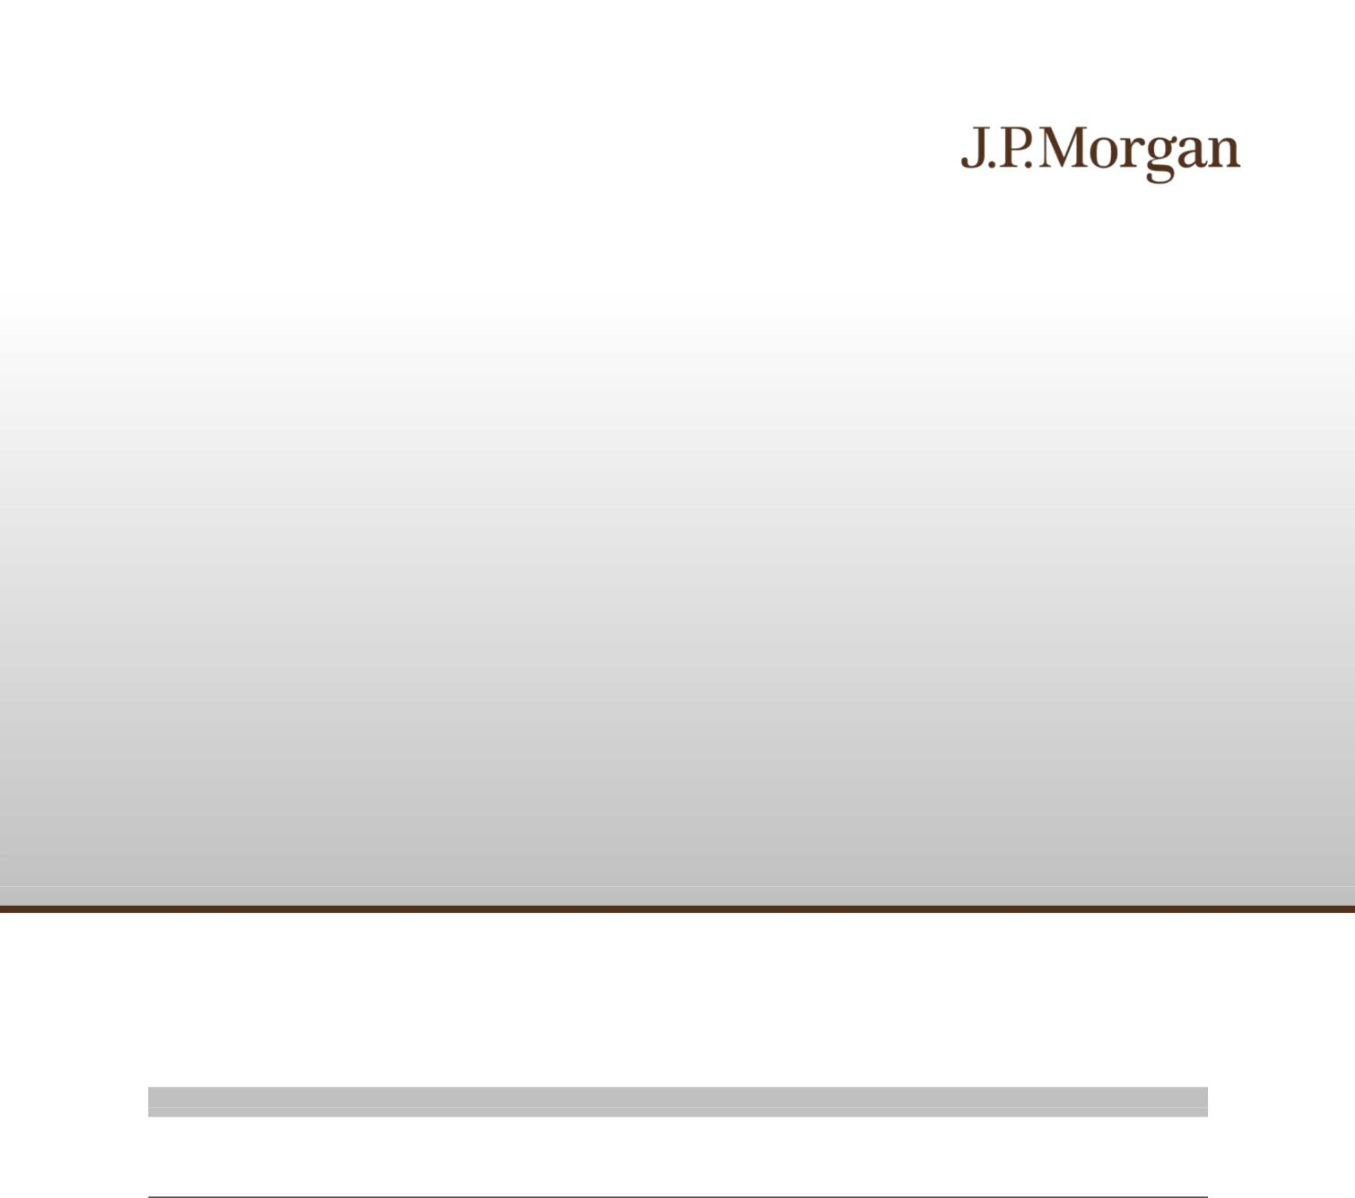

Subject to completion dated June 9, 2026

June , 2026 Registration Statement Nos. 333-293684 and 333-293684-01; Rule 424(b)(2)

JPMorgan Chase Financial Company LLC Structured Investments

Contingent Interest Notes Linked to the Least Performing of the S&P 500® Index, the Nasdaq-100® Technology Sector IndexSM and the Russell 2000® Index due June 22, 2029

Fully and Unconditionally Guaranteed by JPMorgan Chase & Co.

- The notes are designed for investors who seek a Contingent Interest Payment with respect to each Review Date for which the closing level of each of the S&P 500® Index, the Nasdaq-100® Technology Sector IndexSM and the Russell

2000® Index, which we refer to as the Indices, is greater than or equal to 70.00% of its Initial Value, which we refer to as an Interest Barrier.

- Investors should be willing to accept the risk of losing a significant portion or all of their principal and the risk that no Contingent Interest Payment may be made with respect to some or all Review Dates.

- Investors should also be willing to forgo fixed interest and dividend payments, in exchange for the opportunity to receive Contingent Interest Payments.

- The notes are unsecured and unsubordinated obligations of JPMorgan Chase Financial Company LLC, which we refer to as JPMorgan Financial, the payment on which is fully and unconditionally guaranteed by JPMorgan Chase & Co. Any payment on the notes is subject to the credit risk of JPMorgan Financial, as issuer of the notes, and the credit risk of JPMorgan Chase & Co., as guarantor of the notes.

- Payments on the notes are not linked to a basket composed of the Indices. Payments on the notes are linked to the performance of each of the Indices individually, as described below.

- Minimum denominations of $1,000 and integral multiples thereof

- The notes are expected to price on or about June 18, 2026 and are expected to settle on or about June 24, 2026.

- CUSIP: 46661AWU0

Investing in the notes involves a number of risks. See “Risk Factors” beginning on page S-2 of the accompanying prospectus supplement, “Risk Factors” beginning on page PS-12 of the accompanying product supplement and “Selected Risk Considerations” beginning on page PS-5 of this pricing supplement.

Neither the Securities and Exchange Commission (the “SEC”) nor any state securities commission has approved or disapproved of the notes or passed upon the accuracy or the adequacy of this pricing supplement or the accompanying product supplement, underlying supplement, prospectus supplement and prospectus. Any representation to the contrary is a criminal offense.

 | Price to Public (1) | Fees and Commissions (2) | Proceeds to Issuer
Per note | $1,000 | $ | $
Total | $ | $ | $

- See “Supplemental Use of Proceeds” in this pricing supplement for information about the components of the price to public of the notes.
- J.P. Morgan Securities LLC, which we refer to as JPMS, acting as agent for JPMorgan Financial, will pay all of the selling commissions it receives from us to other affiliated or unaffiliated dealers. In no event will these selling commissions exceed $5.00 per $1,000 principal amount note. See “Plan of Distribution (Conflicts of Interest)” in the accompanying product supplement.

If the notes priced today, the estimated value of the notes would be approximately $980.40 per $1,000 principal amount note. The estimated value of the notes, when the terms of the notes are set, will be provided in the pricing supplement and will not be less than $950.00 per $1,000 principal amount note. See “The Estimated Value of the Notes” in this pricing supplement for additional information.

The notes are not bank deposits, are not insured by the Federal Deposit Insurance Corporation or any other governmental agency and are not obligations of, or guaranteed by, a bank.

Pricing supplement to product supplement no. 3-I dated April 17, 2026, underlying supplement no. 1-I dated April 17, 2026 and the prospectus and prospectus supplement, each dated April 17, 2026

Key Terms
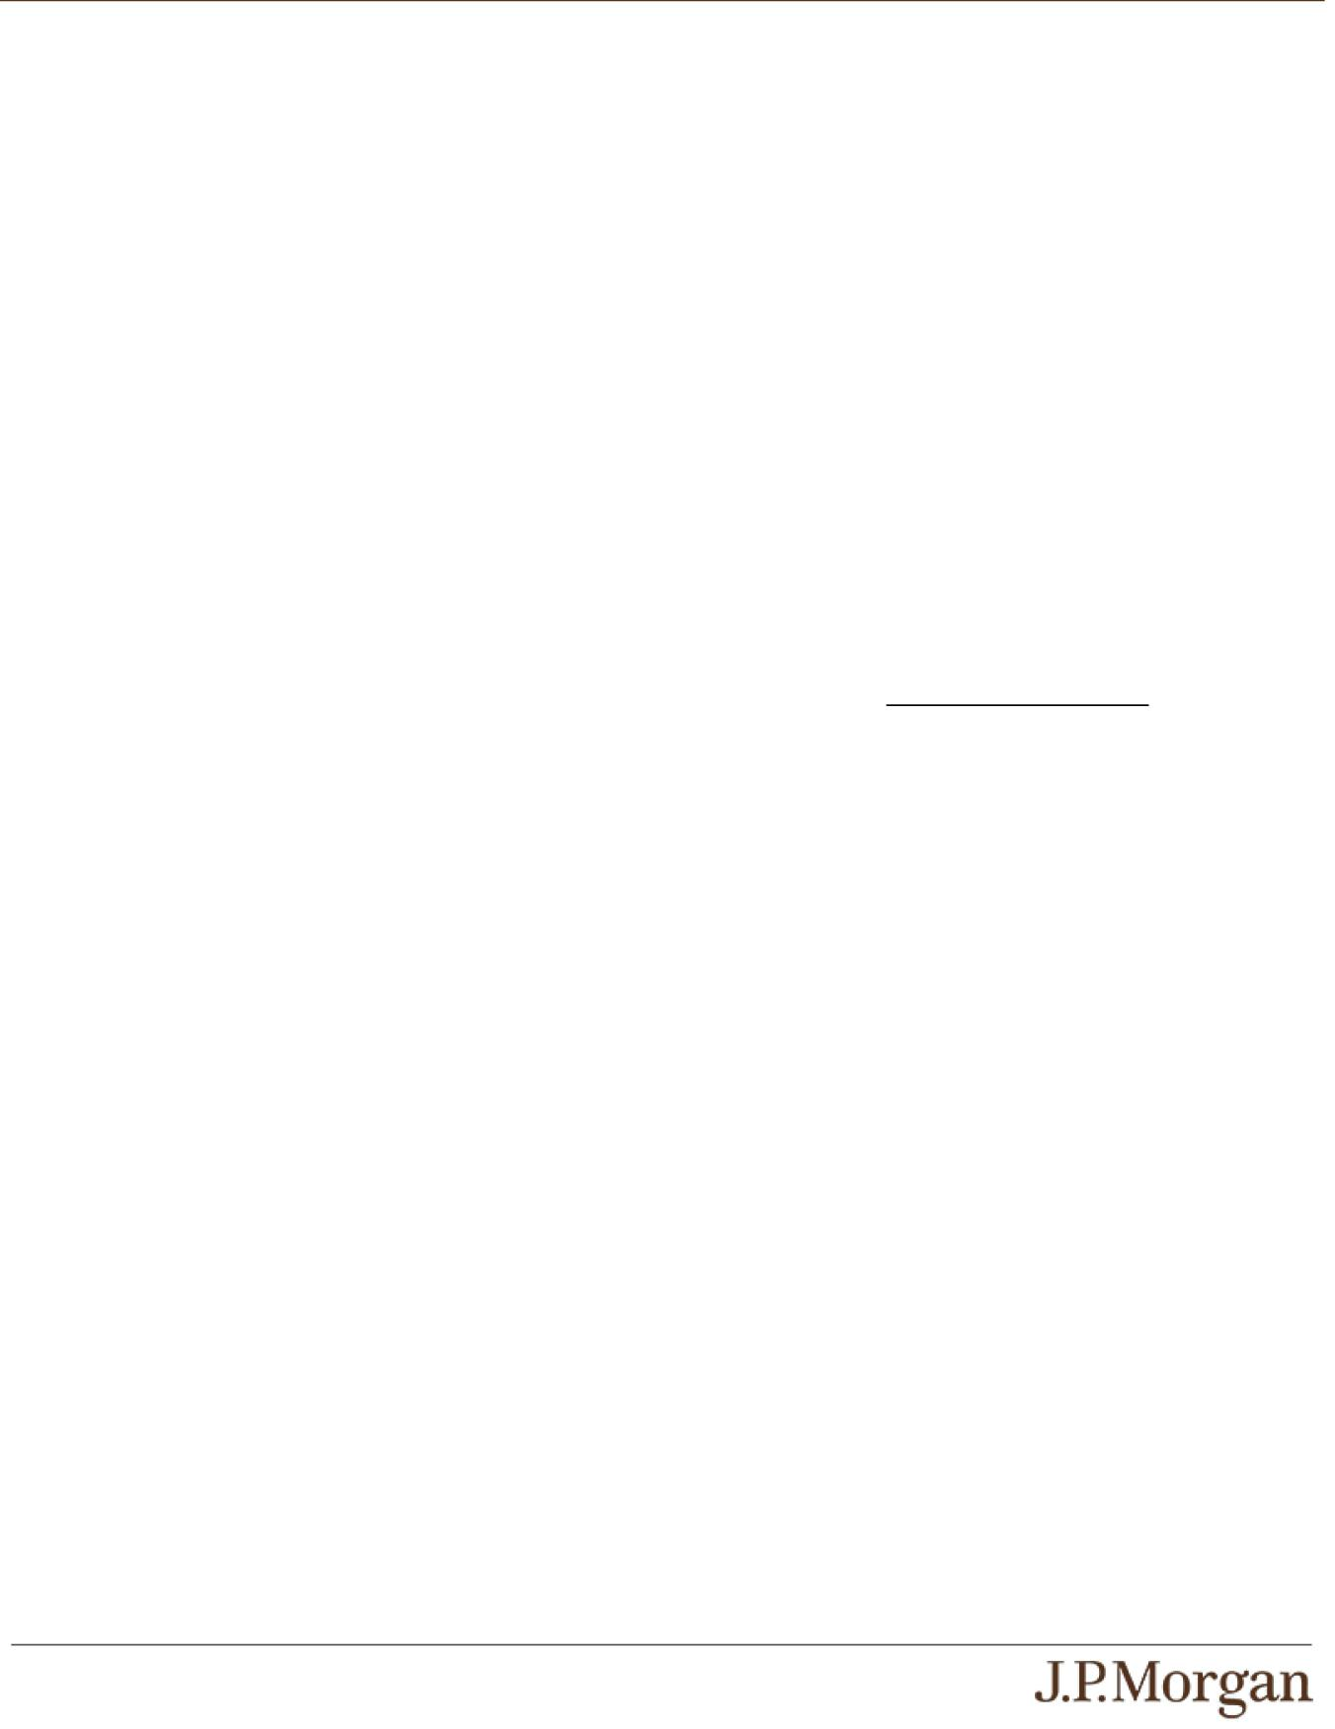

Issuer: JPMorgan Chase Financial Company LLC, a direct, wholly owned finance subsidiary of JPMorgan Chase & Co.

Guarantor: JPMorgan Chase & Co.

Indices: The S&P 500® Index (Bloomberg ticker: SPX), the Nasdaq-100® Technology Sector IndexSM (Bloomberg ticker: NDXT) and the Russell 2000® Index (Bloomberg ticker: RTY)

Contingent Interest Payments: If the closing level of each Index on any Review Date is greater than or equal to its Interest Barrier, you will receive on the applicable Interest Payment Date for each $1,000 principal amount note a Contingent Interest Payment equal to at least $8.4167 (equivalent to a Contingent Interest Rate of at least 10.10% per annum, payable at a rate of at least 0.84167% per month) (to be provided in the pricing supplement).

If the closing level of any Index on any Review Date is less than its Interest Barrier, no Contingent Interest Payment will be made with respect to that Review Date.

Contingent Interest Rate: At least 10.10% per annum, payable at a rate of at least 0.84167% per month (to be provided in the pricing supplement)

Interest Barrier / Trigger Value: With respect to each Index, 70.00% of its Initial Value

Pricing Date: On or about June 18, 2026

Original Issue Date (Settlement Date): On or about June 24, 2026

Review Dates*: July 20, 2026, August 18, 2026, September 18, 2026, October 19, 2026, November 18, 2026, December 18, 2026, January 19, 2027, February 18, 2027, March 18, 2027, April 19, 2027, May 18, 2027, June 21, 2027, July 19, 2027, August 18, 2027, September 20, 2027, October 18, 2027, November 18, 2027, December 20, 2027, January 18, 2028, February 18, 2028, March 20, 2028, April 18, 2028, May 18, 2028, June 20, 2028, July 18, 2028, August 18, 2028, September 18, 2028, October 18, 2028, November 20, 2028, December 18, 2028, January 18, 2029, February 20, 2029, March 19, 2029, April 18, 2029, May 18, 2029 and June 18, 2029 (final Review Date)

Interest Payment Dates*: July 23, 2026, August 21, 2026, September 23, 2026, October 22, 2026, November 23, 2026, December 23, 2026, January 22, 2027, February 23, 2027, March 23, 2027, April 22, 2027, May 21, 2027, June 24, 2027, July 22, 2027, August 23, 2027, September 23, 2027, October 21, 2027, November 23, 2027, December 23, 2027, January 21, 2028, February 24, 2028, March 23, 2028, April 21, 2028, May 23, 2028, June 23, 2028, July 21, 2028, August 23, 2028, September 21, 2028, October 23, 2028, November 24, 2028, December 21, 2028, January 23, 2029, February 23, 2029, March 22, 2029, April 23, 2029, May 23, 2029 and the Maturity Date

Maturity Date*: June 22, 2029

PS-1 | Structured Investments
Contingent Interest Notes Linked to the Least Performing of the S&P 500® Index, the Nasdaq-100® Technology Sector IndexSM and the Russell 2000® Index

Payment at Maturity:

If the Final Value of each Index is greater than or equal to its Trigger Value, you will receive a cash payment at maturity, for each $1,000 principal amount note, equal to (a) $1,000 plus (b) the Contingent Interest Payment applicable to the final Review Date.

If the Final Value of any Index is less than its Trigger Value, your payment at maturity per $1,000 principal amount note will be calculated as follows:

$1,000 + ($1,000 × Least Performing Index Return)

If the Final Value of any Index is less than its Trigger Value, you will lose more than 30.00% of your principal amount at maturity and could lose all of your principal amount at maturity.

Least Performing Index: The Index with the Least Performing Index Return

Least Performing Index Return: The lowest of the Index Returns of the Indices

Index Return:

With respect to each Index,

(Final Value – Initial Value)

Initial Value

Initial Value: With respect to each Index, the closing level of that Index on the Pricing Date

Final Value: With respect to each Index, the closing level of that Index on the final Review Date

- Subject to postponement in the event of a market disruption event and

as described under “General Terms of Notes — Postponement of a Determination Date — Notes Linked to Multiple Underlyings” and

“General Terms of Notes — Postponement of a Payment Date” in the accompanying product supplement

How the Notes Work
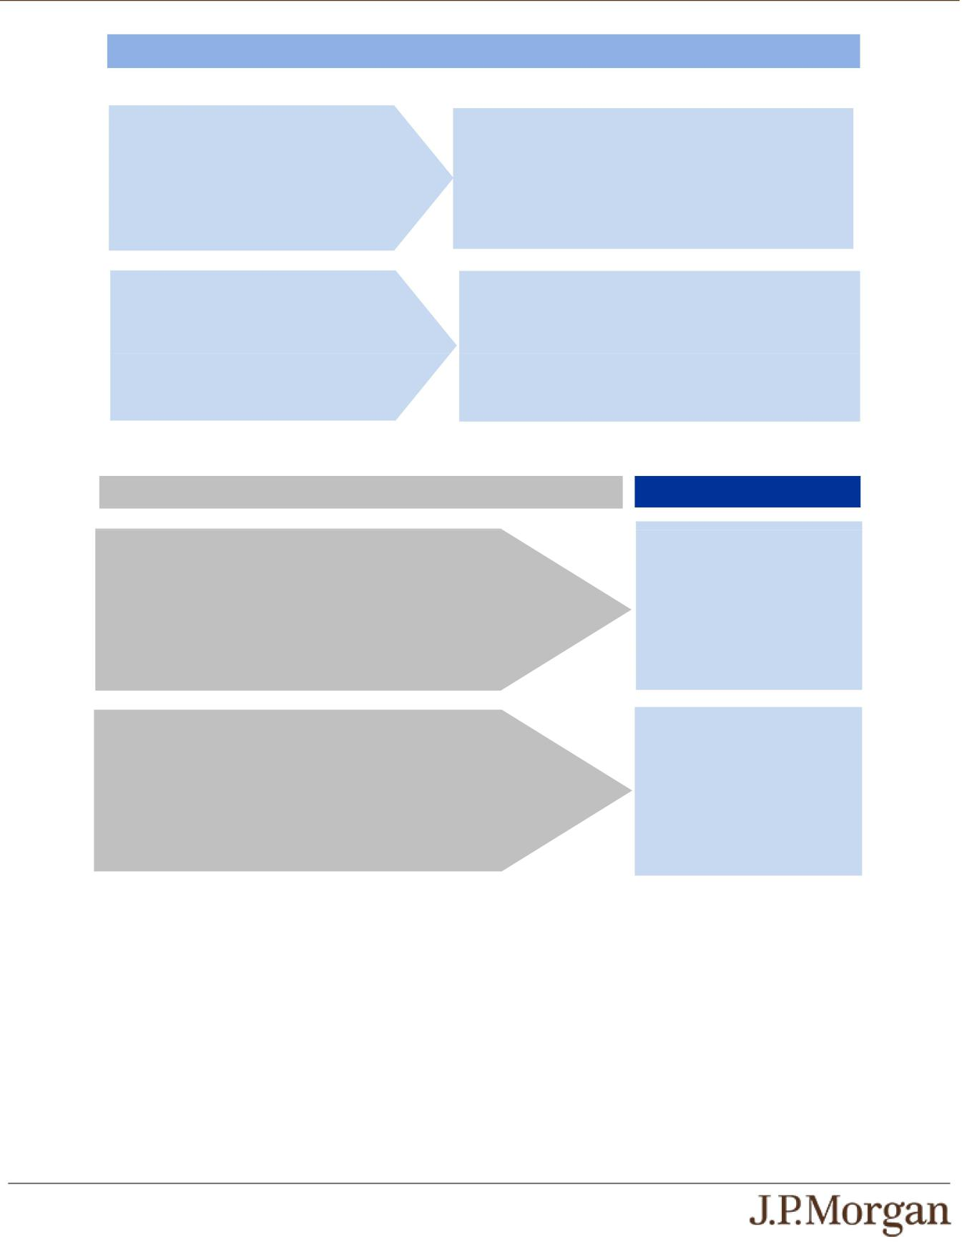

Payments in Connection with Review Dates Preceding the Final Review Date

Review Dates Preceding the Final Review Date

Compare the closing level of each Index to its Interest Barrier on each Review Date.

The closing level of each Index is greater than | You will receive a Contingent Interest Payment on the
The closing level of each Index is greater than | applicable Interest Payment Date.
or equal to its Interest Barrier. | Proceed to the next Review Date.

No Contingent Interest Payment will be made with respect to

The closing level of any Index is less than its the applicable Review Date.
Interest Barrier.

Proceed to the next Review Date.

Payment at Maturity

Final Review Date

The Final Value of each Index is greater than or equal to its Trigger Value.

The Final Value of any Index is less than its Trigger Value.

Payment at Maturity

You will receive (a) $1,000 plus (b) the Contingent Interest Payment applicable to the final Review Date.

You will receive:

$1,000 + ($1,000 × Least
Performing Index Return)

Under these circumstances, you will
lose a significant portion or all of
your principal amount at maturity.

PS-2 | Structured Investments
Contingent Interest Notes Linked to the Least Performing of the S&P 500® Index, the Nasdaq-100® Technology Sector IndexSM and the Russell 2000® Index

Total Contingent Interest Payments

The table below illustrates the hypothetical total Contingent Interest Payments per $1,000 principal amount note over the term of the notes based on a hypothetical Contingent Interest Rate of 10.10% per annum, depending on how many Contingent Interest Payments are made prior to maturity. The actual Contingent Interest Rate will be provided in the pricing supplement and will be at least 10.10% per annum (payable at a rate of at least 0.84167% per month).
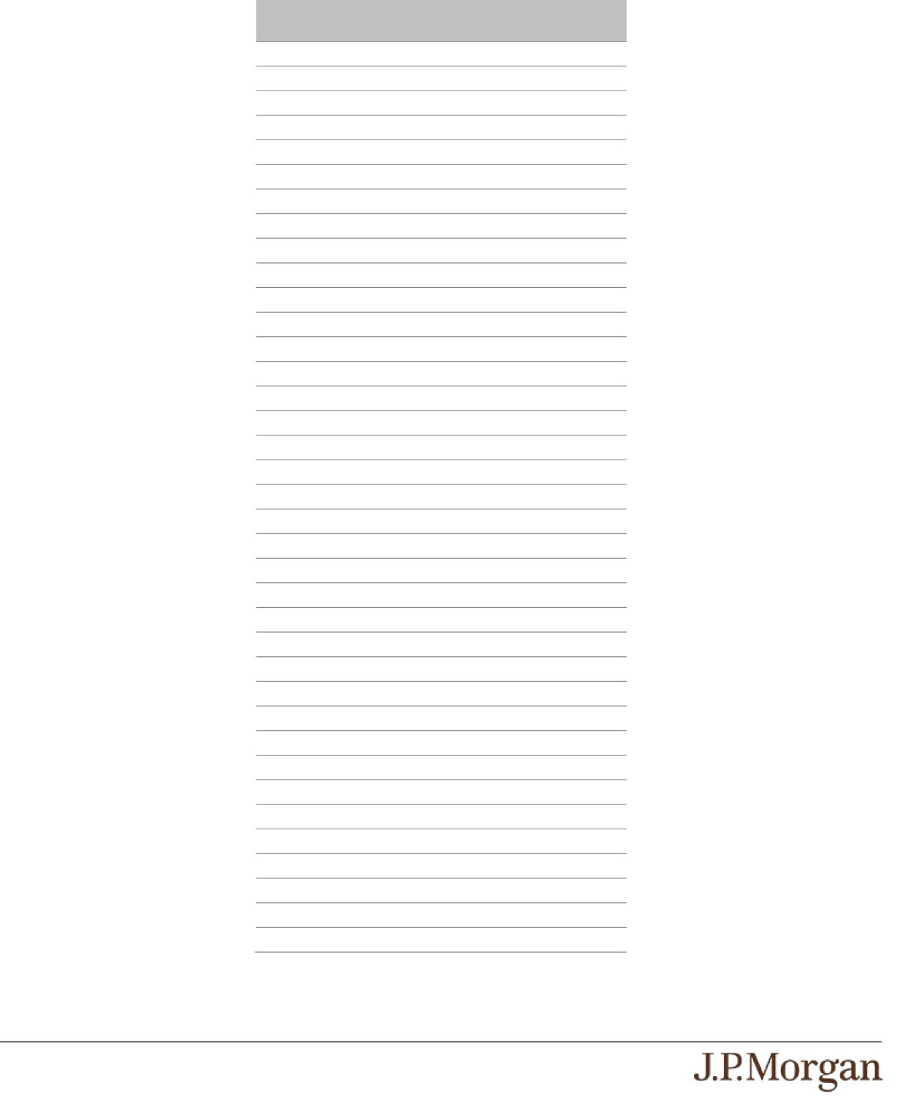

Number of Contingent | Total Contingent Interest
Interest Payments | Payments
36 | $303.0000
35 | $294.5833
34 | $286.1667
33 | $277.7500
32 | $269.3333
31 | $260.9167
30 | $252.5000
29 | $244.0833
28 | $235.6667
27 | $227.2500
26 | $218.8333
25 | $210.4167
24 | $202.0000
23 | $193.5833
22 | $185.1667
21 | $176.7500
20 | $168.3333
19 | $159.9167
18 | $151.5000
17 | $143.0833
16 | $134.6667
15 | $126.2500
14 | $117.8333
13 | $109.4167
12 | $101.0000
11 | $92.5833
10 | $84.1667
9 | $75.7500
8 | $67.3333
7 | $58.9167
6 | $50.5000
5 | $42.0833
4 | $33.6667
3 | $25.2500
2 | $16.8333
1 | $8.4167
0 | $0.0000

PS-3 | Structured Investments
Contingent Interest Notes Linked to the Least Performing of the S&P 500®
Index, the Nasdaq-100® Technology Sector IndexSM and the Russell 2000®
Index

Hypothetical Payout Examples
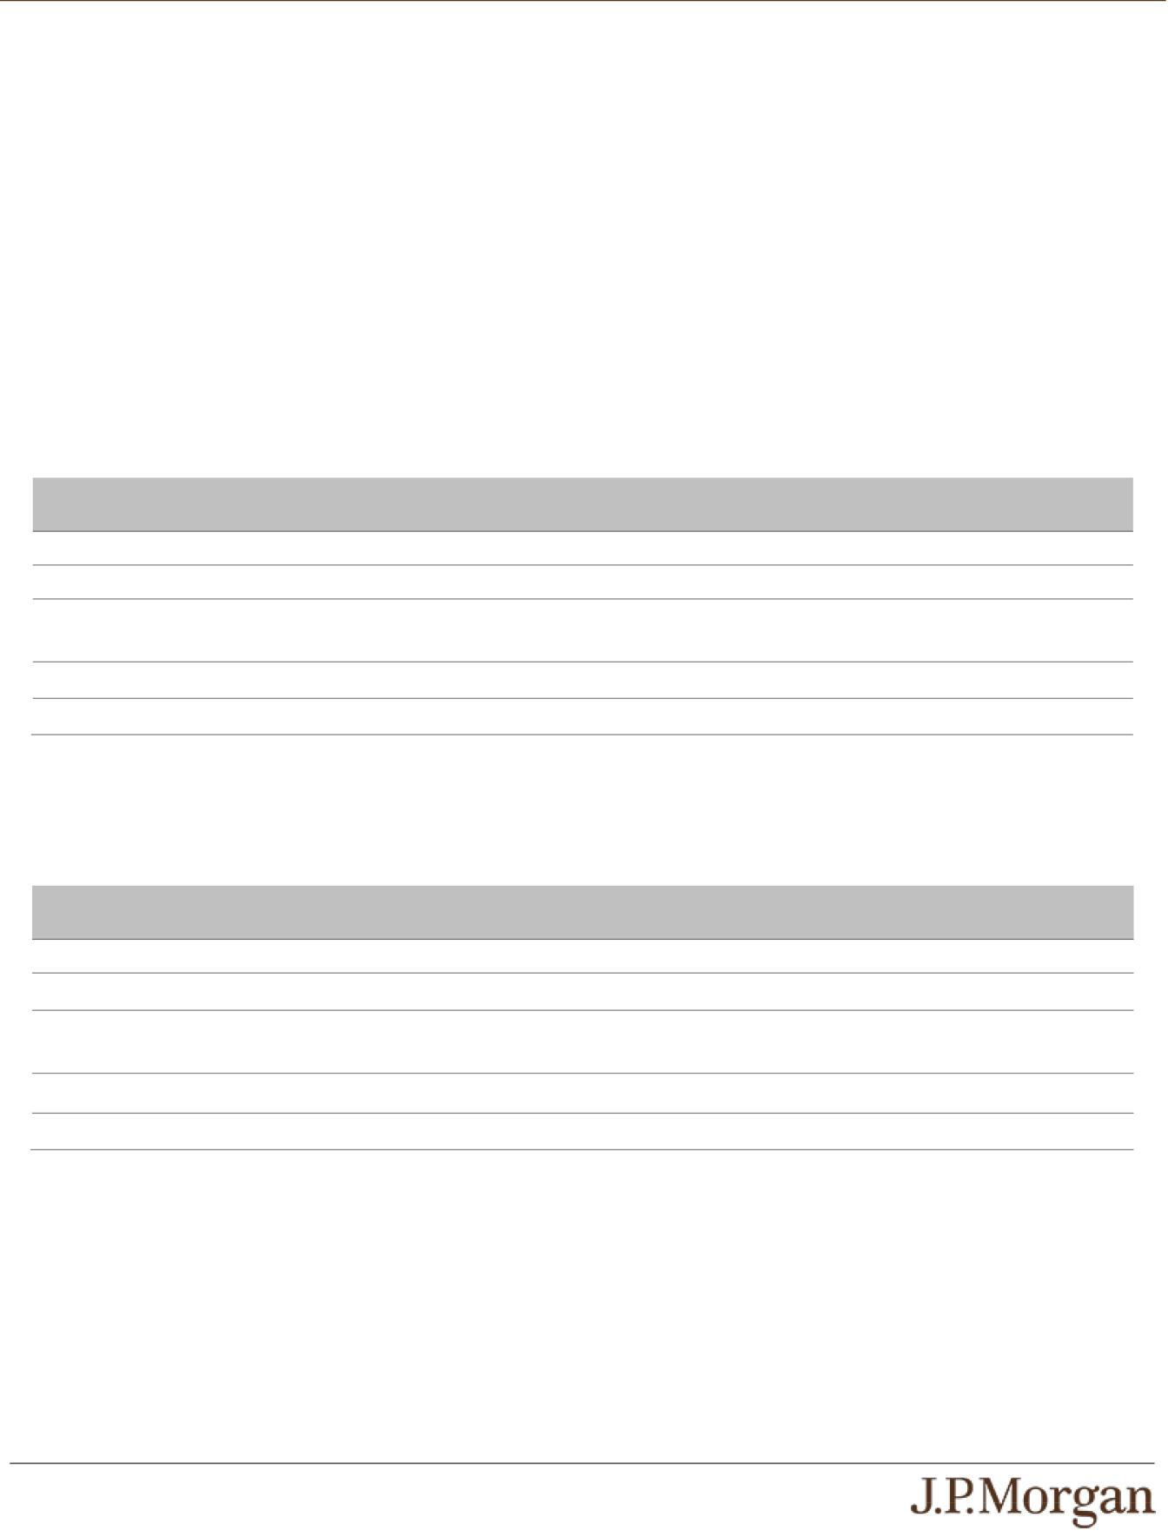

The following examples illustrate payments on the notes linked to three hypothetical Indices, assuming a range of performances for the

hypothetical Least Performing Index on the Review Dates. Solely for purposes of this section, the Least Performing Index with respect to each Review Date is the least performing of the Indices determined based on the closing level of each Index on that Review Date compared with its Initial Value.

The hypothetical payments set forth below assume the following:

- an Initial Value for each Index of 100.00;

- an Interest Barrier and a Trigger Value for each Index of 70.00 (equal to 70.00% of its hypothetical Initial Value); and

- a Contingent Interest Rate of 10.10% per annum.

The hypothetical Initial Value of each Index of 100.00 has been chosen for illustrative purposes only and may not represent a likely actual Initial Value of any Index. The actual Initial Value of each Index will be the closing level of that Index on the Pricing Date and will be provided in the pricing supplement. For historical data regarding the actual closing levels of each Index, please see the historical information set forth under “The Indices” in this pricing supplement.

Each hypothetical payment set forth below is for illustrative purposes only and may not be the actual payment applicable to a purchaser of the notes. The numbers appearing in the following examples have been rounded for ease of analysis.

Example 1 — The Final Value of the Least Performing Index is greater than or equal to its Trigger Value.

Date | Closing Level of Least | Payment (per $1,000 principal amount note)
 | Performing Index
First Review Date | 95.00 | $8.4167
Second Review Date | 85.00 | $8.4167
Third through Thirty-Fifth | Less than Interest Barrier | $0
Review Dates
Final Review Date | 90.00 | $1,008.4167
 | Total Payment | $1,025.25 (2.525% return)

Because the Final Value of the Least Performing Index is greater than or equal to its Trigger Value, the payment at maturity, for each

$1,000 principal amount note, will be $1,008.4167 (or $1,000 plus the Contingent Interest Payment applicable to the final Review Date). When added to the Contingent Interest Payments received with respect to the prior Review Dates, the total amount paid, for each $1,000 principal amount note, is $1,025.25.

Example 2 — The Final Value of the Least Performing Index is less than its Trigger Value.

Date | Closing Level of Least | Payment (per $1,000 principal amount note)
 | Performing Index
First Review Date | 40.00 | $0
Second Review Date | 45.00 | $0
Third through Thirty-Fifth | Less than Interest Barrier | $0
Review Dates
Final Review Date | 40.00 | $400.00
 | Total Payment | $400.00 (-60.00% return)

Because the Final Value of the Least Performing Index is less than its Trigger Value and the Least Performing Index Return is -60.00%, the payment at maturity will be $400.00 per $1,000 principal amount note, calculated as follows:

$1,000 + [$1,000 × (-60.00%)] = $400.00

The hypothetical returns and hypothetical payments on the notes shown above apply only if you hold the notes for their entire term. These hypotheticals do not reflect the fees or expenses that would be associated with any sale in the secondary market. If these fees and expenses were included, the hypothetical returns and hypothetical payments shown above would likely be lower.

PS-4 | Structured Investments
Contingent Interest Notes Linked to the Least Performing of the S&P 500®
Index, the Nasdaq-100® Technology Sector IndexSM and the Russell 2000®
Index

Selected Risk Considerations
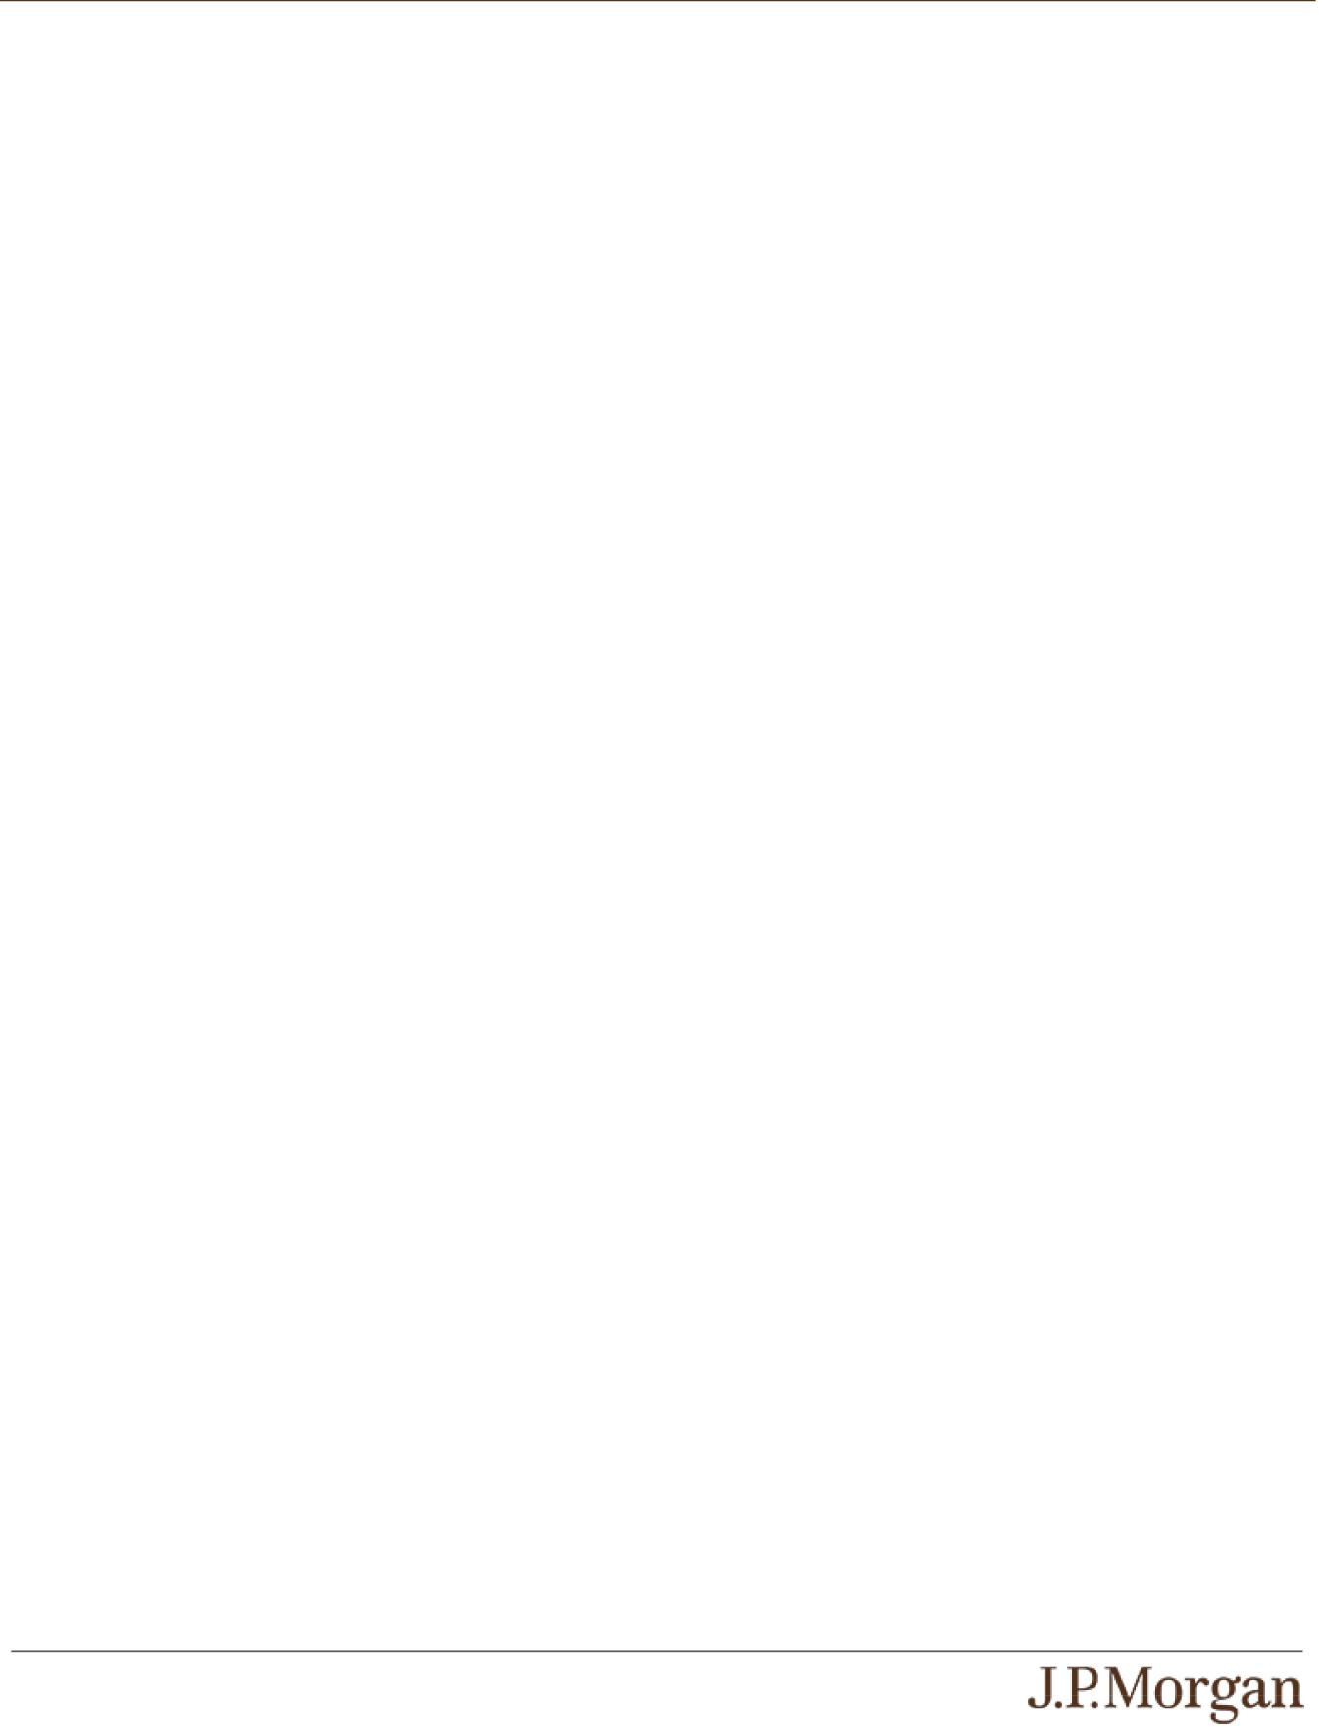

An investment in the notes involves significant risks. These risks are explained in more detail in the “Risk Factors” sections of the accompanying prospectus supplement and product supplement.

Risks Relating to the Notes Generally

- YOUR INVESTMENT IN THE NOTES MAY RESULT IN A LOSS —

The notes do not guarantee any return of principal. If the Final Value of any Index is less than its Trigger Value, you will lose 1% of

the principal amount of your notes for every 1% that the Final Value of the Least Performing Index is less than its Initial Value. Accordingly, under these circumstances, you will lose more than 30.00% of your principal amount at maturity and could lose all of your principal amount at maturity.

- THE NOTES DO NOT GUARANTEE THE PAYMENT OF INTEREST AND MAY NOT PAY ANY INTEREST AT ALL —

We will make a Contingent Interest Payment with respect to a Review Date only if the closing level of each Index on that Review Date is greater than or equal to its Interest Barrier. If the closing level of any Index on a Review Date is less than its Interest
Barrier, no Contingent Interest Payment will be made with respect to that Review Date. Accordingly, if the closing level of any Index on each Review Date is less than its Interest Barrier, you will not receive any interest payments over the term of the notes.

- CREDIT RISKS OF JPMORGAN FINANCIAL AND JPMORGAN CHASE & CO. —

Investors are dependent on our and JPMorgan Chase & Co.’s ability to pay all amounts due on the notes. Any actual or potential change in our or JPMorgan Chase & Co.’s creditworthiness or credit spreads, as determined by the market for taking that credit
risk, is likely to adversely affect the value of the notes. If we and JPMorgan Chase & Co. were to default on our payment obligations, you may not receive any amounts owed to you under the notes and you could lose your entire investment.

- AS A FINANCE SUBSIDIARY, JPMORGAN FINANCIAL HAS NO INDEPENDENT ACTIVITIES AND HAS LIMITED ASSETS —

As a finance subsidiary of JPMorgan Chase & Co., we have no independent activities beyond the issuance and administration of our securities and the collection of intercompany obligations. Aside from the initial capital contribution from JPMorgan Chase & Co., substantially all of our assets relate to obligations of JPMorgan Chase & Co. to make payments under loans made by us to
JPMorgan Chase & Co. or under other intercompany agreements. As a result, we are dependent upon payments from JPMorgan Chase & Co. to meet our obligations under the notes. We are not an operating subsidiary of JPMorgan Chase & Co. and in a bankruptcy or resolution of JPMorgan Chase & Co. we are not expected to have sufficient resources to meet our obligations in
respect of the notes as they come due. If JPMorgan Chase & Co. does not make payments to us and we are unable to make payments on the notes, you may have to seek payment under the related guarantee by JPMorgan Chase & Co., and that
guarantee will rank pari passu with all other unsecured and unsubordinated obligations of JPMorgan Chase & Co. For more information, see “Risk Factors — Holders of securities issued by JPMorgan Financial may be subject to losses if JPMorgan Chase & Co. were to enter into a resolution” in the accompanying prospectus supplement.

- THE APPRECIATION POTENTIAL OF THE NOTES IS LIMITED TO THE SUM OF ANY CONTINGENT INTEREST PAYMENTS THAT MAY BE PAID OVER THE TERM OF THE NOTES,

regardless of any appreciation of any Index, which may be significant. You will not participate in any appreciation of any Index.

- YOU ARE EXPOSED TO THE RISK OF DECLINE IN THE LEVEL OF EACH INDEX —

Payments on the notes are not linked to a basket composed of the Indices and are contingent upon the performance of each individual Index. Poor performance by any of the Indices over the term of the notes may negatively affect whether you will receive a Contingent Interest Payment on any Interest Payment Date and your payment at maturity and will not be offset or mitigated by positive performance by any other Index.

- YOUR PAYMENT AT MATURITY WILL BE DETERMINED BY THE LEAST PERFORMING INDEX.

- THE BENEFIT PROVIDED BY THE TRIGGER VALUE MAY TERMINATE ON THE FINAL REVIEW DATE —

If the Final Value of any Index is less than its Trigger Value, the benefit provided by the Trigger Value will terminate and you will be fully exposed to any depreciation of the Least Performing Index.

- YOU WILL NOT RECEIVE DIVIDENDS ON THE SECURITIES INCLUDED IN ANY INDEX OR HAVE ANY RIGHTS WITH RESPECT TO THOSE SECURITIES.

PS-5 | Structured Investments
Contingent Interest Notes Linked to the Least Performing of the S&P 500®
Index, the Nasdaq-100® Technology Sector IndexSM and the Russell 2000®
Index

- THE RISK OF THE CLOSING LEVEL OF AN INDEX FALLING BELOW ITS INTEREST BARRIER OR TRIGGER VALUE IS GREATER IF THE LEVEL OF THAT INDEX IS VOLATILE.

- LACK OF LIQUIDITY —

The notes will not be listed on any securities exchange. Accordingly, the price at which you may be able to trade your notes is likely to depend on the price, if any, at which JPMS is willing to buy the notes. You may not be able to sell your notes. The notes are not designed to be short-term trading instruments. Accordingly, you should be able and willing to hold your notes to maturity.

- THE FINAL TERMS AND VALUATION OF THE NOTES WILL BE PROVIDED IN THE PRICING SUPPLEMENT —

You should consider your potential investment in the notes based on the minimums for the estimated value of the notes and the Contingent Interest Rate.

Risks Relating to Conflicts of Interest

- POTENTIAL CONFLICTS —

We and our affiliates play a variety of roles in connection with the notes. In performing these duties, our and JPMorgan Chase & Co.’s economic interests are potentially adverse to your interests as an investor in the notes. It is possible that hedging or trading
activities of ours or our affiliates in connection with the notes could result in substantial returns for us or our affiliates while the value of the notes declines. Please refer to “Risk Factors — Risks Relating to Conflicts of Interest” in the accompanying product supplement.

Risks Relating to the Estimated Value and Secondary Market Prices of the Notes

- THE ESTIMATED VALUE OF THE NOTES WILL BE LOWER THAN THE ORIGINAL ISSUE PRICE (PRICE TO PUBLIC) OF THE NOTES —

The estimated value of the notes is only an estimate determined by reference to several factors. The original issue price of the

notes will exceed the estimated value of the notes because costs associated with selling, structuring and hedging the notes are included in the original issue price of the notes. These costs include the selling commissions, the projected profits, if any, that our
affiliates expect to realize for assuming risks inherent in hedging our obligations under the notes, the estimated cost of hedging our obligations under the notes and the fees, if any, paid for third-party data analytics and/or electronic platform services. See “The Estimated Value of the Notes” in this pricing supplement.

- THE ESTIMATED VALUE OF THE NOTES DOES NOT REPRESENT FUTURE VALUES OF THE NOTES AND MAY DIFFER FROM OTHERS’ ESTIMATES —

See “The Estimated Value of the Notes” in this pricing supplement.

- THE ESTIMATED VALUE OF THE NOTES IS DERIVED BY REFERENCE TO AN INTERNAL FUNDING RATE —

The internal funding rate used in the determination of the estimated value of the notes may differ from the market-implied funding rate for vanilla fixed income instruments of a similar maturity issued by JPMorgan Chase & Co. or its affiliates. Any difference may be based on, among other things, our and our affiliates’ view of the funding value of the notes as well as the higher issuance,
operational and ongoing liability management costs of the notes in comparison to those costs for the conventional fixed income instruments of JPMorgan Chase & Co. This internal funding rate is based on certain market inputs and assumptions, which may prove to be incorrect, and is intended to approximate the prevailing market replacement funding rate for the notes. The use of an
internal funding rate and any potential changes to that rate may have an adverse effect on the terms of the notes and any secondary market prices of the notes. See “The Estimated Value of the Notes” in this pricing supplement.

- THE VALUE OF THE NOTES AS PUBLISHED BY JPMS (AND WHICH MAY BE REFLECTED ON CUSTOMER ACCOUNT STATEMENTS) MAY BE HIGHER THAN THE THEN-CURRENT ESTIMATED VALUE OF THE NOTES FOR A LIMITED TIME PERIOD —

We generally expect that some of the costs included in the original issue price of the notes will be partially paid back to you in connection with any repurchases of your notes by JPMS in an amount that will decline to zero over an initial predetermined period. See “Secondary Market Prices of the Notes” in this pricing supplement for additional information relating to this initial period.
Accordingly, the estimated value of your notes during this initial period may be lower than the value of the notes as published by JPMS (and which may be shown on your customer account statements).

PS-6 | Structured Investments
Contingent Interest Notes Linked to the Least Performing of the S&P 500®
Index, the Nasdaq-100® Technology Sector IndexSM and the Russell 2000®
Index

- SECONDARY MARKET PRICES OF THE NOTES WILL LIKELY BE LOWER THAN THE ORIGINAL ISSUE PRICE OF THE NOTES —

Any secondary market prices of the notes will likely be lower than the original issue price of the notes because, among other things, secondary market prices take into account our internal secondary market funding rates for structured debt issuances and, also, because secondary market prices may exclude selling commissions, projected hedging profits, if any, estimated hedging
costs and fees, if any, paid for third-party data analytics and/or electronic platform services that are included in the original issue price of the notes. As a result, the price, if any, at which JPMS will be willing to buy the notes from you in secondary market
transactions, if at all, is likely to be lower than the original issue price. Furthermore, if you sell your notes, you will likely be charged a commission for secondary market transactions, or the price will likely reflect a dealer discount and/or fees for use of an electronic platform to facilitate secondary market activity. Any sale by you prior to the Maturity Date could result in a substantial loss to you.

- SECONDARY MARKET PRICES OF THE NOTES WILL BE IMPACTED BY MANY ECONOMIC AND MARKET FACTORS —

The secondary market price of the notes during their term will be impacted by a number of economic and market factors, which may either offset or magnify each other, aside from the selling commissions, projected hedging profits, if any, estimated hedging
costs and the levels of the Indices. Additionally, independent pricing vendors and/or third party broker-dealers may publish a price for the notes, which may also be reflected on customer account statements. This price may be different (higher or lower) than the
price of the notes, if any, at which JPMS may be willing to purchase your notes in the secondary market. See “Risk Factors — Risks Relating to the Estimated Value and Secondary Market Prices of the Notes — Secondary market prices of the notes will be impacted by many economic and market factors” in the accompanying product supplement.

Risks Relating to the Indices

- JPMORGAN CHASE & CO. IS CURRENTLY ONE OF THE COMPANIES THAT MAKE UP THE S&P 500® INDEX,

but JPMorgan Chase & Co. will not have any obligation to consider your interests in taking any corporate action that might affect the level of the S&P 500® Index.

- RISKS ASSOCIATED WITH THE TECHNOLOGY SECTOR WITH RESPECT TO THE NASDAQ-100® TECHNOLOGY SECTOR INDEXSM —
All or substantially all of the equity securities included in the Nasdaq-100® Technology Sector IndexSM are issued by companies whose primary line of business is directly associated with the technology sector. As a result, the value of the notes may be subject
to greater volatility and be more adversely affected by a single economic, political or regulatory occurrence affecting this sector than a different investment linked to securities of a more broadly diversified group of issuers. The value of stocks of technology companies and companies that rely heavily on technology is particularly vulnerable to rapid changes in technology product cycles,
rapid product obsolescence, government regulation and competition, both domestically and internationally, including competition from foreign competitors with lower production costs. Stocks of technology companies and companies that rely heavily on
technology, especially those of smaller, less-seasoned companies, tend to be more volatile than the overall market. Technology companies are heavily dependent on patent and intellectual property rights, the loss or impairment of which may adversely affect profitability. Additionally, companies in the technology sector may face dramatic and often unpredictable changes in growth rates
and competition for the services of qualified personnel. These factors could affect the technology sector and could affect the value of the equity securities included in the Nasdaq-100® Technology Sector IndexSM and the level of the Nasdaq-100® Technology Sector IndexSM during the term of the notes, which may adversely affect the value of your notes.

- NON-U.S. SECURITIES RISK WITH RESPECT TO THE NASDAQ-100® TECHNOLOGY SECTOR INDEXSM —

Some of the equity securities included in the Nasdaq-100® Technology Sector IndexSM have been issued by non-U.S. companies. Investments in securities linked to the value of such non-U.S. equity securities involve risks associated with the home countries of the issuers of those non-U.S. equity securities.

- AN INVESTMENT IN THE NOTES IS SUBJECT TO RISKS ASSOCIATED WITH SMALL CAPITALIZATION STOCKS WITH RESPECT TO THE RUSSELL 2000® INDEX —

Small capitalization companies may be less able to withstand adverse economic, market, trade and competitive conditions relative to larger companies. Small capitalization companies are less likely to pay dividends on their stocks, and the presence of a dividend payment could be a factor that limits downward stock price pressure under adverse market conditions.

PS-7 | Structured Investments
Contingent Interest Notes Linked to the Least Performing of the S&P 500®
Index, the Nasdaq-100® Technology Sector IndexSM and the Russell 2000®
Index

The Indices
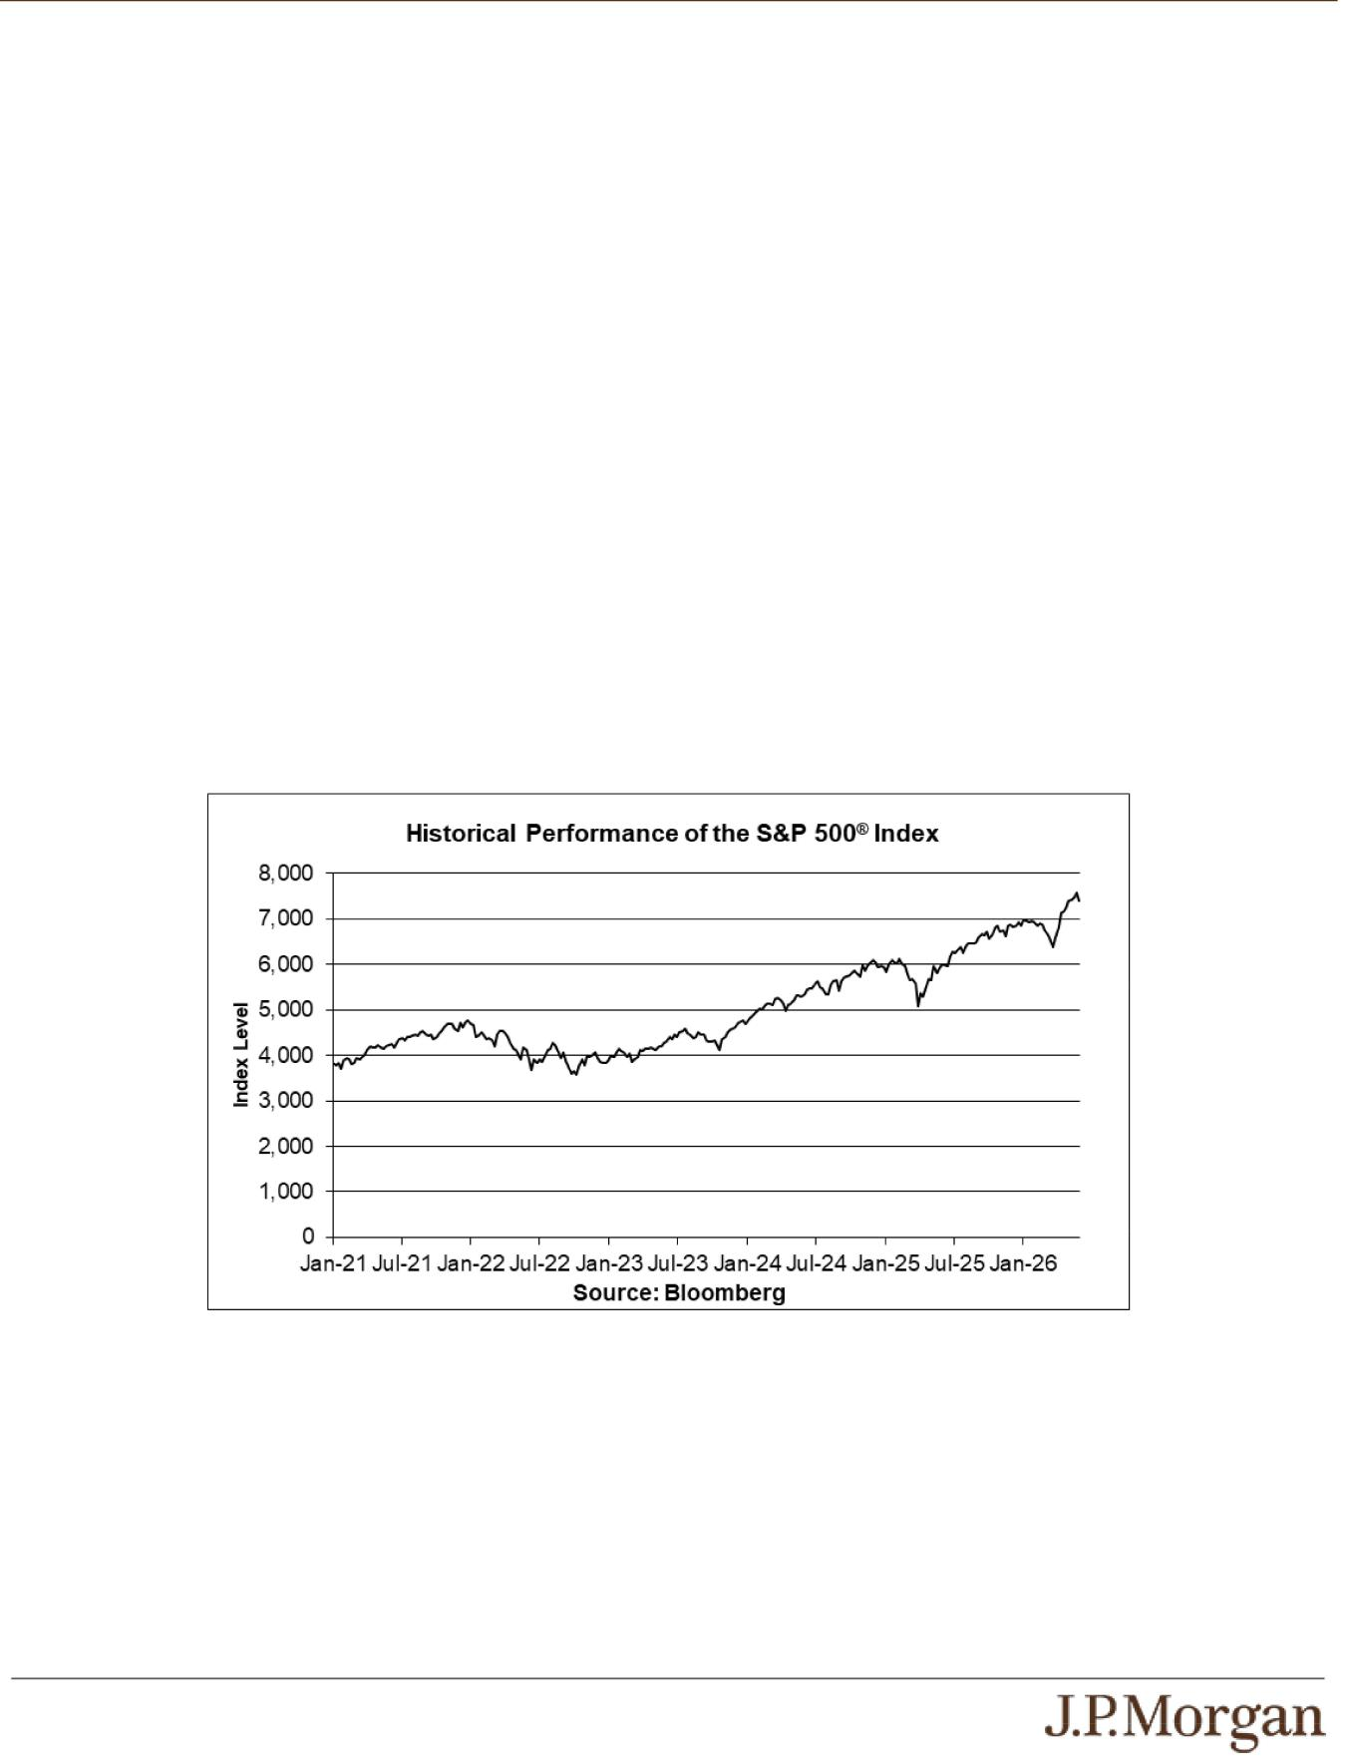

The S&P 500® Index consists of stocks of 500 companies selected to provide a performance benchmark for the large market capitalization segment of the U.S. equity markets. For additional information about the S&P 500® Index, see “Equity Index Descriptions — The S&P U.S. Indices” in the accompanying underlying supplement.

The Nasdaq-100® Technology Sector IndexSM is an equal-weighted, price-return index designed to measure the performance of the technology companies in the Nasdaq-100 Index®. The Nasdaq-100 Index® is a modified market capitalization-weighted index that is designed to measure the performance of 100 of the largest non-financial companies listed on The Nasdaq Stock Market. For additional information about the Nasdaq-100® Technology Sector IndexSM, see “Equity Index Descriptions ― The Nasdaq-100® Technology Sector IndexSM” in the accompanying underlying supplement.

The Russell 2000® Index measures the capitalization-weighted price performance of 2,000 U.S. small-capitalization stocks listed on eligible U.S. exchanges and is designed to track the performance of the small-capitalization segment of the U.S. equity market. The companies included in the Russell 2000® Index are the middle 2,000 of the companies that form the Russell 3000E™ Index, which is composed of the 4,000 largest U.S. companies as determined by total market capitalization and represents approximately 99% of the U.S. equity market. For additional information about the Russell 2000® Index, see “Equity Index Descriptions — The Russell Indices” in the accompanying underlying supplement.

Historical Information

The following graphs set forth the historical performance of each Index based on the weekly historical closing levels from January 8, 2021 through June 5, 2026. The closing level of the S&P 500® Index on June 8, 2026 was 7,405.73. The closing level of the Nasdaq-100® Technology Sector IndexSM on June 8, 2026 was 17,114.81. The closing level of the Russell 2000® Index on June 8, 2026 was 2,855.424. We obtained the closing levels above and below from the Bloomberg Professional® service (“Bloomberg”), without independent verification.

The historical closing levels of each Index should not be taken as an indication of future performance, and no assurance can be given as to the closing level of any Index on the Pricing Date or any Review Date. There can be no assurance that the performance of the Indices will result in the return of any of your principal amount or the payment of any interest.

PS-8 | Structured Investments
Contingent Interest Notes Linked to the Least Performing of the S&P 500®
Index, the Nasdaq-100® Technology Sector IndexSM and the Russell 2000®
Index

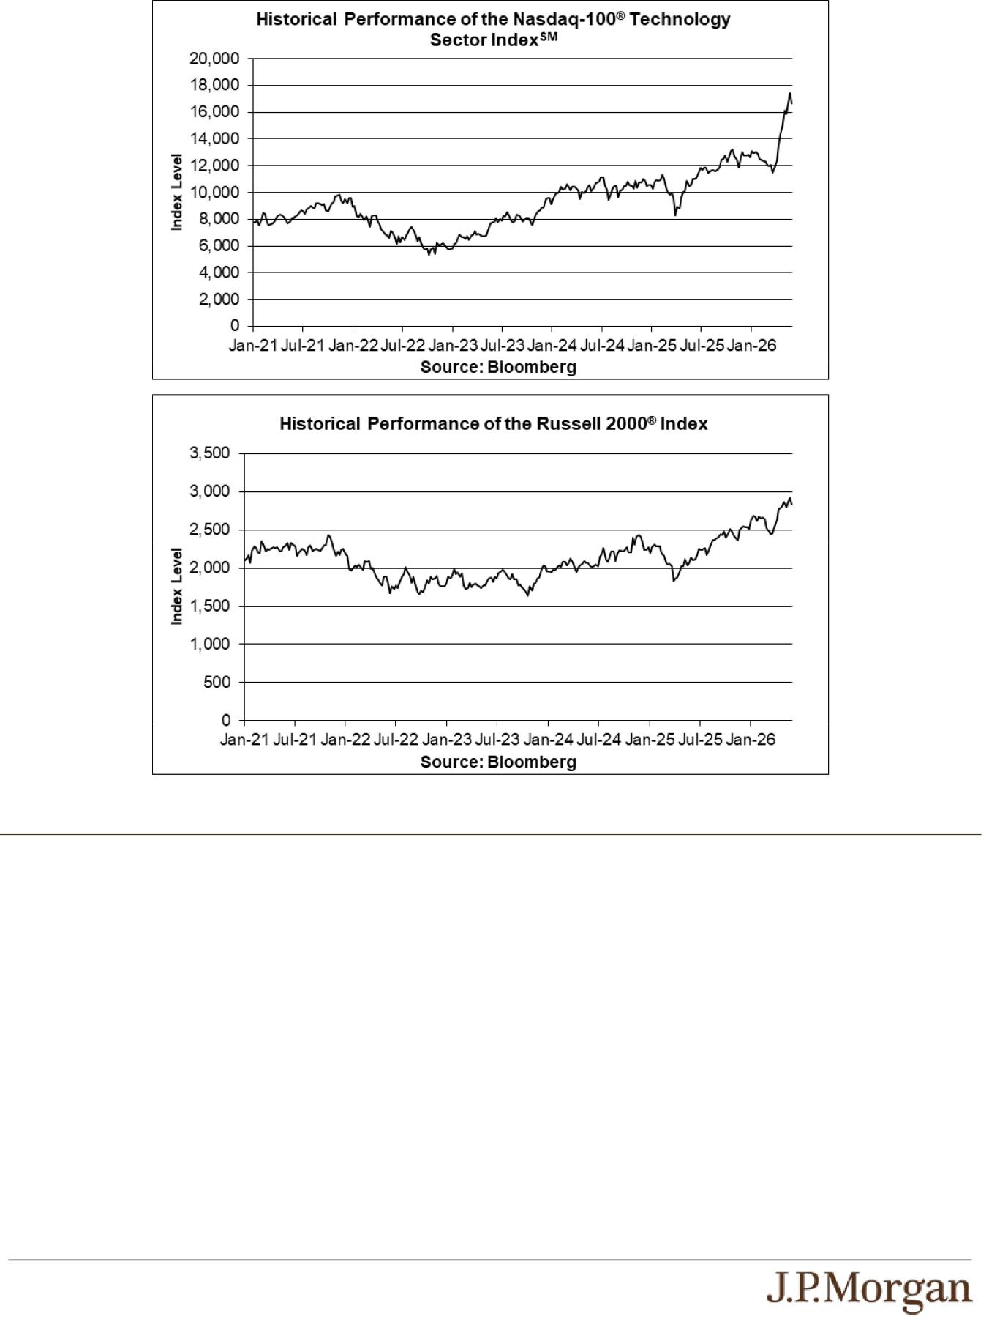

Tax Treatment

You should review carefully the section entitled “United States Federal Taxation” in the accompanying prospectus supplement. In determining our reporting responsibilities we intend to treat (i) the notes for U.S. federal income tax purposes as prepaid forward contracts with associated contingent coupons and (ii) any Contingent Interest Payments as ordinary income, as described in the section entitled “United States Federal Taxation — Tax Consequences to U.S. Holders — Program Securities Treated as Prepaid Financial Contracts with Associated Coupons” in the accompanying prospectus supplement. Based on the advice of Davis Polk & Wardwell LLP, our special tax counsel, we believe that this is a reasonable treatment, but that there are other reasonable treatments that the IRS or a court may adopt, in which case the timing and character of any income or loss on the notes could be materially affected. In addition, in 2007 Treasury and the IRS released a notice requesting comments on the U.S. federal income tax treatment of “prepaid forward contracts” and similar instruments. The notice focuses in particular on whether to require investors in these instruments to accrue income over the term of their investment. It also asks for comments on a number of related topics, including the character of income or loss with respect to these instruments and the relevance of factors such as the nature of the underlying property to which the instruments are linked. While the notice requests comments on appropriate transition rules and effective dates, any Treasury regulations or other guidance promulgated after consideration of these issues could materially affect the tax consequences of an investment in the notes, possibly with retroactive effect. The discussions above and in the accompanying prospectus supplement do not address the consequences to taxpayers subject to special tax accounting rules under Section 451(b) of the Code. You should consult your tax adviser regarding the U.S. federal income tax consequences of an investment in the notes, including possible alternative treatments and the issues presented by the notice described above.

PS-9 | Structured Investments
Contingent Interest Notes Linked to the Least Performing of the S&P 500®
Index, the Nasdaq-100® Technology Sector IndexSM and the Russell 2000®
Index

Non-U.S. Holders — Tax Considerations. The U.S. federal income tax treatment of Contingent Interest Payments is uncertain, and although we believe it is reasonable to take a position that Contingent Interest Payments are not subject to U.S. withholding tax (at least if an applicable Form W-8 is provided), it is expected that withholding agents will (and we, if we are the withholding agent, intend to) withhold on any Contingent Interest Payment paid to a Non-U.S. Holder generally at a rate of 30% or at a reduced rate specified by an applicable income tax treaty under an “other income” or similar provision. We will not be required to pay any additional amounts with respect to amounts withheld. In order to claim an exemption from, or a reduction in, the 30% withholding tax, a Non-U.S. Holder of the notes must comply with certification requirements to establish that it is not a U.S. person and is eligible for such an exemption or reduction under an applicable tax treaty. If you are a Non-U.S. Holder, you should consult your tax adviser regarding the tax treatment of the notes, including the possibility of obtaining a refund of any withholding tax and the certification requirement described above.

Section 871(m) of the Code and Treasury regulations promulgated thereunder (“Section 871(m)”) generally impose a 30% withholding tax (unless an income tax treaty applies) on dividend equivalents paid or deemed paid to Non-U.S. Holders with respect to certain financial instruments linked to U.S. equities or indices that include U.S. equities. Section 871(m) provides certain exceptions to this withholding regime, including for instruments linked to certain broad-based indices that meet requirements set forth in the applicable Treasury regulations. Additionally, a recent IRS notice excludes from the scope of Section 871(m) instruments issued prior to January 1, 2027 that do not have a delta of one with respect to underlying securities that could pay U.S.-source dividends for U.S. federal income tax purposes (each an “Underlying Security”). Based on certain determinations made by us, we expect that Section 871(m) will not apply to the notes with regard to Non-U.S. Holders. Our determination is not binding on the IRS, and the IRS may disagree with this determination. Section 871(m) is complex and its application may depend on your particular circumstances, including whether you enter into other transactions with respect to an Underlying Security. If necessary, further information regarding the potential application of Section 871(m) will be provided in the pricing supplement for the notes. You should consult your tax adviser regarding the potential application of Section 871(m) to the notes.

In the event of any withholding on the notes, we will not be required to pay any additional amounts with respect to amounts so withheld.

The Estimated Value of the Notes
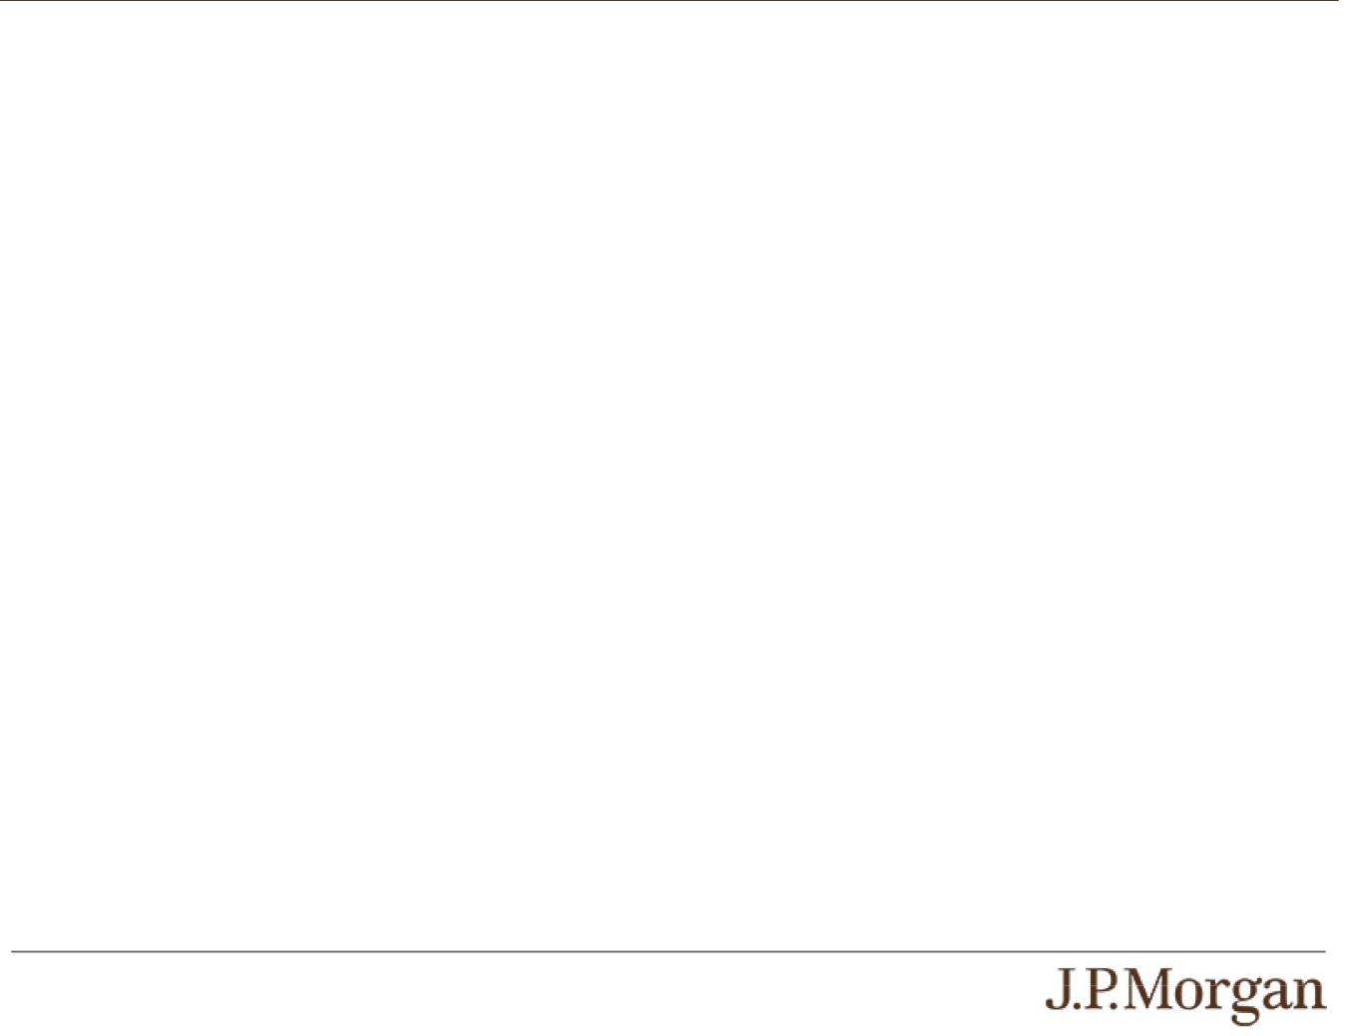

The estimated value of the notes set forth on the cover of this pricing supplement is equal to the sum of the values of the following hypothetical components: (1) a fixed-income debt component with the same maturity as the notes, valued using the internal funding rate described below, and (2) the derivative or derivatives underlying the economic terms of the notes. The estimated value of the notes does not represent a minimum price at which JPMS would be willing to buy your notes in any secondary market (if any exists) at any time. The internal funding rate used in the determination of the estimated value of the notes may differ from the market-implied funding rate for vanilla fixed income instruments of a similar maturity issued by JPMorgan Chase & Co. or its affiliates. Any difference may be based on, among other things, our and our affiliates’ view of the funding value of the notes as well as the higher issuance, operational and ongoing liability management costs of the notes in comparison to those costs for the conventional fixed income instruments of JPMorgan Chase & Co. This internal funding rate is based on certain market inputs and assumptions, which may prove to be incorrect, and is intended to approximate the prevailing market replacement funding rate for the notes. The use of an internal funding rate and any potential changes to that rate may have an adverse effect on the terms of the notes and any secondary market prices of the notes. For additional information, see “Selected Risk Considerations — Risks Relating to the Estimated Value and Secondary Market Prices of the Notes — The Estimated Value of the Notes Is Derived by Reference to an Internal Funding Rate” in this pricing supplement.

The value of the derivative or derivatives underlying the economic terms of the notes is derived from internal pricing models of our affiliates. These models are dependent on inputs such as the traded market prices of comparable derivative instruments and on various other inputs, some of which are market-observable, and which can include volatility, dividend rates, interest rates and other factors, as well as assumptions about future market events and/or environments. Accordingly, the estimated value of the notes is determined when the terms of the notes are set based on market conditions and other relevant factors and assumptions existing at that time.

The estimated value of the notes does not represent future values of the notes and may differ from others’ estimates. Different pricing models and assumptions could provide valuations for the notes that are greater than or less than the estimated value of the notes. In addition, market conditions and other relevant factors in the future may change, and any assumptions may prove to be incorrect. On future dates, the value of the notes could change significantly based on, among other things, changes in market conditions, our or JPMorgan Chase & Co.’s creditworthiness, interest rate movements and other relevant factors, which may impact the price, if any, at which JPMS would be willing to buy notes from you in secondary market transactions.

The estimated value of the notes will be lower than the original issue price of the notes because costs associated with selling, structuring and hedging the notes are included in the original issue price of the notes. These costs include the selling commissions paid to JPMS and other affiliated or unaffiliated dealers, the projected profits, if any, that our affiliates expect to realize for assuming

PS-10 | Structured Investments
Contingent Interest Notes Linked to the Least Performing of the S&P 500®
Index, the Nasdaq-100® Technology Sector IndexSM and the Russell 2000®
Index

risks inherent in hedging our obligations under the notes, the estimated cost of hedging our obligations under the notes and the fees, if any, paid for third-party data analytics and/or electronic platform services. Because hedging our obligations entails risk and may be influenced by market forces beyond our control, this hedging may result in a profit that is more or less than expected, or it may result in a loss. A portion of the profits, if any, realized in hedging our obligations under the notes may be allowed to other affiliated or unaffiliated dealers, and we or one or more of our affiliates will retain any remaining hedging profits. See “Selected Risk Considerations

— Risks Relating to the Estimated Value and Secondary Market Prices of the Notes — The Estimated Value of the Notes Will Be Lower Than the Original Issue Price (Price to Public) of the Notes” in this pricing supplement.

Secondary Market Prices of the Notes
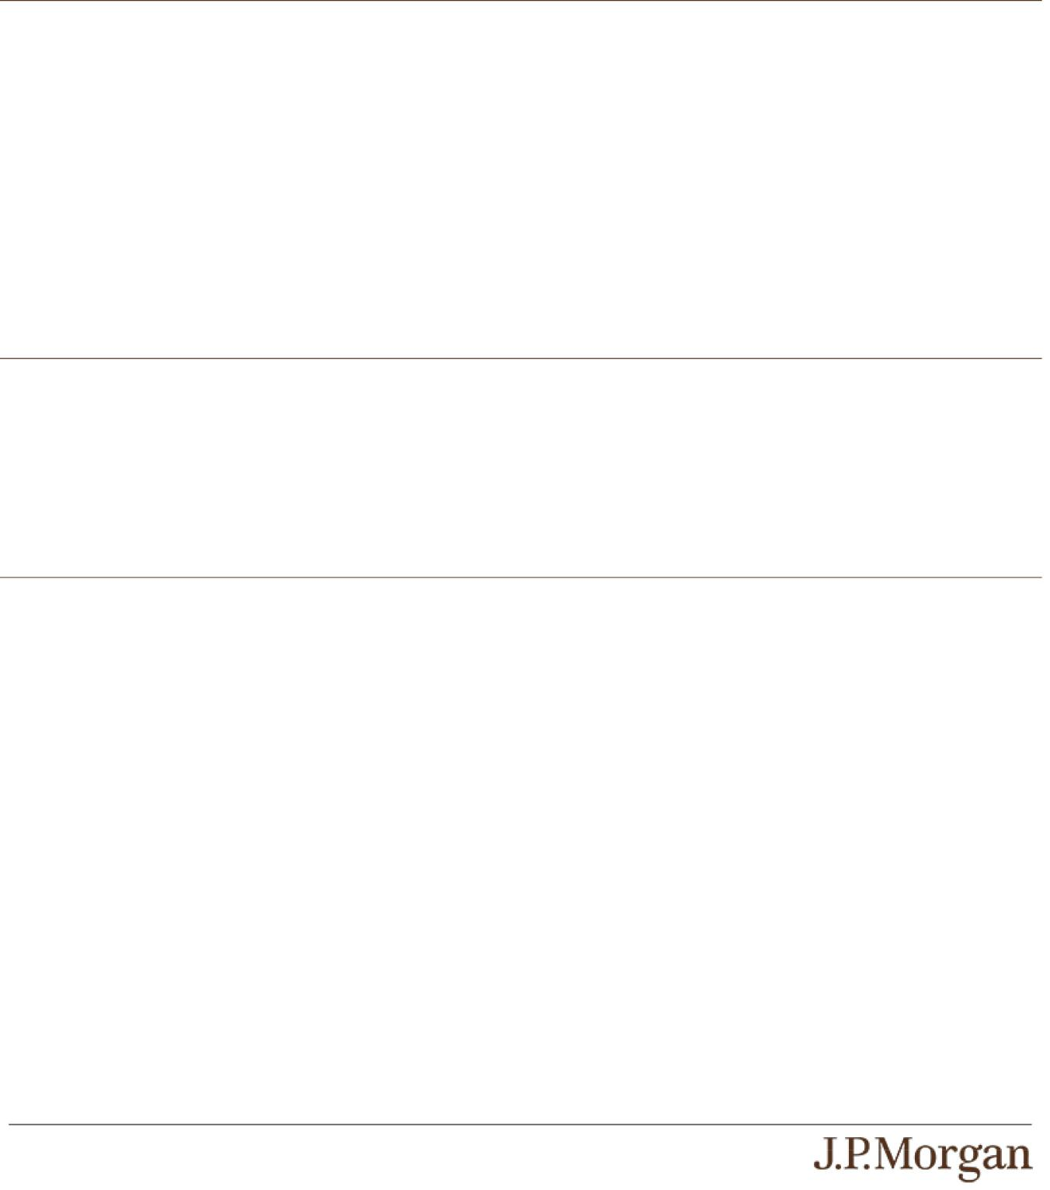

For information about factors that will impact any secondary market prices of the notes, see “Risk Factors — Risks Relating to the Estimated Value and Secondary Market Prices of the Notes — Secondary market prices of the notes will be impacted by many economic and market factors” in the accompanying product supplement. In addition, we generally expect that some of the costs included in the original issue price of the notes will be partially paid back to you in connection with any repurchases of your notes by JPMS in an amount that will decline to zero over an initial predetermined period. These costs can include selling commissions, projected hedging profits, if any, and, in some circumstances, estimated hedging costs, our internal secondary market funding rates for structured debt issuances and the fees paid for third-party data analytics and/or electronic platform services. This initial predetermined time period is intended to be the shorter of six months and one-half of the stated term of the notes. The length of any such initial period reflects the structure of the notes, whether our affiliates expect to earn a profit in connection with our hedging activities, the estimated costs of hedging the notes and when these costs are incurred, as determined by our affiliates. See “Selected Risk Considerations — Risks Relating to the Estimated Value and Secondary Market Prices of the Notes — The Value of the Notes as Published by JPMS (and Which May Be Reflected on Customer Account Statements) May Be Higher Than the Then-Current Estimated Value of the Notes for a Limited Time Period” in this pricing supplement.

Supplemental Use of Proceeds

The notes are offered to meet investor demand for products that reflect the risk-return profile and market exposure provided by the notes. See “How the Notes Work” and “Hypothetical Payout Examples” in this pricing supplement for an illustration of the risk-return profile of the notes and “The Indices” in this pricing supplement for a description of the market exposure provided by the notes.

The original issue price of the notes is equal to the estimated value of the notes plus the selling commissions paid to JPMS and other affiliated or unaffiliated dealers, plus (minus) the projected profits (losses) that our affiliates expect to realize for assuming risks inherent in hedging our obligations under the notes, plus the estimated cost of hedging our obligations under the notes, plus the fees, if any, paid for third-party data analytics and/or electronic platform services.

Additional Terms Specific to the Notes

You may revoke your offer to purchase the notes at any time prior to the time at which we accept such offer by notifying the applicable agent. We reserve the right to change the terms of, or reject any offer to purchase, the notes prior to their issuance. In the event of any changes to the terms of the notes, we will notify you and you will be asked to accept such changes in connection with your purchase. You may also choose to reject such changes, in which case we may reject your offer to purchase.

You should read this pricing supplement together with the accompanying prospectus, as supplemented by the accompanying prospectus supplement relating to our Series A medium-term notes of which these notes are a part, and the more detailed information contained in the accompanying product supplement and the accompanying underlying supplement. This pricing supplement, together with the documents listed below, contains the terms of the notes and supersedes all other prior or contemporaneous oral statements as well as any other written materials including preliminary or indicative pricing terms, correspondence, trade ideas, structures for implementation, sample structures, fact sheets, brochures or other educational materials of ours. You should carefully consider, among other things, the matters set forth in the “Risk Factors” sections of the accompanying prospectus supplement and the accompanying product supplement, as the notes involve risks not associated with conventional debt securities. We urge you to consult your investment, legal, tax, accounting and other advisers before you invest in the notes.

PS-11 | Structured Investments
Contingent Interest Notes Linked to the Least Performing of the S&P 500®
Index, the Nasdaq-100® Technology Sector IndexSM and the Russell 2000®
Index

You may access these documents on the SEC website at www.sec.gov as follows (or if such address has changed, by reviewing our filings for the relevant date on the SEC website):

- Product supplement no. 3-I dated April 17, 2026: http://www.sec.gov/Archives/edgar/data/19617/000121390026045198/ea0285802-20_424b2.pdf

- Underlying supplement no. 1-I dated April 17, 2026: http://www.sec.gov/Archives/edgar/data/19617/000121390026045209/ea0285802-11_424b2.pdf
- Prospectus supplement and prospectus, each dated April 17, 2026: http://www.sec.gov/Archives/edgar/data/19617/000095010326005889/crt_dp245141-424b2.pdf
Our Central Index Key, or CIK, on the SEC website is 1665650, and JPMorgan Chase & Co.’s CIK is 19617. As used in this pricing supplement, “we,” “us” and “our” refer to JPMorgan Financial.

PS-12 | Structured Investments
Contingent Interest Notes Linked to the Least Performing of the S&P 500®
Index, the Nasdaq-100® Technology Sector IndexSM and the Russell 2000®
Index

