JPMorgan Chase Financial Company LLC
Fully and Unconditionally Guaranteed by JPMorgan Chase & Co.

Filed Pursuant to Rule 433 Registration Statement Nos. 333-270004 and 333-270004-01

Market Linked Securities


Market Linked Securities—Auto-Callable with Contingent Coupon and Contingent Downside

Principal at Risk Securities Linked to the Common Stock of Freeport-McMoRan Inc. due December 22, 2028 Fact Sheet dated December 3, 2025 to Preliminary Pricing Supplement dated December 3, 2025

Summary of Terms |  |  |  |  |  |  | Summary of Terms (continued)
Issuer: | JPMorgan Chase Financial Company LLC |  |  |  |  |  | Fees and Commissions: |  | Up to 2.325% for Wells Fargo Securities, LLC
Guarantor: | JPMorgan Chase & C0. |  |  |  |  |  |  |  | (“WFS”); WFS has advised us that dealers, including
Underlying Stock: | The common stock of Freeport-McMoRan Inc. |  |  |  |  |  |  |  | Wells Fargo Advisors (“WFA”), may receive 1.75% of
 | (Bloomberg ticker: FCX) (the “Underlying Stock”) |  |  |  |  |  |  |  | WFS’s fee, and WFA may also receive a distribution
Pricing Date¹: | December 19, 2025 |  |  |  |  |  |  |  | expense fee of 0.075%. In addition, with respect of
 |  |  |  |  |  |  |  |  | certain securities sold in this offering, JPMS may
Issue Date¹: | December 24, 2025
Issue Date¹: |  |  |  |  |  |  |  |  | pay a fee of up to 0.30% to selected dealers in
Stated Maturity Date^{1, 2}: | December 22, 2028
Stated Maturity Date^{1, 2}: |  |  |  |  |  |  |  |  | consideration for marketing and other services in
Principal Amount: | $1,000 per security (100% of par) |  |  |  |  |  |  |  | connection with the distribution of the securities to
Contingent Coupon | On each contingent coupon payment date, you will |  |  |  |  |  |  |  | other dealers.
Payment: | receive a contingent coupon payment at a per |  |  |  |  |  | Tax Considerations: |  | See the preliminary pricing supplement.
 | annum rate equal to the contingent coupon rate if, |  |  |  |  |  | ¹ Subject to change
 | and only if, the stock closing price of the |  |  |  |  |  | ² Subject to postponement
 | Underlying Stock on the related calculation day is
 |  |  |  |  |  |  | Hypothetical Payout Profile (Maturity Payment
 | “contingent coupon payment,” if any, will be
 | greater than or equal to the threshold price. Each
 |  |  |  |  |  |  | Amount)
 | calculated per security as follows:
 |  | ($1,000 × contingent coupon rate) / 4
Contingent Coupon | Quarterly, on the third business day following each
Payment Dates^{1, 2}: | calculation day, provided that the contingent
 | coupon payment date with respect to the final
 | calculation day will be the stated maturity date
Contingent Coupon Rate: | At least 12.40% per annum (to be provided in the
 | pricing supplement)
Automatic Call: | If the stock closing price of the Underlying Stock on
 | any of the calculation days from March 2026 to
 | September 2028, inclusive, is greater than or equal
 | to the starting price, the securities will be
 | automatically called, and on the related call
 | settlement date you will be entitled to receive a cash
 | payment per security in U.S. dollars equal to the
 | principal amount per security plus a final contingent
 | coupon payment.
Calculation Days^{1, 2}: | Quarterly, on the 19th day of each March, June,
 | September and December, commencing March
 | 2026 and ending December 2028. We refer to
 | December 19, 2028 as the “final calculation day.” |  |  |  |  |  | If the securities are not automatically called prior to maturity and the
Call Settlement Date^{1, 2}: | Three business days after the applicable calculation
Call Settlement Date^{1, 2}: |  |  |  |  |  |  | ending price is less than the threshold price, you will lose more than
 | day
 |  |  |  |  |  |  | 40%, and possibly all, of the principal amount of your securities at
Maturity Payment Amount | If the securities are not automatically called:
Maturity Payment Amount |  |  |  |  |  |  | maturity.
(per Security): | · If the ending price is greater than or equal to the
(per Security): |  |  |  |  |  |  | Any return on the securities will be limited to the sum of your contingent
 |  | threshold price: $1,000; or
 |  |  |  |  |  |  | coupon payments, if any. You will not participate in any appreciation of
 | · If the ending price is less than the threshold price:
 |  |  |  |  |  |  | the Underlying Stock, but you will have full downside exposure to the
 |  | $1,000 + ($1,000 × stock return) |  |  |  |  | Underlying Stock on the final calculation day if the ending price is less
 |  |  |  |  |  |  | than the threshold price.
Starting Price: | The stock closing price of the Underlying Stock on
Starting Price: |  |  |  |  |  |  | The securities are unsecured and unsubordinated obligations of JPMorgan Chase
 | the pricing date
 |  |  |  |  |  |  | Financial Company LLC, which we refer to as JPMorgan Financial, the payment on
Ending Price: | The stock closing price of the Underlying Stock on
Ending Price: |  |  |  |  |  |  | which is fully and unconditionally guaranteed by JPMorgan Chase & Co. Any
 | the final calculation day
 |  |  |  |  |  |  | payment on the securities is subject to the credit risk of JPMorgan
Stock Return: | (ending price – starting price) / starting price
Stock Return: |  |  |  |  |  |  | Financial, as issuer of the securities, and the credit risk of JPMorgan
Threshold Price: | 60% of the starting price
Threshold Price: |  |  |  |  |  |  | Chase & Co., as guarantor of the securities.
Calculation Agent: | J.P. Morgan Securities LLC (“ |  |  | JPMS | ”) |  | If the securities priced on the date of the accompanying preliminary pricing
Denominations: | $1,000 and any integral multiple of $1,000 |  |  |  |  |  | supplement, the estimated value of the securities would be approximately $955.30
CUSIP: | 48136LM71 |  |  |  |  |  | per security. The estimated value of the securities, when the terms of the securities
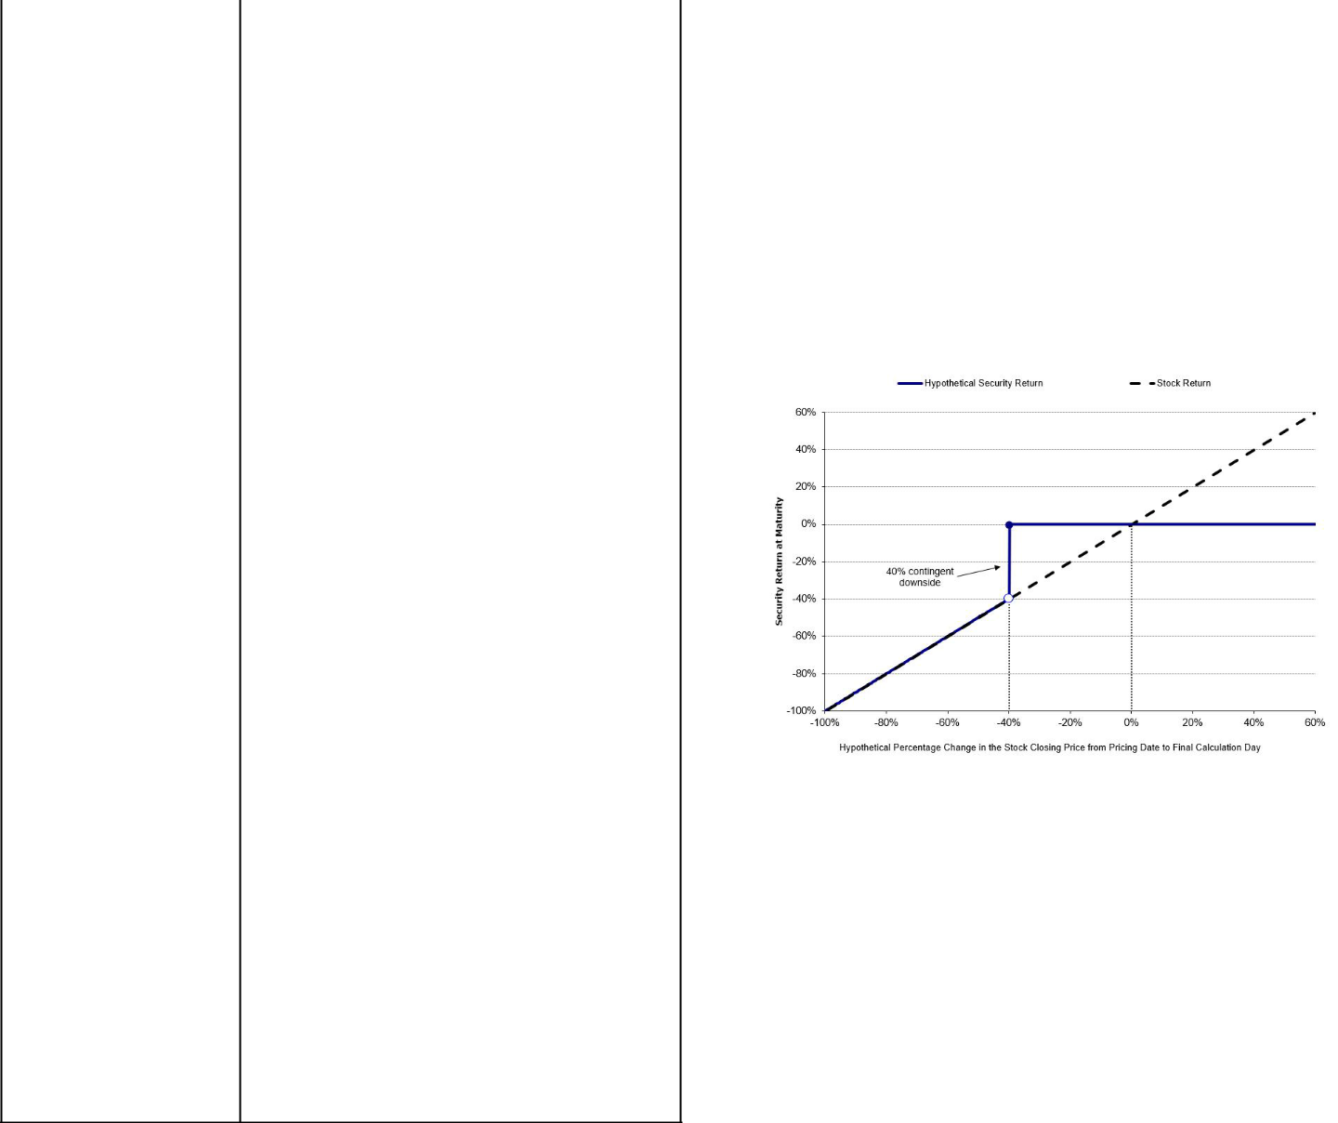
are set, will be provided in the pricing supplement and will not be less than $930.00
per security. See “The Estimated Value of the Securities” in the preliminary pricing

supplement for additional information.

Preliminary Pricing Supplement: http://www.sec.gov/Archives/edgar/data/19617/

000121390025117812/ea0268390-01_424b2.htm

The securities have complex features and investing in the securities involves risks not associated with an investment in conventional debt securities. See “Risk Factors” in the accompanying prospectus supplement and the accompanying product supplement, Annex A to the accompanying prospectus addendum and “Selected Risk Considerations” in the accompanying preliminary pricing supplement.

The securities are not bank deposits, are not insured by the Federal Deposit Insurance Corporation or any other governmental agency and are not obligations of, or guaranteed by, a bank.

THIS FACT SHEET DOES NOT PROVIDE ALL OF THE INFORMATION THAT AN INVESTOR SHOULD CONSIDER PRIOR TO MAKING AN INVESTMENT DECISION. This fact sheet should be read in conjunction with the accompanying preliminary pricing supplement, prospectus, prospectus supplement, prospectus addendum and product supplement.

Selected Risk Considerations

The risks set forth below are discussed in detail in the “Selected Risk Considerations” section in the accompanying preliminary pricing supplement, the “Risk Factors” sections in the accompanying prospectus supplement and product supplement and Annex A to the accompanying prospectus addendum. Please review the risk disclosure carefully.

- If the Securities Are Not Automatically Called and the Ending Price Is Less Than the Threshold Price, You Will Lose More Than 40%, and Possibly All, of the Principal Amount of Your Securities at Maturity.

- The Securities Do Not Guarantee the Payment of Interest and May Not Pay Any Interest at All.

- The Potential Return on the Securities Is Limited to the Sum of Any Contingent Coupon Payments and You Will Not Participate in Any Appreciation of the Underlying Stock.

- You Will Be Subject to Reinvestment Risk.

- The Securities Are Subject to the Credit Risks of JPMorgan Financial and JPMorgan Chase & Co.

- As a Finance Subsidiary, JPMorgan Financial Has No Independent Operations and Has Limited Assets.

- Higher Contingent Coupon Rates Are Associated with Greater Risk.

- The Benefit Provided by the Threshold Price May Terminate on the Final Calculation Day.

- No Dividend Payments or Voting Rights

- Lack of Liquidity

- The Final Terms and Estimated Valuation of the Securities Will Be Provided in the Pricing Supplement.

- The U.S. Federal Tax Consequences of the Securities Are Uncertain, and May Be Adverse to a Holder of the Securities.

- Potential Conflicts

- The Estimated Value of the Securities Will Be Lower Than the Original Issue Price (Price to Public) of the Securities.

- The Estimated Value of the Securities Does Not Represent Future Values of the Securities and May Differ from Others’ Estimates.

- The Estimated Value of the Securities Is Derived by Reference to an Internal Funding Rate.

- The Value of the Securities as Published by JPMS (and Which May Be Reflected on Customer Account Statements) May Be Higher Than the Then-Current Estimated Value of the Securities for a Limited Time Period.

- Secondary Market Prices of the Securities Will Likely Be Lower Than the Original Issue Price of the Securities.

- Many Economic and Market Factors Will Impact the Value of the Securities.

- No Affiliation with the Underlying Stock Issuer

- The Anti-Dilution Protection Is Limited and May Be Discretionary.

- Any Payment on the Securities Will Depend upon the Performance of the Underlying Stock and Therefore the Securities Are Subject to the Risks Associated with the Underlying Stock, Each as Discussed in the Accompanying Preliminary Pricing Supplement and Product Supplement.

SEC Legend: JPMorgan Chase Financial Company LLC and JPMorgan Chase & Co. have filed a registration statement (including a prospectus) with the SEC for any offerings to which these materials relate. Before you invest, you should read the prospectus in that registration statement and the other documents relating to this offering that JPMorgan Chase Financial Company LLC and JPMorgan Chase & Co. has filed with the SEC for more complete information about JPMorgan Chase Financial Company LLC and JPMorgan Chase & Co. and this offering. You may get these documents without cost by visiting EDGAR on the SEC web site at www.sec.gov. Alternatively, JPMorgan Chase Financial Company LLC and JPMorgan Chase & Co., any agent or any dealer participating in this offering will arrange to send you the prospectus and each prospectus supplement as well as any product supplement and preliminary pricing supplement if you so request by calling toll-free 1-866-535-9248.

As used in this fact sheet, “we,” “us” and “our” refer to JPMorgan Financial Company LLC. Wells Fargo Advisors is a trade name used by Wells Fargo Clearing Services, LLC and Wells Fargo Advisors Financial Network, LLC, members SIPC, separate registered broker-dealers and non-bank affiliates of Wells Fargo & Company.

