The information in this preliminary pricing supplement is not complete and may be changed. This preliminary pricing supplement is not an offer to sell nor does it seek an offer to buy these securities in any jurisdiction where the offer or sale is not permitted. Subject to completion dated February 3, 2021

February , 2021 Registration Statement Nos. 333-236659 and 333-236659-01; Rule 424(b)(2)


JPMorgan Chase Financial Company LLC

Structured Investments

Auto Callable Contingent Interest Notes Linked to the ARK Innovation ETF due February 18, 2026

Fully and Unconditionally Guaranteed by JPMorgan Chase & Co.

- The notes are designed for investors who seek a Contingent Interest Payment with respect to each Review Date for which the closing price of one share of the ARK Innovation ETF, which we refer to as the Fund, is greater than or equal to 80.00% of the Initial Value, which we refer to as the Interest Barrier.

- The notes will be automatically called if the closing price of one share of the Fund on any Review Date (other than the first through eleventh and final Review Dates) is greater than or equal to the Initial Value.

- The earliest date on which an automatic call may be initiated is February 14, 2022.

- Investors should be willing to accept the risk of losing up to 80.00% of their principal and the risk that no Contingent Interest Payment may be made with respect to some or all Review Dates.

- Investors should also be willing to forgo fixed interest and dividend payments, in exchange for the opportunity to receive Contingent Interest Payments.

- The Fund is actively managed and is subject to additional risks. Unlike a passively managed fund, an actively managed fund does not attempt to track an index or other benchmark, and the investment decisions for an actively managed fund are instead made by its investment adviser. See “Selected Risk Considerations — Risks Relating to the Fund — An Investment in the Notes Is Subject to Risks Associated with Actively Managed Funds” in this pricing supplement for more information.

- The notes are unsecured and unsubordinated obligations of JPMorgan Chase Financial Company LLC, which we refer to as JPMorgan Financial, the payment on which is fully and unconditionally guaranteed by JPMorgan Chase & Co. Any payment on the notes is subject to the credit risk of
JPMorgan Financial, as issuer of the notes, and the credit risk of JPMorgan Chase & Co., as guarantor of the notes.

- Minimum denominations of $1,000 and integral multiples thereof

- The notes are expected to price on or about February 12, 2021 and are expected to settle on or about February 18, 2021.

- CUSIP: 48132RXX3

Investing in the notes involves a number of risks. See “Risk Factors” beginning on page S-2 of the accompanying prospectus supplement, “Risk Factors” beginning on page PS-12 of the accompanying product supplement and “Selected Risk Considerations” beginning on page PS-6 of this pricing supplement.

Neither the Securities and Exchange Commission (the “SEC”) nor any state securities commission has approved or disapproved of the notes or passed upon the accuracy or the adequacy of this pricing supplement or the accompanying product supplement, prospectus supplement and prospectus. Any representation to the contrary is a criminal offense.

 | Price to Public (1) | Fees and Commissions (2) | Proceeds to Issuer
Per note | $1,000 | $ | $
Total | $ | $ | $

- See “Supplemental Use of Proceeds” in this pricing supplement for information about the components of the price to public of the notes.

- J.P. Morgan Securities LLC, which we refer to as JPMS, acting as agent for JPMorgan Financial, will pay all of the selling commissions it receives from us to other affiliated or unaffiliated dealers. In no event will these selling commissions exceed $37.50 per $1,000 principal amount note. See “Plan of Distribution (Conflicts of Interest)” in the accompanying product supplement.

If the notes priced today, the estimated value of the notes would be approximately $923.80 per $1,000 principal amount note. The estimated value of the notes, when the terms of the notes are set, will be provided in the pricing supplement and will not be less than $900.00 per $1,000 principal amount note. See “The Estimated Value of the Notes” in this pricing supplement for additional information.

The notes are not bank deposits, are not insured by the Federal Deposit Insurance Corporation or any other governmental agency and are not obligations of, or guaranteed by, a bank.

Pricing supplement to product supplement no. 4-II dated November 4, 2020
and the prospectus and prospectus supplement, each dated April 8, 2020

Key Terms

Issuer: JPMorgan Chase Financial Company LLC, an indirect, wholly owned finance subsidiary of JPMorgan Chase & Co.

Guarantor: JPMorgan Chase & Co.

Fund: The ARK Innovation ETF (Bloomberg ticker: ARKK)

Contingent Interest Payments: If the notes have not been automatically called and the closing price of one share of the Fund on any Review Date is greater than or equal to the Interest Barrier, you will receive on the applicable Interest Payment Date for each $1,000 principal amount note a Contingent Interest Payment equal to at least $10.0417 (equivalent to a Contingent Interest Rate of at least 12.05% per annum, payable at a rate of at least 1.00417% per month) (to be provided in the pricing supplement).

Maturity Date*: February 18, 2026

Call Settlement Date*: If the notes are automatically called on any Review Date (other than the first through eleventh and final Review Dates), the first Interest Payment Date immediately following that Review Date

- Subject to postponement in the event of a market disruption event and as described under “General Terms of Notes — Postponement of a Determination Date — Notes Linked to a Single Underlying — Notes Linked to a Single Underlying (Other Than a Commodity Index)” and “General Terms of Notes — Postponement of a Payment Date” in the accompanying product supplement

Automatic Call:

If the closing price of one share of the Fund on any Review Date is less than the Interest Barrier, no Contingent Interest Payment will be made with respect to that Review Date.

Contingent Interest Rate: At least 12.05% per annum, payable at a rate of at least 1.00417% per month (to be provided in the pricing supplement)

Interest Barrier / Buffer Threshold: 80.00% of the Initial Value

Buffer Amount: 20.00%

Pricing Date: On or about February 12, 2021

Original Issue Date (Settlement Date): On or about February 18, 2021

Review Dates*: March 12, 2021, April 12, 2021, May 12, 2021, June 14, 2021, July 12, 2021, August 12, 2021, September 13, 2021, October 12, 2021, November 12, 2021, December 13, 2021, January 12, 2022, February 14, 2022, March 14, 2022, April 12, 2022, May 12, 2022, June 13, 2022, July 12, 2022, August 12, 2022, September 12, 2022, October 12, 2022, November 14, 2022, December 12, 2022, January 12, 2023, February 13, 2023, March 13, 2023, April 12, 2023, May 12, 2023, June 12, 2023, July 12, 2023, August 14, 2023, September 12, 2023, October 12, 2023, November 13, 2023, December 12, 2023, January 12, 2024, February 12, 2024, March 12, 2024, April 12, 2024, May 13, 2024, June 12, 2024, July 12, 2024, August 12, 2024, September 12, 2024, October 14, 2024, November 12, 2024, December 12, 2024, January 13, 2025, February 12, 2025, March 12, 2025, April 14, 2025, May 12, 2025, June 12, 2025, July 14, 2025, August 12, 2025, September 12, 2025, October 13, 2025, November 12, 2025, December 12, 2025, January 12, 2026 and February 12, 2026 (final Review Date)

Interest Payment Dates*: March 17, 2021, April 15, 2021, May 17, 2021, June 17, 2021, July 15, 2021, August 17, 2021, September 16, 2021, October 15, 2021, November 17, 2021, December 16, 2021, January 18, 2022, February 17, 2022, March 17, 2022, April 18, 2022, May 17, 2022, June 16, 2022, July 15, 2022, August 17, 2022, September 15, 2022, October 17, 2022, November 17, 2022, December 15, 2022, January 18, 2023, February 16, 2023, March 16, 2023, April 17, 2023, May 17, 2023, June 15, 2023, July 17, 2023, August 17, 2023, September 15, 2023, October 17, 2023, November 16, 2023, December 15, 2023, January 18, 2024, February 15, 2024, March 15, 2024, April 17, 2024, May 16, 2024, June 17, 2024, July 17, 2024, August 15, 2024, September 17, 2024, October 17, 2024, November 15, 2024, December 17, 2024, January 16, 2025, February 18, 2025, March 17, 2025, April 17, 2025, May 15, 2025, June 17, 2025, July 17, 2025, August 15, 2025, September 17, 2025, October 16, 2025, November 17, 2025, December 17, 2025, January 15, 2026 and the Maturity Date

If the closing price of one share of the Fund on any Review Date (other than the first through eleventh and final Review Dates) is greater than or equal to the Initial Value, the notes will be automatically called for a cash payment, for each $1,000 principal amount note, equal to (a) $1,000 plus (b) the Contingent Interest Payment applicable to that Review Date, payable on the applicable Call Settlement Date. No further payments will be made on the notes.

Payment at Maturity:

If the notes have not been automatically called and the Final Value is greater than or equal to the Buffer Threshold, you will receive a cash payment at maturity, for each $1,000 principal amount note, equal to (a) $1,000 plus (b) the Contingent Interest Payment applicable to the final Review Date.

If the notes have not been automatically called and the Final Value is less than the Buffer Threshold, your payment at maturity per $1,000 principal amount note will be calculated as follows:

$1,000 + [$1,000 × (Fund Return + Buffer Amount)]

If the notes have not been automatically called and the Final Value is less than the Buffer Threshold, you will lose some or most of your principal amount at maturity.

Fund Return:

(Final Value – Initial Value)

Initial Value

Initial Value: The closing price of one share of the Fund on the Pricing Date

Final Value: The closing price of one share of the Fund on the final Review Date

Share Adjustment Factor: The Share Adjustment Factor is referenced in determining the closing price of one share of the Fund and is set equal to 1.0 on the Pricing Date. The Share Adjustment Factor is subject to adjustment upon the occurrence of certain events affecting the Fund. See “The Underlyings — Funds — Anti-Dilution Adjustments” in the accompanying product supplement for further information.
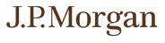

PS-1 | Structured Investments

Auto Callable Contingent Interest Notes Linked to the ARK Innovation ETF

How the Notes Work

Payment in Connection with the First through Eleventh Review Dates
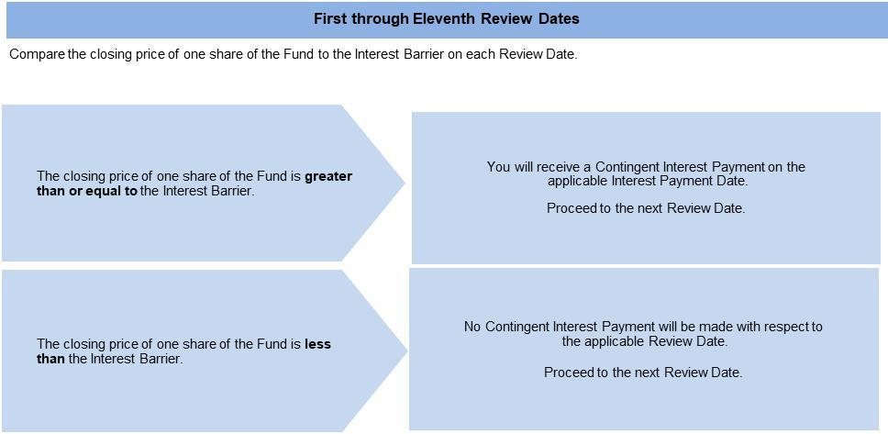

Payments in Connection with Review Dates (Other than the First through Eleventh and Final Review Dates)
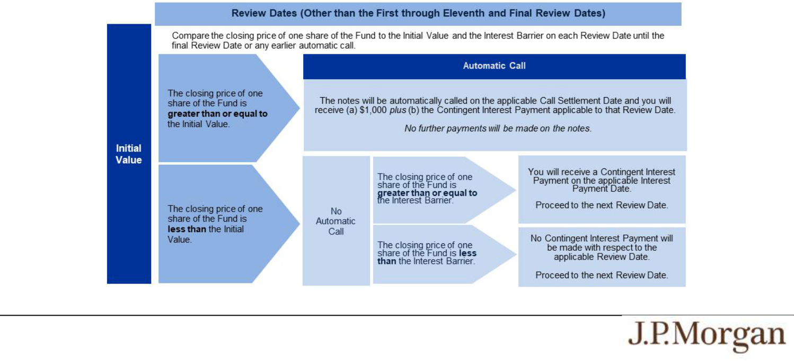

PS-2 | Structured Investments

Auto Callable Contingent Interest Notes Linked to the ARK Innovation ETF

Payment at Maturity If the Notes Have Not Been Automatically Called
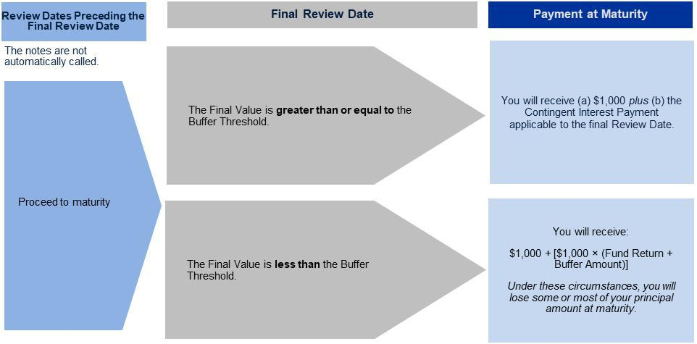

Total Contingent Interest Payments

The table below illustrates the hypothetical total Contingent Interest Payments per $1,000 principal amount note over the term of the notes based on a hypothetical Contingent Interest Rate of 12.05% per annum, depending on how many Contingent Interest Payments are made prior to automatic call or maturity. The actual Contingent Interest Rate will be provided in the pricing supplement and will be at least 12.05% per annum.

 | Number of Contingent | Total Contingent Interest
 | Interest Payments | Payments
 | 60 | $602.5000
 | 59 | $592.4583
 | 58 | $582.4167
 | 57 | $572.3750
 | 56 | $562.3333
 | 55 | $552.2917
 | 54 | $542.2500
 | 53 | $532.2083
 | 52 | $522.1667
 | 51 | $512.1250
 | 50 | $502.0833
 | 49 | $492.0417
 | 48 | $482.0000
 | 47 | $471.9583
 | 46 | $461.9167
 | 45 | $451.8750
 | 44 | $441.8333
 | 43 | $431.7917
 | 42 | $421.7500
 | 41 | $411.7083

PS-3 | Structured Investments

Auto Callable Contingent Interest Notes Linked to the ARK Innovation ETF

40 | $401.6667
39 | $391.6250
38 | $381.5833
37 | $371.5417
36 | $361.5000
35 | $351.4583
34 | $341.4167
33 | $331.3750
32 | $321.3333
31 | $311.2917
30 | $301.2500
29 | $291.2083
28 | $281.1667
27 | $271.1250
26 | $261.0833
25 | $251.0417
24 | $241.0000
23 | $230.9583
22 | $220.9167
21 | $210.8750
20 | $200.8333
19 | $190.7917
18 | $180.7500
17 | $170.7083
16 | $160.6667
15 | $150.6250
14 | $140.5833
13 | $130.5417
12 | $120.5000
11 | $110.4583
10 | $100.4167
9 | $90.3750
8 | $80.3333
7 | $70.2917
6 | $60.2500
5 | $50.2083
4 | $40.1667
3 | $30.1250
2 | $20.0833
1 | $10.0417
0 | $0.0000

PS-4 | Structured Investments

Auto Callable Contingent Interest Notes Linked to the ARK Innovation ETF

Hypothetical Payout Examples

The following examples illustrate payments on the notes linked to a hypothetical Fund, assuming a range of performances for the hypothetical Fund on the

Review Dates. The hypothetical payments set forth below assume the following:

- an Initial Value of $100.00;

- an Interest Barrier and a Buffer Threshold of $80.00 (equal to 80.00% of the hypothetical Initial Value);

- a Buffer Amount of 20.00%; and

- a Contingent Interest Rate of 12.05% per annum (payable at a rate of 1.00417% per month).

The hypothetical Initial Value of $100.00 has been chosen for illustrative purposes only and may not represent a likely actual Initial Value. The actual Initial Value will be the closing price of one share of the Fund on the Pricing Date and will be provided in the pricing supplement. For historical data regarding the actual closing prices of one share of the Fund, please see the historical information set forth under “The Fund” in this pricing supplement.

Each hypothetical payment set forth below is for illustrative purposes only and may not be the actual payment applicable to a purchaser of the notes. The numbers appearing in the following examples have been rounded for ease of analysis.
Example 1 — Notes are automatically called on the twelfth Review Date.

Date | Closing Price | Payment (per $1,000 principal amount note)
First Review Date | $105.00 | $10.0417
Second Review Date | $115.00 | $10.0417
Third through Eleventh Review Dates | Greater than Call Value
Twelfth Review Date | $110.00 | $1,010.0417
 | Total Payment | $1,120.50 (12.05% return)

Because the closing price of one share of the Fund on the twelfth Review Date is greater than or equal to the Initial Value, the notes will be automatically called for a cash payment, for each $1,000 principal amount note, of $1,010.0417 (or $1,000 plus the Contingent Interest Payment applicable to the twelfth Review Date), payable on the applicable Call Settlement Date. The notes are not automatically callable before the twelfth Review Date, even though the closing price of one share of the Fund on each of the first through eleventh Review Dates is greater than the Initial Value. When added to the Contingent Interest Payments received with respect to the prior Review Dates, the total amount paid, for each $1,000 principal amount note, is $1,120.50. No further payments will be made on the notes.

Example 2 — Notes have NOT been automatically called and the Final Value is greater than or equal to the Buffer Threshold.

Date | Closing Price | Payment (per $1,000 principal amount note)
First Review Date | $95.00 | $10.0417
Second Review Date | $85.00 | $10.0417
Third through Fifty-Ninth Review Dates | Less than Interest Barrier | $0
Final Review Date | $90.00 | $1,010.0417
 | Total Payment | $1,030.125 (3.0125% return)

Because the notes have not been automatically called and the Final Value is greater than or equal to the Buffer Threshold, the payment at maturity, for each $1,000 principal amount note, will be $1,010.0417 (or $1,000 plus the Contingent Interest Payment applicable to the final Review Date). When added to the Contingent Interest Payments received with respect to the prior Review Dates, the total amount paid, for each $1,000 principal amount note, is $1,030.125.

PS-5 | Structured Investments

Auto Callable Contingent Interest Notes Linked to the ARK Innovation ETF

Example 3 — Notes have NOT been automatically called and the Final Value is less than the Buffer Threshold.

Date | Closing Price | Payment (per $1,000 principal amount note)
First Review Date | $40.00 | $0
Second Review Date | $45.00 | $0
Third through Fifty-Ninth Review Dates | Less than Interest Barrier | $0
Final Review Date | $50.00 | $500.00
 | Total Payment | $700.00 (-30.00% return)

Because the notes have not been automatically called, the Final Value is less than the Buffer Threshold and the Fund Return is -50.00%, the payment at maturity will be $700.00 per $1,000 principal amount note, calculated as follows:

$1,000 + [$1,000 × (-50.00% + 20.00%)] = $700.00

The hypothetical returns and hypothetical payments on the notes shown above apply only if you hold the notes for their entire term or until automatically called. These hypotheticals do not reflect the fees or expenses that would be associated with any sale in the secondary market. If these fees and expenses were included, the hypothetical returns and hypothetical payments shown above would likely be lower.

Selected Risk Considerations

An investment in the notes involves significant risks. These risks are explained in more detail in the “Risk Factors” sections of the accompanying prospectus supplement and product supplement.

Risks Relating to the Notes Generally

- YOUR INVESTMENT IN THE NOTES MAY RESULT IN A LOSS —

The notes do not guarantee any return of principal. If the notes have not been automatically called and the Final Value is less than the Buffer Threshold, you will lose 1% of the principal amount of your notes for every 1% that the Final Value is less than the Initial Value by more than 20.00%. Accordingly, under these circumstances, you will lose up to 80.00% of your principal amount at maturity.

- THE NOTES DO NOT GUARANTEE THE PAYMENT OF INTEREST AND MAY NOT PAY ANY INTEREST AT ALL —

If the notes have not been automatically called, we will make a Contingent Interest Payment with respect to a Review Date only if the closing price of one share of the Fund on that Review Date is greater than or equal to the Interest Barrier. If the closing price of one share of the Fund on that Review Date is less than the Interest Barrier, no Contingent Interest Payment will be made with respect to that Review Date. Accordingly, if the closing price of one share of the Fund on each Review Date is less than the Interest Barrier, you will not receive any interest payments over the term of the notes.

- CREDIT RISKS OF JPMORGAN FINANCIAL AND JPMORGAN CHASE & CO. —

Investors are dependent on our and JPMorgan Chase & Co.’s ability to pay all amounts due on the notes. Any actual or potential change in our or JPMorgan Chase & Co.’s creditworthiness or credit spreads, as determined by the market for taking that credit risk, is likely to adversely affect the value of the notes. If we and JPMorgan Chase & Co. were to default on our payment obligations, you may not receive any amounts owed to you under the notes and you could lose your entire investment.

- AS A FINANCE SUBSIDIARY, JPMORGAN FINANCIAL HAS NO INDEPENDENT OPERATIONS AND HAS LIMITED ASSETS —

As a finance subsidiary of JPMorgan Chase & Co., we have no independent operations beyond the issuance and administration of our securities. Aside from the initial capital contribution from JPMorgan Chase & Co., substantially all of our assets relate to obligations of our affiliates to make payments under loans made by us or other intercompany agreements. As a result, we are dependent upon payments from our affiliates to meet our obligations under the notes. If these affiliates do not make payments to us and we fail to make payments on the notes, you may have to seek payment under the related guarantee by JPMorgan Chase & Co., and that guarantee will rank pari passu with all other unsecured and unsubordinated obligations of JPMorgan Chase & Co.

- THE APPRECIATION POTENTIAL OF THE NOTES IS LIMITED TO THE SUM OF ANY CONTINGENT INTEREST PAYMENTS THAT MAY BE PAID OVER THE TERM OF THE NOTES,

regardless of any appreciation of the Fund, which may be significant. You will not participate in any appreciation of the Fund.

PS-6 | Structured Investments

Auto Callable Contingent Interest Notes Linked to the ARK Innovation ETF

- THE AUTOMATIC CALL FEATURE MAY FORCE A POTENTIAL EARLY EXIT —

If your notes are automatically called, the term of the notes may be reduced to as short as approximately one year and you will not receive any Contingent Interest Payments after the applicable Call Settlement Date. There is no guarantee that you would be able to reinvest the proceeds from an investment in the notes at a comparable return and/or with a comparable interest rate for a similar level of risk. Even in cases where the notes are called before maturity, you are not entitled to any fees and commissions described on the front cover of this pricing supplement.

- YOU WILL NOT RECEIVE DIVIDENDS ON THE FUND OR THE SECURITIES HELD BY THE FUND OR HAVE ANY RIGHTS WITH RESPECT TO THE FUND OR THOSE SECURITIES.

- THE RISK OF THE CLOSING PRICE OF ONE SHARE OF THE FUND FALLING BELOW THE INTEREST BARRIER OR THE BUFFER THRESHOLD IS GREATER IF THE PRICE OF ONE SHARE OF THE FUND IS VOLATILE.

- LACK OF LIQUIDITY —

The notes will not be listed on any securities exchange. Accordingly, the price at which you may be able to trade your notes is likely to depend on the price, if any, at which JPMS is willing to buy the notes. You may not be able to sell your notes. The notes are not designed to be short-term trading instruments. Accordingly, you should be able and willing to hold your notes to maturity.

- THE FINAL TERMS AND VALUATION OF THE NOTES WILL BE PROVIDED IN THE PRICING SUPPLEMENT —

You should consider your potential investment in the notes based on the minimums for the estimated value of the notes and the Contingent Interest Rate.

Risks Relating to Conflicts of Interest

- POTENTIAL CONFLICTS —

We and our affiliates play a variety of roles in connection with the notes. In performing these duties, our and JPMorgan Chase & Co.’s economic interests are potentially adverse to your interests as an investor in the notes. It is possible that hedging or trading activities of ours or our affiliates in connection with the notes could result in substantial returns for us or our affiliates while the value of the notes declines. Please refer to “Risk Factors — Risks Relating to Conflicts of Interest” in the accompanying product supplement.

Risks Relating to the Estimated Value and Secondary Market Prices of the Notes

- THE ESTIMATED VALUE OF THE NOTES WILL BE LOWER THAN THE ORIGINAL ISSUE PRICE (PRICE TO PUBLIC) OF THE NOTES —

The estimated value of the notes is only an estimate determined by reference to several factors. The original issue price of the notes will exceed the estimated value of the notes because costs associated with selling, structuring and hedging the notes are included in the original issue price of the notes. These costs include the selling commissions, the projected profits, if any, that our affiliates expect to realize for assuming risks inherent in hedging our obligations under the notes and the estimated cost of hedging our obligations under the notes. See “The Estimated Value of the Notes” in this pricing supplement.

- THE ESTIMATED VALUE OF THE NOTES DOES NOT REPRESENT FUTURE VALUES OF THE NOTES AND MAY DIFFER FROM OTHERS’ ESTIMATES —

See “The Estimated Value of the Notes” in this pricing supplement.

- THE ESTIMATED VALUE OF THE NOTES IS DERIVED BY REFERENCE TO AN INTERNAL FUNDING RATE —

The internal funding rate used in the determination of the estimated value of the notes may differ from the market-implied funding rate for vanilla fixed income instruments of a similar maturity issued by JPMorgan Chase & Co. or its affiliates. Any difference may be based on, among other things, our and our affiliates’ view of the funding value of the notes as well as the higher issuance, operational and ongoing liability management costs of the notes in comparison to those costs for the conventional fixed income instruments of JPMorgan Chase & Co. This internal funding rate is based on certain market inputs and assumptions, which may prove to be incorrect, and is intended to approximate the prevailing market replacement funding rate for the notes. The use of an internal funding rate and any potential changes to that rate may have an adverse effect on the terms of the notes and any secondary market prices of the notes. See “The Estimated Value of the Notes” in this pricing supplement.

PS-7 | Structured Investments

Auto Callable Contingent Interest Notes Linked to the ARK Innovation ETF

- THE VALUE OF THE NOTES AS PUBLISHED BY JPMS (AND WHICH MAY BE REFLECTED ON CUSTOMER ACCOUNT STATEMENTS) MAY BE HIGHER THAN THE THEN-CURRENT ESTIMATED VALUE OF THE NOTES FOR A LIMITED TIME PERIOD —

We generally expect that some of the costs included in the original issue price of the notes will be partially paid back to you in connection with any repurchases of your notes by JPMS in an amount that will decline to zero over an initial predetermined period. See “Secondary Market Prices of the Notes” in this pricing supplement for additional information relating to this initial period. Accordingly, the estimated value of your notes during this initial period may be lower than the value of the notes as published by JPMS (and which may be shown on your customer account statements).

- SECONDARY MARKET PRICES OF THE NOTES WILL LIKELY BE LOWER THAN THE ORIGINAL ISSUE PRICE OF THE NOTES —

Any secondary market prices of the notes will likely be lower than the original issue price of the notes because, among other things, secondary market prices take into account our internal secondary market funding rates for structured debt issuances and, also, because secondary market prices may exclude selling commissions, projected hedging profits, if any, and estimated hedging costs that are included in the original issue price of the notes. As a result, the price, if any, at which JPMS will be willing to buy the notes from you in secondary market transactions, if at all, is likely to be lower than the original issue price. Any sale by you prior to the Maturity Date could result in a substantial loss to you.

- SECONDARY MARKET PRICES OF THE NOTES WILL BE IMPACTED BY MANY ECONOMIC AND MARKET FACTORS —

The secondary market price of the notes during their term will be impacted by a number of economic and market factors, which may either offset or magnify each other, aside from the selling commissions, projected hedging profits, if any, estimated hedging costs and the price of one share of the Fund. Additionally, independent pricing vendors and/or third party broker-dealers may publish a price for the notes, which may also be reflected on customer account statements. This price may be different (higher or lower) than the price of the notes, if any, at which JPMS may be willing to purchase your notes in the secondary market. See “Risk Factors — Risks Relating to the Estimated Value and Secondary Market Prices of the Notes — Secondary market prices of the notes will be impacted by many economic and market factors” in the accompanying product supplement.

Risks Relating to the Fund

- AN INVESTMENT IN THE NOTES IS SUBJECT TO RISKS ASSOCIATED WITH ACTIVELY MANAGED FUNDS —

The Fund is actively managed. Unlike a passively managed fund, an actively managed fund does not attempt to track an index or other benchmark, and the investment decisions for an actively managed fund are instead made by its investment adviser. The investment adviser of an actively managed fund may adopt a strategy or strategies that are significantly higher risk than the indexing strategy that would have been employed by a passively managed fund. As an actively managed fund, the Fund is subject to management risk. In managing an actively managed fund, the investment adviser of a fund applies investment strategies, techniques and analyses in making investment decisions for that fund, but there can be no guarantee that these actions will produce the intended results. The ability of the Fund’s investment adviser to successfully implement the Fund’s investment strategy will significantly influence the market price of the shares of the Fund and, consequently, the value of the notes.

- THE PERFORMANCE AND MARKET VALUE OF THE FUND, PARTICULARLY DURING PERIODS OF MARKET VOLATILITY, MAY NOT CORRELATE WITH THE PERFORMANCE OF THE FUND’S NET ASSET VALUE PER SHARE —

Because the shares of the Fund are traded on a securities exchange and are subject to market supply and investor demand, the market value of one share of the Fund may differ from the net asset value per share of the Fund. During periods of market volatility, securities underlying the Fund may be unavailable in the secondary market, market participants may be unable to calculate accurately the net asset value per share of the Fund and the liquidity of the Fund may be adversely affected. This kind of market volatility may also disrupt the ability of market participants to create and redeem shares of the Fund. Further, market volatility may adversely affect, sometimes materially, the prices at which market participants are willing to buy and sell shares of the Fund. As a result, under these circumstances, the market value of shares of the Fund may vary substantially from the net asset value per share of the Fund. For all of the foregoing reasons, the performance of the Fund may not correlate with the net asset value per share of the Fund, which could materially and adversely affect the value of the notes in the secondary market and/or reduce any payment on the notes.

- RISKS ASSOCIATED WITH DISRUPTIVE INNOVATION COMPANIES —

The Fund’s investment strategy involves exposure to companies that the investment adviser believes are capitalizing on disruptive innovation and developing technologies to displace older technologies or create new markets (“disruptive innovation companies”). However, the companies selected by the investment adviser may not in fact do so. Companies that initially develop a novel technology may not be able to capitalize on the technology. Companies that develop disruptive technologies may face political or

PS-8 | Structured Investments

Auto Callable Contingent Interest Notes Linked to the ARK Innovation ETF

legal attacks from competitors, industry groups or local and national governments. These companies may also be exposed to risks applicable to sectors other than the disruptive innovation theme for which they are chosen, and the securities issued by these companies may underperform the securities of other companies that are primarily focused on a particular theme. The Fund may invest in companies that do not currently derive any revenue from disruptive innovations or technologies, and there is no assurance that any company will derive any revenue from disruptive innovations or technologies in the future. A disruptive innovation or technology may constitute a small portion of any company’s overall business. As a result, the success of a disruptive innovation or technology may not affect the value of the equity securities issued by that company.

- AN INVESTMENT IN THE NOTES IS SUBJECT TO RISKS ASSOCIATED WITH MID-SIZE, SMALL AND MICRO-CAPITALIZATION STOCKS —

Some of the equity securities held by the Fund have been issued by mid-size, small or micro-capitalization companies. Mid-size, small and micro-capitalization companies may be less able to withstand adverse economic, market, trade and competitive conditions relative to larger companies. Mid-size, small and micro-capitalization companies are less likely to pay dividends on their stocks, and the presence of a dividend payment could be a factor that limits downward stock price pressure under adverse market conditions.

- NON-U.S. SECURITIES RISK —

Some of the equity securities held by the Fund have been issued by non-U.S. companies. Investments in securities linked to the value of such non-U.S. equity securities involve risks associated with the securities markets in the home countries of the issuers of those non-U.S. equity securities. Also, there is generally less publicly available information about companies in some of these jurisdictions than there is about U.S. companies that are subject to the reporting requirements of the SEC.

- EMERGING MARKETS RISK —

Some of the equity securities held by the Fund have been issued by non-U.S. companies located in emerging markets countries. Countries with emerging markets may have relatively unstable governments, may present the risks of nationalization of businesses, restrictions on foreign ownership and prohibitions on the repatriation of assets, and may have less protection of property rights than more developed countries. The economies of countries with emerging markets may be based on only a few industries, may be highly vulnerable to changes in local or global trade conditions, and may suffer from extreme and volatile debt burdens or inflation rates. Local securities markets may trade a small number of securities and may be unable to respond effectively to increases in trading volume, potentially making prompt liquidation of holdings difficult or impossible at times.

- RECENT EXECUTIVE ORDERS MAY ADVERSELY AFFECT THE PERFORMANCE OF THE FUND —

Pursuant to recent executive orders, U.S. persons are prohibited from engaging in transactions in, or possession of, publicly traded securities of certain companies that are determined to be linked to the People’s Republic of China military, intelligence and security apparatus, or securities that are derivative of, or are designed to provide investment exposure to, those securities. If the issuer of any of the equity securities held by the Fund is in the future designated as such a prohibited company, the value of that company may be adversely affected, perhaps significantly, which would adversely affect the performance of the Fund. In addition, under these circumstances, the Fund is expected to remove the equity securities of that company from the Fund. Any changes to the composition of the Fund in response to these executive orders could adversely affect the performance of the Fund.

- THE ANTI-DILUTION PROTECTION FOR THE FUND IS LIMITED —

The calculation agent will make adjustments to the Share Adjustment Factor for certain events affecting the shares of the Fund. However, the calculation agent will not make an adjustment in response to all events that could affect the shares of the Fund. If an event occurs that does not require the calculation agent to make an adjustment, the value of the notes may be materially and adversely affected.

PS-9 | Structured Investments

Auto Callable Contingent Interest Notes Linked to the ARK Innovation ETF

The Fund
The Fund is an actively-managed exchange-traded fund of ARK ETF Trust, a registered investment company, with an investment objective of long-term growth of capital, that primarily invests in equity securities of U.S. and non-U.S. companies relevant to the Fund’s investment theme of disruptive innovation. For additional information about the Fund, see Annex A in this pricing supplement.

Historical Information

The following graph sets forth the historical performance of the Fund based on the weekly historical closing prices of one share of the Fund from January 8, 2016 through January 29, 2021. The closing price of one share of the Fund on February 2, 2021 was $146.89. We obtained the closing prices above and below

from the Bloomberg Professional® service (“Bloomberg”), without independent verification. The closing prices above and below may have been adjusted by Bloomberg for actions taken by the Fund, such as stock splits.

The historical closing prices of one share of the Fund should not be taken as an indication of future performance, and no assurance can be given as to the closing price of one share of the Fund on the Pricing Date or any Review Date. There can be no assurance that the performance of the Fund will result in the return of any of your principal amount in excess of $200.00 per $1,000 principal amount note, subject to the credit risks of JPMorgan Financial and JPMorgan Chase & Co., or the payment of any interest.
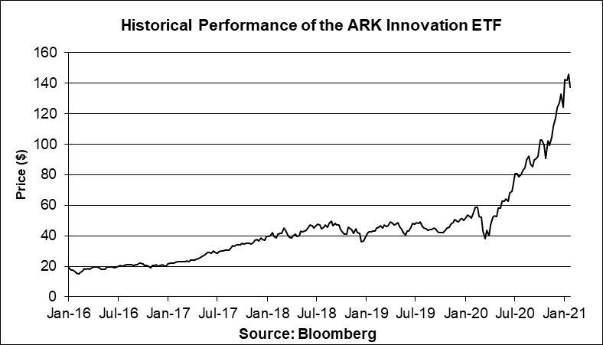

Tax Treatment

You should review carefully the section entitled “Material U.S. Federal Income Tax Consequences” in the accompanying product supplement no. 4-II. In determining our reporting responsibilities we intend to treat (i) the notes for U.S. federal income tax purposes as prepaid forward contracts with associated contingent coupons and (ii) any Contingent Interest Payments as ordinary income, as described in the section entitled “Material U.S. Federal Income Tax Consequences — Tax Consequences to U.S. Holders — Notes Treated as Prepaid Forward Contracts with Associated Contingent Coupons” in the accompanying product supplement. Based on the advice of Davis Polk & Wardwell LLP, our special tax counsel, we believe that this is a reasonable treatment, but that there are other reasonable treatments that the IRS or a court may adopt, in which case the timing and character of any income or loss on the notes could be materially affected. In addition, in 2007 Treasury and the IRS released a notice requesting comments on the U.S. federal income tax treatment of “prepaid forward contracts” and similar instruments. The notice focuses in particular on whether to require investors in these instruments to accrue income over the term of their investment. It also asks for comments on a number of related topics, including the character of income or loss with respect to these instruments and the relevance of factors such as the nature of the underlying property to which the instruments are linked. While the notice requests comments on appropriate transition rules and effective dates, any Treasury regulations or other guidance promulgated after consideration of these issues could materially affect the tax consequences of an investment in the notes, possibly with retroactive effect. The discussions above and in the accompanying product supplement do not address the consequences to taxpayers subject to special tax accounting rules under Section 451(b) of the Code. You should consult your tax adviser regarding the U.S. federal income tax consequences of an investment in the notes, including possible alternative treatments and the issues presented by the notice described above.

Non-U.S. Holders — Tax Considerations. The U.S. federal income tax treatment of Contingent Interest Payments is uncertain, and although we believe it is reasonable to take a position that Contingent Interest Payments are not subject to U.S. withholding tax (at least

PS-10 | Structured Investments

Auto Callable Contingent Interest Notes Linked to the ARK Innovation ETF

if an applicable Form W-8 is provided), a withholding agent may nonetheless withhold on these payments (generally at a rate of 30%, subject to the possible reduction of that rate under an applicable income tax treaty), unless income from your notes is effectively connected with your conduct of a trade or business in the United States (and, if an applicable treaty so requires, attributable to a permanent establishment in the United States). If you are not a United States person, you are urged to consult your tax adviser regarding the U.S. federal income tax consequences of an investment in the notes in light of your particular circumstances.

Section 871(m) of the Code and Treasury regulations promulgated thereunder (“Section 871(m)”) generally impose a 30% withholding tax (unless an income tax treaty applies) on dividend equivalents paid or deemed paid to Non-U.S. Holders with respect to certain financial instruments linked to U.S. equities or indices that include U.S. equities. Section 871(m) provides certain exceptions to this withholding regime, including for instruments linked to certain broad-based indices that meet requirements set forth in the applicable Treasury regulations. Additionally, a recent IRS notice excludes from the scope of Section 871(m) instruments issued prior to January 1, 2023 that do not have a delta of one with respect to underlying securities that could pay U.S.-source dividends for U.S. federal income tax purposes (each an “Underlying Security”). Based on certain determinations made by us, we expect that Section 871(m) will not apply to the notes with regard to Non-U.S. Holders. Our determination is not binding on the IRS, and the IRS may disagree with this determination. Section 871(m) is complex and its application may depend on your particular circumstances, including whether you enter into other transactions with respect to an Underlying Security. If necessary, further information regarding the potential application of Section 871(m) will be provided in the pricing supplement for the notes. You should consult your tax adviser regarding the potential application of Section 871(m) to the notes.

In the event of any withholding on the notes, we will not be required to pay any additional amounts with respect to amounts so withheld.

The Estimated Value of the Notes

The estimated value of the notes set forth on the cover of this pricing supplement is equal to the sum of the values of the following hypothetical components: (1) a fixed-income debt component with the same maturity as the notes, valued using the internal funding rate described below, and (2) the derivative or derivatives underlying the economic terms of the notes. The estimated value of the notes does not represent a minimum price at which JPMS would be willing to buy your notes in any secondary market (if any exists) at any time. The internal funding rate used in the determination of the estimated value of the notes may differ from the market-implied funding rate for vanilla fixed income instruments of a similar maturity issued by JPMorgan Chase & Co. or its affiliates. Any difference may be based on, among other things, our and our affiliates’ view of the funding value of the notes as well as the higher issuance, operational and ongoing liability management costs of the notes in comparison to those costs for the conventional fixed income instruments of JPMorgan Chase & Co. This internal funding rate is based on certain market inputs and assumptions, which may prove to be incorrect, and is intended to approximate the prevailing market replacement funding rate for the notes. The use of an internal funding rate and any potential changes to that rate may have an adverse effect on the terms of the notes and any secondary market prices of the notes. For additional information, see “Selected Risk Considerations — Risks Relating to the Estimated Value and Secondary Market Prices of the Notes — The Estimated Value of the Notes Is Derived by Reference to an Internal Funding Rate” in this pricing supplement.

The value of the derivative or derivatives underlying the economic terms of the notes is derived from internal pricing models of our affiliates. These models are dependent on inputs such as the traded market prices of comparable derivative instruments and on various other inputs, some of which are market-observable, and which can include volatility, dividend rates, interest rates and other factors, as well as assumptions about future market events and/or environments.
Accordingly, the estimated value of the notes is determined when the terms of the notes are set based on market conditions and other relevant factors and assumptions existing at that time.

The estimated value of the notes does not represent future values of the notes and may differ from others’ estimates. Different pricing models and assumptions could provide valuations for the notes that are greater than or less than the estimated value of the notes. In addition, market conditions and other relevant factors in the future may change, and any assumptions may prove to be incorrect. On future dates, the value of the notes could change significantly based on, among other things, changes in market conditions, our or JPMorgan Chase & Co.’s creditworthiness, interest rate movements and other relevant factors, which may impact the price, if any, at which JPMS would be willing to buy notes from you in secondary market transactions.

The estimated value of the notes will be lower than the original issue price of the notes because costs associated with selling, structuring and hedging the notes are included in the original issue price of the notes. These costs include the selling commissions paid to JPMS and other affiliated or unaffiliated dealers, the projected profits, if any, that our affiliates expect to realize for assuming risks inherent in hedging our obligations under the notes and the estimated cost of hedging our obligations under the notes. Because hedging our obligations entails risk and may be influenced by market forces beyond our control, this hedging may result in a profit that is more or less than expected, or it may result in a loss. A portion of the profits, if any, realized in hedging our obligations under the notes may be allowed to other affiliated or unaffiliated dealers, and we or one or more of our affiliates will retain any remaining hedging

PS-11 | Structured Investments

Auto Callable Contingent Interest Notes Linked to the ARK Innovation ETF

profits. See “Selected Risk Considerations — Risks Relating to the Estimated Value and Secondary Market Prices of the Notes — The Estimated Value of the Notes Will Be Lower Than the Original Issue Price (Price to Public) of the Notes” in this pricing supplement.

Secondary Market Prices of the Notes

For information about factors that will impact any secondary market prices of the notes, see “Risk Factors — Risks Relating to the Estimated Value and Secondary Market Prices of the Notes — Secondary market prices of the notes will be impacted by many economic and market factors” in the accompanying product supplement. In addition, we generally expect that some of the costs included in the original issue price of the notes will be partially paid back to you in connection with any repurchases of your notes by JPMS in an amount that will decline to zero over an initial predetermined period. These costs can include selling commissions, projected hedging profits, if any, and, in some circumstances, estimated hedging costs and our internal secondary market funding rates for structured debt issuances. This initial predetermined time period is intended to be the shorter of six months and one-half of the stated term of the notes. The length of any such initial period reflects the structure of the notes, whether our affiliates expect to earn a profit in connection with our hedging activities, the estimated costs of hedging the notes and when these costs are incurred, as determined by our affiliates. See “Selected Risk Considerations — Risks Relating to the Estimated Value and Secondary Market Prices of the Notes — The Value of the Notes as Published by JPMS (and Which May Be Reflected on Customer Account Statements) May Be Higher Than the Then-Current Estimated Value of the Notes for a Limited Time Period” in this pricing supplement.

Supplemental Use of Proceeds

The notes are offered to meet investor demand for products that reflect the risk-return profile and market exposure provided by the notes. See “How the Notes Work” and “Hypothetical Payout Examples” in this pricing supplement for an illustration of the risk-return profile of the notes and “The Fund” in this pricing supplement for a description of the market exposure provided by the notes.

The original issue price of the notes is equal to the estimated value of the notes plus the selling commissions paid to JPMS and other affiliated or unaffiliated dealers, plus (minus) the projected profits (losses) that our affiliates expect to realize for assuming risks inherent in hedging our obligations under the notes, plus the estimated cost of hedging our obligations under the notes.

Supplemental Plan of Distribution

We expect that delivery of the notes will be made against payment for the notes on or about the Original Issue Date set forth on the front cover of this pricing supplement, which will be the third business day following the Pricing Date of the notes (this settlement cycle being referred to as “T+3”). Under Rule 15c6-1 of the Securities Exchange Act of 1934, as amended, trades in the secondary market generally are required to settle in two business days, unless the parties to that trade expressly agree otherwise. Accordingly, purchasers who wish to trade notes on any date prior to two business days before delivery will be required to specify an alternate settlement cycle at the time of any such trade to prevent a failed settlement and should consult their own advisors.

Additional Terms Specific to the Notes

You may revoke your offer to purchase the notes at any time prior to the time at which we accept such offer by notifying the applicable agent. We reserve the right to change the terms of, or reject any offer to purchase, the notes prior to their issuance. In the event of any changes to the terms of the notes, we will notify you and you will be asked to accept such changes in connection with your purchase. You may also choose to reject such changes, in which case we may reject your offer to purchase.

You should read this pricing supplement together with the accompanying prospectus, as supplemented by the accompanying prospectus supplement relating to our Series A medium-term notes of which these notes are a part, and the more detailed information contained in the accompanying product supplement. This pricing supplement, together with the documents listed below, contains the terms of the notes and supersedes all other prior or contemporaneous oral statements as well as any other written materials including preliminary or indicative pricing terms, correspondence, trade ideas, structures for implementation, sample structures, fact sheets, brochures or other educational materials of ours. You should carefully consider, among other things, the matters set forth in the “Risk Factors” sections of the accompanying prospectus supplement and the accompanying product supplement, as the notes involve risks not associated with conventional debt securities. We urge you to consult your investment, legal, tax, accounting and other advisers before you invest in the notes.

PS-12 | Structured Investments

Auto Callable Contingent Interest Notes Linked to the ARK Innovation ETF

You may access these documents on the SEC website at www.sec.gov as follows (or if such address has changed, by reviewing our filings for the relevant date on the SEC website):

- Product supplement no. 4-II dated November 4, 2020: http://www.sec.gov/Archives/edgar/data/19617/000095010320021467/crt_dp139322-424b2.pdf

- Prospectus supplement and prospectus, each dated April 8, 2020: http://www.sec.gov/Archives/edgar/data/19617/000095010320007214/crt_dp124361-424b2.pdf

Our Central Index Key, or CIK, on the SEC website is 1665650, and JPMorgan Chase & Co.’s CIK is 19617. As used in this pricing supplement, “we,” “us” and “our” refer to JPMorgan Financial.

PS-13 | Structured Investments

Auto Callable Contingent Interest Notes Linked to the ARK Innovation ETF

Annex A

The ARK Innovation ETF

All information contained in this pricing supplement regarding the ARK Innovation ETF (the “ARKK Fund”), has been derived from publicly available information, without independent verification. This information reflects the policies of, and is subject to change by, ARK ETF Trust (“ARK Trust”). The ARKK Fund is an actively-managed exchange-traded fund managed by ARK Investment Management LLC (“ARK LLC”), the investment adviser to the ARKK Fund. The ARKK Fund trades on NYSE Arca, Inc. under the ticker symbol “ARKK.”

The investment objective of the ARKK Fund is long-term growth of capital.

As an actively-managed fund, the ARKK Fund is subject to management risk. In managing the ARKK Fund, ARK LLC applies investment strategies, techniques and analyses in making investment decisions for the ARKK Fund, but there can be no guarantee that these actions will produce the intended results. The ability of ARK LLC to successfully implement the ARKK Fund’s investment strategy will significantly influence that ARKK Fund’s performance.

The ARKK Fund will invest under normal circumstances primarily (at least 65% of its assets) in equity securities of U.S. and non-U.S. companies that are relevant to the ARKK Fund’s investment theme of disruptive innovation. ARK LLC defines “disruptive innovation” as the introduction of a technologically enabled new product or service that potentially changes the way the world works. ARK LLC believes that companies relevant to this theme are those that rely on or benefit from the development of new products or services, technological improvements and advancements in scientific research relating to the areas of genomics; innovation in automation and manufacturing, transportation, energy, artificial intelligence and materials; the increased use of shared technology, infrastructure and services; and technologies that make financial services more efficient. ARK LLC defines “genomics” as the study of genes and their functions, and related techniques (e.g., genomic sequencing).

ARK Trust is a registered investment company that consists of numerous separate investment portfolios, including the ARKK Fund. Information provided to or filed with the SEC by ARK Trust pursuant to the Securities Act of 1933, as amended, and the Investment Company Act of 1940, as amended, can be located by reference to SEC file numbers 333-191019 and 811-22883, respectively, through the SEC’s website at http://www.sec.gov.

PS-14 | Structured Investments

Auto Callable Contingent Interest Notes Linked to the ARK Innovation ETF

