Term sheet | Term Sheet to
To prospectus dated November 21, 2008, | Product Supplement No. 133-A-II
prospectus supplement dated November 21, 2008 and | Registration Statement No. 333-155535
product supplement no. 133-A-II dated May 4, 2009 | Dated January 19, 2010; Rule 433

Structured Investments


General

$

Return Enhanced Notes Linked to Oil Service HOLDRSSM Trust Depositary Receipts due July 23, 2010

The notes are designed for investors who seek a return of three times the appreciation of the closing price of the depositary receipts of the Oil Service HOLDRSSM Trust, or Depositary Receipts, up to a maximum total return on the notes of 17.46%* at maturity. Investors should be willing to forgo interest and dividend payments and, if the closing price of the Depositary Receipts declines, be willing to lose some or all of their principal. Any payment on the notes is subject to the credit risk of JPMorgan Chase & Co.
Senior unsecured obligations of JPMorgan Chase & Co. maturing July 23, 2010† Minimum denominations of $10,000 and integral multiples of $1,000 in excess thereof

The notes are expected to price on or about January 22, 2010 and are expected to settle on or about January 27, 2010.
The terms of the notes as set forth below, to the extent they differ or conflict with those set forth in the accompanying product supplement no. 133-A-II, will supersede the terms set forth in product supplement no. 133-A-II. In particular, please refer to “Supplemental Information Relating to Delisting or Suspension of Trading and Termination” in this term sheet for more information.
For purposes of the notes offered by this term sheet, all references in the accompanying product supplement no. 133-A-II to “Reference Stock(s)” will be deemed to refer to “Depositary Receipt(s)” or “HOLDRS” and all references to “common stock” will be deemed to refer to “depositary receipts.”

Key Terms

Depositary Receipts:

Upside Leverage Factor:

Payment at Maturity:

The depositary receipts of the Oil Service HOLDRSSM Trust (NYSE Arca ticker symbol “OIH”), each of which we refer to as a “Depositary Receipt” and collectively as the “Depositary Receipts” or “HOLDRS”

3

If the Final Share Price is greater than the Initial Share Price, you will receive a cash payment that provides you with a return per $1,000 principal amount note equal to the Stock Return multiplied by three, subject to the Maximum Total Return on the notes of 17.46%*. For example, if the Stock Return is more than 5.82%, you will receive the Maximum Total Return on the notes of 17.46%*, which entitles you to a maximum payment at maturity of $1,174.60 for every $1,000 principal amount note that you hold. Accordingly, if the Stock Return is positive, your payment at maturity per $1,000 principal amount note will be calculated as follows, subject to the Maximum Total Return:

$1,000 + ($1,000 x Stock Return x 3)

 | *The actual Maximum Total Return on the notes and the actual maximum payment at maturity will be set on
 | the pricing date and will not be less than 17.46% and $1,174.60 per $1,000 principal amount note,
 | respectively.
 | Your investment will be fully exposed to any decline in the price of the Depositary Receipts. If the
 | Final Share Price declines from the Initial Share Price, you will lose 1% of the principal amount of your notes
 | for every 1% that the closing price of the Depositary Receipts declines beyond the Initial Share Price.
 | Accordingly, if the Stock Return is negative, your payment at maturity per $1,000 principal amount note will
 | be calculated as follows:
 |  |  | $1,000 + ($1,000 x Stock Return)
 | You will lose some or all of your investment at maturity if the Final Share Price declines from the Initial Share
 | Price.
Stock Return: | Final Share Price – Initial Share Price
 |  | Initial Share Price
Initial Share Price: | The closing price of one Depositary Receipt on the pricing date
Final Share Price: | The arithmetic average of the closing prices of one Depositary Receipt on each of the Ending Averaging
 | Dates times the Stock Adjustment Factor on such date
Stock Adjustment Factor: | Set initially at 1.0 on the pricing date and subject to adjustment under certain circumstances. See
 | “Description of Notes — Payment at Maturity” and “General Terms of Notes — Anti-Dilution Adjustments” in
 | the accompanying product supplement no. 133-A-II for further information.
Ending Averaging Dates†: | July 14, 2010, July 15, 2010, July 16, 2010, July 19, 2010 and July 20, 2010
Maturity Date†: | July 23, 2010
CUSIP:

- Subject to postponement in the event of a market disruption event and as described under “Description of Notes — Payment at Maturity” in the accompanying product supplement no. 133-A-II and “Supplemental Information Relating to Delisting or Suspension of Trading and

Termination” in this term sheet

Investing in the Return Enhanced Notes involves a number of risks. See “Risk Factors” beginning on page PS-9 of the accompanying product supplement no. 133-A-II and “Selected Risk Considerations” beginning on page TS-4 of this term sheet.

Neither the Securities and Exchange Commission nor any state securities commission has approved or disapproved of the notes or passed upon the accuracy or the adequacy of this term sheet or the accompanying prospectus supplement and prospectus. Any representation to the contrary is a criminal offense.

 | Price to Public (1) | Fees and Commissions (2) | Proceeds to Us
Per note | $ | $ | $
Total | $ | $ | $

- The price to the public includes the cost of hedging our obligations under the notes through one or more of our affiliates, which includes our affiliates’ expected cost of providing such hedge as well as the profit our affiliates expect to realize in consideration for assuming the risks inherent in providing such hedge. For additional related information, please see “Use of Proceeds” beginning on page PS-20 of the accompanying product supplement no. 133-A-II.

- Please see “Supplemental Plan of Distribution (Conflicts of Interest)” in this term sheet for information about fees and commissions.

The agent for this offering, J.P. Morgan Securities Inc., which we refer to as JPMSI, is an affiliate of ours. See “Supplemental Plan of Distribution (Conflicts of Interest)” in this term sheet.

The notes are not bank deposits and are not insured or guaranteed by the Federal Deposit Insurance Corporation or any other governmental agency, nor are they obligations of, or guaranteed by, a bank.


January 19, 2010

Additional Terms Specific to the Notes

JPMorgan Chase & Co. has filed a registration statement (including a prospectus) with the Securities and Exchange Commission, or SEC, for the offering to which this term sheet relates. Before you invest, you should read the prospectus in that registration statement and the other documents relating to this offering that JPMorgan Chase & Co. has filed with the SEC for more complete information about JPMorgan Chase & Co. and this offering. You may get these documents without cost by visiting EDGAR on the SEC website at www.sec.gov. Alternatively, JPMorgan Chase & Co., any agent or any dealer participating in this offering will arrange to send you the prospectus, the prospectus supplement, product supplement no. 133-A-II and this term sheet if you so request by calling toll-free 866-535-9248.

You may revoke your offer to purchase the notes at any time prior to the time at which we accept such offer by notifying the applicable agent. We reserve the right to change the terms of, or reject any offer to purchase, the notes prior to their issuance. In the event of any changes to the terms of the notes, we will notify you and you will be asked to accept such changes in connection with your purchase. You may also choose to reject such changes in which case we may reject your offer to purchase.

You should read this term sheet together with the prospectus dated November 21, 2008, as supplemented by the prospectus supplement dated November 21, 2008 relating to our Series E medium-term notes of which these notes are a part, and the more detailed information contained in product supplement no. 133-A-II dated May 4, 2009. This term sheet, together with the documents listed below, contains the terms of the notes and supersedes all other prior or contemporaneous oral statements as well as any other written materials including preliminary or indicative pricing terms, correspondence, trade ideas, structures for implementation, sample structures, fact sheets, brochures or other educational materials of ours. You should carefully consider, among other things, the matters set forth in “Risk Factors” in the accompanying product supplement no. 133-A-II, as the notes involve risks not associated with conventional debt securities. We urge you to consult your investment, legal, tax, accounting and other advisers before you invest in the notes.

You may access these documents on the SEC website at www.sec.gov as follows (or if such address has changed, by reviewing our filings for the relevant date on the SEC website):

Product supplement no. 133-A-II dated May 4, 2009:
http://www.sec.gov/Archives/edgar/data/19617/000089109209001800/e35260_424b2.pdf

Prospectus supplement dated November 21, 2008:
http://www.sec.gov/Archives/edgar/data/19617/000089109208005661/e33600_424b2.pdf

Prospectus dated November 21, 2008:

http://www.sec.gov/Archives/edgar/data/19617/000089109208005658/e33655_424b2.pdf

Our Central Index Key, or CIK, on the SEC website is 19617. As used in this term sheet, the “Company, “ “we,” “us” or “our” refers to JPMorgan Chase & Co.

Supplemental Information Relating to Delisting or Suspension of Trading and Termination

For purposes of the notes offered by this term sheet, the information set forth under “General Terms of Notes — Anti-Dilution Adjustments — Reorganization Events” and “General Terms of Notes — Anti-Dilution Adjustments — Delisting of ADSs or Termination of ADS Facility” in the accompanying product supplement no. 133-A-II is deemed to be deleted and replaced in its entirety with the following:

“Delisting of or Suspension of Trading in the Depositary Receipts and Termination of the Oil Service HOLDRSSM Trust

If the Depositary Receipts are delisted from, or trading of the Depositary Receipts is suspended on, the Relevant Exchange and the Depositary Receipts are not listed for trading on another U.S. national securities exchange within five business days from the date of delisting or suspension and a U.S. national securities exchange lists or approves for trading successor or substitute securities that the calculation agent determines, in its sole discretion, to be comparable to the Depositary Receipts (any such successor or substitute securities, “Successor Securities”), such Successor Securities will be deemed to be the Depositary Receipts for purposes of the notes, including for purposes of determining whether a Market Disruption Event exists. Upon any selection by the calculation agent of Successor Securities, the calculation agent will cause notice thereof to be furnished to the trustee, to us and to the registered holders of the notes.

If a “Termination Event” (as defined below) occurs, the maturity date will be accelerated to the third business day following the date we provide notice of the occurrence of the Termination Event to the trustee as described below (the “Notice Date”). The amount payable on the accelerated maturity date per $1,000 principal amount note will be determined by the calculation agent and will be an amount in cash equal to the amount payable at maturity per $1,000 principal amount note as described under the caption “Description of Notes — Payment at Maturity,” calculated as if the five consecutive trading days ending on the Notice Date were the five Ending Averaging Dates.

JPMorgan Structured Investments — TS-1
Return Enhanced Notes Linked to Oil Service HOLDRSSM Trust Depositary Receipts

If the maturity of the notes is to be accelerated because of a Termination Date as described above, we will, or will cause the calculation agent to, provide written notice to the trustee at its New York office, on which notice the trustee may conclusively rely, and to DTC of the cash amount due with respect to the notes as promptly as possible and in no event later than five business days after the date of the occurrence of the Termination Event.

A “Termination Event” with respect to the Depositary Receipts means the occurrence of any of the following events:

- the delisting from trading of the Depositary Receipts on the Relevant Exchange and the failure of the Depositary Receipts to be listed for trading on another U.S. national securities exchange within five business days from the date the Depositary Receipts are delisted and the failure of the Successor Securities, if any, that the calculation agent determines to be comparable to the Depositary Receipts to be listed or approved for trading on a U.S. national securities exchange;

- the resignation of the trustee of the Oil Service HOLDRSSM Trust without the appointment of a successor trustee within 60 days from the date such trustee provides notice to Merrill Lynch, Pierce, Fenner & Smith Incorporated, as initial depositor;

- a vote by 75% or more of the holders of the Depositary Receipts to dissolve and liquidate the Oil Service HOLDRSSM Trust; or

- any other event that would lead to the termination, dissolution or liquidation of the Oil Service HOLDRSSM Trust.”

The HOLDRS Underlying Stocks

The name of the issuer and the Bloomberg ticker symbol of the exchange on which each of the underlying common stocks currently held by the Oil Service HOLDRSSM Trust, which we refer to as the HOLDRS Underlying Stocks, are traded are set forth below:

 | Name of Issuer |  | Ticker |  | Exchange
Baker Hughes Incorporated |  |  | BHI |  | NYSE
BJ Services Company |  |  | BJS |  | NYSE
Cameron International Corporation |  |  | CAM |  | NYSE
Diamond Offshore Drilling, Inc. |  |  | DO |  | NYSE
ENSCO International Incorporated |  |  | ESV |  | NYSE
Exterran Holdings, Inc. |  |  | EXH |  | NYSE
Halliburton Company |  |  | HAL |  | NYSE
Nabors Industries Ltd. |  |  | NBR |  | NYSE
National Oilwell Varco, Inc. |  |  | NOV |  | NYSE
Noble Corporation |  |  | NE |  | NYSE
Rowan Companies, Inc. |  |  | RDC |  | NYSE
Schlumberger N.V. (Schlumberger Limited) |  |  | SLB |  | NYSE
Smith International, Inc. |  |  | SII |  | NYSE
Tidewater Inc. |  |  | TDW |  | NYSE
Transocean Ltd. |  |  | RIG |  | NYSE
Weatherford International Ltd. |  |  | WFT |  | NYSE

The notes are linked solely to the performance of the Depositary Receipts and not to the performance of the HOLDRS Underlying Stocks set forth above, whether individually or in the aggregate. The Depositary Receipts are not the same as the HOLDRS Underlying Stocks and may trade at a discount to the aggregate value of the HOLDRS Underlying Stocks.

For additional information regarding the current HOLDRS Underlying Stocks, please see Annex A to this term sheet.

JPMorgan Structured Investments — TS-2
Return Enhanced Notes Linked to Oil Service HOLDRSSM Trust Depositary Receipts

What Is the Total Return on the Notes at Maturity Assuming a Range of Performance for the Depositary Receipts?

The following table, graph and examples illustrate the hypothetical total return at maturity on the notes. The “total return” as used in this term sheet is the number, expressed as a percentage, that results from comparing the payment at maturity per $1,000 principal amount note to $1,000. The hypothetical total returns set forth below assume an Initial Share Price of $130.00 and a Maximum Total Return on the notes of 17.46%. The hypothetical total returns set forth below are for illustrative purposes only and may not be the actual total returns applicable to a purchaser of the notes. The numbers appearing in the following table, graph and examples have been rounded for ease of analysis.

Final Share Price | Stock Return | Total Return
$234.00 | 80.00% | 17.46%
$214.50 | 65.00% | 17.46%
$195.00 | 50.00% | 17.46%
$182.00 | 40.00% | 17.46%
$169.00 | 30.00% | 17.46%
$156.00 | 20.00% | 17.46%
$143.00 | 10.00% | 17.46%
$137.57 | 5.82% | 17.46%
$136.50 | 5.00% | 15.00%
$133.25 | 2.50% | 7.50%
$130.00 | 0.00% | 0.00%
$123.50 | -5.00% | -5.00%
$117.00 | -10.00% | -10.00%
$104.00 | -20.00% | -20.00%
$91.00 | -30.00% | -30.00%
$78.00 | -40.00% | -40.00%
$65.00 | -50.00% | -50.00%
$52.00 | -60.00% | -60.00%
$39.00 | -70.00% | -70.00%
$26.00 | -80.00% | -80.00%
$13.00 | -90.00% | -90.00%
$0.00 | -100.00% | -100.00%
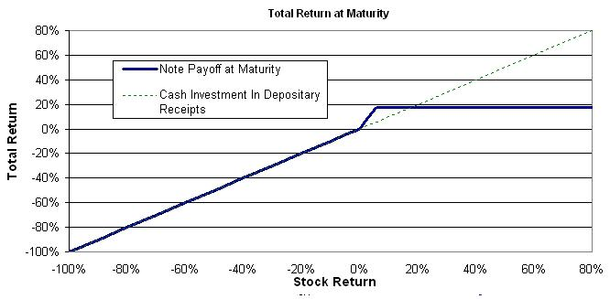

Hypothetical Examples of Amounts Payable at Maturity

The following examples illustrate how the total returns set forth in the table and graph above are calculated.

Example 1: The closing price of the Depositary Receipts increases from the Initial Share Price of $130 to a Final Share Price of $136.50. Because the Final Share Price of $136.50 is greater than the Initial Share Price of $130 and the Stock Return of 5% multiplied by 3 does not exceed the hypothetical Maximum Total Return of 17.46%, the investor receives a payment at maturity of $1,150 per $1,000 principal amount note, calculated as follows:

$1,000 + ($1,000 x 5% x 3) = $1,150

Example 2: The closing price of the Depositary Receipts increases from the Initial Share Price of $130 to a Final Share Price of $156. Because the Final Share Price of $156 is greater than the Initial Share Price of $130 and the Stock Return of 20% multiplied by 3 exceeds the hypothetical Maximum Total Return of 17.46%, the investor receives a payment at maturity of $1,174.60 per $1,000 principal amount note, the maximum payment on the notes.

Example 3: The closing price of the Depositary Receipts decreases from the Initial Share Price of $130 to a Final Share Price of $104. Because the Stock Return is negative and the Final Share Price of $104 is less than the Initial Share Price of $130, the investor receives a payment at maturity of $800 per $1,000 principal amount note, calculated as follows:

$1,000 + ($1,000 x -20%) = $800

JPMorgan Structured Investments — TS-3
Return Enhanced Notes Linked to Oil Service HOLDRSSM Trust Depositary Receipts

Selected Purchase Considerations

APPRECIATION POTENTIAL — The notes provide the opportunity to enhance equity returns by multiplying a positive Stock Return by three, up to the Maximum Total Return on the notes. The actual Maximum Total Return on the notes will be set on the pricing date and will not be less than 17.46%, and accordingly, the actual maximum payment at maturity will not be less than $1,174.60 per $1,000 principal amount note. Because the notes are our senior unsecured obligations, payment of any amount at maturity is subject to our ability to pay our obligations as they become due.
RETURN LINKED TO THE DEPOSITARY RECEIPTS OF THE OIL SERVICE HOLDRSSM TRUST — The return on the notes is linked to
the performance of the depositary receipts of the Oil Service HOLDRSSM Trust. The Oil Service HOLDRSSM Trust is an investment vehicle that holds shares of common stock issued by a group of specified companies that are generally considered to be involved in various segments of the oil service industry. The Oil Service HOLDRSSM Trust was formed under a Depositary Trust Agreement dated as of February 6, 2001 between The Bank of New York Mellon, as trustee, Merrill Lynch, Pierce, Fenner & Smith Incorporated, as the initial depositor, other depositors and the holders of the Depositary Receipts. The Oil Service HOLDRSSM Trust currently holds shares of 16 HOLDRS Underlying Stocks. The Depositary Receipts are not the same as the HOLDRS Underlying Stocks held by the Oil Service HOLDRSSM Trust that are represented by the Depositary Receipts. For additional information regarding the current HOLDRS Underlying Stocks, please see Annex A to this term sheet.

CAPITAL GAINS TAX TREATMENT — You should review carefully the section entitled “Certain U.S. Federal Income Tax Consequences” in the accompanying product supplement no. 133-A-II. Subject to the limitations described therein, and based on certain factual representations received from us, in the opinion of our special tax counsel, Davis Polk & Wardwell LLP, it is reasonable to treat the notes as “open transactions” for U.S. federal income tax purposes. Assuming this characterization is respected, the gain or loss on your notes should be treated as short-term capital gain or loss, whether or not you are an initial purchaser of notes at the issue price. However, the Internal Revenue Service (the “IRS”) or a court may not respect this characterization or treatment of the notes, in which case the timing and character of any income or loss on the notes could be significantly and adversely affected. In addition, in December 2007, Treasury and the IRS released a notice requesting comments on the U.S. federal income tax treatment of “prepaid forward contracts” and similar instruments, such as the notes. The notice focuses in particular on whether to require holders of these instruments to accrue income over the term of their investment. It also asks for comments on a number of related topics, including the character of income or loss with respect to these instruments; the relevance of factors such as the nature of the underlying property to which the instruments are linked; and the degree, if any, to which income (including any mandated accruals) realized by Non-U.S. Holders should be subject to withholding tax. While the notice requests comments on appropriate transition rules and effective dates, any Treasury regulations or other guidance promulgated after consideration of these issues could materially and adversely affect the tax consequences of an investment in the notes, possibly with retroactive effect. Both U.S. and Non-U.S. Holders should consult their tax advisers regarding the U.S. federal income tax consequences of an investment in the notes, including possible alternative treatments and the issues presented by this notice. In addition, based on certain factual assumptions and representations received from us, our special tax counsel is of the opinion that withholding under Sections 897 and 1445 of the Internal Revenue Code of 1986 and the regulations thereunder (collectively, “FIRPTA”) should not be imposed on proceeds paid to Non-U.S. Holders, although it is possible that we may decide (or that the IRS could argue) that we are required to do so. However, under a different set of rules, Non-U.S. Holders could in any event be withheld upon at a rate of up to 30% unless they have submitted a properly completed IRS Form W-8BEN or otherwise satisfied the applicable documentation requirements.

Subject to certain assumptions and representations received from us, the discussion in the preceding paragraph, when read in combination with the section entitled “Certain U.S. Federal Income Tax Consequences” in the accompanying product supplement, constitutes the full opinion of Davis Polk & Wardwell LLP regarding the material U.S. federal income tax consequences of owning and disposing of notes.

Selected Risk Considerations

An investment in the notes involves significant risks. Investing in the notes is not equivalent to investing directly in the Depositary Receipts or in the HOLDRS Underlying Stocks. These risks are explained in more detail in the “Risk Factors” section of the accompanying product supplement no. 133-A-II dated May 4, 2009.

YOUR INVESTMENT IN THE NOTES MAY RESULT IN A LOSS — The notes do not guarantee any return of principal. The return on the notes at maturity is linked to the performance of the Depositary Receipts and will depend on whether, and the extent to which, the Stock Return is positive or negative. Your investment will be fully exposed to any decline in the Final Share Price, as compared to the Initial Share Price.
YOUR MAXIMUM GAIN ON THE NOTES IS LIMITED TO THE MAXIMUM TOTAL RETURN — If the Final Share Price is greater than the Initial Share Price, for each $1,000 principal amount note, you will receive at maturity $1,000 plus an additional amount that will not exceed a predetermined percentage of the principal amount, regardless of the appreciation in closing price of the Depositary Receipts, which may be significant. We refer to this percentage as the Maximum Total Return, which will be set on the pricing date and will not be less than 17.46%.

JPMorgan Structured Investments — TS-4
Return Enhanced Notes Linked to Oil Service HOLDRSSM Trust Depositary Receipts

CREDIT RISK OF JPMORGAN CHASE & CO. — The notes are subject to the credit risk of JPMorgan Chase & Co. and our credit ratings and credit spreads may adversely affect the market value of the notes. Investors are dependent on JPMorgan Chase & Co.’s ability to pay all amounts due on the notes at maturity, and therefore investors are subject to our credit risk and to changes in the market’s view of our creditworthiness. Any decline in our credit ratings or increase in the credit spreads charged by the market for taking our credit risk is likely to affect adversely the value of the notes.
CERTAIN BUILT-IN COSTS ARE LIKELY TO AFFECT ADVERSELY THE VALUE OF THE NOTES PRIOR TO MATURITY — While the payment at maturity, if any, described in this term sheet is based on the full principal amount of your notes, the original issue price of the notes includes the agent’s commission and the estimated cost of hedging our obligations under the notes. As a result, the price, if any, at which JPMSI will be willing to purchase notes from you in secondary market transactions, if at all, will likely be lower than the original issue price, and any sale prior to the maturity date could result in a substantial loss to you. The notes are not designed to be short-term trading instruments. Accordingly, you should be able and willing to hold your notes to maturity.
THE VALUE OF THE DEPOSITARY RECEIPTS IS NOT NECESSARILY REPRESENTATIVE OF THE OIL SERVICE INDUSTRY — While the HOLDRS Underlying Stocks are common stocks of companies generally considered to be involved in various segments of the oil service industry, the HOLDRS Underlying Stocks and therefore the value of the Depositary Receipts may not necessarily follow the price movements of the entire oil service industry generally. If the HOLDRS Underlying Stocks decline in value, the value of Depositary Receipts will likely decline in value even if common stock prices in the oil service industry generally increase in value.
THE STOCK PRICES OF OIL SERVICE COMPANIES HAVE BEEN AND WILL LIKELY CONTINUE TO BE VOLATILE — The stock prices of oil service companies could be subject to wide fluctuations in response to a variety of factors. Price volatility of the HOLDRS Underlying Stocks may adversely affect the closing price of the Depositary Receipts and consequently the trading value of the notes.
THE UNDERLYING SECURITIES HELD BY THE OIL SERVICE HOLDRSSM TRUST ARE CONCENTRATED IN THE OIL SERVICE INDUSTRY — The HOLDRS Underlying Stocks generally have been issued by companies whose primary lines of business are directly associated with the oil service industry. Because the value of the Depositary Receipts to which the notes are linked is determined in part by the performance of the HOLDRS Underlying Stocks, an investment in these notes will be concentrated in this industry. As a result, the value of the notes may be subject to greater volatility and be more adversely affected by a single positive or negative economic, political or regulatory occurrence affecting this industry than would a different investment linked to securities of a more broadly diversified group of issuers. In addition, the oil service industry is significantly affected by a number of factors that influence worldwide economic conditions and energy prices, such as natural disasters, supply disruptions, geopolitical events and other factors that may either offset or magnify each other, including:
the ability of the Organization of Petroleum Exporting Countries (“OPEC”) to set and maintain production levels and pricing;

the level of production in non-OPEC countries;

the demand for oil and gas, which is negatively impacted by economic downturns;

crude oil supply disruptions stemming from world events or domestic problems such as refinery or pipeline outages, fire, explosion, blowouts, loss of well control or oil spills;
the cost of exploring for, developing, producing, refining and marketing oil and gas products;

the policies of various governments regarding exploration and development of oil and gas reserves;

advances in exploration and development technology;

consumer confidence;

the political environment of oil-producing regions;

changes in weather patterns and climatic changes;

the worldwide military and political environment, uncertainty or instability resulting from an escalation or additional outbreak of armed hostilities or further acts of terrorism in the United States or elsewhere; the price and availability of alternative and competing fuels;
domestic and foreign governmental regulations and taxes; and

general economic conditions worldwide.
These or other factors or the absence of such factors could cause a downturn in the oil service industry generally or regionally and could cause the value of some or all of the HOLDRS Underlying Stocks and consequently the Depositary Receipts and the notes to decline during the term of the notes.
THE DEPOSITARY RECEIPTS MAY NOT REPRESENT SOLELY OIL SERVICE COMPANIES — As a result of distributions of securities by the issuers of HOLDRS Underlying Stocks or other corporate events, such as mergers, securities other than the HOLDRS Underlying Stocks that are not involved in the oil service industry may be represented by the Depositary Receipts.

JPMorgan Structured Investments — TS-5
Return Enhanced Notes Linked to Oil Service HOLDRSSM Trust Depositary Receipts

YOU WILL HAVE NO OWNERSHIP RIGHTS IN THE DEPOSITARY RECEIPTS OR IN THE HOLDRS UNDERLYING STOCKS AND THE DEPOSITARY RECEIPTS MAY TRADE AT A DISCOUNT TO THE AGGREGATE VALUE OF THE HOLDRS UNDERLYING STOCKS — Investing in the notes is not equivalent to investing in the Depositary Receipts or in the HOLDRS Underlying Stocks. You will not have any ownership interest or rights in the Depositary Receipts or in the HOLDRS Underlying Stocks, such as voting rights, dividend payments or other distributions. In addition, the Depositary Receipts may trade at a discount to the aggregate value of the HOLDRS Underlying Stocks, which will adversely affect the value of the notes.
THE MATURITY OF THE NOTES WILL BE ACCELERATED IF THE OIL SERVICE HOLDRSSM TRUST IS TERMINATED, DISSOLVED,
OR OTHERWISE LIQUIDATED — The Oil Service HOLDRSSM Trust is subject to termination if, among other things, the trustee resigns and no successor trustee is appointed within 60 days, if 75% or more of the holders of the Depositary Receipts vote to dissolve or liquidate the assets of the Oil Service HOLDRSSM Trust, or if the Depositary Receipts are delisted and are not relisted on another U.S. national securities exchange and no successor securities (as determined in the sole discretion of the calculation agent) are listed on a U.S. national securities exchange. We refer to each of these events as a “Termination Event.” If a Termination Event occurs, the maturity date of the notes will be accelerated. Such acceleration may have a negative effect on your payment, if any, at maturity since the Final Share Price will be calculated based on the five consecutive trading days ending on the date we provide notice of the occurrence of the Termination Event rather than the originally scheduled Ending Averaging Dates. If the payment on your notes is accelerated due to a Termination Event, your investment may result in a loss and you may not be able to reinvest your money in an investment with a comparable return for a similar level of risk. Please see “Supplemental Information Relating to Delisting or Suspension of Trading and Termination” in this term sheet.

NO AFFILIATION WITH THE ISSUER OF THE DEPOSITARY RECEIPTS OR THE ISSUERS OF THE HOLDRS UNDERLYING STOCKS

— We are not affiliated with the Oil Service HOLDRSSM Trust or the issuers of the HOLDRS Underlying Stocks. We assume no responsibility for the adequacy of the information about the Oil Service HOLDRSSM Trust or the issuers of the HOLDRS Underlying Stocks contained in this term sheet. You should make your own investigation into the Oil Service HOLDRSSM Trust and the issuers of the HOLDRS Underlying Stocks. We are not responsible for the Oil Service HOLDRSSM Trust or issuers of the HOLDRS Underlying Stocks’ public disclosure of information, whether contained in SEC filings or otherwise. In addition, the Oil Service HOLDRSSM Trust and the issuers of the HOLDRS Underlying Stocks will not have any obligation to consider your interests as a holder of the notes in taking any action that might affect the value of the Depositary Receipts, the HOLDRS Underlying Stocks and the notes.

NO INTEREST OR DIVIDEND PAYMENTS — As a holder of the notes, you will not receive any interest or dividend payments on the notes. LACK OF LIQUIDITY — The notes will not be listed on any securities exchange. JPMSI intends to offer to purchase the notes in the secondary market but is not required to do so. Even if there is a secondary market, it may not provide enough liquidity to allow you to trade or sell the notes easily. Because other dealers are not likely to make a secondary market for the notes, the price at which you may be able to trade your notes is likely to depend on the price, if any, at which JPMSI is willing to buy the notes.
POTENTIAL CONFLICTS — We and our affiliates play a variety of roles in connection with the issuance of the notes, including acting as calculation agent. In performing these duties, the economic interests of the calculation agent and other affiliates of ours are potentially adverse to your interests as an investor in the notes. We and/or our affiliates may also currently or from time to time engage in business with the Oil Service HOLDRSSM Trust or the issuers of the HOLDRS Underlying Stocks, including extending loans to, or making equity investments in, the Oil Service HOLDRSSM Trust or such issuers or providing advisory services to the Oil Service HOLDRS SM Trust or such issuers. In addition, one or more of our affiliates may publish research reports or otherwise express opinions with respect to the Oil Service HOLDRSSM Trust or the issuers of the HOLDRS Underlying Stocks and these reports may or may not recommend that investors buy or hold the Depositary Receipts or the HOLDRS Underlying Stocks. As a prospective purchaser of the notes, you should undertake an independent investigation of the Oil Service HOLDRSSM Trust or the applicable issuer of the HOLDRS Underlying Stocks that in your judgment is appropriate to make an informed decision with respect to an investment in the notes.
HEDGING AND TRADING IN THE DEPOSITARY RECEIPTS AND THE HOLDRS UNDERLYING STOCKS — While the notes are outstanding, we or any of our affiliates may carry out hedging activities related to the notes, including in the Depositary Receipts, the HOLDRS Underlying Stocks or instruments related to one or more of the Depositary Receipts or the HOLDRS Underlying Stocks. We or our affiliates may also trade in the Depositary Receipts or the HOLDRS Underlying Stocks or instruments related to the Depositary Receipts or the HOLDRS Underlying Stocks from time to time. Any of these hedging or trading activities as of the pricing date and during the term of the notes could adversely affect our payment to you at maturity.
ANTI-DILUTION PROTECTION IS LIMITED — The calculation agent will make adjustments to the Stock Adjustment Factor for the Depositary Receipts to reflect certain events affecting the Depositary Receipts. However, the calculation agent will not make an adjustment in response to all events that could affect the Depositary Receipts. If an event occurs that does not require the calculation agent to make an adjustment, the value of the notes may be materially and adversely affected. See “General Terms of Notes — Anti-Dilution Adjustments” in the accompanying product supplement no. 133-A-II for further information.

JPMorgan Structured Investments — TS-6
Return Enhanced Notes Linked to Oil Service HOLDRSSM Trust Depositary Receipts

MANY ECONOMIC AND MARKET FACTORS WILL INFLUENCE THE VALUE OF THE NOTES — In addition to the closing price of the

Depositary Receipts on any day, the value of the notes will be affected by a number of economic and market factors that may either offset or magnify each other, including:

the expected volatility in the price of the Depositary Receipts;

the time to maturity of the notes;

the dividend rates paid on the Depositary Receipts and the HOLDRS Underlying Stocks;

interest and yield rates in the market generally;

a variety of economic, financial, political, regulatory or judicial events;

the occurrence of certain events affecting the Depositary Receipts that may or may not require an adjustment to the applicable Stock Adjustment Factor, including a merger or acquisition; and
our creditworthiness, including actual or anticipated downgrades in our credit ratings.

Oil Service HOLDRSSM Trust Depositary Receipts

Public Information

All information contained herein on the Oil Service HOLDRSSM Trust and the HOLDRS is derived from publicly available sources and is provided for informational purposes only. Information provided to or filed with the SEC by the Oil Service HOLDRSSM Trust, pursuant to the Securities Exchange Act of 1934, as amended, which we refer to as the Exchange Act, can be located by reference to SEC file number 001-16311, and can

be accessed through www.sec.gov. Additional information relating to the Oil Service HOLDRSSM Trust and the HOLDRS can also be found by reference to SEC registration number 333-52022 through www.sec.gov. We do not make any representation that these publicly available documents are accurate or complete. See “The Reference Stocks” beginning on page PS-21 of the accompanying product supplement no. 133-A-II for more information.

Oil Service HOLDRSSM Trust

The Oil Service HOLDRSSM Trust was formed pursuant to a Depositary Trust Agreement, dated as of February 6, 2001, between The Bank of New York Mellon, as trustee, Merrill Lynch, Pierce, Fenner & Smith Incorporated, as the initial depositor, other depositors and the owners of the HOLDRS. The Oil Service HOLDRSSM Trust is not a registered investment company under the Investment Company Act of 1940, as amended.

The Oil Service HOLDRSSM Trust issues the HOLDRS under the Depositary Trust Agreement. The HOLDRS represent an undivided beneficial ownership interest in the shares of the underlying common stocks held by the Oil Service HOLDRSSM Trust, which we refer to as the HOLDRS Underlying Stocks. Owners of the HOLDRS generally have the same rights and interests in the HOLDRS Underlying Stocks, including voting rights and the right to receive dividends and other distributions. As of the date of this term sheet, there are 16 HOLDRS Underlying Stocks, which may change as a result of reconstitution events, distributions of securities by the issuer of a HOLDRS Underlying Stock or other events. The HOLDRS are separate and distinct from the HOLDRS Underlying Stocks that are represented by the HOLDRS. The HOLDRS Underlying Stocks are the

common stocks of a group of specified companies that, at the time of selection for inclusion in the Oil Service HOLDRS SM Trust, among other things, provided drilling, well-site management and related products and services for the oil service industry and whose common stock is registered under Section 12 of the Exchange Act. The issuers of the HOLDRS Underlying Stocks were, at the time of selection, among the largest capitalized, most liquid companies in the oil service industry as measured by market capitalization and trading volume. For additional information about the current HOLDRS Underlying Stocks, please see Annex A to this term sheet.

The HOLDRS are registered under the Exchange Act, and are listed on the NYSE Arca, Inc., which we refer to as the Relevant Exchange for purposes of the HOLDRS in the accompanying product supplement no. 133-A-II, under the ticker symbol “OIH.”

JPMorgan Structured Investments — TS-7
Return Enhanced Notes Linked to Oil Service HOLDRSSM Trust Depositary Receipts

Historical Information

The following graph sets forth the historical performance of the HOLDRS based on the weekly closing price of the HOLDRS from January 7, 2005 through January 15, 2010. The closing price of the HOLDRS on January 15, 2010 was $130.19. We obtained the closing prices and other information below from Bloomberg Financial Markets without independent verification. The closing prices and this other information may be adjusted by Bloomberg Financial Markets for actions such as public offerings, mergers and acquisitions, spin-offs, delisting and bankruptcy. We make no representation or warranty as to the accuracy or completeness of the information obtained from Bloomberg Financial Markets.

Since the commencement of trading of the HOLDRS, the price of the HOLDRS has experienced significant fluctuations. The historical performance of the HOLDRS should not be taken as an indication of future performance, and no assurance can be given as to the closing price of the HOLDRS during the term of the notes. We cannot give you assurance that the performance of the HOLDRS will result in the return of any of your initial investment at maturity.
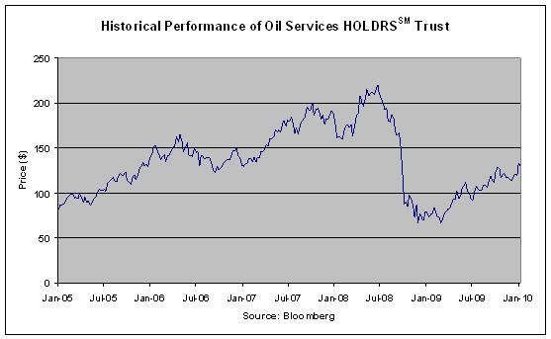

We make no representation as to the amount of dividends, if any, that the HOLDRS will pay in the future. In any event, as an investor in the notes, you will not be entitled to receive dividends, if any, that may be payable on the HOLDRS.

Supplemental Plan of Distribution (Conflicts of Interest)

We own, directly or indirectly, all of the outstanding equity securities of JPMSI, the agent for this offering. The net proceeds received from the sale of the notes will be used, in part, by JPMSI or one of its affiliates in connection with hedging our obligation under the notes. In accordance with NASD Rule 2720, JPMSI may not make sales in this offering to any of its discretionary accounts without the prior written approval of the customer.

JPMSI, acting as agent for JPMorgan Chase & Co., will receive a commission that will depend on market conditions on the pricing date. In no event will that commission exceed $5.00 per $1,000 principal amount note. See “Plan of Distribution” beginning on page PS-38 of the accompanying product supplement no. 133-A-II.

For a different portion of the notes to be sold in this offering, an affiliated bank will receive a fee and another affiliate of ours will receive a structuring and development fee. In no event will the total amount of these fees exceed $5.00 per $1,000 principal amount note.

JPMorgan Structured Investments — TS-8
Return Enhanced Notes Linked to Oil Service HOLDRSSM Trust Depositary Receipts

ANNEX A — HOLDRS UNDERLYING STOCKS

Public Information

All information contained herein on the HOLDRS Underlying Stocks and on the issuers of the HOLDRS Underlying Stocks is derived from publicly available sources and is provided for informational purposes only. Companies with securities registered under the Exchange Act are required to periodically file certain financial and other information specified by the SEC. Information provided to or filed with the SEC by a HOLDRS Underlying Stock issuer pursuant to the Exchange Act can be located by reference to the SEC file number provided below and can be accessed through www.sec.gov. We do not make any representation that these publicly available documents are accurate or complete.

Historical Information of the HOLDRS Underlying Stocks

The graphs contained in this term sheet set forth the historical performance of the HOLDRS Underlying Stocks based on the weekly closing prices (in U.S. dollars) of the HOLDRS Underlying Stocks from January 7, 2005 through January 15, 2010 (or, with respect to the common stock of Exterran Holdings, Inc., from August 24, 2007 through January 15, 2010). We obtained the closing prices and other market information in this term sheet from Bloomberg Financial Markets, without independent verification. The closing prices and this other information may be adjusted by Bloomberg Financial Markets for corporate actions such as public offerings, mergers and acquisitions, spin-offs, delistings and bankruptcy. We make no representation or warranty as to the accuracy or completeness of the information obtained from Bloomberg Financial Markets.

Since the commencement of trading of each HOLDRS Underlying Stock, the price of such HOLDRS Underlying Stock has experienced significant fluctuations. The historical performance of each HOLDRS Underlying Stock should not be taken as an indication of future performance, and no assurance can be given as to correlation between the prices of the HOLDRS Underlying Stocks and the price of the HOLDRS during the term of the notes. The notes are linked solely to the performance of the HOLDRS and not to the HOLDRS Underlying Stocks, individually or in the aggregate. The HOLDRS are not the same as the HOLDRS Underlying Stocks and may trade at a discount to the aggregate value of the HOLDRS Underlying Stocks.

Baker Hughes Incorporated (“Baker Hughes”)

According to its publicly available filings with the SEC, Baker Hughes is a supplier of wellbore-related products and technology services and systems and provides products and services for drilling, formation evaluation, completion and production, and reservoir technology and consulting to the worldwide oil and natural gas industry. The common stock of Baker Hughes, par value $1.00 per share, is listed on the New York Stock Exchange. Baker Hughes’s SEC file number is 001-09397.

Historical Information of the Common Stock of Baker Hughes

The following graph sets forth the historical performance of the common stock of Baker Hughes based on the weekly closing price (in U.S. dollars) of the common stock of Baker Hughes from January 7, 2005 through January 15, 2010. The closing price of the common stock of Baker Hughes on January 15, 2010 was $47.28.
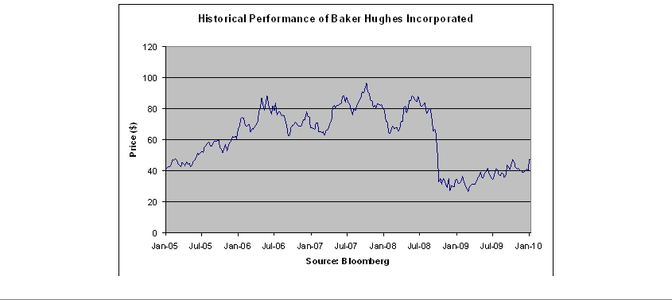

JPMorgan Structured Investments — TS-9
Return Enhanced Notes Linked to Oil Service HOLDRSSM Trust Depositary Receipts

BJ Services Company (“BJ Services”)

According to its publicly available filings with the SEC, BJ Services provides pressure pumping services and other oilfield services to the oil and natural gas industry worldwide. The common stock of BJ Services, par value $0.10 per share, is listed on the New York Stock Exchange. BJ Services Company’s SEC file number is 001-10570.

Historical Information of the Common Stock of BJ Services

The following graph sets forth the historical performance of the common stock of BJ Services based on the weekly closing price (in U.S. dollars) of the common stock of BJ Services from January 7, 2005 through January 15, 2010. The closing price of the common stock of BJ Services on January 15, 2010 was $21.46.
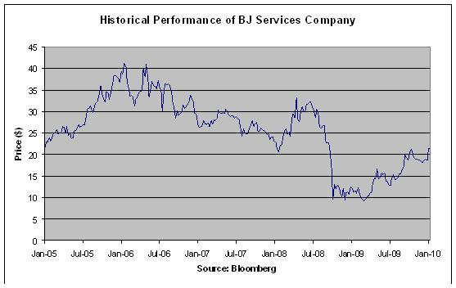

Cameron International Corporation (“Cameron”)

According to its publicly available filings with the SEC, Cameron is a provider of flow equipment products, systems and services to worldwide oil, gas and process industries. The common stock of Cameron, par value $0.01 per share, is listed on the New York Stock Exchange. Cameron’s SEC file number is 001-13884.

Historical Information of the Common Stock of Cameron

The following graph sets forth the historical performance of the common stock of Cameron based on the weekly closing price (in U.S. dollars) of the common stock of Cameron from January 7, 2005 through January 15, 2010. The closing price of the common stock of Cameron on January 15, 2010 was $41.65.
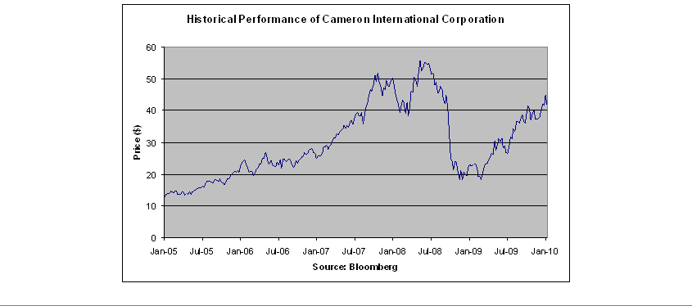

JPMorgan Structured Investments — | TS-10
Return Enhanced Notes Linked to Oil Service HOLDRSSM Trust Depositary Receipts

Diamond Offshore Drilling, Inc. (“Diamond Offshore”)

According to its publicly available filings with the SEC, Diamond Offshore provides contract drilling services to the energy industry. The common stock of Diamond Offshore, par value $0.01 per share, is listed on the New York Stock Exchange. Diamond Offshore’s SEC file number is 001-13926.

Historical Information of the Common Stock of Diamond Offshore

The following graph sets forth the historical performance of the common stock of Diamond Offshore based on the weekly closing price (in U.S. dollars) of the common stock of Diamond Offshore from January 7, 2005 through January 15, 2010. The closing price of the common stock of Diamond Offshore on January 15, 2010 was $102.84.
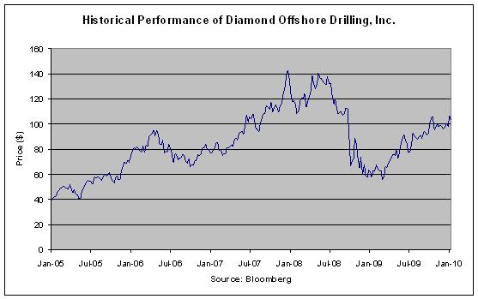

ENSCO International Incorporated (“ENSCO”)

According to its publicly available filings with the SEC, ENSCO is an international offshore contract drilling company. The common stock of ENSCO, par value $0.10 per share, is listed on the New York Stock Exchange. ENSCO’s SEC file number is 001-08097.

Historical Information of the Common Stock of ENSCO

The following graph sets forth the historical performance of the common stock of ENSCO based on the weekly closing price (in U.S. dollars) of the common stock of ENSCO from January 7, 2005 through January 15, 2010. The closing price of the common stock of ENSCO on January 15, 2010 was $44.58.
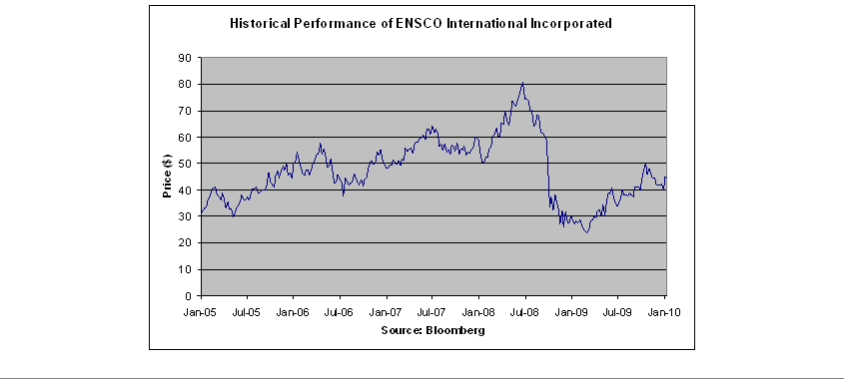

JPMorgan Structured Investments — | TS-11
Return Enhanced Notes Linked to Oil Service HOLDRSSM Trust Depositary Receipts

Exterran Holdings, Inc. (“Exterran”)

According to its publicly available filings with the SEC, Exterran is engaged in the full service natural gas compression business and a provider of operations, maintenance, service and equipment for oil and natural gas production, processing and transportation applications. The common stock of Exterran, par value $0.01 per share, is listed on the New York Stock Exchange. Exterran’s SEC file number is 001-33666.

Historical Information of the Common Stock of Exterran

The following graph sets forth the historical performance of the common stock of Exterran based on the weekly closing price (in U.S. dollars) of the common stock of Exterran from August 24, 2007 through January 15, 2010. The common stock of Exterran commenced trading on the New York Stock Exchange on August 21, 2007. The closing price of the common stock of Exterran on January 15, 2010 was $21.34.
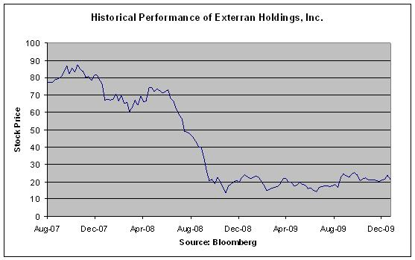

Halliburton Company (“Halliburton”)

According to its publicly available filings with the SEC, Halliburton is a provider of products and services to the energy industry, serving the upstream oil and gas industry throughout the lifecycle of the reservoir, from locating hydrocarbons and managing geological data, to drilling and formation evaluation, well construction and completion, and optimizing production through the life of the field. The common stock of Halliburton, par value $2.50 per share, is listed on the New York Stock Exchange. Halliburton’s SEC file number is 001-03492.

Historical Information of the Common Stock of Halliburton

The following graph sets forth the historical performance of the common stock of Halliburton based on the weekly closing price (in U.S. dollars) of the common stock of Halliburton from January 7, 2005 through January 15, 2010. The closing price of the common stock of Halliburton on January 15, 2010 was $34.03.
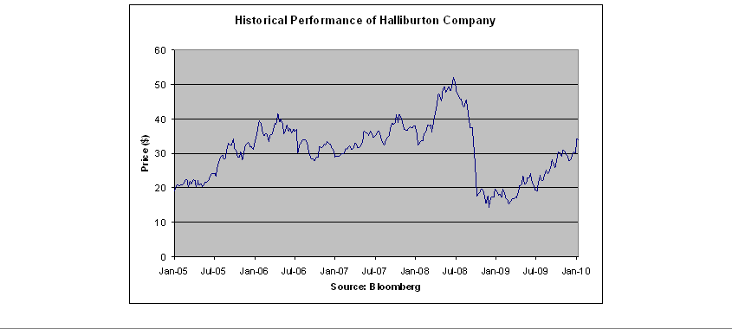

JPMorgan Structured Investments — | TS-12
Return Enhanced Notes Linked to Oil Service HOLDRSSM Trust Depositary Receipts

Nabors Industries Ltd. (“Nabors”)

According to its publicly available filings with the SEC, Nabors, a Bermuda company, is a land drilling contractor, land well-servicing and workover contractor and a provider of ancillary well-site services and logistics services, and invests in oil and gas exploration, development and product activities in the United States, Canada and international areas. The common shares of Nabors, par value $0.001 per share, which we refer to as the “common stock of Nabors,” are listed on the New York Stock Exchange. Nabors’s SEC file number is 001-32657.

Historical Information of the Common Stock of Nabors

The following graph sets forth the historical performance of the common stock of Nabors based on the weekly closing price (in U.S. dollars) of the common stock of Nabors from January 7, 2005 through January 15, 2010. The closing price of the common stock of Nabors on January 15, 2010 was $25.55.
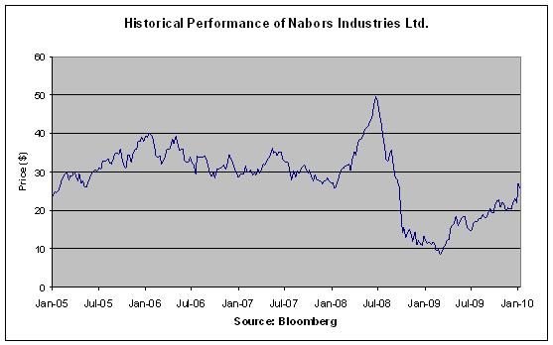

National Oilwell Varco, Inc. (“National Oilwell”)

According to its publicly available filings with the SEC, National Oilwell is engaged in the design, manufacture and sale of equipment and components used in oil and gas drilling and production, and the provision of oilfield services and supply chain integration services to the upstream oil and gas industry. The common stock of National Oilwell, par value $0.01 per share, is listed on the New York Stock Exchange. National Oilwell’s SEC file number is 001-12317.

Historical Information of the Common Stock of National Oilwell

The following graph sets forth the historical performance of the common stock of National Oilwell based on the weekly closing price (in U.S. dollars) of the common stock of National Oilwell from January 7, 2005 through January 15, 2010. The closing price of the common stock of National Oilwell on January 15, 2010 was $46.24.
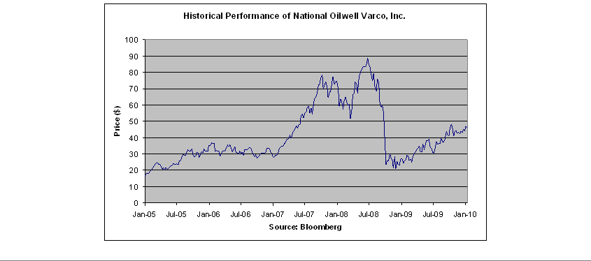

JPMorgan Structured Investments — | TS-13
Return Enhanced Notes Linked to Oil Service HOLDRSSM Trust Depositary Receipts

Noble Corporation (“Noble”)

According to its publicly available filings with the SEC, Noble, a Swiss company, is an offshore drilling contractor for the oil and gas industry. The shares of Noble, par value 4.90 Swiss francs per share, which we refer to as the “common stock of Noble,” are listed on the New York Stock Exchange. Noble’s SEC file number is 000-53604.

Historical Information of the Common Stock of Noble

The following graph sets forth the historical performance of the common stock of Noble based on the weekly closing price (in U.S. dollars) of the common stock of Noble from January 7, 2005 through January 15, 2010. The closing price of the common stock of Noble on January 15, 2010 was $43.73.
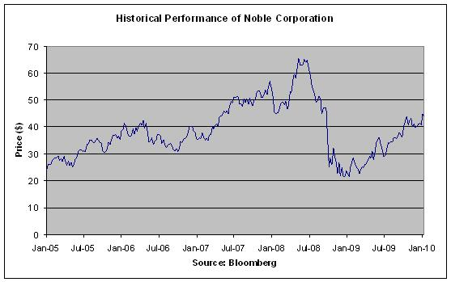

Rowan Companies, Inc. (“Rowan”)

According to its publicly available filings with the SEC, Rowan is a provider of international and domestic contract drilling services. Rowan also produces equipment for the drilling, mining and timber industries. The common stock of Rowan, par value $0.125 per share, is listed on the New York Stock Exchange. Rowan’s SEC file number is 001-05491.

Historical Information of the Common Stock of Rowan

The following graph sets forth the historical performance of the common stock of Rowan based on the weekly closing price (in U.S. dollars) of the common stock of Rowan from January 7, 2005 through January 15, 2010. The closing price of the common stock of Rowan on January 15, 2010 was $24.13.
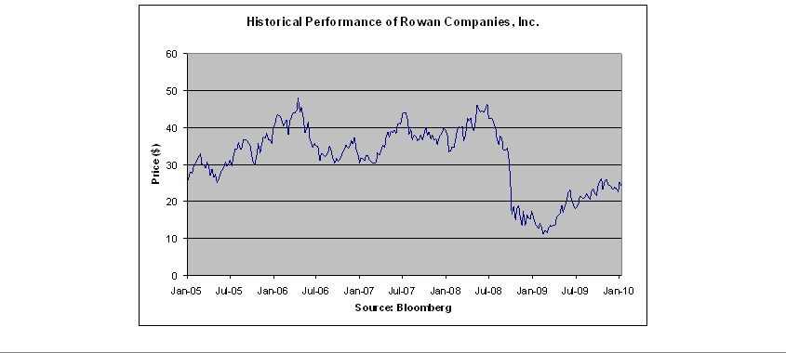

JPMorgan Structured Investments — | TS-14
Return Enhanced Notes Linked to Oil Service HOLDRSSM Trust Depositary Receipts

Schlumberger N.V. (Schlumberger Limited) (“Schlumberger”)

According to its publicly available filings with the SEC, Schlumberger, Netherlands Antilles company, is a supplier of technology, integrated project management and information solutions to customers working in the oil and gas industry worldwide. The common stock of Schlumberger, par value $0.01 per share, is listed on the New York Stock Exchange. Schlumberger’s SEC file number is 001-04601.

Historical Information of the Common Stock of Schlumberger

The following graph sets forth the historical performance of the common stock of Schlumberger based on the weekly closing price (in U.S. dollars) of the common stock of Schlumberger from January 7, 2005 through January 15, 2010. The closing price of the common stock of Schlumberger on January 15, 2010 was $70.83.
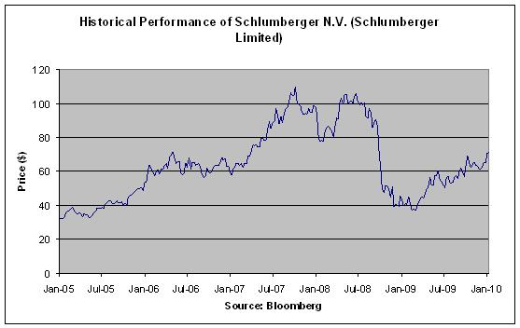

Smith International, Inc. (“Smith International”)

According to its publicly available filings with the SEC, Smith International is a provider of premium products and services used during the drilling, completion and production phases of oil and natural gas development activities. The common stock of Smith International, par value $1.00 per share, is listed on the New York Stock Exchange. Smith International’s SEC file number is 001-08514.

Historical Information of the Common Stock of Smith International

The following graph sets forth the historical performance of the common stock of Smith International based on the weekly closing price (in U.S. dollars) of the common stock of Smith International from January 7, 2005 through January 15, 2010. The closing price of the common stock of Smith International on January 15, 2010 was $30.11.
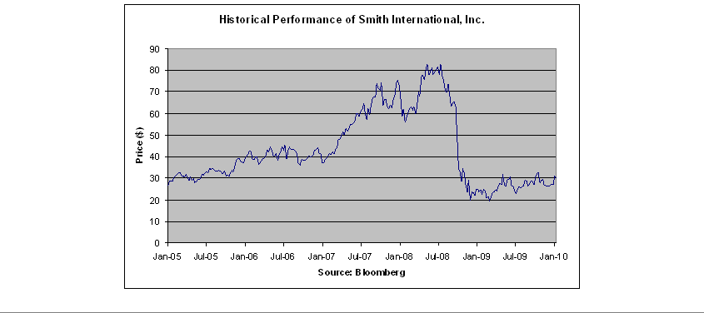

JPMorgan Structured Investments — | TS-15
Return Enhanced Notes Linked to Oil Service HOLDRSSM Trust Depositary Receipts

Tidewater Inc. (“Tidewater”)

According to its publicly available filings with the SEC, Tidewater provides offshore supply vessels and marine support services to the offshore energy industry. The common stock of Tidewater, par value $0.10 per share, is listed on the New York Stock Exchange. Tidewater’s SEC file number is 001-06311.

Historical Information of the Common Stock of Tidewater

The following graph sets forth the historical performance of the common stock of Tidewater based on the weekly closing price (in U.S. dollars) of the common stock of Tidewater from January 7, 2005 through January 15, 2010. The closing price of the common stock of Tidewater on January 15, 2010 was $50.20.
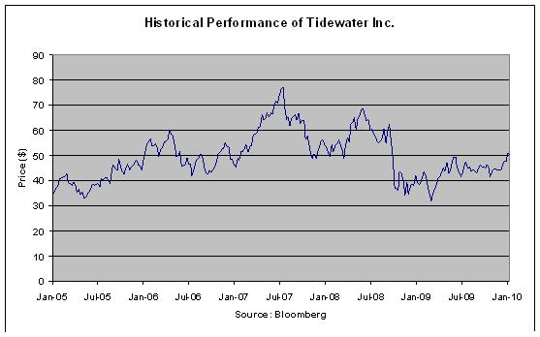

Transocean Ltd. (“Transocean”)

According to its publicly available filings with the SEC, Transocean, a Swiss company, is an international provider of offshore contract drilling services for oil and gas wells. The shares of Transocean, par value Swiss franc 15.00 per share, which we refer to as the “common stock of Transocean,” are listed on the New York Stock Exchange. Transocean’s SEC file number is 000-53533.

Historical Information of the Common Stock of Transocean

The following graph sets forth the historical performance of the common stock of Transocean based on the weekly closing price (in U.S. dollars) of the common stock of Transocean from January 7, 2005 through January 15, 2010. The closing price of the common stock of Transocean on January 15, 2010 was $91.85.
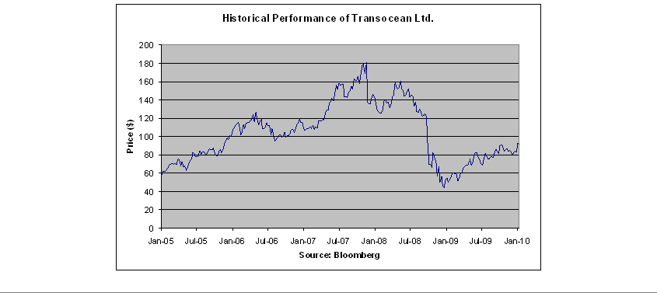

JPMorgan Structured Investments — | TS-16
Return Enhanced Notes Linked to Oil Service HOLDRSSM Trust Depositary Receipts

Weatherford International Ltd. (“Weatherford International”)

According to its publicly available filings with the SEC, Weatherford International provides equipment and services used for drilling, completion and production of oil and natural gas wells throughout the world. The shares of Weatherford International, par value Swiss franc 1.16 per share, which we refer to as the “common stock of Weatherford International,” are listed on the New York Stock Exchange. Weatherford International’s SEC file number is 001-34258.

Historical Information of the Common Stock of Weatherford International

The following graph sets forth the historical performance of the common stock of Weatherford International based on the weekly closing price (in U.S. dollars) of the common stock of Weatherford International from January 7, 2005 through January 15, 2010. The closing price of the common stock of Weatherford International on January 15, 2010 was $18.76.
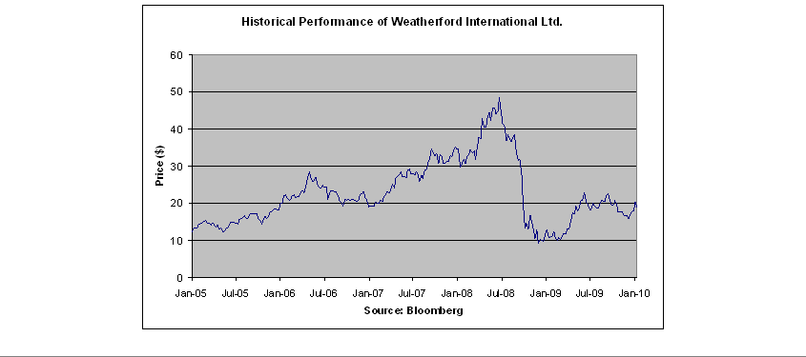

JPMorgan Structured Investments — | TS-17
Return Enhanced Notes Linked to Oil Service HOLDRSSM Trust Depositary Receipts

