The information in this preliminary pricing supplement is not complete and may be changed. This preliminary pricing supplement is not an offer to sell nor does it seek an offer to buy these securities in any jurisdiction where the offer or sale is not permitted.
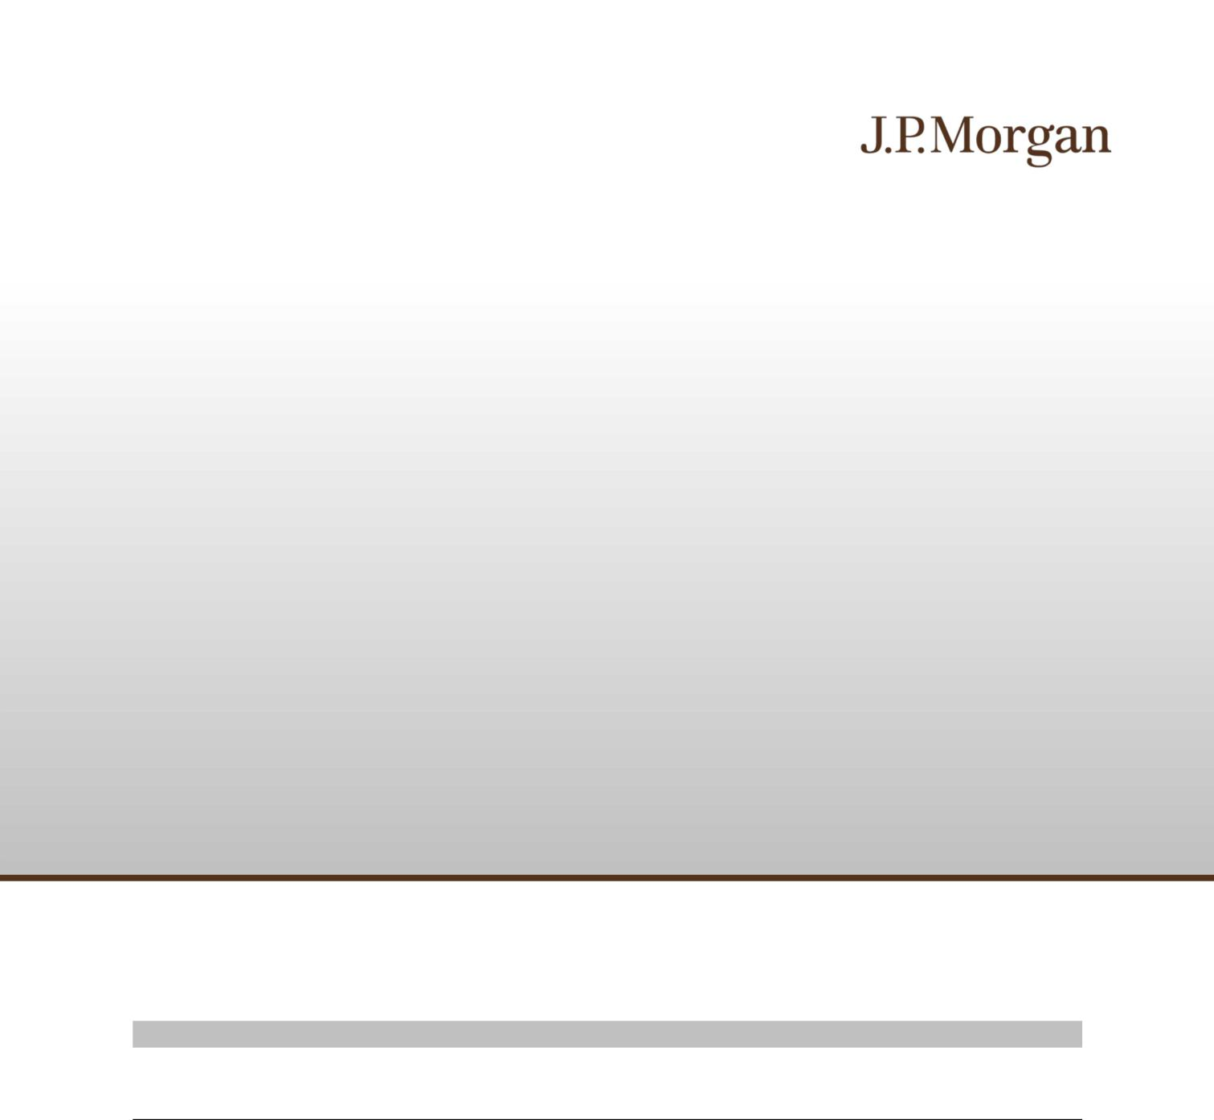
 | Subject to completion dated May 7, 2026
May , 2026 | Registration Statement Nos. 333-293684 and 333-293684-01; Rule 424(b)(2)

JPMorgan Chase Financial Company LLC

Structured Investments

Callable Contingent Interest Notes Linked to the Least Performing of the Russell 2000® Index, the State Street® SPDR® S&P® Regional Banking ETF and the VanEck® Semiconductor ETF due April 18, 2028

Fully and Unconditionally Guaranteed by JPMorgan Chase & Co.

- The notes are designed for investors who seek a Contingent Interest Payment with respect to each Review Date for which the closing value of each of the Russell 2000® Index, the State Street® SPDR® S&P® Regional Banking ETF and the VanEck® Semiconductor ETF, which we refer to as the Underlyings, is greater than or equal to 70.00% of its Initial Value, which we refer to as an Interest Barrier.

- The notes may be redeemed early, in whole but not in part, at our option on any of the Interest Payment Dates (other than the first, second and final Interest Payment Dates).

- The earliest date on which the notes may be redeemed early is August 17, 2026.

- Investors should be willing to accept the risk of losing a significant portion or all of their principal and the risk that no Contingent Interest Payment may be made with respect to some or all Review Dates.
- Investors should also be willing to forgo fixed interest and dividend payments, in exchange for the opportunity to receive Contingent Interest Payments.
- The notes are unsecured and unsubordinated obligations of JPMorgan Chase Financial Company LLC, which we refer to as JPMorgan Financial, the payment on which is fully and unconditionally guaranteed by JPMorgan Chase & Co. Any payment on the notes is subject to the credit risk of JPMorgan Financial, as issuer of the notes, and the credit risk of JPMorgan Chase & Co., as guarantor of the notes.

- Payments on the notes are not linked to a basket composed of the Underlyings. Payments on the notes are linked to the performance of each of the Underlyings individually, as described below.
- Minimum denominations of $1,000 and integral multiples thereof

- The notes are expected to price on or about May 12, 2026 and are expected to settle on or about May 15, 2026.

- CUSIP: 46660TVQ0

Investing in the notes involves a number of risks. See “Risk Factors” beginning on page S-2 of the accompanying prospectus supplement, “Risk Factors” beginning on page PS-12 of the accompanying product supplement and “Selected Risk Considerations” beginning on page PS-5 of this pricing supplement.

Neither the Securities and Exchange Commission (the “SEC”) nor any state securities commission has approved or disapproved of the notes or passed upon the accuracy or the adequacy of this pricing supplement or the accompanying product supplement, underlying supplement, prospectus supplement and prospectus. Any representation to the contrary is a criminal offense.

 | Price to Public (1) | Fees and Commissions (2) | Proceeds to Issuer
Per note | $1,000 | $ | $
Total | $ | $ | $

- See “Supplemental Use of Proceeds” in this pricing supplement for information about the components of the price to public of the notes.

- J.P. Morgan Securities LLC, which we refer to as JPMS, acting as agent for JPMorgan Financial, will pay all of the selling commissions it receives from us to other affiliated or unaffiliated dealers. In no event will these selling commissions exceed $22.25 per $1,000 principal amount note. See “Plan of Distribution (Conflicts of Interest)” in the accompanying product supplement.

If the notes priced today, the estimated value of the notes would be approximately $949.00 per $1,000 principal amount note. The estimated value of the notes, when the terms of the notes are set, will be provided in the pricing supplement and will not be less than $900.00 per $1,000 principal amount note. See “The Estimated Value of the Notes” in this pricing supplement for additional information.

The notes are not bank deposits, are not insured by the Federal Deposit Insurance Corporation or any other governmental agency and are not obligations of, or guaranteed by, a bank.

Pricing supplement to product supplement no. 3-I dated April 17, 2026, underlying supplement no. 1-I dated April 17, 2026 and the prospectus and prospectus supplement, each dated April 17, 2026

Key Terms

Issuer: JPMorgan Chase Financial Company LLC, a direct, wholly owned finance subsidiary of JPMorgan Chase & Co. Guarantor: JPMorgan Chase & Co.
Underlyings: The Russell 2000® Index (Bloomberg ticker:
RTY) (the “Index”) and the State Street® SPDR® S&P® Regional
Banking ETF (Bloomberg ticker: KRE) and the VanEck®
Semiconductor ETF (Bloomberg ticker: SMH) (each of the State
Street® SPDR® S&P® Regional Banking ETF and the VanEck® Semiconductor ETF, a “Fund” and collectively, the “Funds”)

(each of the Index and the Funds, an “Underlying” and collectively, the “Underlyings”)

Contingent Interest Payments: If the notes have not been previously redeemed early and the closing value of each Underlying on any Review Date is greater than or equal to its
Interest Barrier, you will receive on the applicable Interest Payment Date for each $1,000 principal amount note a Contingent Interest Payment equal to at least $11.2917 (equivalent to a Contingent Interest Rate of at least 13.55% per annum, payable at a rate of at least 1.12917% per month) (to be provided in the pricing supplement).

If the closing value of any Underlying on any Review Date is less than its Interest Barrier, no Contingent Interest Payment will be made with respect to that Review Date.

Contingent Interest Rate: At least 13.55% per annum, payable

at a rate of at least 1.12917% per month (to be provided in the pricing supplement)

Interest Barrier: With respect to each Underlying, 70.00% of its Initial Value

Trigger Value: With respect to each Underlying, 50.00% of its Initial Value

Pricing Date: On or about May 12, 2026

Original Issue Date (Settlement Date): On or about May 15, 2026

Review Dates*: June 12, 2026, July 13, 2026, August 12, 2026, September 14, 2026, October 12, 2026, November 12, 2026, December 14, 2026, January 12, 2027, February 12, 2027, March 12, 2027, April 12, 2027, May 12, 2027, June 14, 2027, July 12, 2027, August 12, 2027, September 13, 2027, October 12, 2027, November 12, 2027, December 13, 2027, January 12, 2028, February 14, 2028, March 13, 2028 and April 12, 2028 (final Review Date)

Interest Payment Dates*: June 17, 2026, July 16, 2026, August 17, 2026, September 17, 2026, October 15, 2026, November 17, 2026, December 17, 2026, January 15, 2027, February 18, 2027, March 17, 2027, April 15, 2027, May 17, 2027, June 17, 2027, July 15, 2027, August 17, 2027, September 16, 2027, October 15, 2027, November 17, 2027, December 16, 2027, January 18, 2028, February 17, 2028, March 16, 2028 and the Maturity Date

Maturity Date*: April 18, 2028

- Subject to postponement in the event of a market disruption event and as described under “General Terms of Notes — Postponement of a Determination Date — Notes Linked to Multiple Underlyings” and “General Terms of Notes — Postponement of a Payment Date” in the accompanying product supplement or early acceleration in the event of an acceleration event as described under “General Terms of Notes — Consequences of an Acceleration Event” in the accompanying product supplement and “Selected Risk Considerations — Risks Relating to the Notes Generally — We May Accelerate Your Notes If an Acceleration Event Occurs” in this pricing supplement

Early Redemption:
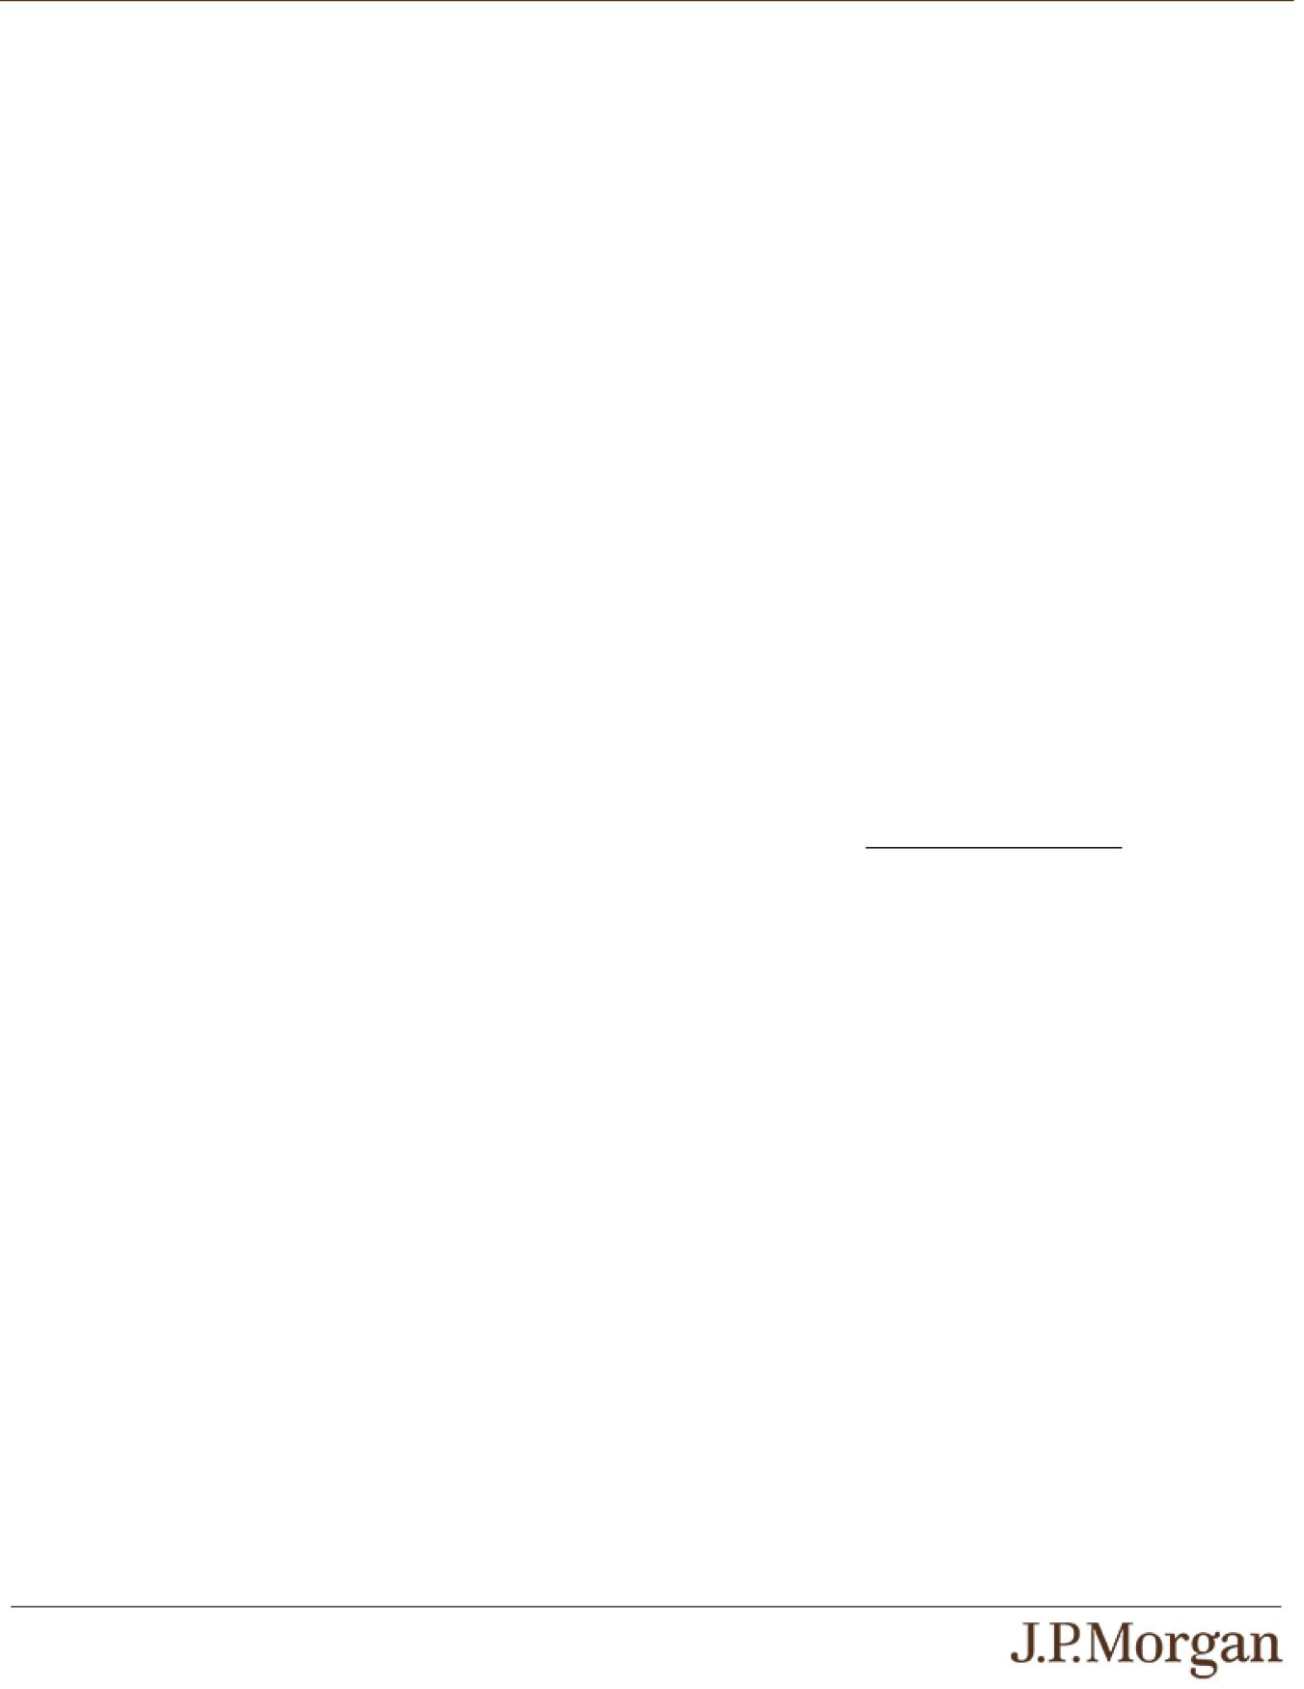

We, at our election, may redeem the notes early, in whole but not in part, on any of the Interest Payment Dates (other than the first, second and final Interest Payment Dates) at a price, for each $1,000 principal amount note, equal to (a) $1,000 plus (b) the Contingent Interest Payment, if any, applicable to the immediately preceding Review Date. If we intend to redeem your notes early, we will deliver notice to The Depository Trust Company, or DTC, at least three business days before the

applicable Interest Payment Date on which the notes are redeemed early.

Payment at Maturity:

If the notes have not been redeemed early and the Final Value of each Underlying is greater than or equal to its Trigger Value, you will receive a cash payment at maturity, for each $1,000 principal amount note, equal to (a) $1,000 plus (b) the Contingent Interest Payment, if any, applicable to the final Review Date.

If the notes have not been redeemed early and the Final Value of any Underlying is less than its Trigger Value, your payment at

maturity per $1,000 principal amount note will be calculated as follows:

$1,000 + ($1,000 × Least Performing Underlying Return)

If the notes have not been redeemed early and the Final Value of any Underlying is less than its Trigger Value, you will lose more than 50.00% of your principal amount at maturity and could lose all of your principal amount at maturity.

Least Performing Underlying: The Underlying with the Least

Performing Underlying Return

Least Performing Underlying Return: The lowest of the Underlying Returns of the Underlyings

Underlying Return:

With respect to each Underlying,

(Final Value – Initial Value)
Initial Value

Initial Value: With respect to each Underlying, the closing value of that Underlying on the Pricing Date

Final Value: With respect to each Underlying, the closing value of that Underlying on the final Review Date

Share Adjustment Factor: With respect to each Fund, the Share Adjustment Factor is referenced in determining the closing value of that Fund and is set equal to 1.0 on the Pricing Date. The Share Adjustment Factor of each Fund is subject to adjustment upon the occurrence of certain events affecting that
Fund. See “The Underlyings — Funds — Anti-Dilution Adjustments” in the accompanying product supplement for further information.

PS-1 | Structured Investments
Callable Contingent Interest Notes Linked to the Least Performing of the
Russell 2000® Index, the State Street® SPDR® S&P® Regional Banking ETF
and the VanEck® Semiconductor ETF

How the Notes Work


Payments in Connection with the First and Second Review Dates

First and Second Review Dates

Compare the closing value of each Underlying to its Interest Barrier on each Review Date.

The closing value of each Underlying is greater than or equal to its Interest Barrier.

The closing value of any Underlying is less than its Interest Barrier.

You will receive a Contingent Interest Payment on the
applicable Interest Payment Date.

Proceed to the next Review Date.

No Contingent Interest Payment will be made with respect to

the applicable Review Date.

Proceed to the next Review Date.

Payments in Connection with Review Dates (Other than the First, Second and Final Review Dates)

Review Dates (Other than the First, Second and Final Review Dates)

Compare the closing value of each Underlying to its Interest Barrier on each Review Date until the final Review Date or any early redemption.

Early Redemption No Early Redemption

The closing value of each

Underlying is greater than or
equal to its Interest Barrier.

The closing value of any Underlying is less than its Interest Barrier.

You will receive (a) $1,000 plus (b) a Contingent Interest Payment on the applicable Interest Payment Date.

No further payments will be made on the

notes.

You will receive $1,000 on the applicable

Interest Payment Date.

No further payments will be made on the

notes.

You will receive a Contingent Interest Payment on the applicable Interest Payment Date.

Proceed to the next Review Date.

No Contingent Interest Payment will be made with respect to the applicable Review Date.

Proceed to the next Review Date.

PS-2 | Structured Investments

Callable Contingent Interest Notes Linked to the Least Performing of the Russell 2000® Index, the State Street® SPDR® S&P® Regional Banking ETF

and the VanEck® Semiconductor ETF

Payment at Maturity If the Notes Have Not Been Redeemed Early
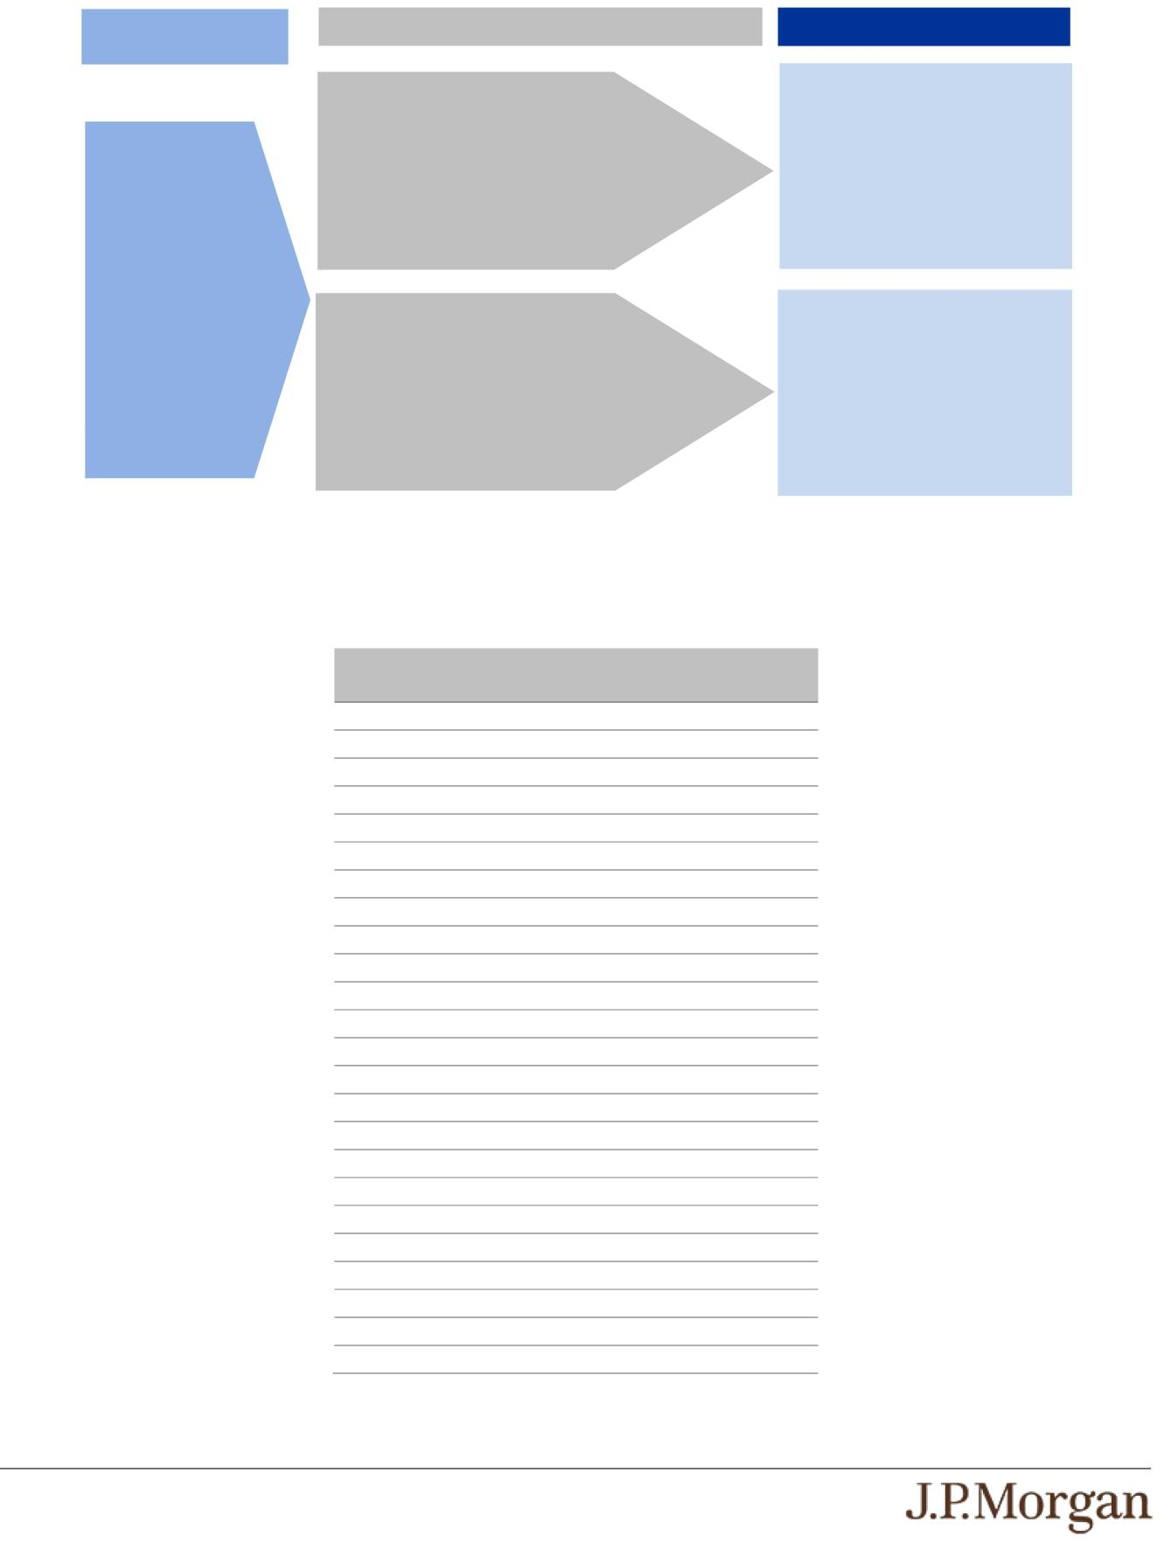

Review Dates Preceding the
Final Review Date

The notes have not been redeemed early prior to the final Review Date.

Proceed to maturity

Final Review Date

The Final Value of each Underlying is greater than or equal to its Trigger Value.

The Final Value of any Underlying is less than its Trigger Value.

Payment at Maturity

You will receive (a) $1,000 plus (b) the Contingent Interest Payment, if any, applicable to the final Review Date.

You will receive:

$1,000 + ($1,000 × Least Performing
Underlying Return)

Under these circumstances, you will lose a significant portion or all of your principal amount at maturity.

Total Contingent Interest Payments

The table below illustrates the hypothetical total Contingent Interest Payments per $1,000 principal amount note over the term of the notes based on a hypothetical Contingent Interest Rate of 13.55% per annum, depending on how many Contingent Interest Payments are made prior to early redemption or maturity. The actual Contingent Interest Rate will be provided in the pricing supplement and will be at least 13.55% per annum (payable at a rate of at least 1.12917% per month).

Number of Contingent | Total Contingent Interest
Interest Payments | Payments
23 | $259.7083
22 | $248.4167
21 | $237.1250
20 | $225.8333
19 | $214.5417
18 | $203.2500
17 | $191.9583
16 | $180.6667
15 | $169.3750
14 | $158.0833
13 | $146.7917
12 | $135.5000
11 | $124.2083
10 | $112.9167
9 | $101.6250
8 | $90.3333
7 | $79.0417
6 | $67.7500
5 | $56.4583
4 | $45.1667
3 | $33.8750
2 | $22.5833
1 | $11.2917
0 | $0.0000

PS-3 | Structured Investments

Callable Contingent Interest Notes Linked to the Least Performing of the Russell 2000® Index, the State Street® SPDR® S&P® Regional Banking ETF

and the VanEck® Semiconductor ETF

Hypothetical Payout Examples
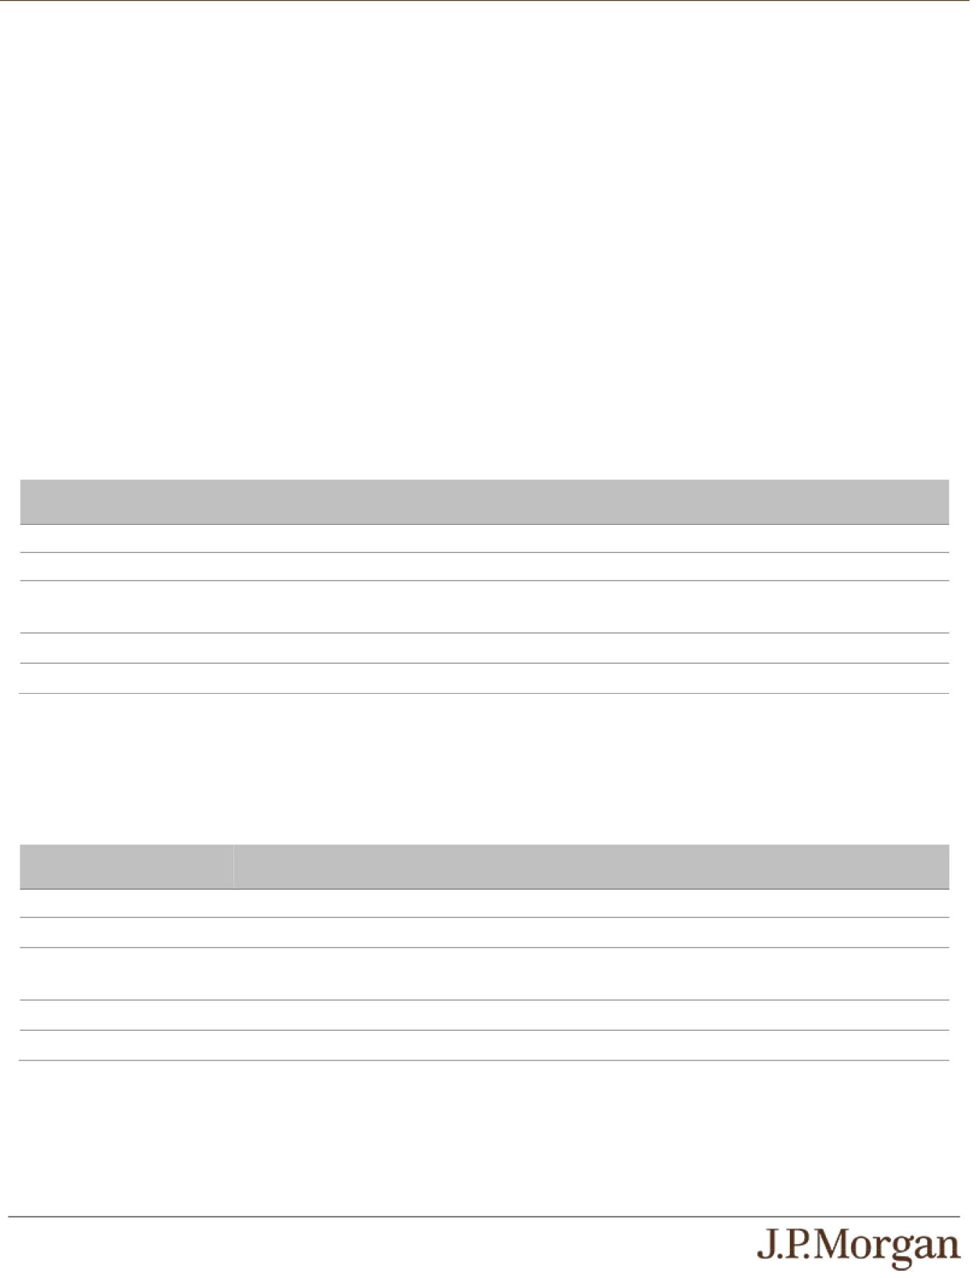

The following examples illustrate payments on the notes linked to three hypothetical Underlyings, assuming a range of performances for the hypothetical Least Performing Underlying on the Review Dates. Solely for purposes of this section, the Least Performing

Underlying with respect to each Review Date is the least performing of the Underlyings determined based on the closing value of each Underlying on that Review Date compared with its Initial Value.

The hypothetical payments set forth below assume the following:

- the notes have not been redeemed early;

- an Initial Value for each Underlying of 100.00;

- an Interest Barrier for each Underlying of 70.00 (equal to 70.00% of its hypothetical Initial Value);

- a Trigger Value for each Underlying of 50.00 (equal to 50.00% of its hypothetical Initial Value); and

- a Contingent Interest Rate of 13.55% per annum.

The hypothetical Initial Value of each Underlying of 100.00 has been chosen for illustrative purposes only and may not represent a likely actual Initial Value of any Underlying. The actual Initial Value of each Underlying will be the closing value of that Underlying on the Pricing Date and will be provided in the pricing supplement. For historical data regarding the actual closing values of each Underlying, please see the historical information set forth under “The Underlyings” in this pricing supplement.

Each hypothetical payment set forth below is for illustrative purposes only and may not be the actual payment applicable to a purchaser of the notes. The numbers appearing in the following examples have been rounded for ease of analysis.

Example 1 — Notes have NOT been redeemed early and the Final Value of the Least Performing Underlying is greater than or equal to its Trigger Value and its Interest Barrier.

Date | Closing Value of Least | Payment (per $1,000 principal amount note)
 | Performing Underlying
First Review Date | 95.00 | $11.2917
Second Review Date | 85.00 | $11.2917
Third through Twenty- | Less than Interest Barrier | $0
Second Review Dates
Final Review Date | 90.00 | $1,011.2917
 | Total Payment | $1,033.875 (3.3875% return)

Because the notes have not been redeemed early and the Final Value of the Least Performing Underlying is greater than or equal to its Trigger Value and its Interest Barrier, the payment at maturity, for each $1,000 principal amount note, will be $1,011.2917 (or $1,000 plus the Contingent Interest Payment applicable to the final Review Date). When added to the Contingent Interest Payments received with respect to the prior Review Dates, the total amount paid, for each $1,000 principal amount note, is $1,033.875.

Example 2 — Notes have NOT been redeemed early and the Final Value of the Least Performing Underlying is less than its Interest Barrier but is greater than or equal to its Trigger Value.

Date | Closing Value of Least | Payment (per $1,000 principal amount note)
 | Performing Underlying
First Review Date | 95.00 | $11.2917
Second Review Date | 80.00 | $11.2917
Third through Twenty- | Less than Interest Barrier | $0
Second Review Dates
Final Review Date | 60.00 | $1,000.00
 | Total Payment | $1,022.5833 (2.25833% return)

Because the notes have not been redeemed early and the Final Value of the Least Performing Underlying is less than its Interest

Barrier but is greater than or equal to its Trigger Value, the payment at maturity, for each $1,000 principal amount note, will be

$1,000.00. When added to the Contingent Interest Payments received with respect to the prior Review Dates, the total amount paid, for

each $1,000 principal amount note, is $1,022.5833.

PS-4 | Structured Investments
Callable Contingent Interest Notes Linked to the Least Performing of the
Russell 2000® Index, the State Street® SPDR® S&P® Regional Banking ETF

and the VanEck® Semiconductor ETF

Example 3 — Notes have NOT been redeemed early and the Final Value of the Least Performing Underlying is less than its Trigger Value.
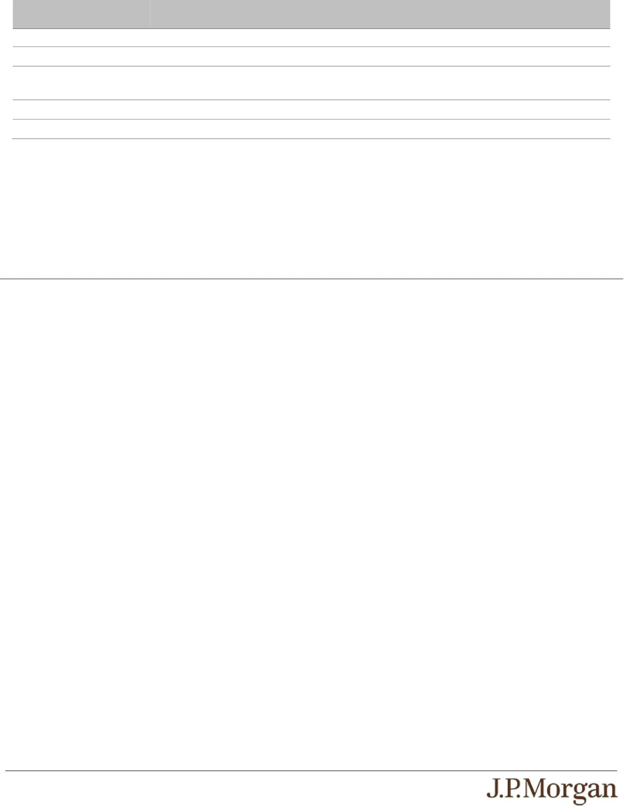
Date | Closing Value of Least | Payment (per $1,000 principal amount note)
 | Performing Underlying
First Review Date | 40.00 | $0
Second Review Date | 45.00 | $0
Third through Twenty- | Less than Interest Barrier | $0
Second Review Dates
Final Review Date | 40.00 | $400.00
 | Total Payment | $400.00 (-60.00% return)

Because the notes have not been redeemed early, the Final Value of the Least Performing Underlying is less than its Trigger Value and the Least Performing Underlying Return is -60.00%, the payment at maturity will be $400.00 per $1,000 principal amount note, calculated as follows:

$1,000 + [$1,000 × (-60.00%)] = $400.00

The hypothetical returns and hypothetical payments on the notes shown above apply only if you hold the notes for their entire term. These hypotheticals do not reflect the fees or expenses that would be associated with any sale in the secondary market. If these fees and expenses were included, the hypothetical returns and hypothetical payments shown above would likely be lower.

Selected Risk Considerations

An investment in the notes involves significant risks. These risks are explained in more detail in the “Risk Factors” sections of the accompanying prospectus supplement and product supplement.

Risks Relating to the Notes Generally

- YOUR INVESTMENT IN THE NOTES MAY RESULT IN A LOSS —

The notes do not guarantee any return of principal. If the notes have not been redeemed early and the Final Value of any

Underlying is less than its Trigger Value, you will lose 1% of the principal amount of your notes for every 1% that the Final Value of the Least Performing Underlying is less than its Initial Value. Accordingly, under these circumstances, you will lose more than 50.00% of your principal amount at maturity and could lose all of your principal amount at maturity.

- THE NOTES DO NOT GUARANTEE THE PAYMENT OF INTEREST AND MAY NOT PAY ANY INTEREST AT ALL —

If the notes have not been redeemed early, we will make a Contingent Interest Payment with respect to a Review Date only if the closing value of each Underlying on that Review Date is greater than or equal to its Interest Barrier. If the closing value of any
Underlying on that Review Date is less than its Interest Barrier, no Contingent Interest Payment will be made with respect to that Review Date. Accordingly, if the closing value of any Underlying on each Review Date is less than its Interest Barrier, you will not receive any interest payments over the term of the notes.

- CREDIT RISKS OF JPMORGAN FINANCIAL AND JPMORGAN CHASE & CO. —

Investors are dependent on our and JPMorgan Chase & Co.’s ability to pay all amounts due on the notes. Any actual or potential

change in our or JPMorgan Chase & Co.’s creditworthiness or credit spreads, as determined by the market for taking that credit risk, is likely to adversely affect the value of the notes. If we and JPMorgan Chase & Co. were to default on our payment obligations, you may not receive any amounts owed to you under the notes and you could lose your entire investment.

- AS A FINANCE SUBSIDIARY, JPMORGAN FINANCIAL HAS NO INDEPENDENT ACTIVITIES AND HAS LIMITED ASSETS —

As a finance subsidiary of JPMorgan Chase & Co., we have no independent activities beyond the issuance and administration of our securities and the collection of intercompany obligations. Aside from the initial capital contribution from JPMorgan Chase &
Co., substantially all of our assets relate to obligations of JPMorgan Chase & Co. to make payments under loans made by us to JPMorgan Chase & Co. or under other intercompany agreements. As a result, we are dependent upon payments from JPMorgan Chase & Co. to meet our obligations under the notes. We are not an operating subsidiary of JPMorgan Chase & Co. and in a
bankruptcy or resolution of JPMorgan Chase & Co. we are not expected to have sufficient resources to meet our obligations in respect of the notes as they come due. If JPMorgan Chase & Co. does not make payments to us and we are unable to make
payments on the notes, you may have to seek payment under the related guarantee by JPMorgan Chase & Co., and that guarantee will rank pari passu with all other unsecured and unsubordinated obligations of JPMorgan Chase & Co. For more

PS-5 | Structured Investments
Callable Contingent Interest Notes Linked to the Least Performing of the
Russell 2000® Index, the State Street® SPDR® S&P® Regional Banking ETF

and the VanEck® Semiconductor ETF

information, see “Risk Factors — Holders of securities issued by JPMorgan Financial may be subject to losses if JPMorgan Chase

& Co. were to enter into a resolution” in the accompanying prospectus supplement.

- THE APPRECIATION POTENTIAL OF THE NOTES IS LIMITED TO THE SUM OF ANY CONTINGENT INTEREST PAYMENTS THAT MAY BE PAID OVER THE TERM OF THE NOTES,

regardless of any appreciation of any Underlying, which may be significant. You will not participate in any appreciation of any Underlying.

- YOU ARE EXPOSED TO THE RISK OF DECLINE IN THE VALUE OF EACH UNDERLYING —

Payments on the notes are not linked to a basket composed of the Underlyings and are contingent upon the performance of each

individual Underlying. Poor performance by any of the Underlyings over the term of the notes may negatively affect whether you will receive a Contingent Interest Payment on any Interest Payment Date and your payment at maturity and will not be offset or mitigated by positive performance by any other Underlying.

- YOUR PAYMENT AT MATURITY WILL BE DETERMINED BY THE LEAST PERFORMING UNDERLYING.

- THE BENEFIT PROVIDED BY THE TRIGGER VALUE MAY TERMINATE ON THE FINAL REVIEW DATE —

If the Final Value of any Underlying is less than its Trigger Value and the notes have not been redeemed early, the benefit provided by the Trigger Value will terminate and you will be fully exposed to any depreciation of the Least Performing Underlying.

- THE OPTIONAL EARLY REDEMPTION FEATURE MAY FORCE A POTENTIAL EARLY EXIT —

If we elect to redeem your notes early, the term of the notes may be reduced to as short as approximately three months and you

will not receive any Contingent Interest Payments after the applicable Interest Payment Date. There is no guarantee that you would be able to reinvest the proceeds from an investment in the notes at a comparable return and/or with a comparable interest rate for a similar level of risk. Even in cases where we elect to redeem your notes before maturity, you are not entitled to any fees and commissions described on the front cover of this pricing supplement.

- YOU WILL NOT RECEIVE DIVIDENDS ON EITHER FUND OR THE SECURITIES INCLUDED IN OR HELD BY ANY UNDERLYING OR HAVE ANY RIGHTS WITH RESPECT TO EITHER FUND OR THOSE SECURITIES.

- THE RISK OF THE CLOSING VALUE OF AN UNDERLYING FALLING BELOW ITS INTEREST BARRIER OR TRIGGER VALUE IS GREATER IF THE VALUE OF THAT UNDERLYING IS VOLATILE.

- WE MAY ACCELERATE YOUR NOTES IF AN ACCELERATION EVENT OCCURS —

Upon the announcement or occurrence of an acceleration event, we may, in our sole and absolute discretion, accelerate the payment on your notes and pay you an amount determined by the calculation agent in good faith and in a commercially reasonable
manner by reference to the values of any fixed-income debt component and any derivatives underlying the economic terms of the notes as of the date of the notice of acceleration. An acceleration event means a Fund is delisted, liquidated or otherwise terminated and the calculation agent determines, in its sole discretion, that no successor fund is available. If the payment on your
notes is accelerated, your investment may result in a loss, and you may not be able to reinvest your money in a comparable investment. Please see “The Underlyings — Funds — Discontinuation or Modification of a Fund” in the accompanying product supplement for more information.

- LACK OF LIQUIDITY —

The notes will not be listed on any securities exchange. Accordingly, the price at which you may be able to trade your notes is likely to depend on the price, if any, at which JPMS is willing to buy the notes. You may not be able to sell your notes. The notes are not designed to be short-term trading instruments. Accordingly, you should be able and willing to hold your notes to maturity.

- THE FINAL TERMS AND VALUATION OF THE NOTES WILL BE PROVIDED IN THE PRICING SUPPLEMENT —

You should consider your potential investment in the notes based on the minimums for the estimated value of the notes and the Contingent Interest Rate.

Risks Relating to Conflicts of Interest

- POTENTIAL CONFLICTS —

We and our affiliates play a variety of roles in connection with the notes. In performing these duties, our and JPMorgan Chase & Co.’s economic interests are potentially adverse to your interests as an investor in the notes. It is possible that hedging or trading

PS-6 | Structured Investments
Callable Contingent Interest Notes Linked to the Least Performing of the
Russell 2000® Index, the State Street® SPDR® S&P® Regional Banking ETF

and the VanEck® Semiconductor ETF

activities of ours or our affiliates in connection with the notes could result in substantial returns for us or our affiliates while the value of the notes declines. Please refer to “Risk Factors — Risks Relating to Conflicts of Interest” in the accompanying product supplement.

Risks Relating to the Estimated Value and Secondary Market Prices of the Notes

- THE ESTIMATED VALUE OF THE NOTES WILL BE LOWER THAN THE ORIGINAL ISSUE PRICE (PRICE TO PUBLIC) OF THE NOTES —

The estimated value of the notes is only an estimate determined by reference to several factors. The original issue price of the notes will exceed the estimated value of the notes because costs associated with selling, structuring and hedging the notes are
included in the original issue price of the notes. These costs include the selling commissions, the projected profits, if any, that our affiliates expect to realize for assuming risks inherent in hedging our obligations under the notes, the estimated cost of hedging our obligations under the notes and the fees, if any, paid for third-party data analytics and/or electronic platform services. See “The Estimated Value of the Notes” in this pricing supplement.

- THE ESTIMATED VALUE OF THE NOTES DOES NOT REPRESENT FUTURE VALUES OF THE NOTES AND MAY DIFFER FROM OTHERS’ ESTIMATES —

See “The Estimated Value of the Notes” in this pricing supplement.

- THE ESTIMATED VALUE OF THE NOTES IS DERIVED BY REFERENCE TO AN INTERNAL FUNDING RATE —

The internal funding rate used in the determination of the estimated value of the notes may differ from the market-implied funding

rate for vanilla fixed income instruments of a similar maturity issued by JPMorgan Chase & Co. or its affiliates. Any difference may be based on, among other things, our and our affiliates’ view of the funding value of the notes as well as the higher issuance, operational and ongoing liability management costs of the notes in comparison to those costs for the conventional fixed income
instruments of JPMorgan Chase & Co. This internal funding rate is based on certain market inputs and assumptions, which may prove to be incorrect, and is intended to approximate the prevailing market replacement funding rate for the notes. The use of an internal funding rate and any potential changes to that rate may have an adverse effect on the terms of the notes and any secondary market prices of the notes. See “The Estimated Value of the Notes” in this pricing supplement.

- THE VALUE OF THE NOTES AS PUBLISHED BY JPMS (AND WHICH MAY BE REFLECTED ON CUSTOMER ACCOUNT STATEMENTS) MAY BE HIGHER THAN THE THEN-CURRENT ESTIMATED VALUE OF THE NOTES FOR A LIMITED TIME PERIOD —

We generally expect that some of the costs included in the original issue price of the notes will be partially paid back to you in connection with any repurchases of your notes by JPMS in an amount that will decline to zero over an initial predetermined period.
See “Secondary Market Prices of the Notes” in this pricing supplement for additional information relating to this initial period. Accordingly, the estimated value of your notes during this initial period may be lower than the value of the notes as published by JPMS (and which may be shown on your customer account statements).

- SECONDARY MARKET PRICES OF THE NOTES WILL LIKELY BE LOWER THAN THE ORIGINAL ISSUE PRICE OF THE NOTES —

Any secondary market prices of the notes will likely be lower than the original issue price of the notes because, among other

things, secondary market prices take into account our internal secondary market funding rates for structured debt issuances and, also, because secondary market prices may exclude selling commissions, projected hedging profits, if any, estimated hedging
costs and fees, if any, paid for third-party data analytics and/or electronic platform services that are included in the original issue price of the notes. As a result, the price, if any, at which JPMS will be willing to buy the notes from you in secondary market transactions, if at all, is likely to be lower than the original issue price. Furthermore, if you sell your notes, you will likely be charged
a commission for secondary market transactions, or the price will likely reflect a dealer discount and/or fees for use of an electronic platform to facilitate secondary market activity. Any sale by you prior to the Maturity Date could result in a substantial loss to you.

- SECONDARY MARKET PRICES OF THE NOTES WILL BE IMPACTED BY MANY ECONOMIC AND MARKET FACTORS —

The secondary market price of the notes during their term will be impacted by a number of economic and market factors, which may either offset or magnify each other, aside from the selling commissions, projected hedging profits, if any, estimated hedging
costs and the values of the Underlyings. Additionally, independent pricing vendors and/or third party broker-dealers may publish a price for the notes, which may also be reflected on customer account statements. This price may be different (higher or lower) than the price of the notes, if any, at which JPMS may be willing to purchase your notes in the secondary market. See “Risk

PS-7 | Structured Investments
Callable Contingent Interest Notes Linked to the Least Performing of the
Russell 2000® Index, the State Street® SPDR® S&P® Regional Banking ETF

and the VanEck® Semiconductor ETF

Factors — Risks Relating to the Estimated Value and Secondary Market Prices of the Notes — Secondary market prices of the notes will be impacted by many economic and market factors” in the accompanying product supplement.

Risks Relating to the Underlyings

- AN INVESTMENT IN THE NOTES IS SUBJECT TO RISKS ASSOCIATED WITH SMALL CAPITALIZATION STOCKS WITH RESPECT TO THE INDEX —

Small capitalization companies may be less able to withstand adverse economic, market, trade and competitive conditions relative to larger companies. Small capitalization companies are less likely to pay dividends on their stocks, and the presence of a dividend payment could be a factor that limits downward stock price pressure under adverse market conditions.

- THERE ARE RISKS ASSOCIATED WITH THE FUNDS —

The Funds are subject to management risk, which is the risk that the investment strategies of the applicable Fund’s investment adviser, the implementation of which is subject to a number of constraints, may not produce the intended results. These constraints could adversely affect the market prices of the shares of the Funds and, consequently, the value of the notes.

- THE PERFORMANCE AND MARKET VALUE OF EACH FUND, PARTICULARLY DURING PERIODS OF MARKET VOLATILITY, MAY NOT CORRELATE WITH THE PERFORMANCE OF THAT FUND’S UNDERLYING INDEX AS WELL AS THE NET ASSET VALUE PER SHARE —

Each Fund does not fully replicate its Underlying Index (as defined under “The Underlyings” below) and may hold securities different from those included in its Underlying Index. In addition, the performance of each Fund will reflect additional transaction
costs and fees that are not included in the calculation of its Underlying Index. All of these factors may lead to a lack of correlation between the performance of each Fund and its Underlying Index. In addition, corporate actions with respect to the equity securities underlying a Fund (such as mergers and spin-offs) may impact the variance between the performances of that Fund and its
Underlying Index. Finally, because the shares of each Fund are traded on a securities exchange and are subject to market supply and investor demand, the market value of one share of each Fund may differ from the net asset value per share of that Fund.

During periods of market volatility, securities underlying each Fund may be unavailable in the secondary market, market

participants may be unable to calculate accurately the net asset value per share of that Fund and the liquidity of that Fund may be adversely affected. This kind of market volatility may also disrupt the ability of market participants to create and redeem shares of a Fund. Further, market volatility may adversely affect, sometimes materially, the prices at which market participants are willing to
buy and sell shares of a Fund. As a result, under these circumstances, the market value of shares of a Fund may vary substantially from the net asset value per share of that Fund. For all of the foregoing reasons, the performance of each Fund may not correlate
with the performance of its Underlying Index as well as the net asset value per share of that Fund, which could materially and adversely affect the value of the notes in the secondary market and/or reduce any payment on the notes.

- RISKS ASSOCIATED WITH THE BANKING INDUSTRY WITH RESPECT TO THE STATE STREET® SPDR® S&P® REGIONAL BANKING ETF —

All or substantially all of the equity securities held by the State Street® SPDR® S&P® Regional Banking ETF are issued by companies whose primary line of business is directly associated with the banking industry. As a result, the value of the notes may be subject to greater volatility and be more adversely affected by a single economic, political or regulatory occurrence affecting this

industry than a different investment linked to securities of a more broadly diversified group of issuers. The performance of bank stocks may be affected by extensive governmental regulation, which may limit both the amounts and types of loans and other financial commitments they can make, the interest rates and fees they can charge and the amount of capital they must maintain.
Profitability is largely dependent on the availability and cost of capital funds and can fluctuate significantly when interest rates change. Credit losses resulting from financial difficulties of borrowers can negatively impact the banking companies. Banks may
also be subject to severe price competition. Competition is high among banking companies and failure to maintain or increase market share may result in lost market share. These factors could affect the banking industry and could affect the value of the equity securities held by the State Street® SPDR® S&P® Regional Banking ETF and the price of the State Street® SPDR® S&P® Regional Banking ETF during the term of the notes, which may adversely affect the value of your notes.
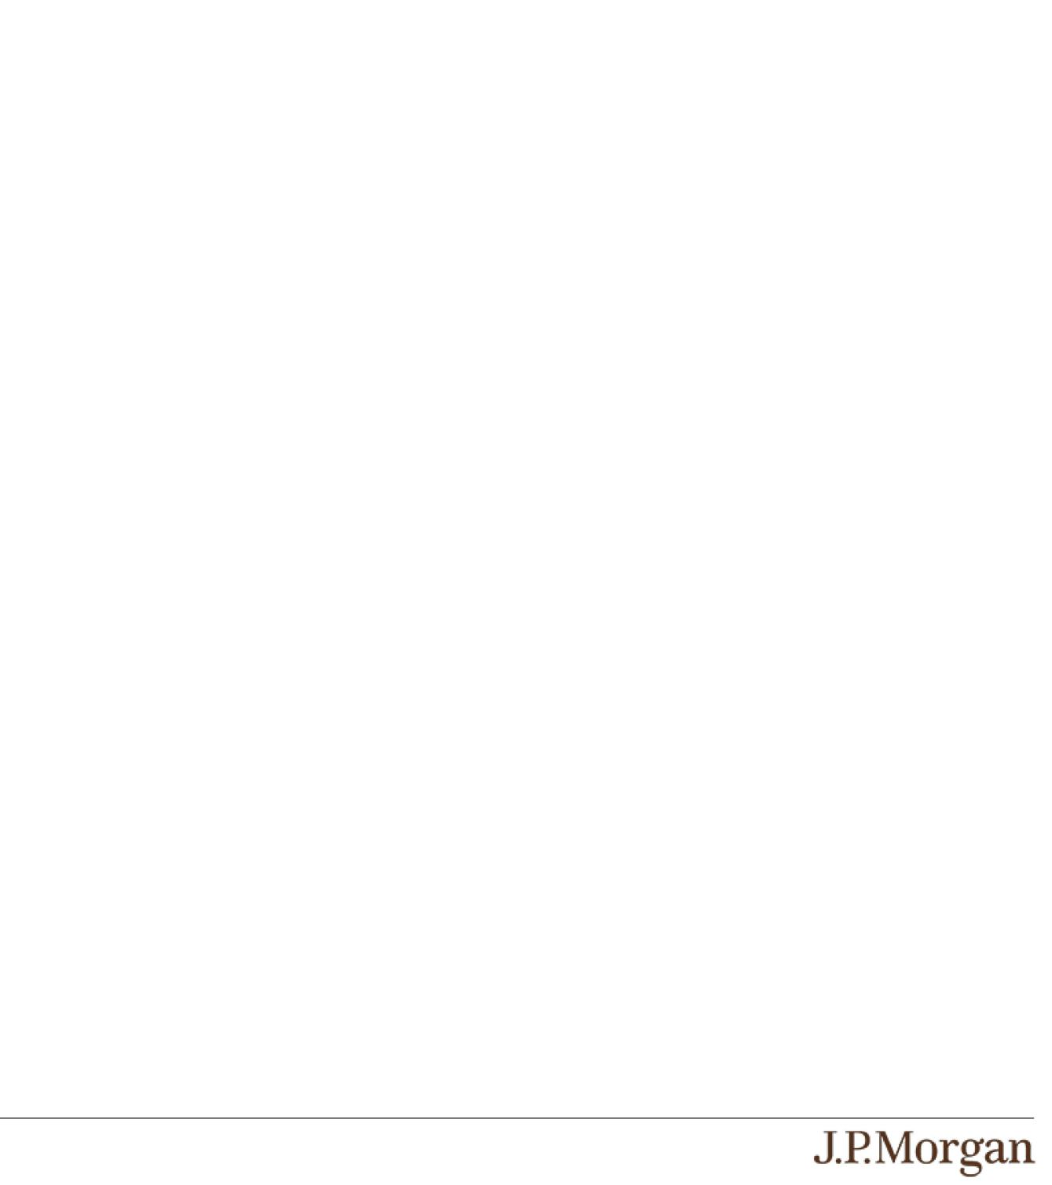

PS-8 | Structured Investments
Callable Contingent Interest Notes Linked to the Least Performing of the
Russell 2000® Index, the State Street® SPDR® S&P® Regional Banking ETF

and the VanEck® Semiconductor ETF

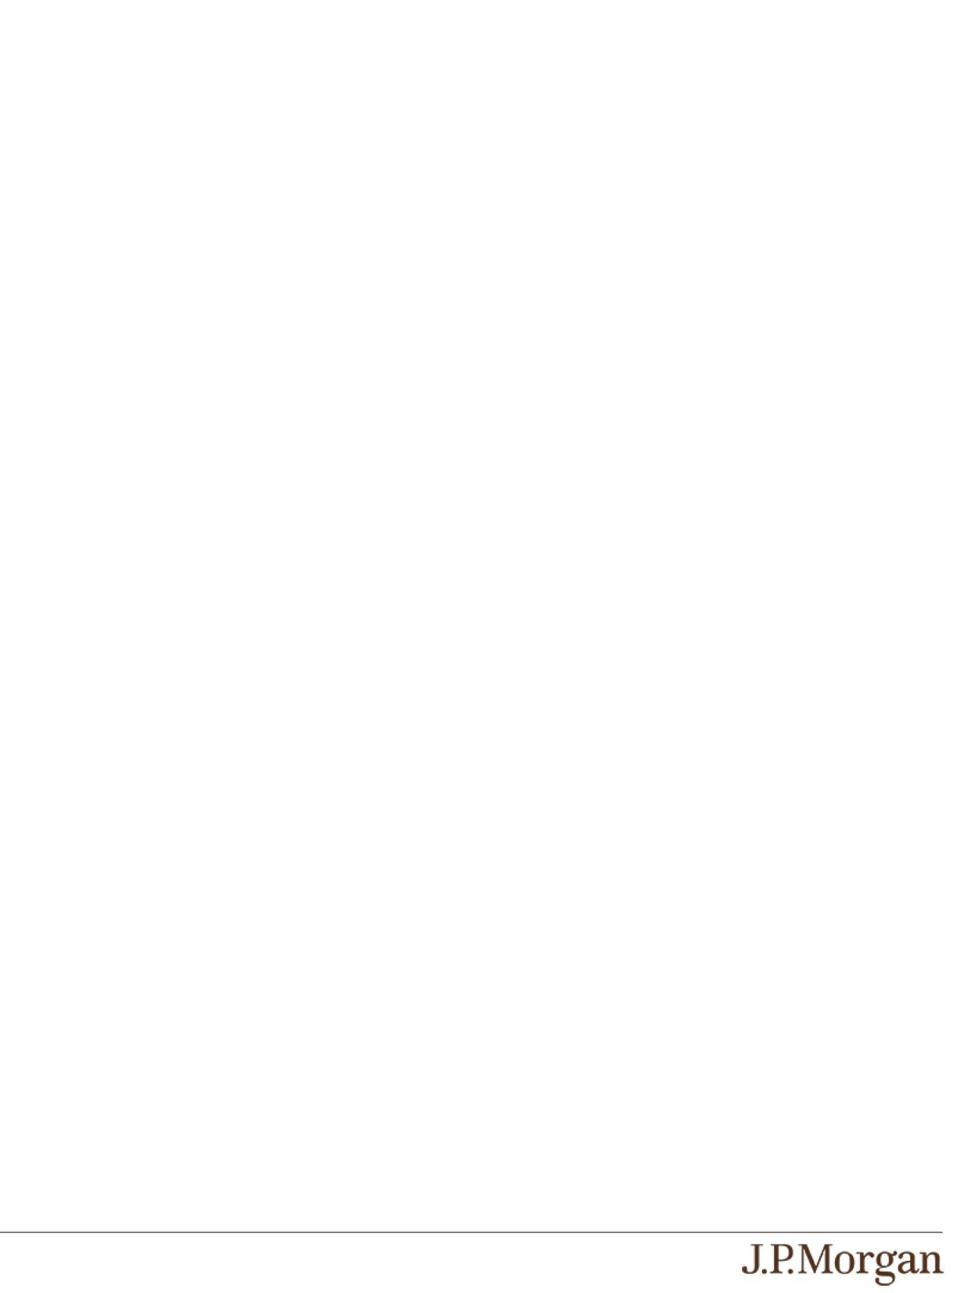
- RISKS ASSOCIATED WITH THE SEMICONDUCTOR INDUSTRY WITH RESPECT TO THE VANECK® SEMICONDUCTOR ETF
—

All or substantially all of the equity securities held by the VanEck® Semiconductor ETF are issued by companies whose primary line of business is directly associated with the semiconductor industry. As a result, the value of the notes may be subject to greater volatility and be more adversely affected by a single economic, political or regulatory occurrence affecting this industry than a

different investment linked to securities of a more broadly diversified group of issuers. Competitive pressures may have a significant effect on the financial condition of companies in the semiconductor industry. As product cycles shorten and manufacturing capacity increases, these companies may become increasingly subject to aggressive pricing, which hampers
profitability. Semiconductor companies are vulnerable to wide fluctuations in securities prices due to rapid product obsolescence. Many semiconductor companies may not successfully introduce new products, develop and maintain a loyal customer base or achieve general market acceptance for their products, and failure to do so could have a material adverse effect on their business,
results of operations and financial condition. Reduced demand for end-user products, underutilization of manufacturing capacity, and other factors could adversely impact the operating results of companies in the semiconductor industry. Semiconductor
companies typically face high capital costs and these companies may need additional financing, which may be difficult to obtain. They also may be subject to risks relating to research and development costs and the availability and price of components. Moreover, they may be heavily dependent on intellectual property rights and may be adversely affected by loss or impairment of
those rights. Some of the companies involved in the semiconductor sector are also engaged in other lines of business unrelated to the semiconductor business, and they may experience problems with these lines of business, which could adversely affect their
operating results. The international operations of many semiconductor companies expose them to risks associated with instability and changes in economic and political conditions, foreign currency fluctuations, changes in foreign regulations, tariffs and trade disputes, competition from subsidized foreign competitors with lower production costs and other risks inherent to international
business. The semiconductor industry is highly cyclical, which may cause the operating results of many semiconductor companies to vary significantly. Companies in the semiconductor industry also may be subject to competition from new market entrants. The
stock prices of companies in the semiconductor industry have been and will likely continue to be extremely volatile compared to the overall market. These factors could affect the semiconductor industry and could affect the value of the equity securities held by the VanEck® Semiconductor ETF and the price of the VanEck® Semiconductor ETF during the term of the notes, which may adversely affect the value of your notes.

- NON-U.S. SECURITIES RISK WITH RESPECT TO THE VANECK® SEMICONDUCTOR ETF —

Some of the equity securities held by the VanEck® Semiconductor ETF have been issued by non-U.S. companies. Investments in securities linked to the value of such non-U.S. equity securities involve risks associated with the home countries of the issuers of those non-U.S. equity securities.

- THE ANTI-DILUTION PROTECTION FOR THE FUNDS IS LIMITED —

The calculation agent will make adjustments to the Share Adjustment Factor for each Fund for certain events affecting the shares of that Fund. However, the calculation agent will not make an adjustment in response to all events that could affect the shares of the Funds. If an event occurs that does not require the calculation agent to make an adjustment, the value of the notes may be materially and adversely affected.

PS-9 | Structured Investments
Callable Contingent Interest Notes Linked to the Least Performing of the
Russell 2000® Index, the State Street® SPDR® S&P® Regional Banking ETF

and the VanEck® Semiconductor ETF

The Underlyings
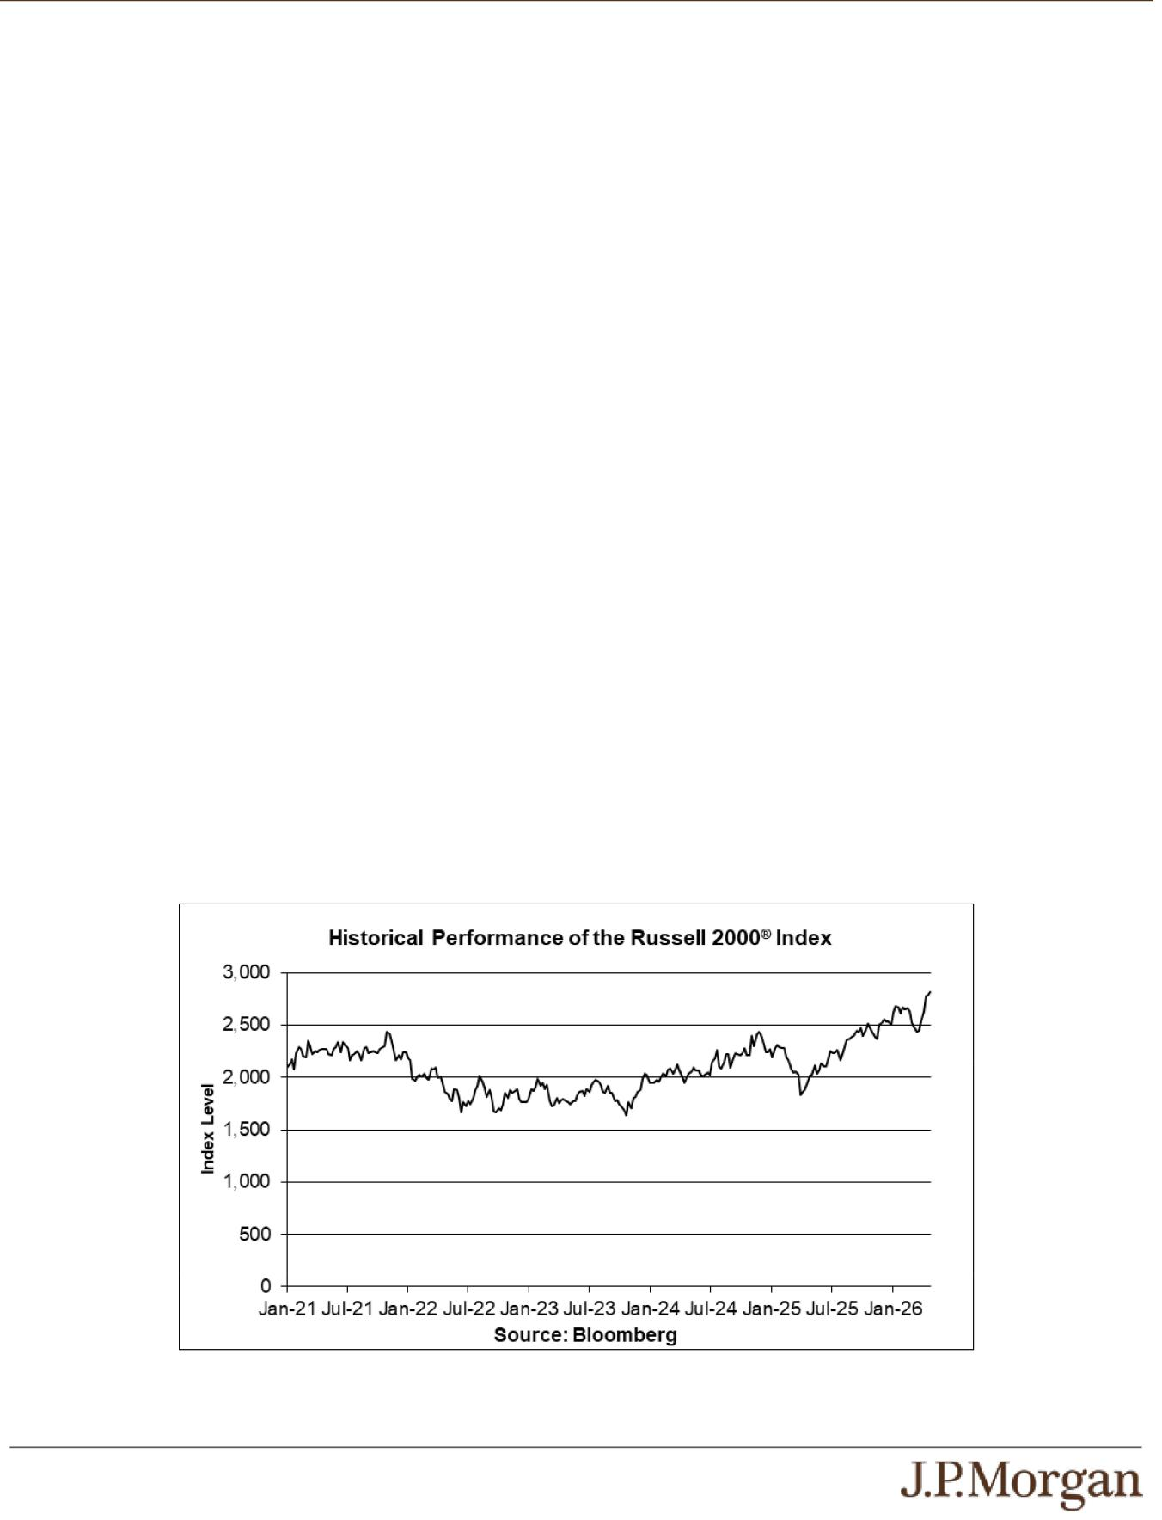

The Index measures the capitalization-weighted price performance of 2,000 U.S. small-capitalization stocks listed on eligible U.S. exchanges and is designed to track the performance of the small-capitalization segment of the U.S. equity market. The companies included in the Index are the middle 2,000 of the companies that form the Russell 3000E™ Index, which is composed of the 4,000 largest U.S. companies as determined by total market capitalization and represents approximately 99% of the U.S. equity market. For additional information about the Index, see “Equity Index Descriptions — The Russell Indices” in the accompanying underlying supplement.

The State Street® SPDR® S&P® Regional Banking ETF is an exchange-traded fund of the SPDR® Series Trust, a registered investment company, that seeks to provide investment results that, before fees and expenses, correspond generally to the total return performance of an index derived from the regional banking segment of the U.S. banking industry, which we refer to as the Underlying Index with respect to the State Street® SPDR® S&P® Regional Banking ETF. The Underlying Index with respect to the State Street® SPDR® S&P® Regional Banking ETF is currently the S&P® Regional Banks Select Industry Index. The S&P® Regional Banks Select Industry Index is a modified equal-weighted index that is designed to measure the performance of the GICS® regional banks sub-industry of the S&P Total Market Index. For additional information about the State Street® SPDR® S&P® Regional Banking ETF, see “Fund Descriptions — The State Street® SPDR® S&P® Industry ETFs” in the accompanying underlying supplement.

The VanEck® Semiconductor ETF is an exchange-traded fund of VanEck® ETF Trust, a registered investment company, that seeks to replicate as closely as possible, before fees and expenses, the price and yield performance of the MVIS® US Listed Semiconductor 25 Index, which we refer to as the Underlying Index with respect to the VanEck® Semiconductor ETF. The MVIS® US Listed Semiconductor 25 Index is designed to track the performance of the largest and most liquid U.S. exchange-listed companies in the semiconductor industry, which only includes companies that derive at least 50% (25% for current components) of their revenues from the semiconductor segment. For additional information about the VanEck® Semiconductor ETF, see “Fund Descriptions — The VanEck® ETFs” in the accompanying underlying supplement.

Historical Information

The following graphs set forth the historical performance of each Underlying based on the weekly historical closing values from January 8, 2021 through May 1, 2026. The closing value of the Index on May 5, 2026 was 2,845.004. The closing value of the State Street® SPDR® S&P® Regional Banking ETF on May 5, 2026 was $69.92. The closing value of the VanEck® Semiconductor ETF on May 5, 2026 was $522.69. We obtained the closing values above and below from the Bloomberg Professional® service (“Bloomberg”), without independent verification. The closing values of the Funds above and below may have been adjusted by Bloomberg for actions taken by the Funds, such as stock splits.

The historical closing values of each Underlying should not be taken as an indication of future performance, and no assurance can be given as to the closing value of any Underlying on the Pricing Date or any Review Date. There can be no assurance that the performance of the Underlyings will result in the return of any of your principal amount or the payment of any interest.

PS-10 | Structured Investments
Callable Contingent Interest Notes Linked to the Least Performing of the
Russell 2000® Index, the State Street® SPDR® S&P® Regional Banking ETF

and the VanEck® Semiconductor ETF

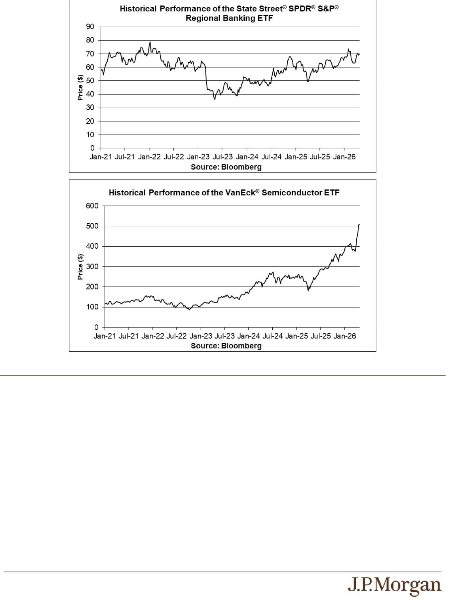

Tax Treatment

You should review carefully the section entitled “United States Federal Taxation” in the accompanying prospectus supplement. In determining our reporting responsibilities we intend to treat (i) the notes for U.S. federal income tax purposes as prepaid forward contracts with associated contingent coupons and (ii) any Contingent Interest Payments as ordinary income, as described in the section entitled “United States Federal Taxation — Tax Consequences to U.S. Holders — Program Securities Treated as Prepaid Financial Contracts with Associated Coupons” in the accompanying prospectus supplement. Based on the advice of Davis Polk & Wardwell LLP, our special tax counsel, we believe that this is a reasonable treatment, but that there are other reasonable treatments that the IRS or a court may adopt, in which case the timing and character of any income or loss on the notes could be materially affected. In addition, in 2007 Treasury and the IRS released a notice requesting comments on the U.S. federal income tax treatment of “prepaid forward contracts” and similar instruments. The notice focuses in particular on whether to require investors in these instruments to accrue income over the term of their investment. It also asks for comments on a number of related topics, including the character of income or loss with respect to these instruments and the relevance of factors such as the nature of the underlying property to which the instruments are linked. While the notice requests comments on appropriate transition rules and effective dates, any Treasury regulations or other guidance promulgated after consideration of these issues could materially affect the tax consequences of an investment in the notes, possibly with retroactive effect. The discussions above and in the accompanying prospectus supplement do not address the consequences to taxpayers subject to special tax accounting rules under Section 451(b) of the Code. You should consult your tax adviser regarding the U.S. federal income tax consequences of an investment in the notes, including possible alternative treatments and the issues presented by the notice described above.

PS-11 | Structured Investments
Callable Contingent Interest Notes Linked to the Least Performing of the
Russell 2000® Index, the State Street® SPDR® S&P® Regional Banking ETF

and the VanEck® Semiconductor ETF

Non-U.S. Holders — Tax Considerations. The U.S. federal income tax treatment of Contingent Interest Payments is uncertain, and although we believe it is reasonable to take a position that Contingent Interest Payments are not subject to U.S. withholding tax (at least if an applicable Form W-8 is provided), it is expected that withholding agents will (and we, if we are the withholding agent, intend to) withhold on any Contingent Interest Payment paid to a Non-U.S. Holder generally at a rate of 30% or at a reduced rate specified by an applicable income tax treaty under an “other income” or similar provision. We will not be required to pay any additional amounts with respect to amounts withheld. In order to claim an exemption from, or a reduction in, the 30% withholding tax, a Non-U.S. Holder of the notes must comply with certification requirements to establish that it is not a U.S. person and is eligible for such an exemption or reduction under an applicable tax treaty. If you are a Non-U.S. Holder, you should consult your tax adviser regarding the tax treatment of the notes, including the possibility of obtaining a refund of any withholding tax and the certification requirement described above.

Section 871(m) of the Code and Treasury regulations promulgated thereunder (“Section 871(m)”) generally impose a 30% withholding tax (unless an income tax treaty applies) on dividend equivalents paid or deemed paid to Non-U.S. Holders with respect to certain financial instruments linked to U.S. equities or indices that include U.S. equities. Section 871(m) provides certain exceptions to this withholding regime, including for instruments linked to certain broad-based indices that meet requirements set forth in the applicable Treasury regulations. Additionally, a recent IRS notice excludes from the scope of Section 871(m) instruments issued prior to January 1, 2027 that do not have a delta of one with respect to underlying securities that could pay U.S.-source dividends for U.S. federal income tax purposes (each an “Underlying Security”). Based on certain determinations made by us, we expect that Section 871(m) will not apply to the notes with regard to Non-U.S. Holders. Our determination is not binding on the IRS, and the IRS may disagree with this determination. Section 871(m) is complex and its application may depend on your particular circumstances, including whether you enter into other transactions with respect to an Underlying Security. If necessary, further information regarding the potential application of Section 871(m) will be provided in the pricing supplement for the notes. You should consult your tax adviser regarding the potential application of Section 871(m) to the notes.

In the event of any withholding on the notes, we will not be required to pay any additional amounts with respect to amounts so withheld.

The Estimated Value of the Notes
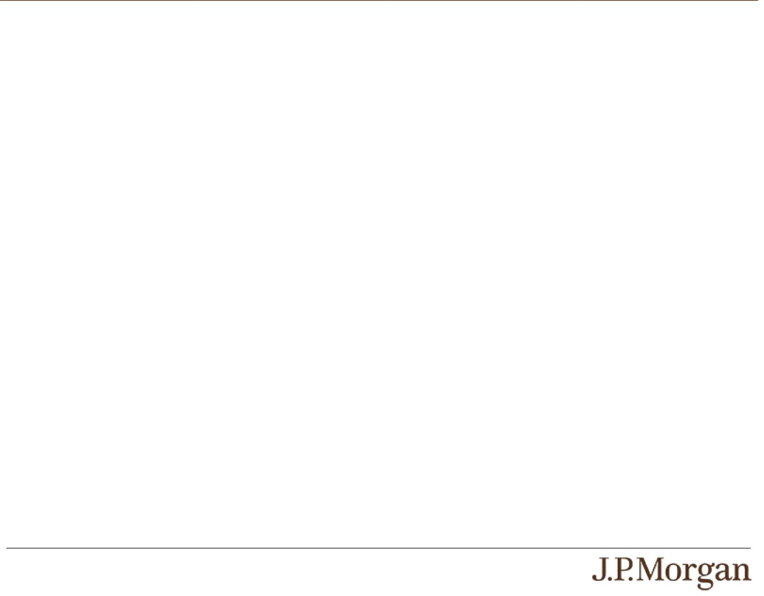

The estimated value of the notes set forth on the cover of this pricing supplement is equal to the sum of the values of the following hypothetical components: (1) a fixed-income debt component with the same maturity as the notes, valued using the internal funding rate described below, and (2) the derivative or derivatives underlying the economic terms of the notes. The estimated value of the notes does not represent a minimum price at which JPMS would be willing to buy your notes in any secondary market (if any exists) at any time. The internal funding rate used in the determination of the estimated value of the notes may differ from the market-implied funding rate for vanilla fixed income instruments of a similar maturity issued by JPMorgan Chase & Co. or its affiliates. Any difference may be based on, among other things, our and our affiliates’ view of the funding value of the notes as well as the higher issuance, operational and ongoing liability management costs of the notes in comparison to those costs for the conventional fixed income instruments of JPMorgan Chase & Co. This internal funding rate is based on certain market inputs and assumptions, which may prove to be incorrect, and is intended to approximate the prevailing market replacement funding rate for the notes. The use of an internal funding rate and any potential changes to that rate may have an adverse effect on the terms of the notes and any secondary market prices of the notes. For additional information, see “Selected Risk Considerations — Risks Relating to the Estimated Value and Secondary Market Prices of the Notes — The Estimated Value of the Notes Is Derived by Reference to an Internal Funding Rate” in this pricing supplement.

The value of the derivative or derivatives underlying the economic terms of the notes is derived from internal pricing models of our affiliates. These models are dependent on inputs such as the traded market prices of comparable derivative instruments and on various other inputs, some of which are market-observable, and which can include volatility, dividend rates, interest rates and other factors, as well as assumptions about future market events and/or environments. Accordingly, the estimated value of the notes is determined when the terms of the notes are set based on market conditions and other relevant factors and assumptions existing at that time.

The estimated value of the notes does not represent future values of the notes and may differ from others’ estimates. Different pricing models and assumptions could provide valuations for the notes that are greater than or less than the estimated value of the notes. In addition, market conditions and other relevant factors in the future may change, and any assumptions may prove to be incorrect. On future dates, the value of the notes could change significantly based on, among other things, changes in market conditions, our or JPMorgan Chase & Co.’s creditworthiness, interest rate movements and other relevant factors, which may impact the price, if any, at which JPMS would be willing to buy notes from you in secondary market transactions.

The estimated value of the notes will be lower than the original issue price of the notes because costs associated with selling, structuring and hedging the notes are included in the original issue price of the notes. These costs include the selling commissions paid to JPMS and other affiliated or unaffiliated dealers, the projected profits, if any, that our affiliates expect to realize for assuming

PS-12 | Structured Investments
Callable Contingent Interest Notes Linked to the Least Performing of the
Russell 2000® Index, the State Street® SPDR® S&P® Regional Banking ETF

and the VanEck® Semiconductor ETF

risks inherent in hedging our obligations under the notes, the estimated cost of hedging our obligations under the notes and the fees, if any, paid for third-party data analytics and/or electronic platform services. Because hedging our obligations entails risk and may be influenced by market forces beyond our control, this hedging may result in a profit that is more or less than expected, or it may result in a loss. A portion of the profits, if any, realized in hedging our obligations under the notes may be allowed to other affiliated or unaffiliated dealers, and we or one or more of our affiliates will retain any remaining hedging profits. See “Selected Risk Considerations

— Risks Relating to the Estimated Value and Secondary Market Prices of the Notes — The Estimated Value of the Notes Will Be Lower Than the Original Issue Price (Price to Public) of the Notes” in this pricing supplement.

Secondary Market Prices of the Notes
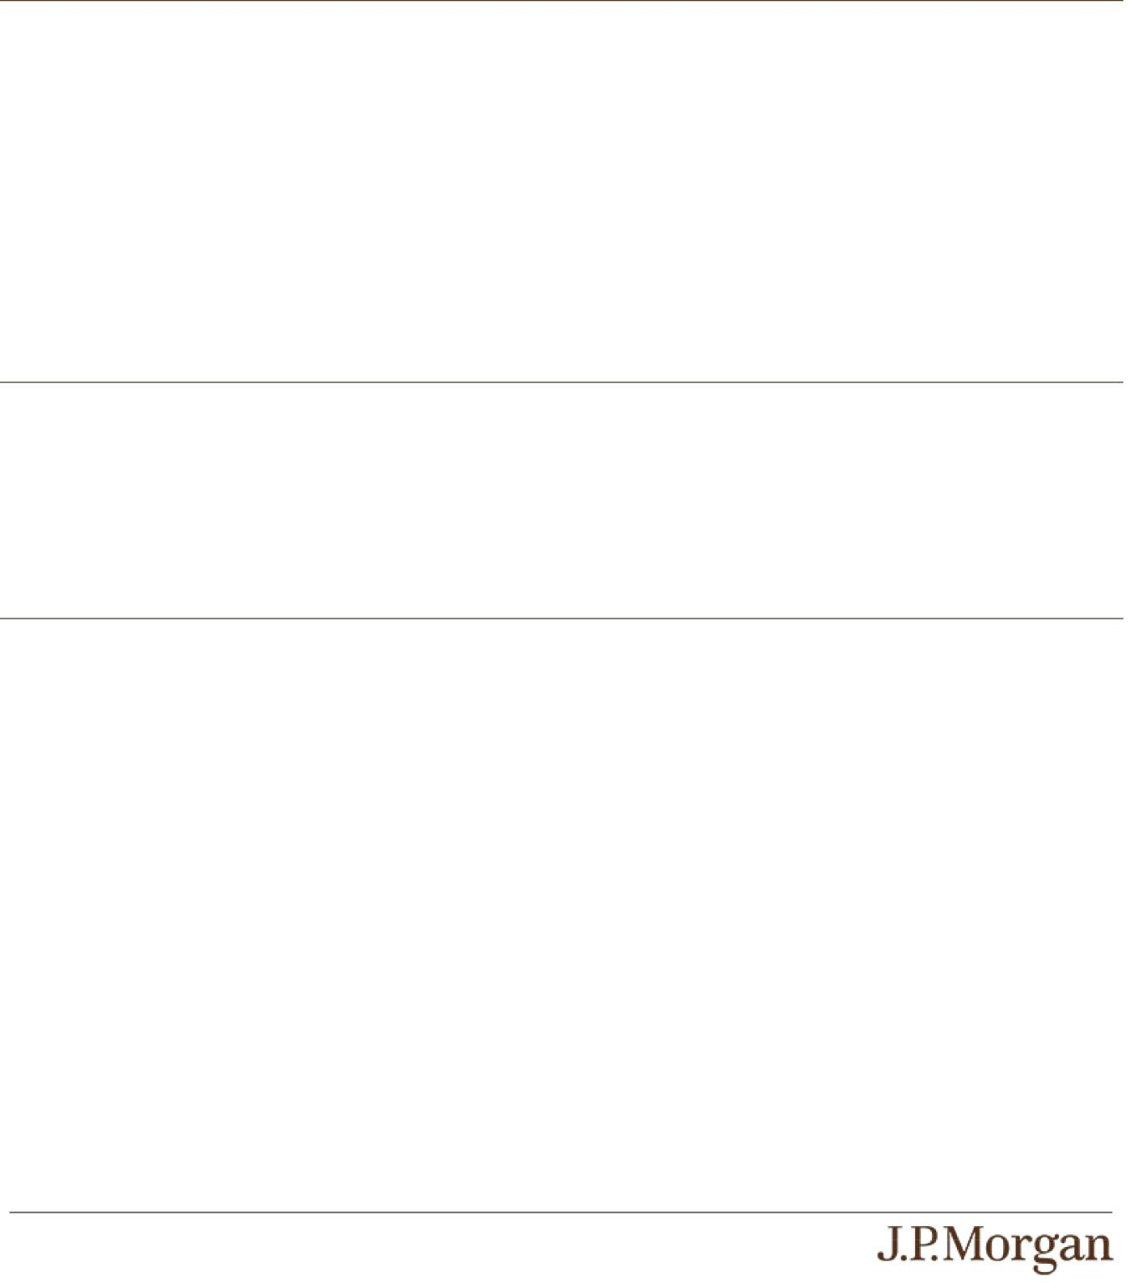

For information about factors that will impact any secondary market prices of the notes, see “Risk Factors — Risks Relating to the Estimated Value and Secondary Market Prices of the Notes — Secondary market prices of the notes will be impacted by many economic and market factors” in the accompanying product supplement. In addition, we generally expect that some of the costs included in the original issue price of the notes will be partially paid back to you in connection with any repurchases of your notes by JPMS in an amount that will decline to zero over an initial predetermined period. These costs can include selling commissions, projected hedging profits, if any, and, in some circumstances, estimated hedging costs, our internal secondary market funding rates for structured debt issuances and the fees paid for third-party data analytics and/or electronic platform services. This initial predetermined time period is intended to be the shorter of six months and one-half of the stated term of the notes. The length of any such initial period reflects the structure of the notes, whether our affiliates expect to earn a profit in connection with our hedging activities, the estimated costs of hedging the notes and when these costs are incurred, as determined by our affiliates. See “Selected Risk Considerations — Risks Relating to the Estimated Value and Secondary Market Prices of the Notes — The Value of the Notes as Published by JPMS (and Which May Be Reflected on Customer Account Statements) May Be Higher Than the Then-Current Estimated Value of the Notes for a Limited Time Period” in this pricing supplement.

Supplemental Use of Proceeds

The notes are offered to meet investor demand for products that reflect the risk-return profile and market exposure provided by the notes. See “How the Notes Work” and “Hypothetical Payout Examples” in this pricing supplement for an illustration of the risk-return profile of the notes and “The Underlyings” in this pricing supplement for a description of the market exposure provided by the notes.

The original issue price of the notes is equal to the estimated value of the notes plus the selling commissions paid to JPMS and other affiliated or unaffiliated dealers, plus (minus) the projected profits (losses) that our affiliates expect to realize for assuming risks inherent in hedging our obligations under the notes, plus the estimated cost of hedging our obligations under the notes , plus the fees, if any, paid for third-party data analytics and/or electronic platform services.

Additional Terms Specific to the Notes

You may revoke your offer to purchase the notes at any time prior to the time at which we accept such offer by notifying the applicable agent. We reserve the right to change the terms of, or reject any offer to purchase, the notes prior to their issuance. In the event of any changes to the terms of the notes, we will notify you and you will be asked to accept such changes in connection with your purchase. You may also choose to reject such changes, in which case we may reject your offer to purchase.

You should read this pricing supplement together with the accompanying prospectus, as supplemented by the accompanying prospectus supplement relating to our Series A medium-term notes of which these notes are a part, and the more detailed information contained in the accompanying product supplement and the accompanying underlying supplement. This pricing supplement, together with the documents listed below, contains the terms of the notes and supersedes all other prior or contemporaneous oral statements as well as any other written materials including preliminary or indicative pricing terms, correspondence, trade ideas, structures for implementation, sample structures, fact sheets, brochures or other educational materials of ours. You should carefully consider, among other things, the matters set forth in the “Risk Factors” sections of the accompanying prospectus supplement and the accompanying product supplement, as the notes involve risks not associated with conventional debt securities. We urge you to consult your investment, legal, tax, accounting and other advisers before you invest in the notes.

PS-13 | Structured Investments
Callable Contingent Interest Notes Linked to the Least Performing of the
Russell 2000® Index, the State Street® SPDR® S&P® Regional Banking ETF

and the VanEck® Semiconductor ETF

You may access these documents on the SEC website at www.sec.gov as follows (or if such address has changed, by reviewing our filings for the relevant date on the SEC website):

- Product supplement no. 3-I dated April 17, 2026: http://www.sec.gov/Archives/edgar/data/19617/000121390026045198/ea0285802-20_424b2.pdf

- Underlying supplement no. 1-I dated April 17, 2026: http://www.sec.gov/Archives/edgar/data/19617/000121390026045209/ea0285802-11_424b2.pdf

- Prospectus supplement and prospectus, each dated April 17, 2026: http://www.sec.gov/Archives/edgar/data/19617/000095010326005889/crt_dp245141-424b2.pdf

Our Central Index Key, or CIK, on the SEC website is 1665650, and JPMorgan Chase & Co.’s CIK is 19617. As used in this pricing supplement, “we,” “us” and “our” refer to JPMorgan Financial.

PS-14 | Structured Investments

Callable Contingent Interest Notes Linked to the Least Performing of the Russell 2000® Index, the State Street® SPDR® S&P® Regional Banking ETF

and the VanEck® Semiconductor ETF

